Electricity Meter Reading and Load Detector using Iot

Ms.V.Valarmathi
Assistant Professor,
Dept. of Information technology
Sri Sairam Engnieering
College
valarmathi.it@sairam.edu.in

Chennai, India

Ajaay A P
Dept. of Information technology
Sri Sairam Engnieering College
sec20it155@sairamtap.edu.in

Chennai, India

Prakash A
Dept. of Information technology
Sri Sairam Engnieering College
Secl21it06@sairamtap.edu.in

Chennai,India

ABSTRACT

Electricity meter reading and load generator is an enhanced way to obtain meter readings. This system is basically designed to bring improvement in traditional way of taking readings and calculations. This paper also addresses on load detecting technology (an advancement in the project) which is integrated with the Iot setup to maintain the accuracy of current consumed by the load. The main objective is to replace the manual way of taking readings with advanced Iot devices and detecting whether correct load is used by the consumer or not. The system mainly proves its accuracy and reliability in taking readings and calculations, also detects the load consumption is correct or not for a house or organization. The system has an advancement, it automatically cuts-off the power supply if the load has reached its maximum demand. By this way it ensures correct load is used by the consumer. The whole idea is integrated with a Mobile Application that calculates the readings according to the unit charge, it also alerts a warning message when the load reaches its maximum demand and cuts-off the power supply.

Keywords— Meter Reading, Iot Setup, Load detection, Mobile Application.

I. INTRODUCTION

Meter readings taken manually exist for long period of time and load supply for a service place also exist manually. Today in modern world the impact of technology growth has spread wide around the globe, many new innovations have lend a way to enhance people way of living and also provided technological solutions for rectifying errors. This paper also depicts the advancement that can be made in electricity meter readings and rectify prolonging errors. This project has advanced features or its implementation can solve a problem in a specific domain. It generally eradicates the manual way of taking meter reading because the probability of making wrong calculation is very high. Instead the electricity setup is integrated with an microcontroller which has inbuilt wifi to send the meter readings to the app built. The App performs calculations according to the readings received. When it comes to electricity calculation each district, area has different amount for per unit charge. We have also considered this and aimed to provide meter bill with correct calculations. So we have included an option to enter the per unit charge in a particular city or district in the app and then it calculates the readings according to the unit charge entered. This project also monitors the load consumption, it ensures to prove correct load is supplied to the consumer by monitoring the maximum demand of the load. If the load reaches the maximum demand it indicates the consumer is involved in fraudulent activity and consuming electricity more than the maximum level. At this time the alert message is given to the government and power supply is cut-off automatically. This App performs multiple tasks like meter reading calculation, allows to enter per unit charge for a location or city, alert message for the government if the load has reached its maximum demand.

II. LITERATURE REVIEW

1. An Internet of Things (IoT)-based smart energy metre that will save time for electricity board employees and minimise errors in bill generation. The electric metre board will be connected to an Arduino board in this setup, which will use a sensor to gather data from the metre board and send notifications or update the data to a web-based system that will be connected via a Wi-Fi module.

2. Rapid advancements in e-metering (Electronic Metering) technology have increased need for a stable and effective Automatic Metre Reading (AMR) system. Electricity billing done this way is safe and economical. A service provider representative is required to visit the installed location of the energy metre at the conclusion of each billing cycle in order to take the reading, record it, and take a picture of the energy metre for use in future data processing (i.e., bill generation). Both the time and labour required of humans in traditional billing are decreased by using this strategy. This study examines energy metre reading devices developed in the previous year utilising a variety of approaches, including GSM and Microcontoller.

3. This study proposed and demonstrated the usage of smart energy metres, which allow customers to use their mobile phones to check their current power consumptions (bills) from anywhere at any time. This idea offers an economical way to bill for electricity. The current energy billing systems are sluggish, expensive, discrete, and erroneous. The main problem with the conventional invoicing approach is energy and power theft. Using GSM technology, the user can receive notifications regarding their power usage (measured in watts), and the device will automatically notify them when their power consumption surpasses a certain threshold and they need to recharge.

4. The primary goal of this project is to use IoT to measure electricity use and determine its cost. Calculations are made using the voltage, current, power consumption, number of units, and associated cost readings.the process of gathering utility metre readings for electricity. The Internet of Things (IoT) offers a cost-effective and efficient way to wirelessly transmit energy consumer information and to monitor electricity consumption.This study suggests a method that reduces errors, a key contributor to energy-related corruption, and eliminates labour by self-regulating metre readings and bill production.

5. The goal of this research project is to provide consumers with smart and efficient electricity distribution through the use of smart metering data. The primary disadvantage of the old metres that were previously in use is that they do not give consumers information; this is something that the smart metre helps with. A smart metre aids consumers in learning how much electricity is used by the equipment in their homes. The purpose of this research project is to quantify and analyse electricity consumption by conducting case studies on different families using data from Smart Metres. Not only can Smart Metre data save electricity, but it also shows how customers use their gadgets.

III. EXISTING SYSTEM

A. METER READING

The Existing system of electricity meter reading done manually by a governmnet official who visits consumers house directly for every one or two months and note down the readings for calculation. After taking down the readings, calculation are made by the official and meter bill is generated. The bill will be refected after two or three days to the consumer. The issue arises here, if the official has made some minor calculation error it would directly reflect in the consumer bill. The electric bill generated now can have a huge amount difference than the actual bill. This prolonging issue has to be addressed to generate correct and accurate electricity bill.

B. LOAD DETECTION

Every house or Organization getting the electricity service from the government must show their maximum amount of current and voltage will be used. The load is generally used to track the current and voltage consumption. This is examined by a government official or government electricity board, after analyzing the service board will provide a load for a particular house or organization. Here, the maximum capacity of load may differ, if the capacity of load is low then it can be used for houses or any other small shops whereas, if the load capacity is high then it can be used in an organization or industrial purpose. Here the problem is, a particular individual can show a part of their workspace and get a small load but actually runs a big industry with that load. As a result they consume huge amount of electricity but their bill amount will low than the actual. However, this comes under illegal activity but its not known to the service provider or to electricity board. Extensive use of electricity with a small load comes under theft of electricity. Even if the act is identified they only charge fine to the consumer but the charge cost is comparatively low to the electricity consumed. This is a serious issue prolonging for several issues, new technologies and innovations must step to rectify these areas.

IV. PROPOSED SOLUTION

A. METER READING USING IOT

The project aims to generate electricity meter reading without the intervention of service providers or officials. Basically this idea proposes an innovative solution that eradicate the manual way of taking readings rather, it replaces with smart Iot devices consists of ESP 32 microcontroller which has inbuilt wiFi to send meter readings to Arduino software. The readings are calculated and the final meter reading is obtained. Additionally, Android App developed shows the meter readings and also the load stage when the circuits are functioning.

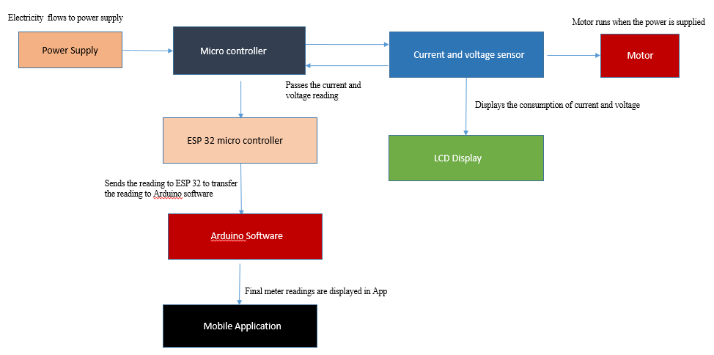

Figure 1: Architecture Flow Diagram

B. LOAD DETECTION USING ARDUINO

The Load is an electrical circuit which manages the flow of electricity and voltage of a house or an organization consumes. In order to prevent the usage of false load for high consuming environment the maximum demand the load can withstand is identified first. The maximum demand for loads differs from low to high based on their capacity. After identifying the load status it is continuously monitored and if the load exceeds its maximum demand the circuit automatically cuts off the power supply. The maximum demand is given to the arduino software where it monitors the usage of current and voltage. If the voltage becomes equal to the load capacity it indicates a warning message through the app and immediately cuts off the electricity supply. An immediate warning message will reach out to the service providers or electricity board to indicate there is a usage of false load in the area. By this way, It prevents the frauds or thefts happening in electricity consumption and also helps to determine the respective loads to be used for a house or for an organization.

V. MODULES DESCRIPTION

A. ELECTRICITY METER SETUP WITH IOT

The idea is to integrate smart iot sensor, micro controllers with electricity meter box to perform meter reading functioning easier. First the power supply will distribute the current and voltage to the respective sensors. The sensor starts to function and readings are shown in LCD display. In order to send the readings to Arduino software an ESP 32 micro controller is attached to the setup. ESP 32 micro controller has inbuilt Wifi and it connects to the arduino software using the hotspot. The Arduino software measures the meter reading and voltage level of the circuit.

Power supply:
An integrated power supply that comes along with the Iot setup mainly responsible for supplying electricity to microcontroller, ESP32 microcontroller, Current and Voltage display. It also ensures a constant electricity flows through the circuit to avoid short circuit

ESP 32 microcontroller:
A micro controller which has inbuilt wifi, capable of transmitting the readings from iot hardware setup to arduino software is used. The main purpose of this module is to transmit the readings to a device that is connected through wifi. ESP 32 micro controller performs vital functioning while integrated with the setup.

Current and Voltage Sensor:
A pair of current and voltage sensors are used to measure the consumption of electricity of the device. It is also used to measure the power flowing through the circuit. The readings when the current and voltage flows through the circuit is simultaneously displayed in the LCD display which comes attached with the iot setup.

LCD Display:
The LCD display is connected to the voltage and current sensors. A 16X2 LCD display is used to show the current, voltage readings separately. It displays the correct meter readings when the power flows through the circuit.

B. MOBILE APPLICATION

The mobile application is going to be developed using java. The major purpose of this application is to make electricity calculations easy and to give a warning message to the authorities when false load is used. This app will be used by the electricity board to make electricity calculations easier, it also helps in determining the whether correct load sanctioned to the consumer or not . This App performs multiple tasks like meter reading calculation, allows to enter per unit charge for a location or city, alert message for the government if the load has reached its maximum demand.

VI. CONCLUSION

In India, they are few areas where people still follow a traditional way for performing tasks eventhough the technological solutions yeild those issues more efficiently. It requires a sense of adaptiblity to switch over new things or new enhnacements for the benefit of human existence. People commit their life to modern society where every field, lifestyle, food, culture, study changes according to time, then its forced to adapt to new innovations, inventions that solves the real time issue of every individual and make life at ease. India is ready to produce valuable and innovative products or solutions that can create a greater impact in every fields. As a outcome, it uplifts country economic growth if indian products are used widely across the globe. This projects also depicts the technological enhancement that can make human life comfortable at the same time maintaining relaiability. The suggested system offers a workable answer to the current issue. Since the technology operates entirely without human intervention, there is extremely little possibility of error. This project would undoubtedly become a technology answer to the inaccuracies that prolong in the manual technique of obtaining measurements, especially in nations like India where the metre readings are taken manually. The project illustrates how technological advancements have led to continued efforts to improve people's lives. This project would undoubtedly prove to be the greatest consumer-severing application if it were ever put into practise. In future, if any other idea that wolud enchance this application more better and make even more reliable it can be included and severed to the society.
VIII. REFERENCES

[1] Electric load forecasting: Literature survey and classification of methods

Hesham Alfares King Fahd University of Petroleum and Minerals

[2] Literature Review on Smart Energy Meter

Vishal Devaliya1 , Ajaysinh Chauhan2 , Feni Faldu3 , Kapishawar Mishra4 , Sourav Choubey5 U.G. Student, Department of Electrical Engineering, SRICT, Vataria, Gujarat, India 1 U.G. Student, Department of Electrical Engineering, SRICT, Vataria, Gujarat, India 2 U.G. Student, Department of Electrical Engineering, SRICTV, Vataria, Gujarat, India 3 U.G. Student, Department of Electrical Engineering, SRICT, Vataria, Gujarat, India 4 Assistant Professor, Department of Electrical Engineering, SRICT, Vataria, Gujarat, India

[3] Review Paper on Smart Energy Meter Using IoT
AYUSHI TIWARI , OSHIN GAIKWAD , POOJA WARGHAT , ROSHANI BAMBAL , SHUBHAM RANDHE , PROF. MADHURI DUBEY Department of Information Technology, S.B.J.I.T.M.R, Nagpur

[4] IoT Based Electric Energy Meter Pratik P. Bakshi Akshay, S. Patil Akshay S. Gavali , Prof. Vibha U. Patel BE Student, Electronics & Telecommunication, MIT College of Engineering, Pune, India Assistant Professor, Electronics & Telecommunication, MIT College of Engineering, Pune, India

[5] Smart Metering for Smart Electricity Consumption Praveen Vadda Sreerama Murthy Seelam School of Computing, Blekinge Institute of Technology, 37179 Karlskrona, Sweden

[6] A Review Paper on Automatic Meter Reading and Instant Billing
Bhushan D. Sawarkar , Mrs. Snehal S. Golait M.E. Student, Department of Computer Technology, Priyadarshini College of Engineering, Nagpur (MH), India Assistant Professor, Department of Computer Technology, Priyadarshini College of Engineering, Nagpur (MH), India

[7] A review paper on automatic energy meter reading system
Nitesh Rawat, Sonia Rana Bhuvesh Yadav Neha Yadav 2016 3rd International Conference on Computing for Sustainable Global Development (INDIACom) New Delhi, India

[8] A REVIEW PAPER ON ARDUINO BASED PREPAID METER USING GSM MODULE

Pratik Korde, Nirmit Jain, Dr. Garima Goswami UG Student, Department of Electrical Engineering, Faculty of Engineering & Computing Teerthanker Mahaveer University, Moradabad(U.P.), 3Associate Professor, Department of Electrical Engineering, Faculty of Engineering & Computing Sciences, Teerthanker Mahaveer University, Moradabad(U.P.)

