IoT's Role in Advancing Precision Agriculture
Rohit Anand¹, Amit Kumar^{1*}, Rupesh Kumar¹, and Krishna Mondal²
¹ Division of Agricultural Engineering, ICAR-Indian Agricultural Research Institute, PUSA- New Delhi-110012
²Department of Agricultural & Food Engineering, Indian Institute of Technology, Kharagpur-West Bengal-721302
*Corresponding author mail ID- aamit8896@gmail.com
ABSTRACT
The integration of the Internet of Things (IoT) with precision agriculture has emerged as a transformative force in the farming industry. It revolutionized farming practices by providing real-time data through sensor networks and analytics. The chapter mainly focuses on the utilization of (IoT) in precision farming and highlights its potential to revolutionize farming practices and enhance agricultural productivity. It provides an overview of the concept of precision agriculture and its benefits, discussing the application of IoT technology in data collection, connectivity options, automation, data management, and analytics. The chapter also addresses the challenges and opportunities in implementing IoT-enabled precision agriculture and presents case studies and success stories that demonstrate the practical applications and benefits of IoT in this field. It also outlines strategies to mitigate these challenges while maximizing the benefits of IoT-driven precision agriculture. As IoT continues to evolve, its application in precision agriculture offers a promising pathway to address global food security and promote resilient farming practices in the face of changing agricultural landscapes. The chapter serves as a valuable resource for researchers, practitioners, and stakeholders interested in understanding and harnessing the power of IoT in the field of precision agriculture.
Keywords: Internet of Things (IoT); Sensors; Automation; Data collection; Control system; Cloud computing; Sustainability; Data management; Analytics
- INTRODUCTION
Precision agriculture has emerged as a technology-driven approach that revolutionizes traditional farming practices by leveraging advanced tools such as the Internet of Things (IoT), data analytics, and automation (Fig.1). It aims to optimize crop production, reduce resource wastage, and improve overall farm management. At its core, precision agriculture involves the integration of various technologies to enable farmers to make informed decisions based on real-time, data-driven insights. By utilizing sensors, drones, and satellite imagery, farmers can monitor and analyze critical factors such as crop health, soil conditions, and weather patterns [1-3]. This granular level of information allows for precise resource allocation, tailored treatments, and targeted interventions to maximize yields while minimizing inputs.
One of the key components of precision agriculture is the IoT, which enables the seamless connectivity of sensors and devices across the agricultural landscape. These IoT devices collect and transmit data, providing farmers with a comprehensive understanding of their operations [4-5]. Soil sensors measure moisture levels and nutrient content, aiding in irrigation and fertilizer management. Aerial imagery and remote sensing technologies detect early signs of plant stress, diseases, or pests, facilitating timely interventions. Livestock monitoring through IoT devices ensures animal health and optimized feed usage. By optimizing resource allocation, precision agriculture reduces input waste, minimizes environmental impact, and supports sustainable farming practices. It allows farmers to conserve water resources through targeted irrigation, minimize chemical usage through precise application, and mitigate the risk of crop diseases and pests through early detection and targeted interventions.
In sum, precision agriculture, empowered by IoT, data analytics, and automation, represents a transformative shift in modern farming practices. By harnessing technology-driven insights, farmers can enhance productivity, reduce costs, and promote sustainability in the agricultural sector. The adoption of precision agriculture holds significant potential to meet the increasing demands of a growing population while addressing environmental concerns.
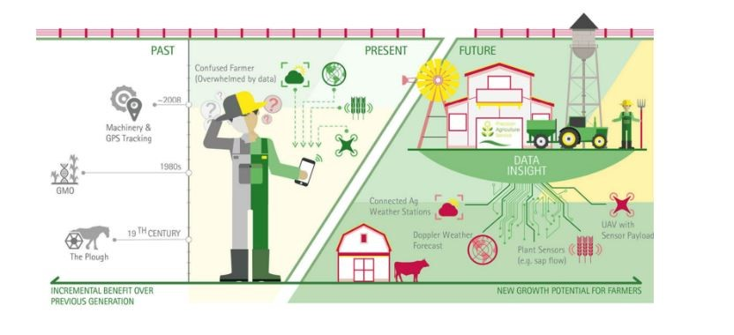
Fig 1: Evolution of Digital Agriculture, source-Accenture

- APPLICATION OF IOT IN PRECISION AGRICULTURE
The application of the Internet of Things (IoT) in precision agriculture has revolutionized the way farmers monitor, manage, and optimize their agricultural practices. IoT technologies provide real-time data and connectivity, enabling precise decision-making and resource allocation [6]. Here are some key applications of IoT in precision agriculture:
- Environmental Monitoring: IoT sensors and weather stations collect data on temperature, humidity, soil moisture, and other environmental factors. This data helps farmers monitor field conditions, track microclimate variations, and make informed decisions regarding irrigation, fertilization, and pest control.
- Crop Health Monitoring: IoT devices, such as drones equipped with multispectral or hyperspectral cameras, capture high-resolution imagery of crops. These images, combined with advanced image processing algorithms, enable farmers to detect early signs of diseases, nutrient deficiencies, and pest infestations [7]. Timely interventions can then be implemented to prevent yield losses.
- Precision Irrigation: IoT-enabled soil moisture sensors and weather data analysis allow for precise irrigation management. Farmers can monitor soil moisture levels in real-time and automate irrigation systems based on plant needs, weather patterns, and evapotranspiration rates [8]. This approach optimizes water usage, minimizes waste, and prevents overwatering or underwatering.
- Livestock Monitoring: IoT devices, such as wearable sensors and GPS trackers, can be attached to livestock to monitor their health, behavior, and location. These devices provide real-time data on animal activity, temperature, and feeding patterns, enabling early detection of health issues, optimizing feed management, and improving overall animal welfare [9].
- Smart Farming Equipment: IoT technologies enable the integration of sensors and GPS systems into farm machinery and equipment. This connectivity allows for precise data collection and analysis, optimizing equipment usage, reducing fuel consumption, and improving overall operational efficiency.
- Supply Chain Management: IoT sensors and trackers enable the monitoring and tracking of agricultural products throughout the supply chain. This includes monitoring temperature and humidity during transportation and storage, ensuring product quality and minimizing losses.
- Data Analytics and Decision Support Systems: IoT-generated data is processed and analyzed using advanced analytics tools and machine learning algorithms. This enables farmers to gain valuable insights, make data-driven decisions, and receive alerts or recommendations for optimal crop management practices.
The application of IoT in precision agriculture offers numerous benefits, including increased efficiency, improved productivity, reduced resource waste, and enhanced sustainability. By leveraging real-time data and connectivity, farmers can make informed decisions, optimize resource allocation, and implement targeted interventions, leading to improved crop yields, cost savings, and environmental stewardship.
- SENSORS AND DATA COLLECTION IN PRECISION AGRICULTURE
Sensors and data collection play a vital role in precision agriculture, enabling farmers to gather valuable information about crops, soil conditions, weather patterns, and other relevant factors [10-11]. These data serve as the foundation for data-driven decision-making and the implementation of precision farming practices. Here are the key aspects of sensors and data collection in precision agriculture:
- Types of Sensors: A variety of sensors are used in precision agriculture to collect data at different levels and for various purposes. Some common types of sensors include:
- Soil Sensors: These measure soil moisture, temperature, pH levels, and nutrient content, providing insights into soil health and irrigation requirements (Fig 2).
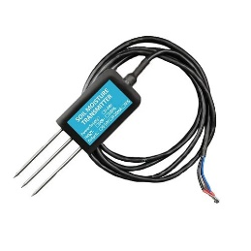
Fig 2: Soil Sensor JXBS-3001-TR-RS
- Weather Sensors: These capture data on temperature, humidity, wind speed, solar radiation, and rainfall, enabling farmers to monitor weather conditions and make informed decisions (Fig 3).
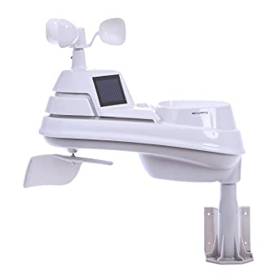
Fig 3: Weather sensor
- Crop Health Sensors: These sensors detect plant stress, diseases, and pests through measures such as chlorophyll levels, leaf temperature, and fluorescence, allowing for early detection and targeted interventions (Fig 4).
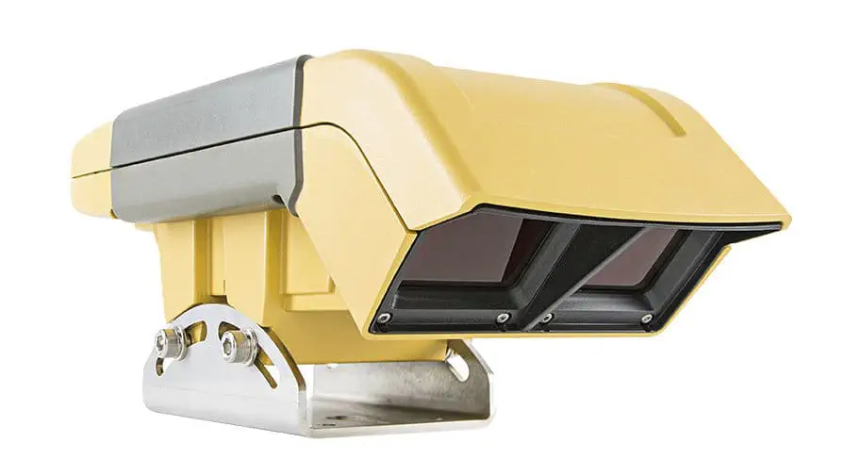
Fig 4: Tractor-mounted crop sensor CROPSPEC
- Imaging Sensors: Aerial and ground-based sensors, including multispectral and hyperspectral cameras, capture imagery that reveals crop health, nutrient deficiencies, and pest infestations (Fig 5,6).
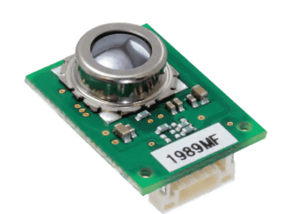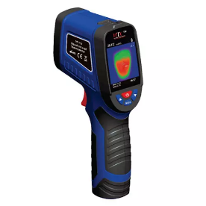
Fig 5: D6T-44L-06H Thermal Sensors Fig 6: HTC 9HZ Thermal Imaging Camera VT-110

- Data Collection Methods: In precision agriculture, data is collected through various methods and technologies, including:
- Wireless Sensor Networks (WSNs): WSNs consist of a network of sensors deployed throughout the field, collecting data and wirelessly transmitting it to a central system for analysis.
- Satellite Imagery: Satellite-based sensors provide high-resolution images of large agricultural areas, helping farmers monitor crop growth, identify variations, and make decisions based on multispectral or radar data.
- Unmanned Aerial Vehicles (UAVs): Drones equipped with sensors and cameras capture detailed imagery of crops, offering high-resolution and real-time data for crop monitoring and analysis.
- Manual Sampling: Traditional soil sampling techniques involve collecting samples from different locations within a field and analyzing them in a laboratory to assess nutrient levels, soil structure, and other parameters.
- Data Quality and Accuracy: Ensuring the quality and accuracy of collected data is crucial in precision agriculture. Calibration and maintenance of sensors are essential to ensure reliable and consistent measurements. Quality control measures, such as data validation and error correction techniques, are employed to eliminate outliers and enhance data accuracy. Proper data management practices, including data storage, organization, and backup, are also vital to maintaining data integrity and accessibility.
- Integration and Interoperability: To derive meaningful insights, data collected from various sensors and sources need to be integrated and analyzed holistically. Interoperability among different sensor technologies, data formats, and software platforms is essential for seamless data integration. Standardized protocols and formats, such as OGC (Open Geospatial Consortium) standards, facilitate data exchange and interoperability between different systems.
- Data Security and Privacy: As data collection in precision agriculture involves sensitive information, data security, and privacy measures are critical. Ensuring secure communication channels, data encryption, access controls, and adherence to data protection regulations are essential to protect the confidentiality and integrity of farm data.
Sensors and data collection are fundamental components of precision agriculture. They enable farmers to gather accurate and timely information about crops, soil conditions, and environmental factors. By employing various sensors and data collection methods, farmers can make informed decisions, implement precise interventions, and optimize their farming practices for improved productivity and sustainability.
- IOT CONNECTIVITY OPTIONS FOR PRECISION AGRICULTURE
IoT connectivity options play a crucial role in enabling seamless communication and data exchange between sensors, devices, and systems in precision agriculture (Fig 7). Some of the key IoT connectivity options commonly used in precision agriculture:
- Wi-Fi: Wi-Fi connectivity provides a reliable and high-speed wireless connection between devices within a limited range. In precision agriculture, Wi-Fi can be deployed in areas with existing infrastructure, such as farm buildings or greenhouses, to connect sensors, control systems, and other IoT devices [12]. Wi-Fi networks offer high bandwidth, making them suitable for transmitting large volumes of data, such as high-resolution imagery or video feeds.
- Cellular Networks: Cellular networks, such as 4G LTE and 5G, provide wide-area coverage, making them suitable for applications where sensors and devices are dispersed across large agricultural areas. Cellular connectivity enables real-time data transmission and remote monitoring [13]. It allows farmers to connect IoT devices in remote locations where other connectivity options might be limited. Cellular networks offer reliable and secure connections, making them a popular choice for precision agriculture applications.
- Low-Power Wide-Area Networks (LPWAN): LPWAN technologies, such as LoRaWAN and NB-IoT, are designed to provide long-range connectivity with low power consumption. These networks are well-suited for precision agriculture, as they can cover large distances while maintaining battery life for IoT devices [14]. LPWAN connectivity enables farmers to monitor sensors placed in expansive fields, track livestock over a wide area, and collect data from remote locations. LPWAN networks offer cost-effective and energy-efficient connectivity options for precision agriculture applications.
- Satellite Communication: Satellite communication provides connectivity in remote and rural areas where traditional terrestrial networks may not be available or reliable. Satellite-based IoT connectivity allows farmers to gather data from sensors and devices located in areas beyond the reach of other connectivity options [15]. This is particularly beneficial for precision agriculture applications in remote regions or for monitoring crops and livestock in vast agricultural landscapes.
- Mesh Networks: Mesh networks utilize interconnected devices to form a network where data can be relayed from one device to another, enabling communication over extended distances. In precision agriculture, mesh networks can be deployed to cover large farms or areas with complex topographies [16]. This connectivity option ensures robust coverage, even in areas with limited infrastructure or connectivity options.
- Bluetooth and Zigbee: Bluetooth and Zigbee are short-range wireless communication technologies suitable for connecting IoT devices within close proximity [17]. They are often used for local data collection and communication between sensors and gateways within a specific area, such as a greenhouse or a localized field plot. Bluetooth and Zigbee provide low-power connectivity options for monitoring and controlling IoT devices in close proximity.
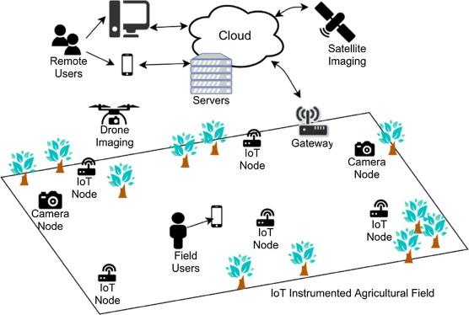
Fig 7: IoT Instrumented Agriculture Field

The choice of IoT connectivity option in precision agriculture depends on various factors, including the farm size, infrastructure availability, data requirements, and cost considerations. In many cases, a combination of different connectivity options may be employed to ensure comprehensive coverage and seamless data transmission across the agricultural landscape.
- DATA MANAGEMENT AND ANALYTICS
In precision agriculture, the use of data management and analytics holds significant importance. These tools assist farmers in making informed decisions tailored to their specific fields. Insights gathered from both historical and current data enable farmers to prepare for potential scenarios and optimize the utilization of resources like water and fertilizer. Remote monitoring facilitates swift issue resolution. Implementing eco-friendly farming practices improves as resources are managed efficiently. Continuous learning from data refines farming techniques, encouraging collaboration among farmers for knowledge exchange. These innovative approaches enhance farming quality, sustainability, and productivity, reshaping the future landscape of agriculture [18-20]. The key aspects of data management and analytics in precision agriculture is shown in Table 1.
Table 1: Aspects of Data Management and Analytics in Precision Agriculture
Aspect | Description | Examples
Data Collection | Gathering data from various sources such as sensors, satellites, drones, weather stations, etc. | GPS trackers, NDVI sensors, climate data
Data Storage | Storing collected data securely and efficiently, often utilizing cloud-based or on-farm storage. | Cloud databases, on-farm servers
Data Integration | Combining data from different sources to provide a holistic view for analysis. | Satellite imagery combined with soil data
Data Quality | Ensuring data accuracy, consistency, and reliability through cleaning and validation processes. | Outlier removal, data validation checks
Data Preprocessing | Cleaning, transforming, and structuring raw data into a usable format for analysis. | Rescaling sensor values, converting formats
Spatial Analysis | Analyzing data in relation to geographical location to make site-specific decisions. | Precision planting based on soil variations
Temporal Analysis | Analyzing data over time to identify trends, patterns, and seasonal variations. | Crop growth tracking, yield trends over years
Variable Rate Tech. | Applying varying inputs based on spatial and crop variations to optimize resource allocation. | Variable fertilizer application based on NDVI
Data Visualization | Presenting data insights through graphs, maps, and dashboards for easy interpretation. | Yield maps, disease heatmaps, growth charts
Decision Support Sys. | Providing actionable insights to aid farmers in making informed decisions about their crops. | Crop advisory systems, planting recommendations
Economic Analysis | Evaluating financial implications of different agricultural practices and decisions. | Cost-benefit analysis of new technology
Regulatory Compliance | Ensuring data collection and practices comply with relevant regulations and standards. | Adhering to data privacy laws, environmental regs
Data Security | Implementing measures to protect sensitive agricultural data from unauthorized access. | Encryption, access controls, secure APIs
Collab. Platforms | Facilitating the sharing of data and insights among stakeholders for better collaboration. | Online platforms for sharing field data
Weather Data Integration | Incorporating forecasts and historical data for decision accuracy in relation to weather. | Weather predictions for planting decisions

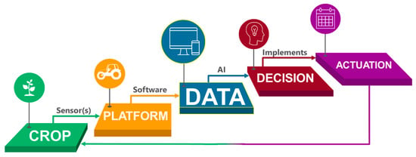
Fig 8: A cycle of Information-Driven Management for Enhanced Agriculture [21]
The integration of data management and analytics into precision agriculture signifies a transformative shift in modern farming. By harnessing the power of information, farmers are equipped with tools to make precise decisions, optimize resources, and mitigate risks (Fig. 8). This synergy not only enhances productivity but also champions sustainable practices, fostering a collaborative ecosystem for ongoing improvement. As technology advances, the role of data management and analytics will continue to drive innovation in agriculture, ensuring a resilient and efficient food production system for the future.

- AUTOMATION AND CONTROL SYSTEMS
Automation and control systems play a pivotal role in precision agriculture by enabling the automation of various agricultural processes and providing precise control over farm operations. These systems leverage technology, sensors, and data to optimize resource utilization, increase efficiency, and improve overall productivity. They enhance efficiency by automating tasks like planting, irrigation, and harvesting, reducing labor and costs [22-23]. Resource management benefits from precise input applications based on real-time data, curbing waste, and optimizing crop growth. As farming gets better with time, automation and control systems help make it ready for the future by using smart technologies and artificial intelligence. These systems make farming easier and more eco-friendly, helping farmers work better. They also help farms stay strong even when faced with big challenges around the world. The key aspects of automation and control systems in precision agriculture are discussed here:
- Automated Irrigation Systems: Automated irrigation systems use sensors, weather data, and soil moisture monitoring to determine the exact water requirements of crops. These systems automatically adjust irrigation schedules and deliver water precisely when and where it is needed, based on real-time data [24]. This approach minimizes water waste, ensures optimal moisture levels, and promotes water conservation.
- Precision Fertilization and Nutrient Management: Automation systems facilitate the precise application of fertilizers and nutrients based on the specific needs of crops. Sensors and data analysis help determine nutrient deficiencies, soil nutrient content, and crop uptake rates (Fig.9). Automated equipment and control systems enable the targeted application of fertilizers, reducing excess usage and minimizing environmental impact [25].
- Crop Protection and Pest Control: Automation systems aid in pest and disease management by utilizing sensors and data analytics to detect early signs of infestation [26]. Automated monitoring systems trigger alerts based on thresholds, enabling timely interventions and targeted treatments. Automated spraying equipment can precisely apply pesticides or biological agents, minimizing chemical usage and maximizing effectiveness.
- Autonomous Farm Machinery: Autonomous farm machinery, such as robotic harvesters or unmanned ground vehicles, can operate independently in the field. These machines use GPS, sensors, and computer vision technology to navigate, perform tasks, and collect data. It reduces labor costs, improves efficiency, and allows for continuous operation, even during off-peak hours or unfavorable weather conditions [27-28].
- Environmental Control in Controlled Environment Agriculture (CEA): Controlled Environment Agriculture (CEA), such as greenhouses or indoor vertical farms, relies heavily on automation and control systems. These systems regulate temperature, humidity, lighting, and ventilation, ensuring optimal growing conditions for crops. Sensors continuously monitor environmental parameters, while automated systems adjust settings to maintain ideal conditions for plant growth and development [29].
- Livestock Monitoring and Management: Automation systems are utilized in livestock farming to monitor and manage animal health, welfare, and feeding. Wearable sensors track vital signs, behavior patterns, and feeding habits, providing real-time insights into animal health and well-being. Automated feeding systems can deliver precise quantities of feed based on individual animal requirements, optimizing nutrition and reducing waste [30].
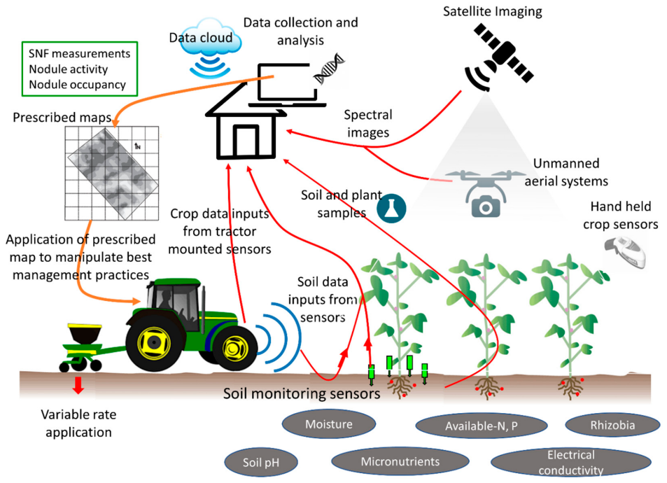
Fig 9: Conceptual Integration Model Enhancing Symbiotic Nitrogen Fixation (SNF) in Precision Agriculture Tools [31]

- CHALLENGES AND OPPORTUNITIES
IoT-enabled precision agriculture offers numerous opportunities to improve farming practices, increase productivity, and promote sustainability. However, several challenges must be addressed to fully realize the potential of this technology. Here are some key challenges and opportunities in IoT-enabled precision agriculture:
- Challenges:

- Connectivity: Reliable and widespread connectivity is essential for IoT devices to function seamlessly. However, many rural areas have limited or unreliable internet access, making it challenging to deploy IoT solutions in these regions. Addressing connectivity gaps through infrastructure development and alternative connectivity options is crucial.
- Data Management and Privacy: The massive volume of data generated by IoT devices requires efficient data management and storage infrastructure. Ensuring data security, privacy, and compliance with regulations poses challenges. Establishing robust data management practices and implementing appropriate security measures are vital to protect sensitive farm data.
- Interoperability and Standardization: IoT devices and platforms often operate on different protocols and standards, creating interoperability challenges. Ensuring compatibility and seamless integration between devices from different manufacturers is essential to maximize the benefits of IoT-enabled precision agriculture.
- Cost and Affordability: IoT technologies can involve significant upfront costs, including the acquisition of sensors, devices, and connectivity infrastructure. The affordability of IoT solutions can be a barrier for small-scale farmers or those operating in resource-constrained environments. Identifying cost-effective solutions and exploring financial incentives or support programs can help overcome this challenge.
- Skill and Knowledge Gap: Adopting IoT-enabled precision agriculture requires farmers and agricultural professionals to acquire new skills and knowledge related to technology, data analytics, and decision-making. Bridging the skill gap through training programs, workshops, and knowledge-sharing platforms is crucial for successful implementation.
- Opportunities:

- Increased Efficiency and Productivity: IoT-enabled precision agriculture enables optimized resource management, such as precise irrigation, targeted fertilization, and timely pest control. This leads to increased efficiency, improved crop yields, and reduced resource wastage, enhancing overall productivity.
- Data-Driven Decision-Making: IoT devices generate real-time data that can be analyzed to gain valuable insights. By harnessing data analytics and machine learning, farmers can make informed decisions regarding crop management, resource allocation, and risk mitigation.
- Sustainability and Environmental Stewardship: IoT-enabled precision agriculture promotes sustainable farming practices. Optimized resource usage, reduced chemical inputs, and improved monitoring and control of environmental factors contribute to enhanced sustainability and minimized ecological impact.
- Predictive and Prescriptive Analytics: IoT-generated data combined with advanced analytics enables predictive and prescriptive capabilities. Farmers can anticipate crop health issues, yield fluctuations, and market trends, empowering them to take proactive measures and optimize farm operations.
- Market Access and Traceability: IoT-enabled systems allow for improved supply chain management, quality control, and traceability. Farmers can track and monitor produce from farm to market, ensuring product quality, meeting regulatory requirements, and enhancing consumer trust.

- CASE STUDIES AND SUCCESS STORIES
Case studies and success stories in IoT-enabled precision agriculture demonstrate the practical applications and benefits of this technology in real-world farming scenarios. Here are a few notable examples:
- The Climate Corporation (Climate FieldView): The Climate Corporation, a subsidiary of Bayer, offers the Climate FieldView platform, which leverages IoT technology for data collection and analytics [32]. The platform integrates data from various sources, including weather stations, soil sensors, and farm equipment. Farmers can access real-time field data, monitor crop health, and make data-driven decisions to optimize planting, fertilization, and irrigation. Climate FieldView has demonstrated significant yield improvements and resource savings for farmers across the globe.

- SoilOptix: It is an IoT-based soil sensing technology that provides detailed soil nutrient maps to optimize nutrient management. The system employs advanced electromagnetic sensors to measure soil properties at high resolution. These sensors are mounted on vehicles that traverse the fields, collecting data on soil composition, moisture content, and nutrient levels. Farmers can use this information to create precise nutrient application plans, leading to improved crop yields and reduced fertilizer waste [33].

- Hands-Free Hectare Project: This project, conducted by researchers at Harper Adams University in the UK, showcases the potential of IoT and automation in arable farming. The project successfully demonstrated the cultivation of a crop (wheat) without any human intervention [34]. Autonomous vehicles, drones, and robotic systems were employed for planting, crop monitoring, spraying, and harvesting. This project highlights the possibilities of reducing labor requirements, increasing operational efficiency, and enabling remote management in precision agriculture.

- Blue River Technology (See & Spray): Blue River Technology, a subsidiary of John Deere, developed the See & Spray system, which combines computer vision and machine learning with precision spraying technology. The system uses cameras and sensors to identify individual plants and selectively apply herbicides only where needed [35]. This targeted approach reduces chemical usage and minimizes the impact on the environment. See & Spray has demonstrated successful weed control and significant cost savings for farmers.
- Sentera FieldAgent: Sentera's FieldAgent platform combines IoT, drones, and data analytics to provide comprehensive field insights. Drones equipped with high-resolution cameras capture imagery of crops, which is then analyzed using advanced algorithms. The platform enables farmers to monitor crop health, identify stress factors, detect diseases, and assess nutrient deficiencies. This allows for timely interventions and optimized resource allocation, resulting in improved yields and cost savings [36].
These case studies and success stories highlight the transformative impact of IoT-enabled precision agriculture. By integrating IoT devices, data analytics, and automation, farmers can optimize resource usage, increase productivity, and enhance sustainability in their farming operations. These examples serve as inspiration for other farmers and stakeholders in adopting IoT solutions for precision agriculture.
- FUTURE DIRECTIONS AND EMERGING TRENDS
Future directions and emerging trends in IoT-enabled precision agriculture are shaping the evolution of farming practices and technology. These trends hold great potential for addressing challenges, improving productivity, and advancing sustainable agricultural systems [38-40]. Some key future directions and emerging trends in IoT-enabled precision agriculture:
- Edge Computing and AI at the Edge: Edge computing involves processing data closer to the source, reducing latency and dependence on cloud infrastructure. In IoT-enabled precision agriculture, edge computing enables real-time data analysis, quick decision-making, and localized control. Integrating artificial intelligence (AI) capabilities at the edge empowers IoT devices to perform advanced analytics, predictive modeling, and autonomous decision-making, enhancing the responsiveness and efficiency of farm operations.

- 5G Connectivity and LPWAN: The advent of 5G networks offers faster and more reliable connectivity, enabling seamless communication among IoT devices and data-intensive applications. 5G technology supports real-time data transmission, facilitates remote monitoring and control, and enhances the scalability of IoT-enabled precision agriculture. Additionally, low-power wide-area networks (LPWAN), such as NB-IoT and LoRaWAN, provide energy-efficient and cost-effective connectivity options for IoT devices deployed in remote or resource-constrained areas.

- Blockchain for Traceability and Supply Chain Management: Blockchain technology is gaining traction in precision agriculture for enhancing traceability, transparency, and trust in the supply chain. By utilizing distributed ledger technology, farmers can record and track every stage of the production and distribution process, ensuring data integrity, product authenticity, and adherence to regulatory standards. Blockchain enables seamless verification of certifications, provenance, and quality, thereby improving market access and consumer confidence.

- Digital Twins and Simulation Modeling: Digital twin technology creates virtual replicas of physical assets, such as crops, soil, or farm equipment. By integrating IoT data with simulation models, farmers can perform virtual experiments, test different scenarios, and optimize farming strategies. Digital twins provide insights into crop growth, resource requirements, and environmental factors, facilitating predictive analysis and precise decision-making.

- Internet of Robotic Things (IoRT): The convergence of IoT and robotics is driving the emergence of the Internet of Robotic Things (IoRT) in precision agriculture. Robots equipped with sensors, computer vision, and autonomous capabilities can perform tasks like seeding, harvesting, and monitoring crops. IoRT enables scalable automation, reduces labor-intensive processes, and improves operational efficiency.

- Data Collaboration and Integration: As precision agriculture becomes more data-intensive, data collaboration and integration are gaining importance. Farmers, researchers, and agricultural stakeholders can collaborate and share data to gain broader insights, benchmark performance, and drive innovation. Data integration across different platforms and systems enables comprehensive analysis, facilitates interoperability, and promotes data-driven decision-making.

- Sustainable and Regenerative Agriculture: IoT-enabled precision agriculture is increasingly aligning with sustainable and regenerative practices. The integration of environmental sensors, IoT devices, and data analytics enables monitoring of soil health, biodiversity, and climate impacts. This data-driven approach helps farmers adopt sustainable practices, conserve natural resources, reduce carbon footprint, and improve ecosystem resilience.

- Human-Machine Collaboration: While automation and IoT technologies continue to advance, human expertise remains vital in precision agriculture. Future trends emphasize human-machine collaboration, where farmers and agricultural professionals leverage IoT tools as decision support systems. The combination of human experience and AI-driven insights leads to more effective and contextually relevant decision-making.

- CONCLUSION
This chapter has explored various aspects of IoT-enabled precision agriculture, including its introduction, application in different farming processes, connectivity options, data management and analytics, automation and control systems, as well as challenges and opportunities. We have also examined case studies and success stories that demonstrate the practical implementation and positive outcomes of IoT-enabled precision agriculture. Furthermore, we discussed future directions and emerging trends that will shape the evolution of IoT-enabled precision agriculture. These include the adoption of edge computing and AI at the edge, the impact of 5G connectivity and LPWAN, the utilization of blockchain for traceability and supply chain management, the integration of digital twins and simulation modeling, the emergence of the Internet of Robotic Things (IoRT), the importance of data collaboration and integration, and the focus on sustainable and regenerative agriculture practices. Thus, the integration of IoT technology into precision agriculture has revolutionized farming practices, offering a wide range of benefits and opportunities. Through the deployment of sensors, connectivity, data analytics, and automation, IoT-enabled precision agriculture has the potential to optimize resource utilization, increase productivity, and promote sustainability in farming operations.

REFERENCES
[1] Zhang, Y. (2019). The role of precision agriculture. Resource Magazine, 26(6), 9-9.
[2] Pierce, F. J., & Nowak, P. (1999). Aspects of precision agriculture. Advances in agronomy, 67, 1-85.
[3] Srinivasan, A. (Ed.). (2006). Handbook of precision agriculture: principles and applications. CRC press.
[4] Torky, M., & Hassanein, A. E. (2020). Integrating blockchain and the internet of things in precision agriculture: Analysis, opportunities, and challenges. Computers and Electronics in Agriculture, 178, 105476.
[5] Monteleone, S., Moraes, E. A. D., Tondato de Faria, B., Aquino Junior, P. T., Maia, R. F., Neto, A. T., & Toscano, A. (2020). Exploring the adoption of precision agriculture for irrigation in the context of agriculture 4.0: the key role of internet of things. Sensors, 20(24), 7091.
[6] Shafi, U., Mumtaz, R., García-Nieto, J., Hassan, S. A., Zaidi, S. A. R., & Iqbal, N. (2019). Precision agriculture techniques and practices: From considerations to applications. Sensors, 19(17), 3796.
[7] Anand, R., Sahni, R. K., Kumar, S. P., Thorat, D. S., & Kumar, A. K. (2023). Advancement In Agricultural Practices with Use of Drones in The Context of Precision Farming. Global Journal of Engineering Sciences (Vol. 11. Issue-2).
[8] Sengupta, A., Debnath, B., Das, A., & De, D. (2021). FarmFox: A quad-sensor-based IoT box for precision agriculture. IEEE Consumer Electronics Magazine, 10(4), 63-68.
[9] Feng, X., Yan, F., & Liu, X. (2019). Study of wireless communication technologies on Internet of Things for precision agriculture. Wireless Personal Communications, 108(3), 1785-1802.
[10] Baggio, A. (2005, June). Wireless sensor networks in precision agriculture. In ACM workshop on real-world wireless sensor networks (REALWSN 2005), Stockholm, Sweden (Vol. 20, pp. 1567-1576).
[11] Nandurkar, S. R., Thool, V. R., & Thool, R. C. (2014, February). Design and development of precision agriculture system using wireless sensor network. In 2014 First International Conference on Automation, Control, Energy and Systems (ACES) (pp. 1-6). IEEE.
[12] Marcu, I., Voicu, C., Drăgulinescu, A. M. C., Fratu, O., Suciu, G., Balaceanu, C., & Andronache, M. M. (2019). Overview of IoT basic platforms for precision agriculture. In Future Access Enablers for Ubiquitous and Intelligent Infrastructures: 4th EAI International Conference, FABULOUS 2019, Sofia, Bulgaria, March 28-29, 2019, Proceedings 283 (pp. 124-137). Springer International Publishing.
[13] Khanna, A., & Kaur, S. (2019). Evolution of Internet of Things (IoT) and its significant impact in the field of Precision Agriculture. Computers and electronics in agriculture, 157, 218-231.
[14] TAŞKIN, D., & Yazar, S. (2020). A Long-range context-aware platform design for rural monitoring with IoT In precision agriculture. International Journal of Computers Communications & Control, 15(2).
[15] Mishra, S. (2021). Emerging Technologies—Principles and Applications in Precision Agriculture. Data Science in Agriculture and Natural Resource Management, 31-53.
[16] Anurag, D., Roy, S., & Bandyopadhyay, S. (2008, May). Agro-sense: Precision agriculture using sensor-based wireless mesh networks. In 2008 first itu-t kaleidoscope academic conference-innovations in ngn: Future network and services (pp. 383-388). IEEE.
[17] Keshtgari, M., & Deljoo, A. (2011). A wireless sensor network solution for precision agriculture based on zigbee technology.
[18] Bendre, M. R., Thool, R. C., & Thool, V. R. (2015, September). Big data in precision agriculture: Weather forecasting for future farming. In 2015 1st international conference on next generation computing technologies (NGCT) (pp. 744-750). IEEE.
[19] Huang, Y., Chen, Z. X., Tao, Y. U., Huang, X. Z., & Gu, X. F. (2018). Agricultural remote sensing big data: Management and applications. Journal of Integrative Agriculture, 17(9), 1915-1931.
[20] Hachimi, C. E., Belaqziz, S., Khabba, S., Sebbar, B., Dhiba, D., & Chehbouni, A. (2022). Smart weather data management based on artificial intelligence and big data analytics for precision agriculture. Agriculture, 13(1), 95.
[21] Saiz-Rubio, V., & Rovira-Más, F. (2020). From smart farming towards agriculture 5.0: A review on crop data management. Agronomy, 10(2), 207.
[22] Liaghat, S., & Balasundram, S. K. (2010). A review: The role of remote sensing in precision agriculture. American journal of agricultural and biological sciences, 5(1), 50-55.
[23] Shaikh, T. A., Rasool, T., & Lone, F. R. (2022). Towards leveraging the role of machine learning and artificial intelligence in precision agriculture and smart farming. Computers and Electronics in Agriculture, 198, 107119.
[24] Ravi, K. S. (2013). A real–time irrigation control system for precision agriculture using WSN in Indian agricultural sectors. International Journal of Computer Science, Engineering and Applications (IJCSEA) Vol, 3.
[25] Hedley, C. (2015). The role of precision agriculture for improved nutrient management on farms. Journal of the Science of Food and Agriculture, 95(1), 12-19.
[26] Zijlstra, C., Lund, I., Justesen, A. F., Nicolaisen, M., Jensen, P. K., Bianciotto, V., ... & de Zande, J. V. (2011). Combining novel monitoring tools and precision application technologies for integrated high‐tech crop protection in the future (a discussion document). Pest Management Science, 67(6), 616-625.
[27] Ghobadpour, A., Monsalve, G., Cardenas, A., & Mousazadeh, H. (2022). Off-road electric vehicles and autonomous robots in agricultural sector: trends, challenges, and opportunities. Vehicles, 4(3), 843-864.
[28] Naik, N. S., Shete, V. V., & Danve, S. R. (2016, August). Precision agriculture robot for seeding function. In 2016 international conference on inventive computation technologies (ICICT) (Vol. 2, pp. 1-3). IEEE.
[29] Srivani, P., & Manjula, S. H. (2019, December). A controlled environment agriculture with hydroponics: variants, parameters, methodologies and challenges for smart farming. In 2019 Fifteenth International Conference on Information Processing (ICINPRO) (pp. 1-8). IEEE.
[30] Banhazi, T. M., & Black, J. L. (2009). Precision livestock farming: a suite of electronic systems to ensure the application of best practice management on livestock farms. Australian Journal of Multi-disciplinary Engineering, 7(1), 1-14.
[31] Thilakarathna, M. S., & Raizada, M. N. (2018). Challenges in using precision agriculture to optimize symbiotic nitrogen fixation in legumes: Progress, limitations, and future improvements needed in diagnostic testing. Agronomy, 8(5), 78.
[32] Bradstreet, C. (2021, June 28). The Climate Corporation awarded for outstanding AI/ML: We’re all winners with sustainable agriculture. OpenTextTM VerticaTM. https://www.vertica.com/blog/the-climate-corporation-awarded-for-outstanding-ai-ml-were-all-winners-with-sustainable-agriculture
[33] SoilOptix | Nutrient Stewardship. (n.d.). Nutrientstewardship.org. Retrieved August 26, 2023, from https://nutrientstewardship.org/partners/soiloptix/
[34] Hands Free Hectare 2: Autonomous farming machinery for cereals production | AHDB. (n.d.). Ahdb.org.uk. Retrieved August 26, 2023, from https://ahdb.org.uk/hands-free-hectare-2-autonomous-farming-machinery-for-cereals-production
[35] Yeshe, A., Gourkhede, P., & Vaidya, P. (2022). Blue River Technology: Futuristic Approach of Precision Farming. Just Agriculture: Punjab, India.
[36] Sentera. (n.d.). Sentera Announces Real-Time Analytics for FieldAgent. Www.prnewswire.com. Retrieved August 26, 2023, from https://www.prnewswire.com/news-releases/sentera-announces-real-time-analytics-for-fieldagent-300814523.html
[37] Thilakarathne, N. N., Yassin, H., Bakar, M. S. A., & Abas, P. E. (2021, December). Internet of Things in Smart Agriculture: Challenges, Opportunities and Future Directions. In 2021 IEEE Asia-Pacific Conference on Computer Science and Data Engineering (CSDE) (pp. 1-9). IEEE.
[38] Ray, P. P. (2017). Internet of things for smart agriculture: Technologies, practices and future direction. Journal of Ambient Intelligence and Smart Environments, 9(4), 395-420.
[39] Sharma, V., Tripathi, A. K., & Mittal, H. (2022). Technological revolutions in smart farming: Current trends, challenges & future directions. Computers and Electronics in Agriculture, 107217.
[40] Sengupta, A., Gill, S. S., Das, A., & De, D. (2021). Mobile edge computing based internet of agricultural things: a systematic review and future directions. Mobile Edge Computing, 415-441.

