Ms. Sushmita Chakraborty
Assistant Professor, Department of Computer Applications (MCA)
Patna Women’s College(Autonomous)
Bailey Road, Patna
Email-id:sush123.chakraborty@gmail.com
A study of Role of Machine Intelligence with Neuromorphic Computing

Abstract: The artificial neural network is based on the machine learning approach that developed from the hypothetical human brain and its system, which consists of numerous, easily processed, highly interconnected elements that process and form an architecture based on the organization of various context portions of the brain. In order to make a machine intelligent and capable of functioning like a human, a huge number of neurons must fire, as defined in this paper. Consequently, a machine built on neural networks is frequently capable of performing tasks that humans, animals, and traditional computers are not always good at. In recent years, the neural network has presented an exceptional potential for research, development, and application to a variety of real-world situations. A different technology cannot supply all the qualities and skills that a neural network can.For instance, compensating for alignment in the text, deciphering noise and signals, and determining whether the proposed loan is good or bad are all examples of reading human handwriting. Other examples include reading and writing multiple languages, such as Korean, Chinese, Japanese, etc. In this study, a neural network that is based on machine learning is introduced in a concise manner.
Keywords: Artificial intelligence, Machine Learning, Smart machine, neural network
_______________________________________________________________________________

INTRODUCTION

This study offers a thorough analysis of neuromorphic computing. Instead of von Neumann's design based on software like perceptrons, neuromorphic computing has gained popularity. The artificial neurons that are interconnected are based on biological neural networks, which are both a difficult machine learning method based on the von Neumann architecture and a theoretical neuroscientific model. Machine intelligence and Neuromorphic Computing are the two categories that make up machine intelligence. The term "machine intelligence" is used to refer to the precision of a machine learning, deep learning, or traditional algorithm output.

Artificial intelligence and machine learning are two words used to describe machine intelligence. Artificial intelligence is built of systems that enable computers to imitate/perform human cognitive processes or accomplish jobs that were previously performed by people. Machine intelligence and artificial intelligence are similar to one another.

Systems that allow a computer system to learn from inputs without directly using linear programming are referred to as machine learning systems. Machine learning is a group of computer methods used in a bigger system to build a model out of past data. The ability for a technology (a machine, gadget, or algorithm) to interact with its surroundings intelligently is known as machine intelligence. When machines are designed with some features of human intellect, machine intelligence is generated.

The term "neuromorphic computing" describes the process of creating computers that are based on and resemble the nervous system and the human brain. Neuromorphic computing, which was first developed in the 1980s and has the potential to function and carry out tasks like the human brain, was inspired by the human brain and the nervous system's operation. (Build a machine with a human brain that functions and completes tasks like a person). These computers are famous for their quick response times because of how quickly they interpret information. A significant feature of neuromorphic computers is their rapid reaction system, which is designed to function like the human brain.
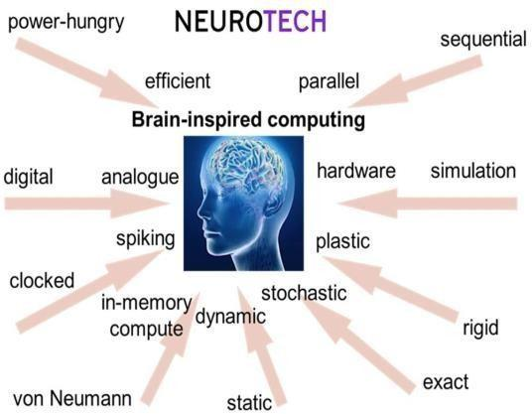

Source: Fig1. https://www.innovationnewsnetwork.com/wp-content

Neuromorphic computing is brain- inspired computing for machine intelligence. It works on neural networks like the human nervous system of Neuron which is the part of the brain likewise CPU which is the brain of a computer. It provides Deep learning that revolves around software-based algorithms and architectures. It is a neural circuit of the brain. In this computing, a chip is put inside it and all computations happen in memory. Memory is the base of neuromorphic chips which can be used as both memory units and computation units. Perform a task efficiently and rapidly provide information.
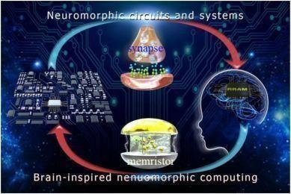

Source: Fig 2. https://ars.els-coh.com/content/image/1-s2.0s2542529321000547-ga 1.jpg
In order to categorize neural networks, there are two primary categories: artificial neural networks and neurobiological networks. The nervous system of an organism's body makes up the biological neural network. Artificial intelligence has steadily evolved into bionic technology as a result of the ongoing advancements in science and technology.
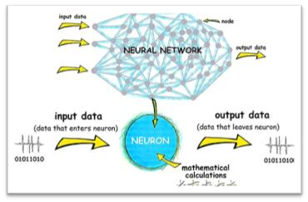

Fig3.https://www.frontiersin.org/files/Articles/560631/frym-0560631-HTML/image_m/figure-3.jpg

In light of this, the numerous information-gathering, transmission, and processing techniques used by the neurobiological network have been compared to those of the artificial neural network. The biological nervous system and brain are modeled by the artificial neural network. Every neuron in an artificial neural network system is interconnected, creating a sophisticated computing network that resembles a biological brain network. Artificial neural networks have a number of benefits, including parallel processing, independence, strong nonlinearity, fault tolerance, etc. the widespread application of this network to machine learning, pattern evolution, and image recognition.

The specified and unique requirements for neuromorphic architecture include reduced power consumption, memory allocation, and computation. Compared to the idea of the conventional Von-Neumann Architecture, it has a high ability to calculate complex computational speed. Therefore, the neuromorphic architecture will be a suitable option for putting machine learning algorithms into practice.

Objective:

Neuromorphic computing proposes the engineering of computers in a way that comprises a million artificial silicon neurons that enabled the transfer of electric increase from one to another. Its goal is to make computers behave like a human brain and work as similarly as possible to the human nervous system. By creating artificial neural systems that implement "neurons" that are comparable to those found in the human brain, neuromorphic computing creates a brain that is as efficient and performs the functions of the human brain.
- To research neural network-based computing, also known as neuromorphic computing. A computer's components are modeled like the brain and nervous system of a human using this technique in computer engineering.
- It also refers to artificial intelligence, which is the ability of a machine to think and act like a human.
- Finding the data sets used to study the idea of a brain-like "spiking" computational framework, neuromorphic computing with regard to the realization of artificial intelligence while lowering the energy requirements of computing platforms. Observing the evidence of neural networks for the development of machine intelligence.
- By studying and anticipating the development of the many environmental characteristics (such as Alexa, Google Translate, and Apple Siri), to actively and intelligently monitor its environment.
- Adopting proactive measures to increase the likelihood of success for a specific objective, in which a wireless network is relevant to some demand for quality-of-service.
- To do computer system activity that incorporates neuro-science, i.e., systems that simply function and operate like a human brain. Additionally, it describes the system memory, which remembers the most common and often utilized actions and also reacts when necessary.

Research on Neural Network-Based Machine Learning Algorithms

- Speed: Using software to simulate neural networks on a computer processor has some flexibility and does not require the usage of hardware, according to the Speed advantage. Because software is typically highly slow and not appropriate for many situations when simulating neural networks, hardware is employed instead. A practical and efficient way to address the practical application of neural networks is through computational processing of convolutional neural networks.

- Fault tolerance The fundamental issue with this implementation of fault tolerance is that there is only one processor, which is insufficient for redundancy. As a result, the complete processing system will cease to work if any issue arises in any link. There is a decrease in overall performance relative to the hardware design, allowing the application to function normally. It offers incomparable advantages which is based on software neural network, nevertheless. As a feed-forward neural structure, the neural network has a high level of layer independence. The neural network's layers are computed individually. They have a lot in common with artificial neural network structures.

Influencing Factors:
- Data set: The sample variables in the research work mostly have the following two features, according to (Yiqiang Lai et al, 2021).
a)The selection of the big data sample.
b)The samples ought to be spread out.
- Initialization: Weight and threshold are the two parts that make up initialization. These two variables have some bearing on how the training is conducted.
- Training Speed: The fundamental factors that affect training speed can also make it slow down.
Analyzing algorithms The input gate and forget gate in the LSTM are combined by the algorithm analysis used to write the machine.

As a result, the NTM writing process is divided into the following two steps:
- The memory must be erased as a first step.
- Writing the recollection is the next stage.
At time t, the write head outputs a weight vector w^{t}, an E-dimensional elimination vector e^{t}, and an E-dimensional addition vector a^{t}. Each element belongs to the interval [0, 1]. Then
  - e (t) the value of the memory matrix can be calculated according to formula (1) to
formula (2):
e^{(t)} = σ(W^{e} h^{(t)}+ b^{e}) (1)
a^{(t)} =W^{e} h^{(t)}+ bª (2)
M^{(t)} = M^{(T-1)} ⌊1-w(t)(e(t))⌋ + w(t)(a(t))T (3)
Among them, 1 in formula (3) denotes a matrix of all ones with a size of NE, h(t) denotes the controller's output at time t, and We denotes the weights and biases that, respectively, correspond to the be limitation vector and addition vector.

Network hyperparameters and their tuning: The hyperparameter is linked to the task that needs to be changed for each job. Table 1 displays the associated parameter's value. The input sequence's length range is indicated by the sequence length. According to earlier research (Luping Shi et al., 2015), a job that is copied, for instance, has a sequence length range of 2 to 11. It should be stated that the input sequence contains the plus sign ("+"), the multiplication symbol ("x"), and the terminator (".").

As a result, the model will actually countless characters than the length of the sequence. The copy algorithm will only copy sequences with a minimum length of 1 and a maximum length of Thus, the order

task | Seque  nce length | Mem  ory size | Traini  ng times
copy | [2,11] | 10 x 8 | 5000  0
addition | [4,22] | 21 x 10 | 1500  00
multiplic  ation | [4,22] | 30 x  10 | 3000  00
Table 1. Task-related parameters

Machine Learning Algorithms Based on Neural Network Technology: Experimental Research

We have an example of how machine learning methods can be used to create neural networks, as reported (Luping Shi et al., 2015).

Example: The Network Hyper parameters and Their Tuning is referred to as NTM. To illustrate the length range of the input sequence, values for the required parameters are presented below the sequence length for each task, along with the hyperparameters associated with the task that need to be changed.

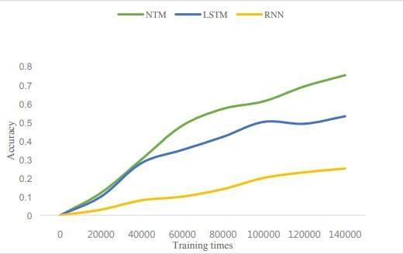

Fig.4.Lai_2021_J._Phy s. Conf ._Ser._2066_012041%20(1).pdf

For instance, the sequence length for a copy task can be anything between 2 and 11. It should be noticed that the input sequence also contains the multiplication symbol (""), the addition sign ("+"), and the termination ("."). As a result, the real amount of characters that the model needs to memorize is less than the length of the sequence.

The length of each addend in addition to the length of each multiplier in multiplication can range from 1 to 10. The length of the sequence that the copy method will duplicate has a minimum length of 1 and a maximum length of 10.

Neuromorphic computing characteristics include:

- Rapid Response System: Neuromorphic computers are renowned for having a rapid response system because of how quickly they analyze data.This computer is designed to operate similarly to the human brain and carry out tasks just like people.
- Low Power Consumption: This concept is based on Spiking Neural Networks (SNN), which are neuromorphic machines that function when electric spikes or impulses are sent through the artificial neurons.
- Greater Adaptability: Neuromorphic computers function in accordance with technological requirements. Neuromorphic computers alter and adapt as the times change, which leads to more precise and effective working.
- Computer systems that once required a lot of area to operate are now much more transportable and convenient thanks to neuromorphic architecture. that don't take up a lot of room

Spiking Neural Unit (SNN)

Previous researchers (Hitesh Dureja et al., 2021) have validated this. In spiking neurons, the input is frequently filtered using a low pass filter. They start to run when a state variable crosses a certain limit. The spike time, "tk," is used in the Dirac Delta function to calculate it. To represent learning in an SNN as a loss function minimization across a large number of training samples, which is akin to traditional machine learning. Finding sets of synaptic weights that permit scattered representation while reducing the sum of all scattered coding losses in the situation of sparse coding is a step in the learning process. Online SNN organically learning takes place with training samples being given to the network in order.

Future Perspective
Neuromorphic processors hold the key to overcoming the Von Neumann structure's development direction restrictions. Because neurons and synapses are processed by brain networks, this is the case. Arithmetic operations (addition, multiplication, subtraction, and division) and logical operations (AND- OR-NOT) make up the traditional processor instruction set, which was created for general-purpose computing. The processing of neuron computing on neuromorphic circuits frequently takes hundreds or thousands of instructions, rendering the hardware's low processing efficiency ineffective.
The existing von Neumann Architecture is utterly inadequate for neural computing. In contrast to the von Neumann structure, where memory and computation are separated and realized in turn, processing and storage are incorporated into the neural network. It has unavoidably limited independent storage and handling structures, which has reduced the effectiveness of the effects of the neural network applications. The long-term planning will make use of a new generation of architecture, such as integrated computing designs and neuromorphic circuits.
The present and the future of Neuromorphic Computing belong to Artificial Intelligence. Neuromorphic computing will replace technological breakthroughs in the area as the engine of artificial intelligence in the third and fourth waves of AI.

Limitations
Neuromorphic technologies attempt to replicate the brain's distinctive functioning abilities by simulating and representing components of its design and dynamics.
Powerful computation Each chip must be individually mapped for energy efficiency in a high-dimensional parameter space. an expedient calibrating procedure.
On the other hand, it is compelled to take shortcuts, including assuming independence between the influence of hardware parameters, which may result in systematic departures from the desired behavior.

According to (Matthew Stewart, 2019), the following limitations are observed when using machine learning and neuromorphic computing: -

Ethics: The ability to gather a significant volume of data has been possible thanks to the rapid expansion of processor power and computer system parallelization. According to Yuval Noah Harari, humanity is purportedly entering a new stage in which people trust data and algorithms more than their own logic and judgment.

Deterministic Issues: Neuromorphic computing and machine learning include performing computer simulations of computational modeling, such as atmospheric pollution, global weather, etc. It overlooks the entire physics by using a neural network with millions of inputs to predict whether there will be any changes in the future, possibilities, and deterministic problems.
This restriction does not last very long, though, as many researchers increasingly focus on physical limitations.
Data: Neuromorphic computing machine learning algorithms need a lot of data to start producing useful results.
It has two characteristics: -
- Absence of Data: Data augmentation and reuse are both undesirable ideas, but having more data is always the best course of action.
- Lack of Good Data: There is a chance that certain data utilization will make the algorithm more egalitarian by skewing the data set along important axes.
Application error: This restriction uses a random system. It may be difficult and against physical rules to apply machine learning to a situation with two variables.
There are essentially two methods:
  - P-hacking: It responds to measurement noise and does not access a big set
of data in a true correlation.
  - Scope of the Analysis: - it lacks a number of qualities associated with the confirmatory analysis.
Interpretability: - it has a lack of interpretability of the methods. Humans follow interpretation by following rules that go beyond technical processes. Machine learning aims to achieve it by practicing and in long-term learning.

Suggestions:
Nowadays, there are a lot of explorations on how to simulate or create synthetic synapses. ASIC is the kind of chip that is designed with stronger performance, smaller size, less power consumption, more progress, and lower cost in developing hardware and software designs. ASIC needs research and development time. It has high-risk technology marketing that will play a major obstacle to future promotion. However, It has a good mold size, great energy consumption, great reliability, strong confidentiality, high computing performance, and high computing efficiency.
Eventually, the algorithm, architecture, and programming scheme of adaptive neuromorphic computing is a wide blank and it will take time to reach the finish line that replaces von Neumann architecture. But over time the frontiers of neuromorphic computing knowledge are being pushed and the possibilities which we think about right now will change the world drastically.

Conclusion:
Although neuromorphic computing has just come to light and received a lot of interest, it is still thought to be in its early stages. At the hardware and software levels, a single application primarily concentrates on the existing solution, and the bulk of the solutions are only capable of handling a small number of apps.

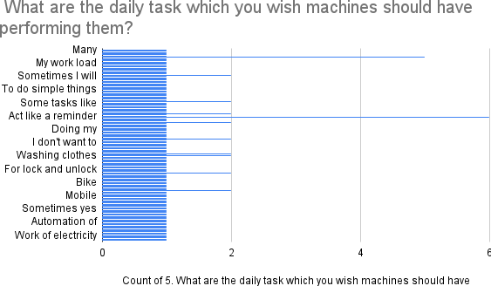

Fig:5
Our poll revealed that many chores that individuals or humans want to complete with a machine's assistance. Despite the fact that these mechanisms are already in place, there are not enough people to use them.

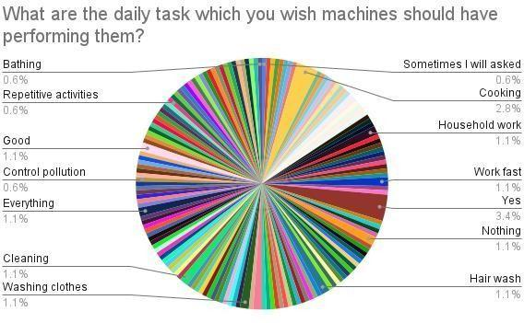

Fig : 6
Generally speaking, according to observation, humans only want to use computers for routine activities. They want machines to handle their problems. Furthermore, a lot of software-based neural network applications are in use, but hardware-based neural network applications are hard to come by because they require more time, money, and distinct methods and designs. It can refine and process the final software-level application that quantifies hardware characteristics, producing a testable response for a specification component.

We firmly believe that neuromorphic computing, utilizing hardware and software implementation, will change the world in the near future. It will be made up of many cutting-edge algorithms running on low-power neuromorphic computing platforms. Making computers act like a human brain is the goal of neuromorphic computing.

Neuromorphic computing proposes the engineering of computers in a way that comprises millions of artificial silicon neurons capable of exchanging electric spikes with one another. The goal of neuromorphic computing is to make computers behave like a human brain and work as similarly as a human along the lines of the human nervous system.

References:
- Yu Zheqi [University of Glasgow], Amir M. Abdulghani, Adnan Zahid [Heriot-Watt University], Hadi Heidari [University of Glasgow] April 2020IEEE Access PP(99):1-1 DOI:10.1109/ACCESS.2020.298583, An Overview of Neuromorphic Computing for Artificial Intelligence Enabled Hardware-Based Hopfield Neural Network, [340484146_An_Overview_of_Neuromorphic_Comput ing_for_Artificial_Intelligence_Enabled_Hardware]
- Ana Laura Lira Cortes [Universidad Autónoma de Querétaro (UAQ)],Mexico, Carlos Fuentes Silva [Universidad Autónoma de Querétaro, Mexico in 2007], December 2020, Artificial Intelligence Models for Crime Prediction in Urban Spaces https://www.researchgate.net/publication/348545670_ Artificial_Intelligence_Models_for_Crime_Prediction_i n_Urban_Spac
- Fanny Rehnström[Orebro University], 2021, How Capable is Artificial Intelligence (AI) in Crime Prediction and Prevention? https://www.diva- portal.org/smash/get/diva2:1581808/FULLTEXT01.pdf
- Fatima Dakalbab, University of Sharjah,Manar Abu Talib, University of Sharjah, Omnia Elmutasim, University of Sharjah, Ali Bou Nassif,University of Sharjah,Sohail Abbas, University of Sharjah, Qassim Nasir,University of Sharjah, Feb 22, 2022, Artificial Intelligence & Crime Prediction: A Systematic Literature Review, https://papers.ssrn.com/sol3/papers.cfm?abstract_id=4039691
- Shah, N., Bhagat, N. & Shah, M. Crime forecasting: a machine learning and computer vision approach to crime prediction and prevention. Vis. Comput.Ind. Biomed, art 4, 9 (2021). https://doi.org/10.1186/s42492 - 021-00075-z

- Meenal Dhande, March 07,2020, What is the difference between AI, machine learning, and deep learning? https://www.geospatialworld.net/blogs/difference- between- ai%EF%BB%BF- machine- learning-and-deep- learning/
- Hitesh Dureja, Yash Garg, Dr. Rishu Chaujar, Bhavya Kumar*4, International Research Journal of Modernization in Engineering Technology and Science REVIEW RESEARCH PAPER NEUROMORPHIC COMPUTING AND APPLICATIONS, fin_irjmets1637689575%20(1).pdf
- Jason Browniee, July 7, 2021, A Gentle Introduction to Long Short-Term Memory Networks by the Experts, https://machinelearningmastery.com/gentle- introduction- long-short-term- memory-networks- experts/
- Alex Graves, December 10,2014, Cornel University, Neural Turing Machines, https://www.arxiv- vanity.com/papers/1410.5401/
- Luping Shi, Jing pei et. al., December 1, 2015, IEEE International Electron Devices Meeting, Development of a neuromorphic computing system
- Matthew Stewart, July 29, 2019, The Limitations of Machine Learning,
https://towardsdatascience.com/the- limitations-of- machine-learning-a00e0c3040c6

