BIO CATALYST
Enzyme: Study of Kinetics and Mechanism

Neeta Lal
PG Department of Zoology Ranchi University
Ranchi, Jharkhand, India
Corresponding author: drneetalal092@gmail.com
Abstract
This chapter deals with the classification, structure binding, kinetics, and properties of enzymes along with the classification and properties of coenzymes. Enzymes play a pivotal role in all the physiological processes occurring in plants and animals including humans. The specific nature of the enzyme is the property of greater interest. The kinetics of enzyme catalysis including the behavior of enzyme by variation of its concentration, substrate concentration, and product formation in different time intervals are incorporated in the chapter. The rate law expression of an enzyme-catalyzed reaction is derived which helps in a better understanding of enzymatic action. The chapter includes various examples of enzymatic action with examples and sites of their production described in various diagrammatic representations and tables. The enzymes, as can be concluded from the chapter, are a valuable part of life supporting physiological actions.
Keywords – EC numbers, classifications, turnover number, specificity, lock and key hypothesis, induced fit theory, Michaelis constant, coenzyme.
The word Enzyme (a Greek word en – in zyme – leaven i.e., present in yeast) was coined by Kuhne in 1878. Buchner, in 1896 extracted a substance capable to carry out fermentation from the cell of a yeast which was later known as zymase enzyme. In 1926, Professor J.B. Sumner isolated from jack beans, by means of acetone, the enzyme urease in crystalline form. Enzymes are proteinaceous compounds (also known as biocatalysts) that increases the rate of biological reactions occurring in living organisms and are also often extracted from the living cell to catalyse some important reactions for commercial purposes.
Enzymes which are actively functional outside the living cells are called exoenzymes, e.g., enzymes present in digestive juices, lysozyme of tears while the enzymes which is functional inside the living cells are called endozymes, e.g., endo amylase used to break large amylose molecule to dextrin enzymes involved in Krebs cycle, enzymes of glycolysis, and so on.
In the latter half of nineteenth and early half of twentieth century several successful attempts were made to extract, characterise and commercially exploit several enzymes. However, it was only possible to crystallise enzymes and establish its catalytic behaviour associated with proteins between 1920 and 1930. This established the belief that enzymes are proteins acquiring the property of catalysis. It was during 1980s biologists observed some ribonucleic acid (RNA) molecules known to be ribozymes also have catalytic effects in gene expression. Simultaneously the bio chemists successfully developed the technology to generate the antibodies called abzymes having significant catalytic role in industries and therapeutics.
I Classification of Enzymes
EC Numbers

Six groups of enzymes as per the reaction, is being categorized. All enzymes are classified according to the “EC numbers”. However, the classification is not applicable for protein structure, amino acid sequence or the mechanism involved in the chemical reactions.
EC number involves a 4-digit number for instance – a.b.c.d, where “a” is considered as class, “b” is known as subclass, “c” is called sub-subclass and “d” is the sub-sub-subclass. The digits “b” and “c” explain the bio-chemical reaction, “d” is said differentiates, different enzymes having same type of function on the basis of the given substrate in the reaction. As for example, the EC number of Alcohol: NAD+ oxidoreductase is 1.1.1.1
Six Classes of Enzymes – Enzyme Classification
EC 1. Oxidoreductases
These enzymes catalyze the process involving the transfer of oxygen atoms or hydrogen or electrons from one substrate to another. They are hence, known as oxidases, reductases or dehydrogenases. For this purpose, an electron donor or an acceptor is said to be required for the completion of the reaction as these are reactions involving reduction and oxidation.
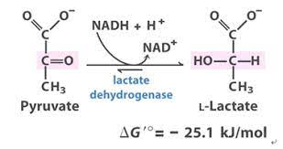
Fig. 1- Reduction of pyruvate to form L- lactate
EC 2. Transferases

These catalysts are used in the transfer of a group other than hydrogen from one substrate to another.
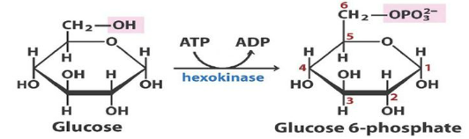
Fig. 2- Formation of glucose- 6- phosphate from glucose

EC 3. Hydrolases
These catalysts are used in the hydrolysis reactions. The examples of these enzymes include esterases, lipases, nitrilases, proteases.
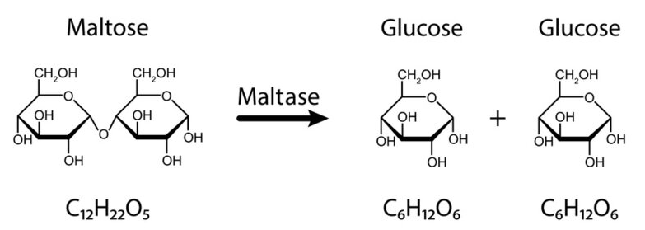
Fig. 3 – Enzymatic hydrolysis of maltose

EC 4. Lyases
These enzymes catalyze the non-hydrolytic removal of functional groups from the substrates. The reaction involves introduction of a double bond in the product or a reverse reaction. These enzymes as aldolases and decarboxylases are involved in the elimination reactions and the addition reactions.
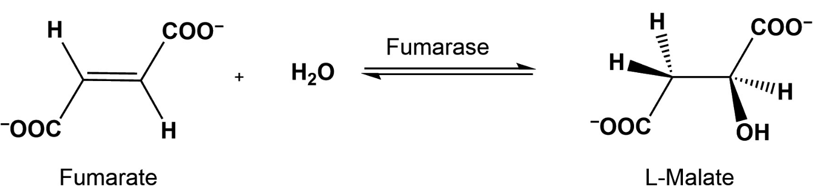
Fig. 4 – Enzymatic conversion of fumarate to malate

EC 5. Isomerases
These enzymes are involved in the catalysis of isomerization reactions resulting in cis-trans isomerizations and racemizations.
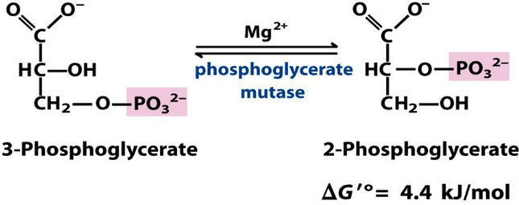
Fig. 5 – Isomerization by enzymatic action

EC 6. Ligases
These enzymes are responsible for catalyzing the synthesis of new bonds, along with ATP cleavage.
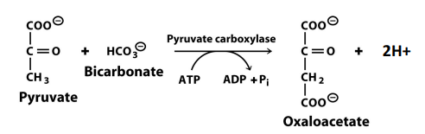
Fig. 6 – Conversion of pyruvate to oxaloacetate by formation of new bond
Enzyme Classification: Secondary Classes of Oxidoreductases in the EC System

Oxidoreductases: second EC digit | Hydrogen or electron donor
1. | Alcohol (CHOH)
2. | Aldehyde or ketone (C = O)
3. | -CH-CH-
4. | Primary amine (CHNH₂ or CHCH₃⁺
5. | Secondary amine (CHNH)
6. | NADH or NADPH (when another redox catalyst in the acceptor)
Table 1 – Secondary classes of Oxidoreductases

Enzyme Classifications: Tertiary Classes of Oxidoreductases in the EC System
Oxidoreductases: thried EC digit | Hydrogen or electron acceptor
1. | NAD⁺ or NADP⁺
2. | Fe³⁺ (e.g. cytochromes)
3. | O₂
4. | Other

Table 2- Tertiary classes of oxidoreductases

Enzymes as catalysts
The catalytic activity of an enzyme can be represented by a constant k_{cat}, which is referred as turnover rate or frequency or number. The constant k_{cat} is defined as the amount of substrate molecules converted to product per unit time. To consider an example, single molecule of an enzyme carbonic anhydrase catalyses the conversion of around 6 lakh molecules of carbon dioxide (CO₂) and water (H₂O), producing bicarbonate (HCO₃⁻), every second.

Enzyme | Turnover number (per second)
Carbonic anhydrase | 600,000
3-Ketosteroid isomerase | 280,000
Acetylcholinesterase | 25,000
Lactate dehydrogenase | 1,000
Chymotrypsin | 100
DNA polymerase I | 15
Tryptophan synthetase | 2
Lysozyme | 0.5
Table 3 – Turnover number (Adapted from: Biochemistry, 5th edition.Berg JM, Tymoczko JL, Stryer L.
New York: W.H. Freeman; 2002.)

Specificity of Enzymes
The enzymes are highly specific in their role to increase the rate of biochemical reactions. A single enzyme can catalyze only a single step or reaction of any physiological process or at the maximum a group of similar type of substrate molecules can undergo reaction catalyzed by any single enzyme i.e., some enzymes demonstrate group specificity. For example, alkaline phosphatase can be used to remove a phosphate group from a variety of substrates.
There are enzymes which demonstrate absolute specificity. As for example, glucose oxidase shows total absolute specificity for β-D-glucose but does not catalyse any other reaction of any other monosaccharides.

Chemical Specificity of Enzymes

Types of Specificity | Action | Examples
Low or Bond Specificity | Acts on any compound with a specific type of bond | Amylase and Lipase
Moderate Specificity | Acts on chemicals not only on specific bonds but also on specific structure surrounding it. | Pepsin, trypsin and chymotrypsin
Absolute Specificity | Acts only one substrate | Uricase, Lactase & Maltase
Optical Specificity | Acts only on stereo-specific structure | L-amino acid oxidase and D-aminoacids oxidase
Dual Specificity (Two substrates) | Acts on Two separate substrates | Xanthin oxidase acts on hypoxanthine and xanthin
Dual Specificity (One substrate but two reactions) | One enzyme act on one substrate by two separate reactions | Isocitrate dehydrogenase acts on isocitrate by oxidation and decarboxylation.
Table 4 – Chemical specificity of enzymes
Classification of enzymes on the basis of chemical nature
- Simple Enzymes:
Some enzymes act as simple protein which upon hydrolysis yield amino acids. These also include digestive enzymes as well.

Types of Digestion | Enzyme | Produced in | Stire of Release | pH Level
Carbohydrate | Salivary amylase | Salivary Glands | Mouth | Neutral
 | Pancreatic Amylase | Pancrease | Small Intestine | Basic
 | Maltase | Small Intestine | Small Intestine | Basic
Protein | Pepsin | Gastric Glands | Stomach | Acidic
 | Trypsin | Pancreas | Small Intestine | Basic
 | Peptidase | Small Intestine | Small Intestine | Basic
Nucleic Acid | Nuclease | Small Intestine | Small Intestine | Basic
 | Nucleosidase | Small Intestine | Small Intestine | Basic
Lipid (fat) | Lipase | Small Intestine | Small Intestine | Basic

Table 5 – List of simple enzymes and their characteristics

(ii) Conjugate Enzymes:

These enzymes contain two constituents – a protein part known as apoenzyme (e.g., flavoprotein) while another part consist of a non-protein called cofactor. Together they are called holoenzyme. Some examples of conjugate enzymes are transferases, oxidoreductases, ligases, and isomerases.

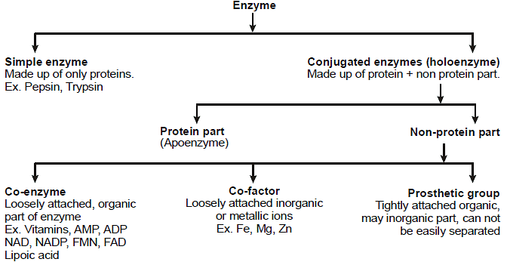
Fig. 7 – Flowchart of enzyme classification

The enzymes can show its activity only when both apoenzyme and cofactor are present together. The cofactor can be simple divalent metallic cations of Ca, Mg, Zn, Co etc or can be a non-protein organic compound called coenzyme such as flavin, haem etc or can be a prosthetic group such as pyridoxal sulphate, flavin mononucleotide (FMN), biotin etc.

(iii) Metallo-enzymes:
The metal cofactors containing both monovalent metal cation of Na, K etc and divalent metal cations of Mg, Mn, Cu etc can be involved in enzymatic reactions. These cations can either be loosely held by the enzyme or can go into the composition of molecule itself. Some of the examples are carboxypeptidase (which acts as hydrolytic enzyme containing Zn coordinated to many amino acid residues of proteins), catalase (used for the decomposition of H₂O₂ containing iron – porphyrin complexes), haemoglobin (also contains iron – porphyrin complexes), chlorophyll (contains magnesium- porphyrin complexes)

(iv) Isoenzymes (Isozymes):
Sometimes same species, tissue or even same cell contains many enzymes in multiple forms which can catalyze the same reaction but have different amino acid composition possessing different physicochemical properties. These enzymes are called isoenzyme or isozyme. As for example glycolytic enzyme, hexokinase which exist as four isoenzymes in various tissues, lactate dehydrogenase (LDH) which carry out anaerobic glucose metabolism, contains two isoenzymes in human out of which one is present in heart while the other is present in skeletal muscles.

PROPERTIES OF ISOZYMES
Different metabolic patterns in different organs.
The isozymes present in the skeletal muscle and in the liver have different properties for glycogen phosphorylase indicating different behaviour of breakdown of glycogen in these two tissues.
Different locations and metabolic roles for isozymes in the same cell.
In mitochondrion and cytosol, the isozymes isocitrate dehydrogenase can cited as example.
Different stages of development in embryonic or foetal tissues and in adult tissues.
LDH isozyme changes as the liver organ develops into its adult form from the child phase. Few enzymes of glucose catabolism present in malignant cells of especially responsible for cancer is present only in foetal isozymes.
Different responses of isozymes to allosteric modulators.
Hexokinase IV (glucokinase) of liver and the hexokinase isozymes of other tissues differ in their sensitivity to inhibition by glucose 6- phosphate.
Lactate dehydrogenase (LDH), the enzymes that are responsible for the reduction of pyruvate to lactate are present in different forms as described below.
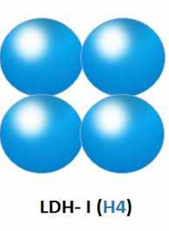  Homotetramer H subunit in  heart cells.Very high  value of Km.Marker  of myocardial infection | 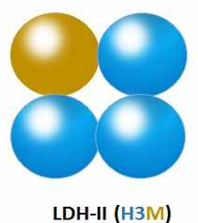  Heterotetramer present in  different tissues | 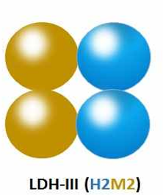  Heterotetramer present  in different tissues | 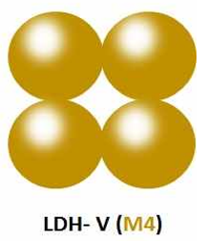  Homotetramer M subunit  in skeletal muscle cells  Very low value of Km  Marker of muscular  Dystrophy
Fig. 8 – Classification of Tetramers

II Enzyme Structure and Substrate Binding

1. Lock and Key Hypothesis:
The enzymes containing amino acids are basically globular proteins ranging in size from less than 100 to more than 2,000 amino acid residues. The arrangement of amino acids can contain one or even more polypeptide chains that can exist as folded and bent form constituting a specific three-dimensional structure which incorporate a smaller area called active site where the substrate can actually bind. These active sites involve fewer number (usually less than 10) of the constituent amino acids. The shape and charge properties of these active sites enable them to bind a single type of substrate molecule only. This makes the enzyme highly specific in its behaviour first proposed by the German chemist Emil Fischer in 1894. This is thus called Fischer’s “Lock and Key” hypothesis.
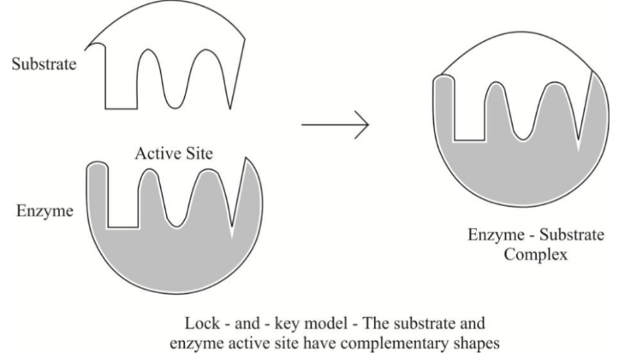
Fig. 9 – Diagrammatic representation of Lock and Key hypothesis

The role of the rest of the protein molecule is to stabilize the active site providing a suitable environment for the site to interact with the substrate. Hence the active site never separates out from the rest of the protein without losing its catalytic behaviour.

2. Induced-Fit Theory:
Due to close approach of substrate or product, the active site of enzymes gets induced by this and undergoes a change in its conformation. This allows a better combination between the enzyme and substrate. 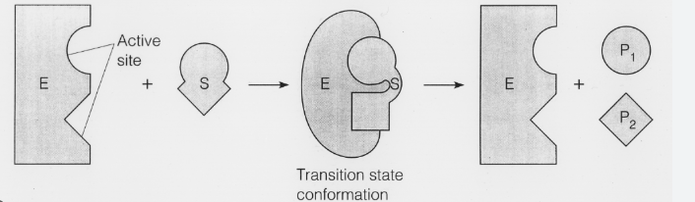
Fig. 10 – Diagrammatic representation of Induced Fit theory

This is known as the induced-fit theory. The structure of the substrate gets changed during this process in a large number of cases thus forming a functional enzyme- substrate complex.

III The Enzyme Kinetics
The study of factors that explain and evaluate the rate of enzyme-catalysed reactions is termed as enzyme kinetics. The theory of kinetics is important to assess and understand this concept of the role of enzymes in metabolism as well as biotechnology.
There are two methods of measurement of enzyme activity.
- Discontinuous method
- Continuous method
In discontinuous method we mix enzyme and substrate together and measure the amount of product formed over a period of time. It’s an easier and quicker method generally used either when we have little knowledge about the system and we just make a primary investigation or when we have larger knowledge about the system and we are certain about the time interval we take.
In continuous method we usually study the rate of a reaction catalyzed by the enzyme. We can also measure the rate of reaction by measuring the rate of disappearance of substrate over a period of time. In the kinetics of enzyme catalyzed reaction, we often use an artificial substrate like chromogen which results in brightly coloured products. This makes us to easily follow the reaction by using colorimeter or spectrophotometer. The example of continuous assays (measurements) is as follows:
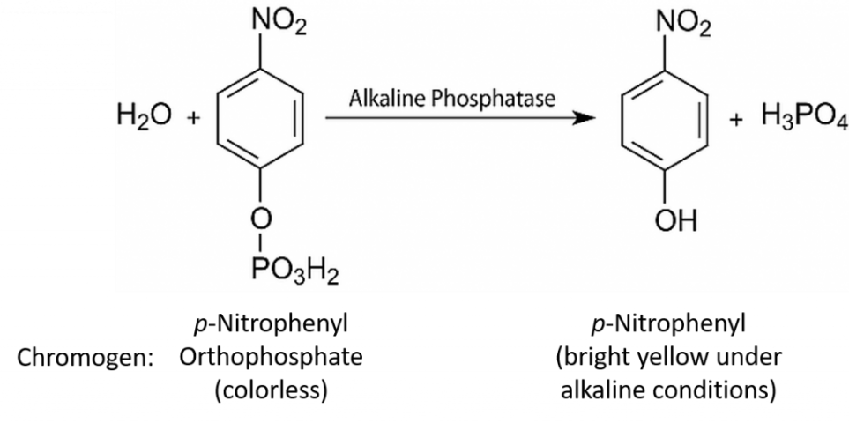
Fig. 11 – Example of Continuous assays

The enzymatic activity is strongly influenced by pH and so we have to set the pH at a specific value and keep it constant throughout the experiment. Thus, we use a buffer solution for this purpose. We mix the substrate solution (chromogen) with buffer solution and then add the enzyme. The observations are noted in spectrophotometer which shows that initially the rate of reaction is fast but after sometimes it may slow down as shown below:
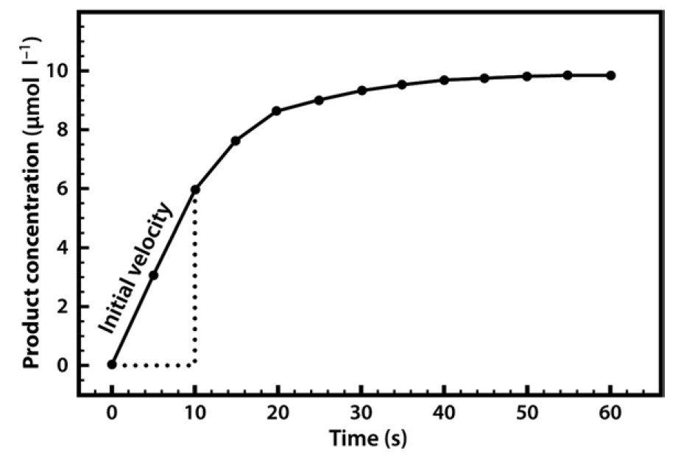

Fig. 12 - Formation of Product in an Enzyme-Catalyzed Reaction, Plotted Against Time.
Upon increasing the concentration of enzyme by two times the rate of reaction gets doubled while upon decreasing the concentration of enzyme by 50% the rate is observed to be half of the initial value. Hence a linear relationship exists between rate of reaction and concentration of the enzyme as observed in the following curve:
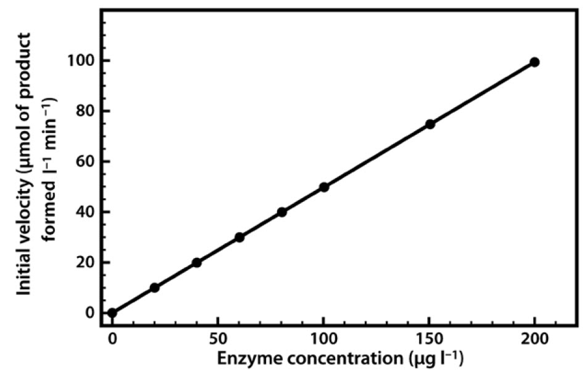

Fig. 13 - Relationship Between Enzyme Concentration and the Rate of an Enzyme-Catalyzed Reaction.
Keeping the concentration of enzyme constant if the concentration of substrate the rate is observed to increase considerably during initial period of time. Upon further increasing the concentration of substrate the rate of the reaction rate starts to decline, until a stage is reached where increasing the substrate concentration has practically little effect on the rate. Here the enzyme is supposed to approach its saturation with respect to substrate, and acquires its maximal velocity (V_{max}), a theoretical limit that will not be truly achieved in any experiment as observed in the graph given below:
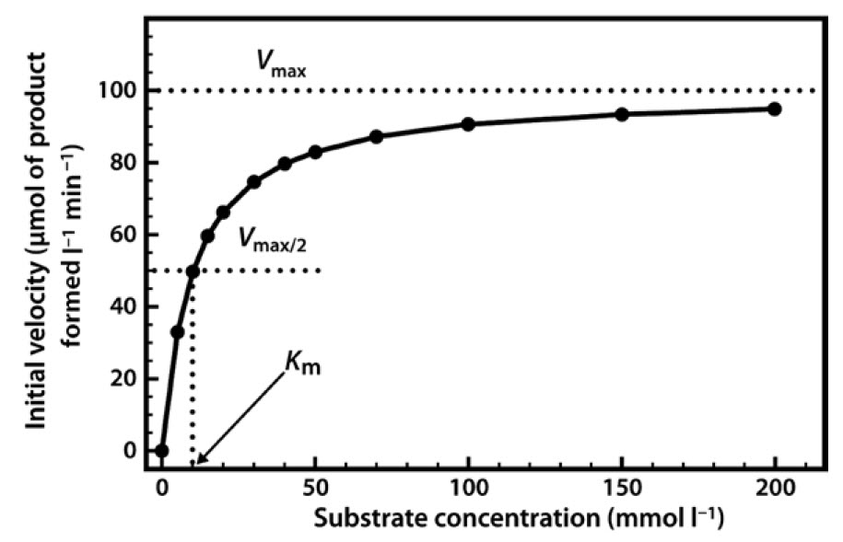

Fig. 14 - Relationship Between Substrate Concentration and the Rate of an Enzyme-Catalyzed Reaction.

Mathematically the equation that describes such a relationship is as follows:
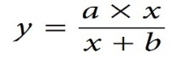
The two constants a and b allow us to describe a hyperbolic relationship, where the constant a is it is V_{max.}, constant b is the value on x-axis giving half of the maximal value of y. In enzymology this is known as the Michaelis constant (K_{m}).
The Michaelis–Menten equation, thus becomes:
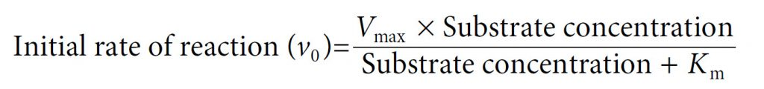
In 1913, Leonor Michaelis and Maud Menten first derived this equation mathematically by giving the mechanism of enzyme catalyzed reaction as follows:
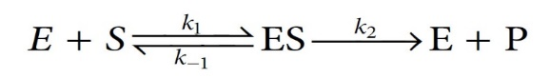
Where k₁ is the rate constant for forward reaction between enzyme (E) and substrate (S) to form enzyme - substrate complex (ES), k₋₁ is the rate of backward reaction in the equilibrium condition where ES yields back E and S and k₂ is the rate of formation of product (P) producing back the enzyme (E) in same concentration as E was initially consumed.
This derivation requires two important assumptions, first that we have considered the initial velocity of the reaction (v₀), when the product concentration is negligibly small (i.e. [S] ≫ [P]), such that we can ignore the possibility of any product reverting to substrate and second that the concentration of substrate largely greater than the concentration of enzyme (i.e. [S] ≫ [E]).
The derivation is as follows:
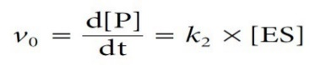
As ES is formed as an intermediate, its concentration is not known. Also, the rate law expression must be expressed in terms of concentration of reactant. Hence, we have to express [ES] in terms of concentration of E and S.
Applying steady-state approximation we can assume that the concentration of the ES complex remains constant although the concentration of substrate and product changes.

Rate of ES complex formation = Rate of ES complex breakdown
Hence, at steady state:
The equation can be rearranged to yield [ES] as follows:
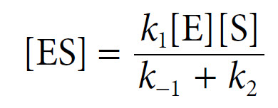
The Michaelis constant K_{m} is hence as follows:
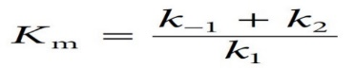
The [ES] equation can then be simplified to:
[ES] = K_{m} [E][S]
Since [S] ≫ [E], hence the concentration of unreacted substrate [S] is almost equal to the total concentration of substrate and the concentration of unreacted enzyme [E] is equal to the total enzyme concentration [E]_{T} minus that combined with substrate [ES]. The equation can now be written as:
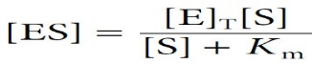
Introducing this term for [ES] into the initial velocity equation we get:
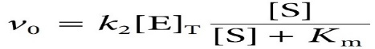
Here k₂[E]_{T} represents V_{max}, the maximal velocity. Thus, Michaelis and Menten gave their final equation as:
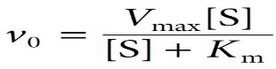
The enzymes catalysing the same reaction, but derived from different organisms, can have widely different K_{m} values. An enzyme with multiple substrates can have different K_{m} values for each substrate.

Typical Range of Values of the Michaelis Constant

Enzyme | K_{m} (mmol I⁻¹)
Carbonic anhydrase | 26
Chymotrypsin | 15
Ribonuclease | 8
Tyrosyl-tRNA synthetase | 0.9
Pepsin | 0.3
Table 6 – Km values of enzymes
Lower the K_{m} value smaller is the amount of enzyme required for substrate to achieve saturation value reaching the maximum velocity at relatively low substrate concentrations. A higher K_{m} value indicates the requirement for high substrate concentrations in order to achieve maximum reaction velocity. Thus, K_{m} is a measure of the affinity of the enzyme for its substrate—in fact it has an inverse relationship, where a higher K_{m} means a low affinity, and vice versa.
The significance of K_{m} value:
- Lower K_{m} value relative to the physiological concentration of substrate indicates that the enzyme probably saturates with substrate, and acts at a constant rate.
- Higher K_{m} value relative to the physiological concentration of substrate indicates that the enzyme will not saturate with substrate, and hence the rate of reaction will vary according to the concentration of substrate due to which the rate of formation of product will depend on the available concentration of substrate.
- In case that an enzyme catalyzes different substrates, the substrate with the lowest K_{m} value is usually the enzyme’s ‘natural’ substrate.
- In case two different enzymes (with similar V_{max}) in different metabolic reactions compete for the same substrate, then the pathway having the enzyme with the lower K_{m} value is considered as the ‘preferred pathway’.
- Phosphofructokinase (PFK) catalyses the first step of the glycolytic pathway, generating energy in the form of ATP for the cell and glucose-1-phosphate uridylyl transferase (GUT) leads to the synthesis of glycogen. Both use hexose monophosphates as substrates. However, K_{m} of PFK is lower than GUT. At lower concentration of cellular hexose phosphate, PFK is active and GUT is remains inactive but at higher hexose phosphate concentrations both pathways become active.
Very often when high concentration of substrate is not taken then it is impossible to estimate K_{m} values from the plot of velocity against substrate concentration because the concentration of substrate is not enough to estimate maximal velocity, and hence we fail to evaluate half-maximal velocity and hence K_{m}. To solve our purpose, we can use Lineweaver–Burk plot (often called the double-reciprocal plot) which is a linear curve where the graph produced can easily be extrapolated, to calculate the values of V_{max} and K_{m} as follows:
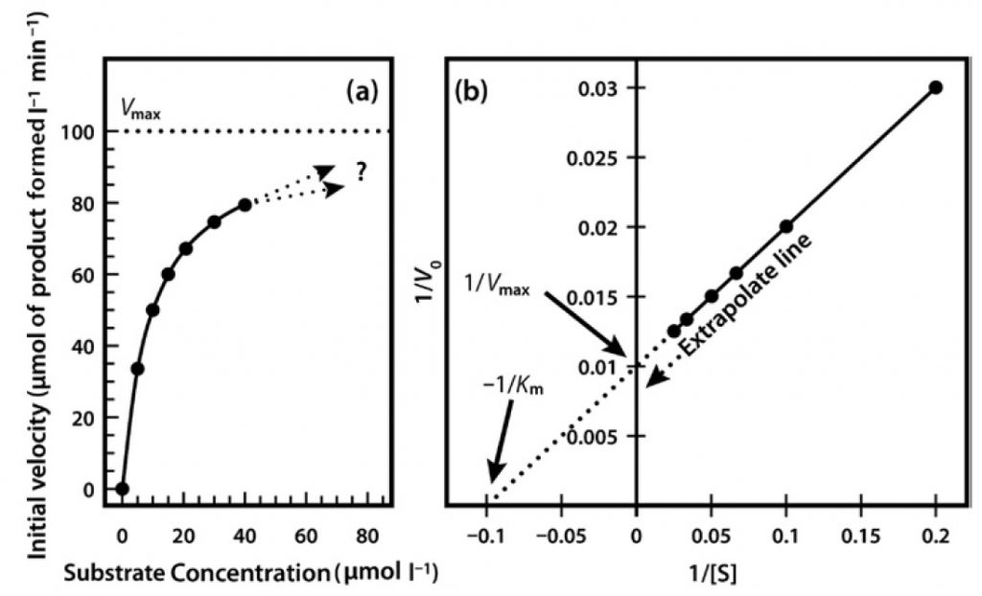
Fig. 15 - Michaelis Menton Kinetics: (a) Direct plot of data (b) Lineweaver-Burk plot of the same kinetic data.

A drawback of Lineweaver–Burk plot is the influence on measurements made at the lowest substrate concentrations. These concentrations may lead to error as it is difficult to make solution of multiple dilutions This can affect reaction rates as they are slow. Often, such points when transformed on the Lineweaver–Burk plot have a significant impact on the line of best fit estimated from the data, and hence the extrapolated values of V_{max} and K_{m} can show error in calculation. This can be studied by observing following two graphs:
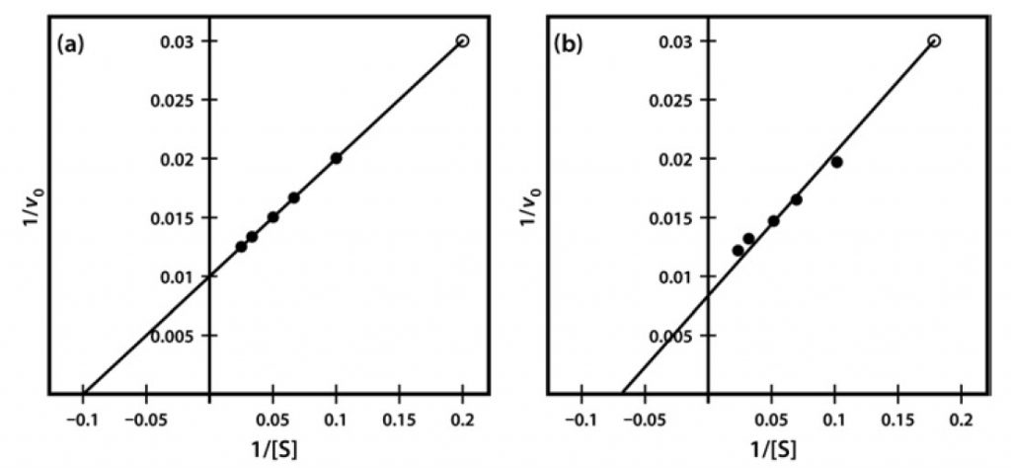
Fig. 16 - Lineweaver-Burk Plot of Similar Kinetic Data, Which Differ Only in a Single Data
Point (Final data point (a) 1/v 0.03 at 1/S of 0.2 and (b) 1/v 0.031 at 1/S of 0.18).

IV Properties of Enzymes:
1. Enzymes are bio catalysts.
2. Reversibility:

Enzymes controlled reactions can theoretically said to be reversible. However, the reversibility of reaction actually depends upon factors like energy requirements, presence of reactant, concentration of final products and pH of reaction medium. The reaction can also be irreversible as in case of decarboxylation and hydrolysis reactions.
The thermodynamics of the reactions control the forward and backward shift of any reaction. The pathways of respiration and photosynthesis best describe this thermodynamic effect. The enzymes responsible for glycolysis and pentose phosphate pathway dissimilate glucose while there are certain enzymes act in the opposite direction in photosynthesis producing glucose from carbon dioxide and water.
3. Heat sensitivity:
All enzymes are sensitive to temperature effect and are thermolabile. Generally, enzymes have optimum effect between 25°-35°C. They turn inactive at freezing temperatures and get denatured at 50°-55° C. Thermal algae and bacteria show exceptional behaviour where enzymes remain functional even at 80°C. Enzymes present in seeds and spores do not denature at 60°-70°C.
4. pH-sensitive:
Each enzyme catalyses the reaction at a particular pH, e.g., sucrase (4-5 pH), pepsin (2 pH), trypsin (8.5 pH). Any change in pH of reaction mixture makes the enzymes ineffective.
5. Specificity of actions:

The substrate specificity of enzymes can be classified as group specificity and stereo-specificity. The group specificity of enzymes can be described when they function on a number of homologous substrates.
For example, hexokinase transfers phosphate group from ATP to at least 23 hexoses or their derivatives like glucose, mannose, fructose, and glucosamine. There are some group specific enzymes which show an absolute group specificity, by catalyzing only on a single compound and not its homologues. Manno kinase, glucokinase and fructokinase are involved in phosphorylation of mannose, glucose and fructose respectively.
Enzymes are also stereo-specific as it is exhibited with both optical and geometric isomers.
(i) If the enzyme is optically specific, then it catalyze either dextro (d) or laevo (l) isomer of the compounds. For example, d. amino acid oxidase oxidises only d. amino-acids and l. amino acid oxidases oxidises only l. amino acids.
(ii) The geometrical specificity can be studied by the effect of enzyme on the cis and trans isomers. For example, fumaric hydratase catalyzes only the trans-isomer fumaric acid and not the cis-isomer malic acid.

6. Enzyme inhibition:

Such substances or compounds that decrease the rate of an enzyme-catalyzed reaction are known as inhibitors and the phenomenon is described as enzyme-inhibition. A diagrammatic representation is shown below:
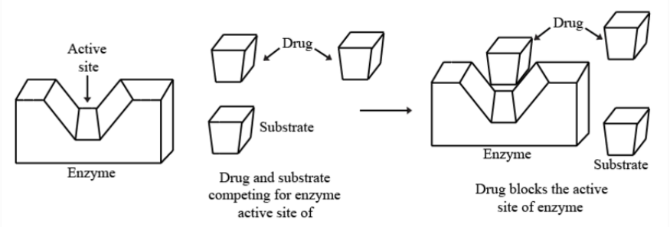
Fig. 17 – Mechanism of Enzyme Inhibition

Types of enzyme inhibitors:

I. On the basis of specificity:
- Co-enzyme inhibitor: These inhibits the coenzymes only. As for example cyanide hydrazine, hydroxyl amine inhibits co- enzyme pyridoxal phosphate.

- Ion-cofactor inhibitor: These are responsible for inhibiting the cofactors which are part of holoenzyme, example: fluoride chelate Mg²⁺ ion of enolase enzyme.

- Prosthetic group inhibitor: These inhibit the prosthetic group part of holoenzyme,
Example: cyanide inhibit Haem of cytochrome oxidase.

- Apoenzyme inhibitor: These are inhibitors for apoenzymes, example: antibiotics.

- Physiological modulator: For example: Adenosine inhibited generation of superoxide anion by neutrophils stimulated with N-formyl methionyl leucyl phenylalanine (FMLP), concanavalin A (Con A), calcium ionophore A23187.

II. On the basis of origin:
- Natural enzyme inhibitor: Natural enzyme inhibitors are those which have grown to
defend a plant or animal against predators, for example: alkaloids, sesquiterpene and saponins, polysaccharides, flavonoids, dietary fibres, ferulic acid, tannins, limonene, and oleuropeins.

- Artificial enzyme inhibitor (synthetic): These are competitive inhibitor drug usage is extensive. Examples include tetrahydrofolate: (anticancer drug), para-aminobenzoic acid: antibiotic etc.

III. On the basis of whether the inhibition is reversible or irreversible

Reversible inhibition: In this type of enzyme inhibition the enzymatic activity can be regained after removal of inhibitors.

Types of reversible inhibition:

i). Competitive inhibition

Competitive inhibitors are substrate analogue which bind to the given substrate that binds the site of enzyme i.e., the active site due to which there occurs competition between the inhibitor and the substrate for binding to enzyme. This type of inhibitor is overcome by increasing the concentration of substrate. The kinetics of reaction is V_{max} remains same and K_{m} increases. This reaction states that, initially the inhibitor binds to the enzyme but with increase in concentration of substrate there occurs release of inhibitor. The substrate then binds the enzymes such that V_{max} remains same while the value of K_{m} increases. Example: Succinate dehydrogenase convert succinate to fumarate.

ii). Non-competitive inhibition:
In this type of inhibition, there does not occur any competition between the given substrate and the inhibitor as the inhibitor binds to enzyme and not on the substrate binding site. As the binding site of substrate and inhibitor to enzyme is not same so, the inhibitor fails to affect the affinity of enzyme towards substrate. This case indicates that, the inhibition fails overcome the increasing substrate concentration. The kinetic reaction states that the V_{max} decreases and K_{m} remains same. This can be understood by the fact that substrate concentration does not have any effect on the inhibition. It can be said that the binding of substrate and inhibitor are equal. The inhibitor can change the conformation of enzyme after binding so that substrate cannot bind to enzyme. Thus, there occurs decrease of V_{max.} Example: Heavy metal poisoning. Hg, Pb etc.results in the distortion of the -SH group present in the enzyme at allosteric site. Doxycycline is a non-competitive inhibitor of proteinase enzyme of bacteria. The non-competitive inhibitor can be removed by pH treatment or by hydrolysis. In case of metal poisoning, chelator is used.

iii). Uncompetitive inhibitor:
The uncompetitive inhibitor is observed in the reactions involving multi-substrate. It is a rare type of inhibition in which the process of inhibition is similar to the non-competitive but this only binds to ES-complex. In this case the substrate first binds to the enzyme forming an ES-complex. After the binding of substrate to the active site of enzyme, the binding site for inhibitor forms at allosteric site so that the inhibitor can bind. The binding of inhibitor results in the distortion of the active as well as the allosteric site of enzyme, inhibiting the catalysis. In this inhibition, V_{max} as well as K_{m} both decreases. Examples: Inhibition of lactate dehydrogenase by oxalate, inhibition of alkaline phosphatase by L-phenylalanine.

iv). Mixed inhibition:
Mixed inhibition is often observed in the multi-substrate reaction which is described as the combination of competitive and the non-competitive inhibition. The mixed inhibitor results in the binding of both the active site and the allosteric site. The kinetics of reaction involves decrease of V_{max} and increase in K_{m}. The decrease in V_{max} is because the inhibitor non-competitively binds to the allosteric site and distorts the enzyme. Similarly, K_{m} increases as inhibitor can also bind to the active site competing with the substrate. This type of inhibition cannot be removed by increasing the concentration of the substrate. Examples: Ketoconazole is an example of mixed inhibitor that binds to 5–α reductase enzyme, Palladium ion is mixed inhibitor of oxidoreductase enzyme.

V Coenzymes:

Many enzymatic reactions are completed in the presence of coenzymes which are compounds having same behaviour as the enzymes as they increase the rate of biological reactions, but are not proteins like the enzymes.

Definition:
A particular kind of cofactor, which is a non-protein organic compound, or a carrier molecule having its role in conjunction with any particular enzyme, are called coenzymes.
The cofactor that firmly binds to the apoenzyme is termed as a prosthetic group; and the organic cofactor that attaches itself to the enzyme protein only at the time of reaction, is called a coenzyme.
In biochemical process occurring inside the cell sometimes hydrogen atoms or electrons are removed from one compound and transferred to another. In such cases a particular enzyme catalyzes the elimination, but a particular coenzyme should be present there to help in this transfer. The coenzyme temporarily can attach the eliminated group and hand over to any other compound acting as acceptor.

Chemical Nature of Coenzymes:

Coenzymes are generally chemical derivatives of the nucleotides where usually the nitrogen base portion of the nucleotides gets substituted by some other chemical unit, generally a derivative of a particular vitamin.
The following coenzymes are important in cellular physiology.
- Flavin derivatives or Flavin nucleotides (FMN and FAD)
Many respiratory enzymes make use of a cofactor as one of the two derivatives of riboflavin (vitamin B₂), flavin mononucleotide (FMN) and flavin adenine nucleotide (FAD).
Structure:
Riboflavin contains a ribose sugar, and a flavin portion. Flavin is a complex triple ring structure. When a phosphate group is attached to riboflavin in cells forming nucleotide like complex then it is known as flavin mononucleotide (FMN) or riboflavin monophosphate. If FMN joins to AMP, a dinucleotide called flavin adenine dinucleotide (FAD) is formed.
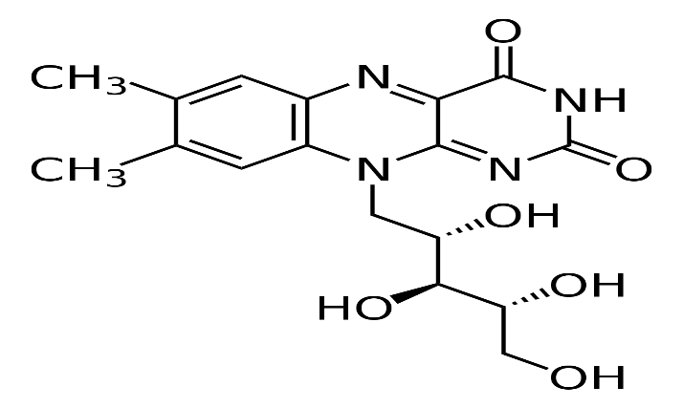
Fig. 18 – Structure of Riboflavin
Functions:
Either FMN or FAD can attach itself with an apoenzyme which is called flavoprotein (FP). This flavoproteins catalyze the removal of hydride ion (H–) and hydrogen ion (H⁺) from a metabolite.
FAD + MH₂ ——–> FADH₂ + M
FMN + MH₂——–> FMNH₂ + M
Where MH₂, is substrate, FADH₂, is the reduced form of FAD, and FMNH₂ is the reduced form of FMN. An important source of hydrogen for this reaction is the reduced pyridine nucleotide.
H⁺ + NADH + FAD ——–> NAD⁺ + FADH₂
The reduced flavoproteins pass their electrons to the cytochromes.
- Pyridine derivatives or Pyridine nucleotides (NAD and NADP).
The first nucleotide coenzyme discovered was co-zymase, or diphosphopyridine nucleotide.
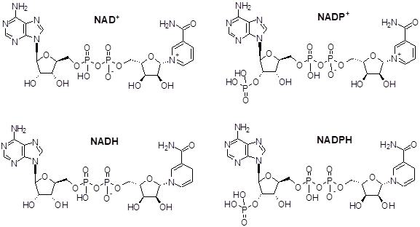
Fig. 19 – Structure of pyridine derivatives
NAD is involved in cellular respiration while NADP is involved in photosynthesis.

NAD | NADP
A coenzyme involved in redox reaction in  the cellular respiration | A coenzyme involved in redox reactions inside  the cell during photosynthesis
Does not contain phosphate group | Contains phosphate group at the 2’ position of ribose ring  which contains adenine moiety
Reduced form is NADH | Reduced form is NADPH
Oxidized form is NAD⁺ | Oxidized form is NADP⁺
Oxidized form is more abundantly present in the cell | Reduced form is more abundantly present inside the cell
NAD⁺ is mostly used as oxidizing agent | NADPH is mostly used as reducing agent
Used in glycolysis, Kreb’s cycle, fatty acids and  sterol synthesis | Used in Calvin cycle, pentose phosphate pathway, lipid  synthesis, chain elongation in fatty acid and  synthesis of cholesterol
Table 7 – Comparative study of NAD and NADP
- Coenzyme A
Coenzyme A can be naturally synthesized from the pantothenate (vitamin B5), present in the foods like meat, vegetables, cereal grains, legumes, eggs, and milk.
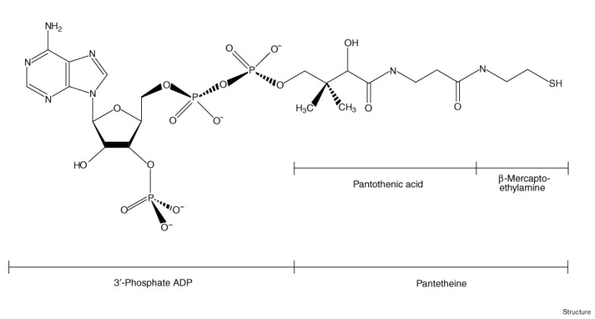
Fig. 20 – Structure of Coenzyme A

It plays a significant role in synthesis and oxidation of fatty acids, oxidation of pyruvate in the citric acid cycle, encoding of genome sequenced. It plays vital role in both anabolic and catabolic processes. Its derivative Acetyl- CoA is helpful in post - translational and allosteric regulations of enzymes pyruvate dehydrogenase and carboxylase so as to maintain and support the partition of synthesis and degradation of pyruvate.

- Coenzyme Q
Coenzyme Q is a quinone and is known as ubiquinone mainly found in the mitochondria and also in microsome and cell nuclei, etc.
The coenzyme Q contains a quinone with a side chain with length varying according to the source of the mitochondria. In animal tissues the quinone mostly possesses 10 isoprenoids units in side chain and is known as coenzyme Q₁₀.
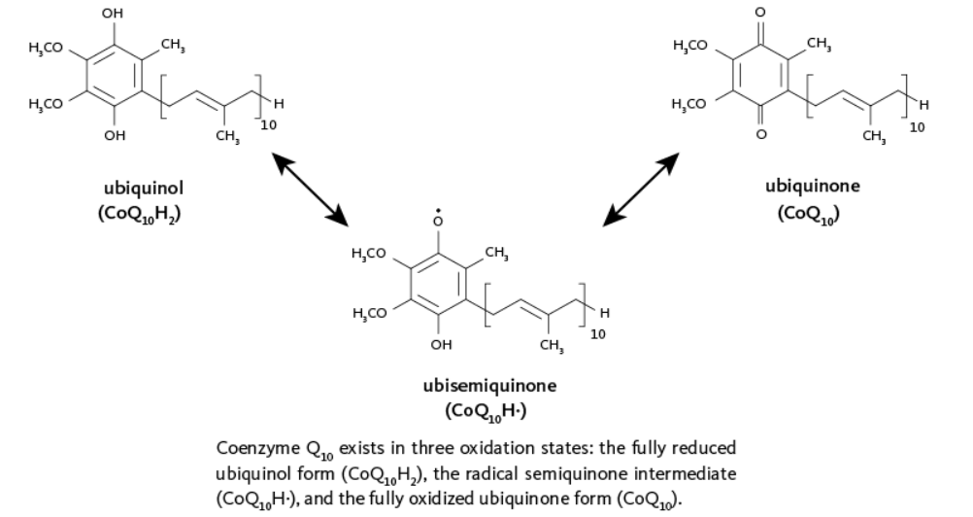
Fig. 21 – structures of Coenzymes Q
The coenzyme Q act as component of the electron transport chain in the mitochondria. It acts as an additional hydrogen carrier between the flavin coenzymes (FAD and FMN) and the cytochromes.

- Cytochromes
Cytochromes are the electron transfer proteins containing different haem groups that primarily generate ATP via an electron transport system within the mitochondria, endoplasmic reticulum and bacterial redox chains.
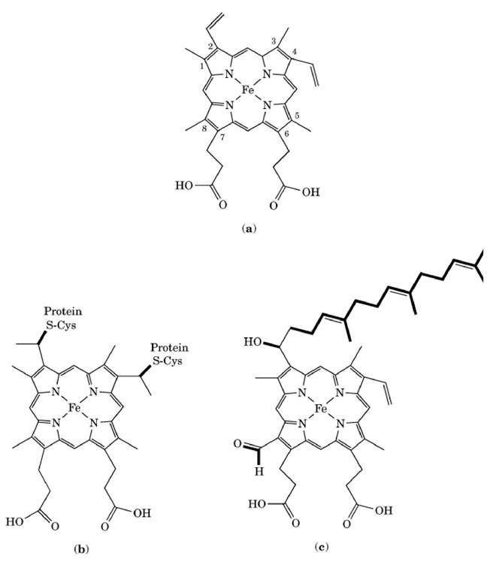
Fig. 22 – Structures of Cytochromes
The physiological activity in all the cytochromes is reversible redox reaction of iron between ferrous and ferric cationic forms. The cytochromes a and b and some type of cytochrome c form the integral proteins of the inner mitochondrial membrane while the cytochrome c is soluble protein associated through electrostatic interactions with the outer surface of the membrane.

The following is a scheme showing the electron transport system.

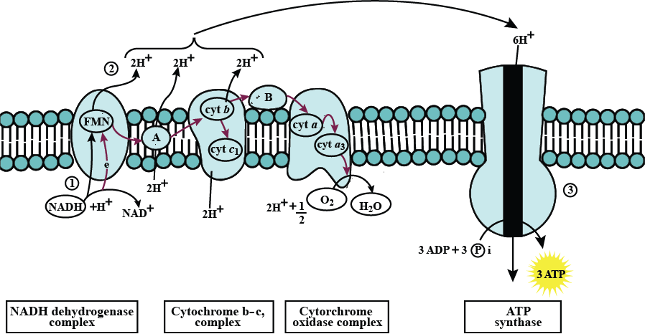
Fig. 23 – Representation of electron transport system
- Thiamine pyrophosphate
Vitamin B1 i.e., thiamine as thiamine pyrophosphate is required for oxidative phosphorylation and pentose phosphate mechanism as a cofactor for α-ketoacid dehydrogenases such as pyruvate dehydrogenase (PDH), α-ketoglutarate dehydrogenase (KGDH), transketolase and branched-chain α-ketoacid dehydrogenase
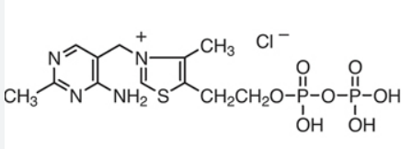

Fig. 24 - Thiamine Pyrophosphate Chloride

References
Robinson, P. (2015) Enzymes: Principles and Biotechnological Applications. Essays in Biochemistry 59:1-41. Available at: https://www.researchgate.net/publication/283779912_Enzymes_principles_and_biotechnological_applications
Jakubowski, H. (2015) Biochemistry Online: An Approach Based on Chemical Logic. Available at: https://employees.csbsju.edu/hjakubowski/classes/ch331/bcintro/default.html
5.07SC Biological Chemistry 1. (2013) MIT OpenCourseWare. Accessed on Oct 17th, 2019 from https://ocw.mit.edu/courses/chemistry/5-07sc-biological-chemistry-i-fall-2013/module-i/session-2/MIT5_07SCF13_Lec4.pdf
Wikipedia contributors. (2019, June 4). Bohr effect. In Wikipedia, The Free Encyclopedia. Retrieved 18:23, October 17, 2019, from https://en.wikipedia.org/w/index.php?title=Bohr_effect&oldid=900236862
Briggs G.E., Haldane J.B.S. A note on the kinetics of enzyme action. Biochem. J. 1925;19:338–339. A classic paper in which the steady-state assumption was introduced into the derivation of the Michaelis–Menten equation.

