Mechanical Properties of Concrete by Partial Replacement of Fine Aggregate with Granulated Coal Ash
Sanjeeb Kumar Chaudhury^{1*}, Sagar Sarangi²
¹ Assistant Professor, Balasore College of Engineering and Technology, Odisha
²Assistant Professor, Sarala Birla University, Ranchi, Jharkhand
sagarsarangicit@gmail.com,
Abstract
In rural area wood is used as a major source of fuel. However granulated coal ash produced from burnt or half burnt is a domestic waste material enrich in various chemical properties. Due to scarcity of good quality fine aggregate in forest region most of the time uneconomic for backward family to use in construction activity. As a result in his experimental fine aggregate is partially replaced with granulated coal ash to investigate the mechanical properties of the concrete. Here, in a varying range from 0% to 25% in weight fraction of fine aggregate has been replaced with granulated coal ash to produce M25 grade of concrete. From the investigation found that 15% partially replacement of fine aggregate with granulated coal ash suitable for producing light weight concrete and beyond that due to finer surface of granulated coal ash not only reduced workability but also reduced the mechanical properties of the concrete specimen.
Keywords: - Granulated Coal; partial replacement; workability; compressive strength; flexural strength
- Introduction
Now-a-days, concrete is the most important requirement for the construction of the structures.
Concrete made with natural aggregate originating from hard rock has a density within a narrow range because the specific gravity of most rocks varies little. Although the volumetric content of the aggregate in the mix affects the density of concrete, this too, is not a major factor. Thus, in practice, the density of normal weight concrete lies within the range of 2200 to 2600 kg/m³. Consequently, the self-weight of concrete element is high and can represent a large proportion of the load on a structure. The use of light weight concrete reduces the cross section of the elements, also reduces the load on the form work. The light weight concrete can be obtained by the use of ash, cenosphere. Granulated Coal in the concrete as the fine aggregate. Granulated Coal is generally obtained from the burnt and unborn wood. The particles size of the GC is vary (75 micron to 300 mm), accordingly they are graded. These materials give effective result for the low strength concrete works. The addition of this reduces the malodorous components of the concrete. Granulated Coal Ash is produced by of burning wood in naturally Environment, and by collecting the pieces of burning wood, and after grinding these pieces and a small amount of addition of cement with water. Some of the improved GCA is commercially utilizable in concrete, concrete products, cement production, sewage sludge stabilization, pavement base materials, lightweight aggregate, reinforced plastics, and other miscellaneous purposes. The residual GCA must usually be disposed of by land filling since it has hardly any commercial value. It is well acknowledged that landfill space is quickly failing in many regions and that the construction of new landfills is very expensive.
A GCA is a lightweight, idle, and empty made to a great extent of silica and alumina and loaded with air or inactive gas, commonly processed as a by-result of coal burning at warm power plants. GCA fluctuates from light black color to practically white shade and their specific gravity extends in the middle of 0.4 g/cm³ to 0.8 g/cm³, which offers them extraordinary lightness. Utilization of industrial waste materials in concrete compensates the lack of natural resources, solving the disposal problem of waste and to find alternative technique to safeguard the nature. There are a number of industrial wastes used as full or partial replacement of coarse aggregate or fine aggregate. This review carries out a thorough assessment about industrial waste substances (Yüksel et al., 2011), which can be adequately utilized in concrete as fine aggregate substitution.
It can be observed that the concrete where sand is replaced by copper slag, imperial smelting furnace slag, class F fly ash exhibits improved strength and durability properties, but it’s slump .increases as the rate of replacement increases in the case of copper slag and the slump decreases in the case of class F fly ash. So GCA is alternative product, which is helpful for the enhancement of the workability of concrete. It can be used as light weight concrete, where acting of load (DL) is very little.
While concrete made with bottom ash reduced compressive strength compared to control specimen; however addition of lower dose of admixture able to enhanced compressive strength observed by (Aggarwal et al., 2007; Ghafoori & Bucholc, 1996; Soman & Sas, 2014). However, by pulverised again bottom ash enhanced it’s pozzolanic properties as a results 20% partial replacement with cement enhanced compressive strength observed by (Jaturapitakkul & Cheerarot, 2003). By addition of pulverised fly ash as secondary cementing material not only improved workability and density but also increased compressive strength of the concrete (Lo et al., 2004). Aramraks, (2006) observed an enhancement of compressive strength by replacement of bottom ash with natural fine aggregate in the concrete. The strength properties of light weight concrete using cinder aggregate was studied by Desai & Sathyam, (2014) and found that quantity of cinder in concrete inversely proportionate with compressive strength. However, 75% replacement of natural aggregate with cinder aggregate enhances compressive strength of the concrete.
- Material
To investigate the mechanical properties of concrete Ordinary Portland cement of 43 grade of ACC brand conforming to IS: 1489(P-1)-2015. Physiochemical properties of cement shown in Table 1. Natural river sand conforming to (Bureau of Indian Standards, 1970) and crush granite stone MSA 20mm used as fine aggregate and coarse aggregate respectively. Details procedure of Granular coal ash (GCA) similar to fine aggregate for partial replacement of natural sand discussed in separate section. Potable drinking water supplied to concrete laboratory used for mixing and curing of the specimen.
  - Preparation of GCA
Wood burnt coal commonly known as charcoal has been collected from household and food corner near by the institute region. After crushed through miller fine particle has been collected as row material for GCA. To make it similar to fine aggregate a ternary blended pallets have been prepared by adding 2% of cement and 3% of fine aggregate in weight fraction as additive along with sprinkling water on it to provide a granular shape. After dried in room temperature stored in a gunny bagged for further use in concrete, Properties of the GCA has been shown in Table 2 and Figure 1.
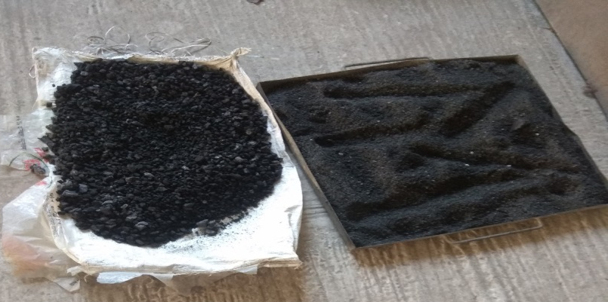
Figure 1 GCA
Table 1 Physio-Chemical properties of Cement
Characteristics | Observed value
Chemical Properties
Silicon dioxide (SiO₂) | 44%
Aluminum oxide (Al₂O₃) | 13%
Calcium oxide (CaO) | 21%
Carbon (C) | 9%
Others chemicals | 13%
Physical Properties
Standard consistency | 32.0 %
Initial Setting Time | 55 Minutes.
Final Setting Time | 290 Minutes.
Specific Gravity | 3.15
Fineness | 8.12 %
Soundness(Le-Chatelier method) | 1.4
Compressive Strength
3days | 20.33 N/mm²
7days | 34.00 N/mm²
28days | 39.66 N/mm²

Table 2
Properties of Aggregate
Tests | FA values | CA Value
Fineness Modulus | 2.63 | 2.82
Specific Gravity | 2.63 | 2.80
Bulk Density | 1540 kg/cum | 1605kg/m³
Water Absorption | 1.33% | 0.50%
Impact | - | 15%

- Methods
Keeping in view of Indian construction industry M25 grade of concrete (1:1.72:3.045), w/c=0.47 for Zone-II has been designed as per IS 10262(Bureau of Indian Standards, 2009). All the ingredients in dry form as per Table 3 have been poured in a rotating laboratory type mixture of rpm 62 for 5 minutes to form a uniform dry mix. Later on required water has been added in to the drum and allowed to rotate another 5 minutes to obtain a uniform concrete mixture. Freshly prepared concrete undergo workability test as per (Bereau of Indian Standard, 1959) and cast in 150mm cubical, 150mmX300mm cylindrical and 100mmX100mmX500mm prism specimen for furthered investigation. After removing from mould allow for submersed curing till the test date. Compressive strength and flexural strength of the specimen has been carryout as per (Bureau of Indian Standards, 1959) whereas for split tensile strength of harden concrete done as per (BIS:5816-1999, 2004) codal specification. Experimental setup shown in Figure 2 Average of three results taken as final results of the specimen and details has been results section.

Table 3 Material details for 1Cum. Concrete
Mix Proportion | Cement(Kg.) | Fine Aggregate(Kg.) | GCA (Kg.) | Coarse Aggregate(Kg.) | Water (Ltr.)
Control | 396.00 | 682.00 | 0 | 1215.00 | 186.12
FA95GCA5 | 396.00 | 647.90 | 34.10 | 1215.00 | 186.12
FA90GCA10 | 396.00 | 613.80 | 68.20 | 1215.00 | 186.12
FA85GCA15 | 396.00 | 579.70 | 102.30 | 1215.00 | 186.12
FA80GCA20 | 396.00 | 545.60 | 136.40 | 1215.00 | 186.12
FA75GCA25 | 396.00 | 511.50 | 170.50 | 1215.00 | 186.12

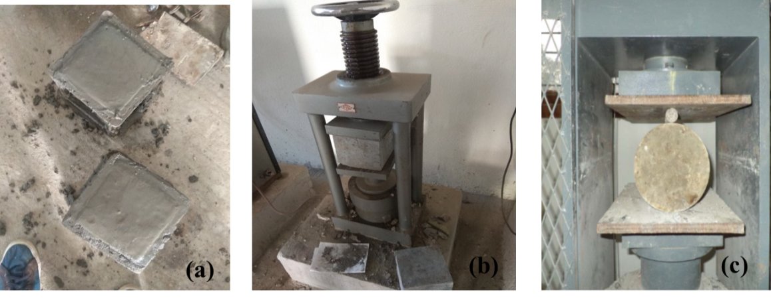
Figure 2 Experimental Setup (a. Casting b. Compressive Strength Setup c. Split Tensile Strength Setup)

- Results and Discussion
  - Workability
From the workability analysis through slump test observed that replacement of granulated coal ash with natural river sand reduced fresh concrete workability properties due to granular size of coal ash. However, partial replacement with river sand based concrete suitable for mass concrete purpose and the detailed test results shown in Table 4.
  - Compressive Strength
From the harden properties of the concrete obtained from compressive strength analysis. From Table 5 and Figure 3 observed that upto 15% of partial replacement of granulated coal ash with natural river sand able to provide target strength of the concrete mixture i.e. 31.60 N/mm² while reducing its density at the maturity of 28days.

  - Tensile Strength
From Figure 4-5 and Table 7-8 observed that partial replacement of granulated coal ash reduced its tensile strength both in split tensile strength and flexural strength. However, experimental data of 28days flexural strength compared with empirical equation (Bureau of Indian Standards, 2000) found similar in Figure 5.

Table 4 Slump Value
Replacement of FA With GCA | Slump Value (mm)
0% | 63mm
5% | 58mm
10% | 56mm
15% | 53mm
20% | 55mm
25% | 51mm

Table 5 Compressive Strength
Replacement of FA With GCA | 7days Compressive strength | Weight (kg) | 28days Compressive strength
0% | 21.773 | 8.295 | 32.88
5% | 23.33 | 8.316 | 32.59
10% | 22.22 | 8.398 | 31.92
15% | 21.48 | 8.112 | 31.70
20% | 18.14 | 7.516 | 28.74
25% | 16.89 | 7.103 | 27.56

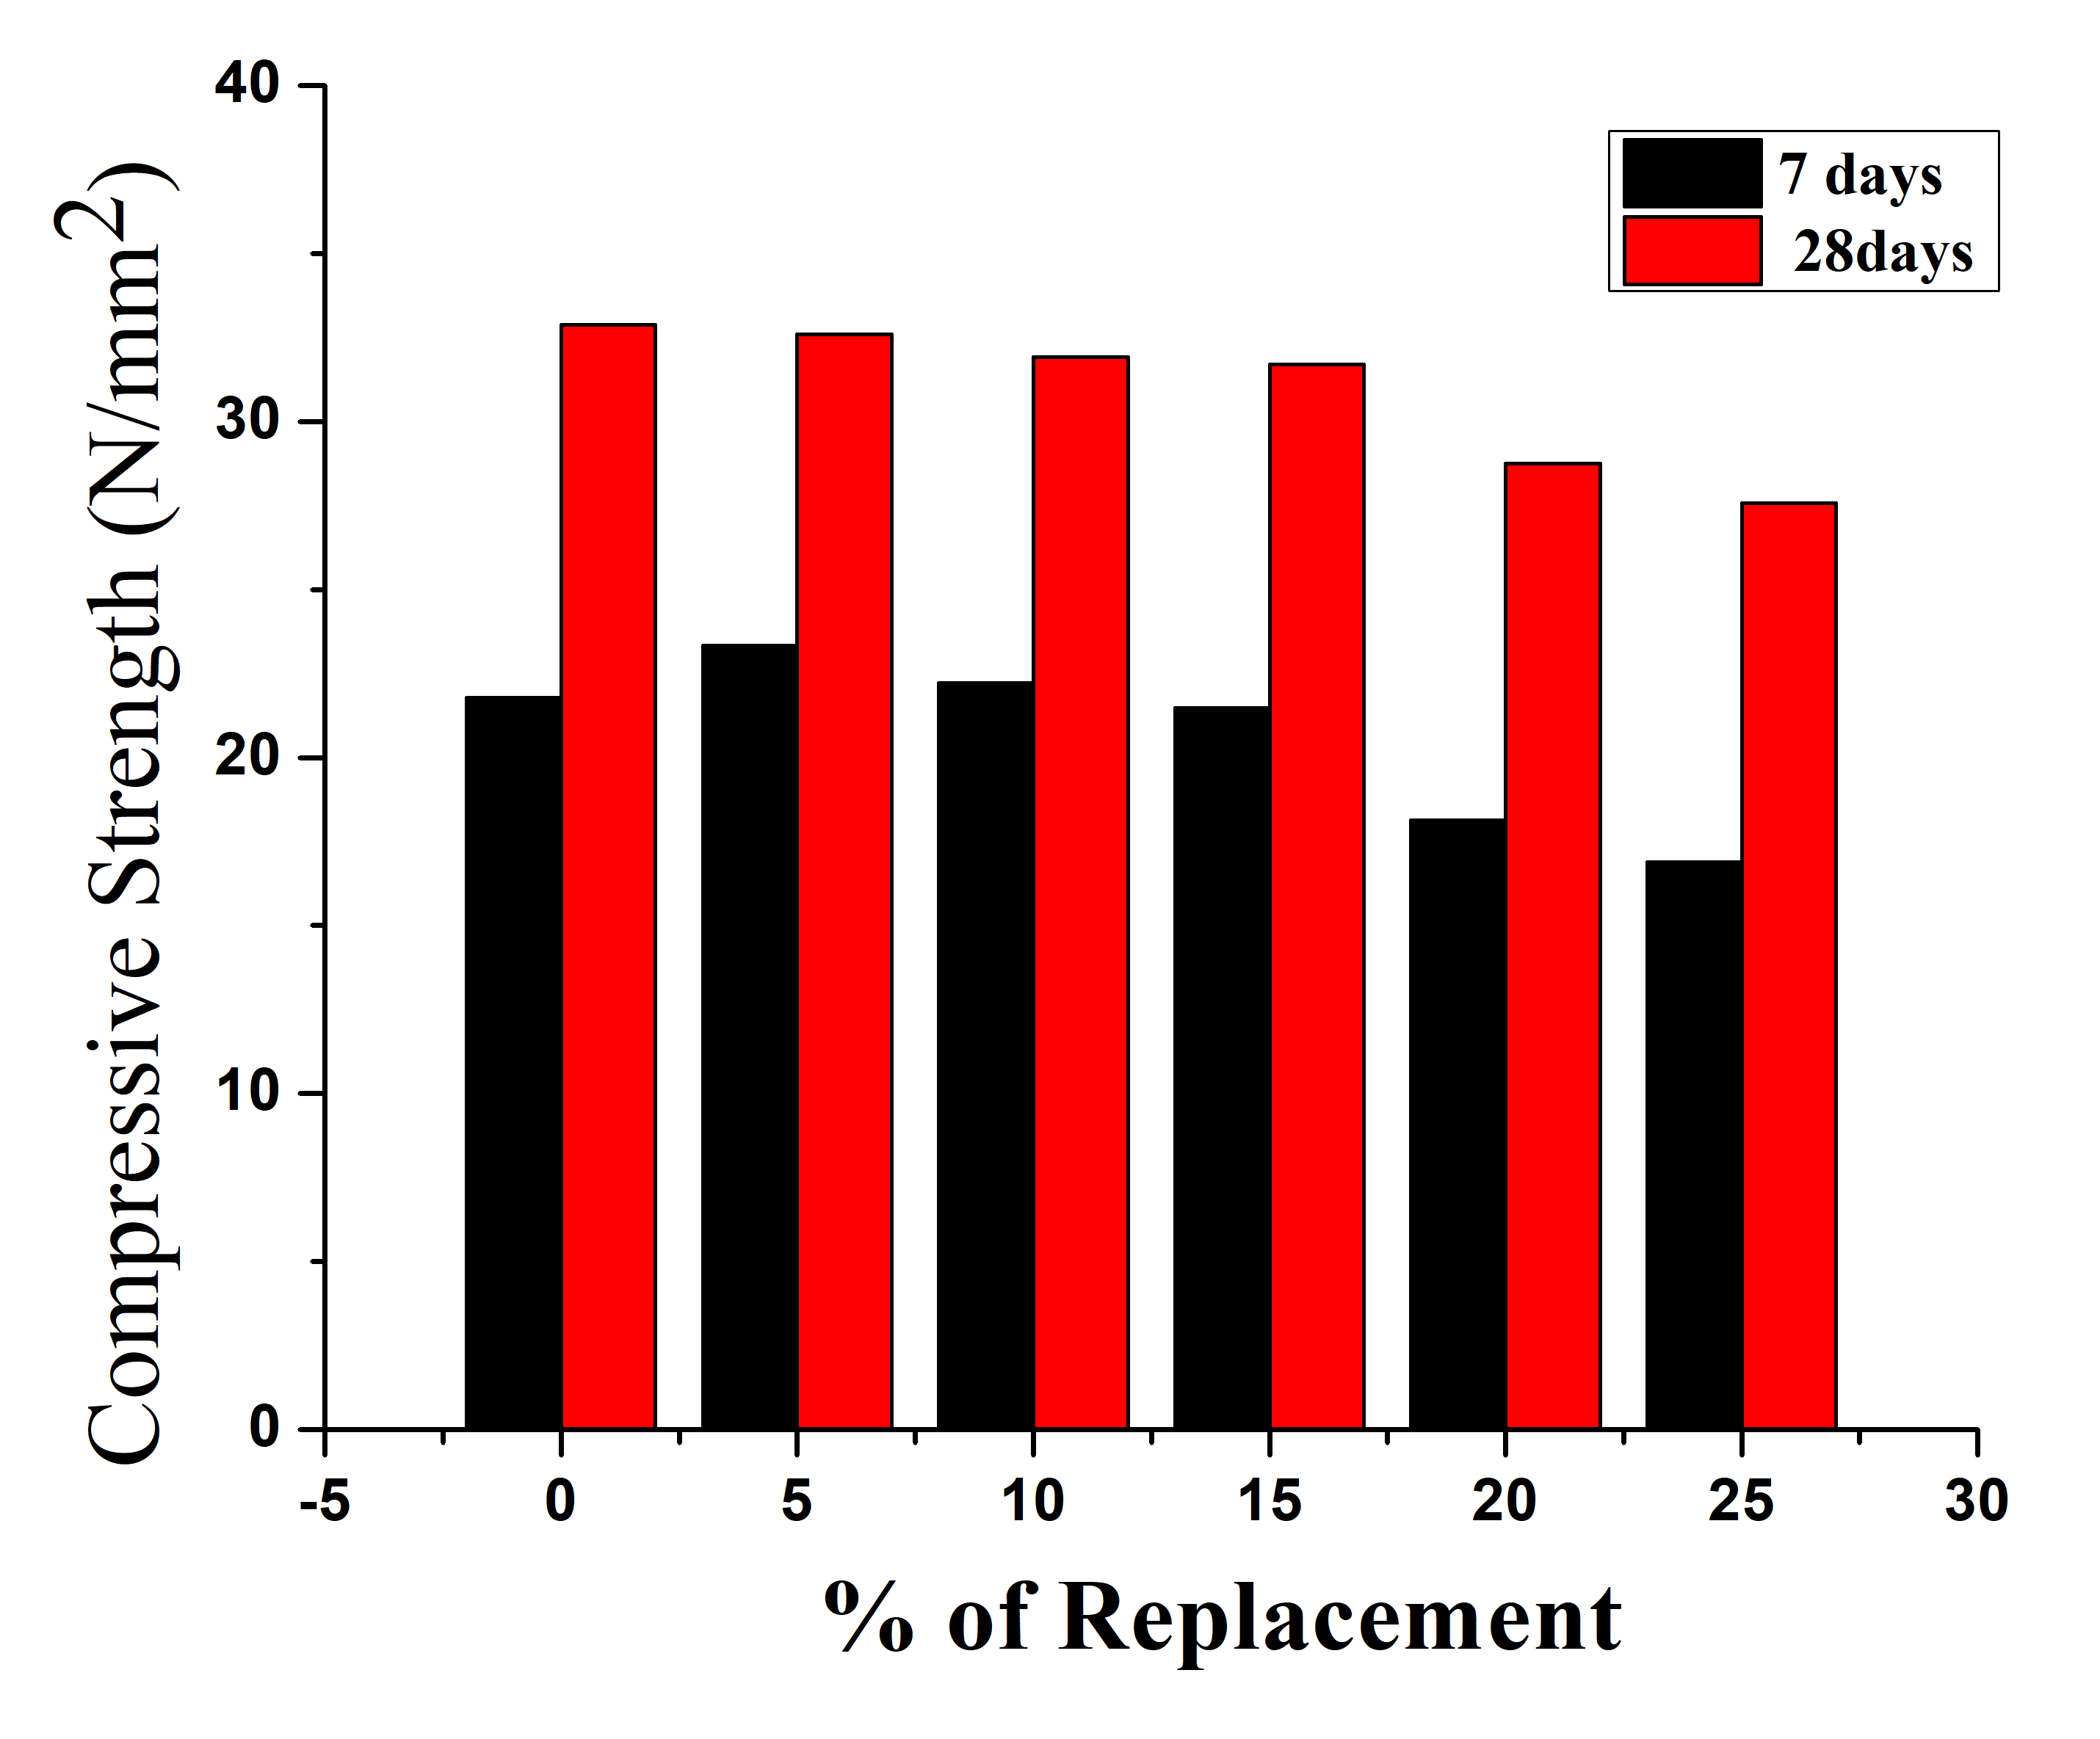
Figure 3 % of Replacement Vs Compressive Strength
Table 7 Split Tensile Strength
Replacement of FA With GCA | 7days Split Tensile Strength | 28days Split Tensile Strength
0% | 1.27 | 4.88
5% | 1.22 | 3.95
10% | 1.20 | 3.58
15% | 1.13 | 2.80
20% | 0.98 | 2.15
25% | 0.82 | 1.49

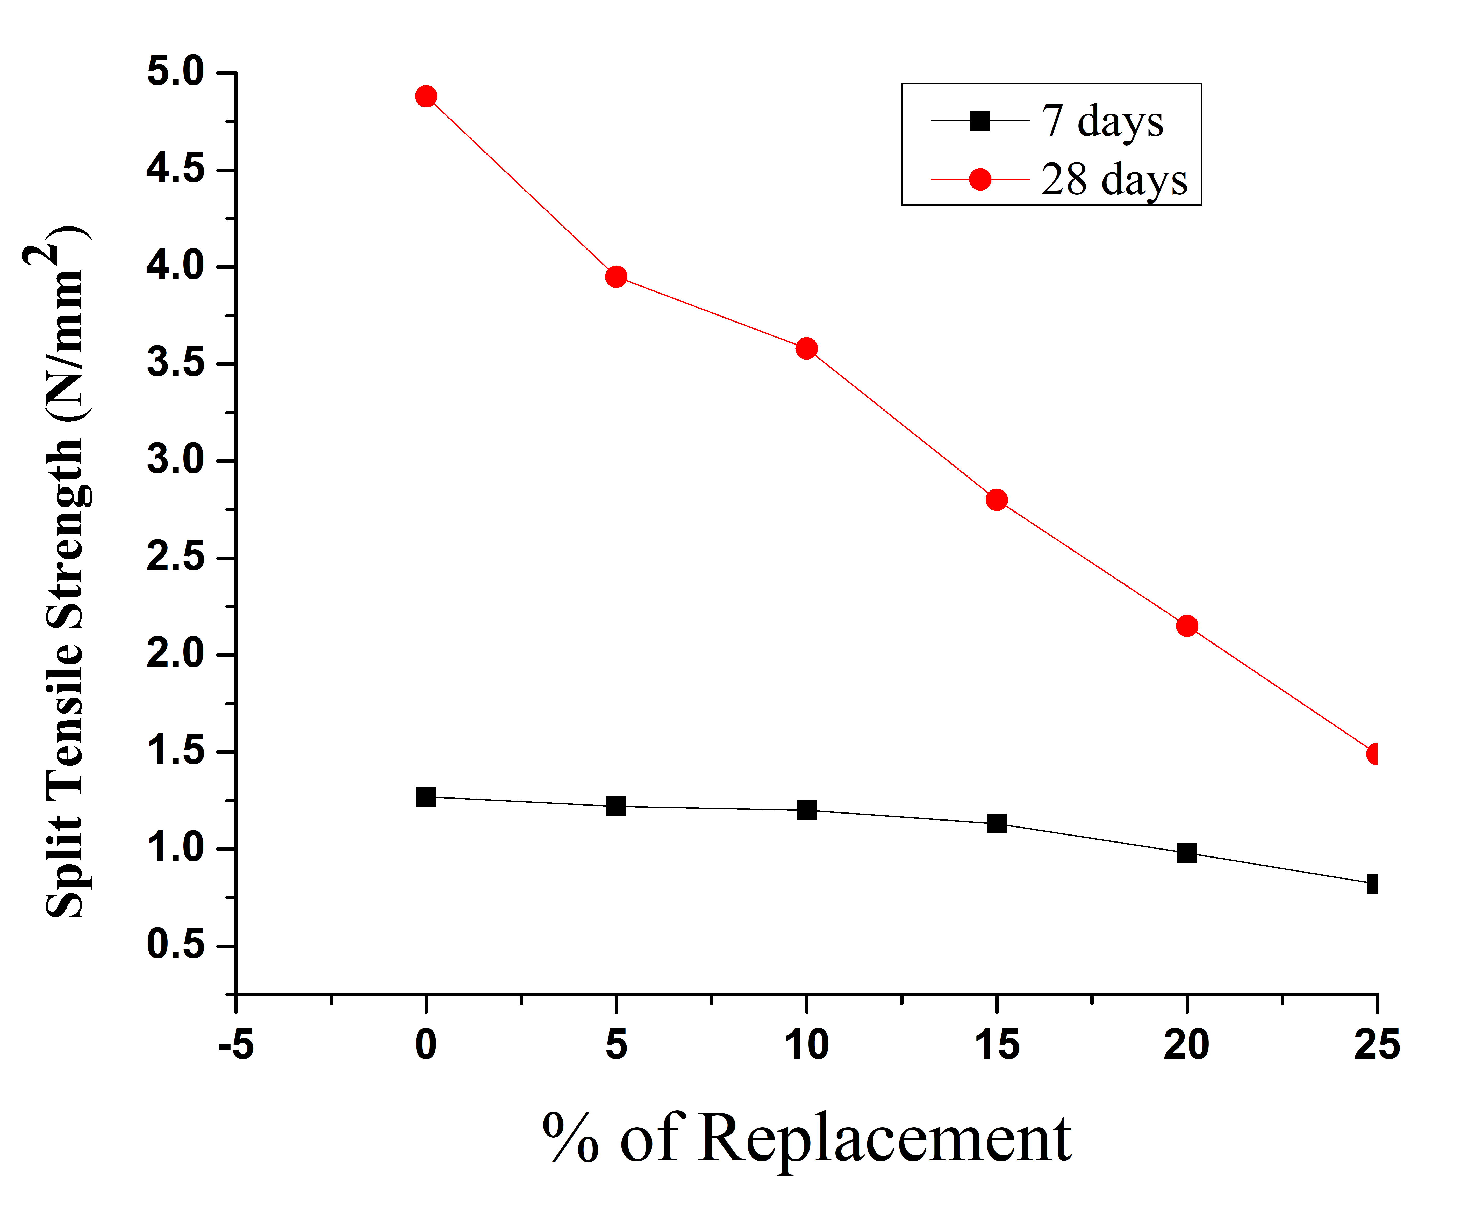
Figure 4 GCA Replacement Vs Split Tensile Strength
Table 6 Flexural Strength
Replacement of FA With GCA | 7days Flexural strength | 28days Flexural strength | Modulus of Elasticity (Bureau of Indian Standards, 2000)
0% | 3.19 | 4.44 | 4.01
5% | 3.05 | 4.03 | 4.00
10% | 2.90 | 3.97 | 3.95
15% | 2.84 | 3.94 | 3.94
20% | 2.695 | 3.705 | 3.75
25% | 2.575 | 3.549 | 3.67

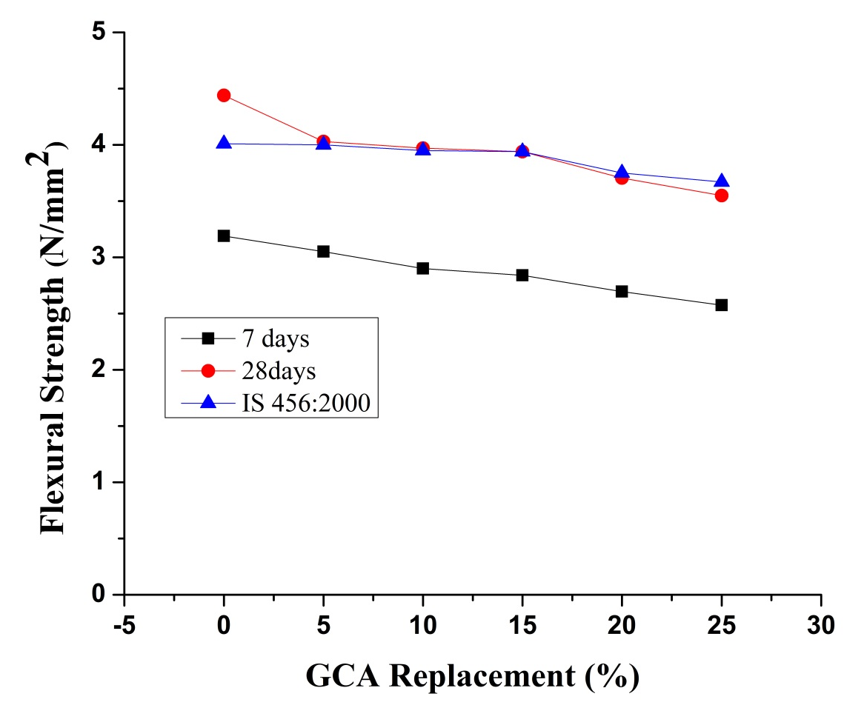
Figure 5 GCA Replacement Vs Flexural Strength
- Conclusion
From this experimental investigation concluded that partial replacement of natural river sand with granulated coal ash able to provide target compressive strength while compromising the tensile properties. Hence, it is an alternative sustainable construction material for rural region due to not only minimizes the cost of natural river sand (fine aggregate) but also reducing the self-weight of the material.

- Reference
- Aggarwal, P., Aggarwal, Y., & Gupta, S. M. (2007). Effect of bottom ash as replacement of bottom ash as replacement of fine aggregates in concrete. Asian Journal of Civil Engineering, 8(1), 49–56.
- Aramraks, T. (2006). Experimental study of concrete mix with bottom ash as fine aggregate. Symposium on Infrastructure Development and the Environment, 1–5.
- Bereau of Indian Standard. (1959). IS 1199: Indian Standard Methods of sampling and analysis of concrete.
- BIS:5816-1999. (2004). Splitting tensile strength of concrete. Bureau of Indian Standards,New Dehli.
- Bureau of Indian Standards. (1959). IS 516-1959, Indian Standard Specification for Methods of Tests for Strength of Concrete.
- Bureau of Indian Standards. (1970). IS 383-1970 Indian Standard Specification for Coarse and Fine Aggregates from Natural Sources for Concrete.
- Bureau of Indian Standards. (2000). IS 456 (2000) Indian code for recommended guidelines for Plane and Reinforced Concrete.
- Bureau of Indian Standards. (2009). IS: 10262(2009) Indian Standard recommended guide line for concrete Mix Design.
- Desai, V. B., & Sathyam, A. (2014). Some Studies on Strength Properties of Light Weight Cinder Aggregate Concrete. International Journal of Scientific and Research Publications, 4(2).
- Ghafoori, N., & Bucholc, J. (1996). Investigation of Lignite-Based Bottom Ash for Structural Concrete. Journal of Materials in Civil Engineering, 8(3), 128–137. https://doi.org/10.1061/(ASCE)0899-1561(1996)8:3(128)
- Jaturapitakkul, C., & Cheerarot, R. (2003). Development of Bottom Ash AsPozzolanic Material. Material, Journal of Materials In Civil Engineering, 48–53. https://doi.org/https://doi.org/10.1061/(ASCE)0899-1561(2003)15:1(4
- Lo, T. Y., Cui, H. Z., & Li, Z. G. (2004). Influence of aggregate pre-wetting and fly ash on mechanical properties of lightweight concrete. Waste Management, 24(4), 333–338. https://doi.org/10.1016/j.wasman.2003.06.003
- Soman, K., & Sas, D. (2014). Strength properties of concrete with partial replacement of sand by bottom ash. International Journal of Innovative Research in Technology, 1(7).
- Yüksel, İ., Siddique, R., & Özkan, Ö. (2011). Influence of high temperature on the properties of concretes made with industrial by-products as fine aggregate replacement. Construction and Building Materials, 25(2), 967–972. https://doi.org/10.1016/j.conbuildmat.2010.06.085

