FUTURISTIC TRENDS IN PHYSIOTHERAPY MANAGEMENT OF BREAST CANCER RELATED LYMPHEDEMA
Afsha Wali¹, Sahar Zaidi^{2*}, Huma Parveen¹, Adeeba Ali¹, Anam Khan¹, Asma Wali¹

Authors’ Affiliation:
¹Student Researcher, Department of Physiotherapy, Jamia Hamdard, New Delhi, India 110062
^{2,CA}Assistant professor, Department of Physiotherapy, Jamia Hamdard, New Delhi, India 110062
ORCID ID: 0000-0002-1950-1150
E-Mail ID: sahar@jamiahamdard.ac.in

ABSTRACT-

Breast cancer-related lymphedema is a chronic condition characterized by the accumulation of lymphatic fluid in the affected limb following breast cancer treatment. Physiotherapy plays a crucial role in the comprehensive management of lymphedema, focusing on reducing swelling, improving limb function, and enhancing quality of life for patients. Recent advancements in physiotherapy techniques have shown promising results in the management of this condition. These include complex decongestive therapy, manual lymphatic drainage, compression therapy, exercise programs, and patient education.
Additionally, emerging technologies such as pneumatic compression devices and laser therapy are being explored as potential adjunctive treatments. Evidence-based research has demonstrated the effectiveness of these interventions in reducing lymphedema volume, improving range of motion, and alleviating symptoms. Furthermore, advancements in tele- rehabilitation have expanded access to physiotherapy services, allowing patients to receive remote guidance and support. Overall, these recent advances in physiotherapy management hold great potential for optimizing outcomes and improving the quality of life. This chapter includes the appropriate or expected treatment for breast cancer related lymphedema and also highlights the effectiveness of various physiotherapeutic interventions on preventing post-operative complications.

INTRODUCTION

The most common malignancy among women globally, breast cancer is the second leading cause of cancer-related mortality in females. Breast cancer refers to tumors that develop in breast tissue, most frequently in the lobules that provide milk to the milk ducts or the inner lining of the ducts. Breast cancer is a metastatic disease that frequently spreads to other organs, including the bone, liver, lung, and brain.
The causes of breast cancer are as follows: previous history, significant
family history, genetic causes, hormonal, environmental causes, lifestyle and dietary causes.
The significant complications involved in breast cancer are arm lymphedema, axillary web
syndrome, radiotherapy, neurological, coagulopathic and hepatic complications.
The most dreaded post-breast cancer surgery consequence, lymphedema frequently causes functional, aesthetic, and psychological impairment in the upper limbs. Lymphedema is fluid accumulation under the skin due to insufficient lymphatic system drainage, which causes swelling in the affected area. Depending on when it develops, Lymphedema can also be categorized as acute or chronic. During breast cancer therapy, upper extremity lymphedema is a common medical consequence marked by abnormal tissue swelling in the extremity.
The sign and symptoms usually seen in breast cancer lymphedema are swelling in limbs, persistent inflammation, limited range of motion, tenderness, edema and stiffness. Various factors increase the risk of lymphedema such as lack of reconstruction, age and family, high BMI, obesity or reproductive factors.
Regular screening allows for subclinical discovery and early treatment of lymphedema, which can help stop the edema from worsening.Physicians need to have a thorough understanding of the diagnosis and severity of upper limb lymphedema in order to treat patients effectively. Medical practitioners have historically made clinical diagnoses of BCRL based on their subjective assessments of edema. Various methods included in diagnosis of lymphedema are water displacement, perometry, bioimpedance spectroscopy and computed tomography. Early detection and prevention may improve a patient’s quality of life. Precautionary recommendations for lymphedema patients include avoiding needle jabs, avoiding limb constriction, elevating the affected limb, maintaining normal body weight, and avoiding strenuous exercise.
The main objective of lymphedema treatment is to lessen edema volume and so enhance the patient's quality of life and functional abilities. Currently, BCRL can be treated surgically and non-surgically.. Deciding which approach is appropriate for an individual patient can be difficult.
Several techniques have been employed in managing BCRL by physiotherapy, with varied degrees of success. Effective treatments for BCRL include pneumatic compression, active resistive exercises with sophisticated decongestive physiotherapy, physical therapy, and low-level laser therapy (LLLT). This chapter will highlight the effectiveness of various treatments available for BCRL.

Prevalence and Epidemiology
The second greatest cause of cancer-related fatalities among women is breast cancer. In the United States, it is the second most common cancer-related death for women and the most common cancer among females globally. Breast cancer refers to tumors that develop in breast tissue, most frequently in the lobules that provide milk to the milk ducts or the inner lining of the ducts. Cancer can develop if the immune system is not functioning effectively or the number of cells created is too big for the immune system to remove. Breast cancer is a multi-step process involving various cell types, which is still challenging to prevent globally. One of the best ways to avoid breast cancer is by early diagnosis. Because of early detection, breast cancer patients' 5-year relative survival rate is above 80% in several developed nations. Breast cancer is an incurable metastatic cancer that frequently spreads to distant organs such the bone, liver, lung, and brain.

Pathogenesis of Breast cancer:
Breast tumor

Hyper-proliferation
Benign tumor/ metastatic

Neoplasm
Angiogenesis
Immune rejection
DNA methylation
Carcinogenesis

Lymphedema

Insufficient lymphatic system drainage results in lymphedema, which is an accumulation of fluid under the skin that causes swelling in the affected area.

One of breast cancer surgery's most dreaded side effects is lymphedema, which frequently causes functional, esthetic, and psychological impairment in the upper limbs.

Lymphedema is a chronic condition marked by areas of high protein content. According to reports, 0% and 77% of breast cancer patients had lymphedema. Depending on when it develops, Lymphedema can also be categorized as acute or chronic.

Acute breast cancer lymphedema typically develops three to six months after a mastectomy and manifests as a pitting, temporary, and self-limited swelling of the upper limbs.
Instead, chronic lymphedema, characterized as non-pitting upper limb edema associated with skin abnormalities and a high risk of developing ulcers and infections, is present for at least three months. According to The International Society of Lymphology Staging System, all these data prove that lymphedema is a progressive disease.

Stage 0: latent or subclinical (swelling is not yet clinically visible despite decreased lymph transport)
Stage 1: early fluid accumulation (tissue edema is clinically apparent, subsides with limb elevation, and may pit).
Stage 2: advanced accumulation of fluid(limb elevation alone rarely reduces swelling, pitting is manifest, until lately tissue fibrosis supervenes)
Stage 3 - lymphostatic elephantiasis (pitting is absent and trophic skin changes such as acanthosis and adipose hypertrophy develop). Within each stage, the severity of lymphedema can be classified based on limb volume differences.

Upper extremities lymphedema is a frequent medical complication of breast cancer treatment and is characterized by abnormal tissue swelling in the extremity.

How does lymphedema occur?
It worsens when the axillary drainage system, a part of operations or laser therapy, becomes dysfunctional. The chest, ribs, and hand are the only parts of the upper body from which lymph fluids drain to the axillary nodes.When more lymph nodes and veins are removed, this flow is more likely to be impacted, which could lead to lymphedema.

Signs and symptoms
- Ripping of tissues

- Infection

- Minimal movement

- Heaviness

- Hardness

- Tenderness

- Soreness

- Numbness
- constant swelling

- Edema

- Itching

- Stiffness

- weakened limb movements
- sensory dysfunction
- Weakness in the grip
- Acute thrombosis, low back pain, disc pain, osteoarthritis, rheumatoid arthritis, infections, or musculoskeletal diseases including adhesive capsulitis and rotator cuff illness are all examples of skin problems.

- negative effects on the patient's quality of life and body image.
- difficulty carrying out certain daily tasks, such as putting on a bra, tying shoes, shampooing one's hair, or hanging up laundry.
- Weakness and hearing loss under high doses of chemotherapy, hormone therapy, and radiation therapy.

External changes, psychological thoughts, and outward manifestations of depression, sadness, and loneliness

Risk factors –

Age

Family history

High BMI

Risk factors

Weight fluctuations Subclinical Edema
Cellulitis

- Age
- inadequate reconstruction

- Family background

- Estrogen

- Reproductive influences

- High BMI

- Weight fluctuations: Lymphedema was more likely to develop in obese women.

- Edema that is not yet clinical
- lymph nodes receive radiation therapy
- Cellulitis

Management of BCRL (Breast cancer related lymphedema)

Management of lymphedema

Medical | Conservative | surgical | physiotherapy
NSAIDS | specialized exercises | Mastectomy | LLL
Skin care | Compression garments | Lumpectomy | MLD
 | self – education |  | CDT

Conservative Treatments:

For extremity lymphedema, CDT is usually regarded as the standard first-line treatment.

It comprises self-education, skin care, specialized workouts, compression clothing, and manual lymph drainage (MLD). CDT is separated into two phases to increase its efficacy and control costs: Phase I Decongestion and Phase II Maintenance . A CDT can benefit from several things, including:
- lymphatic drainage is improved,
- and lymphedema volume, discomfort, and arm heaviness are reduced.
- a reasonable quality of life;
- and fewer cases of cellulitis

Although conservative therapy alone may be able to alleviate symptoms sufficiently, its effectiveness largely depends on patient compliance and their ability to wear compression garments for the rest of their lives.

Compression Bandages and Compression Garments:-

CDT primarily maintains the therapeutic effects of MLD by using compression bandages. Compression bandages apply (1) a resting pressure while the limb is at rest; and
(2) a working pressure when muscles contract and push the skin up against the bandages. Using multi-layered compression bandaging, low-stretch bandages create the highest working pressure.
Compressive multilayer bandaging was used to stimulate lymphatic capillaries and improve lymphatic outflow by externally increasing tissue pressure per the idea of gradually increasing compression.After the MLD application and the workout regimen, bandaging was performed every day for three weeks. A stockinette sleeve, a soft cotton wrap, gauze fingers, and two to three layers of short-stretch bandaging with varying widths, depending on the area to which it is applied, make up the compressive multilayer bandage. Before the next appointment, the bandage should be left on for 21–23 hours. Compression clothing is an important component of CDT since its objective is to sustain the volume reduction brought about by MLD and bandaging. Compression clothing causes a two-way stretch in longitudinal and transverse directions, with the greatest pressure occurring above the wrist and the least in the arm. In order to move the joints, there must be longitudinal pressure. Patients with BCRL typically wear gloves and full arm sleeves to prevent cutaneous backflow. Regarding appropriate compression levels, there is no agreement. Class 2 compression clothing with 30-40 seamless is frequently advised to be worn for at least 12 hours per day.

Exercises and Life-Style -

Both patients with a proven diagnosis of breast cancer and those who are at risk for developing lymphedema should engage in regular exercise as part of their care. This panel exhorts cancer patients to stay active, keeping daily activity during adjuvant therapy and quickly resuming daily activity after surgery.
A progressive regimen of consistent aerobic and resistance exercise is safe and does not provoke BCRL, according to numerous exercise trials in people with breast cancer.

Exercises (figure 1) are a crucial component of CDT with the goals of

- encouraging lymph flow,
- facilitating joint movement, and
- enhancing muscle strength.

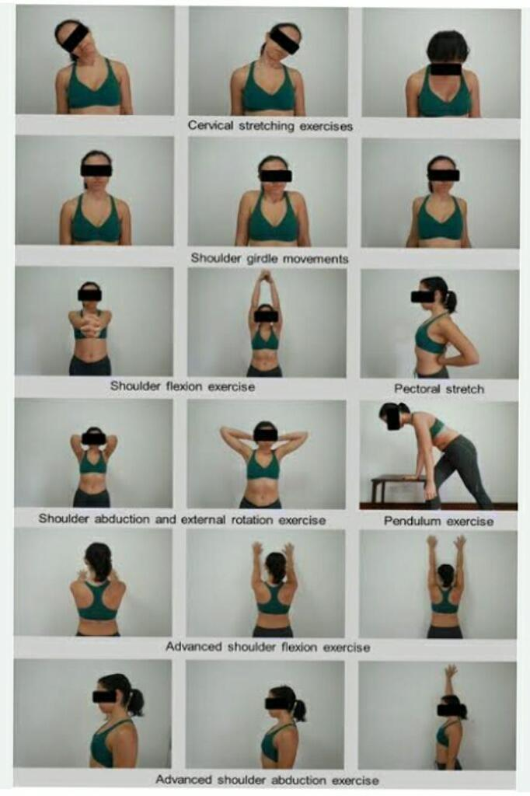
Figure 1: Exercises for Breast cancer related lymphedema

Exercise program:-Exercises for diaphragmatic breathing, posture and trapezius stretching, shoulder girdle mobilization, exercises for upper extremity range of motion, exercises for shoulder abductor and flexor strength, exercises for strengthening elbow flexors, and ball squeeze exercises were all included in the exercise programExercise involvement is known to improve physical and psychosocial circumstances, hence improving quality of life, both during and after oncological therapy.. Recent studies showed that compared to patients who do not exercise,The risk of BCRL is not made worse by a moderate weightlifting program.
Surgical Treatments:-

  - A lumpectomy (removal of the lump alone) or a mastectomy (surgical removal of the entire breast) may be necessary, depending on the size and kind of the tumorThe surgeon must confirm that the tissue removed during the operation has margins free of malignancy, suggesting that the cancer has been thoroughly excised, according to standard procedure. Additional operations to remove additional tissue may be required if the excised tissue does not have clean margins.

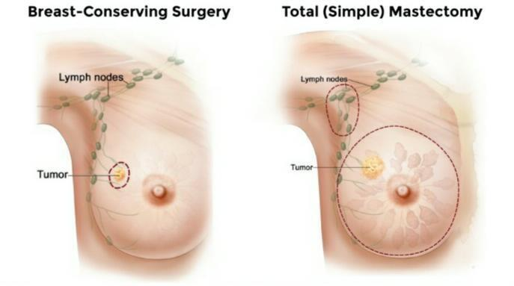
Figure 2: Surgical approaches in breast cancer

Breast-conserving surgery merely removes the tumor and a little portion of healthy tissue around it. Breast conserving surgery includes the following:

Physiotherapy Management :-

Several techniques have been used in the treatment of BCRL with physiotherapy, with varied degrees of success. The management and home maintenance phase of BCRL involves the use of compression bandages, active resistive exercise with complex decongestive physiotherapy, physical exercise (aqua lymph training, swimming, yoga, aerobics), kinesiological taping, low level laser therapy (LLLT), and advanced pneumatic compression device (APCD).
Manual Lymphatic Drainage: MLD is a specific form of massage that has been demonstrated to have a number of physiological effects.

Method: MLD is a skin massage technique that removes interstitial fluid accumulated in tissues and softens fibrotic stiffness with specific hand movements to increase lymphatic flow without increasing capillary filtration.The gentle and rhythmic movements follow the direction of lymph flow. MLD was applied to the side of the affected limb, starting with clearing the supraclavicular and axillary lymph area. The axillo-axillary and axillo-pelvic anastomoses and the lymphatics on the lateral side of the abdomen and shoulder were stimulated and progressed to the edematous limb.The massage was usually performed proximally, beginning with the upper arm and moving down to the axilla before moving to the finger, hand, elbow, and shoulder. With just enough pressure to move the skin's surface, MLD was carried out utilizing a delicate, sweeping motion.

Low – level laser therapy:-

Low level laser therapy (LLLT), often called photobiomodulation (PBM) therapy, has recently gained attention as a non-pharmacological treatment option for BCRL. LLLT (PBM) is a non-invasive type of phototherapy.It uses light with wavelengths between 650 and 1000 nm to modulate biological processes in the target tissue with minimal irradiance. It has been determined that LLLT (PBM) is a safe procedure. LLLT (PBM) has been demonstrated to help lower inflammation, encourage lymph vessel regeneration, enhance lymphatic motility, and prevent tissue fibrosis in several experimental trials.

The nonionizing light-based conservative therapy known as low-level laser therapy has been used to treat lymphedema in breast cancer patients. In laser or photo-biomodulation therapy (PBM), photons of a specific wavelength (650 nm and 1000 nm) penetrate skin tissue to provide low rays and dosages to the targeted location. It has been put in place to prevent tissue stiffness and promote lymphatic fluidity, redness, and lymph vessel repair.

On the other hand, the crucial method for using LLLT (PBM) involves biochemical alterations at the cellular level.

During the course of the therapy, changes are made to lymphocytes, smooth cells, fibroblasts, and osteoblasts.

LLLT has received a lot of attention. It has been used to treat a number of illnesses, including musculoskeletal problems and lymphedema.

Complex decongestive therapy :-

The most frequent therapy, CDT, includes compression therapy, manual lymphatic drainage (MLD), therapeutic exercise, and skin care.
Although CDT is the most frequently utilized treatment for lymphedema, it has been noted that combining methods results in a more thorough and effective course of care. The quality of life for breast cancer patients who have lymphedema can be improved by effective therapy.
There are two phases to CDT:
The skin care, manual lymphatic drainage (MLD), exercises, and compressive multilayer bandaging are all part of the first phase of CDT. The second phase, which includes skin care, remedial exercise, a compression sleeve, and, if necessary, light massage, attempts to safeguard and maximize the results made in the first phase.
It has been demonstrated that CDT, MLD, and bandaging can all reduce lymphedema.

CONCLUSION-

There are various levels of evidence supporting physiotherapy intervention for BCRL. There is compelling evidence to justify the diminution in arm volume caused by Low level laser treatment (LLLT), Kinesiotaping Exercise and (KT). The following moderate evidence indicates Active resistance training is a further strategy, along with compression bandaging for minimizing lymphedema pressure. The residential phase of treatment for the arm with persistent lymphedema uses the Advanced Pneumatic Device for Compression (APCD, Flexi touch) system. There is substantial proof for recommending manual lymphatic drainage, intermittent pneumatic and (MLD) PC compression is effective for treating lymphedema.

References-

- Sharma GN, Dave R, Sanadya J, Sharma P, Sharma K. Various types and management of breast cancer: an overview. Journal of advanced pharmaceutical technology & research. 2010 Apr 1;1(2):109.
- Sun YS, Zhao Z, Yang ZN, Xu F, Lu HJ, Zhu ZY, Shi W, Jiang J, Yao PP, Zhu HP. Risk factors and preventions of breast cancer. International journal of biological sciences. 2017;13(11):1387.
- Cho Y, Do J, Jung S, Kwon O, Jeon JY. Effects of a physical therapy regimen combined with manual lymphatic drainage on shoulder functionality, quality of life, the occurrence of lymphedema, and pain in breast cancer patients with axillary web syndrome following axillary dissection. Cancer Supportive Care.2016 May;24:2047-57.

- Senkus-Konefka E, Jassem J. Complications of breast-cancer radiotherapy. Clinical Oncology. 2006 Apr 1;18(3):229-35.
- Caine GJ, Stonelake PS, Rea D, Lip GY. Coagulopathic complications in breast cancer.

Cancer: Interdisciplinary International Journal of the American Cancer Society. 2003 Oct 15;98(8):1578-86.
- Pereira S, Fontes F, Sonin T, Dias T, Fragoso M, Castro-Lopes JM, Lunet N. Neurological complications of breast cancer: a prospective cohort study. The Breast. 2015 Oct 1;24(5):582-7.
- Diamond JR, Finlayson CA, Borges VF. Hepatic complications of breast cancer. The lancet oncology. 2009 Jun 1;10(6):615-21.
- Martin TJ, Moseley JM. Mechanisms in the skeletal complications of breast cancer.

Endocrine-Related Cancer. 2000 Dec 1;7(4):271-84.

- Miccinilli S, Bravi M, Maselli M, Santacaterina F, Morrone M, Manco D, Toglia R, Sterzi S, Bressi F. The effectiveness of extracorporeal shock wave therapy on breast cancer-related lymphedema: A literature review. Lymphology. 2020;53(3):118-35.
- Mahmood D, Ahmad A, Sharif F, Arslan SA. Clinical application of low-level laser therapy (Photo-biomodulation therapy) in the management of breast cancer-related lymphedema: a systematic review. BMC cancer. 2022 Aug 30;22(1):937.
- Sayegh HE, Asdourian MS, Swaroop MN, Brunelle CL, Skolny MN, Salama L, Taghian AG.Breast cancer-related lymphedema: past, present, and future directions in terms of diagnostic techniques, risk factors, prevention, and management. current reports about breast cancer. 2017 Jun;9:111-21.
- Pappalardo M, Starnoni M, Franceschini G, Baccarani A, De Santis G. Recent updates on diagnosis, severity, and therapy for breast cancer-related lymphedema. Journal of Personalized Medicine. 2021 May 12;11(5):402.
- Taghian NR, Miller CL, Jammallo LS, O’Toole J, Skolny MN.Review of the effects of lymphedema after breast cancer treatment on quality of life. Review articles in oncology and hematology. 2014 Dec 1;92(3):227-34.
- Temur K, Kapucu S. The effectiveness of lymphedema self-management in the prevention of breast cancer-related lymphedema and quality of life: A randomized controlled trial. European Journal of Oncology Nursing. 2019 Jun 1;40:22-35.
- Ahmed RL, Prizment A, Lazovich D, Schmitz KH, Folsom AR.The Iowa Women's Health Study: Lymphedema and quality of life among breast cancer survivors. In the Journal of Clinical Oncology. 2008 Dec 12;26(35):5689.
- Sen EI, Arman S, Zure M, Yavuz H, Sindel D, Oral A. Manual lymphatic drainage may not have an additional effect on the intensive phase of breast cancer-related lymphedema: a randomized controlled trial. Lymphatic Research and Biology. 2021 Apr 1;19(2):141-50.
- Merchant SJ, Chen SL. Prevention and management of lymphedema after breast cancer treatment. The breast journal. 2015 May;21(3):276-84.
- Dudhagara RK, Jagad K.An evidence-based study on the management of breast cancer-related lymphedema by physical therapy. Journal of Health Sciences and Research International. 2020;10(2):162-5.
- Baxter GD, Liu L, Tumilty S, Petrich S, Chapple C, Anders JJ, Laser Lymphedema Trial Team. Low level laser therapy for the management of breast cancer‐related lymphedema: A randomized controlled feasibility study. Lasers in surgery and medicine. 2018 Nov;50(9):924-32.
- Hemmati M, Rojhani-Shirazi Z, Zakeri ZS, Akrami M, Salehi Dehno N. The effect of the combined use of complex decongestive therapy with electrotherapy modalities for the treatment of breast cancer-related lymphedema: a randomized clinical trial. BMC Musculoskeletal Disorders. 2022 Dec;23(1):1-8.

