Low-Profile Dual-Band Filtering Patch Antenna and its LTE band and ISM band Applications
Ch. Pavan Kumar V.M.S.N. *¹, H.D. Praveena ², G Ramakrishna Prasad³, S Harichandra Prasad⁴
Assistant Professor^{1,} Dept. of ECE, Bapatla Engineering College, Bapatla, India.
Assistant Professor^{2,} Dept. of ECE, Mohan Babu university, Tirupathi, India.
Associate Professor^{3,} Dept. of ECE, KLEF Deemed to be university, Vijayawada India.
Associate Professor⁴, Dept. of ECE, Adithya Engineering College, Kakinada, India

Abstract: This paper introduces a compact dual-band filtering patch antenna element and demonstrates its suitability for two specific frequency bands: LTE (Long Term Evolution) in the L-band and ISM (Industrial, Scientific, and Medical) band in the S-band. The proposed design comprises two distinct U-shaped patches, with a smaller patch nested within a larger one. To achieve dual-band resonance, a multi-stub microstrip feed line is employed, allowing independent control of the resonant modes of both patches and the feed line. This flexibility enables precise tuning of the antenna's operating frequencies.
In this study, we implement a low-profile dual-band antenna element operating at 1.9GHz (LTE band) and 2.4GHz (WLAN), which is subsequently simulated and validated using the FEKO Tool. It's worth noting that this design can be adapted for different frequency ranges and applied to various wireless communication applications.
Keywords: Patch antenna, Feed Scheme, Low-profile, Dual-band, Filtering, and FEKO Tool.
A.INTRODUCTION
Antennas capable of operating at two distinct frequencies have become indispensable in modern wireless communication systems. This need arises in various applications, including GPS and GSM services that function across two separate frequency bands. In the realm of satellite communication, antennas with a low frequency ratio are particularly crucial.

One solution to achieve dual-frequency capability is the utilization of a dual-frequency patch antenna featuring an inset feed. This antenna configuration yields a dual-frequency response, with both frequencies sharing the same polarization orientation and maintaining a low frequency ratio. Additionally, this design exhibits reduced sensitivity to the positioning of the feed, enabling the utilization of an inset planar field.

In the RF front end, two paramount passive components are microwave filters and antennas. Typically, antennas and microwave filters are custom-designed separately and interconnected using transmission lines. This approach results in increased losses and larger circuit dimensions. However, integrating these two passive elements harmoniously serves to diminish impedance mismatches, minimize losses, reduce overall size, and consequently, enhance the system's overall performance.

This integrated solution yields a multifunctional module capable of simultaneously performing radiation and filtering functions. Such integration is also pursued to effectively manage bandwidth, effectively shaping the frequency response of the system.
In certain design scenarios, supplementary filtering circuits are incorporated into the antenna feeding networks, resulting in additional insertion loss and a decline in antenna gains. Addressing this issue, the concept of filtering antennas without the need for extra filtering circuits has been introduced in reference [3]. Nevertheless, it's important to note that the filtering antennas discussed in the aforementioned reference are limited to single-band operation.

Recent developments have seen the emergence of dual-band filtering antennas, as discussed in references [4] through [6]. In reference [4], a dual-band antenna and filter are initially designed as separate entities, which are subsequently combined to create a dual-band antenna-filter module. Meanwhile, reference [5] introduces two dual-band planar filtering antennas. In [4], the dual-band capability is achieved using a rectangular patch that generates two orthogonal polarizations at the two desired bands, whereas in [5], the TM10 and TM30 modes of the patch are harnessed to enable dual-band operation. However, it's worth noting that the operating frequencies of these antennas cannot be adjusted independently.
In reference [6], a U-slot patch antenna is seamlessly integrated with a dual-mode stub-loaded resonator through electromagnetic coupling, achieving commendable performance, including harmonic suppression. Nevertheless, this design employs a 2-layer PCB structure and falls short of meeting the low-profile requirement
This article introduces an innovative approach to double band filtering using a patch antenna with a unique power supply. The antenna design features two distinct U-shaped patches and a multi-stub microstrip feed line, with the smaller patch nested within the larger one to conserve space. When the antenna operates in the lower band, the smaller patch remains dormant, effectively serving as an impedance matching circuit between the feed structure and the larger patch. Interestingly, the feed structure exhibits the capability to support two resonant modes, allowing precise control over the frequencies of the two operating bands by manipulating the modes of both patches and the feed structure.
B.ANTENNA ELEMENT MECHANISM
MICROSTRIP ANTENNA DESIGN
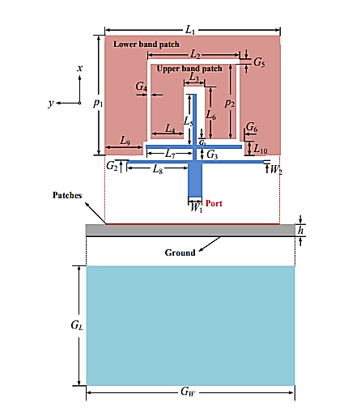
Fig1. Geometry of the Dual-Band filtering patch antenna

Figure 1 illustrates the layout of the dual-band filtering antenna. This antenna configuration comprises two distinct U-shaped patches and a multi-stub feed line. It is constructed on an RT/Duroid 5880 substrate, characterized by a relative permittivity of 2.2 and a thickness of 1.575 mm. Specifically, the larger U-shaped patch operates within the lower frequency band, while the smaller U-shaped patch serves the upper frequency band. To reduce overall size, the smaller patch is nested within the larger one, and both are fabricated on the top layer of the substrate, with the ground plane printed on the substrate's bottom layer.
Table1. List of dimensions of patch
L1 | 63.4 | L9 | 11.1
L2 | 35.6 | L10 | 2
L3 | 7.6 | G1 | 0.7
L4 | 13.7 | G2 | 0.6
L5 | 28.9 | G3 | 1.2
L6 | 30.2 | G4 | 0.3
L7 | 19.8 | G5 | 2.6
L8 | 27.3 | G6 | 2.8
W1 | 4.7 | W2 | 1
P1 | 49.95 | P2 | 40.03
G_{L} | 80 | G_{W} | 100

ANTENNA CONFIGURATION:
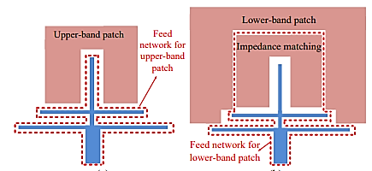
Fig 2. Feed scheme of the antenna

As depicted in Figure 2, a multi-stub microstrip line configuration is employed, comprising a primary transmission line and two transverse stubs. This arrangement serves to feed the inner U-shaped patch, which operates within the upper frequency band. Notably, the outer patch does not emit radiation but instead functions as a load-bearing element. In the context of the lower frequency band, both the multi-stub feed line and the inner patch work in conjunction to feed the outer patch. In this scenario, the inner patch does not resonate but serves as an impedance matching circuit bridging the multi-stub feed line and the outer patch.
Significantly, since the two U-shaped patches and the feed structure can be configured separately, the operational frequency bands can be finely adjusted independently. Parameter L7 and P2 modifications allow precise control over the upper frequency band, while fine-tuning of the lower frequency band can be achieved by adjusting parameters L8 and P1. Importantly, these adjustments exert minimal influence on the upper frequency band, making the antenna design process considerably more convenient and flexible.
The formulas for calculating the width (W) and length (L) of patch antennas, as well as the effective relative permittivity (εᵣ) for microstrip patch antennas, typically depend on the desired resonant frequency (fᵣ) and the speed of light (c) in free space. These formulas are fundamental in microstrip patch antenna design and can be expressed in (2.1) – (2.5)
W = $\frac{c}{2*fr}$*$√\frac{2}{εr+1}$ ------------------------(2.1)
L_{eff} = $\frac{C}{2*fr*√εreff}$ -----------------------(2.2)
ε_{reff} = $\frac{εr+1}{2}$+$\frac{εr-1}{2}$(1+12×$\frac{h}{w}$)^{-1/2}-----------(2.3)
∆L=0.412×h×($\frac{ϵreff+0.3}{εreff-0.258}$)×$(\frac{\frac{w}{h}+0.264}{\frac{w}{h}+0.8}$) ----(2.4)
L=L_{eff} – 2*∆L -----------------------(2.5)
Where, w is the width of the patch;
L_{eff} is the effective length of the patch;
ꜫ_{reff} is the effective relative permittivity;

∆𝐿 is the length extension;

L is the actual length of Microstrip patch antenna.

Case (i) deals with the dimensions regarding with lower band patch i.e, the one operating at resonant frequency of 1.8 GHz.
Width of the patch, W1 = 65.88 mm
Length of the patch, p1 = 55.56mm
Case (ii) deals with the dimensions regarding with upper band patch i.e, the patch operating at resonant frequency of 2.4 GHz.
Width of the patch, W2 = 49.41 mm
Length of the patch, p2 = 41.36 mm
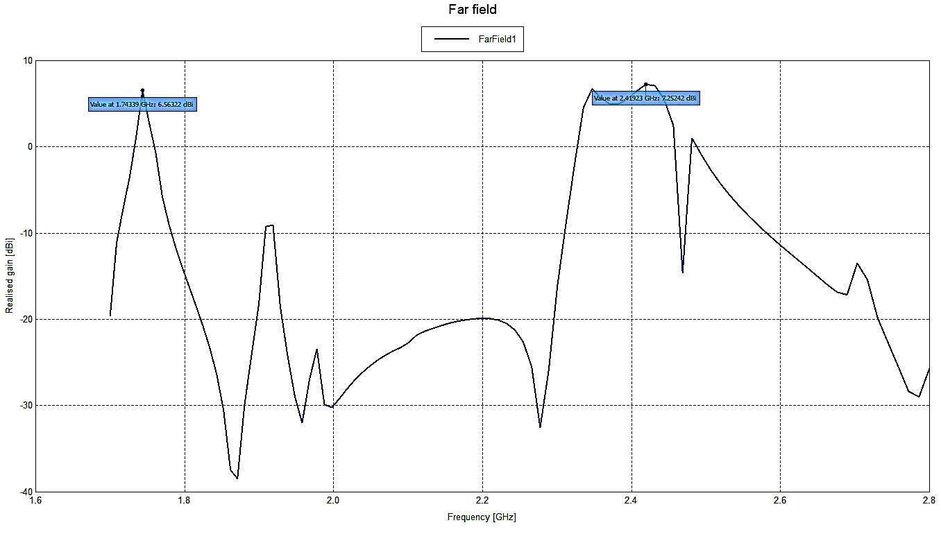
DUAL-BAND FILERING ANTENNA ELEMENT DESIGN USING FEKO TOOL
FEKO TOOL:
FEKO stands as a resilient 3D simulation software package meticulously crafted to tackle a diverse range of electromagnetic complexities. Its utility extends across an expansive spectrum of disciplines and predicaments, encompassing EMC analysis, microstrip antenna and dielectric circuit design and analysis, scattering analysis, and cable modeling.
SIMULATED RESULTS OF MICROSTRIP PATCH ANTENNA:
TOTAL GAIN:
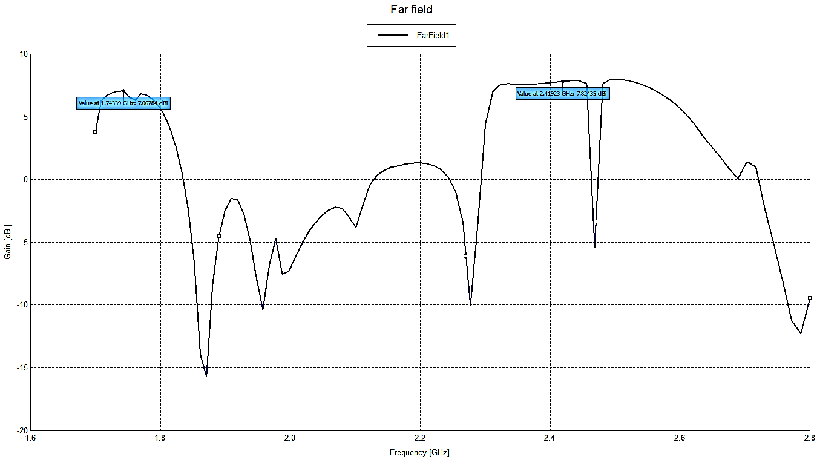
Fig 3. Total gain of microstrip antenna

The power gain, or commonly known as "gain," of an antenna serves as a critical performance metric that blends the antenna's directivity with its electrical efficiency. Typically, antenna gain is quantified as the ratio between the power emitted or received by the antenna when aligned with a distant source within its main beam and the power that would be generated by an idealized, lossless isotropic antenna. This hypothetical isotropic antenna exhibits equal sensitivity to signals arriving from all directions.

Realized gain:
In accordance with IEEE Standard 145-1993, Realized Gain deviates from the previously mentioned gain definitions by accounting for "reductions caused by losses resulting from the mismatch between the antenna's input impedance and a specified impedance." As depicted in Figure 4, it's worth noting that Realized Gain consistently falls short of the standard Gain due to this impedance mismatch-induced loss.
Fig 4. Realized gain of microstrip antenna
RADIATION PATTERNS:

In the realm of antenna design, the concept of a radiation pattern, also known as an antenna pattern or far-field pattern, pertains to the directional (angular) variation in the intensity of radio waves emanating from the antenna or another radiation source. To ascertain the far-field pattern of an antenna, experimental measurements are often conducted at an antenna range. Alternatively, advanced computer programs like FEKO, as depicted in Figure 5, can calculate the far-field radiation pattern based on the antenna's geometric configuration.
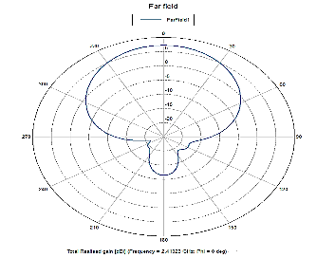
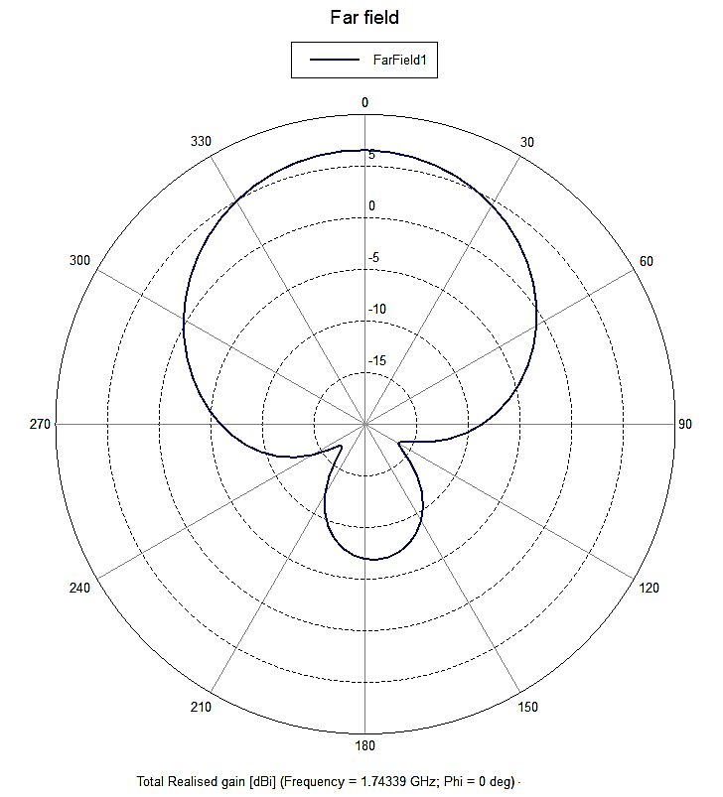
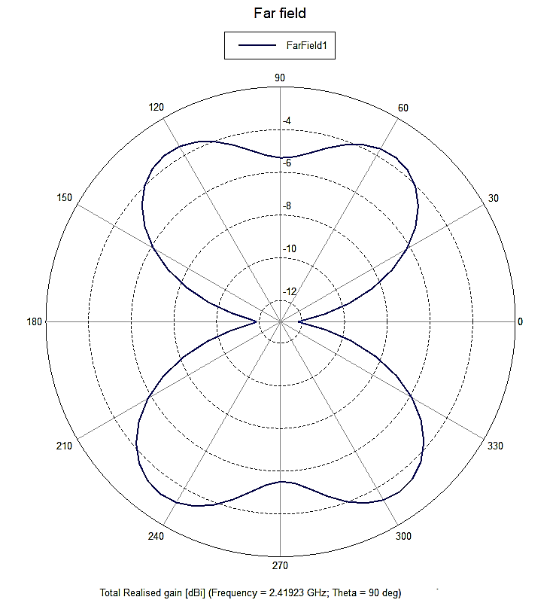
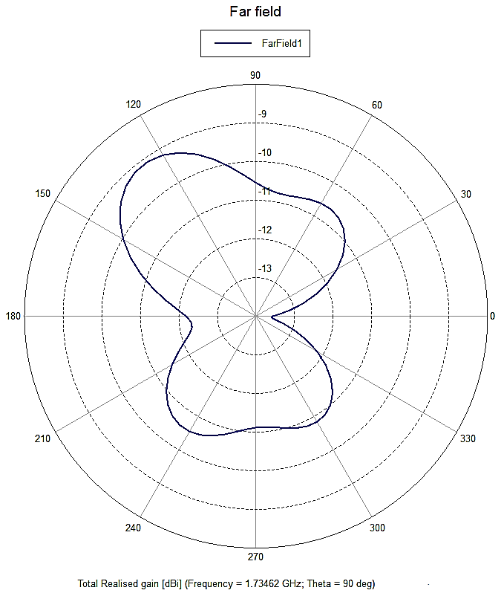

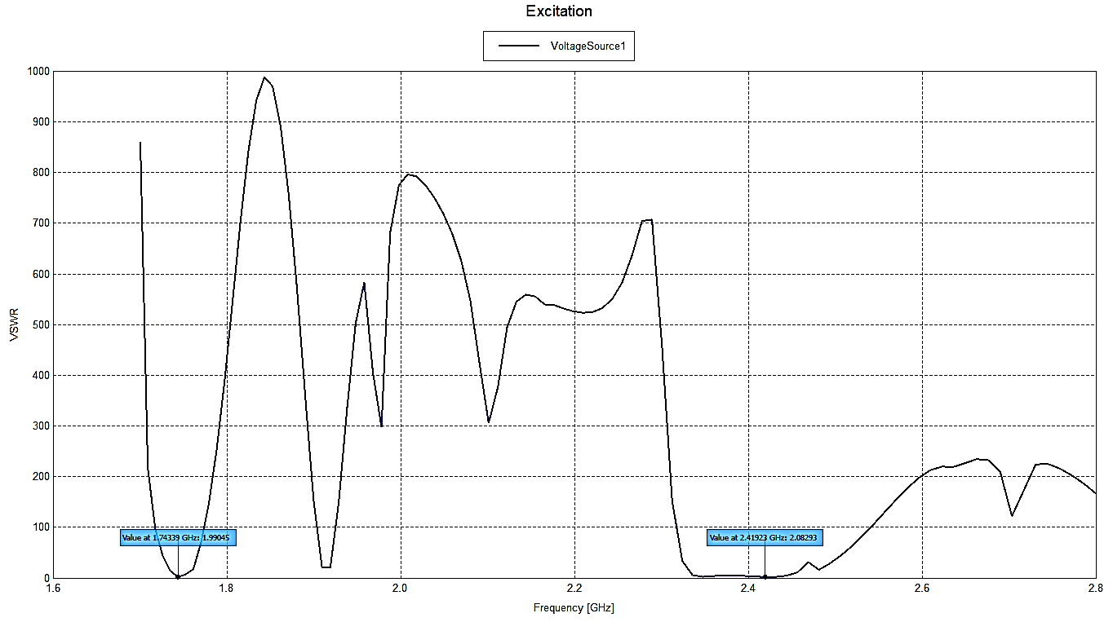
Fig 5. Radiation patterns of microstrip antenna
Current Distribution:
Current flowing in the patches gives an idea about how the electric charges are flowing in the patch and where the maximum current is flowing. In the Fig. 6 and Fig. 7, the current flowing patterns are observed at the resonant frequencies.
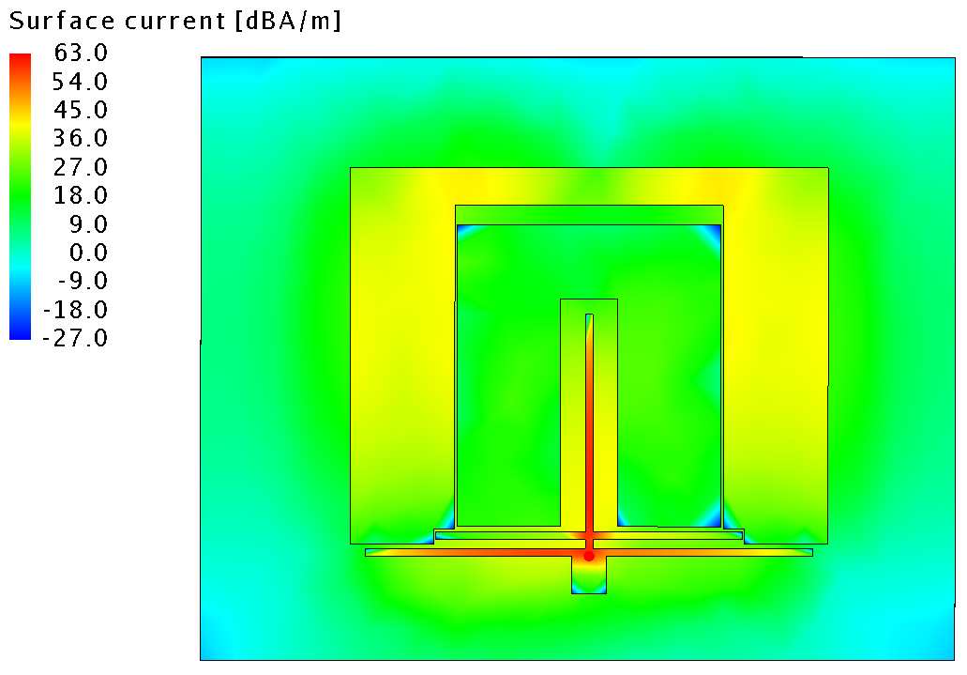
Fig:6 Current distribution at 1.74GHz
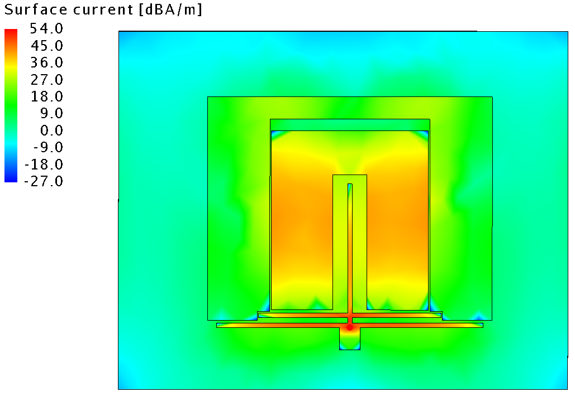
Fig 7: Current distribution at 2.41 GHz
If we observe the current flow in Fig 6 at 1.74 GHz the current flow is more in outer patch when compared to the inner patch. In the same fashion, in Fig 7, the current flow is more in Inner Patch than it is in Outer patch. This explains the filtering property of the designed antenna.
VSWR:
The Standing Wave Ratio (SWR) quantifies the efficiency with which RF power is transferred from the power source through the transmission line and into the load.
Fig 8: VSWR of microstrip antenna
The value of VSWR should be less than or around 2. Higher the value of VSWR, more power will be reflected into the transmission line.

CONCLUSION
A low profile Dual-Band antenna is proposed which operats in LTE band (L-Band) and in ISM band (S-band) for WiFi application. The proposed antenna consists of two separate patchs embedded in one another for size reduction and these patches are excited by multi-stub feed line. The feed structure provides two resonant modes and the these resonant frequencies can be altered by varying the feed structure i.e, length of inner patch for upper frequency translation and varying length of outer patch lower frequency can be altered. The main advantage of this design is low profile and insertion loss of the feeding circuit is negligible.

REFERENCES:
- X. Y. Zhang, Y. Zhang, Y. M. Pan and W. Duan,"Low –Profile Dual-Band Filtering Patch antenna and Its Application to LTE MIMO System," in IEEE Transactions on Antennas and Propagation, vol. 65, no. 1, pp. 103-113, Jan. 2017.
- Dipali S. Yeole, Uday Pandit Khot “Reconfigurable Multiband Microstrip Patch Antenna Design for Wireless Communication Applications,” IEEE International Conference On Recent Trends In Electronics Information Communication Technology, May 20-21, 2016, India.
- X.-Y. Zhang, W. Duan, and Y.-M. Pan, “High-gain filtering patch antenna without extra circuit,” IEEE Trans. Antennas Propag., vol. 63, no. 12, pp. 5883-5888, Dec. 2015.
- D. Zayniyev, and D. Budimir, “Dual-band microstrip antenna filter for wireless communications,” in IEEE Int. Symp. Antennas and Propagation Digest, 2010.
- Y.-J. Lee, G.-W. Cao, and S.-J. Chung, “A compact dual-band filtering microstrip antenna with the same polarization planes,” in Proc. Asia-Pacific Microw. Conf., 2012, pp. 1178-1180.
- C.-X. Mao, S. Gao, Y. Wang, B. Sanz-Izquierdo, Z.-P. Wang, F. Qin, Q.-X. Chu, J.-Z. Li, W.-Gao, and J.-D. Xu, “Dual-band patch antenna with filtering performance and harmonic suppression,” IEEE Trans. Antennas Propag., In press.
- Yiping Zang, Sen Yang, Dan Feng, Chuanhan Zhan and Huiqing Zhai, “Varactor-tuned dual band filter-antenna for wireless applications,” 2016 Asia-Pacific International Symposium on Electromagnetic Compatibility (APEMC), Shenzhen, 2016, pp. 794-796.
- N. A. Murad, M. Esa and S. Tukachil, “Microstrip U-shaped dual-band antenna,” 2005 Asia-Pacific Conference on Applied Electromagnetics, pp. 110–113, Dec. 2005.
- B.Tlili, “Design of C-Slot Microstrip Patch Antenna for WiMax Application,” Loughborough Antennas & Propagation Conference, pp. 521-524, Nov.2009.
- Ramesh Garg, "Microstrip Antenna Design Handbook", Prakash Bhartia Publications, 2000 Edition.
- Yassin, R. A. Saeed and R. A. Mokhtar, "Dual-Band Microstrip Patch Antenna Design Using C-Slot for Wi-Fi and WiMax Applications," 2014 International Conference on Computer and Communication Engineering, Kuala Lumpur, 2014, pp. 228-231.

