Evaluation of Germinated Rice Seed using Convolutional Neural Network

Hema Rajini N
Department of Computer Science and Engineering, Alagappa Chettiar Government College of Engineering and Technology,
Karaikudi – 630003, Tamilnadu, India
auhemasmith@yahoo.co.in

ABSTRACT
Rice is the most important cultivated crops in all over the world particular in Asian countries. The germination of good seed has a great impact in the production of rice and crop yield. Presently the evaluation of seed to be germinated is processed manually by experienced farmer which is a time consuming and tedious task and most importantly it is a destructive method where the rice seed are destroyed by fungus contamination. In our work we proposed a non destructive evaluation of germinated rice seed system based on machine learning. We develop a convolution neural network for classification and segmentation of germinated rice seed. The performance of CNN classification model is shown to be better than the existing SVM classification technique.
Keywords – Seed Germination, Preprocessing, segmentation, classification, SVM, CNN

- INTRODUCTION

Agriculture is the most widespread occupation in the world in which rice is the important agricultural product. The grade of the rice depends on the grade of the seed which is the important factor for successful farming. But it is hard to determine the standard of rice seeds only by using normal vision. The key to successful farming is selection of good seed, so the evaluation of the seed grade is the milestone in the agriculture. Germination Test is one of the seed quality evaluation methods that play an important role in the farming of cereals, vegetables, fruits and specifically rice where the crop production depends on good seed. Hence, it is vital to standardize the quality of rice in order to fix best price in the market. The germination test is the well known indication method for evaluating quality of seed. The seed manufacturers make use of germination process to predict the grade of seed and farmers also using germination process to estimate the quantity of seeds required per area. The cost of farming is significantly reduced by using high germination rated seed, since it reduces the quantity of seeds required per area.
Conventionally the rate of germination is evaluated by spreading the seed on the clammy towel and following 7 days the seed which are developed are numbered, this amount is the germination count of the sample. So as to get high precise esteem, this procedure is repeated with the substantial number of seeds. There are 3 principle complications with this customary assessment technique. The primary issue is tallying, the evaluator must number the seed twice (when germinated), if mistake occurs in this step the blunder will gets doubled. The following issue is the grouping mistake, the evaluator should clearly classify the germinated and un-developed seed and this step requires professional evaluators. The last issue is the evaluator should utilize an immense number of seeds to get highly precise yield which is a tedious procedure.
To wipe out the above discussed issues, the image processing based programmed assessment of germination was proposed. This exploration plans to apply the seed germination test from the International Seed Testing Association with the highest point of paper technique for rice germination. In addition these images are gathered to anticipate rice seed image by utilizing image processing strategies which can recognize the nature of seeds.

- RELATED WORKS

The target of this exploration is to build up the machine learning system which can anticipate rice seed tiny images for rice germination by utilizing image processing strategies. Paween K [1] put the first milestone in image processing based evaluation of rice seed germination by utilizing high definition digital camera to pick the images of rice, root and seed portions to segment the germinated seed. Thuy Thi Nguyen et al [2] proposed machine learning approach for segmenting and classifying germinated rice seed using convolutional neural network. The framework of this paper has three modules whose performances are better than the existing classification methods.
Anisur Rahman et al [3] made a review on several non destructive method of evaluating the germination of seed. These methods can accurately assess the quality of seed. Phan Thi Thu Hong et al [4] developed a computer based automatic classification of seed using powerful classifiers for analyzing color, shape and texture. Hai Vu et al [5] presented an automatic extraction of unwanted seed using hyper spectral image captured from IR camera. The author used SVM classifier for efficient result compared to visual inspection method. M. S. Howarth [6] provides an accurate measurement of growth rate using vision based technique. The growth rate was measured for a complete germination cycle and was compared with traditional growth rate evaluation method.
C. Pornpanomchai [7] combines digital image processing with artificial neural network to predict the germination of rice seed. The system utilized non destructive image processing and ANN for prediction of germination. Olaf Ronneberger et al [8] presented CNN and its training methods for augmenting data from the available samples. The context capturing and localization enables the proposed method to perform in a best way. Kaiming He et al [9] developed residual learning approach for training the samples more easily than the existing methods. This method is easy to optimize and increases the accuracy. Paul Viola et al [10] proposed face detection mechanism that can process at extremely high detection rate. The integral image allows the detector to compute in a fast manner. An AdaBoost learning method is used for efficient classification.
Nobuyuki Otsu [11] discussed an unsupervised nonparametric automatic threshold selecting technique to enhance the separation in grey level histogram. This is a direct method for multiple threshold related problem. P. P. Belsare et al [12] made a research to analyze the seed using automatic seed quality technique. M. Jedra et al [13] utilized speech recognition tolls such as TDNN and TOM for recognizing seed varieties from 1-D electrophoresis. A high recognition rate can be achieved by ensuring the arrangements of gels. Yingrak Auttawaitkul et al [14] applied transparent image processing to identify the seed class. Histogram based color separation is done through frequency light shine. S. Khunkhhett et al [15] presented non destructive evaluation of rice seed using image processing. This automatic classification approach uses segmented image and its feature for better result in classification.

- PROPOSED METHOD

We approach the evaluation of rice seed germination classification by using CNNs. The convolutional neural system (CNN) has a feed-forward counterfeit neural system (ANN), which is fundamentally the same as conventional neural systems. The CNN is an outstanding profound learning design in which single neuron is tiled so that it can react to covering areas in the visual fields. CNNs are an essential class of learnable portrayal applications and they were motivated by natural neural systems. Various variations have been proposed over most recent quite a long while. Be that as it may, the essential segments are fundamentally the same as. CNNs comprise of substituting convolution, pooling and fully connected tasks. Regularly, the convolutional layers are sprinkled with pooling layers to diminish calculation time, and develop further spatial and setup invariance; the last couple of layers (near the yields) will be completely associated 1-dimensional layers.
In the classification of germinated seed evaluation with the proposed CNN architecture, the basic steps (Pre-processing, training, Activation function selections, Regularizations and Ensemble the multiple methods) are used to achieve maximum accuracy from the images. The block diagram of proposed method is given in Figure 1.

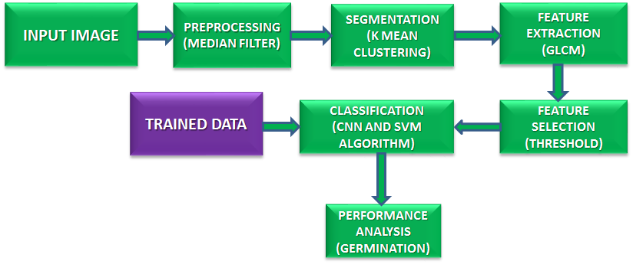
Figure 1: Block diagram of proposed method

Initially the process starts with taking out germinated seed images as input. After loading the image it will go for preprocessing steps. The features can be extracted from germinated part of the seed as shown in Figure 2.

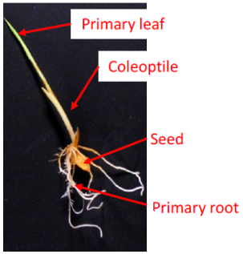
Figure 2: Components of germinated rice seed

It is followed by classification part where it will classify whether the image is proliferative or non proliferative germinated seed image or linger seed image. The program is created utilizing Math works MATLAB programming which it is introduced in a Graphical User Interface. The ideas of Digital Imaging are covered in the accompanying digital image, image pre-processing, image analysis and classification.

- Preprocessing by median filter
The convolutional neural system takes a shot at spatial information of the germinated seed image. An essential advances associated with the preprocessing is resizing the pictures. Prior to nourishing into the engineering for grouping, convert the pictures in to dim scale. And afterward, convert in to the L demonstrate. It is a Monochrome picture which is utilized to features the germination of rice seed. Also, straighten the pictures in single dimensional for handling further.
Pseudo Code
Pre process Image (A, X)
X= required size
A= image
Source: Original JPG image
Output: Pre-processed HSV image
Steps involved in preprocessing:
Step 1: for each Image X
Step 2: do
Step 3: Transform X to hsv format
Step 4: Add dark border of size 1x1 pixel
Step 5: Fuzz A to 10%
Step 6: Trim A
Step 7: Re page A
Step 8: Assume gravity centre for the image A
Step 9: Re-size X
Step 10: Dark background A
Step 11: Close loop
Step 12: Return A

Median Filter
A median filter is said to be median smoother is a non linear order statistics filter that utilizes sliding window where the value of the centre pixel alone is changed in every iteration. The filtered rice image R = R(x, y) obtained from median filter is expressed by

$R \left(x,y\right)={median}_{(k, l)∈W_{h, w}}\left\{D (x+z, y+l)\}\right.$ (1)

Where Wh, w is the sliding window.
The median filter can reduce the noise interference at the cost of change in the smooth pixel value. The median filter can arranges the samples in ascending or descending order but takes long time for computation when number of sample is large. This drawback is minimized by using indirect arrangement procedure where the local histogram is used for calculating median value. The time needed to generate local histogram is minimized by sliding window approach.
An image sensor color camera with high resolution of pixels and long photographic lens is utilized to acquire images without distortion. A chamber is made with a black table as background for taking images. Rice seeds are manually spread on the table. The first step of the image processing is the transformation of the color images picked up by a camera into HSV format. Then by using median filter the dark pixels are eliminated according to equation (2)
$Fg_{HSV}\left(x, y\right)= \left\{\begin{aligned}Im_{HSV}\left(x, y\right);where Im_{V}\left(x, y\right) > θ_{f} \\ 0 ;others\end{aligned}\right.$ (2)
where 𝐼𝑚𝐻𝑆𝑉 is the source image in HSV color space, 𝐼𝑚𝑉 is a V channel of 𝐼𝑚_{𝐻𝑆𝑉} , 𝜃𝑓 is the minimum brightness of the image and 𝐹𝑔_{𝐻𝑆𝑉} is the segmented image in HSV format.

- Segmentation using K-means clustering algorithm
This algorithm is used to partition a set of data into groups based on specific distance measurement. The images are the important source for communicating informations. The extraction of informations plays a vital role in machine learning. Basically the clusters are not hierarchical and do not overlaps each other. All the members of a cluster are closer to its group only and do not centered on other clusters. K-means clustering is an unsupervised learning approach that is ease to implement hence finds application in data mining, feature recognition and analysis and segmentation of images.
The k-means clustering algorithm detects a set R of K clusters R_{j} with cluster mean r_{j} to reduce the sum of square of the error. It is described as
$E= \sum_{j=1}^{k}{\sum_{X_{i}ϵC_{j}}{{∥C_{j}-X_{i}∥}^{2}}}$ (3)
where W is the sum of the square of the error of cluster mean. The above equation is the distance measure between data point X_{i} and cluster mean c_{j}. The Euclidean distance is expressed as
$∥x-y∥ = \sqrt{\sum_{i=1}^{V}{{|x_{i}-y_{i}|}^{2}}}$ (4)
The cluster means C_{i} is the vector defined as
$C_{j}= \frac{1}{C_{j}}\sum_{i∈C_{j}}{X_{i}}$ (5)
Algorithm steps
1: arbitrarily choose k as center of cluster
2: Assume initial value for cluster means
3: repeat above two steps till long changes disappears in cluster
4: for i= 1 to n do
5: let each data point x_{i} to cluster C_{j}
6: end
7: for j= 1 to k do
8: re-evaluate cluster mean c_{j}
9: end
10: return C
In order to segment the root and coleoptiles the segmentation method is used to images that contain root and seed. The hue and saturation are used to extract root and coleoptiles images by locating the white color pixels. The segmentation of root and coleoptiles are given in below equation.
$Root \left(x, y\right)= \left\{\begin{aligned}1 ; where θ_{r1 }<Fg_{s}\left(x, y\right) > θ_{r2} \\ 0 ;others\end{aligned}\right.$ (6)
where 𝐹𝑔_{𝑆} is a saturation channel of seed image, 𝜃𝑟₁ and 𝜃𝑟₂ are threshold value and 𝑅𝑜𝑜𝑡 is the binary image contained only root part.

- GLCM based Feature Extraction
Basically Feature Extraction is used to reduce the amount of pixels needed to describe a huge set of data. It is a general form for developing combination of variables with sufficient memory requirement, low power and satisfying accuracy. The extraction of textual features plays an important role in pattern recognition and image processing. GLCM extracts second order textual features which are used in various applications. GLCM is a matrix whose number of columns and rows is equal to number of grey level in the images. Thus GLCM find the relation between reference pixel and neighboring pixel and presents the distance and spatial relation in the sub region of an image.
The features such as energy, inertia moment, entropy and correlation are considered for implementation.

- Energy
The image homogeneity is measured by the sum of square of second order moment. When pixels are same or when images are homogeneous, the energy or second order moment is also high.

$Energy= \sum_{i=0}^{N_{g}-1}{\sum_{j=0}^{N_{g-1}}{P_{i j}^{2}}}$ (7)
where N_{g} is grey tone

- Inertia moment
It represents the local homogeneity and will be high for uniform grey level and high inverse GLCM. Its weight value is the inverse of the weight of contrast.
$IM= \frac{\sum_{i=0}^{N_{g}-1}{\sum_{j=0}^{N_{g-1}}{P_{i j}}}}{1+ {(i-j)}^{2}}$ (8)

- Entropy
It is the amount of information in the compressed image. It measures the loss of information in the transmitted message.
$Entropy= \sum_{i=0}^{N_{g}-1}{\sum_{j=0}^{N_{g-1}}{P_{i j}}*log⁡(P_{i j})}$ (9)

- Correlation
The linear dependencies of the grey level of neighbor pixels are measured by correlation.
$Correlation= \frac{\sum_{i=0}^{N_{g}-1}{\sum_{j=0}^{N_{g-1}}{\left(i j\right) P_{i j}-μ_{x}}μ_{y}}}{σ_{x}σ_{y}}$ (10)

- CNN Classification
Basically image classifications are of two types supervised and unsupervised. In supervised learning approach the training parameters are created by analyzing the features of training data. Depending on these training parameters, the data will get classified. CNN comes under supervised learning method. CNN works like feed forward ANN which is inspired by the neurons in the brain. It is a deviation of multilayer perceptron which requires less preprocessing technique and are easier to train. Figure 3 shows the layers of CNN.
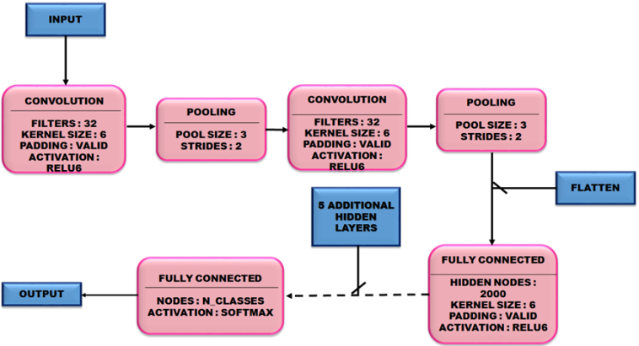
Figure 3: CNN architecture

- Training phase
In the training stage the inputs of the CNN are preprocessed by the training data. The inputs (Figure 4) go on iteratively through all layers (convolutional, pooling and fully connected) to identify the features in the image. The layers in each stage will identify the best features which are required for the classification using feature maps. There must be at least 6 layers to get the model. When the number of layers increases the training stage will be more and more efficient. About 9 convolutional layers, 8 pooling layers and 2 fully linked layers are combined in the present paper. This combination will make the technique to work more accurately and efficiently. The images are easily classified with these numbers of layers.
- Convolutional layers
The overall block of CNN is convolutional layer. This phase consists of filters and these filters have small reception fields. In each of forward pass, it will generate a 2D map of corresponding filter by evaluating the dot product between input and filter entries. From this the network will study about the filters which are activated when specific feature at specific spatial position occurs. The dimensional depth with activation map of each filter will generate the complete output volume of convolutional layer.
$X_{j}^{l}=f\left(\sum_{i∈M_{j}}{X_{i}^{l-1}*K_{ij}^{l}+ b_{j}^{l}}\right)$ (11)

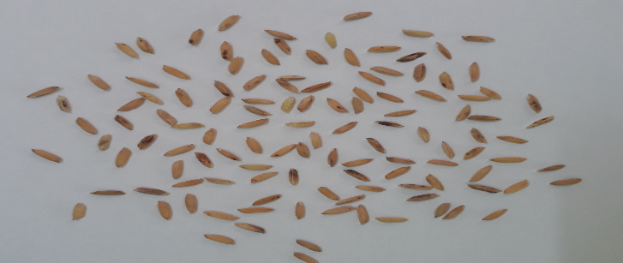
Figure 4: Input Rice image

- Pooling layers
Pooling means non linear sub sampling. The pooling layers are realized by the most common non linear function. The max pooling layer segment the input picture into sum of non overlapping squares and the layer will give the maximum in each sub region. The rough locations relative to other features are found once the features are identified. The intermediate spatial representation of dimension will be reduced by max pooling without affecting the volume of the dimensionality depth. Pooling layers are injected in between convolutional layers.

- Fully connected layers
The fully linked layers perform the high level reasoning of a neural network. This layer links all the neurons of the previous layers (convolutional or pooling or connected). The activation function is computed by a matrix multiplication and then a bias offset is added. This fully connected layer converts the 2D features into 1D feature. The mathematical representation of the convolution layer is expressed as

$Y_{i}^{l}=f\left(z_{i}^{l}\right)$ (12)

with $z_{i}^{l}=\sum_{j=1}^{m_{i}^{l-1}}{w_{i,j}^{l}}y_{i}^{l-1}$ (13)

Image classification using CNN is used in the task of classification of germinated rice seed in this work. The entire rice seed images are used as the dataset and scanned by the unit function. As we are using supervised learning, we need both training and test dataset. In training phase, we need to do some pre-processing steps. Figure 5 shows the workflow of the present work.
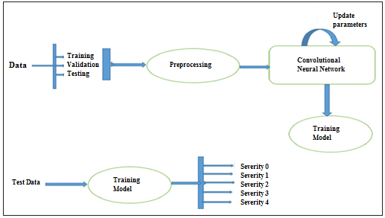
Figure 5: Workflow

As we are using CNN algorithm, only a little preprocessing is needed. Here, only resizing the images and rotation is sufficient. Rotating image in 45°C, 90°C, and 180°C should be done. These rotations will add more images to the training dataset which helps to get an efficient training model. After pre-processing step, the pre-processed dataset will be given to the CNN algorithm.
Consider we are having N*N squared neuron layer and followed by convolutional layer. The filter which we are using is m*m one which is ω. Then the outcome of the convolution layer is of the size (N-m+1)*(N-m+1). To get the non-linearity input, we have to sum up the output from the previous layer which is represented by x^{l}_{x y}.
$X_{x y}^{l}=\sum_{a=0}^{m-1}{\sum_{b=0}^{m-1}{ω_{ab}y_{\left(x+a\right)\left(y+b\right)}^{l-1}}}$ (14)

Then the nonlinearity of the convolution layer is
$y_{ij}^{i}=σ\left(X_{ij}^{l}\right)$ (15)
In addition to sum up the weights, we have to propagate errors back to the previous layers. We use chain rule for finding the errors and propagating it back.

- Testing phase
During testing, the model will find the features of images and classifies according to it. The algorithm will first classify whether the rice seed is germinated or not. If the seed is germinated, then it will check the evaluation level of the seed. The output (Figure 6) for this will be the seed’s germination level. Now, from this output, action can be taken based on the evaluation levels.

- SIMULATION RESULTS

In the detection of germinated rice seed, the training model has 9 classes. The classes are ordered as class 1, class 2, and class 3 up to class 9. Class 9 is the image of the most completely germinated seed. The effectiveness of the proposed method is tested and verified using Matlab simulation environment. Performance comparison and seed classification by the proposed method are given in Table 1 and 2 respectively.
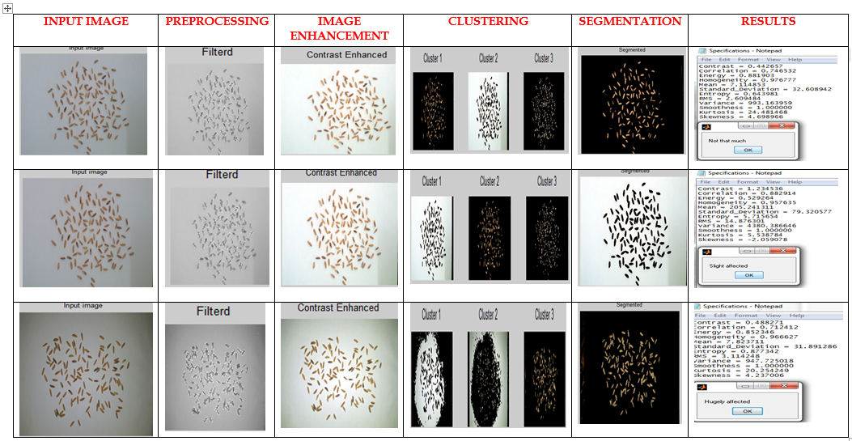
Figure 6: Output at each step in the proposed algorithm

Table 1: Performance comparison
Method Used | Precision (%) | Recall (%) | Fscore (%)
Proposed CNN method | 94.76 | 92.12 | 93.26
SVM classifier method | 57.4 | 63.8 | 61.5

Table 2: Seed classification by the proposed method
 | Precision (%) | Recall (%) | Fscore (%)
Non germinated seed | 90.17 | 45.52 | 59.6
Germinated seed | 97.48 | 99.67 | 98.23

- CONCLUSION

A new approach for evaluation of germinated rice seed is proposed in this paper. The seeds with primary root, coleoptiles and primary leaf are extracted in the HSV color format. This method evaluates the seed count and separates them as germinated or not germinated. The seeds those have roots are treated as germinated. The result of the proposed CNN technique is compared with SVM. The accuracy of our method in seed count is 97.48 % ± 2.52. This method helps farmer in reducing counting time and arranges the germinated rice seed.

REFERENCES

[1] Paween Khoenkaw, “An image-processing based algorithm for rice seed germination rate evaluation,” in 2016 International Computer Science and Engineering Conference (ICSEC), Dec 2016, pp. 1–5.
[2] Thuy Thi Nguyen, Van-Nam Hoang, Thi-Lan Le, Thanh-Hai Tran, Hai-Vu, “A vision based method for automatic evaluation of germination rate of rice seeds,” 1st International Conference on Multimedia Analysis and Pattern Recognition, 2018
[3] A. Rakhman and B.K. Cho, “Assessment of seed quality using nondestructive measurement techniques: A review,” Seed Sci. Res., vol. 26, pp. 285 – 305, 2016.
[4] P. T. T. Hong, T. T. T. Hai, L. T. Lan, V. T. Hoang, V. Hai, and T. T. Nguyen, “Comparative study on vision based rice seed varieties identification,” in 2015 Seventh International Conference on Knowledge and Systems Engineering (KSE), Oct 2015, pp. 377–382.
[5] H. Vu, C. Tachtatzis, P. Murray, D. Harle, T. K. Dao, T. L. Le, I. Andonovic, and S. Marshall, “Spatial and spectral features utilization on a hyper spectral imaging system for rice seed varietal purity inspection,” IEEE RIVF International Conference on Computing Communication Technologies, Research, Innovation, and Vision for the Future (RIVF), Nov 2016, pp. 169–174.
[6] P. C. S. M. Scott Howarth, “Measurement of seedling growth rate by machine vision,” pp. 1836 – 1836 – 10, 1993.
[7] B. Lurstwut and C. Pornpanomchai, “Image analysis based on color, shape and texture for rice seed germination evaluation,” Agriculture and Natural Resources, 2017
[8] O. Ronneberger, P.Fischer, and T. Brox, “U-net: Convolutional networks for biomedical image segmentation,” in Medical Image Computing and Computer-Assisted Intervention (MICCAI), ser. LNCS, vol. 9351. Springer, 2015
[9] K. He, X. Zhang, S. Ren, and J. Sun, “Deep residual learning for image recognition,” CoRR, vol. abs/1512.03385, 2015
[10] P. Viola and M. J. Jones, “Robust real-time face detection,” International Journal of Computer Vision, vol. 57, no. 2, pp. 137–154, May 2004.
[11] N. Otsu, ''A threshold selection method from gray-level histograms," IEEE Transaction on Sys., Man., Cyber, Vol. 9, pp. 62-66, 1979.
[12] P. P. Belsare, S. k. Shah, “Evaluation of seeding growth rate using image processing,” IEEE International conference on computational intelligence and computing research, 2013
[13] M.Jedra, N. El Khattabi, M. Limouri, A. Essaid, “Recognition of seed varieties using neural networks analysis of Electrophoretic images,” IEEE International Joint Conference on neural networks, 2000.
[14] Yingrak Auttawaitkul, Sermsuk Buochareon,Thongchai Maneechukate and Natthawud Dussadee, “Non-destructive Identification of Breeder Rice Seed Using Transparent Image Analysis,” International Conference on Information and Communication Technology, Electronic and Electrical Engineering (JICTEE-2014)
[15] S. Khunkhett, T. Remsungnen, “Non-destructive identification of pure breeding rice seed using digital image analysis,” International Conference on Information and Communication Technology, Electronic and Electrical Engineering (JICTEE-2014)

