SERICULTURE
SAMPAD BHUYAN, BARSHA PRIYADARSHINI, PRIYANKA PRIYADARSHNI, AKANKHYA MOHAPATRA
Corresponding author: priyankapriyadarshini63@gmail.com
PG STUDENT OF C.V. RAMAN GLOBAL UNIVERSITY, BBSR, INDIA 752054

ABSTRACT: Sericulture, the art of silk farming that embraces a prominent place in human history, dating back thousands of years. This practice involves the cultivation of silkworms and the extraction of their precious silk threads, which have been respected for their elegant properties and luxurious cultural significance.
The history of sericulture includes ancient civilizations in China, India, and other regions, where it became a sign of wealth, trade, and cultural exchange. After so many years the knowledge of silk production spread across different parts of the world, expansion connections between diverse societies.
The process of sericulture begins with the careful rearing of silkworms, primarily the species Bombyx mori, in a controlled environment. These insatiable eaters feed exclusively on mulberry leaves, on molting stages before cocooning themselves with a continuous silk thread. After maturation, skilled silk farmers harvest the cocoons and carefully extract the silk fibers, the length can be 900 meters from a single cocoon. The threads are then reeled, combined, and spun into thicker strands, which results in magnificent silk fabric known for its softness and sheen. Sericulture holds substantial economic value outside its historical and cultural significance. Millions of people worldwide rely on silk farming for their livelihood. The silk industry has also applications in medicine, cosmetics, and high-tech sectors. Despite the availability of synthetic alternatives, sericulture continues to be practiced in numerous countries, preserving its rich cultural heritage and economic importance.
KEYWORDS
History, Silk, cocoon, industrial value, economical value, employment, current scenario
INTRODUCTION:
What is sericulture?
It is described as an agro-based industry. It includes rearing of silkworm for the production of raw silk which is the yarn comes out of cocoons spun by certain species of insects. The major activities of sericulture that includes of food plant cultivation to feed the silkworms and then spin silk cocoons and reeling the cocoons for unwinding the silk filament for benefit. Bombyx mori is the widely used species intensively studied as well .
What is silk?
Man is always curious for silk products . Silk remarked as the queen of textiles .It spells luxury ,class ,elegance and comfort. Chemically speaking silk is made of proteins secreted by a caterpillar ,which is popularly known as silkworm. These silkworm feed on the selected food plants and spin cocoons as protective shit.
Why sericulture?
The main benefit of the sericulture specially Tasar is the employment generation to the people in the tribal areas.
1.High employment potential
60-100 lakh person are indulged in various sericulture activities in the country. About 57% of the gross value of silk fabrics flows back to the cocoon growers with share of income.
56.8 % to cocoon grower
6.8% to the reeler
9.1% to the twister
10.7% to the weaver
16.6% to the trade Thus, large chunk of income goes back to the villages from the cities.

2.Low gestation and high returns
Mulberry plants need only six months to grow for beginning of silk worm. Once mulberry planted will go on supporting silkworm rearing after year for 15-20 years.
3.woman friendly occupation
In downstream activities of sericulture woman constitute over 60% of employment. This is possible due to sericulture activities starting from mulberry garden , leaf harvesting and silkworm rearing is more effectively taken up by the woman.
4. Sericulture can be practical even with low land areas. One acre of mulberry garden can support five family.
Throughout history, sericulture has been a bridge connecting cultures and civilizations, as the trade and knowledge of silk production spread from Asia to Europe and the rest of the world. Today, despite advancements in technology and the availability of synthetic fibers, sericulture continues to be practiced in many countries, preserving its cultural heritage and economic significance
History of sericulture
(China)
Confucian texts place the invention of silk manufacture at around 2700 BCE, although archaeological evidence suggests that silk was first cultivated as early as the Yangshao period (5000–3000 BCE).The first known instance of sericulture can be found on a piece of porcelain that was made between 5400 and 5500 years ago in Nancun, Hebei, and was made to resemble a silkworm.It is also thought that silk was used throughout a large portion of South Asia based on the detailed research of ancient silk fibre discovered on Indus Civilization sites reaching back to 2450–2000 BCE. Through a series of encounters on the Silk Road, it eventually made its way to ancient Khotan by the first part of the first century CE. The custom was well-established in India by 140 CE. Byzantine silk, which began in the Mediterranean in the sixth century AD as a consequence of the smuggling of silkworm eggs into the Byzantine Empire, experienced a long-term monopoly among the Byzantine Empire. Roger II of Sicily (1095-1154) attacked Corinth and Thebes, two essential Byzantine silk production centres, in 1147 while on the Second Crusade. He captured the weavers and their tools and established his own silkworks in Palermo and Calabria,[7] eventually bringing the trade to Western Europe.
Indus valley civilization
Recent archaeological research at Harappa and Chanhudaro point to an existence of sericulture in South Asia among 2450 BC and 2000 BC, probably used wild silk strands made by local silkworm species. Antheraea and Philosamia, two species used for producing the Indus silks (eri silk), were used in various instances. It was common to utilize Antheraea assamensis and A. paphia. Researchers from Harvard University who evaluated the silk fibre discovered from the two Indus valley cities of Harappa and Chanhudaro reported their findings in the journal Archaeometry. The fibers, which were processed using methods of degumming and reeling equivalent to those used by the Chinese, were dated to from 2450 and 2000 BCE. The fiber's scanning electron micrographs revealed that part of the fibers were spun after the Similar to the ahimsa silk that Mahatma Gandhi proposed, the silk moth was permitted to break free from its cocoon. Silk weaving is also documented in Nevasa from 1500 BC, and a guild of silk weavers is mentioned in the Arthashastra, which was composed in the fourth century BC. This guild is also mentioned in Gupta inscriptions. India was a significant silk exporter during the Gupta eras, and the majority of the silk was distributed throughout Indian Ocean trade. The Byzantine empire desired the Silk Route to not only acquire silk but also to develop silk weaving throughout Western Asia and Europe. Romans imported all of their silk from India, but Persians established a monopoly of the Indian silk trade.
Cultivation began in India in 140 AD. Later, it spread to Europe, the Mediterranean region, and other Asian nations.Tippu Sultan, the Tiger of Mysore, is thought of as the original creator of the Karnataka silk industry. He sent individuals to Bengal in 1785 to learn sericulture and to establish it in his Mysore Kingdom. He wished for “Mysore to be the foremost silk producing nation.”
The discovery of silk, according to the 27th century BC legend, was an accident. On the basis of legend, Empress Leizu was having tea one day when a silk worm’s cocoon fell into her cup.The thread of the cocoon began to unravel in its attempt to escape. So the Empress thought weaving the thread. The Yellow Emperor challenged his wife to research the life of a silk worm, and as a result, she gained knowledge the art of raising silk worms, also known as sericulture. Her entourage was also taught, and thus the silk business was born.
Silk was kept secret from the rest of the world for a very long time by the Chinese. It wasn’t until the latter second half of the first thousand BC when the Silk Roads or Silk Routes were established across Asia, connecting the Mediterranean world, North Africa, and Europe. In the beginning, countries like as India and Japan learned the science of sericulture rapidly joined the eastern silk monopoly.
Process involved in sericulture
Sericulture is a labour-intensive industry that combines industrial and agricultural activities. Sericulture, as a system of agriculture organization, has enormous effects on the rural population’s economic future. It is capable to become a job-creating sector, particularly in rural and semi-urban areas. Sericulture is an agricultural firm that has been performed in India for generations. The labour-intensive sector remains one of India’s key strengths, attracting with superior quality and beauty that no other country has ever been able to imitate.
Silk has long been trendy, and it has been a key component of international fashion trends in recent years. Sericulture is a complicated industry that includes mulberry leaf production, silkworm rearing (cocoon production), silkworm egg production, silk reeling (yarn production), twisting, and warp production and weft production, printing and dyeing, weaving, finishing, garment design, marketing, and so on. In India, agro-based sericulture has been practiced for millennia. India’s labour-intensive industry maintains one of its main competitive advantages, with its most elegant skills and quality that no other nation has ever been able to equal. Silk has always been fashionable, and it continues to play an important role in current worldwide fashion trends. Sericulture is a multidisciplinary activity that includes mulberry leaf production, silkworm rearing (creating cocoons), silkworm egg production, silk reeling (producing yarn), twisting, warp and weft production, printing and dyeing, weaving, finishing, designing apparel, marketing, and so on. The farmhouse or small-scale industry activity is labour-intensive, farm-focused, and economically enticing. It is particularly suited to farmers.
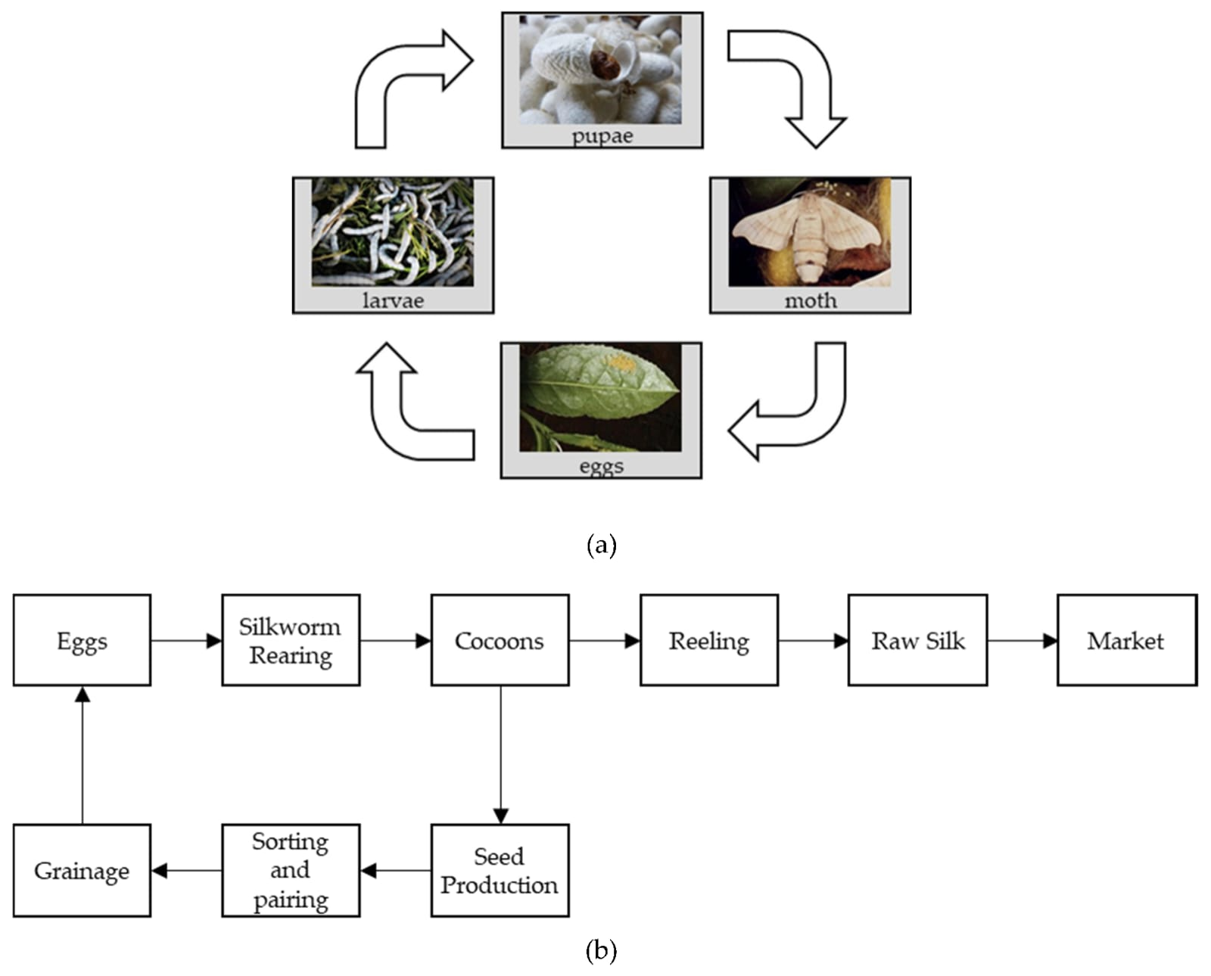

The silkworm caterpillar makes its cocoon through forming and enveloping itself with a long, continuous the fiber, or filament. While approached by air, liquid secretions from two huge glands within the insect emerge across the spinneret, a single exit tube in the head, establishing to create twin filaments composed of fibroin, a protein material. A second set of glands produces sericin, a gummy material that holds the two strands together. Because an emerging moth would break the cocoon strand, the larva is destroyed in the cocoon during the chrysalis stage by steam or hot air.
Raw silk is silk consisting of sericin. The sticky a component should be protected until the yarn or fabric stage, after which it is removed by boiling the silk in soap and water, leaving it soft and glossy with a weight reduction in up to 30%. Spun silk can be produced by twisting together short lengths of silk extracted from damaged cocoons or broken off during processing. Silk filament yarn thickness is measured in denier, which is the amount of grams of weight per 9,000 metres (9,846 yards) of length. Weighting is a processes In which silk is treated with a finishing agent, such as metallic salts, to increase weight, density, and drape quality.

There has long been interest in devising ways to produce silk that is stronger and more elastic than that produced by silkworms or traditional sericulture methods. One approach has involved the introduction of spider silk genes into the silkworm genome; spider silk is known for its remarkable strength and elasticity, but it cannot be mass produced by farming spiders. Genetically modified silkworms spin a strong composite silk that has many potential applications.
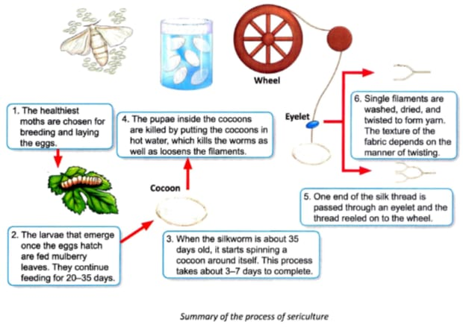

Challenges Faced in sericulture

a) Challenges of Indian silk Industry:-
:- Products are becoming less in demand in the US and Europe.
:- Fabric and raw silk are becoming more expensive.
:- The market for synthetic fibres is becoming more competitive.
:- Additionally, competition is shown with silk-blend fibres.
:- In the Indian market, it is getting harder to find high-quality raw silk.
:-In terms of premium raw silk and silk products, China is a competitor.

b) Sericulture's difficulties and future in Kenya:-
-: Despite the industry's seemingly endless potential, sericulture has only just been introduced in Kenya, over forty years ago.Through live interviews and completed questionnaires, a random sample of respondents provided information on the difficulties faced by the research and extension organisations (International Centre of Insect Physiology and Ecology (ICIPE) and Kenya Agricultural Research Institute (KARI)) and stakeholders in the sericulture industry value chain.It was determined that the industry is currently characterised by negligible cocoon production quantities that are unable to maintain the local and global market. As a means of reducing poverty, silkworm raising is primarily carried out by individuals and a few self-help farming organisations made up primarily of women and young people. Poor agricultural, silkworm-rearing, and cocoon-reeling technologies frequently result in low-quality cocoon and silk thread. According to preliminary statistics, farmers mostly struggle with the following issues: inadequate quality control tools and methods (87%), a lack of technical skills (74%), and a lack of investment money (62%). As a result, it was discovered that despite efforts to advance sericulture in Kenya, some obstacles jeopardise its future.
Economic and Industrial value:-
a) Indian sericulture industry for sustainable rural economy:-
In India, silk is a way of life, and no ceremony is complete without it.It is an integral component of Indian culture and traditions.The science and practise of making silk is known as sericulture. It has been in India from the second century BC and is a very old industry. India has historically been a rural nation, and because more than 70% of the population depends on agriculture and related farm operations for their survival, the country's economy is heavily reliant on these industries.
b) Economic analysis of sericulture: Raigarh District, Chhattisgarh, India:-
Due to its short gestation periods, low capital requirements, high employment potential, and rapid return on investment, sericulture the cultivation of silk worms and ultimately silk fiber has emerged as a promising rural industry in India. Sericulture is split into the farm and industry sectors. Growing food plants for silkworms and raising them to generate cocoons and eggs are both part of the farm industry.The industry sector is made up of reeling, twisting, dying, printing, finishing, and knitting. Per square metre of land, sericulture produces a lot of work and cash. Sericulture offers many opportunities for improving human resource employability and can successfully slow down population migration to cities.
C)Sericulture industry in India:-
Given that the majority of the world's poor still live in rural areas, such as India, eradicating rural poverty remains a top priority for emerging nations. According to estimates from the World Bank, more than 70% of the world's impoverished reside in rural areas. Rural employment generation is one of the main solutions that have been used to date to solve this issue.However, the agriculture industry has had to deal with a variety of issues that have hindered its ability to create more new jobs in rural areas.An effort has been made to develop a strategy model to support and strengthen India's sericulture industry in order to increase silk production and quality, among other things. This article will be useful in identifying the sericulture industry's potential, strengths, and challenges in India so that appropriate policies and strategies for socioeconomic development can be developed.
d) Sericulture as a profit-based industry
Sericulture, which combines industrial and agricultural activities, is one of the labor-intensive sectors. As an agro-based business, sericulture significantly influences the economic future of the rural population. It has promise as a sector that creates jobs, particularly in rural and semi-urban areas.Sericulture is agro-based industry, practiced in India for many centuries. The labour intensive industry remains one of the major strengths of India fascinating with its most exquisite workmanship and beauty which no other country has ever been able to replicate. Silk has always been fashionable and for the last few years, it has remained a strong component of the international fashion trends. Sericulture is multidisplinary activity consists of mulberry leaf production, silkworm rearing (cocoon production), silkworm egg production, silk reeling (yarn production), twisting, Warp and weft making, printing and dyeing, weaving, finishing, garment designing, marketing etc.
Agro-based sericulture has been practised for many millennia in India. With its most beautiful craftsmanship and beauty that no other nation has ever been able to match, India's labor-intensive industry continues to be one of its core competitive advantages. Since it has always been in style, silk has continued to play a significant role in current global fashion trends. Mulberry leaf production, silkworm rearing (producing cocoons), silkworm egg production, silk reeling (producing yarn), twisting, warp and weft production, printing and dyeing, weaving, finishing, designing clothing, marketing, etc. are all part of sericulture, a multidisciplinary activity. This cottage and small-scale sector activity is labor-intensive, focused on farms, and commercially appealing. It is especially suited to farmers, business owners, and artisans who operate in rural areas because it takes little capital but has the potential for relatively larger returns.
Current Scenario of Sericulture in India
Sericulture is well known as the Queen of Textile.This whole study is based Secondary source of data, it is Obtained from central silk board, Mysore. Karnataka. The study of maintained that India has produced 28523 metric tons of raw silk during the 2015-2016. It provides an econonmic supports to the weaker society. As far silk production, sericulture industries have been newly established in Brazil, Egypt, Bulgaria and Madagascar also.The major production is done. in Asia with 90% of mulberry products and almost 100% of non-mulberry silk. While China is ranked as 1st position in the whole world,it provided employment to 1million people in the silk sector.

For the production of silk, Sericulture is referred as the art of rearing. India has been ranked in the 2nd position in terms of silk production. Karnataka is considered as the highest sericulture producing state in India. In our country India sericulture has major rearing states like Tamil Nadu,Andhra Pradesh,West Bengal, Assam,Jammu and Kashmir.It produced 4 varieties of silk in 2020-21. Among them, Mulberry accounted for 70.72℅(23,860 MT), Tasar has 8.02℅(2,705 MT), Eri 20.55℅(6,935 MT) and Muga 0.71℅(239 MT) of the entire raw silk production of 33,739 MT(provisional). In Indian market size has reached INR 451.6 billion in 2022 in sericulture. Hopefully IMARC group expects the market to reach INR 1,194.5 Billion by 2028, expositing a grwoth rate (CAGR) of 17.7℅ during 2023-2028. Simultaneously, the states experience challenges like price inconsistency of cocoon, insufficient of storage facility, lack of proper market, races difficulties in financial support and many more. In our country there is very good prospect in terms of activities related to sericulture. Accordance to this trend in future the state will become 65℅ bi-voltine silk worms rearing in mulberry. Sericulture is labour intensive, which refers to a process or industry that requires a large amount of labours to produce it's goods and services.
Conclusion
Sericulture or silk farming is the process of developing silk from the silkworms insects.
Agro-base of rural industries are increasing rapidly in India which is very important to sericulture. In India, Morus alba is commonly used to obtained high quality silk used sericulture is beneficial in various aspects. More, over it is budget friendly provides self employment and high income platforms to marginal farmers also it educate of the unemployed youth in varied sectors.As it involves the high investment required in the collection and manufacturing of silk, Nowadays silk textiles has become a symbol of status.Silk is involved in the production of silk, cartridge bags, telephone cable insulation for dying, screen printing etc.The future aspects of silk is enhance the quality and quantity production of seed cocoon and reeling cocoons with economic supports. Silk farming makes the silk weaving. sector & from by providing training and diversification. Sericulture intensify, the silk tourism in the state in convergence with the Tourism Mission. It nourish the muga production in the state by encouraging valve addition. It also put forward the technology upgradation among the sericulture farmers. Sericulture brings significant change in various the spheres like socially, economically and culturally also,in
both the areas rural as well as urban with unique features. As we know, India's most famous handloom is Mysore silk, which makes Karnataka special. India's second-largest weaver aver population is Odisha, which has variety and larged mainly inspired by tribal communities, which is the third greatest in India. With an exquisite weaving caving offering a unique identity, the state's textiles represent its cultural identity. Most famous weavs of Odisha is Sambalpuri ikat weavers which are made by complex method called bandha.One of the best silk is Tassar silk which is produced in Sambalpur, Mayurbhanj and many places of Odisha.
There are variety of Paata which is also weaved in Odisha like Berhampuri paata, Bomkai silk, Khandwa paata and many more.The production of these items will enhance the economic state of the country by trading by at the improvements and development of relationship between the countries, hence the country's aspects will be better benifited.
ACKNOWLEDGEMENT
This work is guided by our lecturer DR. R. PRAVALLIKA SREE .
We thank C.V RAMAN GLOBAL UNIVERSITY for giving us this opportunity.
CONFLICT OF INTEREST
The authors declare no conflicts of interest.
REFERENCES
1.Annual report (2009-10) Central silk Board, Ministry of Textiles, Government of India
2. Seri Business Manual – A user’s guide (Farm sector), Central Silk Board publication, Bangalore.
3. T H Somashekar (2005) Keynote address on Indian Silk Industry - Future prospects and challenges in view of
globalization
4. http://www.ffymag.com/admin/issuepdf/17-22_silk_dec11.pdf (Vigneshwara Varmudy Silk Industry: Need to
become competitive, Market survey)
5. http://silkmarkindia.com/
6. http://www.csb.gov.in/assets/Uploads/pdf-files/Note-on-SERI.pdf
7. http://news.oneindia.in/2006/12/28/exhibition-to-showcase-indian-varieties-of-non-mulberry-silk-
1167282649.html
Vigneshwaravarmudy, “Silk Industry: Need To Become Competitive”, Facts For You, December 2011, pp. 18-19.

Geetha, G. S. Srinivasa, G. Jayaram, M. N. S. Iyengar and N. B. VijayaPrakash, “Socio-Economic Determinants of Farmer Oriented Technology Packages for Sericulture: A Field Study”, Indian Journal of Sericulture, Vol. 40, No.1, pp. 96-99, 2001.

R. Anitha, “Indian Silk Industry in the Global Scenario”, EXCEL International Journal of Multidisciplinary Management Studies, Vol. 1, No. 3, pp. 100-110, December 2011.
Gangopadhyay, Debnirmalya, Sericulture Industry in India – A Review (September 14, 2009). India Science and Technology (Online) 2008,

