The Role of Artificial Intelligence in IOT
Practical and Innovative Applications of IOT and IOT Networks
Smart Cities and Smart Mobility

Introduction

The IOT or ‘Internet of Things’ represents collections of devices connected in a network and the technology that allows the communication of devices between themselves and communication of devices with the cloud. The Internet of things demonstrates small physical objects with cameras or sensors, connected in a network that processes the software and other technologies to exchange data with other devices in the network over cloud, Internet, and other communications networks. The data thus received by the cloud or communication network is processed and analyzed by the software and an action is taken accordingly without the user intervention. Additionally, a user interface is provided that allows the user to enter or process the data collected from IOT devices to manipulate the system if needed. Any actions or changes made by the user are communicated to the cloud and then to the IOT devices to effect any changes required.
In the modern world, the idea of IOT networks collecting and sharing information is trivial in every industry. The network runs on global scale in gathering information, the information thus collected is processed by AI techniques and the data is analyzed to help users to make informed and optimal decisions.

1.1 The Rise of IOT

Significant changes in technology enabled the rise and innovations in IOT easy. The devices available, connection to networks and processing to make this innovation possible are cheaper than before thus making the transition easy for everyone.
  - Smartphones – Smartphones are not only available in various models but also budget friendly are now a gateway to the IoT. They serve as personal remote control to connected smart homes, cars, fitness, and health devices.
  - Devices – Cameras or sensors are available in abundance and are much cheaper to make this innovation significant.
  - Bandwidth and Processing - The cost of bandwidth and processing the data has also declined over last few decades thus enabling more IOT devices to be connected and processing the data smartly as millions of data is generated and received with in the network.
  - Big Data – Big data analytics is key to processing the unstructured and voluminous data collected by the IOT devices.
  - Wireless and IP 6 - Wi-Fi connectivity is available for free or at a very low cost and utilizes unlicensed spectrum and thus does not require monthly access fees to a carrier. In addition, most networking equipment now supports IPv6, the newest version of the Internet Protocol (IP) standard that is intended to replace IPv4. IPv4 supports 32-bit addresses, which translates to about 4.3 billion addresses – a number that has become largely exhausted by all the connected devices globally. In contrast, IPv6 can support 128-bit addresses, translating to approximately 3.4 x 1038 addresses – an almost limitless number that can amply handle all conceivable IoT devices.

    - Key Attributes

IoT has key attributes that distinguish it from the “regular” Internet, as captured by Goldman Sachs’s [Source Goldman Sachs’s Global Investment Research] S-E-N-S-E framework: ‘Sensing, Efficient, Networked, Specialized, Everywhere’ (Fig1.1). These attributes may tilt the direction of technology development and adoption, with significant implications for Tech companies – much like the transition from the fixed to the mobile Internet shifted the centre of gravity from Intel to Qualcomm or from Dell to Apple. [1]

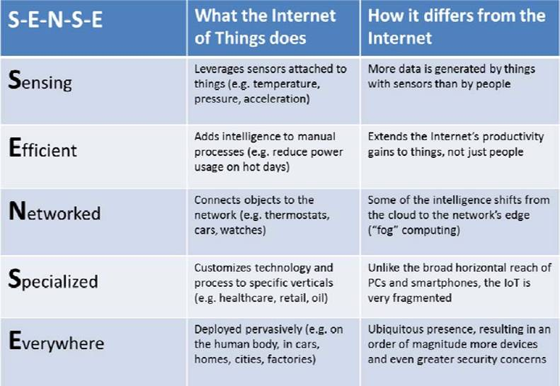
Fig 1.1 IOT Key Attributes

    - Requirements (Fig 1.2)

- Smart Devices
- Cloud Computing
- Big Data Analytics
- Security
- Accessibility
- Asset Management

Fig 1.2 IOT Requirements

  - Usages of IOT:

The IOT adapts the latest trends in blockchain technology for rapid development of smart homes, smart cities, Health care, Transportation, Agriculture, Industries, Traffic Management, security, AI applications. The development has opened a wide range of cyber technologies impacting our daily lives. (Fig 1.3)

Innovations are more using IOT smart devices, like smart homes that are equipped with several sensors throughout the premises, with live video surveillance and remote-control access. These devices can be controlled using remotes or even our phones for simple tasks like switching on lights or heating systems. This not only increases the convenience of operating smart homes but also monitoring for security.

Same can be applied to Traffic management with the digital platform created with IOT sensors and live video streaming can monitor the road for potholes and oil spills thus alerting the users to avoid any road fluctuations. Additionally, sensors and live streaming can be used to alert traffic authorities so that preventive measures can be taken to avoid traffic commotion and repair potholes and oil spills on roads.

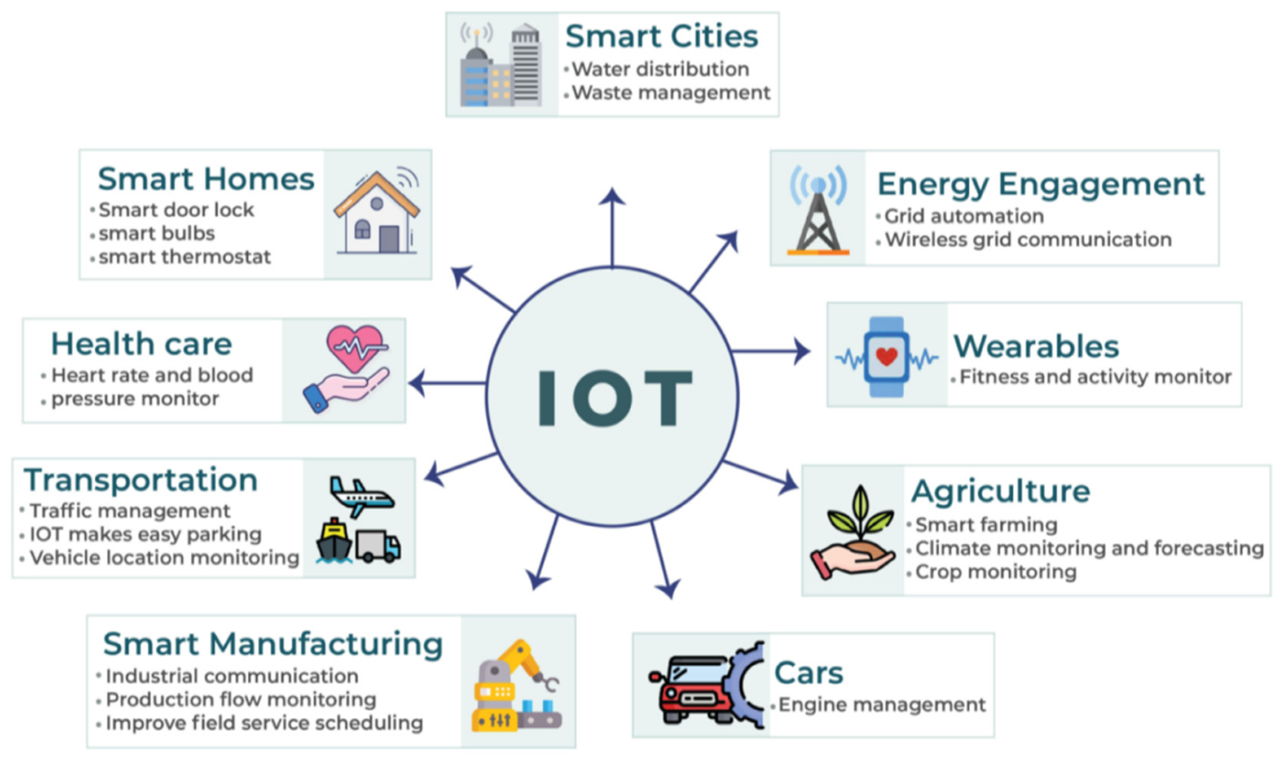
Fig 1.3 Usages of IOT

  - The role of Artificial Intelligence in IOT

The operational IoT devices that are connected in network or cloud create and gather data, the data is thus processed and analyzed by to provide insights and improve efficiency and productivity. The data learning and training processes are adapted by AI in order provide insights. IoT powered by AI generates intelligent technologies that mimic intelligent behaviour and assist in decision-making with little or no human intervention. (Fig 1.4)
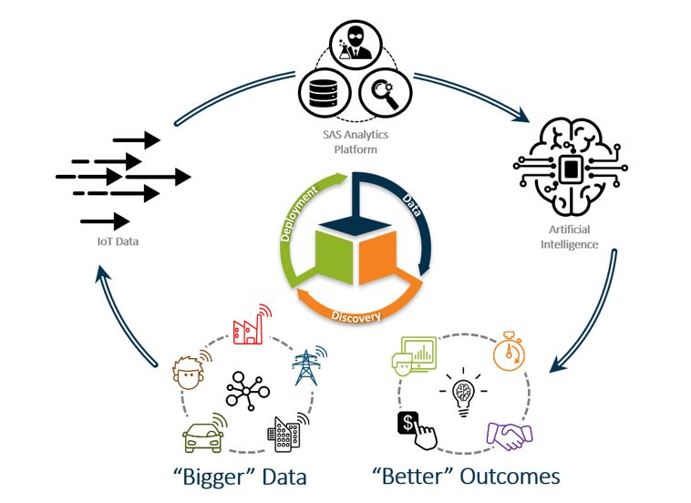

Fig 1.4 The role of AI in IO
There are four broad forms of AI in use today, ranging from simple and almost mechanical to complex and almost human: [2]
- Simple or rule-based AI is software that has rules or policies that relate trigger events to actions. These rules are programmed, so some people might not recognize this as a form of AI. However, many AI platforms rely on this strategy.
- Machine learning (ML) is a form of AI where the application learns behaviour rather than having it programmed in. The learning can take the form of monitoring a live system, relating human responses to events and then repeating them when the same conditions occur by either analyzing past behaviors or having an expert provide the data.
- Inference or neural networks use AI to build an engine that is designed to mimic a simple biological brain and make deductions that generate responses to triggers based on what the engine infers the conditions are. Today, this technology is applied most often to image analysis and complex analytics.
- Generative AI, popularized by ChatGPT, builds a knowledge base by examining millions of online documents and then answers plain-language queries based on that knowledge and a set of rules provided by engineers. The breadth of the knowledge base and the sophistication of the rules that govern queries can make this form of AI seem human, and it represents the state of the art for many involved in the field.

1.4 IOT – Smart Cities and Smart Mobility

Smart mobility creates a process in traffic management that plays a vital role in determining a city’s liveability. The AI trained application in affinity with IOT sensors and Live video streaming from closed circuit television (CCTV) are installed in parking structures to notify users of nearest parking structure available so that the user can park the vehicle in highly commercial areas and use public transport system or walk.
The data thus collected from digital AI platform can be trained using machine learning techniques and can be used more precisely in the future to predict more traffic related issues like traffic congestion, traffic control to minimize air pollution, safety of the commuters etc., regulate traffic and help governments manage expansion of infrastructure. Smart mobility using IoT in traffic management saves commuters a significant amount of time, money and resources thus making public transportation convenient and reliable.
Integrating artificial intelligence with innovative IOT devices in traffic technology helps achieve phenomenal cost savings in smart cities in optimizing the traffic and infrastructure. Digitalization is a must to implement smart control in traffic using IOT capabilities and can be achieved by advanced communication & network technologies with AI.
It helps the smart cities with the following.
- The real time collection of data on traffic sends red alert on traffic congestion thus signalling the commuters of the traffic blockages and suggest alternate routes thus optimizing commute.
- Accurate information on available parking spaces to citizen in real time.
- The cameras, sensors and cellular devices collects feed, and the technology is AI trained to adjust traffic lights, highway lanes, speed limits and highway toll counters for optimizing the flow of traffic.
- The road sensors and video surveillance help locate incidents of any accidents and report them to emergency in hospitals by sending the live location of the incident so that an ambulance can reach in time.
- Adjusting the streetlights to dim or otherwise depending on the weather conditions or onset of night or day.
- Suggesting alternate routes during traffic conditions so that the street capacity is optimized without expanding the infrastructure.

This complex concoction of challenges requires technological advancement and methods including artificial intelligence (AI), big data (BD) and blockchain (BC) techniques for more efficiency and sustainability of smart cities. AI, BD and BC are gaining significant attention in solving many real-life problems. They have been applied in clustering, control, design, image processing, information processing and retrieval, knowledge representation and reasoning, marketing, medical diagnosis, optimization, pattern classification, production planning and scheduling, quality control, etc.

References

[1] https://www.bbvaopenmind.com/en/technology/digital-world/internet-of-things-iot-the-third-wave/
[2] https://www.techtarget.com/iotagenda/tip/AI-and-IoT-How-do-the-internet-of-things-and-AI-work-together

