BREASTFEEDING: - ALTERNATIVES FOR PRE-TERM BABIES

By:-
MEGHA B. KAWALE
(PhD scholar)
Sadhu vaswani college of nursing
BREASTFEEDING:- ALTERNATIVES FOR PRE-TERM BABIES

Aim:-
The aim of the chapter is to find the alternative methods of feeding breast milk to the pre-term babies.
Objectives:-
- To find out the prevalence of pre-term births.
- To assess the feeding problems of the pre-term babies.
- To explain the importance of breast milk for growth and development of pre-term babies.
- To find the alternative methods of feeding breast milk to pre-term babies.
- To compare the two methods of feeding breast milk to pre-term babies i.e. wati spoon and NIFTY cup.

Introduction:
Behera JR, Behera G, Sahu SK (2020), India has a large burden of very low birth weight (VLBW) babies, i.e. those who are <1500 g, account for only about 5% of all live births, but are responsible for most of the neonatal intensive care unit (NICU) bed occupancy and contributes to the most of the expenditure for neonatal care. VLBW babies in general have prolonged NICU stay by virtue of their specific set of problems like respiratory distress, apnoea, intra ventricular haemorrhage, need for mechanical ventilation, total parenteral nutrition, and time required for establishment of enteral feeding.
Provision of prolonged neonatal intensive care consumes both financial and medical resources and also increases the risk of nosocomial infections, disturbances in biological rhythm, poor parent-infant bonding, and possible failure to thrive after discharge. The current availability of NICU beds in India at present is far less than the required number. In order to meet the demands, there has been an increasing trend towards early discharge of neonates from NICUs.

Prevalence
Low birth weight continues to be a significant public health problem globally and is associated with a range of both short- and long- term consequences. Preterm birth is the most common direct cause of neonatal mortality. Every year, 1.1 million babies die from complications of preterm birth. Low birth weight is not only a major predictor of prenatal mortality and morbidity, but recent studies have found that low birth weight also increases the risk for non - communicable diseases such as diabetes and cardiovascular disease later in life^{.[23]}
UNICEF data (December 2021) In India the neonatal mortality rate was 24.8 per 1000 births (2016), 23.7 per 1000 births (2017), 22.6 per 1000 births (2018), 21.4 per 1000 births (2019), 20.3 per 1000 births(2020).^{[10]}

Definition of pre-term
Low birth weight is defined by the World Health Organization (WHO) as weight at birth less than 2500 g (5.5 lb).

Feeding problems of pre-term
An estimated 80% of premature infants will experience difficulty with oral feeding during neonatal intensive care unit (NICU) hospitalization. Feeding difficulties can result from central nervous system immaturity, medical complications, and/or cerebral injury. Immaturity can result in inadequate readiness cues, poor state regulation, and poor oral motor reflexes that support feeding, but most infants will progress to full oral feedings prior to or close to term equivalent age (38–40 weeks postmenstrual age (PMA). While many preterm infants are able to achieve full oral feedings prior to NICU discharge, many continue to have feeding challenges at term equivalent age. In the NICU, the introduction of oral feeding occurs when the infant demonstrates signs of oral feeding readiness, which typically occurs around 34 weeks PMA.
While oral feeding is often the last milestone needed in order for preterm infants to be discharged from the NICU , careful attention must be paid to the feeding process during the delicate neonatal period. Neonatal therapists (largely occupational therapists and speech-language pathologists) can provide assessment and intervention to optimize the early feeding process and drive positive feeding experiences into childhood. While successful oral feeding may be the goal, a focus on quality and positive feeding experiences, especially in the midst of feeding impairment, are important and can be guided by these early therapies.
Following are some feeding problems of pre-term:-
- Poor arousal
- Poor rooting and grasp
- Lack of sucking initiation
- Poor tongue positioning
- Suck–swallow–breathe discoordination
- Inadequate sucking bursts
- Inadequate suction
- Disco-ordination of the jaw and tongue during sucking
- Lack of positive engagement and/or comfort during feeding
- Signs of aspiration
- Difficulty regulating breathing
- Inability to finish feeding

Methods of feeding to pre-term babies:-
There are three ways to feed premature babies: intravenously, through a feeding tube, and directly by mouth. They may receive three different kinds of nutrition: total parenteral nutrition (TPN), breast milk, and infant formula designed for premature babies. How and what a premature baby is fed depends on their gestational age and whether there are complications with any part of the gastrointestinal tract.
Intravenous feeding and parenteral nutrition
Although even the most premature gut is capable of accepting and digesting milk, sometimes the baby may be too unwell to be fed this way. In such cases, premature babies are fed in a way that bypasses the digestive system altogether and delivers nutrition directly to the baby’s bloodstream through an intravenous line (IV) or a catheter. Through this line, a premature baby is initially fed sugar water with essential electrolytes for a few days, followed by a solution called total parenteral nutrition (TPN). Made up of proteins, vitamins, minerals, sugar, fat and water, TPN feeding may go on for days or weeks depending on the maturity of the baby and their ability to feed in an alternative way.

Gavage feeding
Once the premature baby is stable enough to receive feeding through the gut, they can be given gavage or nasogastric (NG) feedings. A small tube is inserted through the nose or mouth and run directly into the baby’s stomach. Small amounts of expressed breast milk or formula are then gently allowed to flow into the stomach. If the baby handles these feedings, they are fed progressively larger quantities.

Breastfeeding and bottle feeding
Once the baby has developed the co-ordination to begin sucking and swallowing, the team will make an effort to help the parents with breast feeding. Most mothers are encouraged to pump their milk right away so that the flow of milk begins and continues. Pumped breast milk can be given to the baby when they are ready for either gavage, breastfeeding or bottle feeding. Many parents have a great desire to feed their child themselves, which enhances their parenting role and helps with the bonding process.

Importance of breast milk
Providing breast milk for a premature may be a challenge, but it is usually possible and it is certainly an effective way to enhance baby's health, growth, and development. Even if baby is unable to breastfeed at first, expressed breast milk can be immediately given after giving birth. When baby is stable, it can have the milk fed to them by a tube or by letting them sip the milk from a tiny cup or bottle. No matter how breast milk is delivered to them, it provides the best nourishment possible at a time when it can make a big difference.
Mothers of premature babies produce breast milk that is slightly different in composition, at least for the first several weeks. This difference is designed to meet baby's particular needs. Premature breast milk is higher in protein and minerals, such as salt, and contains different types of fat that baby can more easily digest and absorb.
The fat in human milk helps to enhance the development of a baby's brain and neurologic tissues, which is especially important for premature infants. Human milk is easier for them to digest than formula. It also avoids exposing their immature intestinal lining to the cow's milk proteins that are found in baby formula created for premature infants. Premature babies who are breastfed are less likely to develop intestinal infections than are babies who are formula-fed. The breast milk a mother produces in the first few days contains high concentrations of antibodies to help the baby fight infection. Even if the baby cannot breastfeed yet, expressing breast milk from the beginning will ensure that the mother’s milk supply is kept up until the baby is able to nurse.
Many NICUs encourage parents to room-in continuously and keep the baby skin to skin (sometimes referred to as kangaroo care), because this has been shown to be beneficial for stability and optimal growth and development of premature babies. Breast milk pumping, or expression, immediately after holding the baby skin-to-skin is a very effective way to increase the milk supply.

Methods of feeding breast milk to pre-term baby
- Wati spoon feeding:-
In Neonatal Division of some hospitals in India, bottle feeding has been totally stopped as a policy to encourage breastfeeding because of its far reaching benefits of reducing infection, especially gastroenteritis. Babies with the gestation of above 32 to 34 weeks are given spoon feeds of expressed breast milk as opposed to bottle feed.

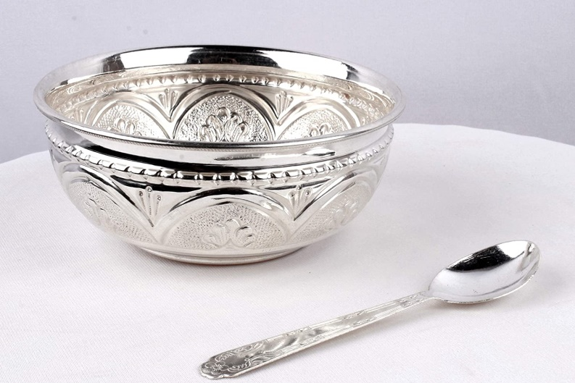

Indications to give milk by wati and spoon:-
- Babies with low birth weight or preterm babies with at least 32 to 34 weeks of gestation.
- Babies who have not been able to establish good suckling reflex are given spoon feed of expressed breast milk alternating with breastfeed eventually to exclusive breast feed.
- Mother is sick or having breast abscess or a Cesarean Section mother who is not able to breast feed immediately.
- Birth defects in infants like cleft palate, birth asphyxia etc.
Procedure of wati spoon feeding: -
- Put a bib on your baby, because some breast milk may spill.
- Expressed breast milk should be taken in a sterile steel bowl and measured with a sterile disposable plastic syringe
- Sit your baby up on your lap using one hand to support your baby's upper back and neck.
- After the baby is placed and positioned properly, 3/4th filled spoon of milk is taken into the spoon
- The lower lip of the baby is pressed with the spoon without tilting it.
- Bring spoon to your baby's mouth and tip so that the breast milk just touches your baby's lips. It should NOT be poured into your baby's mouth.
- Your baby will lap the breast milk up by moving his tongue forward.
- The spoon is not taken out till the baby swallows the milk offered from the spoon
- Allow your baby time to swallow before refilling spoon and offering more breast milk. This will let your baby control the speed of the feeding.
- The baby should be burped after about half the feed has been consumed. To compensate for the slight spilling of milk while feeding, an extra 2-3 ml of milk should be taken than the actual amount required.
- Steel or silver “Palada” with a specific capacity of 5 ml or more, can be used with great success especially in babies with poor sucking reflex as in those with birth asphyxia, cleft palate and septicemia.

The advantages of spoon feeding as opposed to bottle-feed
- It’s an age old traditional practice and hence socially acceptable.
- It can be easily learnt even by a new mother.
- It more hygienic than the bottle; and can be sterilized easily
- It helps in early weight gain and early discharge from hospital of preterm or low birth weight babies and the practice can be continued at home till the baby attains good suckling reflex and sufficient weight.
- Preterm babies initially on breastfeed cannot suck well and easily get tired which leads to lack of weight gain and anxiety in the family. In such a situation, use of alternate spoon feeds of expressed breast milk can help to quickly gain weight.
- NIFTY cup:
Nifty Feeding Cup is a reusable product for feeding breast milk to newborns with breastfeeding difficulties.It is a simple to use, easy to clean and culturally appropriate feeding solution which allows the infant to control the pace of feeding.
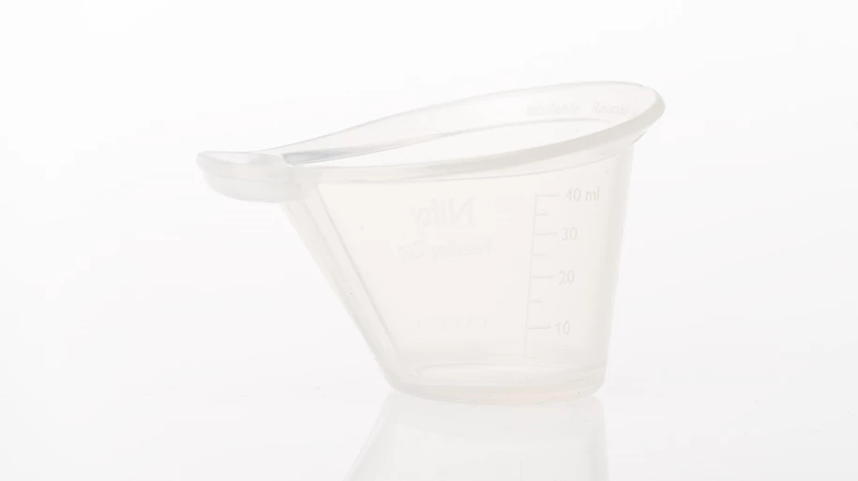

Features:-
- Reusable, boilable, and autoclavable.
- Monitor feeding with millimeter feeding measurements on side of cup.
- Soft silicone material is gentle against the mouth of the infant.
- Reservoir for the infant to lap milk from to control the pace of the feeding.
- Mother can express directly into Nifty.
Material:-
- Made with silicone rubber
- Safe for food contact according to regulation 1935/2004
- Operating Temperature:-18 °C to +50 °C
- Storage temperature: -40 °C to +60 °C
- Not made with natural rubber latex

Dimensions
- Mass: Approx. 23.5 g
- Volume: 5 to 40 ml

Disinfection
- Reusable for use by multiple newborns
- Suitable for reprocessing with the following methods:
  - Steam autoclaving at 136 °C, 10-20 minutes

  - Chemical disinfection with 0.5% chlorine solution, 20 minutes, and rinsed 3 times with clean water afterwards
  - Boiling in water, 10 minutes

Procedure of NIFTY cup feeding

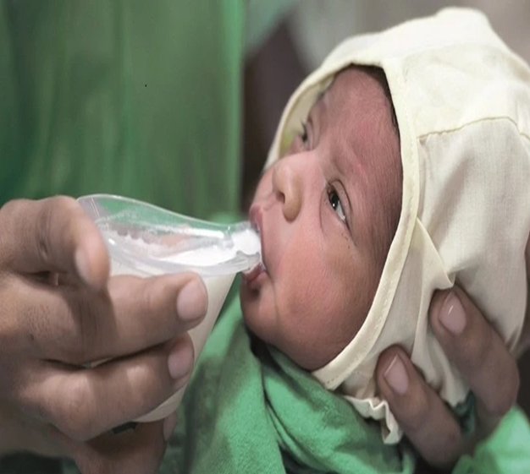
- The mother hand expresses breastmilk into the NIFTY cup.
- The mother then pours the milk into the reservoir and the infants takes in the milk at his or her own pace.
- The cup shape makes this intuitive, hence the NIFTY name: the Neonatal Intuitive Feeding TechnologY (NIFTY).
Advantages of NIFTY cup feeding
- The NIFTY feeding cup optimizes infant feeding. The innovation is in the cup shape and material.
- The NIFTY is large enough for direct hand expression of breastmilk.
- The unique reservoir allows for easy control of the milk flow by the feeder and enables the infant to control the feeding.
- The soft silicone material prevents oral cavity injury and can be boiled or autoclaved.

Comparison between wati spoon feeding and NIFTY cup feeding
Advantage of using NIFTY cup over wati spoon is less spillage, no wastage of breast milk and exact amount of feed taken by the baby can be measured and lastly ease of handling cup than wati spoon.

Conclusion:-
In India the prevalence of pre term births is high and it causes the burden on health care system of India. The main problem of pre- term babies is nutrition which is responsible for their growth and development. To provide them the required nutrition the breast milk is the best feed. Now how to give them i.e method of feeding is already discussed in the above paragraph. To feed breast milk to pre-term babies there are two methods wati spoon and NIFTY cup out of which NIFTY cup has more advantage over wati spoon method.

Research studies related to NIFTY cup are as follows:
  - Mckinney C, Balakrishnan U, Ninan B, Glass R, Cunningham M, Murthy J. A Comparative Study of Two Infant Feeding Tools: The NIFTY Cup and The Paladai. Indian J Pediatr. 2020 Jul 1;87(7):505–11.
  - Mckinney CM, Plange-Rhule G, Ansong D, Cunningham ML, Agyeman I, Coffey PS. A randomized crossover trial comparing the NIFTY cup to a medicine cup in preterm infants who have difficulty breastfeeding at Komfo Anokye Teaching Hospital (KATH) in Kumasi, Ghana. Plos One. 2019 Oct 17;14(10):e0223951.
Doi: 10.1371/journal.pone.0223951. PMID: 31622421; PMCID: PMC6797128.

References:-
- Behera J R, Behera G, Sahu S , Factors Influencing the Age at Discharge of Very Low Birth Weight Preterm Neonates From a Neonatal Intensive Care Unit in Eastern India: A Cohort Study. Cureus. 2020 march;12, 12(12): e11889.
DOI 10.7759/cureus.11889
- https://data.unicef.org/topic/child-survival/neonatal-mortality/
- https://www.parentinginottawa.ca/en/breastfeeding/Spoon--Cup-and-Paced-Bottle-Feeding.aspx#:~:text=Bring%20spoon%20to%20your%20baby's,and%20offering%2 0more%20breast%20milk
- https://www.sangopan.com/why-spoon-feeding-should-be-preferred-than-bottle-feeding/
- https://laerdal.com/in/products/skills-proficiency/neonatal-skill-trainers/NIFTY-feeding-cup/
- New Mother's Guide to Breastfeeding, 3rd Edition (Copyright © 2017 American Academy of Pediatrics)
- Roberta Pineda, Danielle Prince, Jenny Reynolds, Molly Grabill and Joan Smith, Preterm infant feeding performance at term equivalent age differs from that of full-term infants. Springer Nature America, Inc. 2020 Received: 4 November 2019 / Revised: 21 January 2020 / Accepted: 4 February 2020 / Published online: 17 February 2020
https://doi.org/10.1038/s41372-020-0616-2
- WHO Global nutrition targets 2025: low birth weight policy brief :WHO/NMH/NHD/14.5)

