**Power of lactic acid bacteria: Their current application in agriculture**

Essodolom TAALE1*, Amakoé ADJANKE1, Koffi Kibalou PALANGA1, Tiatou SOUHO1 and Atti TCHABI1

1 : Laboratoire des Sciences Agronomiques et Biologiques Appliquées (LaSABA), BP 404, Campus Nord, Route Nationale N°1, Université de Kara, Kara, Togo.

*Auteur correspondant : Email : [e.taale@univkara.net](mailto:e.taale@univkara.net); etaale1981@gmail.com; Tel : (+228) 93 18 28 86 / 98 04 69 64

# Introduction

From ancient times to the present day, humans and animals have always coexisted with microbes. A microbe (from Greek μικρός, mikrós, "small" and βίος, bíos, "life") or microorganism or micro-organism (from Greek μικρός, mikrós, "small" and from ὀργανισμός, organismós, "organism") is a living organism which, individually invisible to the naked eye, can only be observed with the aid of a microscope. It belongs to the group of unicellular organisms (<https://fr.wikipedia.org/wiki/Micro-organisme>). The word microbe was introduced by French surgeon Charles-Emmanuel Sédillot in 1878. The domestication of these microbes has enabled humans to produce a variety of foods (fermented and non-fermented) with diverse and attractive properties, more digestible and thus contributing to achieving food safety but also helping to maintain consumer health. Among these microbes is the group of lactic acid bacteria.

Gram-positive bacteria from *Firmicutes* phylum which genome contain less than 55% of (Guanine+Cytocine), ubiquitous, probiotic, and facultative aerophilic microorganisms, unable to synthesize B-vitamins and amino acids; that it why when growing LAB, a complex nutrient is required as reported by Holzapfel and Wood (2014), Fitzpatrick and O'Keeffe (2001) and Murindangabo et al. (2023). Plants, foods, milk products, human gut, vaginal flora, and on the skin of various living organisms are living places of LAB

LAB have several applications:

* In foods LAB and their produced metabolites inhibit the growth of pathogenic and spoilage microorganisms (Kröckel, 2013); and have some applications in agricultural and medicine sectors hence the name GRAS (Generally Recognized as Safe) attributed by the US Food and Drug Administration (Bintsis, 2018).
* In agriculture their metabolites like polyamines, NO, signal molecules may contribute to plant growth stimulation or stress alleviation (Lamont et al., 2017). Also as PGPM, LAB improve the ability of plants to withstand stressful environments by protecting plants from abiotic stresses and/or by altering the stress response of the plant whose purpose isto improve improving the survival of the entire phytomicrobiome (Lamont et al., 2017). More, biotic and abiotic stresses are regulated by microbe-associated molecular patterns (MAMPs) (Henry et al., 2012) and it was demonstrated that plants treated with LAB increase resilience because of MAMPs they produced (Lamont et al., 2017).

Apart from their proven role in protecting and preserving foodstuffs against pathogenic and spoilage microorganisms, several studies have shown that lactic acid bacteria can be highly beneficial to plant growth (Mundt and Hammer, 1968; Higa and Kinjo, 1991; Vessey, 2003; Tsavkelova *et al.*, 2006; Henry *et al.*, 2012; Gaggìa *et al.*, 2013; Kang *et al.*, 2015; Murindangabo *et al.*, 2023). This study is a review of the literature on the potential application of lactic acid bacteria and their metabolites in agriculture, notably in plant growth, in protecting plants against bio-aggressors and in controlling the accessibility of minerals in the rhizosphere.

# **Methodology**

Data were collected by consulting online available published scientific articles and thesis on potential application of Lactic Acid Bacteria (LAB) and their metabolites in agriculture. So, we searched the electronic bibliographic database of the scopus, Elseviers, Googlscholar, Hinari and Agora using the ‘All databases’ selection. We used a combination of search terms including “lactic acid bacteria” AND “plant growth”, “Lactic Acid bacteria” AND “Agriculture”, “Lactic Acid Bacteria” AND “food protection”, “Lactic Acid Bacteria” AND “soil fertilization”, “Lactic Acid Bacteria” AND “Soil protection”, etc… Collected data were, cleaned, sorted in order to extract and quantify the relevant and valuable information to help an in-depth understanding of current roles played by LAB in agriculture (soil, plant and food). Due to the limited research on this topic, we also identified important review articles and checked the references listed within each and the citations of these as previously described by Murindangabo et al. (2023).

# **Results and discussion**

# **3.1. Presentation of LAB group**

Pfeiler and Klaenhammer (2007), da Silva Sabo et al. (2014), Sadiq *et al.* (2019) and Ogunbanwo et al. (2020) described LAB as Gram-positive, catalase-negative, facultative anaerobic, non-sporulating, non-motile and acid-tolerant bacteria with shapes like a sphere (coccus) or rods, in single cells or couples, tetrads and short to long chains. *Aerococcus*, *Alloiococcus*, *Carnobacterium*, *Enterococcus*, *Lactobacillus*, *Lactococcus*, *Leuconostoc*, *Oenococcus*, *Pediococcus*, *Streptococcus*, *Tetragenococcus*, *Vagococcus* and Weissella containing less than 55% of (Guanine+Cytocine) in their genome are, the different genus belonging to LAB group . Some specific optimal conditions of growth are pH4 and temperature of 30°C for the mesophilic and 44°C for the thermophilic LAB (Taale et al., 2013; da Silva Sabo et al., 2014).

# **3.2. Specificity of LAB groups**

Lactic acid bacteria are a group of microorganisms with a diversified metabolism adaptable to their living environment, an intrinsic quality that enables them to ferment a variety of foods. Fermentation is the transformation of organic matter (e.g. carbohydrates) by enzymes secreted by microorganisms. In fact, lactic acid bacteria use this metabolic pathway to produce the energy they need to grow, as well as metabolites such as organic acids. A distinction is made between lactic acid bacteria: (i) strict homofermenters, which produce mainly lactic acid, (ii) facultative heterofermenters and (iii) strict heterofermenters, which produce acetic and formic acids, ethanol and carbon dioxide in addition to lactic acid (Klaenhammer et al., 2005; Claesson et al., 2007; Pot, 2008), acetoin, bacteriocins, etc... (Taale et al 2013, 2020). (Giraffa, 2014; König and Fröhlich, 2017) have assigned the name "lactic acid bacteria" to this group of microorganisms, referring to the majority product (lactic acid) obtained by metabolizing carbohydrates. These metabolites (organic acids, bacteriocins, enzymes, alcohols and other low-molecular-weight substances) produced give them several properties including antimicrobial and antifungal activities (Moradi et al., 2020, Taale et al 2013).

## **Production of organic acids**

In addition to lactic and acetic acids as major products of their metabolism, lactic acid bacteria can also produce phenyllactic acid (PLA), hydroxyphenylactic acid (OH-PLA), formic acid, propionic acid, butyric acid, coumaric acid, benzoic acid, salicylic acid, vanillic acid and indole-3-lactic acid (ILA), according to (Guimarães et al., 2018). For VickRoy (1985) and Tian et al. (2021), lactic acid is a very important product with diverse applications:

* **used in chemistry** as the first chemical material capable of being converted into various chemicals such as acrylic acid, propylene glycol, acetaldehyde and 2,3-pentanedione due to the presence in its structure of hydroxyl (-OH) and carboxyl (-COOH) groups (Varadarajan and Miller, 1999);
* **in food:** Lactic acid is used in the food industry as an additive (E270), as an antioxidant, acidifier or flavor enhancer. Lactic acid also comes in salt form: sodium salt (E325), potassium salt (E326) and calcium salt (E327). These salts are in powder form and are also water-soluble. It acts as a bacteriostatic agent, notably on pathogenic bacteria such as salmonella (or *Listeria*), and also has a depressant effect on water activity (Chêne, 2002). In wine, L-malic acid, naturally contained in wine, is degraded to L-lactic acid by bacteria (malolactic fermentation). In milk and dairy products, S-lactic acid comes from the breakdown of lactose by bacteria. The fresher the milk is, less S-lactic acid it contains. The concentration of lactic acid in milk is expressed in Dornic degrees (°D): 1 °D corresponds to 0.1 g of lactic acid per liter of milk. The organisms responsible for producing lactic acid are lactobacilli;
* **in cosmetics,** lactic acid is used as part of an aesthetic peel, particularly for colored skin (ranges of aesthetic bleaching products are composed of lactic acid). However, this acid must be applied under the supervision of a dermatologist and in specific dosage and dilution conditions depending on the patient's skin tone;
* **as decontamination agent**, it is a good descaler, soap remover and antibacterial agent. It is also economically advantageous, and is part of a trend towards ingredients that are safer for the environment. Lactic acid is now used in the USA for bacterial decontamination of bovine carcasses in slaughterhouses;
* **in medicine and pharmaceuticals**: when lactic acid bacteria operate in the mouth, the lactic acid produced can lead to tooth decay;
* **in degradable materials industries**: lactic acid is polymerized to produce polylactic acid (PLA), a biodegradable plastic used in 3D-printers, food packaging and surgery;
* leather industry, textile industry, etc...

Lactic acid can be produced by chemical synthesis or by biological methods. The biological or microbial fermentation method uses pure strains with well-known characteristics. It has the advantage of obtaining pure lactic acid in an environmentally-friendly way, as humanity's current objective is to reduce the use of synthetic chemicals in the agri-food, health and pharmaceutical industries. It was with this aim of combating global warming caused by excessive, uncontrolled use and uncontrolled waste management that Oh et al (2005) produced lactic acid from barley, maize and wheat, which are cheap and available raw agricultural substrates, using *Enterococcus faecalis* RKY1 as the fermentative strain. This is a way of valorizing agricultural waste and contributing to the natural recycling of nature's products. For Ryu et al. 2003, the challenge facing mankind is to produce lactic acid at low cost (allowing free access to a large mass), with a bacterial strain possessing the following characteristics: rapid fermentation, low contamination level, high lactic acid yield and low by-product yield, and year-round availability of the starter strain with high multiplication capacity.

## **Proteases**

In addition to organic acids, LAB also produce a variety of enzymes, which are released into the intra- and/or extracellular environment and have diverse applications. Proteases are one such enzyme. They have a low molecular weight and are produced as preproenzymes (Linares-Morales et al., 2020; Worsztynowicz et al., 2020; Ji et al., 2021). Lactic acid bacterial strains can be exopeptidases (which leave the peptide bond close to the carboxy or amino termini of the substrate) or endopeptidases (which cleave peptide bonds away from the substrate termini) (Ramachandran et al., 2016; Mamo and Assefa, 2018; Gurumallesh et al., 2019; Mahajan et al. (2023). Because of their catalytic potential, they are widely used in the meat and dairy industries, in food additives, animal feed, baking and brewing.

## **Lipases**

Due to their kinetic and substrate specificity, triacylglycerol acyl hydrolases or lipases are atypical enzymes (animal, plant or microbial origin) as they can act :

1. as hydrolases in aqueous solution, i.e. catabolizing or hydrolyzing fats, lipids, phospholipids and cholesterol esters into fatty acids and other organic or inorganic compounds. Fatty acids are a source of energy for many organisms, especially polar bears during winter. They also catalyze esterification, acidolysis and alcoholysis reactions;
2. (ii) or as biocatalysts in organic synthesis. As biocatalysts of industrial importance, therapeutic applications and flavoring agents in the food industry, LAB lipases (intracellular or extracellular) are of great importance due to their

They have the capacity to transform fatty acids through hydration, dehydration, isomerization and saturation reactions. Hence their numerous industrial applications (agri-food, chemicals, etc.) as well as therapeutic applications (Fickers *et al.*, 2008; Messaoudi *et al.*, 2010) using *Lactobacillus acidophilus, Latilactobacillus Sake, Lactiplantibacillus Plantarum, Lacticaseibacillus casei*.

Some practical applications of lipases produced by lactic acid bacterial strains:

* **Agricultural and livestock waste management:** Slaughterhouse effluents, poultry waste, etc., can be treated with lipases, i.e. by a biological method that limits environmental pollution. Wastewater from the poultry industry generally contains a high concentration of oil and fat (Lambrechts and Pretorius, 2000), and treating it with microbial lipases helps to prevent unpleasant odors due to the accumulation of solid matter, as well as sedimentation to combat biofilm formation, since they have the capacity to hydrolyze and dissolve the fats present in substrates. Using microbial lipases in the treatment of agro-industrial waste is a way of reducing the use of synthetic chemicals, thus combating global warming and protecting the health of farmers, industrial and agricultural workers and consumers;
* **As biological sensors:** lipases produced by lactic acid bacteria release a number of highly specific molecules during their action, which can be used for detection or clinical diagnosis purposes, particularly with regard to glycerol (Younis and Stewart, 1998).
* **As esterases:** Several studies have shown that esterases produced by Streptococcus (Maicas *et al.*, 1999), *Leuconostoc, Lactococcus* (Stevens and Ough, 1993), and Enterococcus, have the capacity to manufacture and hydrolyze compounds (Katz *et al.*, 2002). These esterase activities occur on whole cells or on products from bacterial cultures. In addition, esterases have more applications in the dairy industry.

## **Enhance food acceptance by consummers by producing exopolysaccharides**

Caggianiello *et al.* (2016) and Zannini *et al.* (2016) have demonstrated that EPS produced by LABs can modify the rheological properties, texture and mouthfeel of food products. EPS are used in the food industry as viscosifiers, stabilizers, emulsifiers or other emulsifying gelling agents. The production of foods with the above-mentioned organoleptic characteristics using EPS-producing strains of lactic acid bacteria could provide an alternative to the reduction of food additives in the food industry. In addition, these foods produced using EPS strains would not only help to reduce blood cholesterol, but also could act as foods with immunostimulant and antitumor effects (Vinderola *et al.*, 2006; Caggianiello *et al.*, 2016). More concretely, in Burkina Faso, the use of dextran (EPS) from LAB for the production of composite bread pieces from local cereals (millet and sorghum) has been initiated by Tapsoba and his team (Tapsoba *et al.*, 2023). This work is being carried out by researchers from the Food Technology Department of the Institut de Recherche en Sciences Appliquées du Centre National de la Recherche Scientifique et Technologique (DTA/IRSAT/CNRST).

# **Ecology niches of lactic acid bacteria**

Lactic acid bacteria are ubiquitous as they are found (table1) in plant and/or decaying matter, vegetables, fruit, dairy products, fermented foods, fermented beverages, silages, juices, wastewater, gastrointestinal tract and in human and animal cavities (Sathe *et al.*, 2007; Trias *et al.*, 2008; Djadouni and Kihal, 2012; Liu *et al.*, 2014). LAB are also halotolerant and survive low water intensity and high salinity in dry environments as Fhoula et al. (2013), isolated and characterized 119 LAB strains from the rhizosphere of olive trees and desert truffles.

Table 1 : LAB diversity in ecosystem

|  |  |  |
| --- | --- | --- |
| **Ecosystem** | **Distinct ecology niches** | **LAB Strains** |
| Agroecosystem | * Phyllosphere * Endosphere * Rhizosphere | *Lactobacillus, Lactococcus, Enterococcus, Leuconostoc* and *Weissella*  *Lactobacillus* |
| Decomposing site | * Plant materials (vegetative propagules, sweet corn, cotton, wheat seeds) * Dairy products * Organics fertilizers * Sevage |
| Fermentation media | * Dairy products * Vegetables * Fruits (strawberry fruit, pepper, cucumber,) * meat, vegetable and cereal plant environments (maize, sorghum, millet) * Beverage * Silage/feed |
| Gut | * Livestock * Pets * Birds * Fish * Bees |
| Cavity of human and animals | * Oral cavity * Vaginal cavity * Intestine |

Source: (Chen et al., 2005; Klaenhammer et al., 2005; Sawadogo‐Lingani et al., 2008; Dalie et al., 2010; de Melo Pereira et al., 2012; Rzhevskaya et al., 2013; Shrestha et al., 2014; Baffoni et al., 2015; Minervini et al., 2015; Tapsoba et al., 2017; Bangar et al., 2021; Raman et al., 2022)

# **Their use in farming and soil fertility**

Seed germination, increase soil fertility, aeration and solubility, mitigating various abiotic stresses, neutralizing toxic gases, stimulating plant, shoot and root growth (Table2) are just some of the effects exerted by lactic acid bacteria and their metabolites (Raman *et al.*, 2022). In addition, LAB promote the biodegradation of soil organic content by producing organic acids (lactic acid, acetic acid, etc.) and bacteriocins. These metabolites have an antagonistic effect against phytopathogens and inhibit fungal and bacterial populations in the rhizosphere and phyllosphere, helping to maintain the hydro-mineral balance, the balance of good microbes and good root health, and in turn plant health and productivity. All this contributes to sustainable, environmentally-friendly agriculture. Promoting plant health through lactic acid bacteria and their metabolites by making mineral and organic elements available to plants, notably by breaking down macromolecular substances in organic matter, degrading indigestible polysaccharides and transforming undesirable aromatic substances, particularly during composting. Lactic acid bacteria also help protect plants against biotic and abiotic stresses (Avis *et al.*, 2008; Lamont *et al.*, 2017; Wang *et al.*, 2021).

  Table 2 Action of LAB on sustainable agriculture

|  |  |  |
| --- | --- | --- |
|  | **Benefit action of LAB** | **References** |
| **Rhizosphere/soil** | * interaction between plants and beneficial microorganisms like LAB, fungi, * 20–40% of the carbohydrates and organic acids are release and attract the LAB and colonize the root systems’ surface favouring their proliferation * Limits: * LAB diversity in soils depends on carbon richness, which is abundant in the fruit tree rhizosphere * not being a dominant bacterial group in most soils * microbial communities in the rhizosphere are largely shaped by plant species and age, as well as environmental factors such as temperature and moisture. | (Ekundayo, 2014; Shrestha et al., 2014; Canarini et al., 2019; Raman et al., 2022) |
| **Microorganisms colonizing rhizosphere or soil** | Rhizobium sp., Bacillus sp., and Pseudomonas sp., mycorrhizal fungi, LAB  **Limit:** LAB have been reported to be most numerous in carbon-rich soil environments, such as those under fruit trees or animal agriculture | (Yanagida et al., 2005, 2006; Reyes-Escogido et al., 2010) |

The potential LAB applications in a sustainable agriculture is represented in figure1.

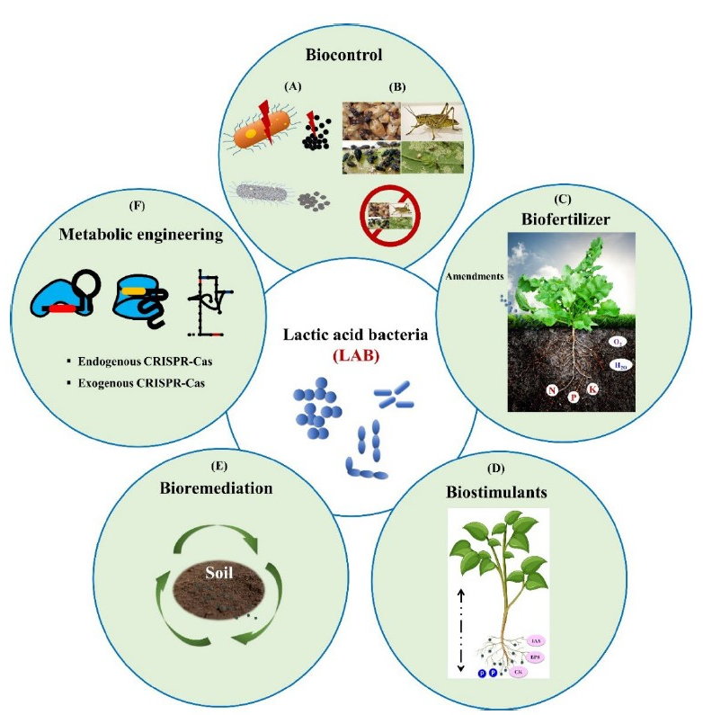

Figure 1 Lactic acid bacteria (LAB) agricultural application. (**A**). Anti-bacterial and anti-fungal activity; (**B**) biopesticides and insecticides; (**C**) biofertilizer increases soil fertility, aeration and retention of moisture content, elevates the mineral uptake and organic decomposition, acetifies the soil and reduces pest diseases. (**D**) IAA, cytokinin, and siderophore secretion increases the root and shoot length and solubilizes the phosphate in the soil. (E) Heavy metal removal, detoxification of fungal mycotoxins, acidification by LA and organic acid, increases organic decomposition, and increases the organic content in the soil, biodegradation. (F) CRISPR-Cas systems and derived molecular machines, endogenous or exogenous engineering to enhanced functional attributes (Raman et al., 2022).

## **LAB as biofertilizer**

Wang *et al.* (2019) defined biofertilizers as polymicrobial mixtures (lactic acid bacteria constitute the major group) whose role is to protect the plant, improve its access to organic nutrients (improves catabolism of organic substances) and especially mineral substances. This polymicrobial mixture:

* ensures the decomposition of a variety of organic materials (Partanen *et al.*, 2010) as well as animal and plant waste to assimilate organic matter such as lignin and cellulose (Hidalgo *et al.*, 2022). Indeed, LAB-based fermented compost materials increase fertility, soil structure and aeration, neutralizing alkalinity and promoting moisture retention and organic acid availability. The use of lactic acid bacteria in composting has the advantage of precipitating calcium, phosphates and iron oxides, thus promoting significant availability of manganese, iron, nitrogen, phosphorus and potassium in amanded soils (Raman *et al.*, 2022; Murindangabo *et al.*, 2023). In short, plant and crop productivity is enhanced;
* is involved in silage formation and in methogenic anaerobic digestion systems (Li *et al.*, 2011);
* increases crop yields and improves organic matter degradation when LAB and bacillus-based biofertilizers are used (Blais, 2013).

Wang et al. (2008) explain that the biofertilizer role (Figure 2) attributed to LAB strains could be due to their natural ability to interact with plants. For Lamont *et al.* (2017), the symbiotic relationship between plants and LAB could be exploited to improve agricultural production.

## **Symbiotic Relations between Plants and LABs**

Nature is so fascinating that, at the same time as some living creatures clash and repel each other, others live in harmony (usually symbiosis), sometimes becoming interdependent in the struggle for survival and the search for food. In fact, symbiosis, or living together, is a mutually beneficial coexistence, i.e. a close and lasting relationship between different species. Nature is full of symbiotic relationships of all kinds, like the bee and the flower, the clown fish and the anemone, or the human intestine and the prokaryotic intestinal bacteria that live there. The organisms involved in a symbiotic relationship are called symbionts. There are three types of symbiotic relationship. (https://dailygeekshow.com/relation-symbiotique/):

* **the first is called mutualism.** In this type of symbiosis, the relationship is beneficial for both symbionts. In other words, it's a win-win association between the two organisms involved. Some examples of mutualism: (i) mutualism between bees and flowers. In effect, flowers provide food for bees by collecting nectar, and flowers reproduce thanks to bees carrying pollen from one flower to another; (ii) mutualism between lactic acid bacteria and plants, i.e. they cohabit and provide mutual benefits. Rhizobia, Bacillus, Pseudomonas and mycorrhizal fungi are common symbiotic micro-organisms in the rhizosphere (Vessey, 2003). MPPVs can promote plant growth by improving nutrient acquisition, enhancing the host plant's ability to resist biotic and abiotic stresses, acting as biocontrol agents (BCAs), and producing compounds that directly stimulate plant growth via several simultaneous mechanisms (Avis *et al.*, 2008). According to Lamont et al. (2017), if the plant-LAB relationship offers a benefit to the plant, this relationship can be encouraged or manipulated to improve agricultural production. For them, plants interact with diverse communities of beneficial, benign and pathogenic microorganisms in the environment and need to be able to distinguish between members of these communities to optimize their growth;
* **commensalism:** Commensal relationships are those in which one species derives all the benefits from its relationship with the other, while the other receives no benefit or detriment from the symbiosis. These benefits may concern locomotion, shelter, food or protection from the host species. An example of commensalism is the relationship between orchids and the trees they grow on. Although orchids depend on the host tree for sunlight, the plant is not a source of harm to the tree. Orchids are small, easy-to-support plants with their own photosynthesis process. This means that the plant does not extract any nutrients from the tree, apart from the water that runs off the outer bark;
* **parasitism:** We tend to think of symbiosis as a harmonious, peaceful relationship, but this is not always the case. In the case of parasitism, one of the organisms benefits from the symbiotic relationship to the detriment of the other. Lice are a perfect example of parasitism. They live on the scalp, where they suck blood and cause itching in the host. Parasitism generally involves two types of host: the definitive host and the intermediate host. The definitive host harbors an adult parasite, while the intermediate host unknowingly harbors a juvenile parasite.

## **LAB as biostimulant**

Tsavkelova et al. (2006) demonstrated that some PGPMs produce hormones (figure2) that can stimulate plant growth. Thus, *Lactobacillus acidophilus* has been reported to produce cytokinens (Lynch, 1985), and some strains of Lactobacillus have been shown to produce indole-3-acetic acid (IAA)(Mohite, 2013; Shrestha et al., 2014; Giassi et al., 2016) while others do not (Kang et al., 2015). As biostimulants, LAB can directly promote plant growth or seed germination, as well as alleviating various abiotic stresses (Lamont et al., 2017). Higa (2001), Somers *et al.* (2007) and Paulsen *et al.* (2009) precise that since 1930s, *Lactobacillus*, was used as an indispensable component of sustainable agriculture, to control pests, condition soils, and stimulate plant growth.

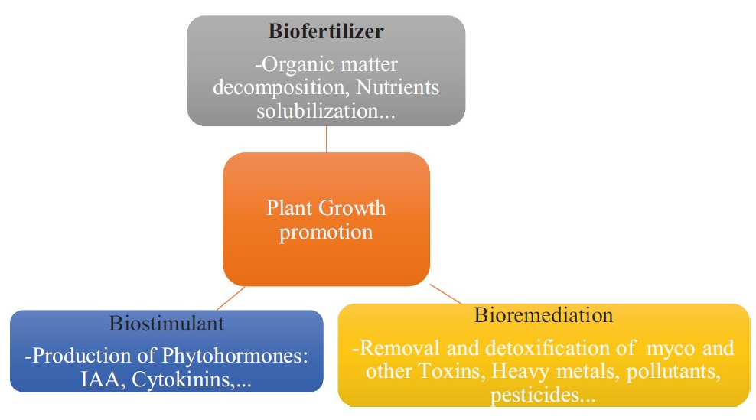

Figure 2 The role played by lactic acid bacteria in the enhancement of plant growth (Murindangabo et al., 2023).

# **Actions of LAB and their metabolites on crop aggressors/ agents of food spoilage**

Their ability to produce organic acids, phenolic compounds, antimicrobial metabolites (fungal, bacterial), and aromatic substances (figure 3) (Taale *et al.*, 2013; Taale *et al.*, 2020) has placed LAB among the best food preservatives (Dalie *et al.*, 2010). Indeed, they are used in wineries and breweries to start malolactic fermentation; in bakeries and other plant and animal food and beverage plants, and play an important role in the production of cheese, bread, yoghurt, silage, ... (Nguyen *et al.*, 2015). Fermented foods are where LAB have served most as an effective biocontrol agent, as they are inoculated to control a wide variety of fungal and bacterial plant pathogens (Lamont et al., 2017) and thus help reduce food spoilage (Muhialdin *et al.*, 2013). Indeed, according to Sadiq *et al.* (2019), around 50% of fruit and vegetables in tropical regions rot each year due to the action of fungal species. For the Food and Agriculture Organization of the United Nations (FAO), mycotoxin contamination of food crops is as high as 25% worldwide, and as high as 60-80% (Eskola *et al.*, 2020). Corn, peanuts and nuts are the most exposed to aflatoxins produced by the genera *Aspergillus, Penicillium, Fusarium and Alternaria* (Wagacha and Muthomi, 2008). *F. oxysporum* is a telluric pathogenic fungus causing significant damage to horticultural crops by reducing crop yields, particularly in banana production.

Aflatoxins are mycotoxins, secondary metabolites of certain fungal species, and constitute a public health problem due to their teratogenic, carcinogenic, mutagenic and immunosuppressive effects (Dalie, 2010; Abrunhosa *et al.*, 2016; Ji *et al.*, 2016; Gonelimali *et al.*, 2018). Some examples of successful LAB applications to control food spoilage (Figures 3 and 4) and extend shelf life are listed below:

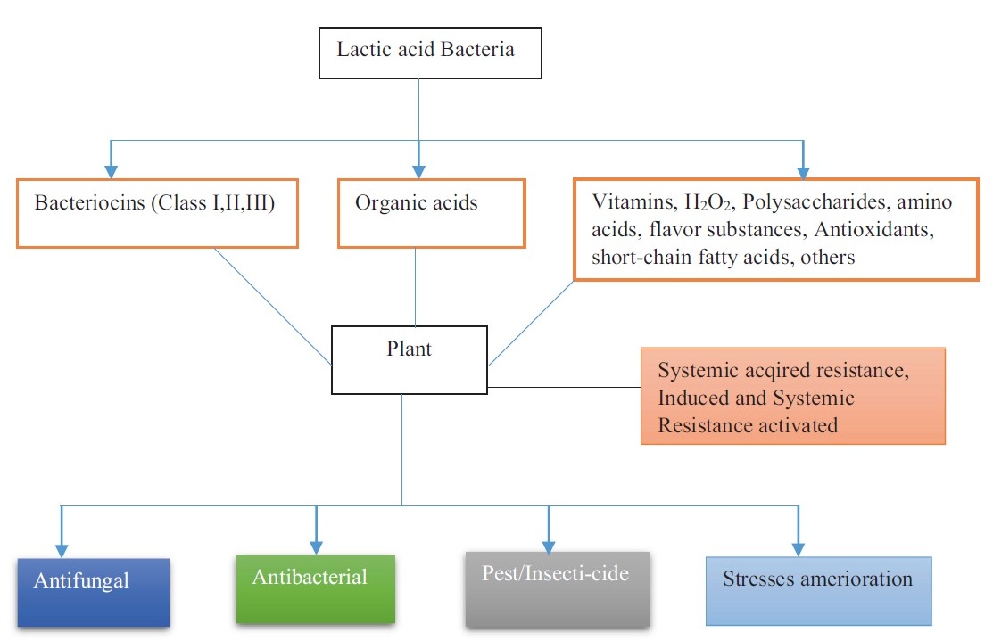

Figure 3 The role of lactic acid bacteria in biocontrol and stress amelioration(Murindangabo et al., 2023)

**Dairy products:** Fungal contamination of dairy foods can occur at various stages, from dairy farms to different dairy processing units and consumers' homes (Garnier *et al.*, 2017). Dairy products are highly susceptible to fungal spoilage, which leads to economic losses and is a public health issue due to the possible production of mycotoxins (Fernandez *et al.*, 2017). *Lactobacillus plantarum, Lactobacillus rhamnosus* and *Lactobacillus casei* have been successfully used to combat fungal spoilage in dairy products (Fernandez *et al.*, 2017; Xu *et al.*, 2021).

**Bakery:** The most widespread fungal species contaminating bakery products belong to the genera *Aspergillus, Penicillium, Eurotium, Monilia, Mucor, Endomyces, Cladosporium, Fusarium* and *Rhizopus* (Lavermicocca *et al.*, 2000; Lavermicocca *et al.*, 2003; Guynot *et al.*, 2005); they are responsible for off-flavors, the production of mycotoxins and allergenic compounds.

**Silage:** Lactic acid bacteria (LAB) have applications in many industrial fields, and play an important role in the process of preserving wet fodder for animal feed (silage). The basic principle of silage is to store surplus forage, preserving its stability and nutritional value until it is needed to feed animals. This process takes place under anaerobic conditions, where Enterococcus *faecalis, E. lactis, E. faecium, Lactocillus plantarum, Lb. acidophilus, Lb. brevis, Lb. buchneri, Lb. casei, Lb. citrovorum, Lb. curvatus, Lb. dextranicum, Lb. fermentum, Lb. mesenteroides, Lb. viridescens, Pediococcus acidilactici, Ped. cerevisae, Ped. pentosaceus* inhibit the proliferation of spoilage microorganisms, which are less tolerant of acidic conditions (Santos *et al.*, 2013; Paradhipta *et al.*, 2021).

Fresh fruit and vegetables naturally contain microorganisms that eventually spoil them, but some of these microorganisms (*Lactobacillus, Leuconostoc, Weissella, Tetragenococcus and Pediococcus*) play a key role in their fermentation process (Gbashi *et al.*, 2023). Their metabolism releases carbon dioxide (CO2), ethanol (ethyl alcohol) and lactic and acetic acids from natural plant sugars, which often help to inhibit other harmful and undesirable microorganisms that may cause spoilage or undesirable characteristics in the final product. The CO2 produced helps maintain the low-oxygen conditions required by fermentative bacteria, while stabilizing the color and flavor of vegetables (Gbashi et al., 2023). LAB isolated from fresh fruit and vegetables have been used as biocontrol agents against the phytopathogenic and spoilage bacteria and fungi *Xanthomonas campestris, Erwinia carotovora, Penicillium expansum, Monilinia laxa*, and *Botrytis cinerea* (Trias et al., 2008).

Figure 4 illustrate the potential role of LAB and its metabolites in the food production and food security.



Figure 4 Food applications of LAB against fungal contamination

Source: (Bangar et al., 2021)

For (Trias *et al.*, 2008), (Roselló et al., 2013) and (Konappa et al., 2016) there are three known mechanisms by which LAB acts as a biocontrol agent:

1. through the production of antimicrobial compounds,
2. reactive oxygen species ;
3. and bacteriocins (nisin, reutericyclin, sakacin, lacticin, pediocin); by excluding pathogens by pre-emptively colonizing plant tissues vulnerable to infection, and by altering the plant immune response.

**Conclusion**

In the fight against global warming and, above all, to reduce the use of chemically-synthesized products in agriculture and agricultural products during storage and processing, it is essential for less advanced countries such as those in Africa to seek innovative solutions that protect the environment and consumer health by using bacteria naturally present in nature and in food matrices. Among these bacteria are the lactic acid bacteria that colonize most of our traditional products/foods such as mawè, agbélima, etc. in Togo. The symbiotic action of these bacteria with plants and their roots and soil microorganisms is an alternative path to be explored in order to reduce the use of chemical fertilizers in a sustainable agriculture. To achieve this, less advanced countries such as Togo need to invest in application research, by promoting the use of products by local populations and by equipping laboratories whose analyses will reassure consumers, but also enable isolated strains to be used for other useful purposes.

References

Abrunhosa, L., Morales, H., Soares, C., Calado, T., Vila-Chã, A.S., Pereira, M., Venâncio, A., 2016. A Review of Mycotoxins in Food and Feed Products in Portugal and Estimation of Probable Daily Intakes. Critical Reviews in Food Science and Nutrition 56, 249-265.

Avis, T.J., Gravel, V., Antoun, H., Tweddell, R.J., 2008. Multifaceted beneficial effects of rhizosphere microorganisms on plant health and productivity. Soil Biology and Biochemistry 40, 1733-1740.

Baffoni, L., Gaggia, F., Dalanaj, N., Prodi, A., Nipoti, P., Pisi, A., Biavati, B., Di Gioia, D., 2015. Microbial inoculants for the biocontrol of Fusarium spp. in durum wheat. BMC microbiology 15, 1-10.

Bangar, S.P., Sharma, N., Kumar, M., Ozogul, F., Purewal, S.S., Trif, M., 2021. Recent developments in applications of lactic acid bacteria against mycotoxin production and fungal contamination. Food Bioscience 44, 101444.

Bintsis, T., 2018. Lactic acid bacteria as starter cultures: An update in their metabolism and genetics. AIMS Microbiology 4, 665-684.

Blais, A., 2013. Lactic acid and bacillaceae fertilizer and method of producing same. Google Patents.

Caggianiello, G., Kleerebezem, M., Spano, G., 2016. Exopolysaccharides produced by lactic acid bacteria: from health-promoting benefits to stress tolerance mechanisms. Applied Microbiology and Biotechnology 100, 3877-3886.

Canarini, A., Kaiser, C., Merchant, A., Richter, A., Wanek, W., 2019. Root exudation of primary metabolites: mechanisms and their roles in plant responses to environmental stimuli. Frontiers in Plant Science 10, 157.

Chen, Y.S., Yanagida, F., Shinohara, T., 2005. Isolation and identification of lactic acid bacteria from soil using an enrichment procedure. Letters in applied microbiology 40, 195-200.

da Silva Sabo, S., Vitolo, M., González, J.M.D., Oliveira, R.P.d.S., 2014. Overview of Lactobacillus plantarum as a promising bacteriocin producer among lactic acid bacteria. Food Research International 64, 527-536.

Dalie, D.K.D., 2010. Biocontrôle des moisissures du genre Fusarium productrices de fumonisines par sélection de bactéries lactiques autochtones de maïs.

Dalie, D.K.D., Deschamps, A.M., Richard-Forget, F., 2010. Lactic acid bacteria – Potential for control of mould growth and mycotoxins: A review. Food Control 21, 370-380.

de Melo Pereira, G.V., Magalhães, K.T., Lorenzetii, E.R., Souza, T.P., Schwan, R.F., 2012. A multiphasic approach for the identification of endophytic bacterial in strawberry fruit and their potential for plant growth promotion. Microbial ecology 63, 405-417.

Djadouni, F., Kihal, M., 2012. Antimicrobial activity of lactic acid bacteria and the spectrum of their biopeptides against spoiling germs in foods. Brazilian Archives of Biology and Technology 55, 435-444.

Ekundayo, F.O., 2014. Isolation and identification of lactic acid bacteria from rhizosphere soils of three fruit trees, fish and ogi. International Journal of Current Microbiology and Applied Sciences 3, 991-998.

Eskola, M., Kos, G., Elliott, C.T., Hajšlová, J., Mayar, S., Krska, R., 2020. Worldwide contamination of food-crops with mycotoxins: Validity of the widely cited ‘FAO estimate’ of 25%. Critical Reviews in Food Science and Nutrition 60, 2773-2789.

Fernandez, B., Vimont, A., Desfossés-Foucault, É., Daga, M., Arora, G., Fliss, I., 2017. Antifungal activity of lactic and propionic acid bacteria and their potential as protective culture in cottage cheese. Food Control 78, 350-356.

Fickers, P., Destain, J., Thonart, P., 2008. Les lipases sont des hydrolases atypiques: principales caractéristiques et applications. Biotechnologie, agronomie, société et environnement 12.

Fitzpatrick, J.J., O'Keeffe, U., 2001. Influence of whey protein hydrolysate addition to whey permeate batch fermentations for producing lactic acid. Process Biochemistry 37, 183-186.

Gaggìa, F., Baffoni, L., Di Gioia, D., Accorsi, M., Bosi, S., Marotti, I., Biavati, B., Dinelli, G., 2013. Inoculation with microorganisms of Lolium perenne L.: evaluation of plant growth parameters and endophytic colonization of roots. New biotechnology 30, 695-704.

Garnier, L., Valence, F., Mounier, J., 2017. Diversity and control of spoilage fungi in dairy products: An update. Microorganisms 5, 42.

Gbashi, S., Moyo, S.M., Olopade, B., Kewuyemi, Y., Areo, O.M., Lawal, O.M., Momoh, C.O., Igbashio, M.D., Njobeh, P.B., 2023. African fermented vegetable and fruit-based products. Indigenous Fermented Foods for the Tropics. Elsevier, pp. 227-244.

Giassi, V., Kiritani, C., Kupper, K.C., 2016. Bacteria as growth-promoting agents for citrus rootstocks. Microbiological Research 190, 46-54.

Gonelimali, F.D., Lin, J., Miao, W., Xuan, J., Charles, F., Chen, M., Hatab, S.R., 2018. Antimicrobial properties and mechanism of action of some plant extracts against food pathogens and spoilage microorganisms. Frontiers in microbiology 9, 1639.

Guynot, M.E., Marin, S., Setu, L., Sanchis, V., Ramos, A.J., 2005. Screening for antifungal activity of some essential oils against common spoilage fungi of bakery products. Food Science and Technology International 11, 25-32.

Henry, G., Thonart, P., Ongena, M., 2012. PAMPs, MAMPs, DAMPs and others: an update on the diversity of plant immunity elicitors. BASE.

Hidalgo, D., Corona, F., Martín-Marroquín, J.M., 2022. Manure biostabilization by effective microorganisms as a way to improve its agronomic value. Biomass Conversion and Biorefinery 12, 4649-4664.

Higa, T., 2001. The technology of effective microorganisms–Concept and philosophy in Proceedings of a Seminar on the Application of Effective Microorganisms (EM) Techniques in Organic Farming. organised by the International Society of

the Royal Agricultural College.

Higa, T., Kinjo, S., 1991. Effect of lactic acid fermentation bacteria on plant growth and soil humus formation. In: In: Parr, J.F., Hornick, S.B., Whitman, C.E. (Eds.), Proceedings of the First International Conference on Kyusei Nature Farming. , US Department of Agriculture, Washington, DC,, pp. 140-147.

Holzapfel, W.H., Wood, B.J.B., 2014. Introduction to the LAB. Lactic acid bacteria: Biodiversity and taxonomy, 1-12.

Ji, C., Fan, Y., Zhao, L., 2016. Review on biological degradation of mycotoxins. Animal Nutrition 2, 127-133.

Kang, S.-M., Radhakrishnan, R., You, Y.-H., Khan, A.L., Park, J.-M., Lee, S.-M., Lee, I.-J., 2015. Cucumber performance is improved by inoculation with plant growth-promoting microorganisms. Acta Agriculturae Scandinavica, Section B — Soil & Plant Science 65, 36-44.

Katz, M., Medina, R., Gonzalez, S., Oliver, G., 2002. Esterolytic and Lipolytic Activities of Lactic Acid Bacteria Isolated from Ewe's Milk and Cheese. Journal of Food Protection 65, 1997-2001.

Klaenhammer, T.R., Barrangou, R., Buck, B.L., Azcarate-Peril, M.A., Altermann, E., 2005. Genomic features of lactic acid bacteria effecting bioprocessing and health. FEMS Microbiology Reviews 29, 393-409.

Konappa, N.M., Maria, M., Uzma, F., Krishnamurthy, S., Nayaka, S.C., Niranjana, S.R., Chowdappa, S., 2016. Lactic acid bacteria mediated induction of defense enzymes to enhance the resistance in tomato against Ralstonia solanacearum causing bacterial wilt. Scientia Horticulturae 207, 183-192.

Kröckel, L., 2013. The role of lactic acid bacteria in safety and flavour development of meat and meat products. Lactic Acid Bacteria—R & D for Food, Health and Livestock Purposes; Kongo, JM, Ed, 129-151.

Lambrechts, M.G., Pretorius, I.S., 2000. Yeast and its importance to wine aroma.

Lamont, J.R., Wilkins, O., Bywater-Ekegärd, M., Smith, D.L., 2017. From yogurt to yield: Potential applications of lactic acid bacteria in plant production. Soil Biology and Biochemistry 111, 1-9.

Lavermicocca, P., Valerio, F., Evidente, A., Lazzaroni, S., Corsetti, A., Gobbetti, M., 2000. Purification and characterization of novel antifungal compounds from the sourdough Lactobacillus plantarum strain 21B. Applied and environmental microbiology 66, 4084-4090.

Lavermicocca, P., Valerio, F., Visconti, A., 2003. Antifungal activity of phenyllactic acid against molds isolated from bakery products. Applied and Environmental Microbiology 69, 634-640.

Li, Y., Park, S.Y., Zhu, J., 2011. Solid-state anaerobic digestion for methane production from organic waste. Renewable and Sustainable Energy Reviews 15, 821-826.

Liu, W., Pang, H., Zhang, H., Cai, Y., 2014. Biodiversity of lactic acid bacteria. Lactic acid bacteria: Fundamentals and practice, 103-203.

Lynch, J.M., 1985. Origin, Nature and Biological Activity of Aliphatic Substances and Growth Hormones Found in Soil. In: Vaughan, D., Malcolm, R.E. (Eds.), Soil Organic Matter and Biological Activity. Springer Netherlands, Dordrecht, pp. 151-174.

Maicas, S., Gil, J.-V., Pardo, I., Ferrer, S., 1999. Improvement of volatile composition of wines by controlled addition of malolactic bacteria. Food Research International 32, 491-496.

Messaoudi, A., Belguith, H., Gram, I., Hamida, J.B., 2010. Classification of EC 3.1. 1.3 bacterial true lipases using phylogenetic analysis. African journal of biotechnology 9, 8243-8247.

Minervini, F., Celano, G., Lattanzi, A., Tedone, L., De Mastro, G., Gobbetti, M., De Angelis, M., 2015. Lactic acid bacteria in durum wheat flour are endophytic components of the plant during its entire life cycle. Applied and environmental microbiology 81, 6736-6748.

Mohite, B., 2013. Isolation and characterization of indole acetic acid (IAA) producing bacteria from rhizospheric soil and its effect on plant growth. Journal of soil science and plant nutrition 13, 638-649.

Muhialdin, B.J., Hassan, Z., Saari, N., 2013. Lactic acid bacteria in biopreservation and the enhancement of the functional quality of bread. Lactic acid bacteria R & D for food, health and livestock purposes, 155-172.

Mundt, J.O., Hammer, J.L., 1968. Lactobacilli on plants. Applied microbiology 16, 1326-1330.

Murindangabo, Y.T., Kopecký, M., Perná, K., Nguyen, T.G., Konvalina, P., Kavková, M., 2023. Prominent use of lactic acid bacteria in soil-plant systems. Applied Soil Ecology 189, 104955.

Nguyen, N.K., Dong, N.T.N., Nguyen, H.T., Le, P.H., 2015. Lactic acid bacteria: promising supplements for enhancing the biological activities of kombucha. SpringerPlus 4, 91.

Ogunbanwo, S.T., Rashidat, O.O., Oladele, A.C., Chigozie, O., 2020. Bio-control of Vibrio species in cultured milk by in situ bacteriocin production from lactic acid bacteria. World Journal of Advanced Research and Reviews 6, 050-058.

Paradhipta, D.H.V., Joo, Y.H., Lee, H.J., Lee, S.S., Noh, H.T., Choi, J.S., Kim, J., Min, H.G., Kim, S.C., 2021. Effects of Inoculants Producing Antifungal and Carboxylesterase Activities on Corn Silage and Its Shelf Life against Mold Contamination at Feed-Out Phase. Microorganisms 9.

Partanen, P., Hultman, J., Paulin, L., Auvinen, P., Romantschuk, M., 2010. Bacterial diversity at different stages of the composting process. BMC microbiology 10, 1-11.

Paulsen, H.M., Schrader, S., Schnug, E., 2009. A critical assessment of the Rusch theory on soil fertility as basis for soil management in organic farming. Landbauforschung Völkenrode 59, 253-268.

Pfeiler, E.A., Klaenhammer, T.R., 2007. The genomics of lactic acid bacteria. Trends in microbiology 15, 546-553.

Raman, J., Kim, J.-S., Choi, K.R., Eun, H., Yang, D., Ko, Y.-J., Kim, S.-J., 2022. Application of Lactic Acid Bacteria (LAB) in Sustainable Agriculture: Advantages and Limitations. International Journal of Molecular Sciences.

Reyes-Escogido, L., Balam-Chi, M., Rodríguez-Buenfil, I., Valdés, J., Kameyama, L., Martínez-Pérez, F., 2010. Purification of bacterial genomic DNA in less than 20 min using chelex-100 microwave: examples from strains of lactic acid bacteria isolated from soil samples. Antonie van Leeuwenhoek 98, 465-474.

Roselló, G., Bonaterra, A., Francés, J., Montesinos, L., Badosa, E., Montesinos, E., 2013. Biological control of fire blight of apple and pear with antagonistic Lactobacillus plantarum. European Journal of Plant Pathology 137, 621-633.

Rzhevskaya, V.S., Teplitskaya, L.M., Oturina, I.P., 2013. Colonization of rhizoplane of cucumber roots by microorganisms which are components of the microbial preparation “Embiko®”. Regulatory Mechanisms in Biosystems 4, 63-70.

Sadiq, F.A., Yan, B., Tian, F., Zhao, J., Zhang, H., Chen, W., 2019. Lactic Acid Bacteria as Antifungal and Anti-Mycotoxigenic Agents: A Comprehensive Review. Comprehensive Reviews in Food Science and Food Safety 18, 1403-1436.

Santos, E.M., Silva, T.C., Macedo, C.H.O., Campos, F.S., 2013. Lactic acid bacteria in tropical grass silages. Lactic Acid Bacteria-R and D for Food, Health and Livestock Purposes. Kongo, M. Ed. InTech, Croatia, 335-362.

Sathe, S.J., Nawani, N.N., Dhakephalkar, P.K., Kapadnis, B.P., 2007. Antifungal lactic acid bacteria with potential to prolong shelf‐life of fresh vegetables. Journal of Applied Microbiology 103, 2622-2628.

Sawadogo‐Lingani, H., Diawara, B., Traoré, A.S., Jakobsen, M., 2008. Technological properties of Lactobacillus fermentum involved in the processing of dolo and pito, West African sorghum beers, for the selection of starter cultures. Journal of Applied Microbiology 104, 873-882.

Shrestha, A., Kim, B.S., Park, D.H., 2014. Biological control of bacterial spot disease and plant growth-promoting effects of lactic acid bacteria on pepper. Biocontrol Science and Technology 24, 763-779.

Somers, E., Amke, A., Croonenborghs, A., van Overbeek, L.S., Vanderleyden, J., 2007. Lactic acid bacteria in organic agricultural soils.

Stevens, D.F., Ough, C.S., 1993. Ethyl carbamate formation: reaction of urea and citrulline with ethanol in wine under low to normal temperature conditions. American Journal of Enology and Viticulture 44, 309-312.

Taale, E., Djery, B., Sina, H., Kogno, E., Karou, S.D., Traore, A.S., Baba-Moussa, L., Savadogo, A., Ameyapoh, Y., 2020. Indigenous Food and Food Products of West Africa: Employed Microorganisms and Their Antimicrobial and Antifungal Activities Non Ribosomal Peptide Synthetase View project Fight against diabetes in Benin View project. In: Verma, D.K., Patel, A.R., Srivastav, P.P., Mohapatra, B., Niamah, A.K. (Eds.), Microbiology for food and health: Technological development and advances. Apple Academic Press, Inc., Canada, pp. 149-194.

Taale, E., Savadogo, A., Zongo, C., Ilboudo, A.J., Traore, A.S., 2013. Bioactive molecules from bacteria strains: case of bacteriocins producing bacteria isolated from foods. Current Research in Microbiology and Biotechnology 1, 80-88.

Tapsoba, F.W.-B., Waré, L.Y., Samandoulougou, S., Compaoré-Sérémé, D., Sawadogo-Lingani, H., 2023. Use of exopolysaccharides from lactic acid bacteria to develop cereal-based food: Perspectives and challenges for Burkina Faso. Lactic Acid Bacteria as Cell Factories, 153-163.

Tapsoba, F.W., Sawadogo-Lingani, H., Coda, R., Compaore-Sereme, D., Katina, K., Kabore, D., Haro, H., Dicko, M.H., Maina, N.H., 2017. Characterization of exopolysaccharides producing LAB isolated from Zoom-koom, a cereal-based traditional beverage from Burkina Faso. International Journal of Biosciences 11, 45-60.

Trias, M.R., Bañeras Vives, L., Montesinos Seguí, E., Badosa Romañó, E., 2008. Lactic acid bacteria from fresh fruit and vegetables as biocontrol agents of phytopathogenic bacteria and fungi. International Microbiology, 2008, núm. 11. p. 231-236.

Tsavkelova, E.A., Klimova, S.Y., Cherdyntseva, T.A., Netrusov, A.I., 2006. Microbial producers of plant growth stimulators and their practical use: a review. Applied biochemistry and microbiology 42, 117-126.

Vessey, J.K., 2003. Plant growth promoting rhizobacteria as biofertilizers. Plant and soil 255, 571-586.

Vinderola, G., Perdigón, G., Duarte, J., Farnworth, E., Matar, C., 2006. Effects of the oral administration of the exopolysaccharide produced by Lactobacillus kefiranofaciens on the gut mucosal immunity. Cytokine 36, 254-260.

Wagacha, J.M., Muthomi, J.W., 2008. Mycotoxin problem in Africa: current status, implications to food safety and health and possible management strategies. Int J Food Microbiol 124, 1-12.

Wang, Y., Bi, L., Liao, Y., Lu, D., Zhang, H., Liao, X., Liang, J.B., Wu, Y., 2019. Influence and characteristics of Bacillus stearothermophilus in ammonia reduction during layer manure composting. Ecotoxicology and environmental safety 180, 80-87.

Wang, Y., Wu, J., Lv, M., Shao, Z., Hungwe, M., Wang, J., Bai, X., Xie, J., Wang, Y., Geng, W., 2021. Metabolism Characteristics of Lactic Acid Bacteria and the Expanding Applications in Food Industry. Frontiers in Bioengineering and Biotechnology 9.

Xu, R., Sa, R., Jia, J., Li, L., Wang, X., Liu, G., 2021. Screening of Antifungal Lactic Acid Bacteria as Bioprotective Cultures in Yogurt and a Whey Beverage. Journal of Food Protection 84, 953-961.

Yanagida, F., Chen, Y.-s., Shinohara, T., 2005. Isolation and characterization of lactic acid bacteria from soils in vineyards. The Journal of general and applied microbiology 51, 313-318.

Yanagida, F., Chen, Y.-s., Shinohara, T., 2006. Searching for bacteriocin-producing lactic acid bacteria in soil. The Journal of General and Applied Microbiology 52, 21-28.

Younis, O.S., Stewart, G.G., 1998. SUGAR UPTAKE AND SUBSEQUENT ESTER AND HIGHER ALCOHOL PRODUCTION BY SACCHAROMYCES CEREVISIAE. Journal of the Institute of Brewing 104, 255-264.

Zannini, E., Waters, D.M., Coffey, A., Arendt, E.K., 2016. Production, properties, and industrial food application of lactic acid bacteria-derived exopolysaccharides. Applied Microbiology and Biotechnology 100, 1121-1135.