**CHAPTER 1: Quantum Mechanics at a Glance for Beginners**

1. Dr. Arvind Kumar Sharma, Professor (Department of Physics), Swami Vivekanand Subharti University, Meerut- 250005

Email: arvindsharmaphy@gmail.com

2. Dr. Mohd. Israil, Associate Professor (Department of Physics), Swami Vivekanand Subharti University, Meerut- 250005

Email: israilsaifi@gmail.com

3. Dr. Nirdesh Kumar Singh, Associate Professor (Department of Physics), Swami Vivekanand Subharti University, Meerut- 250005

Email: [k_nirdeshsingh@rediffmail.com](mailto:k_nirdeshsingh@rediffmail.com)

##### 1.0 Introduction- As we know that Mechanics is a branch of physics which deals the motion of objects. It is mainly divided into four types on the basis of size and speed of objects given in (Table- 1):

**Table 1-**

|  |  |  |  |  |
| --- | --- | --- | --- | --- |
| **S.No.** | **Mechanics** | **Size of object** | **Speed of object v** | **Examples** |
| 1 | Classical or Newtonian Mechanics | Macroscopic (i.e. size greater than that of atoms) | $$v≪Speed of light c$$ $$(≈3×{10}^{8} m/s)$$ | Motion of bicycle, scooter, car, train. Aeroplane etc. |
| 2 | Quantum Mechanics | Microscopic (i.e. size comparable to atoms) | $$v≪c$$ | Motion of atom, molecule, electron, proton, neutron etc. |
| 3 | Relativistic Mechanics | Macroscopic | $$v ≈c$$ | Motion of photon, meson etc. |
| 4 | Relativistic Quantum Mechanics or Quantum Field Theory | Microscopic | $$v ≈c$$ | Motion of EM radiations |

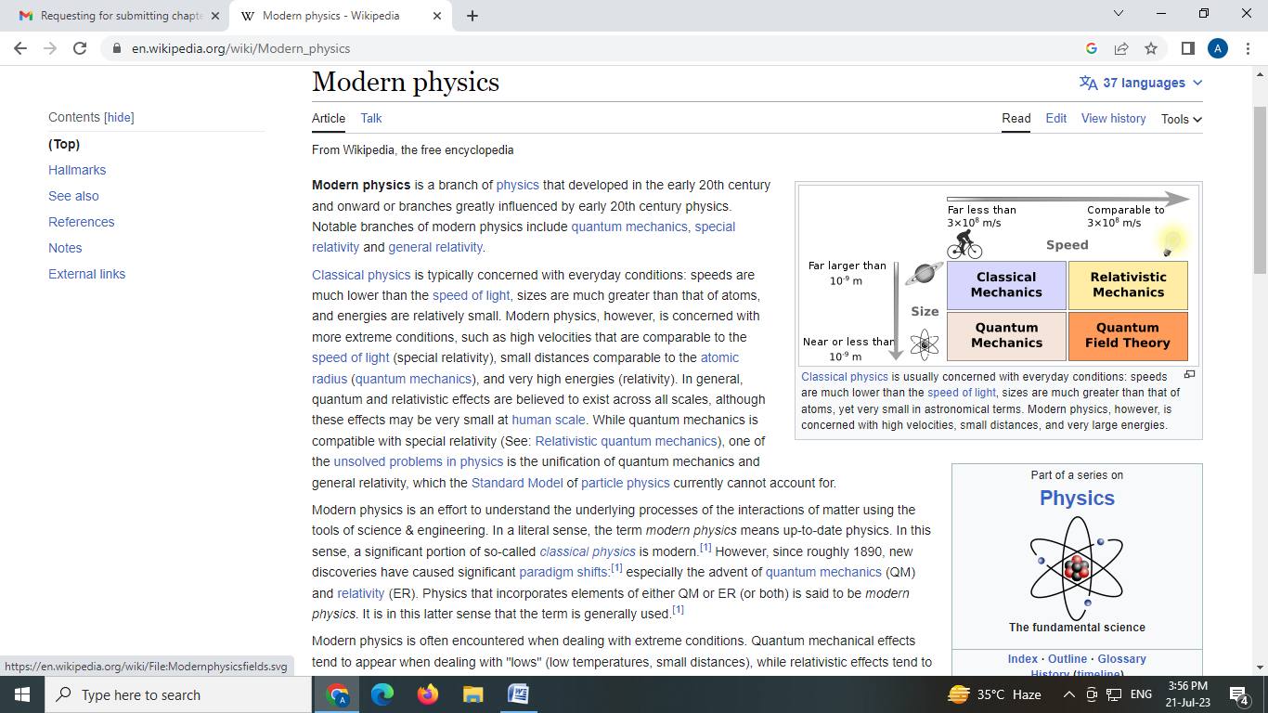

**(Courtesy to Google website)**

The word “quantum” comes from the Latin word which means “how much”. Quantum mechanics is the study of how atomic particles exist and interact with each other. Quantum models always involve something coming in discrete amounts e.g. energy $E=n hν$, where $n=0, 1, 2,3, ⋯$ where $h (=6.67×{10}^{-34}J s or {6.67×{10}^{-34}}/{1.6×{10}^{-19}=}4.1356677×{10}^{-15} eV⋅s )$ is a fundamental physical constant occurring in quantum mechanics called **Planck constant**. The reduced Planck constant or Dirac constant is denoted by **ħ = h/2π**. **Niels Bohr and Max Planck** are the founding fathers of Quantum Physics; each received a Nobel Prize in Physics for their work on quanta.

A great revolution occurs in Physics during 1900- 1930.**Quantum mechanics** is the study of matter and its interactions with energy on the scale of atomic and subatomic particles. This era was called Quantum Mechanics (QM). QM is applied to explain the behavior of microscopic particles (e.g. electrons, protons, neutrons, hydrogen atom, potential wells, potential barriers, tunneling etc.). The idea of quantization was first introduced by **Max Planck** in 1900 to explain the whole spectrum of black- body. Most of the inventions are made by several Physicists including Albert Einstein (Photo electric Effect), Arthur Holly Compton (Compton Effect), Werner Heisenberg (Heisenberg’s uncertainty relations), **Louis Victor de Broglie** (Matter Waves or de Broglie waves), Erwin Schrödinger (Schrödinger wave equations), **Max Born** (Wave functions) and Paul Adrien Maurice Dirac (Dirac equation) etc. Quantum theory converts into classical physics when size of the particle becomes macroscopic. In quantum mechanics, particles have wavelike properties, and a particular wave equation, the Schrödinger equation, governs how these waves behave in different situations.

The first law of quantum physics states that the boundary between matter and energy is not always in a state of stability or finite, i.e. everything is made of matter and energy. The relationship between matter and energy is exhibited at different atomically levels. There are basically four important principles of quantum mechanics, proven experimentally and which apply to the behavior of nuclear particles at small distances: the quanta of electromagnetic energy, the uncertainty principle, the Pauli Exclusion Principle, and the wave theory of particles of matter.

Applications of quantum mechanics are based upon quantum effects, like integrated circuits and lasers. Quantum mechanics is also critically important for understanding how individual atoms are joined by covalent bonds to form molecules. **Quantum mechanics is practical used in** Lasers, Solar cells, Electron microscopes, Atomic clocks used for GPS, MRI scanners for medical imaging. It is typically applied to microscopic systems, e.g. molecules, atoms and sub-atomic particles. The waves could be measured in particle-like small packets of energy called quanta led to the branch of physics that deals with atomic and subatomic systems which we today call Quantum Mechanics.

Thus, Quantum mechanics is the branch of physics that deals with the behavior of matter and energy on the scale of atoms and subatomic particles or waves. The term "quantum mechanics" was first coined by Max Born in 1924.In this chapter we will discuss **Particle Properties of Waves**: Spectrum of Black Body radiation, Compton Effect, Photoelectric effect, and their explanations based on Max Planck’s Quantum hypothesis. **Wave Properties of Particles**: Louis de Broglie’s hypothesis of matter waves and their experimental verification by Davisson- Germer’s experiment and Thomson’s experiment.

##### In the honour of Max Planck the whole world celebrate World Quantum Day on 14 April, i.e. a reference to 4.14 due to $h \left(4.1356677×{10}^{-15} eV⋅s \right).$ World Quantum Day is an annual celebration for promoting public awareness and understanding of quantum science and technology around the world. Quantum Mechanics or Relativity (or both) is said to be Modern Physics.

##### Quantum entanglement (i.e. Entangle Photons) is the phenomenon that occurs when a group of [particles](https://en.wikipedia.org/wiki/Particle) are generated, interact, or share spatial proximity in a way such that the [quantum state](https://en.wikipedia.org/wiki/Quantum_state) of each particle of the group cannot be described independently of the state of the others, including when the particles are separated by a large distance. Quantum entanglement is when a system is in a "superposition" of more than one state.  Entanglement is a primary feature of quantum mechanics which is not present in classical mechanics. Entanglement is a special kind of superposition that involves two separated locations in space.

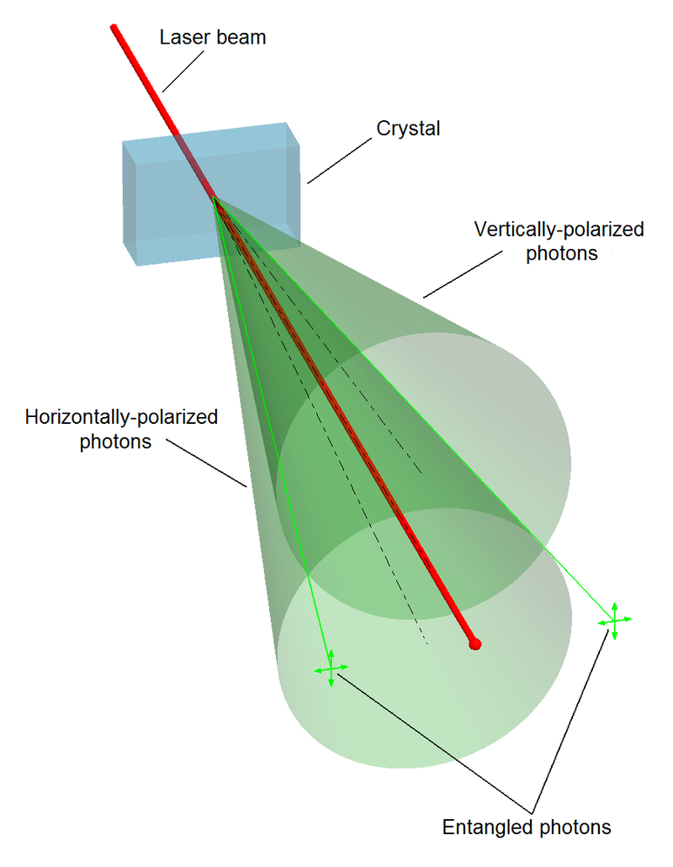

**(Courtesy to Google website)**

[Measurements](https://en.wikipedia.org/wiki/Measurement#Quantum_mechanics) of [physical properties](https://en.wikipedia.org/wiki/Physical_properties) such as [position](https://en.wikipedia.org/wiki/Position_(vector)), [momentum](https://en.wikipedia.org/wiki/Momentum), [spin](https://en.wikipedia.org/wiki/Spin_(physics)), and [polarization](https://en.wikipedia.org/wiki/Polarization_(waves)) performed on entangled particles can, in some cases, be found to be perfectly [correlated](https://en.wikipedia.org/wiki/Correlated). For example, if a pair of entangled particles is generated such that their total spin is known to be zero, and one particle is found to have clockwise spin on a first axis, then the spin of the other particle, measured on the same axis, is found to be anticlockwise.

**Examples-**

1. If someone toss (or flip) a coin but doesn't look at the result. The fellow knows it is either heads or tails. The fellow just doesn’t know which it is. Superposition means that it is not just unknown to the fellow, its state of heads or tails does not even exist until you look at it (make a measurement). Similarly, entanglement (superposition of two separate places) of a group of photos, it could be a photon encountering on a 50-50 splitter. After the splitter, the photon could be in path A, or it could be in path B. In this case, the superposition is between

* a photon in path A and no photon in path B
* no photon in path A and a photon in path B.

As a normal human being, the fellow thinks that it is in just one path or the other path, and it is just that one does not know about. But in fact, it is in both, until you actually measure it. Again, that normal human being wants to say that if I measured it and found it in path A.

|  |  |  |
| --- | --- | --- |
| **S.N**. | **EM Wave** | **Matter Wave** |
| 1 | An oscillating charged particle gives rise to the EM wave. | A matter wave is associated with a moving microscopic particle. |
| 2 | The speed of an EM wave is constant in a medium. Its speed is  in vacuum. | Its speed is always greater than the speed of light. |
| 3 | Its wave length is inversely proportional to the energy of photon, i.e. . | Its wave length is inversely proportional to the momentum of microscopic particle, i.e. . |
| 4 | An EM wave can be radiated into space by an oscillating charged particle. | A Matter wave cannot be emitted by a moving microscopic particle. |
| 5 | In an EM wave its electric and magnetic fields oscillate  to the direction of motion. | A de- Broglie wave is associated with neutral and charged microscopic particles. A charged moving microscopic particle has electric and magnetic fields. |

1.1 **de-Broglie concept of matter waves-**

|  |  |
| --- | --- |
| Louis de Broglie | **Prince Louis-Victor de Broglie** [15thAugust, 1892 – 19th March, 1987]-In **1924**, French physicist first time introduced the idea of matter wave or de Broglie wave. In **1929**, de Broglie was awarded **Nobel Prize** for this discovery **‘the wave nature of electron’**.**(Courtesy to Google website)** |

Up to 1923, a matter was considered to be particle in nature. de Broglie extended the idea of dual nature of light to all microscopic particles (e.g. electrons, protons, neutrons, alpha particles etc.). According to quantum hypothesis, a light consists of packets of energy called photons. de Broglie deduced the connection between particle nature and wave nature from the Planck’s energy formula and Einstein’s energy- mass relation of electromagnetic (EM) wave.



where h is Planck’s constant, is frequency of EM wave and  is wavelength of EM wave





 or, ⇒

E and P are the characteristics of particle whereas  and  are the characteristics of wave. Thus, particle and wave natures are related to each other by the Planck’s constant h which gives dual nature of EM wave (or light).

Louis de Broglie proposed a hypothesis which is known as **de Broglie hypothesis** i.e. **a moving particle is associated with a wave which is called de Broglie or matter wave.** A moving macroscopic particle has two different velocities namely one corresponds to the mechanical motion of the particle denoted  by and other corresponds to matter wave denoted by.From eqs. (1.201) and (1.202) we put the value of  and from the formula of matter wave in equation.



**Properties of matter waves-**

1. These waves are generated only when microscopic particles are in motion. If speed  of the particle is zero (i.e.) then the wavelength of matter wave  on the other hand if  then.
2. These waves are independent of nature of microscopic particles, i.e. either the particles are charged or neutral.

3. Speed of matter waves is always greater than the speed of light, i.e.  .

**Note- A matter wave cannot be split as electromagnetic waves do this.**

**The experimental proof of de Broglie wave for slow electron was given by Davisson- Germer and for fast moving electron was given by G.P. Thomson.** In **1937**, C.J. Davisson and G.P. Thomson shared **Nobel Prize** for experimental confirmation of matter waves.

**Application of de Broglie wave- Bohr’s condition for the quantization of angular momentum**

Let an electron of mass  is revolving with velocity in an nth circular orbit of radius  around the nucleus of an atom (e.g. hydrogen atom). According to de Broglie hypothesis, wavelength of the de Broglie wave is given by:



Here, the motion of the electron can be thought as the wave of  traveling along the circumference of the orbit. Thus, for a circular path its circumference is integral multiple of the wavelength, i.e.





⇒

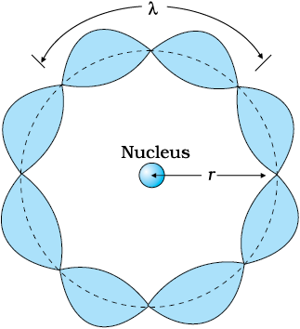 **(Courtesy to Google website)** It represents Bohr’s condition for the quantization of angular momentum

**Example 1.101- Why do not we see the wave properties of a macroscopic object (e.g. baseball, cat, man, elephant, earth etc.)?**

**Solution 1.101-** An object will appear wave like if it exhibits interference or diffraction pattern when its size ‘a’ is of the order of the wavelength, i.e. . But in case of macroscopic objects the essential condition of diffraction is not satisfied.

**Example 1.102-Does, de Broglie hypothesis have any relevance to macroscopic matter?**

**Solution 1.102-**de Broglie relation can be applied to both microscopic and macroscopic. For example A car (i.e. a macroscopic object) of mass 100 Kg is moving at a speed of 100 m/s then it will have de- Broglie Wavelength $λ= \frac{6.63×{10}^{-34}}{100 ×100}=6.63×{10}^{-30} m$

The car consists of very small wavelength which corresponds to high frequencies. Waves below certain wavelength or beyond certain frequencies undergo particle-antiparticle annihilation to create mass. So, wave nature or de Broglie wavelength is not observable in the macroscopic matter.

**1.2 Phase velocity (or wave velocity)** **-**When a single wave of definite wavelength  travels in a medium, then its velocity of propagation in the medium is called the phase velocity **or** the velocity with which a point of constant phase moves is called phase velocity.

Propagation of a wave along positive x- axis is given as:



where  is amplitude of the wave,  is wave vector,  is position vector and  is angular frequency of the wave.

The phase of the wave is 

When the phase is constant at a point then 

Or, 

Thus, phase velocity  is given by:

⇒

$$V_{p}= \frac{ω}{k}$$

When wavelength  of a wave is greater (or smaller) than the separation  between two consecutive particles of the medium in which it propagates, then the medium is known as non- dispersive (or dispersive) medium, i.e. . In a **non- dispersive medium** is **constant**, i.e. waves of different frequencies and wavelengths travels with same velocity. **Examples**- (i) free space is non- dispersive medium for electromagnetic waves. (ii) Air is non- dispersive medium for sound waves. (iii) A continuous string is non- dispersive medium for transverse waves produced in it. In a **non- dispersive medium** is **not constant.**

**Group velocity (or particle velocity****)** **-**From the relation between particle velocity  and de Broglie wave velocity  we have:



It is clear from above expression that a material particle a not be equivalent to a single wave because. This difficulty was resolved by **Erwin Schrödinger**. He assumed that that moving material particle is not equivalent to a single wave but equivalent to a wave packet. A wave packet consists of a group of waves. Each wave has slightly different velocity and wavelength. The amplitude of each wave is so chosen that they interfere constructively over a small region of space where the particle can be localized and outside of this region they interfere destructively so the amplitude of the resultant waves falls rapidly to zero.

A wave packet is a small region of constructive interference between two (or more) waves of same amplitude but slightly different angular frequencies which is formed by the superposition the waves. Let these waves having the amplitude  but slightly different angular frequencies and; and slightly different wave numbers  and are moving along x- axis. Let the two waves are mathematically represented by:





Applying the principle of superposition we have:







Since  and  are very small quantities, then and. Thus, above equation becomes as:



where is the amplitude of the wave packet. It changes both in space and time by a very slow-moving envelope of frequency  and wave number. It forms a standing wave which can be imagined by combining two identical waves moving in opposite directions. This represents beats. The phase of the wave packet is

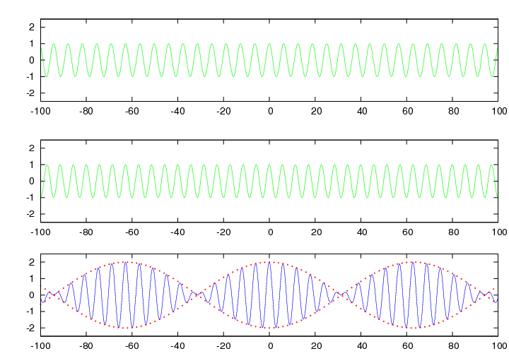

**(Courtesy to Google website)**

The observed velocity of the wave group or wave packet is called **group velocity**.It is defined as:



(i) Relation between phase and group velocities- From the formula of phase velocity, we have the angular frequency.





⇒

For normal dispersive medium is positive. This shows that .

For anomalous dispersive medium is negative. This shows that .

For non- dispersive medium is zero. This shows that .

(ii) Relation between particle, phase  and group  velocities- According to de Broglie hypothesis, a moving microscopic particle consists of a group of waves. The total energy  and momentum  of the particle are given

Case (i) relativistic mechanics: Total energy  is given by

or, 

Angular frequency  is given as:

, where 





Wave number  is given as:







On dividing eq. (1.211) from eq. (1.212), we have phase velocity





⇒



Case (ii) In Non- relativistic mechanics: Total energy  is given by



From de Broglie concept, we have:



The phase velocity is given by:

⇒



**Ex. 1.201- Calculate the phase velocity given by $E_{x}= E_{0}\cos\left(ωt-kz\right) A/m$ with a frequency of 5 GHz and a wavelength in the material medium of 3.0 cm is**

**Sol. 1.201- Given: $v=5 GHz= {5 X10}^{9}Hz, λ=3.0 cm \& c= {3 X10}^{8} m/s$**

$$v_{p}= \frac{ω (=2πv)}{k (=\frac{2π}{λ})}=vλ= {5X10}^{9} X .03=1.5 {X10}^{8}m/s=c/2$$

**Ex. 1.202- Estimate the phase velocity of a wave having a group velocity of 6 x 106**is   
**Sol. 1.202- Given: $v_{g}=6X {10}^{6} m/s$**

$$v_{p}v_{g}= c^{2} or v_{p}= \frac{c^{2}}{v_{g}}=\frac{{\left(3X {10}^{8}\right)}^{2}}{6X {10}^{6}}= \frac{3X {10}^{10}}{2}=1.5 X {10}^{10}=150 X {10}^{8} m/s$$

**Q.1.203 1 MHz plane wave travelling in a dispersive medium has a phase velocity $3×{10}^{8}m/s$. The phase velocity as a function of wavelength is given by $v_{p}=K \sqrt{λ}$, where K is a constant. Calculate the group velocity.**

**Sol. 1.203 -**Given: f = 1 MHz, $v_{p}= 3×{10}^{8} m/s$& $v_{p}=K \sqrt{λ}$

$$v_{g}= v_{p}-λ\frac{dv_{p}}{dλ}= K \sqrt{λ}- λ \frac{dK \sqrt{λ}}{dλ} = K \sqrt{λ}- λK\frac{1}{2}\frac{1}{\sqrt{λ}}= \frac{K \sqrt{λ}}{2}$$

$$= \frac{v_{p}}{2}= \frac{3×{10}^{8}}{2}= 1.5×{10}^{8} m/s$$

**1.3 Heisenberg’s uncertainty principle (or the principle of indeterminacy) –**

|  |  |
| --- | --- |
|  | **Werner Karl Heisenberg** [5th December, 1901 – 1st February, 1976]- Werner Karl Heisenberg was a German theoretical physicist and philosopher who **discovered (1925) a way** to formulate quantum mechanics in terms of matrices. In 1927 he published his [uncertainty principle](https://www.britannica.com/science/uncertainty-principle). He got **Nobel Prize** in Physics **1932** for this work. **(Curtsey of Google)** |

**in case of microscopic particles** **it is impossible to determine exactly the position and momentum of them simultaneously.** Heisenberg's approach was to quantum mechanics as being matrix algebra. Similarly, some others canonical variables (e.g. energy and time; angular momentumand angular displacement ) cannot be determined simultaneously. Heisenberg’s uncertainty relations are: **,  & ** where $∆$ denotes uncertainty

There is an interesting story of Heisenberg, when he was driving a vehicle very fast and suddenly the beaked his at red light, he is stopped by a policeman then his answer is quoted in fellow as:

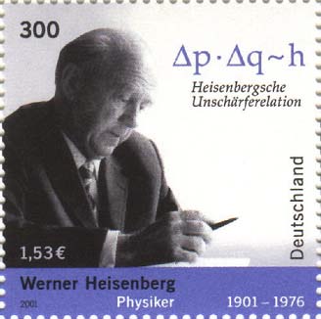**(Curtsey of Google)**

**Applications of Heisenberg’s uncertainty principle-**

* 1. Electrons cannot exists inside a nucleus
  2. Existence of protons and neutrons inside the nucleus of an atom
  3. Radius of Bohr’s first orbit
  4. Binding energy of an electron in an atom
  5. Zero point energy of a harmonic oscillator
  6. Zero point energy of a particle in one dimensional box
  7. Finite value for the natural width of a spectral line

|  |  |
| --- | --- |
|  | **Max Born** (11 December 1882 – 5 January 1970) was a German physicist and mathematician who developed [quantum mechanics](https://en.wikipedia.org/wiki/Quantum_mechanics). He won the 1954 [Nobel Prize in Physics](https://en.wikipedia.org/wiki/Nobel_Prize_in_Physics) for his "fundamental research in quantum mechanics, especially in the statistical interpretation of the [wave function](https://en.wikipedia.org/wiki/Wave_function)". **The term "quantum mechanics" is due to Born.** He also made contributions to [solid-state physics](https://en.wikipedia.org/wiki/Solid-state_physics) and [optics](https://en.wikipedia.org/wiki/Optics) and supervised the work of a number of notable physicists in the 1920s and 1930s. **(Curtsey of Google)** |

**1.4 Wave function and its Physical interpretation-**

In a water wave, the quantity varies periodically is height of the water surface (or level). In a sound, wave, the quantity varies periodically is pressure in the medium. Similarly, a quantity which varies in a matter wave is called wave function. It is denoted by Greek letter phi. The value of the wave function associated with a moving microscopic particle in particular position and time is concerned to the finding the probability there. Thus, displacement of a de Broglie wave is a wave function of space and time, i.e. . In general, a wave function  is a complex quantity (real and imaginary parts). Let  is represented as:

$$ψ\left(\overset{→}{r,t}\right) = A + iB = ψ_{0}e^{i\left(\overset{→}{k}⋅\overset{→}{r} - ωt\right)} .....\left(\text{1.4}01\right)$$

where, A and B are real functions;  is amplitude of the wave;  is wave vector;  is position vector. The complex conjugate of  is given as:





It implies that probability is always real and positive quantity.

It is impossible to specify the position of a microscopic particle but it is possible to assign probabilities for observing it at any given position. The quantity, the square of the absolute value of, shows the intensity of matter wave. **Probability density** represents probability of finding the particle in a given unit volume at a given instant of time. Wave function  itself is not a measurable quantity but its probability density is measurable. **Note-**The displacement of any matter wave may be positive, negative or zero at any time but its **probability can never negative**.

The complex nature of the wave functionis no concern to us. Here, we are interested only in a single dimension (say x- axis) along the observing direction and for a given time.

**Max Born interpretation of wave function**-The probability that a particle will be found in the infinitesimal interval  about the point, denoted by  is



where  is complex conjugate of .

The probability that a particle be in a particular space and time must lie between 0 (i.e. the particle is not there) and 1 (i.e. the particle is there). Let us consider an intermediate probability is 0.3, i.e. there is 30% chance of finding the particle in the given space and time. The probability that the particle will be found in a certain region  is the integral of the probability density over the region is given by:



For a microscopic object, if the probability of finding the object over all space is finite then it is somewhere, i.e.

⇒ Normalization condition of a wave function

Besides being nonmalleable of the wave function, it must be single valued, since the probability density has only one particular value at a certain place and time and continuous. Every wave function can be normalized by multiplying it by a proper constant.

 is not normalized. It can be normalized if  is divided by the square root of the constant K, i.e..



This shows that the particle does not exist there.

* **Characteristics of a wave function-**A wave function to be acceptable over a specified interval, it must satisfy the following conditions:

(1)  Must be continuous and single valued everywhere.

(2) Its partial derivatives i.e.  must be continuous and single valued everywhere.

(3)  Must be nonmalleable i.e. it must has a finite value 1.

(4)  Must be a solution of Schrödinger’s wave equation.

**Physical significance of a wave function**- A wave function explains behaviors of the particle at a given position $\vec{r}$ and a given timet. The magnitude of the wave function is large in the region where the probability of finding the particle is high and it’s vice versa is also true. Thus, a wave function measures the probability of the particle around a particular position.

**Applications of wave functions-**

(i) To determine probability of finding a particle in a given space.

(ii) To determine average or expectation value of a physical observable quantity f is given as:

$<f> = \frac{\int_{-∞}^{∞}{{}^{*}\left(r, t\right)f_{op}(r, t) dτ}}{\int_{-∞}^{∞}{{}^{*}(r, t)(r, t) dτ}} ⋯⋯(1.404 ii)$ where $dτ=dx dydz$

In case of normalized wave function $\int_{-∞}^{∞}{{}^{*}(r, t)(r, t) dτ}=1$ the denominator of the above expression becomes unity, then

$$<f> = \int_{-∞}^{∞}{{}^{*}{\left(r, t\right) f}_{op}(r, t) dτ}$$

**Examples:** (i) Expectation value of position vector $r$**:**

$$<r> = \int_{-∞}^{∞}{{}^{*}\left(r, t\right) r (r, t) dτ}= = \int_{-∞}^{∞}{{}^{*}\left(r, t\right) (x\hat{i}+y\hat{j}+z\hat{k}) (r, t) dτ}$$

(ii) Expectation value of momentum or velocity $p$ **or v:**

$$<p> = \int_{-∞}^{∞}{{}^{*}{\left(r, t\right)p}_{op}\left(r, t\right)dτ=\int_{-∞}^{∞}{{}^{*}\left(r, t\right)\left(-iℏ∇\right)\left(r, t\right)dτ}}$$

$$= -iℏ \int_{-∞}^{∞}{{}^{*}\left(r, t\right)\left(\frac{∂}{∂x}\hat{i}+ \frac{∂}{∂y}\hat{j}+\frac{∂}{∂z}\hat{k}\right)(r, t) dτ}$$

(iii) Expectation value of total energy E:

$$<E> = \int_{-∞}^{∞}{{}^{*}{\left(r, t\right) E}_{op}\left(r, t\right) dτ=\int_{-∞}^{∞}{{}^{*}\left(r, t\right)\left(iℏ\frac{∂}{∂t}\right)\left(r, t\right)dτ}}$$

$$= iℏ\int_{-∞}^{∞}{{}^{*}\left(r, t\right)\left(\frac{∂}{∂t}\right)(r, t) dτ}$$

(iv) Expectation value of potential V: $<V> = \int_{-∞}^{∞}{{}^{*}\left(r, t\right) V(r) (r, t) dτ}$

**1.5 Time-dependent Schrödinger wave equation-**

|  |  |
| --- | --- |
| After the cat: Celebrating Schrödinger's 75-year influence on biology | New  Scientist | **Erwin Rudolf Josef Alexander Schrödinger** [12 August 1887 – 4 January 1961, Austrian theoretical Physicist]- Schrödinger, along with [Paul Dirac](https://en.wikipedia.org/wiki/Paul_Dirac), won the [Nobel Prize in Physics](https://en.wikipedia.org/wiki/Nobel_Prize_in_Physics) in 1933 for his work on quantum mechanics. He is most known for his "[Schrödinger's cat](https://en.wikipedia.org/wiki/Schr%C3%B6dinger%27s_cat) or Quantum Cat" thought experiment. He is known as father of wave function and cosmologist. **(Curtsey of Google)** |
| https://upload.wikimedia.org/wikipedia/commons/thumb/9/91/Schrodingers_cat.svg/330px-Schrodingers_cat.svg.png | [**Schrödinger's cat**](https://en.wikipedia.org/wiki/Schr%C3%B6dinger%27s_cat) **or Quantum Cat-** It is not a reality but a paradox that after consuming the poison by the cat there is certain probability of the live or alive. This concept is used in case of probability of finding a particle: across a barrier, outside the finitely deep potential well etc. which is impossible in real sense. (**Curtsey of Google)** |

According to de- Broglie concept a matter wave is associated to a moving particle. The wavelength of the matter wave is given as:

$$λ= \frac{h}{p} or, p= \frac{h}{λ}=\frac{ h}{2π}\frac{2π}{ λ}= ℏk$$

Where  is momentum of the particle,  is Planck’s constant,  wave number and.

According to Planck- Einstein energy relation total energy (E) of the particle is given by:

$E=hv= \frac{ h}{2π} 2πv= ℏω$ where  is angular frequency of the wave.

Motion of the particle along positive x-axis is given as:

$$Ψ\left(\vec{x},t\right)= Ψ_{0}e^{i\left(\vec{k_{x}} . \vec{x}- ωt\right)}⋯⋯\left(i\right)$$

Putting the value of k and ω from equation (1.501) and equation (1502) in equation (i), we get.

$$Ψ\left(\vec{x},t\right)= Ψ_{0}e^{\frac{i}{ℏ}\left(\vec{p_{x}} . \vec{x}- Et\right)}$$

where  is **wave function** which is a complex and measurable quantity taken in quantum mechanics,  is initial amplitude of the wave and i = √-1

On partially differentiating equation (1.0703) w.r.t. ‘’, we get.



On multiplying by ‘i’ on both sides in above equation and arrange it, we have.

$iℏ\frac{∂Ψ\left(\vec{x},t\right)}{∂x}= -p_{x}Ψ\left(\vec{x},t\right)⇒$ Operator form of momentum

On partially differentiating equation (1.0803) w.r.t. ‘t’, we get:

$$\frac{∂Ψ\left(\vec{x},t\right)}{∂t}=Ψ_{0}\left(-\frac{i}{ℏ}E\right)e^{\frac{i}{ℏ}\left(\vec{p_{x}} . \vec{x}- Et\right)}=-\frac{i}{ℏ}E Ψ\left(\vec{x},t\right)⋯⋯(1.505)$$

On multiplying by ‘i’ on both sides in above equation and arrange it, we have:

$iℏ\frac{∂Ψ\left(\vec{x},t\right)}{∂x}= E Ψ\left(\vec{x},t\right)⇒$ Operator form of energy

In non-relativistic case total energy of the particle is the sum of kinetic energy (K.E.) plus potential energy (P.E. or U) given as:

$E=K.E. +P.E. = \frac{p^{2}}{2m}+U \left(x, t\right)⋯(ii)$ where m is the mass of the particle.

Multiplying on both sides in above equation, we have:

$$EΨ\left(\vec{x},t\right)= \frac{p^{2}}{2m}Ψ\left(\vec{x},t\right)+U Ψ\left(\vec{x},t\right) ⋯⋯(1.507)$$

Now, putting the value of E and p in operator form in above equation we have:



It is Schrödinger’s time dependent equation in one dimensional motion of the particle. It can be given in three-dimensional motion of the particle by replacing  and then above equation becomes as:

**It is 3-D time dependent Schrödinger Wave Equation**

**Time-independent Schrödinger wave equation-**

If the potential energy is a function of position only, i.e. , then the time dependent SWE is separable. Thus, a plane monochromatic wave can be written as:



where,  and 

Using eq. (1.508) in 3-D time dependent Schrödinger Wave Equation , we get:



Or, 

On dividing in above equation by, we get:



or, 



**Applications of Time independent**

1. **Motion of a particle in one dimensional infinitely deep potential well-**

A particle is restricted to one dimensional motion between the barriers of length. The height of the potential barriers goes to infinity. The one dimensional region can be divided into three parts (I, II and III) (Fig. 1.5 a). To solve this problem we use initial and boundary conditions.

Initial conditions- 

II

III

U = 0

∞↑U



Boundary conditions- 



Free Electron

* In regions I and III the **time independent** SWE is given as:



x= a

x= 0

**Fig. 1.5 a- Motion of a free electron in infinitely deep potential well**

As  at the boundaries of the potential well then. Therefore, LHS also becomes zero so the above equation is ignored because its both sides become zero.

In region II the time independent SWE is given as:





or,  

Here, it is convenient to write the solution of eq. (1.602) as a sum of sines and cosines than as a sum of exponential terms, i.e.



On applying boundary condition (eq. iii) in the wave function, we have:

, or 

$Ψ_{3}\left(x\right)= \sqrt{\frac{2}{a}}$ $\sin{\frac{3π}{a}}x$ I



$E_{1}= \frac{h^{2}}{8ma^{2}}$

$$E_{2}=4 E_{1}$$

$$E_{2}=9 E_{1}$$

$Ψ_{2}\left(x\right)= \sqrt{\frac{2}{a}}$ $\sin{\frac{2π}{a}}x$

$Ψ_{1}\left(x\right)= \sqrt{\frac{2}{a}}$ $\sin{\frac{π}{a}}x$

On applying boundary condition (eq. iv) in the wave function, we have:



or,  Otherwise wave function will be zero.



or,  , where, 

Substituting the value of k from eq. (1.504) in eq. (1.503), we have:



Substituting the value of k from eq. (2.604) in eq. (v), we have:

⇒



**Fig.1.6 b** **Eigen functions & Eigen values in infinitely deep potential well**

To calculate the wave function, we must normalize the wave function, i.e.



or,  or, 

Substituting the value of B from eq. (1.606) in eq. (1.604), we get:



⇒



**Wave or Eigen** function corresponding to nth energy level is given by:

**2. Motion of a particle in three dimensional infinitely deep potential wells-**

It is the application of time independent SWE. Here, the wave function must be a function of three spatial coordinates, i.e.  only. Thus, the SWE is given as:



Here, we consider a particle is restricted to three dimensional motions between the barriers of length,  and along x, y and z axes, respectively or motion of a free particle constrained inside a box of dimensions (a, b, c). We apply the same approach to solve (determine wave functions and energy levels) this problem as we used one dimensional infinitely deep potential well. The walls of the box are closed; they are infinite potential barriers, and the wave functions must be zero at the walls and beyond. So, we solve the SWE inside the box (U = 0). The particle is free inside the box. Therefore, the x-, y- and z- dependent part of the wave functions must be independent of each other. The above equation becomes as:



Its solution is given as:



where A is a normalization constant. The quantities  are determined by applying boundary conditions.

 at,  and , we have:

,  and 

where ,  and  are integers whose values varies 1,2,3 ……

Thus, we have



On partially differentiating eq. (1.509) w.r.t. x, we get:



and 

Similarly we get:









For cubical box  we have  and.

For ground state  we have: and.

For first excited state;  or  we have  and 





Thus we have three wave functions corresponding to the first excited state which is three fold degenerate states. Generally, an energy state or level is **degenerate** when there is more than one wave function for a given energy. The degeneracy in this case is due to the symmetry of the cube. Degeneracy results from particular properties of the potential energy function  that describe the system. A perturbation of potential energy can remove the degeneracy. Degeneracy can also be removed by applying external electric (Stark effect) or magnetic fields (Zeeman effect) If the box had three unequal sides (i.e. cuboids) then the degeneracy is removed because the three quantum numbers in different orders (211, 121, 112) would result in three different energies. Degeneracy also occurs in classical systems, e.g. in planetary motion, orbits of different eccentricities may have same energy.

1. **Qualitative analysis of finite potential well-**

A potential well whose depth is finite is called finite potential well. One dimensional finite square well potential is similar to infinite one, but here we let the potential be  rather than infinite in the region  (region I) and (region III); otherwise zero in the region  (region II). In regions I and III; time independent SWE is given as:



or,  where is a constant. It  is positive because. The solution of eq. (1.513) has exponential forms  and. The positive exponential must be rejected in region III where  to keep  finite as; similarly the negative exponential must be rejected in region I where  to keep  finite as. Thus we have and. The coefficients A and B are determined by matching these wave functions smoothly onto the wave function in the interior of the well. We require  and its first derivative  to be continuous at  and. This can be done only for certain value of  which corresponds to allowed energies for the bound particles. The wave functions join smoothly at the boundaries of the potential well. Figure 2.7 b shows the wave functions and probability densities corresponding to three lowest allowed particle energies. Wave function  is nonzero at the walls increases the de Broglie wave outside the well.

In the region II, time independent SWE is given as:



where 

Instead of sinusoidal solution of solution of eq. (2.702), we write it in term of exponential as:



On applying boundary conditions, i.e.  we get quantized energy values  and particular wave functions. The particle has a finite probability of being outside the well. Here, the wave functions join smoothly at the edge of the well and approach zero exponentially outside the well. The occurrence of the particle outside the well is prohibited classically, but it occurs in quantum mechanics. Because of the exponentially decrease of the wave functions  and. The probability of the particle penetrates a distance greater than  being to decrease remarkably. The distance  is known as **penetration depth**.



⇒ $δ ∝ \frac{1}{\sqrt{U-E}}$

If  then , i.e. the wave function will not come out in case of infinitely deep potential well. For first energy state ,  is very large therefore  is small. For second energy state ,  is smaller than  therefore  is larger than .



It is clear from above equation that the penetration length is proportional to Planck’s constant  which violets the concept of classical physics. This result is also consistent (or favorable) with the uncertainty principle because in order for the particle to be in the well, the uncertainty  of the energy must be very large. This can occur only for very short period of time  according to Heisenberg’s uncertainty relation (i.e.  ). At a distance  beyond the well, the amplitude of the wave function has fallen to of its value at the boundaries and approaches zero exponentially in the regions I and III. Thus, the exterior wave is necessarily zero beyond penetration depth on either side of the potential well. In case of electrons tunneling through semiconductors and nuclear alpha decay the value of penetration depth is  and.

Here, the allowed energies are given by the expression of energy by replacing, i.e.





It is clear from eq. (2.703) and eq. (2.704) is energy dependent and smaller than length  of the well. The approximation is best for the lower- lying states and breaks down completely as  approaches , where  becomes infinite. Thus, the particles with energies are not bound to the well, i.e. they may be found with comparable probability in the exterior regions I and III.

**Eigen Functions and Eigen values in various cases are shown in below figure-**

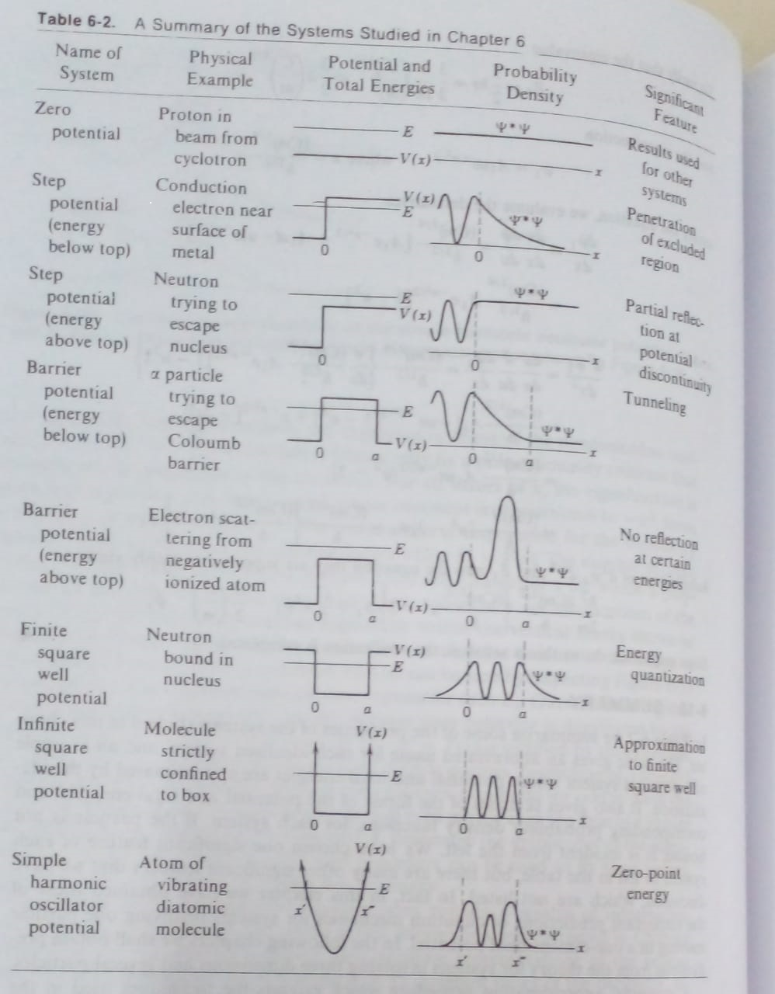

(From Quantum Physics of Atom, Molecules, Solids, Nuclei & Particles **Robert Eisberg & Robert Resnick)**

**References:**

1. Quantum Physics of Atom, Molecules, Solids, Nuclei & Particles-by **Robert Eisberg & Robert Resnick**; Wiley

2. Quantum Physics (Vol. 4) by **Eyvind H Wichman**; Mc Graw Hill

3. Modern Physics by **Raymond A. Sevey, Clement Moses and Curl Moyer,** Tomson Brooks/ Cole, Cengage Learning

4. Modern Physics by **Stephen T. Thornton and Andrew Rex**; Tomson Brooks/ Cole, Cengage Learning