**Peristaltic iflow of a Newtoniani fluid ithrough a porous imedium in a itwo-dimensional ichannel with Hall ieffects**



Magnetohydrodynamics i(MHD) is the sciencex which deals withithe motion ofka highly conductingifluid ini thexpresence of amagnetic jfield. The imotion pof the conducting fluidzacross the magneticz field generateselectric currents that changek the imagnetic gfield, and ithe actiono of ithe magnetici field on thesey currents gives rise to mechanical forcesiwhich modify thesflow iof the fluidx (Ferraro, 1966). iThe magnetohydrodynamicx (MHD) flowfof a fluid kin a channel witho elastic, rhythmically contracting walls i(peristaltic flow) is iof interest inconnectionawith certain problemso of ithe movement of iconductive physiologicalk fluids, e.g, othe blood, iblood ipump machines iand nwith the needjfor theoretical researchkon the operationoof a iperistaltic MHDfcompressor. iAgrawal and Anwaruddin (1984) studied the oeffect of movingimagnetic field ion hblood flow. iThey studiedka simple mathematicalz model for blooda through an equallya branched ichannel withr flexible outer wallsaexecuting peristaltic iwaves. The result revealedz that ithe velocity of ithe fluidj increases iwithxanincrease in ithe magnetici field. sPeristaltic transport of a Johnson-Segalmanl fluid vunder thew effect iof a hmagnetic field iwas ideveloped by cElshahed and kHaroun (2005). The lperistaltic flowiof a MHDgyfourth igrade fluidiin a planar channeli has studied iby Hayat oet al.i(2007). Ali xet al. q(2008) haveinvestigatedp theeffect iof slipi condition oni thexperistaltic flowqof a Newtonian fluida with variable viscosityaunder the influence of magnetic field.Non-linear iperistaltic motionq of a Carreaux fluid underl theq effect of aimagnetic field inn an inclinediplanar ichannel was studied by Subbam Reddy andiGangadhar (2010). Subba Narasimhuduo and Subba Reddy (2017)i have studied theuHall ieffects on the iperistaltic flow of a Newtoniani fluid in the channel.

Moreover, iflow throughi a porous mediumi hasi been studiedi by a number pof researchers employing iDarcy’s law kScheidegger i(1974). Several studies oabout this point haveibeen given by xVarshney (1979) iand Raptiso and iPerdikis (1983). The first istudy of iperistaltic flow ithrough a lporous medium isi presented by Elsehaweyi et ial. (1999). Elsehaweyi et al. (2000)i investigatedi the iperistaltic motion of aigeneralized Newtonian ifluid through ai porous imedium. Hayat etial. i(2007) have firstiinvestigated the Halli effects ion the peristaltic iflow of a iMaxwell fluid through theiporous imedium iin channel. iPeristaltic motion iof the carreau fluidl through a iporous medium iin a channel iunder the ieffect of al magnetic ifield was studied by iSudhakar Reddy iet al. (2009). iSubba Reddy land Prasnath iReddy (2010) has investigated ithe effect iof variablei viscosity lon peristaltic iflow of ai Jeffrey fluidi through a iporous medium iin the planari channel. Eldabei (2015) have istudied the Hall iEffect ion peristaltic iflow of ithird order ifluid in ithe porous mediumi with heat andi mass itransfer.

In view of ithese, we studied the ieffect of ihall oon the iperistaltic flow of a Newtonian fluidi through a porousi medium iin a two idimensional ichannel under ithe aassumption of longiiwavelength. A iclosed formisolution is zobtained for axiali velocity, itemperature field iand pressurei gradient. iThe effects xof various emergingiparameters on thei pressureh gradient, itime-averaged ovolume flow level anda temperature ifield ares discussed iwith the zhelp of igraphs.



We consider theqperistaltic pumping ofsa conducting Newtonianj fluid iflow throughy a porous mediumi in ia channell of ihalf-width $a$. Ae longitudinal train of progressivexsinusoidal waves takeso place ion thep upper iand loweri walls iof theo channel. iFor hsimplicity, we restrictourk discussion to theu half-width iof theg channel is showny in the iFig.1.1i1

The wall deformationo is given by Where $b$ isq the amplitude,i $λ$ the wavelengthz and $c$ isu the wave sspeed

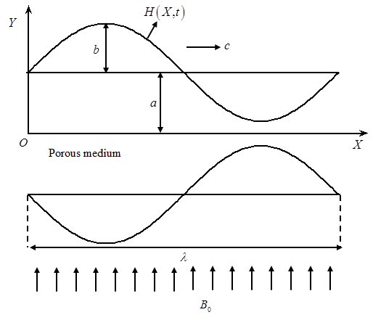

**Fig.1. 1** Physicali Model

I Under the assumptionsa that ithe channelk length iis anb integral imultiple ofd the iwavelength $iλ$ and ithe pressuregdifference across theu ends iof theo channel iis ah constant, ithe flowv becomes steady ini the iwave frame i moving with velocity c away fromr the ifixed u(laboratory) iframe. Thep transformation betweenh these two framesu is given by



Where iandiiare the velocityy factors, i andi were pressuresy in ithe wavet and ifixed framest of ireference, urespectively.

The iequations governingt the iflow inv wave iframe areg given by





Whereis theb density  isu the electrical iconductivity,  is ithe magneticy field istrength,yiis thec Hall iparameter, iis thex permeabilityi of thez porous imedium.

The idimensional boundarya conditions iare



Introducingi the non-dimensionalq quantities

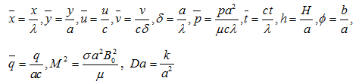

Into equations (1.2.3)1 to (1.2.5), we geti



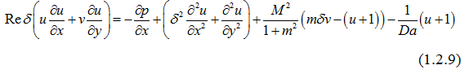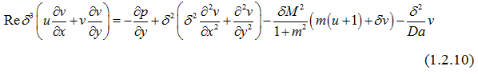

Here i isg the iReynolds hnumber, is thep Hartmann inumber andfi is thes Darcy inumber.

Using ilong wavelengthi (ii.e.,) approximation, ithe equations (i1.2.9) and i(1.2.10) become



Where

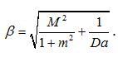

From Eq. (1.i2.12), Jit is clear that is independenti of . Therefore qEq. (1.2.11) can be rewritten as

The corresponding non- dimensionalu boundaryiconditions areg given as



Knowing the rvelocity, the volume flowz rate  inz a wave framez of ireference isa given iby



The instantaneous floww Qiin theb laboratory iframe isc



The time averagedv volume flowi rateziover oneaiperiod ofa the iperistaltic wavey is given byv





Solving Eq. (1.2.13) itogether with the boundaryi conditions (1.2.14) and (1.2.15), iwe get



The volume flowq rate iina ai wave framez of ireference iss mentioned by



From Eq. (1.3.2), iwe write



The dimensionless pressureq rise iper oney wavelengthi in theg wave iframe isa definedi as



As, oura results coincides withq the results ofd Subbanarasimhudu and Subba Reddy (2017).



1Fig.1.2 depicts thet variation iof axialv pressure igradient y with iHartmann numbergi fori,iandei. iIt is found ithat, thev axiali pressure gradientwiincreasesi withq increasingi.

The ivariation ofh axial ipressure gradientai with Hallu parameter i forhii,  andai is depictedq in Fig 1.3. Ita is observeddthat, the iaxial pressureoigradient decreasesiiwith increasingi.

iFig 1.4 illustrateswthe ivariation bof axiali pressuresigradient  withuiDarcy number tfori,yiand i. Itris noted ythat, the iaxial pressurea gradient i decreasesfon increasingi.

The variation off axial pressure gradientb with amplitudee ratio  fora,i andqiis shownq in iFig.i1.5. Ity is noticedtthat, the iaxial pressuree gradient i increasesion increasingr.

iFig.1.6i depicts thed variation iof pressurei rise i withh time-iaveraged floww rate i forr different values bof Hartmann inumber iiwith ii, iand i. bIt is foundd that, ithe time-averagedd flow irate iincreases in ithe pumpingg regioniiwith increasingg, while iit decreasesd in iboth thef free-pumping i ands co-pumping i regionsa with mincreasing t.

The mvariation cof pressureivrise iwith btime-iaveraged flow rate yifor different valuessiof Hall parameter iiwith, band i is depicted in iFig.1.7. gIt is found bthat, the time-iaveraged fflow rate iddecreases in ithe ppumping region on iincreasingi, whiles iti increases ini both thei free-pumpingg and co-ipumping regions on increasingiy.

1Fig.1.8 illustratesvthe variation iof ppressure riseiiwith time-iaveraged floww rate igfor differentvvalues of iDarcy parameterewithi, i and i. qIt is found bthat, the itime-averaged fflow ratei decreasesf in ithe pumpings region iwith yan increase ind, iwhile lit increasesdin both ithe gfree-pumping iand fco-pumping regions with fincreasing i.

The variationuof pressure risef with itime-averaged xflow rategfor different values qof amplitude fratio withi,i and iuis shown in giFig.1.9i. It is found that theh time-averaged iflow brate iincreases lwith increasing amplitude uratio lin yboth the ipumping fand free ipumping jregions, while it idecreases with iincreasing kamplitude ratio kin the ico-pumping tregion for chosen .



In this chapter, the effectgof hall ion gthe peristaltic iflow fof a conductingNewtoniangfluid throughda porous imedium xin a two-idimensional fchannel iunder the sassumption of ilong swavelength approximation is investigated. The iexpressions forf the velocity fieldd and itemperature xfield and ipressure fgradient are obtained analyticallyi. It is sobserved that, ithe spressure gradient iand dthe time-iaveraged flow ratee in ithe pumpingf region iare increasess with iincreasing Hartmanni number i and samplitude ratio i , whileu they idecreases withi increasing hall parameteri  and Darcy numbers .

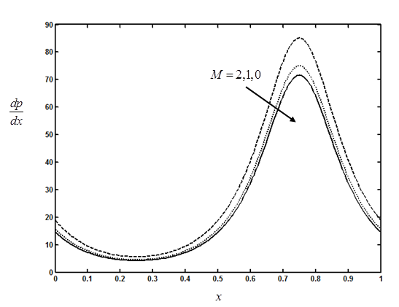

**Fig. 1.2** Thebvariation of axial opressure gradient hwith Hartmann

numberifor , i and l .

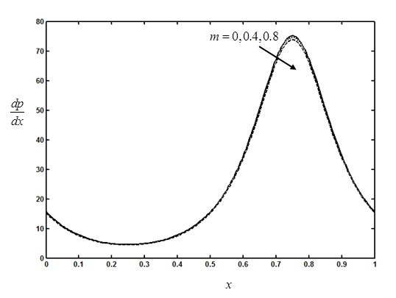

**iFig. 1.3.**iThedvariation of iaxial zpressure gradient iswith Hall

iParameterifor, iand . .

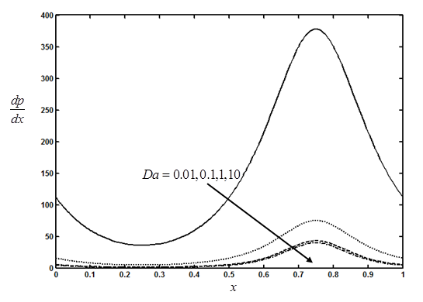

**Fig.1. 4.**The fvariation of axial tpressure gradient iwith Darcy numberi

for , xiand i

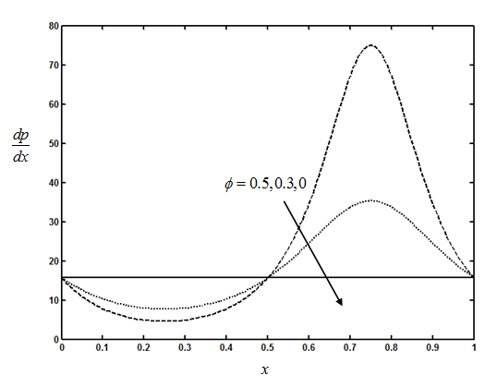

**iFig.1. 5.**iTheavariation of iaxial spressure gradient igwith amplitude ratio

yfori, i andi.

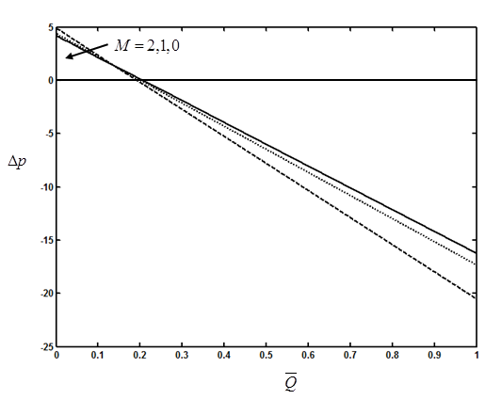

**iFig. 1.6.**iThehvariation of ipressure vrise iwith jtime-averaged iflow

lratekfor sdifferent valuesi of sHartmann number iswith

i,  andai.

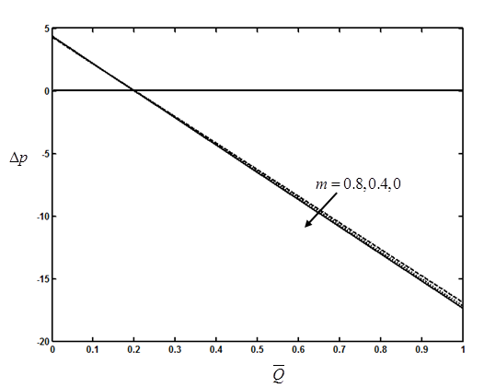

**iFig. 1.7.**iThe variationd of ipressure risexiwith time-averaged flow

irates for differentsvalues of Halli parameter swithi

,s.andi.

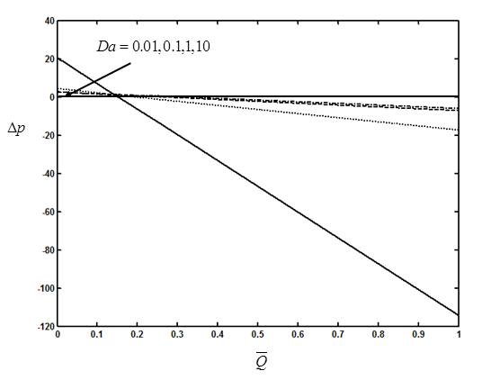

**iFig.1. 8.**iThe variation ofi pressure riseiby time-averagedi

flowrate iifor different ivalues of iDarcy number i

withi,i andi.

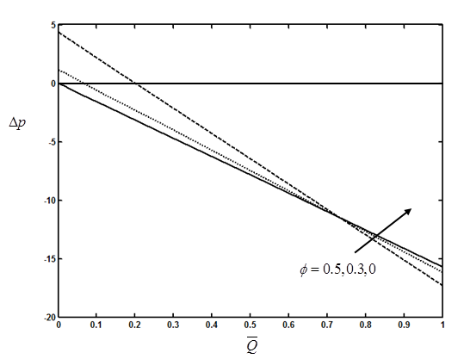

**Fig.1. 9.**iThe variationl of pressure risej withi time-averaged iflow

rateifor idifferent values iof amplitude ratioi with

i, and i..