Transforming Agriculture: The Rise of Smart Farming"

Manjusha Tyagi*¹, Arun Kumar², Saurabh Guleri³, Naveen Gaurav⁴

Associate Professor &HOD (Microbiology)School of Basic &Applied science*1
Dean &Professor (Biotechnology) School of Basic &Applied science, SGRR, University, Dehradun² Associate Professor (Botany) School of Basic &Applied science, SGRR, University, Dehradun³
Associate Professor &HOD (Biotechnology) School of Basic &Applied science, SGRR, University, Dehradun⁴ Corresponding Author -manjushatyagi2008@gmail.com, manjushatyagi@sgrru.ac.in

ABSTRACT

Smart farming, also known as precision agriculture, is a modern agricultural approach that leverages advanced technologies, data analytics, and automation to optimize various aspects of farming operations. This abstract provides an overview of the key components and benefits associated with smart farming. Smart farming integrates cutting-edge technologies such as sensors, drones, GPS systems, and Internet of Things (IoT) devices to collect real-time data on various environmental and agricultural parameters. This data is then analyzed using advanced algorithms and artificial intelligence to make informed decisions and improve farming practices.
One of the primary objectives of smart farming is to enhance resource efficiency. Through precise monitoring and control of factors like soil moisture, temperature, and nutrient levels, farmers can optimize irrigation, fertilization, and pesticide application, reducing resource wastage and environmental impact. Automation plays a crucial role in smart farming, with autonomous vehicles and machinery being employed for tasks like planting, harvesting, and pest control. This not only reduces labor requirements but also enhances efficiency and productivity.
Data-driven decision-making is a hallmark of smart farming. Farmers can access real-time information about their crops and livestock, enabling them to respond promptly to changing conditions and make informed choices about crop selection, planting times, and breeding strategies.
Smart farming also promotes sustainability by minimizing the use of chemicals, conserving water, and reducing greenhouse gas emissions. It allows for precise management of resources, which is especially important in the face of climate change and increasing global food demand.
Furthermore, smart farming contributes to better risk management by providing early warnings for potential issues such as disease outbreaks or adverse weather conditions. This proactive approach can mitigate losses and improve yield predictability.
In conclusion, smart farming represents a transformative shift in agriculture, harnessing the power of technology and data to optimize farming practices, improve resource efficiency, and promote sustainability. It offers the potential to address the challenges of feeding a growing global population while minimizing the environmental impact of agriculture.
Introduction

Smart farming, also known as precision agriculture or digital agriculture, is a modern and innovative approach to farming that leverages technology, data, and automation to optimize various aspects of agricultural practices. It represents a significant transformation in the way we produce food and manage agricultural systems, aiming to make farming more efficient, sustainable, and productive.
The key components of smart farming include:
Advanced Technology: Smart farming relies on a wide range of technologies, including sensors, drones, GPS systems, satellites, Internet of Things (IoT) devices, and robotics. These technologies enable the collection of real-time data from the field.
Data Analytics: The data collected from sensors and other sources are processed and analyzed using sophisticated algorithms and artificial intelligence (AI) tools. This analysis provides valuable insights into various aspects of farming, such as soil health, weather conditions, crop growth, and livestock well-being.
Automation: Automation is a core element of smart farming. Autonomous vehicles, machinery, and robots are used for tasks like planting, harvesting, weeding, and even monitoring livestock. Automation reduces labor requirements and increases efficiency.
Data Connectivity: Smart farming systems are connected through the internet, allowing farmers to monitor and control their operations remotely. This connectivity facilitates real-time decision-making and remote management of equipment.
Precision Management: One of the central goals of smart farming is precision management. Farmers can apply resources like water, fertilizers, and pesticides more precisely based on the specific needs of their crops or livestock. This reduces waste and environmental impact.
Benefits of Smart Farming:
Smart farming offers numerous benefits, including:
Increased Efficiency: By optimizing resource usage and automating routine tasks, smart farming can significantly increase farm efficiency and productivity.
Sustainability: Smart farming promotes sustainable agriculture by reducing chemical usage, conserving water, and minimizing environmental impact.
Data-Driven Decision-Making: Farmers can make informed decisions based on real-time data, leading to better crop management, disease prevention, and risk mitigation.
Cost Reduction: Through improved resource management and reduced labor costs, smart farming can lead to cost savings for farmers.
Enhanced Yield and Quality: Smart farming practices can result in higher crop yields and improved product quality.
Remote Monitoring: Farmers can monitor and manage their operations remotely, providing flexibility and reducing the need for constant on-site presence.
Risk Management: Smart farming systems provide early warnings for potential issues, such as disease outbreaks or adverse weather conditions, allowing farmers to take proactive measures.smart farming represents a transformative shift in agriculture, driven by technological advancements and data-driven decision-making. It holds the potential to address the challenges of feeding a growing global population while ensuring environmental sustainability and economic viability for farmers. As technology continues to advance, smart farming is expected to play an increasingly crucial role in the future of agriculture.Smart farming, also known as precision agriculture or digital agriculture, is a modern and innovative approach to farming that leverages technology, data, and automation to optimize various aspects of agricultural practices. It represents a significant transformation in the way we produce food and manage agricultural systems, aiming to make farming more efficient, sustainable, and productive. The use of electronic systems and data processing, have brought about profound changes in the agricultural working climate (Navarro et al., 2020). The strategic and managerial issues involved, the changes provide updated information from the manufacturing processes and the markets and agents involved in the production (Zamora- Izquierdo et al., 2019). Smart farming relies on a wide range of technologies, including sensors, drones, GPS systems, satellites, Internet of Things (IoT) devices, and robotics. These technologies enable the collection of real-time data from the field. (Pivoto et al., 2018). smart farming represents a transformative shift in agriculture, driven by technological advancements and data-driven decision-making. (Hemdan and Manjaiah, 2018). It holds the potential to address the challenges of feeding a growing global population while ensuring environmental sustainability and economic viability for farmers. (Liakos et al., 2018).As technology continues to advance, smart farming is expected to play an increasingly crucial role in the future of agriculture. Smart farming play a important role in our society its fills the growing food needs of the world’s population. (Rezk et al., 2020)
Smart farming systems are connected through the internet, allowing farmers to monitor and control their operations remotely. This connectivity facilitates real-time decision-making and remote management of equipment. (Charo, 2015) and it is useful of safely and cleanly of advanced food farming technology. The Internet of Things (IoT) (Tilman et al., 2002) and data mining, such as modern software technology (Sachs, 2015), have a part of the daily lives of people, expanding their ability to alter their environment. In general, IoTs and data analysis are used in agro-industrial and environmental areas to diagnose and track smart farming systems, providing essential information to the final farmer, the client, and the assets of agro-products and systems (Walter et al., 2017).
Some methods have been developed These are as follows-
1.Advanced Technology: Smart farming relies on a wide range of technologies, including sensors, drones, GPS systems, satellites, Internet of Things (IoT) devices, and robotics. These technologies enable the collection of real-time data from the field.

2. Data Analytics: The data collected from sensors and other sources are processed and analyzed using sophisticated algorithms and artificial intelligence (AI) tools. This analysis provides valuable insights into various aspects of farming, such as soil health, weather conditions, crop growth, and livestock well-being.
3.Automation: Automation is a core element of smart farming. Autonomous vehicles, machinery, and robots are used for tasks like planting, harvesting, weeding, and even monitoring livestock. Automation reduces labor requirements and increases efficiency.
4.Data Connectivity: Smart farming systems are connected through the internet, allowing farmers to monitor and control their operations remotely. This connectivity facilitates real-time decision-making and remote management of equipment.
5.Precision Management: One of the central goals of smart farming is precision management. Farmers can apply resources like water, fertilizers, and pesticides more precisely based on the specific needs of their crops or livestock. This reduces waste and environmental impact.
Smart farming offers numerous benefits, including:
- Increased Efficiency: By optimizing resource usage and automating routine tasks, smart farming can significantly increase farm efficiency and productivity.
- Sustainability: Smart farming promotes sustainable agriculture by reducing chemical usage, conserving water, and minimizing environmental impact (Rezk et al., 2020).
- Data-Driven Decision-Making: Farmers can make informed decisions based on real-time data, leading to better crop management, disease prevention, and risk mitigation.
- Cost Reduction: Through improved resource management and reduced labor costs, smart farming can lead to cost savings for farmers.
- Enhanced Yield and Quality: Smart farming practices can result in higher crop yields and improved product quality.
- Remote Monitoring: Farmers can monitor and manage their operations remotely, providing flexibility and reducing the need for constant on-site presence.
- Risk Management: Smart farming systems provide early warnings for potential issues, such as disease outbreaks or adverse weather conditions, allowing farmers to take proactive measures.
In conclusion, smart farming represents a transformative shift in agriculture, driven by technological advancements and data-driven decision-making. It holds the potential to address the challenges of feeding a growing global population while ensuring environmental sustainability and economic viability for farmers. As technology continues to advance, smart farming is expected to play an increasingly crucial role in the future of agriculture. (Rezk et al., 2020).

What is Smart farming (SF)?

Smart farming integrates cutting-edge technologies such as sensors, drones, GPS systems, and Internet of Things (IoT) devices to collect real-time data on various environmental and agricultural parameters. This data is then analyzed using advanced algorithms and artificial intelligence to make informed decisions and improve farming practices. (Pivoto et al., 2018), which came within a virtual ubiquitous computing environment with the addition of transmission of agricultural data. (Wolfert et al., 2017). These components of computing are embedded in objects and linked to each other and the internet. SF is a term derived from software engineering and computer science (Pivoto et al., 2018), which came about in a virtual, pervasive computing world with the addition of computing technology and the transmission of agricultural data (Wolfert et al., 2017). Such computing elements are embedded and interconnected with each other and the internet in objects. IMFS is characterized as a system for the collection, processing, storage, and dissemination of data in the format required for operations and functions of rural property (Sørensen et al., 2010). The use of SF instruments is made possible in agriculture by the use of sensors. A sensor is an electro-technical device that senses environmental physical quantities and converts these measurements into a signal that an instrument can interpret. (Lehmann et al., 2012) are the measurements read by the sensors. The Internet of Things (IoT) is also noteworthy, a concept that is one of the SF- related inventions introduced in 1999 by Kevin Ashton, a British entrepreneur, and that shares with the IMFS the idea of an intelligent environment (Pivoto et al., 2018). The IoT allows objects to be controlled remotely via an existing network infrastructure, providing opportunities for real-world and computer-based systems to communicate more directly (Gubbi et al., 2013). The use of IoT is based on the infrastructure of the internet, and this presents several limitations, especially when dealing with a large number of network devices and when other systems are integrated (Singh and Kaur 2019). A new level of technology in agriculture is being applied by SF systems, including robotics, mapping and geomatics technologies, decision-making, and statistical processes. The most promising SF technologies include developments in sensors, data processing, telemetry, and positioning technologies, but they take time and effort to produce and disseminate these technologies. Other factors that can impact the existing technological paradigm also exist. The Schumpeter study (Pivoto et al., 2018), which focused on the essence of economic growth through innovation, provided one of the discussions on emerging technology. Development in technology changes output patterns and can differentiate between economic growth in regions and countries
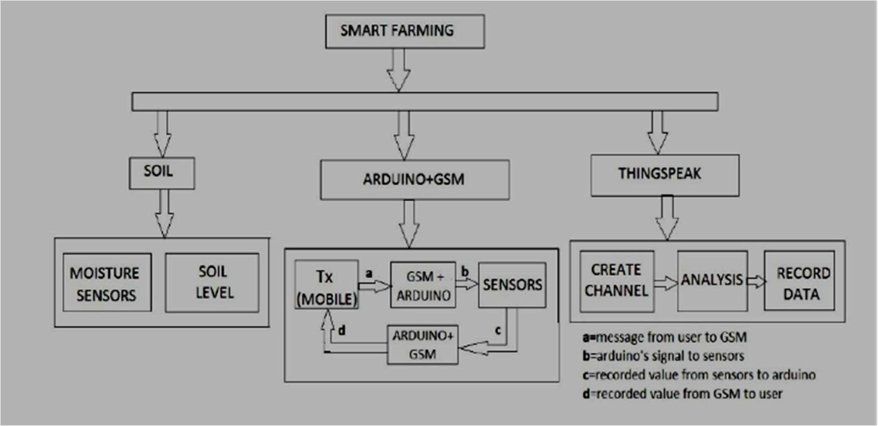
.

This model was developed by Perez and Freeman and Perez (Gautam and Yanagiya 2012) as a way of clarifying the technology and innovation arise. (Pivoto et al., 2018), smart farming arises a new technology in various field (Gomes and Dewes 2017), with productive practices more profitable and viable (Pivoto et al., 2018).Deep structural changes have occurred in the agricultural sector, the use of cloud computing (Liao et al., 2017). The formal and institutionalized organization of departments of research and development (R&D) (Pivoto et al., 2018) may, however, need to be changed.According to the World Bank (2017), public and private R&D expenditure were concentrated in some countries in 2013, including the USA, South Korea, Japan ,Germany and Denmark. (Pivoto et al., 2018), i.e. that they are supposed to perform research because SF requires interrelated management, electronics, manufacturing, and other research technologies. (Klerkx et al., 2019) .
Precision Agriculture: IoT sensors and devices are used to collect data on soil moisture, temperature, humidity, and nutrient levels. This data helps farmers make informed decisions about planting, irrigation, and fertilization, leading to increased crop yields and resource efficiency. Stočes et al., 2016
Water Management: Water scarcity is a critical issue in agriculture. IoT-based systems can monitor soil moisture levels and weather conditions in real-time. Farmers can then optimize irrigation schedules, reducing water wastage and ensuring crops receive the right amount of water.
Cost Management: IoT allows for better management of resources, including labor and machinery. By tracking the performance and location of farm equipment, farmers can optimize their usage, reduce fuel consumption, and lower operational costs.
Predictive Maintenance: IoT sensors on agricultural machinery can detect signs of wear and tear in real-time. This enables proactive maintenance, reducing downtime and repair costs.
Livestock Management: IoT devices are used to monitor the health and well-being of livestock. Sensors can track temperature, humidity, and even individual animal behavior. This data helps farmers identify and address health issues promptly.
Crop Monitoring: Drones equipped with IoT technology can provide aerial imagery and data on crop health. This information helps farmers detect diseases, pests, or nutrient deficiencies early, allowing for targeted interventions.
Supply Chain Optimization: IoT is used to track the movement and condition of agricultural products throughout the supply chain. This ensures product quality and safety while reducing waste and spoilage.
Market Access: IoT-based platforms and mobile apps connect farmers directly to markets, helping them access pricing information, negotiate fair prices, and reduce dependency on middlemen.
Environmental Sustainability: IoT enables sustainable farming practices by minimizing resource wastage, reducing chemical usage, and promoting eco-friendly agriculture.
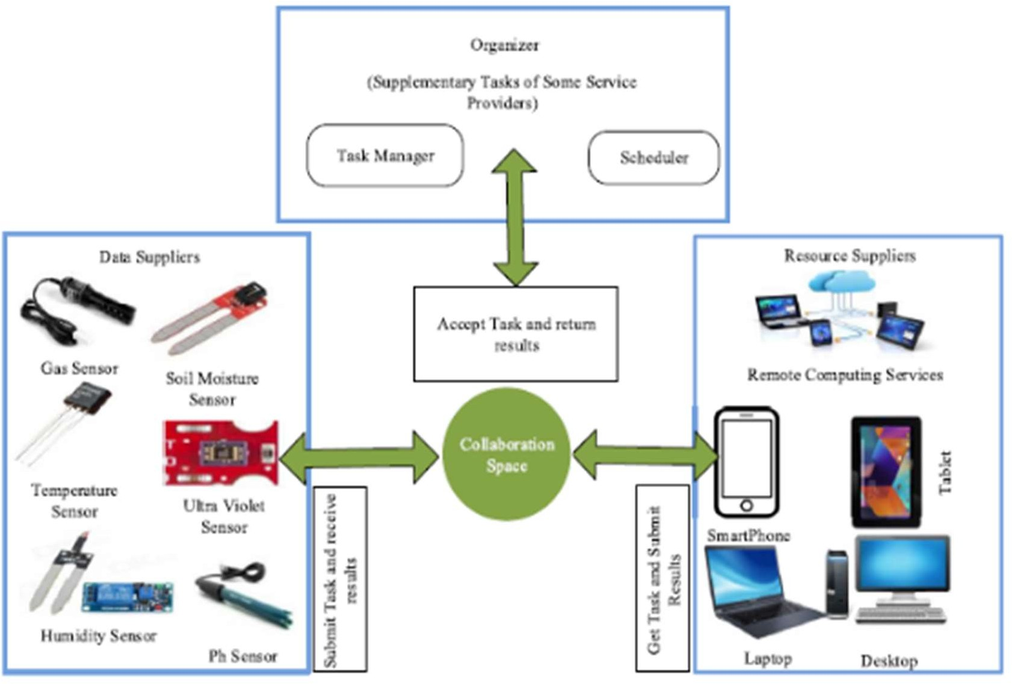
Data-Driven Decision Making: IoT generates a wealth of data that can be analyzed to make data-driven decisions. Machine learning and AI algorithms can process this data to provide insights and recommendations for optimizing farm operations.While IoT has brought about significant improvements in agriculture, it's important to note that challenges remain, such as data security and privacy concerns, the digital divide in rural areas, and the need for training and education among farmers to effectively leverage IoT technologies. Nonetheless, IoT continues to play a vital role in addressing the challenges faced by the agricultural sector and increasing its overall sustainability and productivity.By exploring different problems and difficulties in agriculture, the IoT has brought about a big shift in the agricultural world (Ray, 2017). With the advancement of technology, IoT-based farmers and technologists are now expected to be able to find solutions to farmers' challenges, such as water shortage, cost management, and productivity issues (Kamienski et al., 2019; Elijah et al., 2018). Through state-of-the-art IoT technologies and solutions to boost performance while reducing costs, all these problems have been developed. Efforts on wireless sensor networks allow us to collect and send data to main servers from sensor devices (Ojha et al., 2015). Data collected from sensors provide information on the different environmental conditions in order to ensure proper monitoring of the entire system. The crop assessment, monitoring of environmental conditions or crop productivity and and attacks on wild animals and theft, so on (Zhang et al., 2017; Agrawal et al., 2019). Furthermore, IoT offers well- organized scheduling of limited resources to ensure efficiency is increased by the best use of IoT. Agriculture provide cost-effective and simple interactions through secure and unbroken Livestock, Greenhouse, Farmer, and Field monitoring . IoT agricultural networks use sensors and cameras to watch over crops and animals in real-time. (Farooq et al., 2019).

In addition to being considered for crop evaluation, monitoring of environmental conditions or crop productivity such as field management, soil and crop monitoring, movement of unwanted products, attacks on wild animals and theft, so on (Zhang et al., 2017; Agrawal et al., 2019). Furthermore, IoT offers well-organized scheduling of scarce resources to ensure performance is improved by the best use of IoT. Agricultural trends that through individual greenhouse, field monitoring livestock, farmer, and, provide easy and cost-effective connections through secure and unbroken connectivity. Thus, IoT agricultural networks allow the monitoring of crops and animals in real-time, using wireless devices (Farooq et al., 2019).

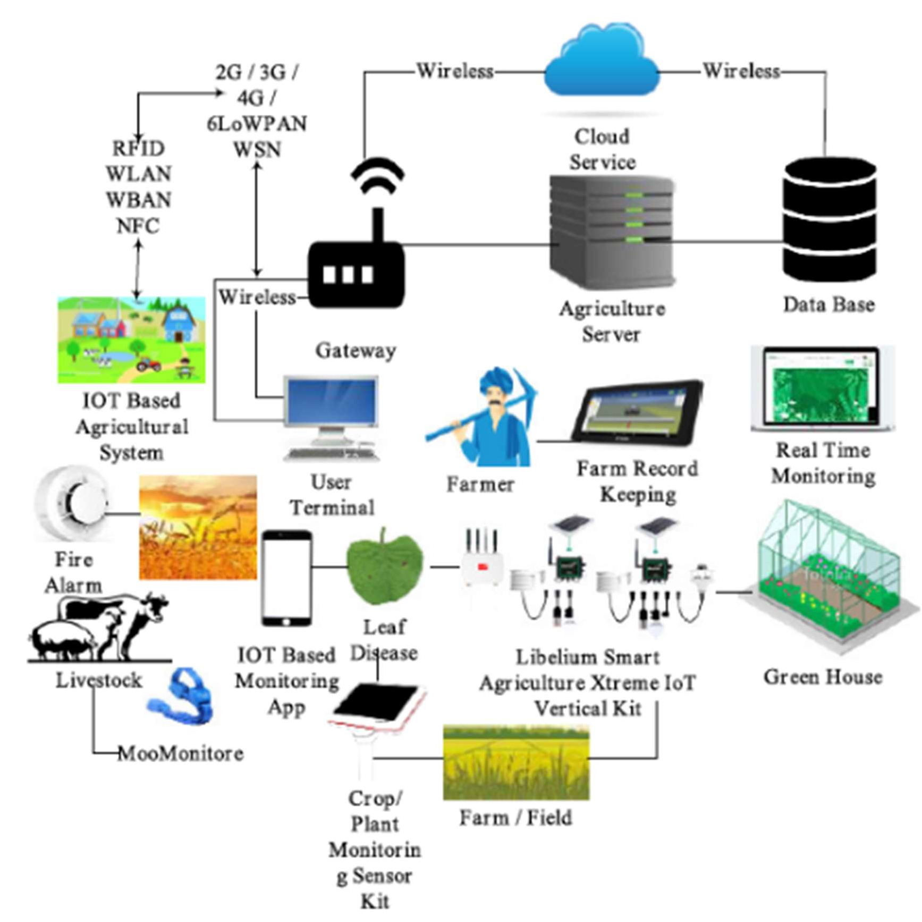
Figure A conceptual example of pervasive solutions for agriculture focused on IoT.

The diverse applications, protocols, and research developments in IoT agriculture, citing relevant studies (Jayaraman, et al., 2016; Shabadi and Biradar, 2018). It highlights the importance of IoT policies and guidelines in agriculture worldwide. The text emphasizes the need for a comprehensive study of IoT in agriculture to assess its current state. It underscores the role of IoT innovation in revolutionizing agricultural technologies and introduces a new section in the literature as a contribution to IoT agricultural techniques

Application in IoT system in agriculture

The IoT farming system is used in many areas, including precise farming, keeping track of animals, and monitoring greenhouses. They divided agricultural applications into three parts: IoT farming apps, smartphone apps, and sensor-based apps. They made a picture that shows these different types of applications and reviewed the IoT solutions available for farming today. (Farooq et al., 2019).

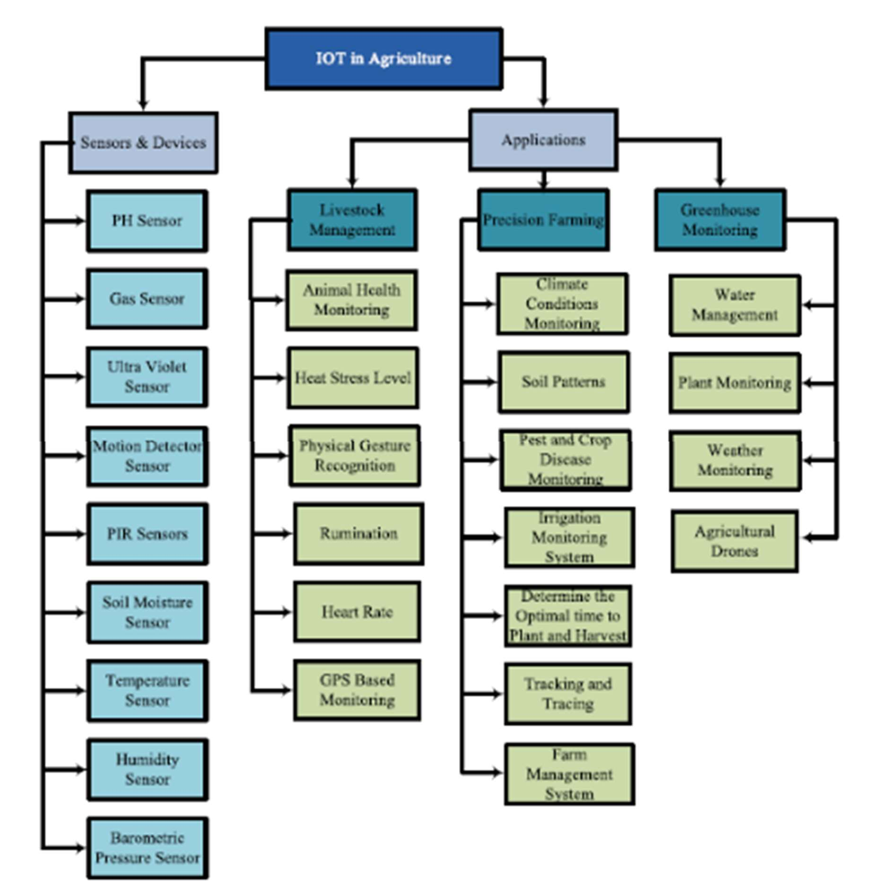
Figure IoT structure
- PRECISION FARMING
Precision farming, often referred to as precision agriculture, is a modern farming approach that harnesses advanced technologies to optimize agricultural practices. In precision farming, farmers utilize a variety of tools such as GPS technology, drones, IoT sensors, and data analytics to collect and analyze data about their fields and crops. This data-driven approach allows farmers to make informed decisions regarding planting, irrigation, fertilization, and pest control. (Popović et al., 2017).The key goal of precision farming is to maximize crop yields while minimizing resource wastage. By precisely tailoring their actions based on real-time data, farmers can reduce costs, conserve resources like water and fertilizers, and reduce the environmental impact of agriculture. (Jayaraman et al., 2016)Precision farming offers numerous benefits, including increased productivity, improved crop quality, and enhanced sustainability. It also plays a crucial role in addressing global challenges like food security and climate change. As technology continues to advance, precision farming is expected to play an increasingly significant role in the future of agriculture, helping farmers feed a growing world population while minimizing the ecological footprint of farming practices. (Nakutis et al., 2015)

Monitoring Climatic Condition Monitoring climatic conditions is a fundamental aspect of precision farming. It involves the continuous observation and recording of weather-related data in agricultural fields. This data typically includes parameters such as temperature, humidity, precipitation, wind speed, and solar radiation. Monitoring climatic conditions is essential because weather greatly influences crop growth and health. (Brandt et al., 2017)Farmers use various IoT sensors, weather stations, and satellite data to collect real-time information about the climate. By closely tracking these conditions, farmers can make informed decisions regarding irrigation scheduling, pest management, and crop protection. For example, they can adjust irrigation plans based on rainfall forecasts to avoid overwatering or under-watering crops. (Talavera et al., 2017).Monitoring climatic conditions also helps farmers respond proactively to extreme weather events such as droughts, frost, or heavy storms. It enables them to implement protective measures like covering crops or deploying frost prevention methods.

Monitoring Soil patterns using IoT

Monitoring soil patterns using IoT (Internet of Things) technology is a crucial aspect of precision farming. It involves the deployment of IoT sensors and devices in agricultural fields to collect data about soil properties and conditions. These sensors measure factors like soil moisture levels, temperature, pH, nutrient content, and compaction. (de Morais et al., 2019),By continuously monitoring soil patterns, farmers can gain valuable insights into the health and quality of their soil. This data enables them to make informed decisions about planting, fertilization, and irrigation. (Barbedo et al., 2018).

Monitoring of crop and pest disease using IoT
Monitoring crop and pest diseases using IoT (Internet of Things) technology is a crucial component of precision farming that helps farmers protect their crops and optimize their yields. Here's how it works:
Disease Detection: IoT sensors and cameras are deployed in fields to monitor crops continuously. These sensors can detect early signs of diseases, such as changes in leaf color, texture, or temperature.
Data Collection: The sensors collect data on crop health, weather conditions, and the presence of pests. This information is transmitted to a central system for analysis.
Data Analysis: In the central system, advanced analytics and machine learning algorithms process the data in real-time. They can identify patterns and anomalies associated with crop diseases and pest infestations. (Zhang et al., 2014)
Precision Treatment: Armed with real-time information, farmers can apply pesticides or treatments precisely where and when they are needed, reducing the need for widespread chemical use.
Historical Data: IoT systems also collect historical data, enabling farmers to track disease patterns over time. This information can inform long-term disease management strategies and help prevent future outbreaks. (Giordano et al., 2018).
By monitoring crop and pest diseases with IoT, farmers can proactively manage their fields, minimize crop losses, reduce the environmental impact of chemical use, and ultimately improve crop yields and profitability. It's a valuable tool in modern agriculture for sustainable and efficient farming practices. (Barbedo et al., 2018).
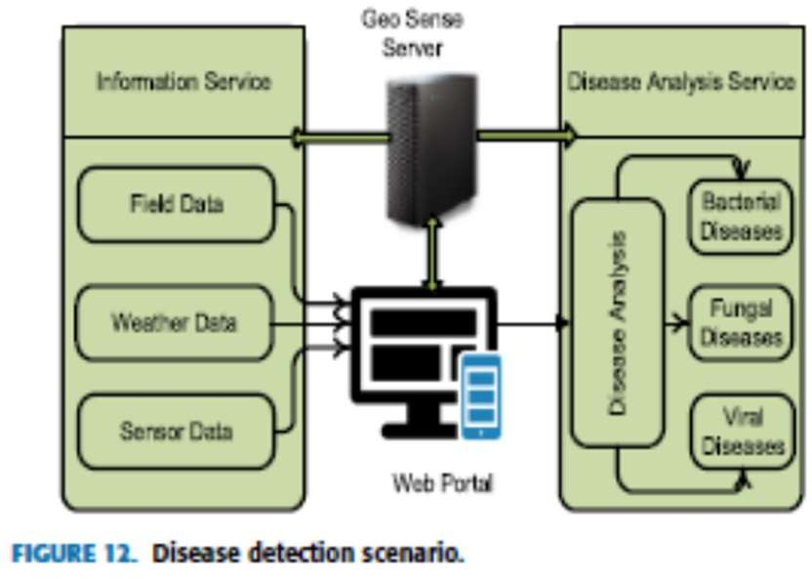

Monitoring Irrigation System

Monitoring irrigation systems using IoT (Internet of Things) technology is an essential aspect of precision farming that helps optimize water usage and crop health. Here's how it works:
Sensor Deployment: IoT sensors are placed strategically throughout the field and irrigation system. These sensors can measure soil moisture levels, weather conditions, and water flow rates.
Real-Time Data Collection: The sensors continuously collect data and transmit it wirelessly to a central control system. This data includes soil moisture levels, temperature, humidity, and even data from weather forecasts. Keswani et al., 2019).
- Data Analysis: In the central control system, the collected data is analyzed in real-time. Algorithms assess soil moisture to determine when and how much irrigation is needed.
- Automatic Control: IoT technology allows for precise control of irrigation equipment. Based on the data and analysis, the system can automatically adjust irrigation schedules, duration, and the amount of water applied. (Nawandar and Satpute, 2019)
- Remote Monitoring: Farmers can monitor the irrigation system remotely using smartphones or computers. They receive alerts and notifications about system status and any issues that may arise, such as equipment malfunctions. (bin Ismail and Thamrin, 2017)
- Efficiency and Water Savings: By using IoT-driven precision irrigation, farmers can ensure that crops receive the right amount of water at the right time, reducing water wastage and the risk of overwatering, which can lead to root diseases and nutrient leaching. (Katyaraet al., 2017).
- Cost Reduction: Precision irrigation not only conserves water but also saves on energy and labor costs, as it eliminates the need for manual monitoring and irrigation adjustments.Monitoring irrigation systems through IoT technology is a smart farming practice that contributes to water conservation, increased crop yields, and sustainable agricultural practices. It allows farmers to make informed decisions and respond quickly to changing conditions, resulting in healthier crops and improved resource efficiency. (Navarro-Hellín et al., 2015)

Determine the Optimum Plant and Harvest Time

Determining the optimum plant and harvest time is a critical aspect of precision farming, and IoT technology plays a significant role in making these decisions. Here's how it works:
Data Collection: IoT sensors and devices are placed in the fields to continuously collect data related to crop growth and environmental conditions. These sensors measure parameters such as soil moisture, temperature, humidity, and light intensity.
Crop Monitoring: Throughout the growing season, IoT systems monitor the growth and development of crops. They track factors like the number of growing degree days, which is a measure of heat accumulation, and the progress of flowering and fruiting.
Data Analysis: The collected data is analyzed using algorithms and machine learning techniques. By comparing the real-time data with historical records and crop models, the system can predict the optimal planting and harvesting times.
Decision Support: Farmers receive recommendations and alerts based on the analysis of the data. These recommendations indicate the ideal window for planting and harvesting to maximize yield and crop quality.
Environmental Factors: IoT technology also considers environmental factors such as weather forecasts. It can adjust recommendations based on upcoming weather conditions to avoid adverse events like frost damage or heavy rain during harvest.
Resource Optimization: Determining the optimum times for planting and harvesting helps farmers optimize resource use, including water, fertilizers, and labor, while minimizing the risk of crop loss due to unfavorable conditions.
Yield Maximization: The goal is to maximize crop yield while ensuring that crops are harvested at their peak quality, which is important for marketability and profitability.By leveraging IoT technology to determine the optimum plant and harvest times, farmers can make informed decisions that lead to higher yields, better crop quality, and more efficient farming practices, ultimately contributing to the success and sustainability of their agricultural operations.(Khan, and Kumar, 2020).

Tracing and Tracking using IoT

Tracing and tracking using IoT (Internet of Things) technology is a powerful tool in agriculture and supply chain management: (Satyanarayana and Mazaruddin, 2013)
Asset Monitoring: IoT sensors and tracking devices are attached to assets such as vehicles, machinery, and containers to monitor their location and condition in real-time.
Crop and Livestock Tracking: Farmers can track the movement and health of crops and livestock, ensuring they are where they should be and in good condition.
Supply Chain Visibility: IoT enables end-to-end visibility in the supply chain. It tracks the journey of agricultural products from farm to market, providing valuable insights.
Temperature and Humidity Control: Sensors monitor temperature and humidity during transportation, crucial for preserving the quality of perishable goods.
Quality Assurance: IoT data helps verify the quality and safety of agricultural products, ensuring they meet regulatory standards.
Efficient Logistics: Real-time tracking optimizes logistics operations, reducing transportation costs and delivery times.
Inventory Management: IoT helps manage inventory levels efficiently, preventing overstocking or shortages.
Loss Prevention: If a problem arises, such as a temperature spike or unexpected delay, IoT alerts stakeholders, allowing them to take corrective action.
Consumer Transparency: Consumers can access information about the origin and handling of products, enhancing transparency and trust.
Risk Mitigation: By closely monitoring products and processes, IoT reduces the risk of spoilage, contamination, and loss, benefiting both farmers and consumers while improving overall supply chain efficiency. (Farooq et al., 2019).

Farm Management System

A farm management system is a comprehensive platform that integrates various technological tools and data-driven solutions to streamline and optimize agricultural operations. This system serves as a digital dashboard for farmers, enabling them to make informed decisions, improve productivity, and enhance sustainability. (Gardašević et al., 2017).Farm management systems typically encompass a range of functionalities, including crop and soil monitoring using IoT sensors, weather forecasting, irrigation control, livestock tracking, and inventory management. They gather real-time data from these sources, allowing farmers to assess the condition of their crops, soil, and animals. (Katyaraet al., 2017),One of the key advantages of farm management systems is their ability to provide actionable insights. Through data analysis and visualization, farmers can identify trends, detect anomalies, and make timely adjustments in irrigation, fertilization, and pest control. These systems also help optimize resource allocation, reducing waste and costs.
Furthermore, farm management systems enhance the traceability and transparency of agricultural practices. They allow farmers to track the entire lifecycle of their products, from planting to harvest and distribution. This traceability benefits both farmers and consumers, as it ensures product quality, safety, and compliance with regulations.Farm management systems are essential tools in modern agriculture, empowering farmers to achieve greater efficiency, sustainability, and profitability while meeting the demands of an ever-changing and technology-driven agricultural landscape. (Bodake et al., 2018).

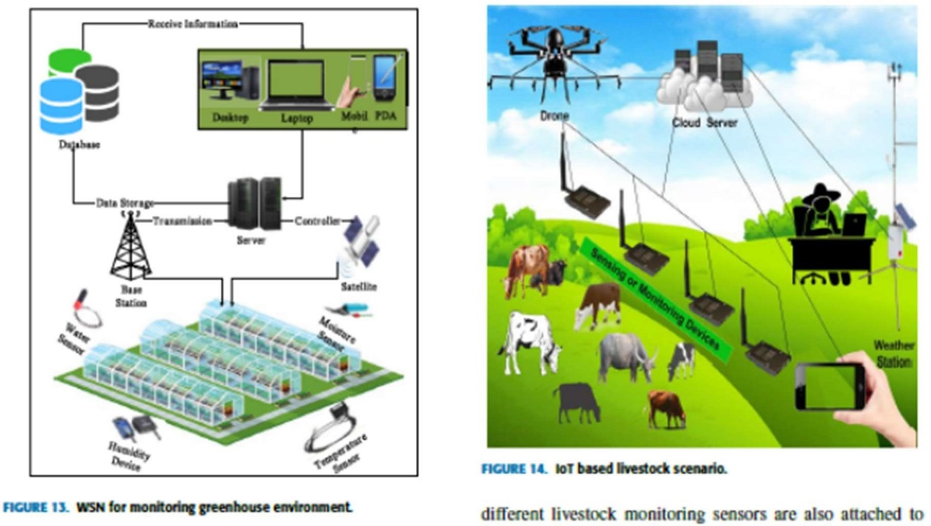
Figure Tracking Livestock
Figure WSN for green house environment monitoring
- Agricultural Drones
Agricultural drones, also known as unmanned aerial vehicles (UAVs), have emerged as a transformative technology in modern agriculture. These flying machines equipped with cameras and sensors offer farmers a bird's-eye view of their fields and livestock, revolutionizing various aspects of farm management. Agricultural drones are primarily used for crop monitoring and management. They capture high-resolution images and collect data on plant health, moisture levels, and pest infestations. This data enables farmers to make precise decisions about irrigation, fertilization, and pesticide application, resulting in improved crop yields and resource efficiency. (Zhang et al., 2014; Bodake et al., 2018).Moreover, agricultural drones are invaluable for assessing the overall health of a farm. They can swiftly identify areas of concern, such as diseased plants or waterlogged sections, allowing for targeted interventions. Drones are also used for livestock management, helping ranchers count and monitor their herds. Additionally, they aid in disaster assessment and response, providing critical information during events like floods or wildfires.Despite their numerous advantages, the adoption of agricultural drones does pose challenges related to regulations, privacy concerns, and the need for specialized training. Nevertheless, their potential to increase productivity, reduce environmental impact, and enhance overall farm management makes them a promising technology in the modern agricultural landscape. (Köksal and Tekinerdogan, 2019

Monitoring of Greenhouse

Monitoring of greenhouses is a pivotal practice in modern agriculture, and it has been significantly enhanced by the integration of Internet of Things (IoT) technology. Greenhouses create controlled environments for cultivating crops, enabling year-round production and precise management of temperature, humidity, light, and carbon dioxide levels. IoT-based greenhouse monitoring systems use a network of sensors and actuators to collect real-time data on these vital parameters. (Ma et al., 2015; Katsoulas e al., 2017).These sensors continuously measure variables such as temperature, humidity, soil moisture, and light intensity, transmitting the data to a central control system. Farmers can access this information remotely, allowing them to make immediate adjustments to create optimal growing conditions for their crops. For instance, if the temperature rises too high, the system can activate cooling mechanisms to prevent heat stress in plants. (González-Amarillo et al., 2018).
IoT-enabled greenhouse monitoring not only enhances crop quality and yield but also promotes resource efficiency. By precisely regulating environmental factors, farmers can reduce energy consumption and water usage, resulting in cost savings and reduced environmental impact. Additionally, early detection of issues like pest infestations or disease outbreaks is possible, enabling rapid response and minimizing crop loss.

In summary, IoT-based greenhouse monitoring is an essential tool for modern agriculture, ensuring the year-round production of high-quality crops while promoting sustainability and resource conservation in greenhouse farming.

A: WATER MANAGEMENT
Water management involves efficient and responsible use of water resources. In agriculture, it includes techniques like precise irrigation, monitoring soil moisture, and conserving water to optimize crop production while minimizing waste and environmental impact. It's crucial for food security and sustainability as water resources become scarcer with a growing global population (Windsperger et al., 2019).

B: PLANT MONITORING
Plant monitoring involves the continuous tracking and assessment of plants' health and growth. This is done through various methods, including the use of sensors, cameras, and data analysis. It helps farmers and gardeners make informed decisions about watering, fertilizing, and protecting plants from pests and diseases, ultimately improving crop yields and plant quality. Plant monitoring is a key component of precision agriculture and horticulture, allowing for more efficient and sustainable plant care. (Shirsath et al., 2017).

C: CLIMATE MONITORING

Several requirements, such as the protection of ventilation, carbon dioxide, and oxygen levels temperature, are combined to preserve and determine the optimum environment for plants under strict limits. This can be done by deploying IoT-driven greenhouses where for good decision-making, smart devices, and sensors share their information (Windsperger et al., 2019).

LIVESTOCK MONITORING
Livestock monitoring is the practice of using technology, such as sensors and tracking devices, to keep a close watch on the health, behavior, and location of animals like cows, sheep, and poultry. This monitoring helps farmers ensure the well-being of their livestock by detecting issues like illness or stress early. It also assists in optimizing feeding schedules, managing herd movements, and enhancing overall animal welfare. Livestock monitoring contributes to more efficient and sustainable livestock farming practices, improving both animal health and farm productivity. (Corkery et al., 2013).

Farmers can track their location by marking RFID on an individual animal, thereby preventing the animal from being stolen. Connected sensors and wearables in livestock help farmers to monitor the animals' overall activities and the data transmitted to the cloud helps farmers to identify the problems directly. Smart farming sensors are used by Cowlar and SCR Allflex to monitor animal health, activity, temperature, nutrition and to collect information on each person as well as on the herd (Ma et al., 2015; Katsoulas et al., 2017). In the field of livestock, numerous studies have been performed. Wireless devices have been used, which are most useful both for large farms and for hazardous gas monitoring.
To monitor weather conditions through weather stations and to detect other field events via all other data sources used in the farm, various IoT sensing systems were mounted throughout the field. The sensed information is stored on a cloud server and can be used by the user to make a decision. Users can use different smart devices to connect remotely (Laptops, Tablets, and Mobile, etc.). Some IoT basic livestock monitoring applications have been discussed below:

A: ANIMAL TEMPERATURE MONITORING

A core feature of animal health monitoring is the detection of disease signs and avoidance. For dogs, the typical body temperature is 38.3ᵒC-39.2ᵒC, and for cows, it is 38.5ᵒC-39.5ᵒC. When the body temperature increases or falls from the normal body temperature, any illness is caused by the animal (Shi et al., 2019).

B: HEAT STRESS LEVEL

During the summer season, increased heat stress reduces the milk yield of cows, posing cost-production challenges for farmers. Furthermore, heightened animal stress and reduced moisture content can lead to the risk of livestock mortality. (Farooq et al., 2019).

C: PHYSICAL GESTURE RECOGNITION

Physical gesture recognition is a technology that enables machines and computer systems to interpret and understand human gestures and movements. It plays a significant role in bridging the gap between human communication and technology interfaces. This technology relies on sensors, cameras, and advanced algorithms to detect and analyze gestures, including hand movements, body postures, and facial expressions. (Farooq et al., 2019).One of the most common applications of physical gesture recognition is in human-computer interaction, where it enhances user experience by allowing users to control devices and software through natural movements. For instance, it is used in gaming consoles, where players can control characters or actions using body gestures. In healthcare, it aids in rehabilitation by tracking patients' movements during physical therapy sessions, ensuring they perform exercises correctly.
Physical gesture recognition also has implications in various industries, such as automotive, where it can enable touchless control of in-car systems, improving safety and convenience. Moreover, it has potential applications in robotics, where robots can understand and respond to human gestures, making human-robot collaboration more intuitive and efficient. (Farooq et al., 2019).

D: RUMINATION

Rumination control involves using a monitoring device in the animal's nose to track the digestion process. This technology provides farmers with precise insights into the animal's health by analyzing its digestive activity, helping detect any potential issues early on for better care and management. (Farooq et al., 2019).

E: HEART RATE

Heart rate calculation is an indirect technique that affects the agitation and tension of the cow. The cow's average heart rate is between 43 and 84 bpm, while the calf's usual heart rate is 100 to 140 bpm. It is possible to continuously track the use of IoT devices and heart rate monitors (Farooq et al., 2019).

F: GPS BASED MONITORING

GPS-based monitoring uses satellite technology to track and record the location, movement, and sometimes even the condition of objects or individuals in real-time. It's widely applied in various fields, including transportation, logistics, wildlife tracking, and personal navigation. By utilizing GPS data, businesses and organizations can enhance efficiency, safety, and decision-making, while individuals benefit from accurate positioning and navigation services in everyday life. GPS is used to acquire farm specification and sends the tracked parameters to the central monitoring station using a wireless sensor network. The use of wireless technology such as Zigbee, WIFI, and LoWPAN (Saravanan and Saraniya, (2018) have been used to deter theft of livestock, wild attacks, or weather conditions.

B. AGRICULTURAL SOLUTIONS BY USING SMARTPHONES

In recent years, there has been a notable revolution in technology with the integration of electronic devices into smartphones, transforming them into powerful IoT engines. In agriculture, this convergence has led to the development of diverse hardware and software solutions, making smartphones versatile tools for farmers. These innovations empower agriculturalists with real-time data, remote control capabilities, and precision management tools, ultimately enhancing farm efficiency and productivity. A strong (but not complete) survey has been presented on smartphone apps offering agricultural solutions (Barh and Balakrishnan, 2018). Several recent applications give similar functionalities. These smartphone apps are not limited; several e-Farming apps have therefore been developed by developers from around the world, highlighting some of the preferred apps that have been discussed according to their popularity.

C. IoT DEVICES AND SENSORS IN AGRICULTURE

IoT devices and sensors have transformed agriculture by providing real-time data for precision farming. Soil moisture sensors optimize irrigation, weather stations offer accurate climate insights, and GPS trackers enhance asset management. Drones equipped with sensors monitor crop health, while livestock sensors ensure animal welfare. Smart irrigation systems and environmental sensors promote resource-efficient practices, ultimately increasing crop yields and sustainability in agriculture. (Navarro et al, 2020).

V. IoT AGRICULTURAL SECURITY

IoT agricultural security involves deploying sensors and cameras to protect farms from theft and vandalism. These devices monitor fields, livestock, and equipment in real-time. They alert farmers to suspicious activity, enabling swift response and safeguarding valuable assets. (Navarro et al, 2020). IoT security systems can also include access control measures to prevent unauthorized entry. By enhancing farm security, IoT technology helps farmers protect their investments and maintain the integrity of their operations, contributing to overall agricultural sustainability and success. (Alpay and Erdem, (2019).

VI IoT AGRICULTURAL CHALLENGES

IoT in agriculture faces several challenges:
Data Management: Handling vast amounts of data generated by IoT sensors requires robust storage and processing solutions.
Cost: The initial investment in IoT infrastructure can be a barrier for small-scale farmers.
Connectivity: Remote rural areas may lack reliable internet connectivity, hindering IoT adoption.
Security: Protecting IoT systems from cyber threats is critical to prevent data breaches and disruptions.
Standardization: Lack of universal IoT standards can lead to compatibility issues among devices and platforms.
Privacy: Balancing data collection for farming benefits while respecting privacy concerns poses a challenge. Addressing these challenges is crucial for maximizing the potential of IoT in agriculture. (Han et al., 2018).

HARDWARE CHALLENGES
Hardware challenges in IoT agriculture involve the development and deployment of robust, reliable, and cost-effective hardware solutions for farm environments. These challenges include:
1.Environmental Durability: Agricultural settings can be harsh, with exposure to extreme temperatures, moisture, and dust, making it essential to design hardware that can withstand such conditions.
2.Power Efficiency: IoT devices in the field often rely on batteries or solar power, requiring hardware that minimizes energy consumption to ensure long-term operation.
3.Scalability: Agricultural operations vary widely in size, and hardware should be scalable to suit both small-scale and large-scale farms. (Steele, 2012).
4.Interoperability: Ensuring compatibility among various IoT devices and sensors from different manufacturers is crucial for creating integrated and efficient systems.
5.Affordability: Cost-effective hardware solutions are necessary to make IoT technology accessible to a broader range of farmers, including those with limited resources.
6.Maintenance: Remote and challenging farm locations can make hardware maintenance difficult, requiring designs that minimize the need for frequent servicing .(Walter et al., 2017).

NETWORKING CHALLENGES
Networking challenges in IoT agriculture pertain to the establishment and maintenance of robust and reliable communication networks that connect IoT devices and sensors in remote farm environments. These challenges include:
Connectivity: Ensuring seamless connectivity in rural and remote areas where farm operations often take place can be a challenge due to limited internet infrastructure.
Data Transmission: Transmitting large volumes of data generated by IoT devices efficiently and without delays is essential for timely decision-making.
Scalability: Network architectures must accommodate the scalability needs of IoT deployments, whether on small family farms or large commercial operations.
Security: Protecting IoT communication from cyber threats and data breaches is critical to maintaining the integrity of farm data and operations.
Latency: Minimizing communication delays or latency is crucial for real-time monitoring and control of agricultural processes.
Cost: Balancing the cost of network infrastructure with the benefits it provides can be challenging for farmers, especially in resource-constrained settings. (Ibarra-Esquer et al.,2017).
Addressing these networking challenges is essential for ensuring the effective implementation and performance of IoT systems in agriculture, enabling farmers to harness the full potential of data-driven decision-making and smart farming practices.

SECURITY REQUIREMENTS

IoT-based smart agriculture safety requirements are similar to the traditional protection scenario (Glaroudis et al., 2020). Therefore we need to pay attention to the following safety criteria to achieve a stable farming solution:
- Confidentiality: Only approved users should be able to access agricultural information or personal data related to it.
- Integrity: Integrity guarantees that no change is made to the data or content collected and stored.
- Authentication: Authentication guarantees that the identity to which they link should be possessed by peer devices.
- Data freshness: it consists of key freshness and freshness data, as some measurements are often used in IoT agricultural networks, so it is necessary to ensure that each message is fresh.
- Non-Repudiation: This means a node is never going to refuse to send an earlier sent text.
- Authorization: authorization here means that for a network or any other resource, only authorized devices are allowed.
- Self-healing: if any IoT-based agricultural network device fails or fails to provide energy other than the network equipment, it should be able to provide some degree of protection.

SECURITY CHALLENGES

Security challenges in IoT agriculture are critical due to the potential risks associated with data breaches, cyberattacks, and unauthorized access. These challenges include:
Data Privacy: Protecting sensitive farm data, including crop information and livestock records, from unauthorized access and data theft is paramount.
Device Vulnerabilities: IoT devices and sensors can be vulnerable to exploitation if not adequately secured, potentially compromising the entire network.
Network Security: Ensuring the security of communication channels between devices and data repositories is essential to prevent eavesdropping and interception of data.
Updates and Patch Management: Regular updates and patch management for IoT devices are crucial to address vulnerabilities and mitigate security risks. (Lakhwani et al., 2019).
Authentication and Access Control: Implementing robust authentication and access control measures is necessary to limit access to authorized personnel only.
Compliance: Navigating and adhering to relevant data protection and cybersecurity regulations, which may vary by region, adds complexity to IoT security in agriculture.Addressing these security challenges is essential to safeguard the sensitive data and operations critical to modern farming while harnessing the benefits of IoT technology. (Munir et al., 2018

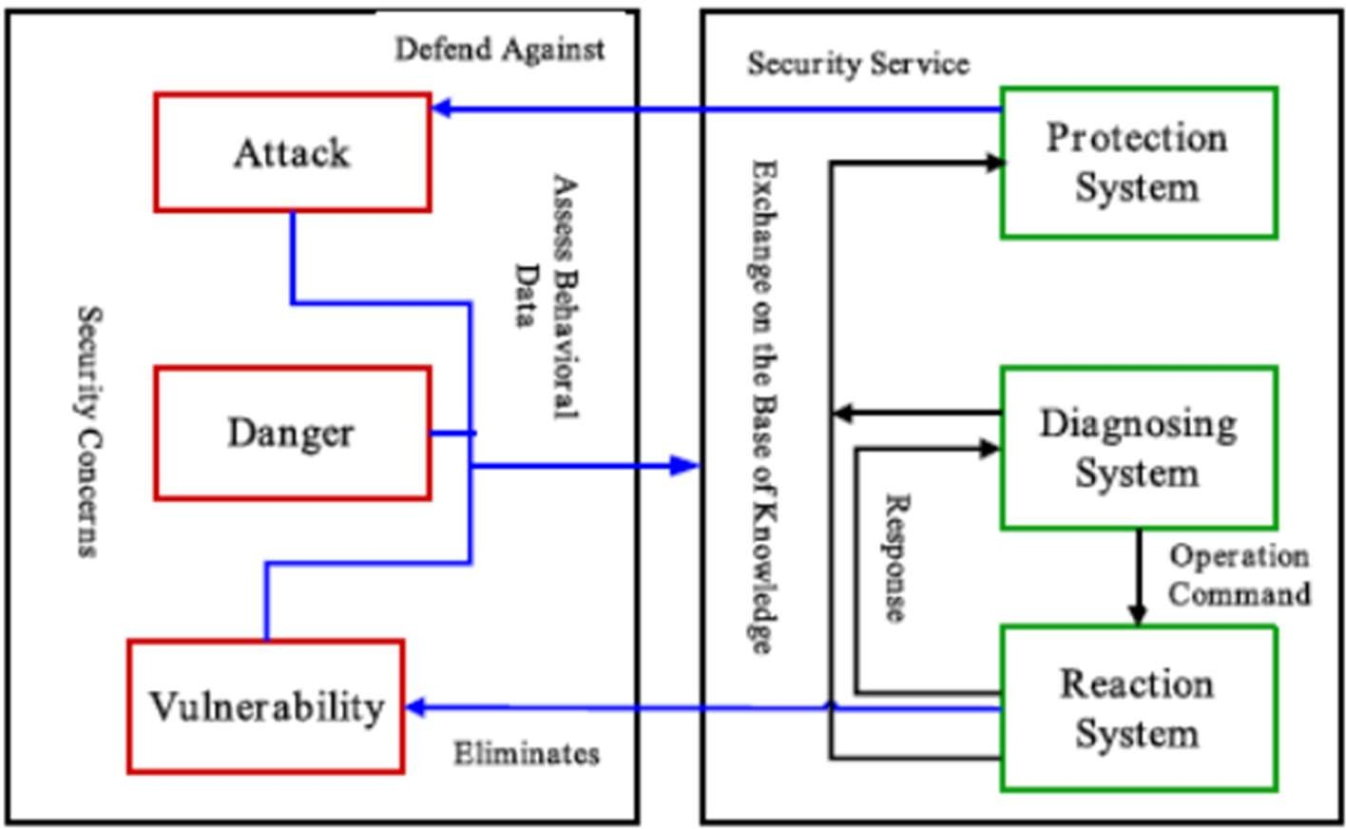

Figure Security Model for Smart Farming
There is a disparity between sensor nodes and RFID tags, which is why when implementing encryption algorithms, intrusion detection policies, key distribution, and routing policies, hardware constraints should be taken into consideration (Syafarinda et al., 2018). Data flows from the end device to the gateway in the IoT model, and data is also uploaded to other networks, such as the cloud infrastructure, during this stage. For sensor nodes, several security policies are available, such as identity authentication, data filtering, cryptographic algorithms, mechanisms for controlling data flow, so on. Security threats also include cheating, wiretapping, replaying, and tampering. During the data collection process, confidentiality, authentication, and integrity should be used (Stočes et al., 2016).

STACK CHALLENGES

With IoT-based architectures at risk, such as vulnerability, denial of services, unauthorized access, and multiple virus injections, secure wireless media transmission is a major challenge in IoT implementation. In this way, such attacks violate the privacy and confidentiality of data. The application layer is one of the highest layers according to the IoT vision and, due to its processing capacity and storage nature, is closely related to the cloud. Security concerns, such as data security, backup, recovery, and privacy, in the application layer and cloud are very similar. Therefore, access rights for physical users, devices, and organizations to data, information, and ownership should be regulated and managed by control mechanisms.
- THREAT MODEL

The agricultural threat model of IoT is composed of three instances. Cloud networks are the first, native network expansion is the second, and cloud services are the third. The hazard can arise from an internal or external network. If an attack is carried out by an agricultural device, it can be considered one of the most serious attacks. Since it is very difficult to locate the malicious device inside the network, Furthermore an opponent might attack an agricultural system and a network and use a power device to penetrate the network, such as a smartphone, laptop or tablet device or even the same type of IoT device (Jayaraman et al., 2016).
- ATTACK TAXONOMY

In the IoT model, there are many types of attacks that an attacker can target by implementing a strategy for potential or existing IoT farming devices and networks. The threat to farming in the IoT may be unpredictable and tangible, predictable. In this chapter, current and potential threats are classified based on three key factors: the destruction of information, hosting, and networking (Jayaraman et al., 2016).

ATTACKS Based On INFORMATION DISRUPTIONS

Attacks based on information disruptions are malicious actions aimed at disrupting the flow of critical data and services. These attacks can manifest in various forms:
Distributed Denial of Service (DDoS): Attackers flood a network or system with excessive traffic, rendering it inaccessible to users.
Data Manipulation: Attackers tamper with data integrity, altering information or causing data corruption, which can mislead decision-making processes.
Network Intrusion: Unauthorized access to IoT networks can disrupt data communication, leading to service interruptions or data theft.
Sensor Spoofing: Attackers may manipulate sensor data, providing false readings that can mislead farmers or automated systems, impacting decision accuracy and farm operations.Protecting against information disruption attacks in IoT agriculture involves robust network security, data encryption, and intrusion detection measures to ensure data integrity and system availability. (Madushanki et al., 2019).

ATTACKS Based On HOST PROPERTIES
Attacks based on host properties target vulnerabilities within individual IoT devices or sensors:
Device Exploitation: Attackers identify weaknesses in IoT device software or hardware to gain unauthorized access or control over the device.Firmware Vulnerabilities: Outdated or unpatched firmware can expose devices to exploitation, making them susceptible to attacks that compromise their functionality or security. (Madushanki et al., 2019).

ATTACKS Based On NETWORKS PROPERTIES
IoT Network Isolation: Protecting against these attacks involves implementing strong encryption, authentication, and access control measures, as well as regularly monitoring network traffic for anomalies. (Madushanki et al., 2019).

IoT AGRICULTURAL PLATFORMS
More complicated than other IoT end applications, the IoT agricultural architecture requires a real-time monitoring system with additional stringent requirements. This involves customized computing platform for libraries running time. To build an efficient platform, a service-oriented approach (SOA) can also be used; various APIs can use these services.Appropriate frameworks and libraries should also be developed so that the available text, classes, codes, and other useful data can be used in detail by agricultural developers (Farooq et al., 2019).

IoT SMART FARMING POLICIES AND SUCCESS STORIES
IoT smart farming policies have gained traction globally as governments and organizations recognize the potential of IoT technology to transform agriculture. These policies typically focus on fostering innovation, ensuring data privacy, and promoting sustainable farming practices. (Rezk et al., 2020). Here are a few success stories and examples of IoT smart farming policies European Union's Common Agricultural Policy (CAP): The CAP includes provisions to encourage the adoption of digital technologies, including IoT, in agriculture. It supports initiatives like the European Innovation Partnership for Agricultural Productivity and Sustainability (EIP-AGRI), which promotes smart farming practices. India's National Mission on Agricultural Extension and Technology (NMAET): The Indian government has launched the NMAET to encourage the use of technology, including IoT, in agriculture. (SARMA, and KATTA, 2020). It supports farmers in adopting IoT solutions for better crop management and resource utilization. (Farooq et al., 2020). Israel has been a pioneer in adopting IoT and precision agriculture. Their policies and investments in smart farming have resulted in significant improvements in crop yields and resource efficiency. (Huang et al., 2017).. As technology continues to advance, it's likely that more countries and organizations will adopt similar policies and initiatives to support the modernization of farming through IoT. (Bonomi et al., 2014).
Reference
- Al-Fuqaha, A., Guizani, M., Mohammadi, M., Aledhari, M., & Ayyash, M. (2015). Internet of things: A survey on enabling technologies, protocols, and applications. IEEE communications surveys & tutorials, 17(4), 2347-2376.
- Alpay, Ö., & Erdem, E. (2019). The control of greenhouses based on fuzzy logic using wireless sensor networks. International Journal of Computational Intelligence Systems, 12(1), 190-203.
- Barbedo, J. G. A., Koenigkan, L. V., Halfeld-Vieira, B. A., Costa, R. V., Nechet, K. L., Godoy, C. V., ... & Oliveira, S. A. S. (2018). Annotated plant pathology databases for image-based detection and recognition of diseases. IEEE Latin America Transactions, 16(6), 1749-1757.
- Barh, A., & Balakrishnan, M. (2018). Smart phone applications: Role in agri- information dissemination. Agricultural Reviews, 39(1), 82-85.
- bin Ismail, M. I. H., & Thamrin, N. M. (2017, November). IoT implementation for indoor vertical farming watering system. In 2017 International Conference on Electrical, Electronics and System Engineering (ICEESE) (pp. 89-94). IEEE.
- Bodake, K., Ghate, R., Doshi, H., Jadhav, P., & Tarle, B. (2018). Soil based fertilizer recommendation system using Internet of Things. MVP Journal of Engineering Sciences, 1(1).
- Bonomi, F., Milito, R., Natarajan, P., & Zhu, J. (2014). Fog computing: A platform for internet of things and analytics. In Big data and internet of things: A roadmap for smart environments (pp. 169-186). Springer, Cham.
- Brandt, P., Kvakić, M., Butterbach-Bahl, K., & Rufino, M. C. (2017). How to target climate-smart agriculture? Concept and application of the consensus-driven decision support framework “targetCSA”. Agricultural Systems, 151, 234-245.
- Brun-Laguna, K., Diedrichs, A. L., Chaar, J. E., Dujovne, D., Taffernaberry, J. C., Mercado, G., & Watteyne, T. (2016, June). A demo of the PEACH IoT-based frost event prediction system for precision agriculture. In 2016 13th Annual IEEE International Conference on Sensing, Communication, and Networking (SECON) (pp. 1-3). IEEE.
- Charo, R. A. (2015). Yellow lights for emerging technologies. Science, 349(6246), 384-385.
- Corkery, G., Ward, S., Kenny, C., & Hemmingway, P. (2013). Monitoring environmental parameters in poultry production facilities. In Computer Aided Process Engineering-CAPE Forum 2013, 2013. Institute for Process and Particle Engineering, Graz University of Technology, Austria.
- Duang-Ek-Anong, S., Pibulcharoensit, S., & Phongsatha, T. (2019). Technology Readiness for Internet of Things (IoT) Adoption in Smart Farming in Thailand. International Journal of Simulation--Systems, Science & Technology, 20(5).
- Farooq, M. S., Riaz, S., Abid, A., Abid, K., & Naeem, M. A. (2019). A Survey on the Role of IoT in Agriculture for the Implementation of Smart Farming. IEEE Access, 7, 156237-156271.
- Farooq, M. S., Riaz, S., Abid, A., Umer, T., & Zikria, Y. B. (2020). Role of IoT Technology in Agriculture: A Systematic Literature Review. Electronics, 9(2), 319.
- Gardašević, G., Veletić, M., Maletić, N., Vasiljević, D., Radusinović, I., Tomović, S., & Radonjić, M. (2017). The IoT architectural framework, design issues and application domains. Wireless personal communications, 92(1), 127-148.
- Gautam, P., & Yanagiya, R. (2012). Reflection of cross-disciplinary research at Creative Research Institution (Hokkaido University) in the Web of Science database: appraisal and visualization using bibliometry. Scientometrics, 93(1), 101-111.

SECURITY REQUIREMENTS

IoT-based smart agriculture safety requirements are similar to the traditional protection scenario (Glaroudis et al., 2020). Therefore we need to pay attention to the following safety criteria to achieve a stable farming solution:
- Confidentiality: Only approved users should be able to access agricultural information or personal data related to it.
- Integrity: Integrity guarantees that no change is made to the data or content collected and stored.
- Authentication: Authentication guarantees that the identity to which they link should be possessed by peer devices.
- Data freshness: it consists of key freshness and freshness data, as some measurements are often used in IoT agricultural networks, so it is necessary to ensure that each message is fresh.
- Non-Repudiation: This means a node is never going to refuse to send an earlier sent text.
- Authorization: authorization here means that for a network or any other resource, only authorized devices are allowed.
- Self-healing: if any IoT-based agricultural network device fails or fails to provide energy other than the network equipment, it should be able to provide some degree of protection.

SECURITY CHALLENGES

Security challenges in IoT agriculture are critical due to the potential risks associated with data breaches, cyberattacks, and unauthorized access. These challenges include:
Data Privacy: Protecting sensitive farm data, including crop information and livestock records, from unauthorized access and data theft is paramount.
Device Vulnerabilities: IoT devices and sensors can be vulnerable to exploitation if not adequately secured, potentially compromising the entire network.
Network Security: Ensuring the security of communication channels between devices and data repositories is essential to prevent eavesdropping and interception of data.
Updates and Patch Management: Regular updates and patch management for IoT devices are crucial to address vulnerabilities and mitigate security risks. (Lakhwani et al., 2019).
Authentication and Access Control: Implementing robust authentication and access control measures is necessary to limit access to authorized personnel only.
Compliance: Navigating and adhering to relevant data protection and cybersecurity regulations, which may vary by region, adds complexity to IoT security in agriculture.
Addressing these security challenges is essential to safeguard the sensitive data and operations critical to modern farming while harnessing the benefits of IoT technology. (Munir et al., 2018

Figure Security Model for Smart Farming

There is a disparity between sensor nodes and RFID tags, which is why when implementing encryption algorithms, intrusion detection policies, key distribution, and routing policies, hardware constraints should be taken into consideration (Syafarinda et al., 2018). Data flows from the end device to the gateway in the IoT model, and data is also uploaded to other networks, such as the cloud infrastructure, during this stage. For sensor nodes, several security policies are available, such as identity authentication, data filtering, cryptographic algorithms, mechanisms for controlling data flow, so on. Security threats also include cheating, wiretapping, replaying, and tampering. During the data collection process, confidentiality, authentication, and integrity should be used (Stočes et al., 2016).

STACK CHALLENGES

With IoT-based architectures at risk, such as vulnerability, denial of services, unauthorized access, and multiple virus injections, secure wireless media transmission is a major challenge in IoT implementation. In this way, such attacks violate the privacy and confidentiality of data. The application layer is one of the highest layers according to the IoT vision and, due to its processing capacity and storage nature, is closely related to the cloud. Security concerns, such as data security, backup, recovery, and privacy, in the application layer and cloud are very similar. Therefore, access rights for physical users, devices, and organizations to data, information, and ownership should be regulated and managed by control mechanisms.

- THREAT MODEL

The agricultural threat model of IoT is composed of three instances. Cloud networks are the first, native network expansion is the second, and cloud services are the third. The hazard can arise from an internal or external network. If an attack is carried out by an agricultural device, it can be considered one of the most serious attacks. Since it is very difficult to locate the malicious device inside the network, Furthermore an opponent might attack an agricultural system and a network and use a power device to penetrate the network, such as a smartphone, laptop or tablet device or even the same type of IoT device (Jayaraman et al., 2016).

- ATTACK TAXONOMY

In the IoT model, there are many types of attacks that an attacker can target by implementing a strategy for potential or existing IoT farming devices and networks. The threat to farming in the IoT may be unpredictable and tangible, predictable. In this chapter, current and potential threats are classified based on three key factors: the destruction of information, hosting, and networking (Jayaraman et al., 2016).

ATTACKS Based On INFORMATION DISRUPTIONS

Attacks based on information disruptions are malicious actions aimed at disrupting the flow of critical data and services. These attacks can manifest in various forms:
Distributed Denial of Service (DDoS): Attackers flood a network or system with excessive traffic, rendering it inaccessible to users.
Data Manipulation: Attackers tamper with data integrity, altering information or causing data corruption, which can mislead decision-making processes.
Network Intrusion: Unauthorized access to IoT networks can disrupt data communication, leading to service interruptions or data theft.
Sensor Spoofing: Attackers may manipulate sensor data, providing false readings that can mislead farmers or automated systems, impacting decision accuracy and farm operations.Protecting against information disruption attacks in IoT agriculture involves robust network security, data encryption, and intrusion detection measures to ensure data integrity and system availability. (Madushanki et al., 2019).

ATTACKS Based On HOST PROPERTIES

Attacks based on host properties target vulnerabilities within individual IoT devices or sensors:
Device Exploitation: Attackers identify weaknesses in IoT device software or hardware to gain unauthorized access or control over the device.Firmware Vulnerabilities: Outdated or unpatched firmware can expose devices to exploitation, making them susceptible to attacks that compromise their functionality or security. (Madushanki et al., 2019).

3)ATTACKS Based On NETWORKS PROPERTIES

IoT Network Isolation: Protecting against these attacks involves implementing strong encryption, authentication, and access control measures, as well as regularly monitoring network traffic for anomalies. (Madushanki et al., 2019).

IoT AGRICULTURAL PLATFORMS
More complicated than other IoT end applications, the IoT agricultural architecture requires a real-time monitoring system with additional stringent requirements. This involves customized computing platform for libraries running time. To build an efficient platform, a service-oriented approach (SOA) can also be used; various APIs can use these services.Appropriate frameworks and libraries should also be developed so that the available text, classes, codes, and other useful data can be used in detail by agricultural developers (Farooq et al., 2019).

IoT SMART FARMING POLICIES AND SUCCESS STORIES
IoT smart farming policies have gained traction globally as governments and organizations recognize the potential of IoT technology to transform agriculture. These policies typically focus on fostering innovation, ensuring data privacy, and promoting sustainable farming practices. (Rezk et al., 2020). Here are a few success stories and examples of IoT smart farming policies European Union's Common Agricultural Policy (CAP): The CAP includes provisions to encourage the adoption of digital technologies, including IoT, in agriculture. It supports initiatives like the European Innovation Partnership for Agricultural Productivity and Sustainability (EIP-AGRI), which promotes smart farming practices. India's National Mission on Agricultural Extension and Technology (NMAET): The Indian government has launched the NMAET to encourage the use of technology, including IoT, in agriculture. (SARMA, and KATTA, 2020). It supports farmers in adopting IoT solutions for better crop management and resource utilization. (Farooq et al., 2020). Israel has been a pioneer in adopting IoT and precision agriculture. Their policies and investments in smart farming have resulted in significant improvements in crop yields and resource efficiency. (Huang et al., 2017).. As technology continues to advance, it's likely that more countries and organizations will adopt similar policies and initiatives to support the modernization of farming through IoT. (Bonomi et al., 2014).
Reference

- Al-Fuqaha, A., Guizani, M., Mohammadi, M., Aledhari, M., & Ayyash, M. (2015). Internet of things: A survey on enabling technologies, protocols, and applications. IEEE communications surveys & tutorials, 17(4), 2347-2376.
- Alpay, Ö., & Erdem, E. (2019). The control of greenhouses based on fuzzy logic using wireless sensor networks. International Journal of Computational Intelligence Systems, 12(1), 190-203.
- Barbedo, J. G. A., Koenigkan, L. V., Halfeld-Vieira, B. A., Costa, R. V., Nechet, K. L., Godoy, C. V., ... & Oliveira, S. A. S. (2018). Annotated plant pathology databases for image-based detection and recognition of diseases. IEEE Latin America Transactions, 16(6), 1749-1757.
- Barh, A., & Balakrishnan, M. (2018). Smart phone applications: Role in agri- information dissemination. Agricultural Reviews, 39(1), 82-85.
bin Ismail, M. I. H., & Thamrin, N. M. (2017, November). IoT implementation for indoor vertical farming watering system. In 2017 International Conference on Electrical, Electronics and System Engineering (ICEESE) (pp. 89-94). IEEE.
- Bodake, K., Ghate, R., Doshi, H., Jadhav, P., & Tarle, B. (2018). Soil based fertilizer recommendation system using Internet of Things. MVP Journal of Engineering Sciences, 1(1).

- Bonomi, F., Milito, R., Natarajan, P., & Zhu, J. (2014). Fog computing: A platform for internet of things and analytics. In Big data and internet of things: A roadmap for smart environments (pp. 169-186). Springer, Cham.
- Brandt, P., Kvakić, M., Butterbach-Bahl, K., & Rufino, M. C. (2017). How to target climate-smart agriculture? Concept and application of the consensus-driven decision support framework “targetCSA”. Agricultural Systems, 151, 234-245.
- Brun-Laguna, K., Diedrichs, A. L., Chaar, J. E., Dujovne, D., Taffernaberry, J. C., Mercado, G., & Watteyne, T. (2016, June). A demo of the PEACH IoT-based frost event prediction system for precision agriculture. In 2016 13th Annual IEEE International Conference on Sensing, Communication, and Networking (SECON) (pp. 1-3). IEEE.
- Charo, R. A. (2015). Yellow lights for emerging technologies. Science, 349(6246), 384-385.
- Corkery, G., Ward, S., Kenny, C., & Hemmingway, P. (2013). Monitoring environmental parameters in poultry production facilities. In Computer Aided Process Engineering-CAPE Forum 2013, 2013. Institute for Process and Particle Engineering, Graz University of Technology, Austria.
- Duang-Ek-Anong, S., Pibulcharoensit, S., & Phongsatha, T. (2019). Technology Readiness for Internet of Things (IoT) Adoption in Smart Farming in Thailand. International Journal of Simulation--Systems, Science & Technology, 20(5).
- Farooq, M. S., Riaz, S., Abid, A., Abid, K., & Naeem, M. A. (2019). A Survey on the Role of IoT in Agriculture for the Implementation of Smart Farming. IEEE Access, 7, 156237-156271.
- Farooq, M. S., Riaz, S., Abid, A., Umer, T., & Zikria, Y. B. (2020). Role of IoT Technology in Agriculture: A Systematic Literature Review. Electronics, 9(2), 319.
Gardašević, G., Veletić, M., Maletić, N., Vasiljević, D., Radusinović, I., Tomović, S., & Radonjić, M. (2017). The IoT architectural framework, design issues and application domains. Wireless personal communications, 92(1), 127-148.
- Gautam, P., & Yanagiya, R. (2012). Reflection of cross-disciplinary research at Creative Research Institution (Hokkaido University) in the Web of Science database: appraisal and visualization using bibliometry. Scientometrics, 93(1), 101-111.

- Giordano, S., Seitanidis, I., Ojo, M., Adami, D., & Vignoli, F. (2018, March). IoT solutions for crop protection against wild animal attacks. In 2018 IEEE International Conference on Environmental Engineering (EE) (pp. 1-5). IEEE.
- Glaroudis, D., Iossifides, A., & Chatzimisios, P. (2020). Survey, comparison and research challenges of IoT application protocols for smart farming. Computer Networks, 168, 107037.
- Goap, A., Sharma, D., Shukla, A. K., & Krishna, C. R. (2018). An IoT based smart irrigation management system using Machine learning and open source technologies. Computers and electronics in agriculture, 155, 41-49.
- Gomes, J., & Dewes, H. (2017). Disciplinary dimensions and social relevance in the scientific communications on biofuels. Scientometrics, 110(3), 1173-1189.
- González-Amarillo, C. A., Corrales-Muñoz, J. C., Mendoza-Moreno, M. Á., Hussein,
A. F., Arunkumar, N., & Ramirez-González, G. (2018). An IoT-based traceability system for greenhouse seedling crops. IEEE Access, 6, 67528-67535.
- Gubbi, J., Buyya, R., Marusic, S., & Palaniswami, M. (2013). Internet of Things (IoT): A vision, architectural elements, and future directions. Future generation computer systems, 29(7), 1645-1660.
- Gupta, M., Abdelsalam, M., Khorsandroo, S., & Mittal, S. (2020). Security and privacy in smart farming: Challenges and opportunities. IEEE Access, 8, 34564-34584.
- Han, L., Yang, G., Yang, H., Xu, B., Li, Z., & Yang, X. (2018). Clustering field-based maize phenotyping of plant-height growth and canopy spectral dynamics using a UAV remote-sensing approach. Frontiers in plant science, 9, 1638.
- Hemdan, E. E. D., & Manjaiah, D. H. (2018). Cybercrimes investigation and intrusion detection in internet of things based on data science methods. In Cognitive Computing for Big Data Systems Over IoT (pp. 39-62). Springer, Cham.
- Huang, Y., Zhou, C., Cao, N., & Zhou, L. (2017, July). Research on application of local fruit E-commerce based on Internet of Things. In 2017 IEEE International Conference on Computational Science and Engineering (CSE) and IEEE International Conference on Embedded and Ubiquitous Computing (EUC) (Vol. 2, pp. 191-194). IEEE.
- Ibarra-Esquer, J. E., González-Navarro, F. F., Flores-Rios, B. L., Burtseva, L., & Astorga-Vargas, M. A. (2017). Tracking the evolution of the internet of things concept across different application domains. Sensors, 17(6), 1379.

- Jayaraman, P. P., Yavari, A., Georgakopoulos, D., Morshed, A., & Zaslavsky, A. (2016). Internet of things platform for smart farming: Experiences and lessons learnt. Sensors, 16(11), 1884.
- Kamienski, C., Soininen, J. P., Taumberger, M., Dantas, R., Toscano, A., Salmon Cinotti, T., & Torre Neto, A. (2019). Smart water management platform: Iot-based precision irrigation for agriculture. Sensors, 19(2), 276.
- Katsoulas, N., Bartzanas, T., & Kittas, C. (2017). Online professional irrigation scheduling system for greenhouse crops.
- Katyara, S., Shah, M. A., Zardari, S., Chowdhry, B. S., & Kumar, W. (2017). WSN based smart control and remote field monitoring of Pakistan’s irrigation system using SCADA applications. Wireless Personal Communications, 95(2), 491-504.
- Keswani, B., Mohapatra, A. G., Mohanty, A., Khanna, A., Rodrigues, J. J., Gupta, D., & de Albuquerque, V. H. C. (2019). Adapting weather conditions based IoT enabled smart irrigation technique in precision agriculture mechanisms. Neural Computing and Applications, 31(1), 277-292.
- Khan, T. F., & Kumar, D. S. (2020). Ambient crop field monitoring for improving context based agricultural by mobile sink in WSN. Journal of Ambient Intelligence and Humanized Computing, 11(4), 1431-1439.
- Klerkx, L., Jakku, E., & Labarthe, P. (2019). A review of social science on digital agriculture, smart farming and agriculture 4.0: New contributions and a future research agenda. NJAS-Wageningen Journal of Life Sciences, 90, 100315.
- Köksal, Ö., & Tekinerdogan, B. (2019). Architecture design approach for IoT-based farm management information systems. Precision Agriculture, 20(5), 926-958.
- Lakhwani, K., Gianey, H., Agarwal, N., & Gupta, S. (2019). Development of IoT for smart agriculture a review. In Emerging Trends in Expert Applications and Security (pp. 425-432). Springer, Singapore.
- Lehmann, R., Reiche, R., & Schiefer, G. (2012). Future internet and the agri-food sector- state of the art of future internet research. Informationstechnologie für eine nachhaltige Landbewirtschaftung–Fokus: Forstwirtschaft.
- Liakos, K. G., Busato, P., Moshou, D., Pearson, S., & Bochtis, D. (2018). Machine learning in agriculture: A review. Sensors, 18(8), 2674.

- Liao, Y., Deschamps, F., Loures, E. D. F. R., & Ramos, L. F. P. (2017). Past, present and future of Industry 4.0-a systematic literature review and research agenda proposal. International journal of production research, 55(12), 3609-3629.
- Ma, J., Li, X., Wen, H., Fu, Z., & Zhang, L. (2015). A key frame extraction method for processing greenhouse vegetables production monitoring video. Computers and Electronics in Agriculture, 111, 92-102.
- Madushanki, A. R., Halgamuge, M. N., Wirasagoda, W. S., & Syed, A. (2019). Adoption of the Internet of Things (IoT) in agriculture and smart farming towards urban greening: A review.

- Mahbub, M. (2020). A smart farming concept based on smart embedded electronics, internet of things and wireless sensor network. Internet of Things, 9, 100161.
- Muller, A. (2020). project Investigating the potential of international Landcare.
- Munir, M. S., Bajwa, I. S., Naeem, M. A., & Ramzan, B. (2018). Design and implementation of an IoT system for smart energy consumption and smart irrigation in tunnel farming. Energies, 11(12), 3427.
- Nakutis, Z., Deksnys, V., Jaruevicius, I., Marcinkevicius, E., Ronkainen, A., Soumi, P., & Andersen, B. (2015, September). Remote agriculture automation using wireless link and iot gateway infrastructure. In 2015 26th International Workshop on Database and Expert Systems Applications (DEXA) (pp. 99-103). IEEE.
- Navarro, E., Costa, N., & Pereira, A. (2020). A systematic review of IoT solutions for smart farming. Sensors, 20(15), 4231.
- Navarro-Hellín, H., Torres-Sánchez, R., Soto-Valles, F., Albaladejo-Pérez, C., López- Riquelme, J. A., & Domingo-Miguel, R. (2015). A wireless sensors architecture for efficient irrigation water management. Agricultural Water Management, 151, 64-74.
- Nawandar, N. K., & Satpute, V. R. (2019). IoT based low cost and intelligent module for smart irrigation system. Computers and Electronics in Agriculture, 162, 979-990.
- Ojha, T., Misra, S., & Raghuwanshi, N. S. (2015). Wireless sensor networks for agriculture: The state-of-the-art in practice and future challenges. Computers and Electronics in Agriculture, 118, 66-84.

- Pivoto, D., Waquil, P. D., Talamini, E., Finocchio, C. P. S., Dalla Corte, V. F., & de Vargas Mores, G. (2018). Scientific development of smart farming technologies and their application in Brazil. Information processing in agriculture, 5(1), 21-32.
- Popović, T., Latinović, N., Pešić, A., Zečević, Ž., Krstajić, B., & Djukanović, S. (2017). Architecting an IoT-enabled platform for precision agriculture and ecological monitoring: A case study. Computers and electronics in agriculture, 140, 255-265.
- Ray, P. P. (2017). Internet of things for smart agriculture: Technologies, practices and future direction. Journal of Ambient Intelligence and Smart Environments, 9(4), 395- 420.
- Relf-Eckstein, J. E., Ballantyne, A. T., & Phillips, P. W. (2019). Farming Reimagined: A case study of autonomous farm equipment and creating an innovation opportunity space for broadacre smart farming. NJAS-Wageningen Journal of Life Sciences, 90, 100307.
- Rezk, N. G., Hemdan, E. E. D., Attia, A. F., El-Sayed, A., & El-Rashidy, M. A. (2020). An efficient IoT based smart farming system using machine learning algorithms. Multimedia Tools and Applications, 1-25.
- Sachs, J. D. (2015). The age of sustainable development. Columbia University Press.
- Santos, M. D., Lacatan, L. L., & Balazon, F. G. (2019). Cloudbased smart farming for crop production suitability using wireless sensor technology. Test Eng. Manag, 81(11- 12), 5043-5052.
- Saravanan, K., & Saraniya, S. (2018). Cloud IOT based novel livestock monitoring and identification system using UID. Sensor Review.
- SARMA, V. S., & KATTA, P. K. (2020). SMART FARMING USING AGRI AIUTO APP IN INDIA. Journal of Natural Remedies, 21(4), 239-243.
- Satyanarayana, G. V., & Mazaruddin, S. D. (2013, April). Wireless sensor based remote monitoring system for agriculture using ZigBee and GPS. In Proceedings of the Conference on Advances in Communication and Control Systems-2013. Atlantis Press.
- Shi, X., An, X., Zhao, Q., Liu, H., Xia, L., Sun, X., & Guo, Y. (2019). State-of-the-art internet of things in protected agriculture. Sensors, 19(8), 1833.
- Shirsath, D. O., Kamble, P., Mane, R., Kolap, A., & More, R. S. (2017). IoT based smart greenhouse automation using Arduino. International Journal of Innovative Research in Computer Science & Technology, 5(2), 234-8.

- Singh, G., & Kaur, G. (2019). Green Smart Agriculture System. In Green and Smart Technologies for Smart Cities (pp. 147-164). CRC Press.
- Sørensen, C. G., Fountas, S., Nash, E., Pesonen, L., Bochtis, D., Pedersen, S. M., & Blackmore, S. B. (2010). Conceptual model of a future farm management information system. Computers and electronics in agriculture, 72(1), 37-47.
- Steele, J. (2012). Understanding Virtual Sensors: From Sensor Fusion to Context-Aware Applications. online] Electronic Design. com, Jul, 10.
- Stočes, M., Vaněk, J., Masner, J., & Pavlík, J. (2016). Internet of things (iot) in agriculture-selected aspects. Agris on-line Papers in Economics and Informatics, 8(665- 2016-45107), 83-88.
- Suebsombut, P., Chernbumroong, S., Sureephong, P., Jaroenwanit, P., Phuensane, P., & Sekhari, A. (2020, March). Comparison of Smart Agriculture Literacy of Farmers in Thailand. In 2020 Joint International Conference on Digital Arts, Media and Technology with ECTI Northern Section Conference on Electrical, Electronics, Computer and Telecommunications Engineering (ECTI DAMT & NCON) (pp. 242- 245). IEEE.
- Syafarinda, Y., Akhadin, F., Fitri, Z. E., Widiawan, B., & Rosdiana, E. (2018, November). The precision agriculture based on wireless sensor network with MQTT protocol. In IOP Conference Series: Earth and Environmental Science (Vol. 207, No. 1, p. 012059).
- Talavera, J. M., Tobón, L. E., Gómez, J. A., Culman, M. A., Aranda, J. M., Parra, D. T.,& Garreta, L. E. (2017). Review of IoT applications in agro-industrial and environmental fields. Computers and Electronics in Agriculture, 142, 283-297.
- Tiammee, S., Wongyai, J., Udomwong, P., Phaphuangwittayakul, A., Saenchan, L., & Chanaim, S. (2019, August). Smart Farming in Thailand. In 2019 13th International Conference on Software, Knowledge, Information Management and Applications (SKIMA) (pp. 1-7). IEEE.
- Tilman, D., Cassman, K. G., Matson, P. A., Naylor, R., & Polasky, S. (2002). Agricultural sustainability and intensive production practices. Nature, 418(6898), 671- 677.
- Turner, L. W., Udal, M. C., Larson, B. T., & Shearer, S. A. (2000). Monitoring cattle behavior and pasture use with GPS and GIS. Canadian Journal of Animal Science, 80(3), 405-413.

- Walter, A., Finger, R., Huber, R., & Buchmann, N. (2017). Opinion: Smart farming is key to developing sustainable agriculture. Proceedings of the National Academy of Sciences, 114(24), 6148-6150.
- Windsperger, B., Windsperger, A., Bird, D. N., Schwaiger, H., Jungmeier, G., Nathani, C., & Frischknecht, R. (2019). Greenhouse gas emissions due to national product consumption: from demand and research gaps to addressing key challenges. International Journal of Environmental Science and Technology, 16(2), 1025-1038.
- Wolfert, S., Ge, L., Verdouw, C., & Bogaardt, M. J. (2017). Big data in smart farming– a review. Agricultural Systems, 153, 69-80.
- World Bank. Research and development expenditure (% of GDP). Link: http://data.worldbank.org/indicator/GB.XPD.RSDV.GD.ZS; 2017.
- Zamora-Izquierdo, M. A., Santa, J., Martínez, J. A., Martínez, V., & Skarmeta, A. F. (2019). Smart farming IoT platform based on edge and cloud computing. Biosystems engineering, 177, 4-17.
- Zhang, S., Chen, X., & Wang, S. (2014, August). Research on the monitoring system of wheat diseases, pests and weeds based on IOT. In 2014 9th International Conference on Computer Science & Education (pp. 981-985). IEEE.
- Zhang, X., Zhang, J., Li, L., Zhang, Y., & Yang, G. (2017). Monitoring citrus soil moisture and nutrients using an iot based system. Sensors, 17(3), 447.

