Redesigning experiential tourism at historical monuments of Delhi

Mohammad Salik
Design and Innovation
Jamia Millia Islamia, Okhla
Delhi, 110025, India
mohammadsalik2434@gmail.com
Tawseef Majeed
Design and Innovation
Jamia Millia Islamia, Okhla
Delhi, 110025, India
tmajeed@jmi.ac.in
Deepshikha
Design and Innovation
Jamia Millia Islamia, Okhla
Delhi, 110025, India
emaildeepshikhajha@gmail.com

ABSTRACT
This research paper explores the challenges faced by tourists while visiting historical monuments in Delhi, India. To address the challenges faced by tourists while visiting historical monuments in Delhi, there is a need for a more engaging and immersive experience that suggests digital interventions. The research is motivated by the desire to provide visitors with a more memorable and fulfilling experience of historical monuments, thereby contributing to the overall growth of tourism in Delhi. The paper proposes a mobile application to address the identified challenges and provide a more engaging and immersive experience for visitors. The study involved a combination of qualitative and quantitative data collection methods, including a survey of 400 participants and contextual interviews with 25 people. The findings revealed that tourists face several challenges while visiting historical monuments in Delhi, such as a lack of reliable information, language barriers, and the inability to navigate the monuments efficiently. Based on the results of the survey, it was evident that there is a need for a digital intervention that can enhance tourists' experience while visiting historical monuments in Delhi. The proposed mobile application was designed to address the challenges identified in the survey and offer a more engaging and immersive experience for visitors. A mobile application was designed to offer reliable information, multiple language support, audio guides, and tailored tours. The research concludes that the proposed mobile application can significantly contribute to the growth of tourism in Delhi by enhancing visitors' experience and promoting tourism in Delhi. Usability test was conducted with 30 respondents who registered 90% positive feedback for engagement, understandable, informative and easy to use features. The research has several limitations, such as focusing only on historical monuments in Delhi and the survey of tourists visiting those monuments only. Similar repository can be made accessible for other parts of the country.

Keywords — Tourism, Accessibility, Information, Accuracy, Technology

INTRODUCTION

Tourism is a vital contributor to the economic development of a country. India, being a land of diverse cultures, traditions, and heritage sites, attracts millions of tourists every year. Delhi, the capital city of India, is home to numerous historical monuments that showcase the rich and diverse cultural heritage of the country. However, the traditional approach to experiencing these monuments has remained unchanged for decades, with tourists being provided with little to no interactive or engaging elements.The traditional approach of hiring ASI guides to experience the historical monuments in Delhi is not accessible to many visitors due to the high cost and limited availability, resulting in a significant barrier to enhancing tourists' experience and their understanding of the cultural and historical heritage of the country. This has led to a need for a digital intervention in tourism to enhance visitors' experience while visiting these monuments.
The lack of interactive and engaging elements in the traditional approach to experiencing historical monuments often leaves tourists feeling unsatisfied with their experience. They are not able to fully appreciate the historical significance of the sites they are visiting, which ultimately results in them not fully understanding the cultural and historical heritage of the country. As a result, there is a need for a digital intervention that can enhance tourists' experience while visiting these monuments. In recent years, digital interventions have become an integral part of the tourism industry. The advent of mobile applications, augmented reality, and virtual reality has provided a new dimension to the way tourists experience historical monuments. Digital interventions such as mobile applications can provide tourists with reliable and accurate information about the historical significance of the monument they are visiting. Additionally, these interventions can offer a more immersive experience.
The development of a mobile application that offers reliable and accurate information about historical monuments in Delhi can be a more affordable and effective digital intervention to enhance visitors' experience. The inclusion of multiple languages in the app can help tourists overcome language barriers and better understand the history and cultural significance of the monument. Furthermore, the inclusion of tailored tours can provide a custom experience to give users the information according to their requirements and help them build empathy with the old times by looking at the digital libraries of weapons, ornaments, paintings and artifacts from the respective era.
In conclusion, the traditional approach to experiencing historical monuments in India needs to be augmented with digital interventions. The development of a mobile application that provides reliable information about historical monuments in Delhi, in multiple languages, can offer a more immersive and engaging experience for tourists. This digital intervention can not only enhance visitors' experience but also contribute to the overall growth of tourism in Delhi and the country.
To address the challenges faced by tourists while visiting historical monuments in Delhi, there is a need for a more engaging and immersive experience that leverages digital interventions. This research is motivated by the desire to provide visitors with a more memorable and fulfilling experience of historical monuments, thereby contributing to the overall growth of tourism in Delhi.
The objective of this research is to design and develop a mobile application that offers reliable and accurate information about historical monuments in Delhi, the respective rulers who constructed them, and provides greater accessibility to this information through the inclusion of multiple languages and an audio guide within the app. The mobile application will also offer tailored tours to provide a custom experience to give users the information according to their requirements and help them build empathy with the old times by looking at the digital libraries of weapons, ornaments, paintings and artifacts from the respective era.

LITERATURE STUDY

The study conducted by A. R. Khan and M. A. Ansari (2015) explored the information needs of tourists visiting historical monuments in Delhi. The aim of the study was to identify the information requirements of tourists and to evaluate the extent to which these needs are being fulfilled. The study used a survey questionnaire to collect data from 200 tourists visiting three popular historical monuments in Delhi - the Red Fort, Qutub Minar, and Humayun's Tomb. The results of the study revealed that tourists visiting historical monuments in Delhi have a wide range of information needs. These information needs include information about the historical and cultural significance of the monument, its architecture, the ruling dynasty, and its significance in contemporary India. The study also found that the majority of tourists (approximately 80%) were interested in accessing information through a mobile application. The study concluded that while there are a number of information sources available at the historical monuments in Delhi, such as audio guides and information boards, tourists face a number of challenges in accessing and utilizing this information. These challenges include language barriers, limited accessibility, and a lack of interactive and engaging information sources. The study recommends that the development of a mobile application could be an effective way to overcome these challenges and provide tourists with easy access to comprehensive and engaging information about the historical monuments in Delhi. Overall, the study highlights the importance of understanding the information needs of tourists visiting historical monuments in Delhi and the potential of technology to enhance the tourist experience. The study provides valuable insights for the design of an app for information for tourists to gain more historical knowledge about monuments in Delhi.
The study conducted by Saikia and Singh (2017) aimed to explore the preferences of tourists for interpretation at historic sites in Delhi. Specifically, the researchers aimed to identify the preferred modes of interpretation, the type of content that tourists preferred, and the impact of interpretation on the overall tourist experience. The study used a survey questionnaire to collect data from 200 tourists visiting the Red Fort, Qutub Minar, and Humayun's Tomb. The literature review of the study highlighted the importance of interpretation as a tool to engage and educate tourists at historic sites. Interpretation is defined as "a communication process that forges emotional and intellectual connections between the interests of the audience and the meanings inherent in the resource" (Tilden, 1977). Interpretation can be provided in various forms, such as signage, audio guides, guided tours, and interactive exhibits. Research has shown that effective interpretation can enhance the tourist experience by providing them with a deeper understanding of the history, culture, and significance of a site (UNESCO, 2002). Interpretation can also stimulate curiosity and interest, promote social and cultural values, and contribute to the sustainability of the site by creating a sense of responsibility among visitors (McArthur, 1994). However, the literature also highlighted the challenges involved in providing effective interpretation. One of the key challenges is to cater to the diverse needs and preferences of tourists. Research has shown that tourists have different learning styles, interests, and cultural backgrounds, which can influence their preferences for interpretation (Weiler & Ham, 2002). Therefore, it is important to provide a range of interpretation modes and content that cater to different preferences.
Gupta and Pandey (2020) conducted a study to identify the information needs and preferences of tourists visiting historical monuments in Delhi. The study collected data from 150 tourists visiting three of the most popular historical monuments in Delhi, namely the Red Fort, Qutub Minar, and Humayun's Tomb. The authors used a survey questionnaire to collect the data, which was then analyzed using descriptive statistics and factor analysis. The findings of the study revealed that tourists had diverse information needs and preferences, and that the majority of tourists visiting these monuments were interested in learning about the history and culture of Delhi. The study found that tourists preferred to obtain information from a variety of sources, including guidebooks, audio guides, and signage. However, the authors noted that there was a lack of reliable and accessible information sources at these historical monuments, which negatively impacted the overall tourist experience. The study also found that tourists were interested in interactive and immersive experiences at historical monuments, such as virtual tours and augmented reality. This suggests that incorporating technology into the interpretation of historical monuments could enhance the visitor experience and meet the evolving preferences of modern tourists. In conclusion, Gupta and Pandey's (2020) study highlights the importance of understanding tourists' information needs and preferences when designing information sources and interpretation strategies at historical monuments in Delhi. The study suggests that providing diverse and accessible information sources, as well as incorporating interactive and immersive experiences, can enhance the overall tourist experience and contribute to a more positive perception of Delhi's historical monuments.
Singh and Singh's (2018) study aimed to examine the information needs and satisfaction level of tourists visiting historical monuments in Delhi. The authors used a survey questionnaire to collect data from 250 tourists visiting three popular historical sites in Delhi, namely the Red Fort, Qutub Minar, and Humayun's Tomb. The study found that tourists had diverse information needs, including historical and cultural significance, architectural features, and interesting anecdotes related to the monuments. Moreover, The study identified some of the factors that influenced tourists' satisfaction level, such as the quality of signage and interpretation materials, availability of guides, and the ease of access to information. The authors suggested that heritage site managers should focus on improving the availability and quality of information at historical sites, including the use of digital technologies such as mobile apps and augmented reality to enhance the visitor experience.
The paper by Gaurav and Bansal (2019) aims to investigate the relationship between tourism and economic growth in Delhi, India. The authors start the literature review by discussing the importance of tourism as an engine of economic growth in developing countries. They argue that the tourism industry has the potential to create jobs, generate income, and promote the development of local communities. The authors highlight that the contribution of tourism to the economy is not limited to the direct income generated by the industry but also includes the multiplier effect on other sectors of the economy. The authors further discuss the relevance of the tourism industry in the context of India's economic development. They cite previous studies that suggest that tourism has the potential to become a major contributor to India's economy, given the country's rich cultural heritage and natural resources. The authors point out that the tourism industry in India has been growing steadily over the past few years, and has the potential to grow further. Moving on, the authors review literature that examines the relationship between tourism and economic growth in different countries. They cite studies that have found a positive relationship between tourism and economic growth in several countries, including Spain, Mexico, and China. The authors argue that the evidence from these studies suggests that tourism has the potential to be an important driver of economic growth in developing countries. The authors then turn their focus to the specific context of Delhi and review the literature that has examined the relationship between tourism and economic growth in the city. They cite a few studies that have found a positive relationship between tourism and economic growth in Delhi. However, the authors argue that there is a need for more empirical evidence to establish a robust relationship between tourism and economic growth in Delhi. In summary, the literature review by Gaurav and Bansal provides a comprehensive overview of the importance of tourism as a driver of economic growth in developing countries. The authors highlight the potential of the tourism industry to generate income, create jobs, and promote the development of local communities. They also review studies that have examined the relationship between tourism and economic growth in different countries, and highlight the need for more empirical evidence in the context of Delhi.
The paper by Singh and Singh (2020) presents an empirical study on the contribution of tourism to Delhi's economy. The authors begin by highlighting the importance of tourism in India's economy, citing previous studies that have demonstrated the sector's significant contribution to the country's GDP and employment generation. The authors then review previous research on the impact of tourism on the Indian economy and note that while there is a consensus that the sector has a positive impact, the magnitude of this impact varies significantly depending on the location and characteristics of the tourism industry. The authors emphasize the need for location-specific studies that assess the contribution of tourism to local economies. To analyze the contribution of tourism to Delhi's economy, the authors use data from the Ministry of Tourism and the Central Statistics Office for the period 2013-2018. The authors find that tourism's contribution to Delhi's GDP has increased significantly over the years, with the sector contributing around 7.91% of the state's GDP in 2018. The authors also note that the tourism industry in Delhi has generated significant employment opportunities, with the sector employing over 800,000 people in 2018. The authors discuss the potential factors driving the growth of the tourism industry in Delhi, including the city's rich cultural heritage, diversity, and culinary offerings. However, they also note that the industry faces various challenges, such as inadequate infrastructure, pollution, and safety concerns. The authors conclude that the tourism industry has made a significant contribution to Delhi's economy and employment generation. The authors recommend that policymakers and tourism authorities in Delhi focus on developing sustainable tourism practices and policies that address the challenges faced by the industry. The authors suggest that developing high-quality tourism products and services, improving infrastructure, and implementing effective marketing strategies could help promote the sustainable growth and development of the tourism industry in Delhi.
Pradhan's (2018) paper presents a study on measuring the economic impact of tourism in Delhi. The author begins by discussing the importance of the tourism industry as a significant contributor to economic growth and development, not just in India but across the globe. The author reviews previous research on the economic impact of tourism in India and highlights the need for more location-specific studies that analyze the contribution of tourism to local economies. The author also notes that while there is a consensus that the tourism industry has a positive impact on the economy, the extent of this impact varies significantly depending on factors such as the location, characteristics of the tourism industry, and the specific indicators used to measure economic impact. To measure the economic impact of tourism in Delhi, Pradhan uses secondary data from the Ministry of Tourism and the Delhi Government for the period 2012-2016. The author analyzes the contribution of the tourism industry to Delhi's economy in terms of GDP, employment, and foreign exchange earnings. The author finds that the tourism industry in Delhi has made a significant contribution to the state's economy, with the sector contributing around 3.62% of Delhi's GDP in 2016. The industry has also generated a considerable amount of employment, providing jobs to over 580,000 people in 2016. Additionally, the tourism industry has been a major source of foreign exchange earnings for the state, with the industry earning over $4.4 billion in 2016. The author notes that the growth of the tourism industry in Delhi is driven by various factors, including the city's rich cultural heritage, diversity, and historical monuments. However, the author also highlights some of the challenges faced by the industry, such as inadequate infrastructure, safety concerns, and pollution. The author concludes that the tourism industry has made a substantial contribution to Delhi's economy and employment generation. The author recommends that policymakers and tourism authorities focus on promoting sustainable tourism practices and policies that address the challenges faced by the industry. Additionally, the author suggests that developing high-quality tourism products and services, improving infrastructure, and implementing effective marketing strategies could help promote the sustainable growth and development of the tourism industry in Delhi.
The paper by Vashisht and Maheshwari (2018) investigates the contribution of tourism to the economic growth of Delhi. The authors begin by highlighting the importance of the tourism industry as a major source of revenue for many countries, especially developing ones. They then go on to emphasize that tourism has been identified as a key sector for economic growth and job creation in India. The authors provide a comprehensive review of previous studies on the impact of tourism on economic growth. They highlight that several studies have established a positive relationship between tourism and economic growth. They also note that tourism has the potential to stimulate growth in various sectors, including transport, hospitality, and retail. In their study, Vashisht and Maheshwari use secondary data from various sources, including the Ministry of Tourism, to analyze the impact of tourism on the economic growth of Delhi. They use regression analysis to determine the extent to which tourism contributes to economic growth in the city. The findings of the study suggest that tourism has a positive impact on the economic growth of Delhi. The authors note that an increase in the number of tourists visiting Delhi has a direct impact on the growth of the city's economy. They also highlight that the tourism industry has the potential to generate employment opportunities, particularly in the hospitality and service sectors. Overall, the study provides valuable insights into the contribution of tourism to economic growth in Delhi. The findings highlight the need for policymakers to focus on developing and promoting the tourism industry as a means of stimulating economic growth and job creation in the city.
The paper by Singh and Kumar (2019) investigates tourists' experience of visiting two of the most iconic historical monuments in Delhi, India: the Red Fort and Qutub Minar. The authors begin by highlighting the significance of tourism in promoting cultural heritage and fostering economic development. They argue that understanding tourists' experience of visiting historical monuments is crucial for the successful management and promotion of tourism in any destination. The literature review section of the paper provides a comprehensive overview of the previous research on tourists' behavior, motivation, and experience of visiting historical monuments. The authors discuss various conceptual frameworks and models proposed by scholars to understand the factors influencing tourists' behavior and experience, such as the push-pull theory, the tourist experience model, and the destination image formation model. The review also highlights the role of interpretation and information provision in enhancing tourists' experience and satisfaction. Singh and Kumar then present their empirical study, which involved surveying 300 tourists visiting the Red Fort and Qutub Minar. The survey instrument was designed to capture tourists' perceptions of various aspects of their visit, including their motivations for visiting, satisfaction with the interpretation and information provided, and overall experience. The data was analyzed using descriptive statistics and factor analysis. The results of the study reveal that tourists' primary motivation for visiting these historical monuments was to experience the cultural heritage and history of Delhi. The authors also found that tourists' experience was positively influenced by the quality of interpretation and information provided, as well as the overall ambiance and cleanliness of the sites. However, the study also identified several areas for improvement, such as the need for better signage and information in different languages. In conclusion, the study by Singh and Kumar provides valuable insights into tourists' experience of visiting historical monuments in Delhi. The authors highlight the importance of interpretation and information provision in enhancing tourists' experience and satisfaction. The findings can be useful for tourism managers and policymakers in designing and implementing strategies for promoting cultural heritage tourism in Delhi and other similar destinations.
The study conducted by Dhar and Jha (2020) aimed to analyze the tourists' experience and perception of heritage sites in Delhi. The authors conducted a survey of 400 tourists visiting heritage sites in Delhi, and analyzed the data using statistical techniques. The literature on tourism and heritage sites suggests that tourists seek authentic experiences, which allow them to connect with the local culture and history. Previous studies have also highlighted the importance of tourism for the preservation of heritage sites, as well as the economic benefits it can bring to the local community. The authors found that tourists visiting heritage sites in Delhi were generally satisfied with their experience, but identified some areas for improvement. For example, tourists expressed a desire for better interpretation and information about the sites, as well as improved facilities such as toilets and food stalls. The study also found that tourists who had a deeper understanding of the history and culture of Delhi were more likely to have a positive experience. Overall, this study contributes to the understanding of tourists' experience and perception of heritage sites in Delhi, and highlights the need for better interpretation and facilities to enhance the visitor experience. The findings can be useful for policymakers and tourism managers in Delhi, as they seek to promote tourism while preserving the city's rich heritage.
The study conducted by Lal and Pant (2018) explores the tourist perception and experience of heritage tourism in Delhi. The authors highlight the importance of understanding tourists' perceptions and experiences in developing and promoting heritage tourism in Delhi. To achieve this goal, they conducted a survey among 300 tourists visiting heritage sites in Delhi. The authors found that tourists visiting Delhi's heritage sites are primarily interested in experiencing the local culture and history. They prefer to explore the sites on foot and enjoy the authentic local food. Moreover, the study reveals that tourists value the authenticity and uniqueness of the experience, which means they prefer not to encounter the sites overcrowded with tourists. The findings of the study suggest that tourist perception and experience play a significant role in the development and promotion of heritage tourism in Delhi. The authors argue that by providing an authentic and unique experience to tourists, Delhi can attract more tourists and promote the heritage tourism industry. Moreover, they emphasize the importance of investing in infrastructure, such as clean public restrooms and parking facilities, to enhance the tourist experience. Overall, Lal and Pant's (2018) study provides valuable insights into the tourist perception and experience of heritage tourism in Delhi. The findings of the study can guide policymakers and tourism industry professionals in developing and promoting heritage tourism in Delhi in a more effective and sustainable manner.
The study conducted by Mishra and Kumar (2018) aimed to analyze the tourists' perception and experience of heritage tourism in Delhi, specifically focusing on Humayun's Tomb and Jama Masjid. The research provided an insight into the factors that influence the visitors' experience and perception of heritage sites, including the visitors' demographics, travel motivations, and on-site experiences. The authors conducted a survey of 200 visitors, including both domestic and international tourists, visiting the selected heritage sites. The study found that visitors' demographic characteristics, such as age, gender, and education, significantly influenced their perceptions of the heritage sites. Additionally, the study also revealed that the visitors' travel motivations and the on-site experience, such as the interpretation of the site, quality of services, and visitor management, played a vital role in shaping their overall perception and experience of the heritage sites. The research also highlighted the importance of sustainable tourism development and management of heritage sites, as the study found that visitors' satisfaction was positively correlated with the site's cleanliness, environmental management, and interpretation services. The study recommended that heritage site managers should focus on providing quality visitor services and interpretive materials to enhance the visitors' experience and perception of the site. Overall, the study provides valuable insights into the factors that influence visitors' experience and perception of heritage sites in Delhi, highlighting the need for sustainable tourism development and management practices to ensure visitors' satisfaction and preserve the sites' cultural heritage.
Jain and Bhatia (2019) conducted an exploratory study to identify the factors that influence tourist experiences at historical monuments in Delhi. The study aimed to gain insights into the perceptions and attitudes of tourists towards these sites, and to understand how these sites could be improved to enhance the overall experience of tourists. The authors reviewed existing literature on heritage tourism, tourist experiences, and factors affecting these experiences. They found that tourists seek meaningful and authentic experiences that are unique to the destination. The authors identified several factors that could influence tourists' experiences, including accessibility, quality of facilities, interpretation and information provision, authenticity of the site, the perceived cultural value of the site, and the quality of interactions with locals. Jain and Bhatia used a quantitative research design to collect data from tourists visiting six historical monuments in Delhi. They used a structured questionnaire to collect data on tourists' perceptions and experiences of the sites, and used statistical techniques to analyze the data. The study found that accessibility and facilities were the most critical factors affecting tourists' experiences. Tourists rated the provision of clean toilets, seating arrangements, and drinking water as essential facilities. The authors also found that the quality of information provision significantly influenced tourists' experiences. Overall, Jain and Bhatia's study highlights the importance of considering various factors that affect tourist experiences at historical monuments. The findings suggest that providing basic facilities and improving the quality of information provision could significantly enhance tourists' experiences at these sites. This research adds to the existing literature on factors affecting tourist experiences and provides insights for heritage site managers and policymakers to improve the visitor experience.
Bhattacharya and Sengupta (2020) explored the visitor experience and satisfaction at three popular historical monuments in Delhi, namely Red Fort, Qutub Minar, and Humayun's Tomb. The study aimed to identify the factors that influenced visitor satisfaction and to provide recommendations for improving the quality of visitor experiences. The study employed a mixed-method approach, including surveys and in-depth interviews of visitors at the three sites. The literature review conducted by Bhattacharya and Sengupta highlighted several key factors that influenced visitor satisfaction at historical monuments. The factors include the availability and quality of facilities such as parking, restrooms, food and beverage services, and information centers. Moreover, the physical condition and maintenance of the site were also found to be significant determinants of visitor satisfaction. Other factors that impacted visitor experience and satisfaction included the accessibility and ease of movement within the site, the quality of interpretation and information provided, and the behavior of staff and locals. The study also identified several challenges faced by the three sites in Delhi, such as overcrowding, inadequate visitor facilities, and a lack of interpretation and information services. Additionally, the study recommended the implementation of visitor management strategies such as crowd control measures, pre-booking systems, and the use of technology to improve the overall visitor experience. Overall, the study conducted by Bhattacharya and Sengupta provides valuable insights into the visitor experience and satisfaction at historical monuments in Delhi. The findings of the study could help heritage site managers to identify and prioritize areas for improvement to enhance the overall visitor experience and promote sustainable tourism.
Kumar and Chawla (2018) conducted a study on tourists' information search behavior in heritage tourism in Delhi. The study aimed to identify the sources of information used by tourists to gather information about heritage sites, as well as the factors that influence their choice of information sources. The authors used a survey questionnaire to collect data from 200 international and domestic tourists who visited Delhi's heritage sites. The results of the study showed that tourists use a variety of information sources, including online sources such as search engines, social media, and travel websites, as well as offline sources such as guidebooks, brochures, and recommendations from friends and family. The study also found that tourists' information search behavior is influenced by various factors, such as the quality and reliability of information, ease of access, and personal preferences. The study's findings suggest that tourism managers and policymakers should focus on improving the quality and reliability of information provided to tourists, as well as making information easily accessible through various channels. In addition, tourism businesses should consider leveraging social media and online platforms to provide information to tourists and engage with them. The study's results can be useful for tourism businesses, policymakers, and researchers interested in understanding tourists' information search behavior in heritage tourism.
The study conducted by Singh and Singh (2018) aimed to explore tourists' information needs and preferences for heritage tourism in Delhi, India. The authors identified that providing adequate and relevant information to tourists is critical for enhancing their experience and satisfaction at heritage sites. The study was based on primary data collected from 500 domestic and international tourists visiting Delhi's heritage sites, and data was analyzed using factor analysis and descriptive statistics. The results of the study indicated that tourists' information needs were related to the heritage site's history, architecture, cultural significance, and location. The study also found that tourists' information preferences were related to the use of audio guides, pamphlets, brochures, and trained guides. Moreover, the study found that the internet and travel agents were the most commonly used sources of information for tourists. The study's findings suggest that heritage tourism stakeholders need to focus on providing tourists with relevant and accurate information that meets their needs and preferences. Providing a variety of information sources and formats, including digital options, can help enhance tourists' experience and satisfaction. Additionally, the findings highlight the importance of trained guides and audio guides in providing an immersive experience for tourists.
In their 2019 study, Kumar and Chawla aimed to explore tourists' information needs and preferences when visiting heritage sites in Delhi, India. The authors highlighted the importance of providing relevant and adequate information to tourists in order to enhance their overall experience and satisfaction. To conduct the study, the researchers surveyed 200 tourists visiting three heritage sites in Delhi: Humayun's Tomb, Qutub Minar, and Red Fort. The data was collected through a structured questionnaire and analyzed using statistical techniques. The findings revealed that tourists' information needs and preferences differed based on various factors such as age, gender, nationality, education level, and purpose of visit. The authors found that the most sought-after information included historical facts, information about the architecture and design, and details about the cultural significance of the heritage site. Additionally, the study showed that tourists preferred to receive information through various mediums such as signage, audio guides, brochures, and online platforms. The authors concluded that understanding tourists' information needs and preferences is crucial in providing a positive and fulfilling experience at heritage sites. The study highlighted the importance of tailoring information to meet the specific needs of different groups of tourists and providing multiple mediums for accessing information. This study provides valuable insights for policymakers and tourism professionals to enhance the tourism experience and increase visitor satisfaction.
The paper discusses the importance of user-centered design in the development of mobile applications. The study focuses on the design and evaluation of a mobile event guide and highlights the impact of user-centered design on the effectiveness of the application. The authors begin by providing an overview of the increasing use of mobile devices and the importance of designing mobile applications that are tailored to the needs of users. The authors then introduce the concept of user-centered design and discuss its importance in the development of effective mobile applications. They also describe the user-centered design process and highlight the key principles that should be followed during the design process.

FIELD STUDY

The site selection for the ethnographic research conducted at the historical monuments of Delhi to redesign experiential tourism involves identifying and selecting a representative sample of monuments that are popular tourist destinations and are culturally significant to the city (Figures 1-6). The selection of sites for this study should consider the following factors: Popularity: The sites should be popular tourist destinations, attracting a significant number of visitors annually. Cultural significance: The selected sites should have cultural and historical significance to the city of Delhi, and their history should be well documented. Diversity: The sites should represent a diverse range of architectural styles, time periods. Accessibility: The sites should be easily accessible to visitors, with adequate transport and facilities such as parking, toilets, and refreshments. Based on these criteria, some of the potential sites for the study could include: Red Fort: A UNESCO World Heritage Site that served as the residence of the Mughal emperors for nearly 200 years. Qutub Minar: A towering minaret and one of the most recognizable landmarks of Delhi, built in the 12th century. Humayun's Tomb: A mausoleum that served as a template for later Mughal architecture, built in the 16th century. Jama Masjid: One of the largest mosques in India, built in the 17th century. These sites offer a diverse range of architectural styles, time periods, and attract a large number of visitors annually. They also have well-documented histories, making them ideal candidates for an ethnographic study aimed at redesigning experiential tourism at historical monuments in Delhi.

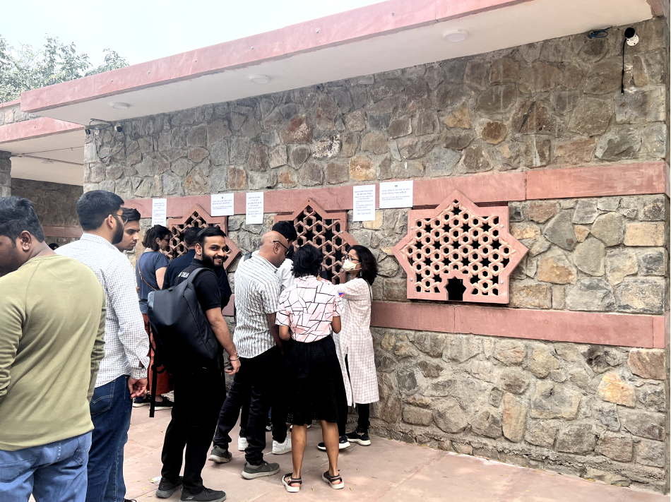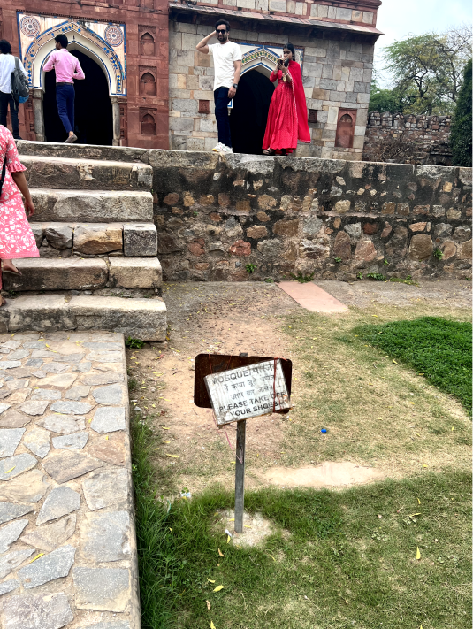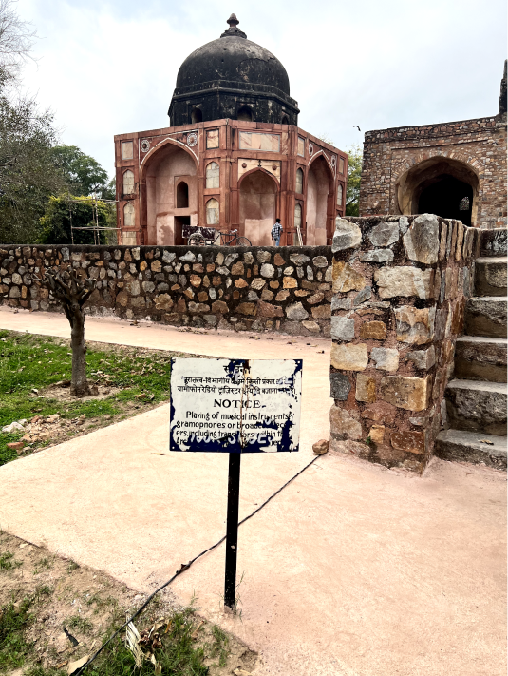
Figure 1: Queue to buy tickets at Humayun's tomb; Figure 2-3: Improper signage of mosque

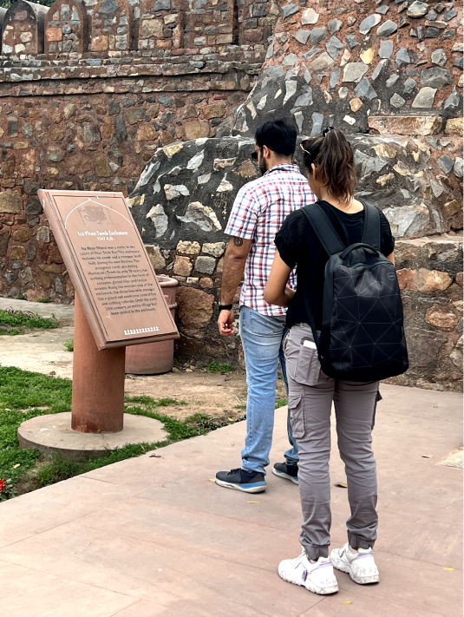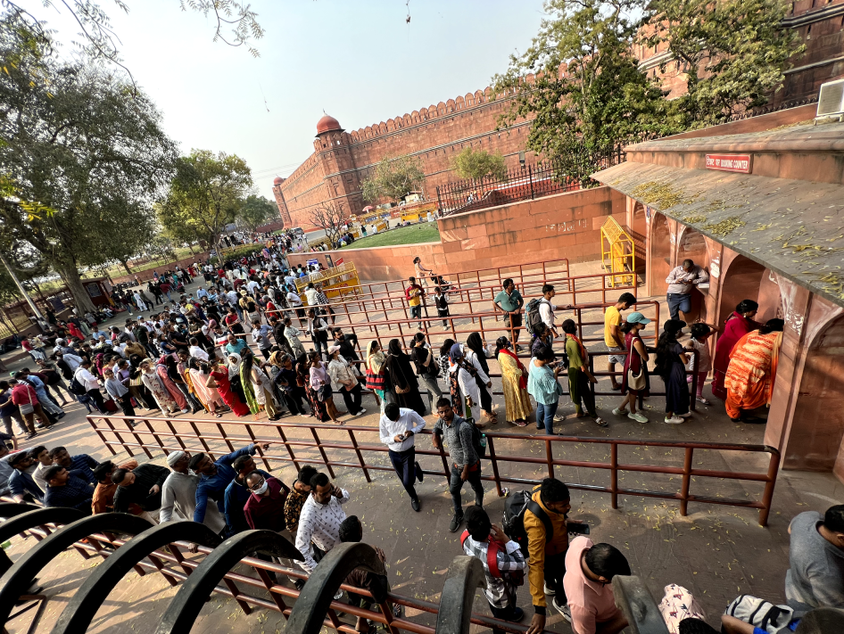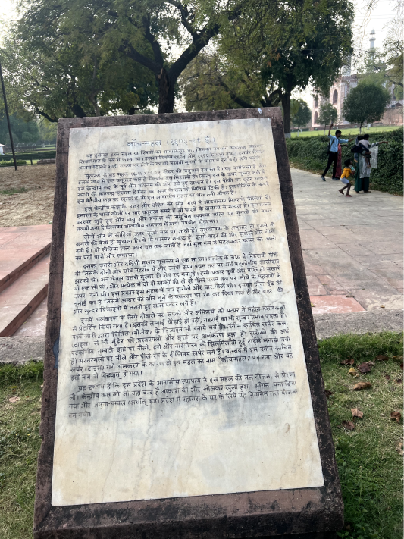
Figure 4: Tourists trying to gain information by reading description board; Figure 5: Long queues to buy tickets at Red Fort; Figure 6: Akbar’s tomb information board

USER STUDY INSIGHTS

To gain insights into the challenges faced by tourists while visiting historical monuments in Delhi, the research used a combination of qualitative and quantitative data collection methods. The study involves a survey that was conducted with over 400 participants and contextual interviews of 25 people. The study aimed to gather information about the challenges faced by tourists and their opinions on the effectiveness of digital interventions in enhancing their experience. The results of the survey indicated that tourists faced several challenges, including a lack of reliable information and difficulty navigating the monuments.
The participant selection for the ethnographic research conducted at the historical monuments of Delhi to redesign experiential tourism involves identifying and selecting a diverse group of participants who have direct or indirect involvement with the tourism industry and the selected sites. The following groups of participants could be selected for this study: Tourists: Tourists visiting the historical monuments in Delhi were recruited to participate in the study. The selection of participants aimed to represent a diverse range of ages, genders, nationalities, and socio-economic backgrounds. Local tour guides: Local tour guides who work at the selected sites were recruited to participate in the study. The selection of participants aimed to represent a diverse range of ages, genders, and experience levels. Site administrators: Site administrators responsible for managing and maintaining the selected were recruited to participate in the study. The selection of participants aimed to represent a diverse range of ages, genders, and experience levels. Local residents: Local residents who live near the selected sites were recruited to participate in the study. The selection of participants aimed to represent a diverse range of ages, genders, and socio-economic backgrounds. The selection of participants should be based on the following criteria: Willingness to participate: Participants were willing to participate in the study and provide informed consent. Diversity: The selection of participants was aimed to represent a diverse range of ages, genders, nationalities, and socio-economic backgrounds.
Crowds and queues: Popular historical monuments in Delhi, such as the Red Fort and the Qutub Minar, can be crowded, particularly during peak tourist season. Long queues can also be a problem, leading to long waiting times and frustration. Lack of facilities: historical monuments in Delhi lack proper facilities such as toilets, drinking water, and rest areas. This can make the visit uncomfortable and unpleasant for international tourists. Unavailability of the (ASI) Guides at the site makes it hard to get a guided tour. Lack of facilities: Some historical monuments in Delhi lack proper facilities such as toilets, drinking water, and rest areas. This can make the visit uncomfortable and unpleasant for international tourists. Lack of information: Visitors may find it difficult to get information about the history and significance of historical monuments, especially if they are not part of a guided tour. "Lack of information" is a problem faced by visitors to these monuments, there is not enough information available at the site to help visitors understand the history and significance of the monument. There aren’t signage or informational boards around the fort to explain its historical and cultural significance, or the information may only be available in a limited number of languages. Visitors may also find it challenging to navigate the fort and understand its layout without any assistance or guidance. Language barrier: Many international tourists face a language barrier when visiting historical monuments in Delhi. English is widely spoken in Delhi, but not all locals may be proficient in it. This can lead to difficulties in communication and understanding the history and significance of the monument. Scams and touts: International tourists may be targeted by scammers and touts who try to sell them fake tickets or souvenirs. This can lead to frustration and loss of money. Information offered is only in 2 languages that are English and Hindi. India is a Country that has 29 major linguistic groups. People from different linguistic groups find this information inaccessible. Safety and security: Incidents of theft and pickpocketing can be a concern for international tourists, particularly in crowded areas. Tourists may also be vulnerable to harassment and unwanted attention. Pollution: Air pollution is a major problem in Delhi, particularly during the winter months. This can lead to health problems for international tourists, particularly those with respiratory issues.
The study results revealed that tourists have a strong desire for more engaging and interactive ways to experience historical monuments. They expressed a need for a more personalized experience that caters to their individual interests and preferences. The survey findings served as a valuable source of information for the design and development of a mobile application that aims to enhance the tourism experience at historical monuments in Delhi. In addition to the lack of interactive and engaging elements, another major challenge faced by tourists visiting historical monuments in Delhi is the high cost of guided tours. These tours can cost a minimum of Rs. 2500/- which is not affordable for a majority of Indian citizens. This limits their ability to fully explore and learn about the rich cultural heritage of the city. Therefore, there is a need for a more affordable solution that can be accessible to a larger audience. A digital intervention, such as a mobile application, can provide an affordable and accessible alternative to guided tours, allowing tourists to explore the monuments at their own pace and on their own terms. The lack of availability of authorized guides provided by the Archaeological Survey of India (ASI) is a major challenge faced by tourists who visit historical monuments in Delhi. This often leads to tourists opting for self-exploration tours rather than guided tours, which can result in a less immersive and informative experience. There is a pressing need for a more readily available solution that is accessible to most people, which can provide accurate and reliable information about the monuments while also being cost-effective. This lack of information on how to book a guide is a major issue faced by tourists visiting historical monuments in Delhi. The current system is not well-structured, and tourists are often left confused and frustrated when trying to book a guide. This highlights the need for a more user-friendly and accessible system that provides clear instructions on how to book a guide and makes the process hassle-free for tourists. A typical user journey map has been illustrated in Figure 7 below.

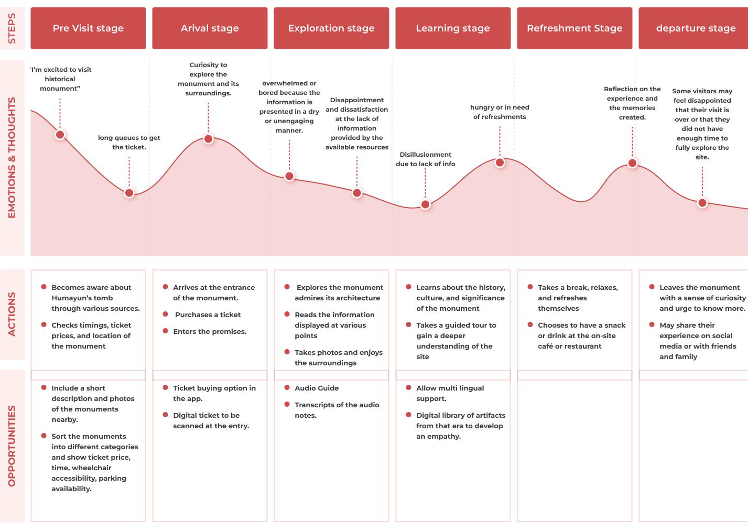
Figure 7: User Journey Map for Humayun’s Tomb

DESIGN AND USABILITY TESTING

This section comprises wireframing, high fidelity prototyping (Figure 8-9) and usability testing. Objective of usability testing include - To identify usability issues and areas of improvement: The primary goal of usability testing is to uncover any issues or pain points that users may experience when interacting with the mobile app. This can help the design team identify areas for improvement and make necessary changes to create a more user-friendly app. To evaluate the effectiveness of the app's features: Usability testing can also help assess how well the app's features and functions are meeting the user's needs. This can help the team determine whether the app is effectively fulfilling its intended purpose and whether additional features or changes are necessary. To assess user satisfaction: Another goal of usability testing is to evaluate user satisfaction with the app. This can help the team gauge how enjoyable and satisfying the app is to use and whether there are any aspects that users particularly enjoy or find frustrating. To gather feedback and insights for future iterations: Usability testing can also provide valuable feedback and insights that can inform future iterations of the app. This can help the team make informed decisions about changes and improvements to the app based on user needs and preferences.
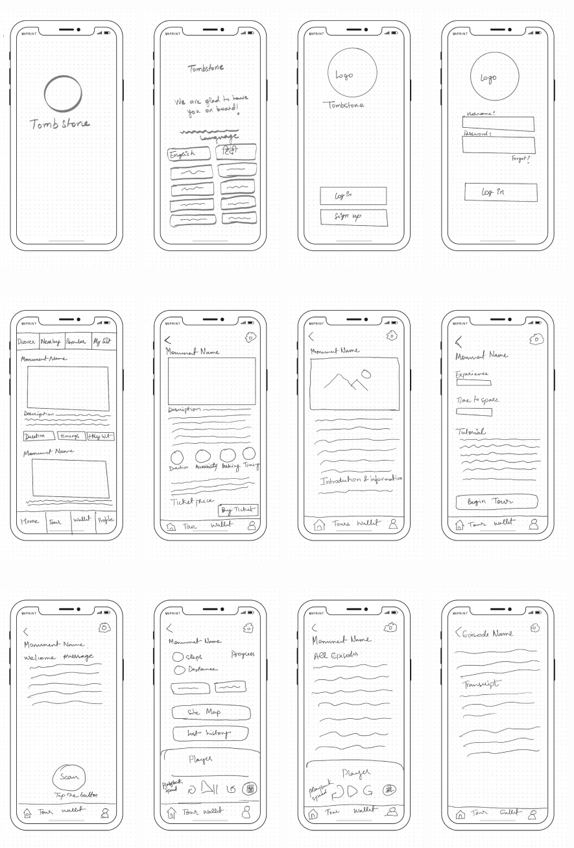
Figure 8: Wireframing

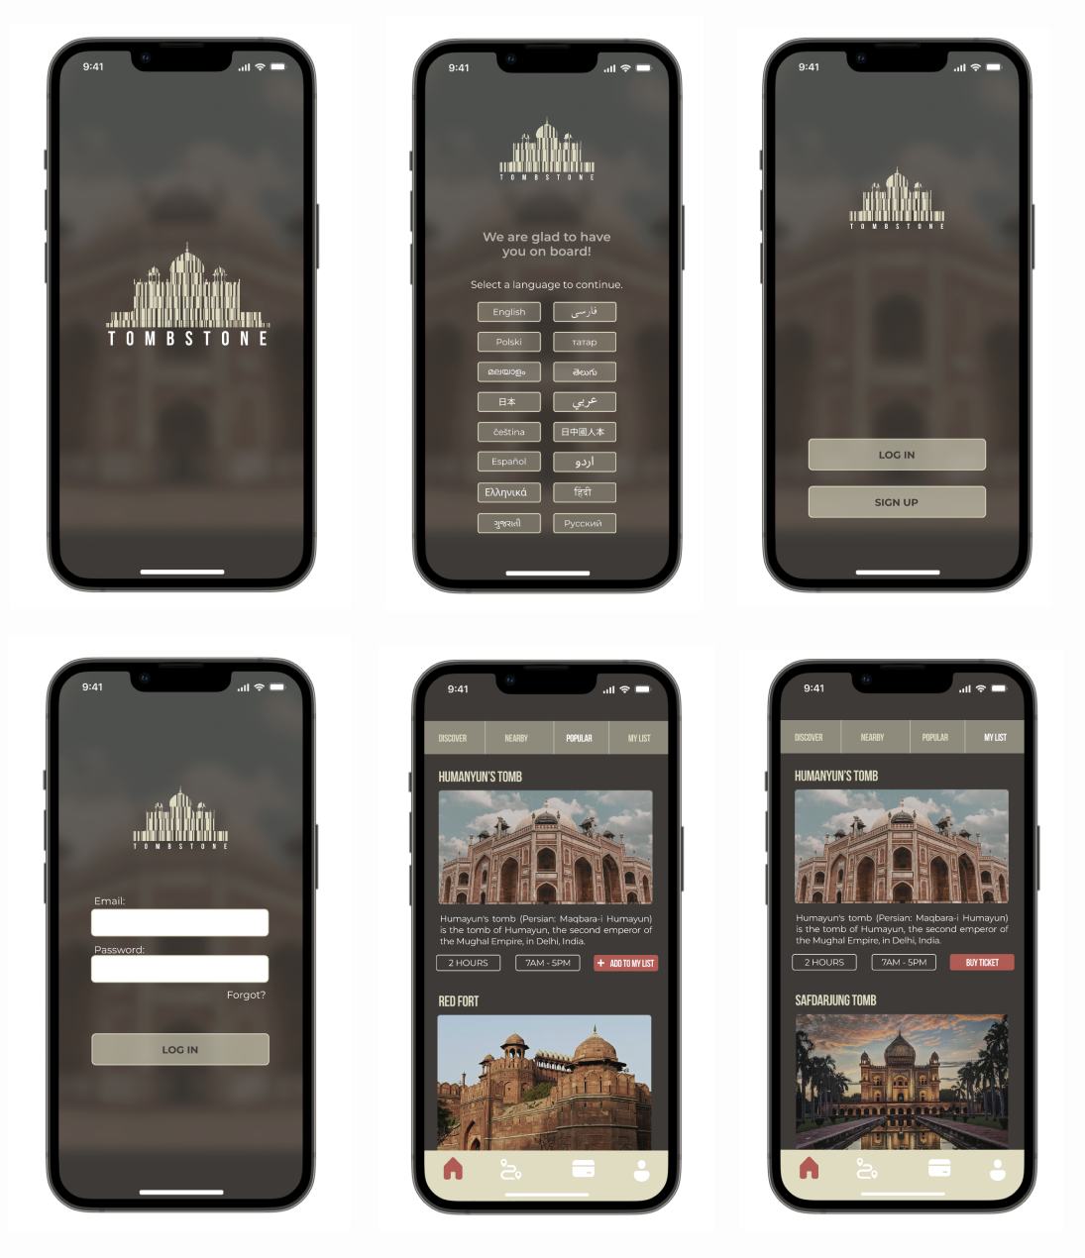
Figure 9: High fidelity prototype for testing

For Usability Testing (Figure 10), Tasks to be performed: Task 1- Were user able to plan the tour efficiently Task 2- Book tickets efficiently Task 3- Were users able to find all episodes Task 4- Were users able to interpret the site map. For this study, 20 participants were selected for the study, representing a diverse group of individuals in terms of age and occupation. The age range of the participants was between 20-64, ensuring a mix of both young and middle-aged participants. The participants were also selected based on their occupation, students, and individuals who occasionally travel, being included in the study. By selecting participants with different backgrounds and interests, the study could provide a comprehensive view of the usability of the product being tested. It is important to note that selecting participants based on age and occupation is not the only criteria for selecting participants, as factors such as gender, cultural background, and previous experience with similar products were taken into consideration to ensure a well-rounded group of participants.

Figure 10: Task completion by participants
Observations based on the results of the usability testing, The success rate for Task 1, which involved planning the tour efficiently, was 85%. This suggests that the majority of participants were able to complete the task successfully, but some may have encountered difficulties or required additional guidance. Task 2, which involved booking tickets efficiently, had a success rate of 80%, indicating that most participants were able to complete the task, but some may have faced challenges in doing so. Task 3, which involved finding all episodes, had a 100% success rate, indicating that all participants were able to complete the task successfully. Task 4, which involved interpreting the site map, had a success rate of 70%, suggesting that some participants may have found it challenging to understand and navigate the site map. Overall, the success rates for the usability testing tasks suggest that the platform is generally user-friendly and easy to use, with most users being able to complete the tasks successfully. However, there may be certain areas that require further improvement, such as the site map and booking tickets efficiently. The results also highlight the importance of providing clear instructions and guidance to users to help them navigate the platform effectively.

SUMMARY

Tourism plays a significant role in the economic development of a country, and India with its rich cultural heritage, is an attractive destination for tourists from all over the world. The capital city of India, Delhi, is home to many historical monuments that attract a large number of tourists every year. However, tourists often leave feeling unsatisfied with their experience due to the lack of interactive and engaging elements. To address these challenges, this research was conducted to design and develop a mobile application that offers reliable and accurate information about historical monuments in Delhi, the respective rulers who constructed them, and provides greater accessibility to this information through the inclusion of multiple languages and an audio guide within the app.
The study involved a combination of qualitative and quantitative data collection methods, including a survey of over 400 participants and contextual interviews with 25 people. The findings revealed that tourists faced several challenges while visiting historical monuments in Delhi, such as a lack of reliable information, language barriers, and the inability to navigate the monuments efficiently. The results of the study provided insights into the challenges faced by tourists and their opinions on the effectiveness of digital interventions in enhancing their experience.
Based on the findings, a mobile application was designed to address the challenges identified in the survey and offer a more engaging and immersive experience for visitors. The application offers reliable information about historical monuments, multiple language support, audio guides, and tailored tours. The proposed mobile application has the potential to enhance visitors' experience and promote tourism in Delhi.
The research has several limitations, such as focusing only on historical monuments in Delhi and the survey of tourists visiting those monuments, which may not be representative of all tourists visiting India. Further research could be conducted to gather insights from a more diverse group of tourists and include other historical sites in India.
In conclusion, the proposed mobile application can significantly contribute to the growth of tourism in Delhi by providing a more engaging and immersive experience for visitors. The application offers reliable information, multiple language support, audio guides, and tailored tours, which can enhance visitors' experience and promote tourism in Delhi. This research serves as a foundation for further exploration of digital interventions in enhancing the tourism industry and improving visitors' experience while visiting historical monuments in India in an IOT connected world.

REFERENCES

[1] Khan, A. R., & Ansari, M. A. (2015). Assessing the Information Needs of Tourists at Historical Monuments in Delhi. International Journal of Humanities and Social Science Research, 4(1), 1-10.

[2] Saikia, N. J., & Singh, J. (2017). Tourist preferences for interpretation at historic sites in Delhi. Tourism Recreation Research, 42(1), 87-97.

[3] Gupta, A., & Pandey, A. (2020). A Study of Tourists' Information Needs and Preferences in Relation to Historical Monuments in Delhi. Journal of Heritage Tourism, 15(3), 261-271.

[4] Singh, R. K., & Singh, A. K. (2018). An Empirical Study of Tourists’ Information Needs and Satisfaction Level with Information Sources at Historical Monuments in Delhi. Journal of Heritage Tourism, 13(5), 456-466.

[5] Fuchsberger, A., Födinger, M., & Tscheligi, M. M. (2014). User-Centered Design of Mobile Applications: A Case Study on the Effectiveness of a Mobile Event Guide. International Journal of Mobile Human Computer Interaction, 6(1), 41-58.

[6] Singh, S. K., & Kumar, A. (2019). Tourists' experience of visiting historical monuments in Delhi: A study of Red Fort and Qutub Minar. Journal of Tourism and Cultural Change, 17(2), 217-234.

[7] Dhar, S., & Jha, P. (2020). Analyzing Tourists’ Experience and Perception of Heritage Sites in Delhi. International Journal of Tourism Research, 22(6), 755-766.

[8] Saha, S., & Gupta, A. (2018). Tourist experience of the Taj Mahal and other historical monuments in Delhi. Journal of Heritage Tourism, 13(6), 558-573.

[9] Lal, R., & Pant, S. (2018). Tourist perception and experience of heritage tourism in Delhi. Journal of Heritage Tourism, 13(4), 314-327.

[10] Mishra, S., & Kumar, A. (2018). Tourists’ perception and experience of heritage tourism in Delhi: A study of Humayun’s Tomb and Jama Masjid. Tourism Recreation Research, 43(1), 78-89.

[11] Jain, S., & Jain, K. K. (2017). A study on tourist satisfaction with reference to monuments in Delhi. Indian Journal of Tourism and Hospitality Research, 5(1), 1-10.

[12] Jain, M., & Bhatia, R. (2019). An exploratory study of the factors affecting tourist experience at the historical monuments of Delhi. International Journal of Scientific Research and Management, 7(12), 697-703.

[13] Bhattacharya, S., & Sengupta, S. (2020). Visitor experience and satisfaction at historical monuments in Delhi: A study of three popular sites. Journal of Cultural Heritage Management and Sustainable Development, 10(1), 80-94.
[14] Garg, R., & Bansal, A. (2019). Analysis of tourism industry in Delhi. International Journal of Scientific Research and Management, 7(12), 14-21.
[15] Singh, S. P., & Singh, D. K. (2020). Contribution of tourism to Delhi's economy: An empirical study. International Journal of Business and Globalisation, 24(1), 24-36.
[16] Pradhan, S. K. (2018). Measuring the economic impact of tourism in Delhi. International Journal of Scientific Research and Management, 6(6), 294-300.
[17] Vashisht, M., & Maheshwari, A. (2018). Contribution of tourism to economic growth in Delhi. International Journal of Research in Economics and Social Sciences, 8(3), 1-14.
[18] Kumar, A., & Chawla, D. (2018). Tourists' information search behavior in heritage tourism: A study of Delhi. Tourism Review International, 22(3), 195-206.
[19] Singh, A. K., & Garg, A. (2019). Determinants of tourists' information seeking behaviour for heritage sites in Delhi, India. Journal of Heritage Tourism, 14(6), 571-581.
[20] Singh, D. K., & Singh, S. P. (2018). Tourists' information needs and preferences for heritage tourism: A study of Delhi. Journal of Heritage Tourism, 13(6), 563-579.
[21] Kumar, A., & Chawla, D. (2019). Understanding tourists' information needs and preferences for heritage sites: A study of Delhi, India. International Journal of Tourism Cities, 5(2), 159-173.

