Experiment and Numerical Analysis of Plate Heat Exchanger Using TiO2+MWCNT Nano fluid
Manojkumar. N. Udgire¹, Dr. Vishwajit Bhagwat², Girish.M.Deshmukh³
^{1,3}Assistant Professor, Department of Mechanical Engineering, Chhatrapati Shivaji Maharaj University, Panvel-410206, Navi Mumbai. Maharashtra, India
²Assistant Professor, Department of Automobile Engineering, Dhole Patil College of Engineering Pune, Near Eon IT Park Kharadi Pune -412207, Maharashtra, India
*Corresponding Author Email:udgiremanojkumar@gmail.com, vishwajit333@gmail.com

Abstract
In this work, experimental and numerical investigations were carried out in a plate heat exchanger with TiO2+MWCNT/water at different volume concentrations (0% to 1.50%) to study the effects on heat transfer and pressure drop. A discrete- phase model was created for the study using the software CFD (Fluent 14.0), and the results were compared with the experimental results and the consistent model. The results of the experimental investigation of the plate heat exchanger agree well with the results of CFD. The results from CFD were validated by the experimental results and found to be in good agreement
Keywords: CFD Analysis; Hybrid Nano fluid; Thermal Conductivity;

Introduction
Plate heat exchangers are generally constructed of thin plates. The plates are either smooth or formed of corrugated plates; they are connected to the heat exchanger. Flow arrangement is feasible for PHE, depending on the heat exchanger arrangement, which includes the number of channels, pass orientation, type of channel flow, and at the location of inlet and outlet relationships on the frame. The plate heat exchanger is a device that transports thermal energy through two or more fluids by the convection property of fluids. Lozano et al [1] studied the large number of possible arrangements and the infinite diversity of industrial plates. The colloidal suspension of nanoparticles (1-100 nm) in a base fluid is called a Nano fluid, which is a new type of heat transfer fluid for various heat transfer approaches where the heat transfer property is considerably higher than the base fluid. Tiwari et al [2] illustrated the different Nano fluids at different temperatures and concentrations of nanoparticles CeO2, Al2O3, TiO2, and SiO2 with water based thermal conductivity studied 35.9%, 26.3%, 24.1%, and 13.9%, respectively, at perfect volume concentrations. Kwon et al [3] conducted an experiment to analyze the heat transfer properties of Al2O3 with water Nano fluids as the base fluid for PHE and their volume concentration in the range of 0-6%. The results showed that the OHTC was increased by 3%. Wu et al [4] studied a double tube coil heat exchanger with nanoparticles of Al2O3 and water as the base fluid, and the volume concentration ranged from 0.78to 7.4%. In the study, they observed the overall effect of nanoparticles on heat in the presented grades of nanoparticles. Ghozatloo et al. [5] oncluded the result in a shell and tube heat exchanger using graphene with the base fluid water, volume concentration range 0.05-0.1%. The result is HTC improved in 13.1% in
~0.1% A. Joker et al [6] organized a numerical investigation of the Nano fluid Al2O3 with the base fluid water in a corrugated three-channel PHE using CFD with concentrations in the range of 1-4.0% by volume while controlling laminar flow. The result of their study shows that the heat flux decreases with increasing volume concentration of the Nano fluid. They concluded that the complex flow control of Nano fluids in the three-dimensional structure of PHEs, which is slightly different from the simple geometries, such as the circular tubes

Experimentation

The preparation of Nano fluids is the basic process in the use of nanoparticles for heat transfer applications. In this process improve the thermal conductivity, viscosity with the different volume concentration and temperature.

2.1 Measurement of Nano fluid Thermal Conductivity
To measure the thermal conductivity of the hybrid Nano fluid, we use the KD2 Pro thermal property analyzer. The KD2 Pro unit consists of a handheld controller and a sensor installed in the medium. For inspection KS1 unit needle sensor or bi-needle there diameter -1.3 mm, length - 60mm at micro-processor is used to identify or evaluate thermal conductivity of hybrid Nano fluids. The accuracy of the device is the thermal conductivity 0.2–2.0 W/m K of the Nano fluid by the designer, which claims ±5%. Investigation of the result of TiO2-CNT/water on thermal conductivity; Nano fluids were prepared in volume concentrations thermal conductivity is found at different concentrations.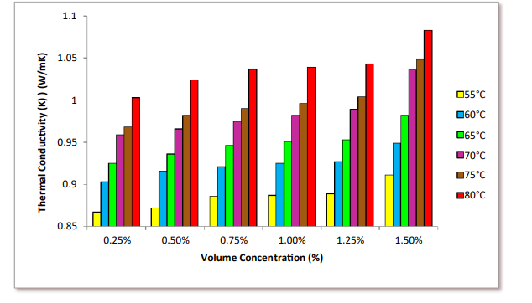
Figure 1 Variation of thermal conductivity K_{nf} for TiO2 - MWCNT nanofluid with different volume concentration

The thermal conductivity at 0.25%, 0.50%, 0.75%, 1.0%, 1.25% and 1.50% of the volume concentration of the Nano fluid was determined for the temperature ranges 55oC, 60oC, 65oC, 70oC, 75oC and 80oC. The thermal conductivity measured at 1.50% hybrid Nano fluid is 1.083 W/m K at a temperature of 80oC, which is 60.85% higher than the thermal conductivity of the base fluid (0.659 W/m K).

Measurement of Nano fluid Viscosity
We performed the measurement of viscosity using the Brookfield digital viscometer LVDV - II + Pro. This viscometer is adopted by operating the immersed part, which is called a spindle, attached by beryllium-copper spring. In the LVDV – II + Pro type viscometer spring torque 673.7 (dyne - cm) and accuracy ± 1%full scale range are established.
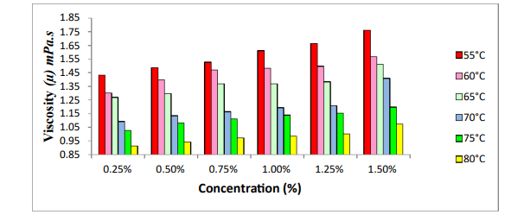

Figure 2 The variation viscosity (µ) mPas for TiO2-MWCNT hybrid nanofluid with different concentration

The viscosity of the hybrid Nano fluid was calculated at different temperatures (55oC, 60oC, 65oC, 70oC, 75oC, and 80°C) and concentrations of nanoparticles (0.25%, 0.50%, 0.75%, 1.0%, 1.25%, and 1.50%) during plate heat exchanger operation. The viscosity of the hybrid Nano fluid follows the trend of the base fluid, where it decreases exponentially with the change in temperature. However, as the nanoparticles associated with the base fluid expand, the viscosity value also increases. This is evidence that increasing the nanoparticle concentration in the hybrid Nano fluid increases the internal shear stress of the fluid and thus the viscosity. To investigate the effects of TiO2-CNT on viscosity, a Nano fluid with increased volume concentration was prepared 0.25%, 0.50%, 0.75%, 1.0%, 1.25%, and 1.50%. In the diagram, the volume concentration increases and the viscosity increases at a temperature of 55°C. The viscosity of the hybrid Nano fluid is 1.762 mPas at a volume concentration of 1.50%. So we write that when the volume concentration increases, the viscosity also increases.
3. CFD Simulation of Plate Heat Exchanger
The CFD section includes the management of the equations, the details of the mesh generation and the boundary conditions associated with the numerical investigation. The leading calculations are explained using the commercial CFD package (Fluent 14.0).

3.1 Solution Methodology
A business package CFD (ANSYS/Fluent 14.0) was used to solve the management equations with associated simplified assumptions:
The PHE operates under unchanged state conditions.
The heat exchange surface was assumed to be free of fouling.
There is no mis-circulation of the flow and the flow is uniformly isolated in each of the channels.
The flow remains single-phase in the channels.
The outer walls of the PHE are insulated.
The κ– ε representation was used in the simulation of CFD because some numerical simulations of PHE with water have used this model since it is able to determine the optional flow. Initially the whole of the heat exchanger was modeled with both the hot and cold fluid zones to predict the exact flow and heat transfer process. But the domain was too large to solve and it reached the computational limitation to generate the mesh.

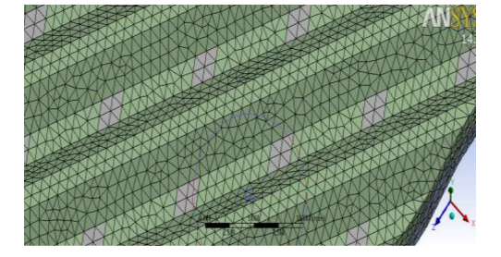
Figure 3 Mesh of the domain with maximum size of 1mm

The corrugated plate, modeled with some approximations in the distribution region of the corrugated plate, and the whole plate heat exchanger were originally designed for analysis. In the real model of the heat exchanger, there were 5 layers for the cold fluid and 4 layers for the hot fluid, so the fluid zones for both the heat exchanger and the computational domain used for the analysis were determined accordingly

Mesh Generation
To solve the problem, the three zones were first connected in the design modeler so that the connected mesh is generated. The initial mesh generated for the geometry was highly skewed with a skewness of 0.99, resulting in divergence in the simulation. The initial mesh generation was done in Ansys ICEM CFD with the following options
Physical reference: CFD
- Preferred solver: Fluent
- Relevance: 10
- Advanced size function: curvature on
- Relevance center: fine
- Smoothing: high
- Transition: slow
- Span angle center: fine
- Growth rate 1:2
To create a "good" mesh, the minimum and maximum size of the element is changed. The following table shows the number of nodes and elements generated at different maximum sizes
Table 1
Maximum size (mm) | Number of nodes | Number of elements
1mm | 2,76,031 | 13,74,893
0.8 mm | 5,08,727 | 26,10,609
0.6 mm | 10,97,741 | 57,72,746
0.5 mm | 17,62,153 | 94,57,683

The mesh details are given below:
Cells – 14, 37,429
Faces – 61, 80,719
Nodes – 37, 62,686

Boundary Conditions
The inlet, outlet, walls, and surfaces are selected during mesh generation to apply boundary conditions accordingly. The boundary conditions for the inlet are set as velocity inlet, and for the outlet as pressure outlet. For the thermal conditions of the walls of the fluid zone exposed to the atmosphere, the adiabatic conditions are used, and for those in contact with the corrugated plate, the coupled boundary conditions are used.
The values of the different boundary conditions for the water-water heat exchange are as follows:
Cold fluid inlet velocity: 0.0176 m/sec (as accordance to 220 kg/hr)
Hot fluid inlet velocity: 0.01 m/sec (as accordance to 100 kg/hr)
Cold Inlet temperature: 293 K
Hot Inlet Temperature: 348 K
Turbulence Intensity: 6%
Hydraulic Diameter: 30 mm
Back Flow Temperature: 320 K

Analysis and Solution
The governing equations were solved using the commercial CFD package FLUENT 14.0 under the following simplifying assumptions; the figure below shows the plot of the residuals versus the number of iterations to obtain the converged solution for the water-water combination.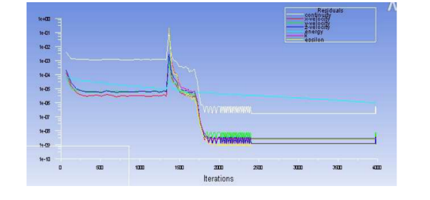
Figure 4 Graph of residual with respect to the Iterations

The time required to obtain the converged solution for one combination is approximately 16 hours and 3978 iterations are required on a second generation Intel i5 processor. Since the heat exchange is in lateral direction, double precision is considered and parallel processing is performed with all 8 processors in working mode to achieve 100% utilization.

Results and Discussion
The results of the computational fluid dynamics for the domain with the water-water combination and the water-Nano fluid combination are shown and discussed in this section. As discussed earlier, the corrugation of the plates is necessary to increase the turbulence in the flow and also to avoid recirculation of the fluid between the plates, otherwise the formation of hot spots will lead to irregular heat exchange.
The velocity profile of the cold fluid zone and the hot fluid zone is shown in the figure.

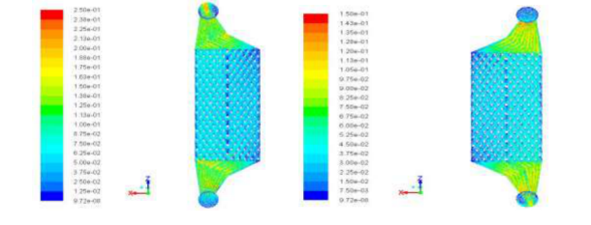

Figure 5 The velocity profile of the cold fluid and the hot fluid

The temperature distribution of the fluid zone clearly shows that the temperature in the distribution area does not change at first, and then the heat exchange between the fluid zones takes place. The temperature distribution of the water-water combination of the cold liquid zone and the hot liquid zone is shown in the following figures, respectively.
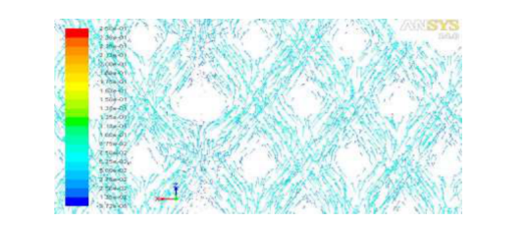

Figure 6 The velocity vector of the cold fluid showing the turbulence generated

After getting converged solution for water-water flow, data was compared with the theoretical analysis of heat exchanger for same inlet temperatures and flow rate. Outlet temperature and pressure drop are as follows for both the cases:
 | Theoretical analysis | CFD analysis
Hot water mass flow rate | 100 kg/hr | 100 kg/hr
Cold water mass flow rate | 220 kg/hr | 220 kg/hr
Hot water inlet temperature | 348 K | 348 K
Cold water inlet temperature | 293 K | 293 K
Hot water outlet temperature | 316.2 K | 318.21 K
Cold water outlet temperature | 315.1 K | 312.34 K
Hot water side pressure drop | 145.87 Pa | 140.929 Pa
Cold water side pressure drop | 415.2 Pa | 297.211 Pa

The corrugated plate three different surfaces were created to obtain the temperature distribution of the plate at different regions shown in figure.

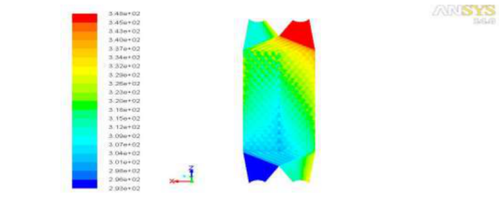
Figure 8 Distribution of temperature of the corrugated plate

Conclusions

The main conclusions from the experimental and CFD simulations using (Fluent 14.0) and the geometry created in Ansys 14.0 are the following features. The hybrid nanofluid has optimal volume concentrations in which the heat transport shows an extreme increase. The experimental results are in exact agreement with the results from CFD, which confirms that the simulation of a uniform mixture of hybrid nanofluid (TiO2-MWCNT) can be successfully used to predict the application of plate heat exchangers The hybrid nanofluid is favorable to improve the performance of the PHE, despite the unfavorable increase in viscosity. The largest temperature arises approximately in the upper orifice of the hot fluid, while the smallest temperature in the cold fluid flows through the lower orifice, the temperature slope is larger, and the heat transfer result is additionally acceptable.

REFERENCES
- A. Louzano, F. Barreras, N. Fueyo, S. Santodomingo. The flow in an oil/water plate heat exchanger for automotive industry. Applied Thermal Engineering 2008.28 (10).1109
- A.K. Tiwari et.al. Performance comparison of the plate heat exchanger using different nanofluids. Exp Therm Fluid Sci. 49 (2013) 141–51
- Kwon YH, et.al. Heat transfer and pressure drop characteristics of nanofluids in a plate heat exchanger. J Nanosci Nanotechnol 2011; 11:5769–74
- Wu Z, et.al. Pressure drop and convective heat transfer of water and nanofluids in a double-pipe helical heat exchanger. Appl Therm Eng 2013; 60:266–74
- A. Ghozatloo, A. Rashidi, M. Shariaty-Niassar. Convective heat transfer enhancement of graphene nanofluids in shell and tube heat exchanger. Exp Therm Fluid Sci. 53 (2014) 136-41.
- A. Jokar and S.P. O’Halloran. Heat transfer and fluid flow analysis of nanofluids in corrugated plate heat exchangers using computational fluid dynamics simulation. J Therm Sci and Engg Applications. 5 (2013) 011002-1.
- [7] Choi S., Enhancing thermal conductivity of fluids with nanoparticles, ASME FED 231/MD 66, 1995, pp. 99-103.
- Gupta M., Singh V., Kumar R., Said Z., A review on thermophysical properties of nanofluids and heat transfer applications, Renewable and Sustainale Energy Reviews 74: 638-670, 2017
- Keblinski P., Eastman J. A., Cahill D. G., Nanofluids for thermal transport, Materials Today 8:36-44, 2005
- Kabeel A. E., Maaty A. E., Samadony E. Y., The effect of using nanoparticles on corrugated plate heat exchanger having different surface profiles, Applied Thermal Eng. 52:221-229, 2009
- Khairul M. A., Alim M. A., Mahbubul I. M., Saidur R., Hepbasli A., Hossain A., Heat transfer performance and exergy analysis of a corrugated plate heat exchanger using metal oxide nanofluids, International Communications in Heat and Mass Transfer 50:8-14, 2014
- Maré T., Halefadl S., Sow O., Estelle P., Duret S., Bazantay F., Comparison of the thermal performances of two nanofluids at low temperature in a plate heat exchanger, Experimental Thermal and Fluid Science 35:1535-1543, 2011
- Huang D., Wu Z., Sunden B., Pressure drop and convective heat transfer of Al2O3/water and MWCNT/water nanofluids in a chevron plate heat exchanger, International Journal of Heat and Mass Transfer 89:620-626, 2015.
- Sun B., Peng C., Zuo R., Yang D., Li H., Investigation on the flow and convective heat transfer characteristics of nanofluids in the plate heat exchanger, Experimental Thermal and Fluid Science 76:75-86, 2016
- Xing M., Yu J., Wang R., Experimental study on the thermal conductivity enhancement of water based nanofluids using different types of carbon nanotubes, International Journal of Heat and Mass Transfer 88:609-616, 2015
- Zamzamian A., Oskouie S. N., Doosthoseini A., Joneidi A., Pazouki M., Experimental investigation of forced convective heat transfer coefficient in nanofluids of Al2O3/EG and CuO/EG in a double pipe and plate heat exchanger under turbulent flow, Experimental Thermal and Fluid Science 35:495-502, 2011
- Kwon Y. H., Kim D., Li C., Lee J., Hong D., Heat transfer and pressure drop characteristics of nanofluids in a plate heat exchanger, Journal of Nanoscience and Nanotechnology 11:5769- 5774, 2011
- Fard M. H., Talaie M. R., Nasr S., Numerical and experimental investigation of ZnO/water nanofluid in the concentric tube and plate heat exchangers, Thermal Science 5:183-194, 2011
- Majdi H., Abed A. M., Effect of nanofluids on the performance of corrugated channel within out-of-phase arrangement, International Journal of Thermal Science 92:230-238, 2015
- Gherasim I., Galanis N., Nguyen C., Numerical study of nanofluid flow and heat transfer in a plate heat exchanger, Computational Thermal Sciences: An Int. Journal 5:317-332, 2013
- Khoshwaght–Aliabadi M., Hormozi F., Zamzamian A., Effects of geometrical parameters on performance of plate-fin heat exchanger: vortex generator as core surface and nanofluid as working media, Applied Thermal Engineering 70:565-579, 2011.

