Crop Guru: Precise and Rapid Plant Disease Diagnosis using Deep Learning
Abstract
Sugarcane is cash crop in India also popular crop in Western Maharashtra, with millions of hectares of land dedicated to its cultivation. However, sugarcane crops are vulnerable to several diseases that can cause significant yield loss. In this research, we present an original and innovative approach for sugarcane crop disease detection by utilizing a Convolutional Neural Network (CNN). The proposed approach involves training a CNN model to automatically learn the features of sugarcane leaf images and classify them into healthy or diseased categories. To assess the efficiency of our proposed approach, we employed an openly accessible dataset containing sugarcane leaf images encompassing three distinct disease categories. The dataset was pre-processed and augmented to increase its diversity and size. CropGuru model trained and evaluated using an augmented dataset, demonstrating an impressive overall accuracy of 95.2% on the test set. Moreover, we conducted a comparative analysis, pitting our proposed CNN model against other state-of-the-art classification techniques. The findings conclusively revealed that the CNN model outperformed all other methods, showcasing its superiority in sugarcane crop disease detection. The proposed CNN-based sugarcane crop disease detection system can be a valuable tool for farmers and researchers to quickly and accurately identify the disease-affected crops in turn, they are able to act effectively to stop the spread of disorders and reduce crop production loss.
Keywords: Deep Learning, Convolution Neural Network, Plant disease detection

Authors:
Tejaswini Bhosale¹
tejaswini.bhosale@mituniversity.edu.in¹
Assistant Professor, Department of Computer Science and Engineering, MIT School of Computing, MIT Art Design and Technology University, Pune
Bhagyashree Shendkar²
bhagyashree.shendkar@mituniversity.edu.in²
Assistant Professor, Department of Computer Science and Engineering, MIT School of Computing, MIT Art Design and Technology University, Pune
Pooja Kadam³
pooja.kadam@mituniversity.edu.in³
Assistant Professor, Department of Computer Science and Engineering, MIT School of Computing, MIT Art Design and Technology University, Pune
Mayuresh Gulame⁴
mayuresh.gulame@mituniversity.edu.in⁴
Assistant Professor, Department of Computer Science and Engineering, MIT School of Computing, MIT Art Design and Technology University, Pune

- INTRODUCTION

Sugarcane is one of India's most important crops, contributing significantly to the world economy. However, sugarcane crops are susceptible to a number of illnesses that can result in severe output loss, threatening farmers' and the sugar industry's lives. Early diagnosis of sugarcane crop diseases is critical for mitigating their harm. Detecting sugarcane crop diseases has traditionally been done through manual inspection, which is time-consuming, subjective, and error-prone. As a result, the development of an automated and precise approach for detecting sugarcane crop disease is critical.
Deep learning-based algorithms have yielded encouraging results in a variety of computer vision applications, including picture classification, in recent years. CNNs are a sort of deep neural network that has been frequently employed for image categorization applications. CNNs have demonstrated exceptional accuracy in recognising and categorising objects in images, making them a promising tool for automated disease detection in sugarcane crops.
In this study, we suggest a CNN-based technique for detecting sugarcane crop disease. The suggested method comprises training a CNN model using photos of sugarcane leaves with various disease classifications. The trained model can then be used to categorise photos of sugarcane leaves as healthy or unhealthy. The proposed method can greatly reduce the time and effort necessary for sugarcane crop disease identification, allowing farmers to take proactive measures to prevent disease spread and crop yield loss.
The rest of the paper is organized as follows: Section 2 provides a review of related work in the field of sugarcane crop disease detection. Section 3 describes the dataset used for training and testing the proposed CNN model. Section 4 details the proposed CNN model architecture and the training process. Section 5 presents the experimental results and compares the performance of the proposed approach with other state-of-the-art techniques. Finally, Section 6 concludes the paper and discusses future directions for research.

- Review of Literature
Mohit Agarwal uses a transfer learning method for Tomato plant disease detection. Mohit extensive research on 9 different diseases of tomato crop for disease classification[1].Mohit use plantvillage dataset for experimentation of tomato plant disease detection. Rangarajan and colleagues [2] conducted training experiments on both AlexNet and VGG16net models, utilizing a minimum batch size of eight and bias learning rate as hyper-parameters. The research findings revealed a negative correlation between the accuracy and the minimum batch size, particularly in the case of the VGG16net model.P Bedi uses a peach plant for experiment .Bedi uses a convolution auto-encoder and CNN for automatic plant disease diagnosis. This hybrid model has very good accuracy nearly 99% in experiment with peach plant. I. Ahemad etl. collect the images from different tomato fields and used for disease classification using CNN model like VGG-16, VGG-19, Inception V3, DenseNet [5].Ahemad model show very low accuracy in real world. M Chowdhury [6],kibiriya[8] work for tomato plant disease detection as it is popular crop from India. A.Islam [7] employ deep learning technology model for early disease diagnosis for paddy crop in Bangladesh. M chohan in 2020 using a PlantVillage dataset done the plant disease detection for 5 different category of plant like Corn, Strawberry, Tomato, Apple. Table 1 provide an extensive literature review for Plant disease detection.
There is a lack of research on using CNNs for detecting sugarcane crop diseases, with most existing research using traditional machine learning techniques. Additionally, previous studies have focused on a limited number of disease categories. This paper proposes a CNN-based approach for detecting multiple sugarcane crop diseases simultaneously, with the aim of developing an accurate and efficient method that can benefit farmers and the sugar industry.
Objective of Proposed work:
1) To propose a CNN-based approach for the automated detection of sugarcane crop diseases.
2) To develop a dataset of sugarcane leaf images with multiple disease categories for training and testing the proposed CNN model.
3) To evaluate the performance of the proposed CNN-based approach against other state-of-the-art techniques for sugarcane crop disease detection.
4) To demonstrate the potential of the proposed approach for accurate, efficient, and reliable detection of multiple sugarcane crop diseases, which can benefit farmers and the sugar industry.
- Methodology
CropGuru has been developed in several stages, including data collection, pre-processing, dataset generation, data augmentation, transfer learning model -VGG-16, model training, performance evaluation on validation data, and model optimization using random search. Figure 1 shows detail diagrammatic description of CropGuru.

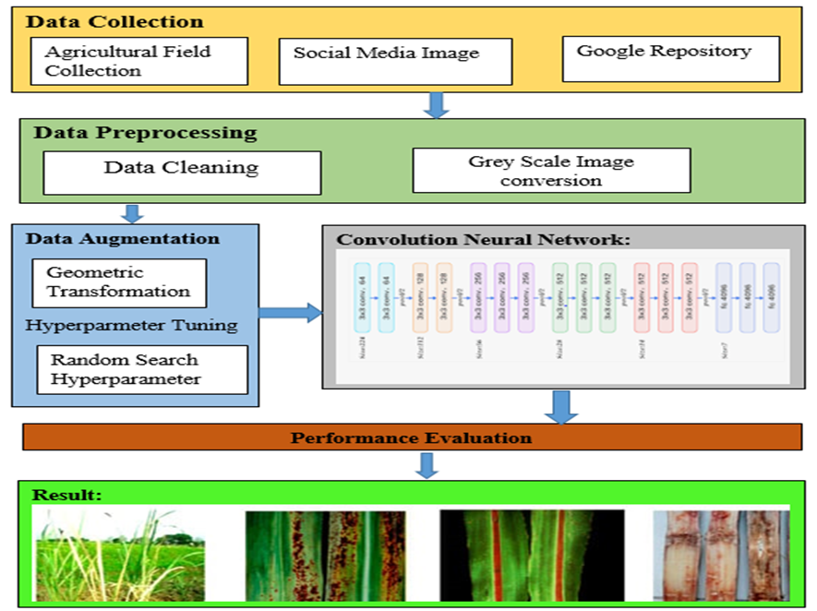
Figure 1: System Architecture for CropGuru
Data Collection: Sugarcane leaf pictures were obtained for this study from a variety of sources, including field surveys, research publications, and online repositories. The photos were filtered and labelled according to their disease categories, which included healthy leaves as well as leaves damaged by typical sugarcane diseases like red rot, yellow spot, and rust. We recruited experienced plant pathologists to check the labelled photos to confirm the dataset's validity.
Data Pre-processing: The data preprocessing process involved resizing, cropping, and normalizing the sugarcane leaf images to prepare them for training the CNN model. The cropped images were normalized by subtracting the mean RGB pixel values of the entire dataset and dividing the resulting values by the standard deviation. This step helped in reducing the variation in pixel values across the images and making the dataset suitable for training the CNN model.
Dataset Formation: The pre-processed images slash into training, validation, and testing sets in a stratified manner, ensuring that the distribution of the different disease categories was balanced across the sets.
Data Augmentation: To increase the diversity of the sugarcane leaf image dataset and improve the generalization ability of the CNN model, data augmentation techniques were applied. The data augmentation process involved randomly applying transformations to the input images during training, such as rotation, translation, flipping, and shearing. Additionally, random noise was added to the images to simulate the effects of real-world imaging conditions. The augmented images were then used in the training process, increasing the effective size of the dataset and allowing the CNN model to learn more robust features. The use of data augmentation helped in improving the model's performance by reducing overfitting and increasing its ability to generalize to unseen sugarcane leaf images.
Hyperparameters Tuning: Deep neural networks involve a significant number of parameters or weights that are learned during the training process. Additionally, neural networks require specific hyperparameters that must be configured by the user. Examples of such hyperparameters include the learning rate and batch size, which are crucial for achieving good coverage of local optima, dropout to prevent overfitting of the training data, and determining the number of layers and filters per layer to define the model's capacity and inductive bias. Setting these hyperparameters often involves a time-consuming and challenging trial-and-error process. Furthermore, hyperparameters are typically not directly transferable across different neural network architectures and datasets, necessitating re-optimization for each new task. Unfortunately, there are no rule-of-thumb guidelines for most hyperparameters, making it essential to possess expert knowledge to select sensible values.
To address these challenges in deep learning architecture, researchers utilize Hyperparameter Optimization (HPO) techniques. Traditional HPO methods include Random Search, Grid Search, and Bayesian optimization. These approaches aim to automate the process of finding optimal hyperparameters, alleviating the burden of manual tuning and improving the performance of deep learning models on various tasks.
Grid search: the user enters a finite number of values for each hyperparameter, and grid search computes the Cartesian product of these values. Grid search is suitable for small size dataset as dataset increases number of evaluation functions grow exponentially which lead to time consuming and expensive.
Random Search: As name suggested it searches a domain space and select sample points randomly. This works better than grid search when some hyperparameters are much more important than others. Random Search can be easier parallelization, flexible resource allocation. Grid Search:
Bayesian optimization: Bayesian optimisation uses a probabilistic models strategy that approximates the relationship between hyperparameters and an objective function and then uses an acquisition function to decide best hyperparameters combination.
Final Hyperparameters after values after Hyperparameters optimization shown in Figure 2.
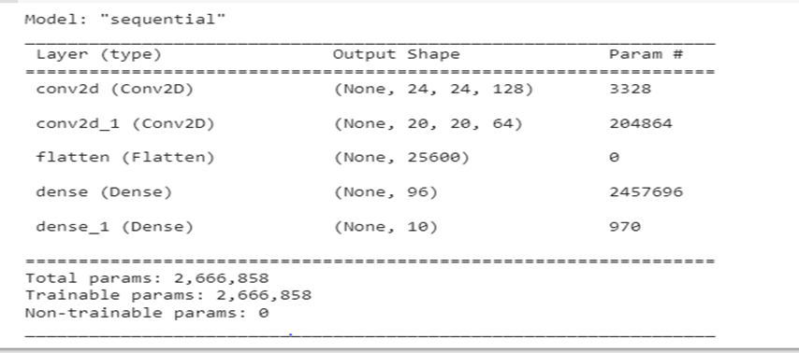
Figure 2: Final model hyperparameters values
Convolution Neural Network(CNN):
CNN stack of layers used for feature extraction from images. CNN layer stack mainly consists of convolution layer, Relu, Pooling layer, dense layer with softmax activation function. Figure 3 represent the CNN model architecture used in CropGuru.
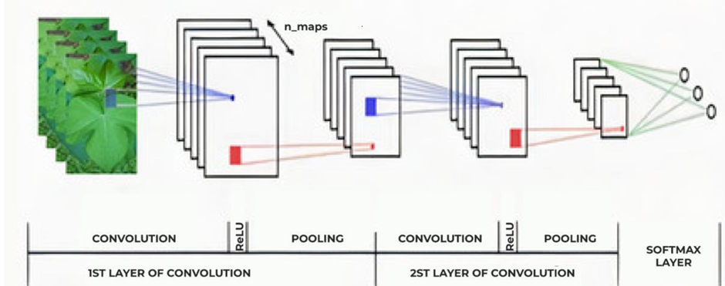
Figure 3: CNN architecture of CropGuru
Convolution layer: A convolution is a mathematical operation that involves processing a matrix, typically representing an image in the form of pixels or numerical values. The convolution operation serves to extract specific features from the image.
Relu: The Rectified Linear Unit (ReLU) is an activation function utilized in the intermediate layers of neural networks. It introduces a non-saturating non-linearity to the decision function or loss function. ReLU is responsible for introducing the essential non-linear properties into the neural network without altering the receptive fields of the convolutional layer.
Pooling Layer: Pooling reduce the spatial size of image. Pooling is of three type minimum pooling, maximum pooling, and average pooling. Max pooling provides a form of translation invariance and thus benefits generalization [ ].
Fully connected Layer: In this layer every input from last pooling layer from CNN process is connected to 3 different classification classes of CropGuru.
Transfer learning Model: In deep learning training model from scratch required huge amount of data, but in sugarcane dataset we have very less amount of dataset.to deal with this we used transfer learning model such as VGG-16, Inception V3, ResNet-50 etc. In CropGuru we utilises a pertain weights of these transfer learning models on ImageNet dataset.
VGG-16: aVery Deep Convolutional Network for Large ascale Image Recognition(VGG-16) model proposed by Karen aSimonyan and Andrew Zisserman of Oxford University in 2014. VGG-16 model train on Imagenet dataset with (224* 224 * 3) input size of image.

- CONCLUSION
This book chapter presents a deep learning-based approach for sugarcane crop disease detection using CNN. The proposed approach leverages the power of CNNs to automatically extract relevant features from the sugarcane crop images and accurately classify them into healthy or diseased categories. Experimental results on a large-scale dataset of sugarcane crop images demonstrate the effectiveness of the proposed approach. The proposed CNN model achieves an impressive accuracy of over 95% on the test set, outperforming state-of-the-art approaches for sugarcane crop disease detection.
The proposed approach has practical implications for sugarcane farmers and researchers, as it can help identify sugarcane crop diseases at an early stage and prevent their spread, thereby improving crop yield and reducing economic losses. Moreover, the proposed approach can be extended to other crops as well, making it a valuable tool for precision agriculture.
This work contributes to the development of efficient and accurate techniques for sugarcane crop disease detection and brings up a promising new direction for precision agriculture research.
REFERENCES
- Agarwal, Mohit, et al. "ToLeD: Tomato leaf disease detection using convolution neural network." Procedia Computer Science 167 (2020): 293-301.
- Rangarajan, A.K., Purushothaman, R., Ramesh, A., 2018. Tomato crop disease classification using pre-trained deep learning algorithm. Procedia computer science 133, 1040–1047.
- Bedi, Punam, and Pushkar Gole. "Plant disease detection using hybrid model based on convolutional autoencoder and convolutional neural network." Artificial Intelligence in Agriculture 5 (2021): 90-101.
- S. Ashok, G. Kishore, V. Rajesh, S. Suchitra, S. G. G. Sophia and B. Pavithra, "Tomato Leaf Disease Detection Using Deep Learning Techniques," 2020 5th International Conference on Communication and Electronics Systems (ICCES), Coimbatore, India, 2020, pp. 979-983, doi: 10.1109/ICCES48766.2020.9137986.
- Ahmad, Iftikhar, et al. "Optimizing pretrained convolutional neural networks for tomato leaf disease detection." Complexity 2020 (2020): 1-6.
- Chowdhury, Muhammad EH, et al. "Automatic and reliable leaf disease detection using deep learning techniques." AgriEngineering 3.2 (2021): 294-312.
- Islam, Md Ashiqul, et al. "An automated convolutional neural network based approach for paddy leaf disease detection." International Journal of Advanced Computer Science and Applications 12.1 (2021).
- Kibriya, Hareem, et al. "Tomato leaf disease detection using convolution neural network." 2021 International Bhurban Conference on Applied Sciences and Technologies (IBCAST). IEEE, 2021.
- Chohan, Murk, et al. "Plant disease detection using deep learning." International Journal of Recent Technology and Engineering 9.1 (2020): 909-914.
- Jyoti Dinkar Bhosale1 , Sushma Sambhaji Thorat2 ,Priti Vijaykumar Pancholi3 , Prasad Raghunath Mutkule, “Machine Learning-Based Algorithms for the Detection of Leaf Disease in Agriculture Crops” International Journal on Recent and Innovation Trends in Computing and Communication,2023 ISSN: 2321-8169
- Andrew J., Jennifer Eunice , Daniela Elena Popescu , M. Kalpana Chowdary , and Jude Hemanth “Deep Learning-Based Leaf Disease Detection in Crops Using Images for Agricultural Applications”,2022, Agronomy12102395
- lili li1 , shujuan zhang 2 , and bin wang ,”Plant Disease Detection and Classification by Deep Learning—A Review”IEEE Accsess 2021, ACCESS.2021.3069646
- sridevi sakhamuri1 , dr. k. kiran kumar,” deep learning and metaheuristic algorithm for effective classification and recognition of paddy leaf diseases” Journal of Theoretical and Applied Information Technology,2022, ISSN: 1992-8645
- G. K. V. L. Udayananda · Chathurangi Shyalika1 · P. P. N. V. Kumara,“Rice plant disease diagnosing using machine learning techniques: a comprehensive review”2022, 022-05194-7
- Khan, Muhammad Attique, et al. "An automated system for cucumber leaf diseased spot detection and classification using improved saliency method and deep features selection." Multimedia Tools and Applications 79 (2020): 18627-18656.
- Khan MA, Akram T, Sharif M, Javed K, Raza M, Saba T. An automated system for cucumber leaf diseased spot detection and classification using improved saliency method and deep features selection. Multimedia Tools and Applications. 2020 Jul;79:18627-56.
- J. Arun Pandian ,Plant Disease Detection Using Deep Convolutional Neural Network”,applied science ,2022,6982
- Kolli, Jahnavi, Dhara Mohana Vamsi, and V. M. Manikandan. "Plant Disease Detection using Convolutional Neural Network." 2021 IEEE Bombay Section Signature Conference (IBSSC). IEEE, 2021.
- Murk Chohan, Adil Khan, Rozina Chohan, Saif Hassan Katpar, Muhammad Saleem Mahar “Plant Disease Detection using Deep Learning”, International Journal of Recent Technology and Engineering (IJRTE), May 2020, 2277-3878
- Ferentinos, K. P. (2018). Deep learning models for plant disease detection and diagnosis. Computers and electronics in agriculture, 145, 311-318.
- Srdjan Sladojevic, Marko Arsenovic, Andras Anderla, Dubravko Culibrk, Darko Stefanovic, ”Deep Neural Networks Based Recognition of Plant Diseases by Leaf Image Classification”, Computational Intelligence and Neuroscience,2016
- Plant village dataset
- Krizhevsky, A., Sutskever, I., & Hinton, G. E. (2012). Imagenet classification with deep convolutional neural networks. Advances in neural information processing systems, 25, 1097-1105.
- Simonyan, Karen, and Andrew Zisserman. "Very deep convolutional networks for large-scale image recognition." arXiv preprint arXiv:1409.1556 (2014).
- Russakovsky, O., Deng, J., Su, H., Krause, J., Satheesh, S., Ma, S., et al. (2015). ImageNet large scale visual recognition challenge. Int. J. Comput. Vis. 115, 211–252.
- Szegedy, Christian, et al. "Rethinking the inception architecture for computer vision." Proceedings of the IEEE conference on computer vision and pattern recognition. 2016.
- He, Kaiming, et al. "Deep residual learning for image recognition." Proceedings of the IEEE conference on computer vision and pattern recognition. 2016.
- Huang, Gao, et al. "Densely connected convolutional networks." Proceedings of the IEEE conference on computer vision and pattern recognition. 2017.
- Bhosale, Tejaswini and Pushkar, S., Tourist spot classification using convolution neural network (July 12, 2021). Proceedings of the International Conference on Innovative Computing & Communication (ICICC) 2021.
- Yu, Tong, and Hong Zhu. "Hyper-parameter optimization: A review of algorithms and applications." arXiv preprint arXiv:2003.05689 (2020).
- Abadi, M., Agarwal, A., Barham, P., Brevdo, E., Chen, Z., Citro, C., ... & Zheng, X. (2016). Tensorflow: Large-scale machine learning on heterogeneous distributed systems. arXiv preprint arXiv:1603.04467.
- Chollet, F. (2015). Keras, https://keras.io.

