Swarm and Swarm Intelligence – Introductory Study into collective behaviour of natural and artificial systems

A. Manju Priya, AP/AI&DS
Dept of Artificial Intelligence & Data Science
Sriram Engineering College
Thiruvallur Dist, Veppampattu Tamil Nadu.

Padmapriya. V, AP/CSE
Dept of Computer Science Engineering
Sriram Engineering College
Thiruvallur Dist, Veppampattu Tamil Nadu.

Biju Daniel. T
Dept of Artificial Intelligence & Data Science
Sriram Engineering College
Thiruvallur Dist, Veppampattu Tamil Nadu.

S. Esther Praveena, AP/AI & DS
Dept of Artificial Intelligence & Data Science
Sriram Engineering College
Thiruvallur Dist, Veppampattu Tamil Nadu.

- ABSTRACT
Swarm intelligence, inspired by the collective behavior observed in social organisms, has emerged as a powerful paradigm in both natural and artificial systems. The concept of a swarm refers to a large group of simple agents that interact locally with one another and their environment, giving rise to complex and intelligent behavior at the group level. Swarm intelligence, on the other hand, represents the ability of a swarm to self-organize, adapt, and solve complex problems without central control. In nature, swarms of social insects such as bees, ants, termites, and birds exhibit remarkable abilities in foraging, navigation, resource allocation, and defense. These organisms demonstrate how the interactions of simple individuals can lead to efficient and robust solutions to various challenges faced in their environments.
In artificial systems, researchers have successfully translated the principles of swarm intelligence into algorithms and techniques for optimization, decision-making, and problem-solving. Popular swarm intelligence algorithms, such as Ant Colony Optimization, Particle Swarm Optimization, and Artificial Bee Colony, have shown great promise in tackling complex optimization and search tasks.
This paper provides an overview of the fundamental concepts of swarm intelligence and explores the similarities and differences between natural and artificial swarms. It delves into the principles of self-organization, decentralized decision-making, and adaptation that underpin swarm intelligence, allowing these systems to cope with dynamic and uncertain environments.
Furthermore, the paper examines the application domains of swarm intelligence, ranging from robotics and autonomous systems to data clustering, image processing, and network routing. The potential of swarm robotics in solving real-world challenges, such as environmental monitoring, disaster response, and precision agriculture, is also explored.
Swarm intelligence presents a compelling avenue for understanding and harnessing emergent collective behavior in both biological and computational contexts. The interplay of simplicity, local interactions, and adaptation enables swarms to tackle complex problems efficiently, making them a valuable source of inspiration for the design of intelligent systems in various fields. The study of swarm intelligence continues to advance, offering exciting possibilities for creating adaptive, robust, and scalable solutions in the ever-evolving landscape of artificial intelligence and beyond.

- KEYWORDS
Swarm-intelligence, collective-behavior, social-organisms, self-organization, adaptation, efficient-problem-solving, optimization, natural-systems, artificial-systems.

- INTRODUCTION
Swarm and Swarm Intelligence are fascinating concepts inspired by the collective behavior observed in social organisms such as ants, bees, and birds. These captivating phenomena have captured the attention of scientists and researchers, leading to remarkable insights into how simplicity and local interactions can lead to complex and intelligent behavior at the group level.
At its core, a swarm is a large group of simple agents that interact with each other and their environment following basic rules or behaviors. The agents in a swarm may lack individual intelligence, yet their collective actions can give rise to emergent behavior, enabling the group to achieve sophisticated tasks and objectives.
Swarm intelligence, on the other hand, refers to the ability of these swarms to self-organize, adapt, and solve complex problems without relying on centralized control or decision-making. It is a distributed form of intelligence that arises from the interactions and cooperation among the agents, resulting in efficient and robust problem-solving capabilities.
In this exploration of swarm and swarm intelligence, we will delve into the fundamental principles, applications, and significance of these concepts in both natural and artificial systems. By studying the interactions and behaviors of swarms, we can gain valuable insights into the fascinating world of emergent collective intelligence and its potential to revolutionize various fields, from robotics and optimization to data analysis and beyond.

- EXISTING SYSTEM OF SWARM INTELLIGENCE

- Swarm Robotics:
Swarm robotics involves multiple simple robots collaborating and coordinating their actions to achieve tasks collectively. It finds applications in tasks like exploration, search and rescue, and environmental monitoring.

- Swarm-based Image and Data Clustering:
Swarm intelligence techniques have been applied to image segmentation and data clustering tasks, where groups of similar objects or data points are identified.

- Traffic Control and Network Routing:
Swarm intelligence algorithms have been used to optimize traffic flow and manage network routing in dynamic and complex systems.

- Swarm-based Sensor Networks:
In sensor networks, swarm intelligence techniques help in self-organization, energy-efficient data routing, and information gathering.

- Swarm-based Optimization in Artificial Intelligence:
Swarm intelligence algorithms have been integrated into various machine learning and deep learning approaches to enhance optimization and hyperparameter tuning processes.

- Robotic Swarms for Precision Agriculture:
Swarms of small robots equipped with sensors and actuators are being developed for precision agriculture tasks like crop monitoring, seeding, and pesticide application.

- Behavioral Modeling in Social Sciences:
Swarm intelligence principles are also applied in behavioral modeling to understand the dynamics of social systems and decision-making processes.

- SWARM INTELLIGENCE ALGORITHMS

- ANT COLONY OPTIMIZATION (ACO):
Ant Colony Optimization (ACO) is a popular metaheuristic algorithm inspired by the foraging behavior of ants. It was introduced by Marco Dorigo in the early 1990s as a way to solve optimization problems, particularly combinatorial optimization problems, where the goal is to find the best solution among a vast number of possible solutions. ACO is based on the observation that ants, through their pheromone-based communication and trail-following behavior, can find the shortest path between their nest and a food source.
The algorithm models the foraging behavior of ants in the following way:

Solution Representation: ACO represents potential solutions to the optimization problem as paths on a graph, where nodes represent problem-specific components (e.g., cities in the Traveling Salesman Problem), and edges represent connections between these components.

Pheromone Trails: Ants deposit a chemical substance called pheromone on the paths they traverse. The amount of pheromone on an edge is proportional to the quality of the solution that includes that edge.

Stochastic Path Selection: When ants are searching for a solution, they probabilistically choose the next node to visit based on the amount of pheromone on the edges and the heuristic information (e.g., distance between nodes).

Local Updating: After each ant completes a path, it updates the pheromone levels on the edges it traversed. This updating is typically local, and the amount of pheromone deposited is inversely proportional to the cost of the solution found by the ant.

Global Pheromone Update: After a certain number of iterations or when all ants have completed their tours, a global pheromone update is performed. This update involves evaporating a certain amount of pheromone from all edges and adding additional pheromone to the edges that belong to the best solution found so far.

Through the interaction of multiple ants and the pheromone-based communication, ACO gradually converges towards an optimal or near-optimal solution to the optimization problem. The pheromone trails guide the ants towards the better solutions, and over time, the paths with higher quality solutions tend to have more pheromone, attracting more ants to explore those paths.
ACO has been successfully applied to various combinatorial optimization problems, including the Traveling Salesman Problem (TSP), Vehicle Routing Problem (VRP), Job Scheduling, and many others. It is particularly useful for problems where the solution space is large and discrete, making it challenging to explore all possible solutions exhaustively.
One of the key strengths of ACO is its ability to handle dynamic environments, where the optimal solution may change over time. The pheromone-based approach allows ACO to adapt to changes in the problem domain and find new solutions as the environment evolves.
Overall, Ant Colony Optimization is a powerful and versatile optimization algorithm that draws inspiration from the collective intelligence of ants to solve complex optimization problems effectively.
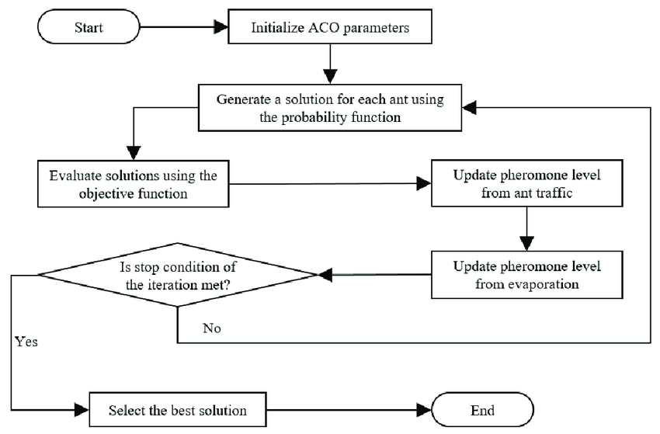
Figure 1. Data Flow Diagram of Ant Colony Optimization (ACO) Algorithm.

- PARTICLE SWARM OPTIMIZATION (PSO):
Particle Swarm Optimization (PSO) is a powerful metaheuristic optimization algorithm inspired by the social behavior of birds flocking or fish schooling. Introduced by Eberhart and Kennedy in 1995, PSO is designed to solve optimization problems by simulating the collaborative behavior of particles in a multi-dimensional search space. The algorithm is particularly effective for continuous and multi-dimensional optimization problems, where the goal is to find the optimal solution among a large set of possible solutions. PSO works by iteratively moving a group of particles through the search space to explore and exploit potential solutions. Each particle represents a potential solution, and its position in the search space corresponds to a particular set of solution parameters. Additionally, each particle maintains its velocity, which determines its direction and speed during the search.
Here's a step-by-step explanation of how PSO works:
Initialization:
- The PSO algorithm begins by initializing a population of particles randomly within the search space.
- Each particle is assigned a random position and velocity.
Fitness Evaluation:
- Each particle's position is evaluated using an objective function, which represents the fitness or quality of the solution.
- The fitness value indicates how well the particle's position performs in the optimization problem.
Finding Personal Best (pBest):
- Each particle maintains its personal best position (pBest), which is the position with the highest fitness value it has encountered so far.
- Initially, each particle's pBest is set to its current position.
Finding Global Best (gBest):
- Among all the particles in the population, the one with the best fitness value is designated as the global best (gBest).
- gBest represents the overall best solution found by any particle in the entire population.
Particle Movement:
- In each iteration (or time step), each particle updates its velocity and position based on its current position, pBest, and gBest.
- The new velocity is determined by combining the particle's previous velocity, its tendency to move towards its pBest, and its tendency to move towards the gBest.
- The particle then moves to its new position in the search space based on the updated velocity.
Update Personal and Global Best:
- After moving to the new position, each particle updates its pBest if its new position leads to a better fitness value.
- The global best (gBest) is also updated based on the best fitness value found among all the particles.
Termination:
- The PSO algorithm continues for a fixed number of iterations or until a termination condition is met (e.g., reaching a satisfactory fitness value).

PSO's strength lies in its ability to balance exploration and exploitation of the search space. The particles are encouraged to explore new areas by following their pBest and gBest, and this collective intelligence helps guide the search towards promising regions of the solution space.
PSO has been successfully applied to a wide range of optimization problems, including function optimization, engineering design, neural network training, image processing, and more. It is relatively easy to implement, computationally efficient, and can handle both continuous and discrete optimization problems.
Overall, Particle Swarm Optimization is a versatile and effective optimization algorithm, leveraging the concept of social collaboration to efficiently find solutions to complex optimization problems.
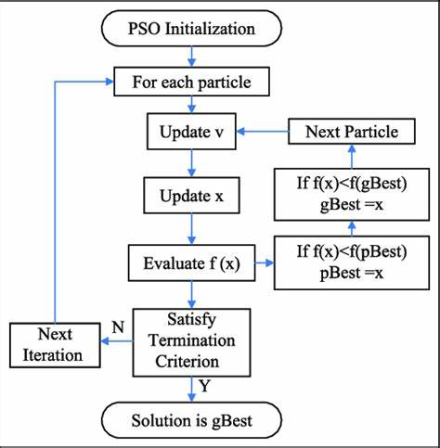
Figure 2. Flowchart of Particle Swarm Optimization (PSO) Algorithm.

- ARTIFICIAL BEE COLONY (ABC):
Artificial Bee Colony (ABC) is a nature-inspired metaheuristic optimization algorithm inspired by the foraging behavior of honeybees. It was introduced by Dervis Karaboga in 2005 as a way to solve optimization problems, particularly continuous optimization problems. ABC mimics the food foraging process of honeybees, where bees explore their environment, communicate their findings, and collectively converge on the best food sources.

The algorithm models the foraging behavior of honeybees in the following way:

Solution Representation:
- ABC represents potential solutions to the optimization problem as "food sources" in a multidimensional search space.
- Each food source corresponds to a specific set of solution parameters.
Employed Bees Phase:
- During this phase, a group of employed bees is assigned to the current food sources in the search space.
- Employed bees evaluate the quality (fitness) of the food source they are associated with.
Onlooker Bees Phase:
- Onlooker bees watch the employed bees and choose a food source probabilistically based on its fitness value.
- Food sources with higher fitness values have a higher probability of being chosen by onlooker bees.
Employed Bees Exploration:
- The employed bees perform local search and exploration around their respective food sources.
- They generate new candidate solutions by perturbing the parameters of their current food source.
Abandoned Food Sources:
- Some food sources may become less attractive over time due to limited improvement.
- If a food source is not improved for a certain number of iterations, it is considered abandoned.
Scout Bees Phase:
- Scout bees are responsible for discovering new food sources by exploring the search space randomly.
- They replace the abandoned food sources with new randomly generated solutions.
Memorizing the Best Solution:
- Throughout the iterations, ABC keeps track of the best solution found so far, which corresponds to the food source with the highest fitness value.
ABC aims to balance exploration and exploitation of the search space by leveraging both employed bees' exploitation of known food sources and scout bees' exploration of new regions. The algorithm adapts over time as better food sources are discovered, and it can escape local optima by employing scout bees to explore beyond the current solutions. ABC is particularly well-suited for continuous optimization problems with a large number of dimensions, and it has been applied to various domains, including function optimization, parameter tuning in machine learning algorithms, and engineering design. One of the advantages of ABC is its simplicity and ease of implementation, making it accessible to researchers and practitioners. However, its performance may depend on parameter tuning and problem characteristics. Overall, Artificial Bee Colony is a promising and efficient optimization algorithm inspired by the foraging behavior of honeybees, offering an effective approach to solve complex continuous optimization problems.
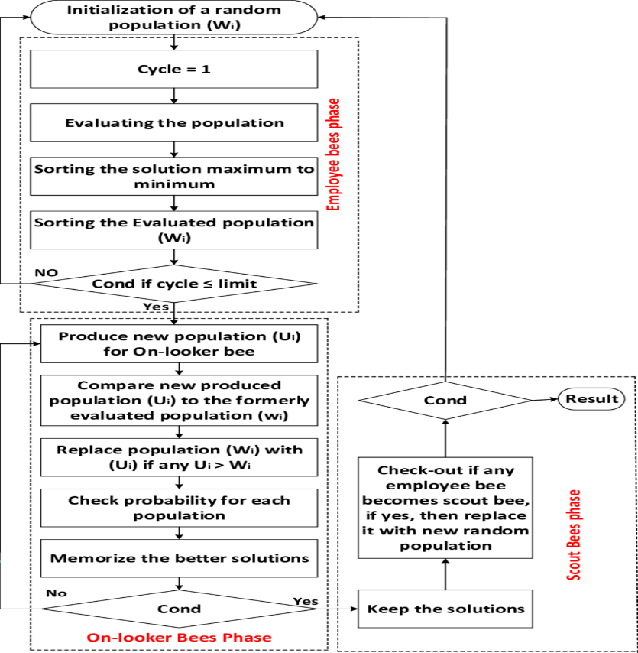
Figure 3. Flowchart of Artificial Bee Colony (ABC) Algorithm.

- EMERGING SWARM INTELLIGENCE IN THE 21ST CENTURY TECHNOLOGIES
Swarm Intelligence, a concept inspired by the collective behavior observed in social organisms, has been steadily gaining traction and making significant contributions to various technologies in the 21st century. The ability of simple agents to interact locally and self-organize to achieve complex goals has sparked interest in its application across a wide range of domains. Here, we explore how Swarm Intelligence is emerging in 21st-century technologies, revolutionizing the way we approach complex problems and enabling more efficient and robust solutions.
Robotics and Autonomous Systems:
Swarm Intelligence has ushered in a new era of robotics and autonomous systems. Researchers are exploring the potential of swarms of simple robots that can collaborate and coordinate their actions to achieve tasks collectively. These robotic swarms find applications in environmental monitoring, disaster response, precision agriculture, exploration of hazardous environments, and more. By leveraging decentralized decision-making and collaboration, these systems demonstrate improved adaptability, fault tolerance, and scalability.

Internet of Things (IoT):
In the realm of IoT, Swarm Intelligence is enhancing the efficiency and management of large-scale networks of interconnected devices. By applying the principles of local interactions and global optimization, Swarm Intelligence optimizes resource allocation, routing, and data management in IoT systems. This leads to better utilization of resources, improved reliability, and enhanced performance in diverse IoT applications.
Autonomous Vehicles and Drones:
Swarm Intelligence is transforming the way we approach autonomous vehicles and drones. Coordinating fleets of self-driving cars or drones using decentralized control algorithms based on Swarm Intelligence allows for efficient navigation and adaptability to dynamic environments. These systems can optimize traffic flow, ensure safe maneuvering, and enhance the overall mobility experience.
Healthcare and Medical Applications:
In healthcare, Swarm Intelligence is finding applications in disease diagnosis, drug discovery, and treatment optimization. Swarm-based algorithms aid in optimizing treatment plans, identifying optimal drug combinations, and predicting disease progression. Additionally, they help in analyzing complex medical data, leading to better decision-making and personalized healthcare solutions.
Supply Chain Management:
Swarm Intelligence is making its mark in supply chain management by optimizing logistics, inventory management, and routing. By considering local interactions and global objectives, Swarm-based algorithms lead to efficient resource allocation, reduced costs, and improved overall supply chain performance.
Image and Video Analysis:
Swarm Intelligence is increasingly used in image and video processing tasks, such as object tracking, segmentation, and feature extraction. The ability of swarms to collectively identify patterns and detect objects in complex visual scenes contributes to advanced image recognition and analysis capabilities.
Financial Markets:
In the financial sector, Swarm Intelligence techniques are employed in trading and portfolio optimization. Swarm-based algorithms help in predicting market trends, managing risk, and optimizing investment portfolios, contributing to more informed decision-making in financial markets.
Communication Networks:
Swarm Intelligence is applied to improve network efficiency, routing, and resource allocation in communication systems. By leveraging the principles of decentralized decision-making, these algorithms optimize the performance of wireless networks, ad hoc networks, and sensor networks.
The emergence of Swarm Intelligence in 21st-century technologies exemplifies its versatility and potential in addressing complex challenges. By harnessing the power of collective intelligence, these technologies become more adaptive, scalable, and efficient, revolutionizing industries and shaping a smarter and interconnected future. As research and innovation in Swarm Intelligence continue to advance, we can expect even more exciting applications and transformative solutions in the years to come.

- SUBLIMATION OF SWARM INTELLIGENCE INTO SOCIAL MEDIA METADATA VIA COMMUNICATION NETWORKS:

The concept of sublimation involves transforming one form of energy or expression into another. In the context of Swarm Intelligence and social media metadata, sublimation would involve applying the principles and insights from Swarm Intelligence to enhance the management, organization, and utilization of metadata in social media platforms. Here's how Swarm Intelligence can be sublimated into social media metadata:

- Decentralized Metadata Management:
Swarm Intelligence emphasizes decentralized decision-making, where simple agents interact locally to achieve collective goals. In social media metadata, this can translate into decentralized management of metadata. Instead of relying solely on centralized algorithms or systems, metadata can be managed by individual users and community-driven interactions. Users can add relevant tags, categories, or labels to their content, and these locally added metadata can collectively contribute to the overall organization of content on the platform.
- Self-Organization and Clustering:
Swarm Intelligence exhibits self-organization, where individual agents come together to form patterns and structures. In the context of social media metadata, this can be applied to automatically cluster similar content based on user-generated metadata. By leveraging Swarm Intelligence algorithms like Ant Colony Optimization or Particle Swarm Optimization, metadata can be used to cluster related posts, images, or videos, enhancing content discoverability and creating personalized user experiences.
- Adaptive Recommendation Systems:
Swarm Intelligence is known for its adaptability to changing environments. Social media platforms can sublimate this characteristic by creating adaptive recommendation systems based on user-generated metadata. By analyzing how users interact with content and their metadata preferences, the recommendation algorithms can dynamically adjust to users' changing interests and deliver more relevant content.
- Optimal Content Distribution:
Swarm Intelligence algorithms often optimize the distribution of resources. In the context of social media, this can be applied to optimize the distribution of content based on user preferences and interactions. By analyzing metadata patterns and user behavior, platforms can dynamically prioritize content delivery to maximize engagement and user satisfaction.
- Crowd-Sourced Trend Identification:
Swarm Intelligence relies on the collective behavior of individuals to identify trends and patterns. In social media metadata, this can manifest as crowd-sourced trend identification, where popular topics, hashtags, or content themes emerge based on the collective contributions of users. Trending tags and topics can be identified and highlighted based on the frequency and quality of user-generated metadata.
- Swarm-based Sentiment Analysis:
Sentiment analysis is a valuable tool in social media analytics. Swarm Intelligence can be sublimated into sentiment analysis by aggregating and analyzing the sentiments expressed through user-generated metadata. By capturing the collective sentiments of the community, platforms can gain deeper insights into user preferences and emotions.
By sublimating Swarm Intelligence into social media metadata, platforms can enhance content discovery, user engagement, and overall user experience. Leveraging the collective intelligence of users through decentralized and adaptive approaches can lead to more effective content organization, better recommendations, and a more engaging and vibrant social media ecosystem.
- DIFFERENTIATING BETWEEN SWARM INTELLIGENCE AND NEURAL NETWORKS.
What are Neural Networks?
Neural Networks in Artificial Intelligence are computational models inspired by the structure and function of the human brain. They consist of interconnected nodes (neurons) organized in layers to process and learn from input data. Neural networks use a combination of weights and activation functions to compute outputs, enabling them to learn complex patterns and relationships in the data. They are widely used for various tasks, such as classification, regression, image recognition, and natural language processing. Neural Networks can be applied to collective behavior analysis to gain insights and understand the patterns and dynamics exhibited by groups of interacting entities. Collective behavior analysis involves studying how simple individual behaviors give rise to complex group behavior. Neural Networks offer several advantages in this context:
Pattern Recognition: Neural Networks excel at pattern recognition, allowing them to identify and categorize collective behavior patterns in large datasets. By training the network on examples of known collective behaviors, it can automatically detect similar patterns in new data.
Sequence Analysis: In many collective behaviors, the order and sequence of actions are essential. Recurrent Neural Networks (RNNs) and Long Short-Term Memory (LSTM) networks are well-suited for analyzing sequential data, enabling the identification of temporal dependencies and trends in the behavior.
Trajectory Prediction: Neural Networks can be used to predict the future trajectories of individuals in a group, helping to anticipate potential collective behavior outcomes and assess group dynamics over time.
Clustering and Segmentation: Unsupervised learning algorithms like Self-Organizing Maps (SOMs) and Kohonen Networks can cluster individuals based on their behavior, enabling the identification of distinct subgroups and collective behavior patterns.
Dimensionality Reduction: Collective behavior analysis often involves high-dimensional data. Neural Networks can perform dimensionality reduction through techniques like autoencoders, helping to visualize and understand the data more effectively.
Anomaly Detection: Neural Networks can identify unusual or abnormal collective behavior that deviates from typical patterns, facilitating the detection of outliers and potential disruptions in the group dynamics.
Multi-Agent Simulations: Neural Networks can be used to model individual behaviors in agent-based simulations and study how interactions between agents lead to collective behavior emergence.
By leveraging Neural Networks in collective behavior analysis, researchers can uncover hidden patterns and relationships, gain a deeper understanding of group dynamics, and potentially predict and control the outcomes of collective behaviors in various domains, such as animal groups, social networks, traffic systems, and swarm robotics.
Also, as in accordance with the present era curriculum with the repetitive factors such as Neural networks, Model Training, Support Vector Machines, Reasoning-based Complexities etc. Let us see the impact of Swarm Intelligence Technologies with impetus toward centralized feature technologies like Neural Networks in the following differentiation.
Features | Swarm Intelligence | Neural Networks
Nature of Inspiration | Inspired by the collective behavior based on social organisms such as Bees, Ants and Birds. | Inspired by the Structure and Function of the Human Brain.
Approach | Decentralized, simple agents interact locally to achieve complex goals. | Centralized network of interconnected neurons processing data.
Learning Paradigm | Typically based on local interactions and emergent behavior. | Learns from data using supervised or unsupervised learning.
Use of Data | Often used for optimization and problem-solving tasks. | Primarily used for pattern recognition and function approximation.
Main Application Areas | Optimization, routing, clustering, and task allocation problems. | Image recognition, natural language processing, prediction tasks.
Ability to Learn | Relatively simple agents with limited individual intelligence, but the collective behavior leads to intelligent outcomes. | Neural networks learn complex patterns and relationships in data.
Network Structures | No strict predefined structure, highly adaptive. | Organized in layers with neurons interconnected through weights.
Use of Heuristics | Uses local heuristics (e.g., pheromones in Ant Colony Optimization) for decision-making. | Uses activation functions to introduce non-linearity and learn from data.
Termination Condition | Typically runs for a fixed number of iterations or until a stopping criterion is met. | Trained until convergence on a specific objective or loss function.
Nature of Optimization | Focuses on collective optimization, often with decentralized control. | Optimization process based on minimizing or maximizing objective functions.
Popularity | Increasingly popular in various optimization domains and robotics. | Ubiquitous in machine learning and artificial intelligence.

While both Swarm Intelligence and Neural Networks are inspired by different natural phenomena and have distinct approaches, they both demonstrate remarkable capabilities in addressing various real-world challenges. Swarm Intelligence excels in collective problem-solving and optimization tasks, while Neural Networks are widely used for pattern recognition, classification, and function approximation tasks. Both fields continue to evolve, offering valuable insights and solutions in the ever-advancing landscape of artificial intelligence and optimization.
- MERITS AND DEMERITS OF SWARM INTELLIGENCE

- MERITS:
Swarm Intelligence offers several merits in the field of Artificial Intelligence in the present era. These advantages make it a promising approach for addressing complex and dynamic problems. Some of the key merits of Swarm Intelligence in Artificial Intelligence include:
Robustness and Adaptability: Swarm Intelligence algorithms are inherently robust and adaptable. They can handle uncertain and dynamic environments, making them suitable for real-world applications where conditions may change over time.
Decentralized Decision-Making: Swarm Intelligence promotes decentralized decision-making, where simple agents interact locally to achieve collective goals. This approach reduces the need for centralized control, making the system more scalable and resilient to individual failures.
Parallelism and Scalability: Swarm Intelligence algorithms often allow parallel processing, which leads to efficient computation, especially in large-scale problems. As the size of the problem increases, the collective intelligence of the swarm can be harnessed to tackle complex tasks.
Global Optimization: Swarm Intelligence techniques excel in global optimization, where the goal is to find the best solution among a vast number of possibilities. The collective behavior of the swarm facilitates exploration of the solution space and increases the likelihood of finding optimal or near-optimal solutions.
Flexibility and Generality: Swarm Intelligence is a versatile approach that can be applied to a wide range of problems, from optimization and clustering to scheduling and route planning. Its generality allows it to be adapted and customized for various domains and applications.
Minimal Domain Knowledge: Swarm Intelligence algorithms often require minimal domain-specific knowledge. Instead, they rely on simple rules and interactions between agents to achieve intelligent behavior, making them more accessible for problem-solving in diverse fields.
Nature-Inspired Inspiration: The inspiration from natural systems, such as ant colonies, bird flocks, and fish schools, provides a biological basis for problem-solving, leading to innovative solutions and insights.
Energy Efficiency: In some cases, Swarm Intelligence algorithms can be more energy-efficient compared to traditional optimization techniques, as they leverage local interactions and adapt to changing conditions.
Potential for Real-World Applications: Swarm Intelligence is increasingly finding applications in various real-world scenarios, including robotics, traffic management, supply chain optimization, and healthcare, showcasing its practical relevance and effectiveness.
Hybridization with Other Techniques: Swarm Intelligence can be easily combined with other AI techniques, such as neural networks and genetic algorithms, to create hybrid approaches that leverage the strengths of each component.
These merits make Swarm Intelligence a valuable and promising paradigm in the present era of Artificial Intelligence. Its ability to handle complex and dynamic problems, adapt to changing environments, and offer efficient and robust solutions positions it as a promising direction for future AI research and applications.
- DEMERITS:
While Swarm Intelligence offers several advantages in the field of Artificial Intelligence, it also has some limitations and challenges. Understanding these demerits is crucial for ensuring appropriate and effective application of Swarm Intelligence in the present era. Some of the key demerits of Swarm Intelligence in Artificial Intelligence include:
Premature Convergence: Swarm Intelligence algorithms may suffer from premature convergence, where the swarm settles on suboptimal solutions too quickly and fails to explore the entire solution space thoroughly. This can happen if the exploration-exploitation balance is not adequately maintained.
Complexity and Parameter Tuning: Some Swarm Intelligence algorithms can be complex, requiring careful tuning of various parameters to achieve optimal performance. Selecting the right parameters and adjusting them for different problem domains can be challenging and time-consuming.
Sensitivity to Initial Conditions: The performance of Swarm Intelligence algorithms can be sensitive to the initial conditions and random factors. Small variations in initial states or parameters may lead to significantly different outcomes, affecting the reliability of results.
Lack of Global Problem Understanding: Individual agents in Swarm Intelligence often have limited information about the overall problem or global state. While this decentralized approach can be advantageous in some cases, it may hinder the ability to achieve a holistic view of the entire system.
Scalability Issues: As the size of the swarm and problem complexity increase, the computational requirements of Swarm Intelligence algorithms may become prohibitive. Scalability can be a significant concern for large-scale applications.
Lack of Convergence Guarantee: Unlike some optimization techniques that guarantee convergence to a global optimum under certain conditions, Swarm Intelligence algorithms do not always offer such guarantees. The success of the algorithm may rely on empirical validation and sensitivity to problem specifics.
Overfitting: Swarm Intelligence algorithms can potentially overfit the training data, especially in cases where the swarm becomes too specialized in specific regions of the solution space, leading to reduced generalization ability.
Trade-off Between Exploration and Exploitation: Striking the right balance between exploration of new solutions and exploitation of known good solutions is critical in Swarm Intelligence. If this balance is not managed effectively, the algorithm may struggle to converge to high-quality solutions.
Lack of Interpretability: Swarm Intelligence algorithms often produce emergent behavior that may be difficult to interpret and explain. Understanding the decision-making process of individual agents in the swarm can be challenging.
Convergence Speed: In some cases, Swarm Intelligence algorithms may take longer to converge to a satisfactory solution compared to more specialized optimization techniques, especially for high-dimensional or complex problems.
Despite these demerits, Swarm Intelligence remains a valuable and promising approach in Artificial Intelligence, particularly for problems involving collective behavior, optimization in dynamic environments, and situations where decentralized decision-making is advantageous. By understanding these limitations and combining Swarm Intelligence with other AI techniques judiciously, researchers can harness its strengths while mitigating its challenges.
- CASE STUDY – IS SWARM INTELLIGENCE COMPATIBLE WITH NEURAL NETWORK ENGINES OR TECHNIQUES.
Yes, Swarm Intelligence is compatible with Neural Network engines and techniques, and in fact, they can be combined to create powerful hybrid approaches. The integration of Swarm Intelligence with Neural Networks leverages the strengths of both paradigms, leading to enhanced optimization, learning, and problem-solving capabilities. Some common ways Swarm Intelligence is applied in conjunction with Neural Networks are:
Optimization of Neural Network Parameters: Swarm Intelligence algorithms, such as Particle Swarm Optimization (PSO) or Genetic Algorithms (GA), can be used to optimize the weights and biases of Neural Networks. These algorithms explore the high-dimensional parameter space more efficiently than traditional optimization methods, leading to better convergence and improved performance of the Neural Network.
Neural Network Architecture Search: Swarm Intelligence can aid in the automatic discovery of optimal Neural Network architectures. By exploring the space of possible architectures using techniques like Ant Colony Optimization (ACO) or Genetic Algorithms, Swarm Intelligence helps find architectures that perform well on specific tasks or datasets.
Hyperparameter Tuning: Swarm Intelligence algorithms can optimize hyperparameters of Neural Networks, such as learning rate, dropout rate, and the number of hidden layers. This process helps in achieving better generalization and performance of the Neural Network.
Feature Selection: In combination with Neural Networks, Swarm Intelligence can assist in selecting relevant features from high-dimensional datasets. By using Swarm Intelligence-based feature selection techniques, the Neural Network can focus on the most informative features, improving its efficiency and accuracy.
Ensemble Learning: Swarm Intelligence can be used to optimize the weights of individual Neural Networks in an ensemble. This ensemble approach combines the predictions of multiple Neural Networks, enhancing the overall prediction accuracy and reducing overfitting.
Transfer Learning: Swarm Intelligence can facilitate the transfer of knowledge from one Neural Network to another. By using Swarm Intelligence-based transfer learning techniques, the knowledge learned from one task or domain can be effectively utilized to improve the performance of another Neural Network on a related task or domain.
The integration of Swarm Intelligence with Neural Networks is often referred to as "Swarm Intelligence-assisted Neural Networks" or "Swarm-Enhanced Neural Networks." This synergy allows researchers to explore more diverse solutions, tackle complex optimization problems, and improve the generalization and adaptability of Neural Networks across various domains. Overall, the compatibility between Swarm Intelligence and Neural Network engines and techniques opens up new possibilities for solving challenging AI problems, and their combination represents a fruitful direction for advancing artificial intelligence research and applications.
- REFERENCES
[1] Marco Dorigo and Thomas Stützle on "Ant Colony Optimization".
[2] "Swarm Intelligence: Principles, Advances, and Applications" by Simon Garnier, Mario S. Mingozzi, and Christian Blum.
[3] Swarm Intelligence: Introduction and Applications" by Christian Blum and Daniel Merkle.
[4] "Swarm Intelligence: From Natural to Artificial Systems" by Eric Bonabeau, Marco Dorigo, and Guy Theraulaz.
[5] "Swarm Intelligence: Focus on Ant and Particle Swarm Optimization" by Felix T.S. Chan, Manoj Kumar Tiwari, and Ashutosh Tiwari.
[6] "Handbook of Swarm Intelligence: Concepts, Principles, and Applications" edited by Bijaya Ketan Panigrahi, Yuhui Shi, and Meng-Hiot Lim.
[7] "Particle Swarm Optimization" by Maurice Clerc.
[8] "Artificial Bee Colony Algorithm and Its Application to Generalized Traveling Salesman Problems" by Jeng-Shyang Pan, Shyi-Ming Chen, and Chia-Hung Wang.
[9] “Overview of Swarm Intelligence” by IEEE Explore, oct 24 2010.

