The Menace of Invasive Insect Species and it’s Management

Author information
Rahul Kumar Pandey
Department of zoology, CMP Degree College, 211002, Prayagraj, Uttar Pradesh
rahul335pandey@gmail.com

Introduction
Invasive insect species refers to non-native species (also known as exotic species) that have been introduced to a new environment and have ability to cause harm to the ecosystem, biodiversity. These invasive insects are also harmful to human health and economy directly or indirectly. Besides of these, insects are a very manifold group of organisms and are important because of their rich diversity in ecosystem function. Insects have greater impact on agriculture, and most agricultural pests are invasive or exotic species that have been introduced into new ecosystem. These Arthropods, when introduced outside of their original habitat, can avoid their natural predators, parasites, and diseases that would normally control their population. Additionally, they may come across unfamiliar host plants and animals. When co-evolutionary relationships are disrupted in this way, invading species have the chance to dominate and change the areas they invaded. Thus, these exotic species are capable of compete, establish and replace and ultimately pushes the native species to extinction, and this phenomenon has been observed in various instances. For example The grape phylloxera, Daktulosphaira vitifoloae, managed to invade Europe in mid-1800s, and the emerald ash borer, Agrilus planipennis, was introduced to north America and Europe in early 2000s. However, severe pest invasions are still rare with an estimated rate of about one in every 1,000 attempts (Williamson. 1996). The impact of arthropod invasion on global development and prosperity, especially on human health, clean water, nutritious food, sustainable economies and resilient environments, is a significant and often overlooked challenge. The negative consequences of these invasions on food and the environment are noticeable, such as when the fall armyworm, Spodoptera frugiperda, consumes maize crops in Africa (Sileshi et al. 2019), invasive species like Dendroctonus valens, kills expanses of pine in china (Sun et al. 2013), or Philornis downsi, flies attack on Darwin’s finches have direct visible effects (Koop et al. 2020, and Fessl et al. 2002). However some indirect effects are less apparent, such as spittlebugs spreading non-native bacterium Xylella fastidiosa (Occhibove et al. 2020), Halyomorpha halys stink bugs spreading aflatoxin producing fungi in the USA(Opoku et al. 2019), or Aedes albopictus, mosquitos transmitting dengue viruses in South America(Rezende et al. 2020). These indirect effects can be more hidden and difficult to detect. Invasive arthropods can create obstacles to economic growth in developing countries, as they can cause phytosanitary issues that limit or completely halt the trade of plant based products to global markets. Unfortunately this issue is often not fully acknowledged or appreciated. To achieve various humanitarian goals, it is crucial to find solutions to this problem of arthropod or insect invasions.
In India the situations of invasive pests are alarming, the country has experienced at least 10 major infestations of pest and invasive weeds (most of them were caused by invasive pests) in the past 15 years, The most recent was a fall armyworm that destroyed maize crop in the country in 2018. India had to import maize in 2019 due to damage caused by these, pest invasive (Jitendra 2019). According to some estimates India stands in second place after the USA on the list of invasion cost bearing countries (Yadav 2022).
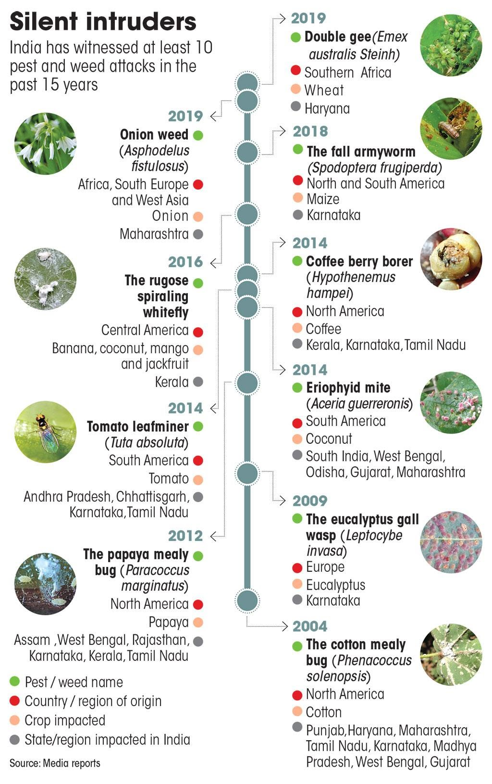
Fig.1: Recent 10 major attacks of invasive species in India
The proliferation of invasive insects has surged due to the growth of global trade. Thus, it is crucial to enhance international coordination among affected countries and the native country of these species to recognize the danger and implement various measures to mitigate their impact (Garcia et al. 2020).

Common traits of an invasive insect species
- Fast growth.
- Short life cycle.
- Very high and rapid reproduction even at unfavourable conditions.
- More compatible to survive with the alien ecosystem.
- Ability to move long distance.
- Phenotypic plasticity.
- Tolerance of wide range of environmental conditions.
- Rapacious feeders.
- Strong potential to compete with a native species.
- Association with humans.
(Sharma et al. 2018)

Pathways of invasion
A pathway of invasion means method of introduction of an invasive species into new environment. In general, these routs of invasion can be classified as either natural or man-made and man-made pathways further classifies into intentional and non-intentional. Natural pathway includes wind, ocean currents and other forms of natural dispersal that can move species to new habitat Man-made pathway (human-assisted) are pathways created or mediated by human activity.
- Intentional, a deliberate act by humans to relocate a species beyond its natural habitat is referred to as intentional introduction. This includes instances such as introducing organisms for biological control or transferring species for purposes like horticulture or the pet trade. It is important to note that intentional introductions should not be universally classified as either positive or negative. The evaluation of a specific intentional pathway depends on the assessment of the individual organisms involved and their overall impact, whether it is beneficial or detrimental.
- Unintentional, which is the inadvertent or accidental movement of species as a by-product of some other human activity. Examples of unintentional pathways are ballast water discharge (e.g. red tide organism). Pest and diseases in imported plants, firewood and other agricultural products. For example fire ants (NISIC, US department of agriculture).

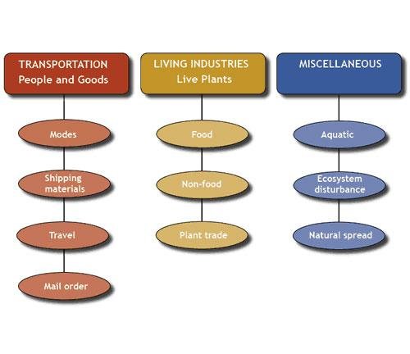
Fig. 2: Pathways of invasion
Source: www.invasivespeciesinfo.gov/subject/pathways

The stages of invasion

Transport
The initial phase of a biological invasion necessitates the relocation of a species outside of its original habitat. With the rise of globalization, the amount and regularity of species being transported beyond their natural range is growing (Mayerson and Moony 2007).The transportation of a species to a new location is a key step in the process of invasion, and it can occur through various means. One example is the movement of goods and commodities via shipping containers across oceans, which accounts for the majority of world trade volume.

Introduction
To inhabit a new area outside their natural range, insects need to be moved there either actively or passively. Passive transport, which is facilitated by vectors, refers to the insect being transported without actively moving itself. Human or human-related movements are the most common vectors for this. However, controlling the movement of invasive species through passive transport is difficult. Even with strict quarantine inspections, it can be challenging to detect the early stages of the insect, which may be transported by tourists unknowingly. A single female insect can cause significant damage in a new environment because it reproduces quickly and lacks its natural predators. Timber beetles (Cerambycidae) found in Antarctica is an example of passive transport where the beetles were likely introduced through logs transported to one of the base camps (Osycza et al. 2012).
Insects have a natural ability to migrate over long distances and will move away from unfavourable conditions. One such insect is the fall armyworm, which is a recent invasive species in India. These insects are highly skilled fliers (Johnson. 1987 and Bajracharya et al. 2019) and can cover up to 100 kilometres in a few hours, which suggests that they may have flown from Africa to India. However, it is still unclear how they arrived in India. Another example is the Monarch butterfly, which is originally from North America, but was observed migrating to Australia in the 1800s (Nail et al. 2019).

Establishment
The process of short-term colonization is common among insects, but a species cannot be considered invasive until it has successfully established itself in a new environment. This establishment depends on the amount of individuals that are introduced into the new environment, and it is aided by disturbances that occur in the receiving environment. Such disturbances can create opportunities for the invasive species to thrive, as they may be better adapted to these conditions than native species (Diez et al. 2012). Insects are particularly susceptible to becoming invasive due to the abundance of resources and decreased competition in disturbed environments.
The rapid spread of invasive insects can also be attributed to global warming, which has changed the availability of resources and suitability of habitats. This has disrupted the natural balance of native insects and created favourable conditions for alien species to thrive (Kelley. 2014). However, it is important to note that certain regions may be less impacted by climate change in terms of insect invasiveness, but it generally has a negative impact on native species (Pachauri et al. 2014).

Spread
Spreading refers to the process by which a species expands its range to other areas, which is influenced by environmental factors such as weather conditions, microclimate, and habitat quality (Bonte et al. 2004), as well as the presence of predators and competition with other species. An individual insect's decision to spread can be based on its behavioural responses, such as aggression or sociality, or morphological responses, such as the development of wings in aphids. Human-mediated transportation is also a means by which established insects can spread, conserving their energy, but the success of this method depends on the permeability of the new habitat (Renault et al. 2018).

Why are they matter of concern?
Invasive insects are a matter of concern due to the significant negative impacts they can have on ecosystems, biodiversity, economies and agriculture sector. They also act as vectors for diseases that can affect both humans and animals. Invasive insects can disrupt crucial ecosystem services such as pollination and nutrient cycling. Pollinators, such as bees, are essential for the reproduction of many plants, including food crops. if invasive insects displaced native pollinators, it can lead to reduce pollination and negatively impact plant diversity and agriculture productivity. Invasive insect can alter habitats and ecosystems by modifying the physical structure of plants or by consuming native vegetation. This can lead to changes in availability of food and shelter for other species, impacting the overall ecological balance. Invasive insects can cause decline in biodiversity by preying on or displacing native species, leading to imbalances in food chain and overall environment functioning.
Invasive insect species possess significant threat for native species. These invasive insects are emerging threat for the world. Some of the major impacts of invasive insect species are given below:

Economical costs
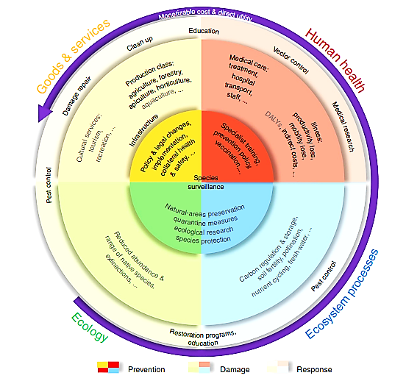
Figure 3 | Market and non-market cost categories associated with invasive insect damages. Costs are subdivided into ‘goods and services’ (yellow) and ‘human health’ (red), ‘regulating services’ (sensu non-commercial, but potentially monetizable, such as carbon regulation and pollination not otherwise quantified in agricultural yield estimates; blue) and ‘ecological’ costs (not typically monetizable; green). Owing mainly to a lack of monetary estimates, we could not compile costs for the categories and subcategories coloured in grey. The inner circle (darkest colours) encapsulates costs associated with prevention; the middle circle (mid-range colours) includes costs associated with damage from invasive insects; the outer circle (lightest colours) covers costs associated with responses or follow-up to invasive insect incursions. The outermost purple arrow indicates the general increase in our ability to estimate monetizable costs, and the direct relevance to human commerce and well being. DALY, disability-adjusted life year (lifespan lost because of burden of insect-borne disease; not assessed)
(Bradshaw 2016)

Invasive insects are responsible for causing a minimum of $70 billion worth of damage globally each year in terms of goods and services, with reproducible studies indicating a cost of $25.2 billion per year. There is no clear trend in annual cost rates over time, and most cost estimates are based on direct measurements, although extrapolated costs tend to be higher. North America has the highest reported annual costs at $27.3 billion, followed by Europe at $3.6 billion per year. However, this difference is likely due to differences in research efforts rather than actual regional costs. The list of the top 10 most costly species does not change significantly regardless of whether all estimates or only reproducible estimates are included.
A study suggests that the most expensive insect in the world is the Formosan subterranean termite Coptotermes formosanus , estimated to cost $30.2 billion globally each year. However, this estimate is not reliable as it is based on a single non-sourced value for the US, a personal communication for a single city, and an invalidated assumption about global costs. A more credible ranking of costly insects places the diamondback moth Plutella xylostella as the most expensive, costing $4.6 billion per year. Other expensive insects include the brown spruce longhorn beetle Tetropium fuscum, the gypsy moth, and the Asian long-horned beetle Anoplophora globripennis, with costs ranging from $3.0 to $4.5 billion per year in various regions
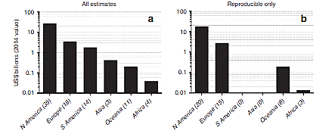
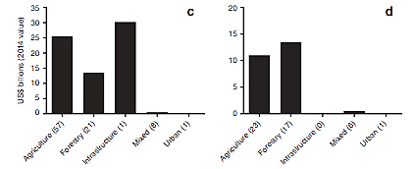
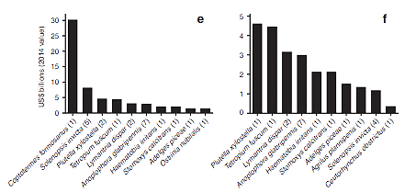

Fig. 4: goods and service costs associated with invasive insects. direct goods and service costs are categorized by major region(a,b), type (c,d) and by the 10 costliest insects(e,f). the first column includes all estimates regardless of reproducibility(a,c,e), whereas the second only includes costs for which estimates can be verified(reproducible’ b,d,f). all costs expressed as annual 2014 US$.
(Bradshaw et al. 2016)

Human health
The annual costs of invasive insects amount to over $6.9 billion, but this figure does not include costs related to malaria because it is not caused by invasive insect vectors in most areas. The economic impacts on productivity, income, tourism, blood supply systems, personal protection, and quality of life, as well as historical epidemics of yellow fever and dengue, are also excluded due to the lack of relevant cost estimates. The majority of estimates for health-related costs are based on actual data rather than predictions, with 79% and 93% of estimates (including reproducible-only estimates) being direct and indirect costs, respectively. Medical care is the main expenditure category, accounting for 75% and 88% of all and reproducible-only health-related estimates, respectively. Dengue is responsible for 84% of total health costs, followed by West Nile virus at 15%, with the highest annual health costs occurring in Asia ($2.84 billion), North America ($2.06 billion), and Central/South America ($1.85 billion).
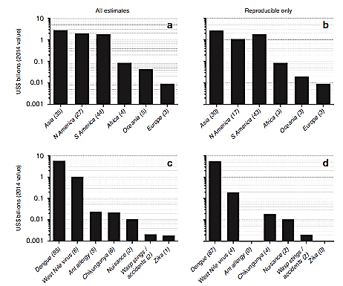
Fig. 5: Human health costs associated with invasive insects. Direct human health costs are categorized by major region (a,b) and disease (c,d). The first column includes all estimates regardless of reproducibility (a,c), whereas the second only includes costs for which estimates can be verified (‘reproducible’; b,d). All costs expressed as annual 2014 US dollars. Bracketed numbers in the x axis labels indicate the number of estimates per category.
(Bradshaw et al. 2016)

Threat to biodiversity
The issue of invasive species keeps becoming worse. Nearly 40% of all known causes of animal extinction can be attributed to invasive species (SCBD, 2006). Invasive species represent the greatest threat to biodiversity on isolated ecosystems, such as islands, as these lack natural rivals and predators that often regulate the population of invasive (CBD. 2009). Invasive species can harm biodiversity through a variety of mechanisms. They can proliferate rapidly without any natural predators or controls, resulting in the displacement of native species that may not have evolved defences against the invader or be able to compete with it. Invasive species can directly harm native species by preying on them, competing with them for resources, spreading disease, or inhibiting their ability to reproduce. Additionally, invasive species can indirectly alter the food web and reduce the abundance or diversity of species that provide vital habitats for native wildlife (Simberloff. 2013). They may also offer little nutritional value to local wildlife, and displace or destroy native food sources. By these Invasive insects can pose a significant threat to biodiversity, as they can disrupt entire ecosystems and cause serious ecological and economic harm. Here are some examples of invasive insects and their impact on biodiversity:
- Spotted Lanternfly: The Spotted Lanternfly is an invasive insect that feeds on a wide range of plants, including grapes, hops, and fruit trees. The insect has caused significant damage to agricultural crops and threatens the biodiversity of natural ecosystems in the north-eastern United States.
- European Spruce Bark Beetle: The European Spruce Bark Beetle is an invasive beetle that attacks spruce trees, causing significant damage to forest ecosystems in North America. The beetle can kill healthy trees, leading to a loss of biodiversity and an increase in wildfire risk.
- Argentine Ant: The Argentine Ant is an invasive species that has spread to many parts of the world, including North America, Europe, and Asia. The ant outcompetes native ant species for food and resources, disrupting local ecosystems and threatening biodiversity.
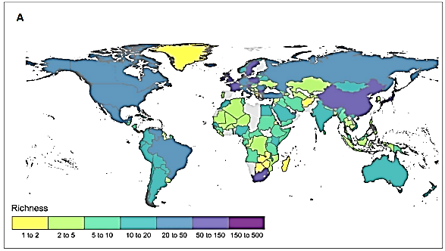
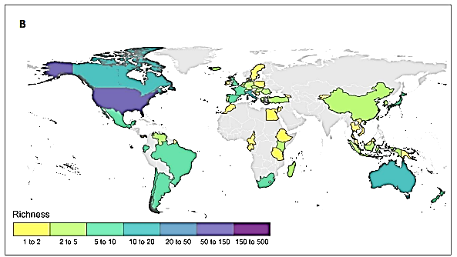
Fig. 6: A. Global distribution of known alien and invasive insect populations that harm the environment at a national scale (n = 7049, according to GRIIS, as of 11th June 2020). B. Number of alien insect species with published evidence of environmental impact per country. Country boundary data was obtained from the Global Administrative Areas (GADM) database
Fig source: Clarke and Mcgeoch 2022

Threat to agriculture
Invasive pest species pose a significant threat to agro-ecosystems as they can dominate the ecosystem without natural enemies or control. This dominance can lead to competition with native species and eventual replacement of the native species by the non-native ones. This replacement can severely alter and even lead to the collapse of the entire ecosystem. Invasive pests can cause negative impacts on ecosystem structure and species composition by outcompeting native species for resources and altering nutrient cycling. This, in turn, can lead to a decline in biodiversity, ecosystem health, economic stability, and agricultural yield (Sharma et al. 2018).
A scientific assessment found that the consequences of climate change are increasing the destructiveness of plant pests on economically significant crops. Professor Maria Lodovica Gullino from the University of Turin in Italy and ten other co-authors from around the world collaborated on the review, titled "The Impact of Climate Change on Plant Pests - A Global Challenge to Prevent and Mitigate Plant Pest Risks in Agriculture, Forestry, and Ecosystems," which was produced under the supervision of the Secretariat of the International Plant Protection Convention, which is housed by the FAO. The International Year of Plant Health, which ends this month, included the study as one of its major objectives. The FAO estimates that pests are responsible for up to 40% of the annual loss in crop production worldwide, and that losses from invasive insects alone amount to at least $70 billion annually. According to QU Dongyu, the Director-General of FAO, the review's conclusions should serve as a warning to everyone about the possible effects of climate change on the severity, geographic distribution, and infectiousness of pests globally (New guidelines to prevent the global spread of plant pests and diseases 2009). Some of the examples are
- Although it originates originally from Asia, the brown marmorated stink bug has spread to North America, Europe, and South America. It damages crops significantly and feeds on a variety of fruits, vegetables, and ornamental plants.
- Fall Armyworm: This insect is native to the Americas but has spread to Africa and Asia, where it has become a significant threat to crops like maize, sorghum, and rice. It can cause severe damage to crops and has the potential to cause famine in areas with poor food security.
- Pink Bollworm: This insect is native to Asia but has spread to Africa, Europe, and the Americas. It feeds on cotton bolls, causing significant damage to the crop and reducing yield.
- Originally from Asia, the citrus longhorn beetle has now spread to North America, Europe, and South America. It can seriously harm forests and orchards and attacks a variety of plants, such as citrus, apple, and oak.
- Coconut Rhinoceros Beetle: This beetle is native to Southeast Asia but has spread to the Pacific Islands, where it is a significant threat to coconut palms, a vital crop for many communities in the region.
- Western Corn Rootworm: This insect is native to North America but has spread to Europe, where it has become a significant threat to corn crops. It can cause significant damage to roots, reducing yield and quality.

Indian scenario
The impact of invasive species on agriculture and food security is a serious concern, in India also. Insects are among the most destructive invasive species, causing significant damage to crops and transmitting diseases and viruses to plants. In India alone, as of 2019, 23 species of invasive insects have been reported, and according to 2020 data, there are 32 Invasive Insects are in India, leading to huge losses in agriculture (Singh and Kushwaha. 2019).
One example of the devastating impact of invasive insects on crops in India is the Papaya mealybug. This invasive species caused immense damage to crops, leading to huge losses for farmers. However, the importation of a parasitoid known as Acerophagus papayae Noyes and Schauff proved to be a successful intervention in controlling the pest. The introduction of this parasitoid helped to save crops worth Rs. 435 crores, including papaya, tapioca, and mulberry. Additionally, the use of pesticides to control the pest was reduced, resulting in an annual savings of Rs. 244.5 crores in Tamil Nadu. This example demonstrates the importance of identifying and controlling invasive species in agriculture to reduce crop losses and ensure food security (Kumar et al. 2017).
Overall, it is crucial to implement effective management strategies to prevent the spread of invasive species and control their populations to minimize the impact on agricultural production and food security. In addition, investments in research and development of innovative and sustainable pest management techniques can help to mitigate the risks associated with invasive species in agriculture. Some of the Invasive insects of India are mentioned below:
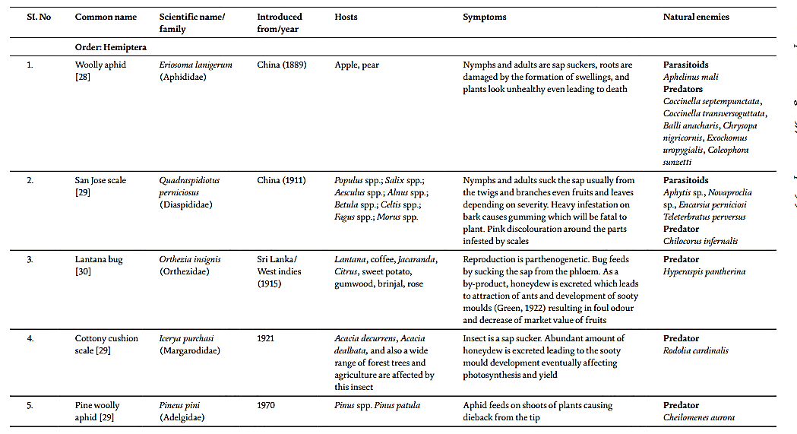

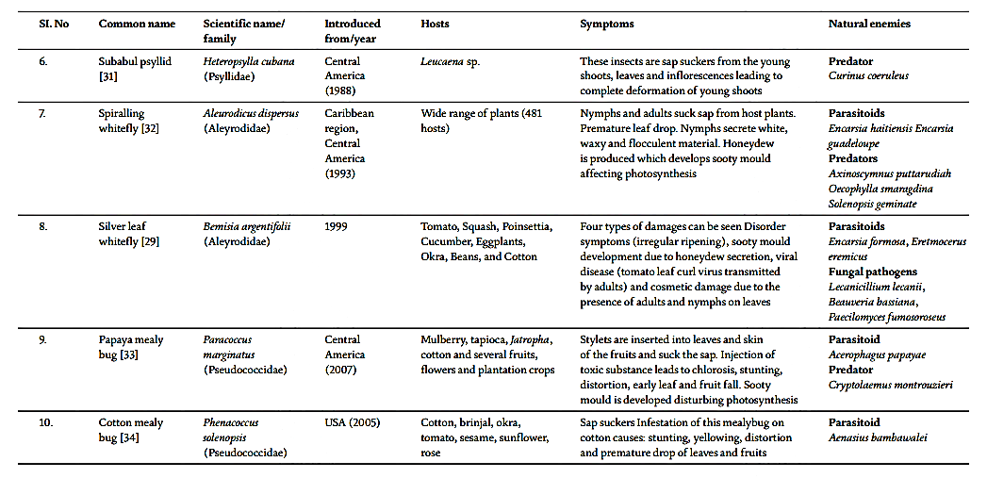
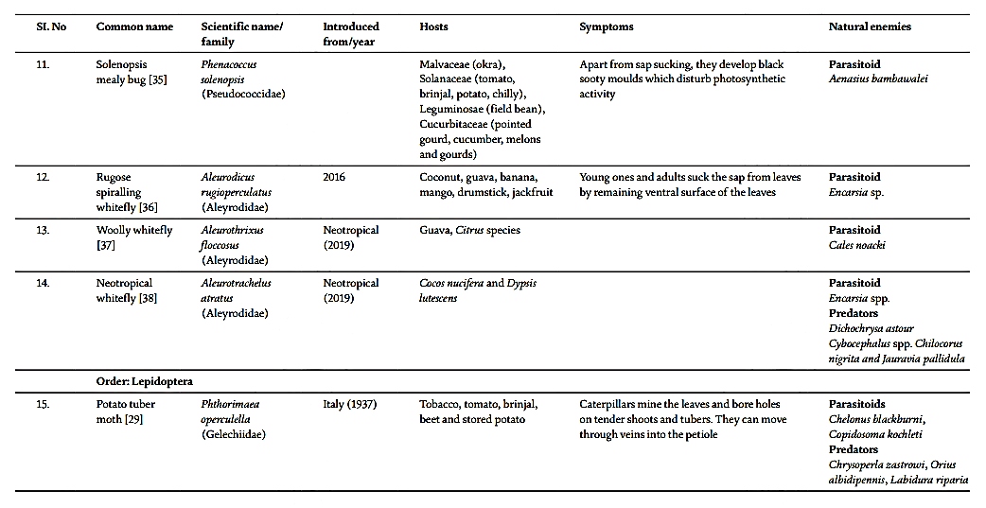
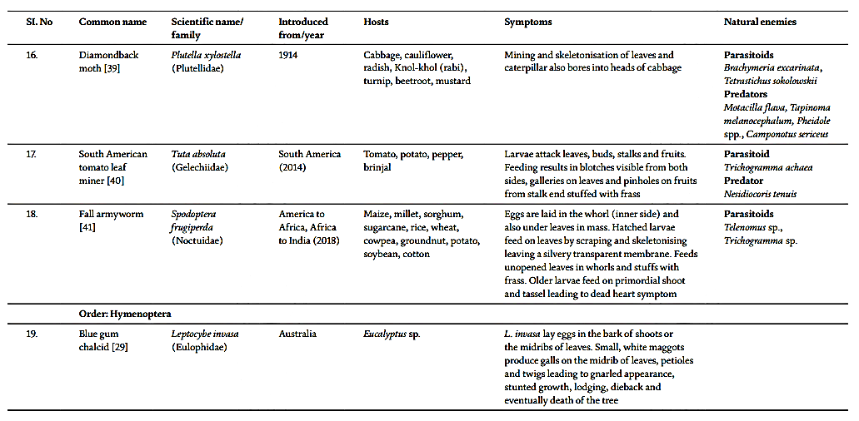
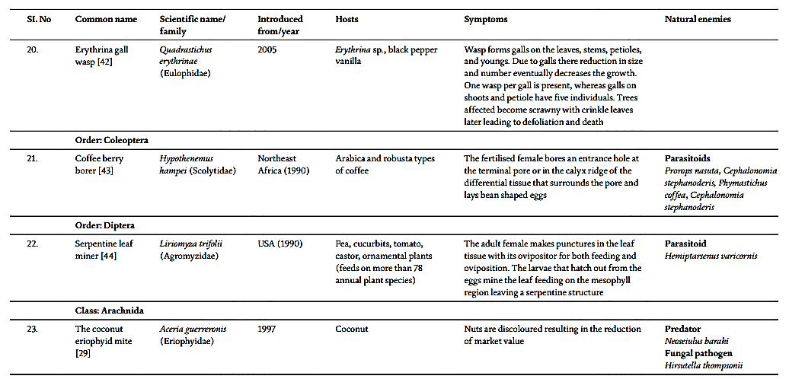Table source: Singh et al. 2020.

Climate change and Invasive Species

Environments that are better suited for invasive species to flourish and spread can be produced by climate change. Additionally, it may change how native groups interact with one another and may modify how well the local environment supports native species. Through the introduction of new species, the expansion of previously established species, and the conversion of non-native species into invasive ones as a result of shifting ecological conditions, climate change can result in invasive species.
Temperature has a strong impact on insects, as their growth, reproduction, and survival are often limited by the availability of summer heat and extreme temperatures. As a result, climate change is likely to cause range expansion or contraction for different insect species, depending on their life history, resource availability, and niche requirements. Insect with traits that facilitate invasiveness, such as a broad diet, widespread distribution, and physiological adaptability to changing conditions, may benefit from climate change. Climate change could also lead to an increase in vector borne diseases, which involves insect carriers, as many vectors are expected to expand their range within Europe, and new vectors may be introduced from tropical regions. For instance, the Aedes albopictus mosquito, which transmits dengue fever, spread to 22 northern provinces of Italy eight years after its introduction (source: www.cbd.int).
The life cycles of insects are highly influenced by temperature, and it is predicted that they will respond quickly to climate change by moving to new areas where they can thrive. The mountain pine beetle, which typically infests lodgepole pine forests but can also affect other types of pine trees, this has experienced a significant outbreak in British Columbia since the 1990s. This has resulted in extensive damage to the forests. The population of the beetle has grown so large that it is now considered the largest outbreak ever recorded. This has been made possible by hot summers, which promote beetle reproduction, and mild winters, which increase the chance of offspring surviving.
Under usual circumstances, native bark beetles like the mountain pine beetle target decaying or already dead wood and offer crucial ecosystem benefits like nesting places for birds, prey for predators and the recycling of nutrients. However, due to climate change, several regions that were previously unsuitable for mountain pine beetle infestations are now favourable. This indicates that a significant proportion of the boreal forest may be susceptible to the beetle infestations, and it is likely that the beetle population expands towards the east (source: www.cbd.int).

Prediction and Prevention
The most widely accepted method for dealing with invasive alien species is to predict and prevent their arrival. This involves identifying which species or pathways pose a risk and taking measures to prevent their entry into a particular area. To determine the effectiveness of this approach, a clear standard for success must be established. However, as the number of introduced arthropod species continues to rise, each new occurrence of an invasive species may be seen as a failure in biosecurity (Pysek et al. 2020).The growth rate of global trade has exceeded that of species arrivals, indicating that efforts to enhance biosecurity have been moderately successful (Venette et al. 2020).
Some other authors are also hopeful about the potential of integrating future systems to predict and prevent the spread of pests. They believe that improved horizon scanning and real-time global surveillance can offer more dynamic and accurate insights into emerging threats (Poland et al. 2019 and Roy et al. 2019).To improve the detection of insects during their journey, advanced methods such as those utilizing environmental DNA or the analysis of volatile chemical profiles should be developed (Lucas. 2011 and Larson et al. 2020). Assessing the risk of pests in a specific geographical area will continue to be crucial for biosecurity measures. It helps determine whether goods can be imported, organize surveillance programs, and plan responses in case a harmful species enters a vulnerable region (Venette et al. 2010). This passage is discussing the need for reliable, scalable, and affordable approaches to assess the likelihood of species invasion and the potential harm they can cause. Typically, these assessments focus on identifying the conditions that support the establishment of invasive species. However, it is crucial to develop models that are transferable to new environments and time frames, which is becoming a significant
challenge for statistical models and machine learning (Morey et al. 2020). Process-based models are attractive, but their usage is limited due to the large amount of data they require, which makes it impractical to apply them to numerous species that need to be studied (Venette. 2017). New developments in technology and data access have made it easier to collect data on changes in insect populations, including their distribution, abundance, and life cycle patterns. These advances have also led to improvements in understanding the genetic makeup of invasive species and how they interact with their environment, which can help with predicting their behaviour in the future. Overall, these advancements have increased the accuracy and precision of forecasting models for insect populations (Estoup et al. 2010, Cristescu. 2015 and Roe et al. 2019).

Management of Invasive Insects
The management process of invasive insect species includes management at three different levels of invasion of pests
- To manage invasive species effectively, it is recommended to take preventive measures such as performing a pest risk analysis (PRA), implementing quarantine measures, and carrying out monitoring activities to prevent the entry of the invasive pests. This approach is considered the most effective way to manage invasive species when they have not been yet introduced.
- In case where an invasive species has been introduced but has not spread to nearby areas, post quarantine measures should been taken. These measures may include rejecting the shipment or consignment from which the pest was introduced and eradicating which the pest through fumigation of the entire consignment lot.
- If introduced pest has successfully established itself, different curative measures are necessary for its management. These may include implementing cultural, biological and chemical methods of control (Singh et al. 2020).
In Indian context, The Indian government has created laws to address the issue of invasive species. The first such law was introduced in 1914, known as the Destructive Insects and Pests Act 1914, aimed at preventing the entry of invasive species (Plant quarantine india n.d.).Over time, laws related to plant quarantine in India have undergone various changes. At present, the Plant Quarantine Order of 2003 is the main legislation addressing plant quarantine concerns in India. This order includes updated import policies and mandatory measures aimed at limiting the import of plants or plant products that are infested with pests. The order emphasizes the importance of conducting a Prior Risk Assessment (PRA) to determine the necessary phytosanitary measures required to safeguard plant resources from invasive pests (MHFW, The Gazette of India, 2017).
Plant quarantine facilities include:
- An integrated information management system.
- An integrated pest risk analysis system and a national pest risk analysis unit for conducting integrated pest surveillance.
- An integrated phytosanitary border control system.
- A national phytosanitary database.
- A national management centre for phytosanitary certification to continuously review the national standards for export phytosanitary certification. (Singh. et al. 2020).
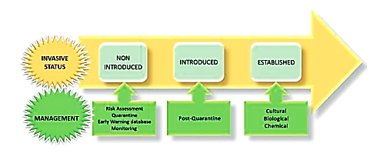
Fig7: management of invasive insects
Fig source: Singh et al. 2020.

Initial Detection
The invasion of non-native species typically starts with their initial arrival, which could occur through means such as international exports like shipments of lumber. These species have the potential to establish themselves in a new habitat, proliferate, and eventually reach pest concentrations and becoming invasive (Lodge et al. 2006).The United States continues to see an average of about 2.5 non-native forest insect species per year (Aukema et al. 2010), despite the establishment of new measures in the early 20th century to reduce the entry of invasive pests. Before their populations out of control, new methods have been developed to find and eliminate invading insects. For instance, Biosecurity New Zealand advises on how to report any new occurrences and lists potential invasive risks to the nation on its website. While this was going on, a study team created two unique locations in China for the planting of sentinel trees from Mediterranean and temperate regions to help them identify any potential Asian bug species that might infiltrate European trees (Roques et al. 2015). Seven different tree species were planted as part of the study, and they were checked each month for four years to look for dangerous insects. The seedlings were hammered over a sheet to collect any insects, and the list of possibly invasive Asian pests that were discovered as a result. Identification is challenging because only 26% of the insects that were collected had species-level identification. Despite the fact that the study offered a practical method for identifying possible invasive insects before they settle, it is a lengthy, labor-intensive procedure that takes years and is expensive. The authors suggest the need for molecular databases to improve insect identification (Mclaughlin et al. 2019).

Biological Control
Biological Control refers to the deliberate intervention by humans in the natural environment, where natural enemies are employed to manage pests and reduce their populations. This approach involves targeting the invasive species by directing the natural enemies towards them. The success of invasive insect species in a new environment can be attributed to the absence of their natural predators, which allows them to thrive. To address this issue, the practice of biological control, or bio control, involves importing the natural predators of invasive pests with the aim of reducing their populations. This approach is not new and has been in use since ancient times. For instance, there are historical records dating back to the tenth century, of Oecophylla ants being sold in Chinese markets for farmers to release as a means of protecting their citrus crops (Liu. 1939). In 1889, Albert Koebele conducted a successful experiment in biological control by intentionally releasing Australian vedalia lady beetles, also known as Rodolia cardinalis, to combat populations of the cottony cushion scale insect, Icerya purchasi. This led to a rapid and significant reduction in the pest population, providing great benefits to farmers dealing with the issue. This event served as strong evidence for the effectiveness of biocontrol in managing invasive insects (Caltagirone and Doutt. 1989).Currently, green lacewings belonging to the Chrysopidae family are commonly utilized as a biological control method to regulate various types of insect pests in diverse locations such as agricultural fields and woodland areas (Tauber et al. 2000, Yang et al. 2014). bio control is an attractive option for managing invasive insects due to its potential to be non-toxic and target specific to particular species, as opposed to using pesticides.

Chemical control
The management of pests and diseases often involves the application of various chemical substances such as pesticides, herbicides, fungicides, and insecticides. While these chemicals can be highly efficient, they also pose potential risks to non-target species and the broader environment. For the insect control pesticides are used. Pesticides are commonly used around the world to protect crops and humans from damage caused by insect pests. Although these treatments can be successful in reducing the populations of invasive pests, they contain various poisonous chemicals that are released into the environment to specifically target certain species. The use of such treatments can be highly effective, as demonstrated by the application of Volium Flexy (which contains chlorantraniliprole and thiamethoxam) on farmers' field crops. This resulted in a mortality rate of more than 85% for the polyphagous pest Helicoverpa armigera, leading to an improvement in tomato crop yield (Abbas et al. 2015). Invasive social wasps can be controlled by using fipronil-laced bait stations, which have been found to significantly reduce their population. At several field stations in New Zealand, the use of such bait stations led to a reduction of over 90% in the traffic of these wasps (Edward et al. 2017).
Despite the benefits of insecticides in controlling target pests, their use can also cause harm to non-target organisms and negatively impact the environment that researchers aim to safeguard. This is highlighted in Rachel Carson's book "Silent Spring" (Carson. 1962).Rachel Carson's book "Silent Spring" revealed the true effects of the insecticide DDT on both public health and the environment. It brought attention to the harmful impact of DDT and was a significant factor in the establishment of the Environmental Protection Agency in 1970 (Paull. 2013).Even now, researchers continue to uncover further consequences of DDT exposure. One such effect is the potential for multi-generational, epigenetic obesity, which has been studied after exposure to this insecticide in previous generations (Skinner et al. 2013). In order to address the concerns surrounding non-target effects of insecticides, selective insecticides are being developed to target specific species. In the case of the painted apple moth Teia anartoides invasion in Auckland and Hamilton, New Zealand, the bacteria Bacillus thuringiensis var. Kurstaski (Btk), also known as Foray 48B, was utilized as a spray. This led to a significant decrease in populations of the moth, with numbers dropping to as low as 1% compared to previous years. However, in areas with denser vegetation, the success of this approach was not as significant (Charles et al. 2005, Richardson et al. 2005).In order to control certain invasive insect pest species such as lepidopteran and coleopteran, transgenic Bt cotton crops have been employed in countries such as India, China, South Africa, Mexico, and Argentina (Qaim. 2009, Krishna and Qaim. 2012) The use of Bt as a nontoxic insecticide with broad distribution is a promising development in the field of pest control. This is especially notable in the context of the successful use of transgenic Bt cotton crops to control invasive insect pest species.

Sterile insects
Recent advancements in genetic techniques have shown promise in combating invasive pests. The sterile male technique (SMT) is considered a more humane approach to managing invasive populations, as it targets a species' reproduction without harming non-target species in the same environment. In SMT, sterile males (SMs) are dispersed in vast numbers into a population where they mate with females and give birth to little or no progeny. If enough SMs are released and mated with, the population size in the following generation decreases as a result. SMT has been used for decades with excellent success, especially in reducing New World screwworm C. hominivorax population sizes. The management and even eradication of populations in a number of nations, including Belize, some Caribbean Islands, Costa Rica, El Salvador, Guatemala, Honduras, Libya, Mexico, Nicaragua, Panama north of the Canal, and the United States, has been achieved as a result of its global implementation (Vargas-Teran et al. 2005). Releasing a sufficient number of sterile males to achieve a significant reduction in population size requires the rearing and release of large quantities of insects. Previous SMT releases have involved the release of more than 12 million sterile males per week. However, producing such a high number of sterile males can be expensive, which can place a significant burden on poorer countries (Vreysen et al. 2007).

RNA Interference
RNA interference (RNAi) is a technique in genetics that specifically targets a particular organism. It involves using double-stranded RNAs (dsRNA) from an external source to degrade specific messenger RNAs (mRNAs), thereby suppressing the expression of the targeted gene.(Zamor. 2001). To use RNAi for controlling insect pests, systemic RNAi would need to be implemented. This involves silencing the targeted gene not only in the exposed cell but also in adjacent cells. The dsRNA and silencing signals derived from dsRNA spread through channels that transport dsRNA, resulting in neighboring cells being affected. In the case of the nematode C. elegans, the ideal length for dsRNA molecules to facilitate systemic spread of RNAi is greater than 50 bp (Feinberg and Hunter. 2003). According to Whangbo and Hunter (2008) and Huvenne and Smagghe (2010), an environmental response strategy could be adopted, in which the dsRNA is absorbed from the environment around the cell and silencing occurs in all the cells that have done so. The high specificity of RNAi makes it an attractive tool for managing insect pests as it reduces the risk of toxicity spreading to non-target organisms in the environment. Insects can be made to ingest RNAi through systemic endocytosis, using common methods such as microinjection and feeding. The frizzled and frizzle-2 genes were initially successfully suppressed by microinjection in Drosophila embryos, leading to abnormalities resembling the loss of wingless function (Kennerdell and Carthew, 1998).Despite the fact that multiple laboratory studies (Travanty et al. 2004, Boisson et al. 2006, Mutti et al. 2006) have shown that microinjection is effective at controlling insects. Microinjection would be difficult to use in field investigations, though. An strategy that could be employed in field studies is oral intake because it is less invasive. The western corn rootworm (Diabrotica virgifera virgiera), which affects crops, can be controlled by feeding insects transgenic plants containing dsRNA. Feeding pea aphids (Acyrthosiphon pisum) a diet enriched with dsRNA has also been shown to be an effective pest control method, regardless of the aphid's life stage. Because only a little amount of dsRNA reaches the gut epithelium, RNAi via eating may not always be effective.

Discussion
The insects are the one of the most diverse group of organisms. But when these insects became invasive, after establishing themselves in new environment, they become a threat to the local species and ultimately threaten the local biodiversity, agriculture and human health. If these invasive insects are not controlled properly then these can cause some serious damage to economy. There are some management methods for controlling invasive insects, which are implemented by countries, but these methods are not enough until it should implemented worldwide, which can control these invasive insects, if they have been implemented immaculately. The problem of invasive insects requires international attention as well as local management methods implementation.

Conclusion
The invasion of non-native insect species can have a significant impact on ecosystems, agriculture, economies, and human health. Invasive insect species have the potential to displace and cause the extinction of native species, disrupt co-evolutionary relationships, and lead to the spread of diseases. These invasive species can also cause direct harm to human health and the economy, as seen in instances where crops are destroyed or plant-based products are unable to be traded. The impact of invasive insect species is a global issue, with developing countries being particularly vulnerable. Therefore, effective management strategies must be implemented to prevent their spread and mitigate their impact. Management strategies include prevention measures, such as early detection and monitoring of invasive species, quarantine, and regulations on the trade of live plants and animals. Additionally, management strategies may include biological control, chemical control, and cultural control. The successful management of invasive insect species requires a coordinated effort among governments, researchers, and stakeholders. By taking action to manage the spread of invasive insect species, we can protect ecosystems, ensure food security, and safeguard human health and the economy.

Acknowledgement
I would like to express my special thanks of gratitude to my teacher Dr. Hemlata Pant, Assistant professor, Department of Zoology, CMP Degree College, Prayagraj, Uttar Pradesh. Thank you madam for giving me opportunity to work on this topic “ The Menace of Invasive Alien Species and it’s Management” , and also for guiding me.

References
- Abbas, G., N. Hassan, M. Farhan, I. Haq, and H. Karar. 2015. Effect of selected insecticides on Helicoverpa armigera Hubner (Lepidoptera : Noctuidae ) on tomato (Lycopersicon esculentum Miller) and their successful management. Advances in Entomology. 3: 16–23.
- Aukema, J. E., D. G. McCullough, B. Von Holle, A. M. Liebhold, K. Britton, and S. J. Frankel. 2010. Historical accumulation of nonindigenous forest pests in the Continental United States. Bioscience. 60: 886–897.
- Bajracharya AS, Bhat B, Sharma P, Shashank PR, Meshram NM, Hashmi TR. First record of fall army worm Spodoptera frugiperda (JE Smith) from Nepal. Indian Journal of Entomology. 2019;81(4):635-639.
- Baum, J. A., T. Bogaert, W. Clinton, G. R. Heck, P. Feldmann, O. Ilagan, S. Johnson, G. Plaetinck, T. Munyikwa, M. Pleau, et al. 2007. Control of coleopteran insect pests through RNA interference. Nat. Biotechnol. 25: 1322–1326.
- Boisson, B., J. C. Jacques, V. Choumet, E. Martin, J. Xu, K. Vernick, and C. Bourgouin. 2006. Gene silencing in mosquito salivary glands by RNAi. FEBS Lett. 580: 1988–1992.
- Bonte D, Baert L, Lens L, Maelfait J-P. Effects of aerial dispersal, habitat specialisation, and landscape structure on spider distribution across fragmented grey dunes. Ecography. 2004;27(3):343-349.
- Bradshaw, C. J. A., Leroy, B., Bellard, C., Roiz, D., Albert, C., Fournier, A., Barbet-Massin, M., Salles, J.-M., Simard, F., & Courchamp, F. (2016). Massive yet grossly underestimated global costs of invasive insects. Nature Communications, 7, 12986. doi:10.1038/ncomms12986.
- Caltagirone, L., and R. Doutt. 1989. The history of the Vedalia beetle importation to California and its impact on the development of biological control. Annu. Rev. Entomol. 34: 1–16.
- Carson, R. 1962. Silent Spring. Houghton Mifflin, Boston, MA.
- Charles, J. G., D. J. Allan, A. Chhagan, and L. E. Jamieson. 2005. Effectiveness of Foray 48B over time after application against the painted apple moth. N.Z. Plant Prot. 58: 12–16.
- Clarke, D. A., & McGeoch, M. A. (2022). Invasive alien insects represent a clear but variable threat to biodiversity. Insect Conservation and Diversity, 1-37.
- Cristescu ME. Genetic reconstructions of invasion history. Mol Ecol. (2015) 24:2212–25. doi: 10.1111/mec.13117.
- Diez JM, D’Antonio CM, Dukes JS, Grosholz ED, Olden JD, Sorte CJ, et al. Will extreme climatic events facilitate biological invasions? Frontiers in Ecology and the Environment. 2012;10(5):249-257.
- Edwards, E., R. Toft, N. Joice, and I. Westbrooke. 2017. The efficacy of Vespex® wasp bait to control Vespula species (Hymenoptera: Vespidae) in New Zealand. Int. J. Pest Manag. 63: 266–272.
- Estoup A, Guillemaud T. Reconstructing routes of invasion using genetic data: why, how and so what? Mol Ecol. (2010) 19:4113–30. doi: 10.1111/j.1365-294X.2010.04773.x
- Feinberg, E. H., and C. P. Hunter. 2003. Transport of dsRNA into cells by the transmembrane protein SID-1. Science. 301: 1545–1547.
- Fessl B, Tebbich S. Philornis downsi - a recently discovered parasite on the Galapagos archipelago - a threat for Darwin’s finches? Ibis. (2002) 144:445–51. doi: 10.1046/j.1474-919X.2002.00076.x
- García-López, J., Hulme, P. E., Hirsch, H., Pauchard, A., Vilà, M., & Pergl, J. (2020). Global environmental risks of biological invasions from trade: a comprehensive assessment and implications for governance. Ecology Letters, 23(8), 1248-1260. doi: 10.1111/ele.13547
- https://www.downtoearth.org.in/news/agriculture/why-india-is-vulnerable-to-attacks-by-alien-species-66189, Jitendra. 2019.
- https://www.indiatimes.com/amp/explainers/news/invasive-alien-species-cost-indian-economy-127-billion-us-dollars-last-6-decades-explainer-569577.html. (Yadav 2022)
- https://www.invasivespeciesinfo.gov/subject/pathways. NISIC,US department of agriculture.
- Huvenne, H., and G. Smagghe. 2010. Mechanisms of dsRNA uptake in insects and potential of RNAi for pest control: a review. J. Insect Physiol. 56: 227–235.
- Johnson SJ. Migration and the life history strategy of the fall armyworm, Spodoptera frugiperda in the Western Hemisphere. International Journal of Tropical Insect Science. 1987;8(4-6):543-549.
- Kelley AL. The role thermal physiology plays in species invasion. Conservation Physiology. 2014;2(1):1-14
- Kennerdell, J. R., and R. W. Carthew. 1998. Use of dsRNA-mediated genetic interference to demonstrate that frizzled and frizzled 2 act in the wingless pathway. Cell. 95: 1017–1026.
- Koop JAH, Causton CE, Bulgarella M, Cooper E, Heimpel GE. Population structure of a nest parasite of Darwin’s finches within its native and invasive ranges. Conserv Genet. (2020) 2020. doi: 10.1007/s10592-020-01315-0
- Krishna, V. V., and M. Qaim. 2012. Bt cotton and sustainability of pesticide reductions in India. Agric. Sys. 107: 47–55.
- Kumar, M., Chander, S., & Kumar, S.,(2017). Papaya Mealybug: A Successful story of Biological Controle in India, In Biological Control of Insect Pests Using Egg Parasitoid, 219-230. Springer, Cham.
- Larson ER, Graham BM, Achury R, Coon JJ, Daniels MK, Gambrell DK, et al. From eDNA to citizen science: emerging tools for the early detection of invasive species. Front Ecol Environ. (2020) 18:194–202. doi: 10.1002/fee.2162
- Liu, G. 1939. Some extracts from the history of entomology in China. Psych. 46: 23–28.
- Lodge, D. M., S. Williams, H. J. MacIsaac, K. R. Hayes, B. Leung, S. Reichard, R. N. Mack, P. B. Moyle, M. Smith, D. A. Andow, et al. 2006. Biological invasions: recommendations for U.S. policy and management. Ecol. Appl. 16: 2035–2054.
- Lucas JA. Advances in plant disease and pest management. J Agric Sci. (2011) 149:91–114. doi: 10.1017/S0021859610000997
- Mao, J., and F. Zeng. 2012. Feeding-based RNA interference of a gap gene is lethal to the pea aphid, Acyrthosiphon pisum. PLoS One. 7: e48718.
- McLaughlin, G. M., & Dearden, P. K. (2019). Invasive insects: Management methods explored, Journal of Insect Science,20, 1-9.
- Meyerson, L.A., and Mooney, H.A., (2007). Invasive Alien Species in an Era of Globalization. Frontiers in Ecology and Environment.5, 199-208.
- MHFW. The Gazette of India. Notification.1037, 1-3. 2017. Available from: http://www.cdsco.nic.in/ writereaddata/GSR327(E) Dated 03_04_2017.pdf.
- Morey AC, Venette RC. Minimizing risk and maximizing spatial transferability: challenges in constructing a useful model of potential suitability for an invasive insect. Ann Entomol Soc Am. (2020) 113:100–13. doi: 10.1093/aesa/saz049.
- Mutti, N. S., Y. Park, J. C. Reese, G. R. Reeck, G. Amdam, Z. Simoes, K. R. Guidugli, K. Norberg, S. W. Omholt, Y. Arkane, et al. 2006. RNAi knockdown of a salivary transcript leading to lethality in the pea aphid, Acyrthosiphon pisum. J. Insect. Sci. 6: 1–7.
- Nail KR, Drizd L, Voorhies KJ. Butterflies across the globe: A synthesis of the current status and characteristics of monarch (Danaus plexippus) populations worldwide. Frontiers in Ecology and Evolution. 2019;7:362.
- Occhibove F, Chapman DS, Mastin AJ, Parnell SSR, Agstner B, Mato-Amboage R, et al. Eco-epidemiological uncertainties of emerging plant diseases: the challenge of predicting Xylella fastidiosa dynamics in novel environments. Phytopathology. (2020) 110:1740–50. doi: 10.1094/PHYTO-03-20-0098-RVW.
- Opoku J, Kleczewski NM, Hamby KA, Herbert DA, Malone S, Mehl HL. Relationship between invasive brown marmorated stink bug (Halyomorpha halys) and fumonisin contamination of field corn in the Mid-Atlantic U.S. Plant Dis. (2019) 103:1189–95. doi: 10.1094/PDIS-06-18-1115-RE.
- Osyczka P, Mleczko P, Karasiński D, Chlebicki A. Timber transported to Antarctica: A potential and undesirable carrier for alien fungi and insects. Biological Invasions. 2012;14(1):15-20.
- Pachauri RK, Allen MR, Barros VR, Broome J, Cramer W, Christ R, et al. Climate Change 2014: Synthesis Report. Contribution of Working Groups I, II and III to the Fifth Assessment Report of the Intergovernmental Panel on Climate Change. Ipcc; 2014.
- Paull, J. 2013. The Rachel Carson letters and the making of Silent Spring. Sage Open. July-September: 51–53.
- Plant Quarantine India [Internet]. Available from: http:// plantquarantineindia.nic.in/PQISPub/ docfiles/dip_act.html.
- Poland TM, Rassati D. Improved biosecurity surveillance of non-native forest insects: a review of current methods. J Pest Sci. (2019) 92:37–49. doi: 10.1007/s10340-018-1004-y
- Pysek P, Hulme PE, Simberloff D, Bacher S, Blackburn TM, Carlton JT, et al. Scientists’ warning on invasive alien species. Biol Rev. (2020) 95:1511–34. doi: 10.1111/brv.12627.
- Qaim, M. 2009. The economics of genetically modified crops. Annu. Rev. Resour. Econ. 1: 665–693.
- Renault D, Laparie M, McCauley SJ, Bonte D. Environmental adaptations, ecological filtering and dispersal central to insect invasions. Annual Review of Entomology. 2018;63:345-368.
- Rezende HR, Romano CM, Claro IM, Caleiro GS, Sabino EC, Felix AC, et al. First report of Aedes albopictus infected by dengue and zika virus in a rural outbreak in Brazil. PLoS ONE. (2020) 15:e0229846. doi: 10.1371/journal.pone.0229847.
- Richardson, B., M. K. Kay, M. O. Kimberley, J. G. Charles, and B. A. Gresham. 2005. Evaluating the benefits of dose-response bioassays during aerial pest eradication operations. N.Z. Plant Prot. 58: 17–23.
- Roe AD, Torson AS, Bilodeau G, Bilodeau P, Blackburn GS, Cui MM, et al. Biosurveillance of forest insects: part I - integration and application of genomic tools to the surveillance of non-native forest insects. J Pest Sci. (2019) 92:51–70. doi: 10.1007/s10340-018-1027-4.
- Roques, A., J. Fan, B. Courtial, Y. Zhang, and A. Yart. 2015. Planting sentinel European trees in Eastern Asia as a novel method to identify potential insect pest invaders. PLoS One 10: 1–19.
- Roy HE, Bacher S, Essl F, Adriaens T, Aldridge DC, Bishop JDD, et al. Developing a list of invasive alien species likely to threaten biodiversity and ecosystems in the European Union. Glob Change Biol. (2019) 25:1032–48. doi: 10.1111/gcb.14527
- Secretariat of the convention on Biological Diversity (SCBD). 2006. Global Biodiversity Outlook2. Montreal, 81 + vii pages.
- Sharma, K.R., Jaiswal, D.K., Babu, S.R., Saraoj, A.K. (2018). IMPACT OF INVASIVE INSECT PESTS SPECIES ON AGRO-ECOSYSTEM IN INDIA AND THEIR MANAGEMENT, Indian Journal of Agriculture and Allied Sciences, 4, 19-25.
- Sileshi GW, Gebeyehu S, Mafongoya PL. The threat of alien invasive insect and mite species to food security in Africa and the need for a continent-wide response. Food Secur. (2019) 11:763–75. doi: 10.1007/s12571-019-00930-1
- Simberloff, D. (2013). Invasive species: what everyone needs to know. Oxford University Press.
- Singh, K., & Kushwaha, S. (2019). Invasive Alien Insect in India: A Comprehensive Review. Journal of Experimental Zoology,India,22(1),1-25.
- Singh, S., Sharma, J. H., Udikeri, A., & Ansari, H. (2020). Invasive insects in India: Status, impact, and management. Intech open, 1-16. doi: 10.5772/intechopen.91986
- Skinner, M. K., M. Manikkam, R. Tracey, C. Guerrero-Bosagna, M. Haque, and E. E. Nilsson. 2013. Ancestral dichlorodiphenyltrichloroethane (DDT) exposure promotes epigenetic transgenerational inheritance of obesity. BMC Med. 11: 228.
- Sun JH, Lu M, Gillette NE, Wingfield MJ. Red turpentine beetle: innocuous native becomes invasive tree killer in China. Annu Rev Entomol. (2013) 58:293–311. doi: 10.1146/annurev-ento-120811-153624
- Tauber, M. J., C. A. Tauber, K. M. Daane, and K. S. Hagen. 2000. Commercialization of predators : recent lessons from green lacewings. Am. Entomol. 46: 26–38.
- Travanty, E. A., Z. N. Adelman, A. W. E. Franz, K. M. Keene, B. J. Beaty, C. D. Blair, A. A. James, K. E. Olson. 2004. Using RNA interference to develop dengue virus resistance in genetically modified Aedes aegypti. Insect. Biochem. Mol. Biol. 34: 607–613.
- Venette RC. Climate analyses to assess risks from invasive forest insects: simple matching to advanced models. Curr Forestry Rep. (2017) 3:255–68. doi: 10.1007/s40725-017-0061-4.
- Vargas-Terán, M., H. C. Hofmann, and N. E. Tweddle. 2005. Impact of screwworm eradication programmes using the sterile insect technique, pp. 629–650. In V. A. Dyck, J. Hendrichs, and A. S. Robinson (eds.), Sterile insect technique: principles and practice in area-wide integrated pest management. Springer Netherlands, Dordrecht, the Netherlands.
- Venette, R. C., & Hutchison, W. D. (2021). Invasive insect species: Global challenges, strategies, and opportunities. Frontiers in Insect Science, 1, 1-4.
- Venette RC, Kriticos DJ, Magarey RD, Koch FH, Baker RHA, Worner SP, et al. Pest risk maps for invasive alien species: a roadmap for improvement. Biosci. (2010) 60:349–62. doi: 10.1525/bio.2010.60.5.5
- Venette RC, Morey AC. Advances in understanding the ecology of invasive crop insect pests and their impact on IPM. In: Kogan M, Heinrichs EA. Integrated Management of Insect Pests: Current and Future Developments. Cambridge, UK: Burleigh Dodds Science Publishing. (2020). p. 161–90. doi: 10.19103/AS.2019.0047.06
- Vreysen, M., A. Robinson, and J. Hendrichs. 2007. Area-wide control of insect pests from research to field implementation. Springer, Dordrecht, The Netherlands.
- Whangbo, J. S., and C. P. Hunter. 2008. Environmental RNA interference. Trends Genet. 24: 297–305.
- Williamson M, Fitter A. The varying success of invaders. Ecology. (1996) 77:1661–6. doi: 10.2307/2265769.
- www.cbd.int, invasive alien species a threat to biodiversity, 22 may 2009.
- Yang, N., L. Zang, S. Wang, J. Guo, H. Xu, F. Zhang, and F. Wan. 2014. Biological pest management by predators and parasitoids in the greenhouse vegetables in China. Biol. Control. 68: 92–102.
- Zamore, P. D. 2001. RNA interference: listening to the sound of silence. Nat. Struct. Biol. 8: 746–750.

