**Catalytic Activity of Electron Beam Irradiated Pd/C on**

**2-methyl nitro benzene**

**SURESH B1 and Dr G. Vanmathi 2**

1 Research Scholar, (Reg.No 21112102031003), Department of Chemistry, Kamaraj College, Thoothukudi – 628003

2 Associate Professor of Chemistry, Kamaraj College, Thoothukudi – 628003

Affiliated to Manonmanium Sundaranar University, Abishekapatti, Tirunelveli – 627 012, Tamil Nadu, India

**Abstract**

In this study nitro compounds viz., 2 – methyl nitro benzene reduced by 10% Pd/C (50% wet) to 2 – methyl aniline and it is confirmed from MASS and NMR studies. The product yield was 70%. The hydrogenation was complete in 9.30 h. The catalysts were then irradiated by electron beam to various dosages from 0 kGy, 150 kGy, 200 kGy and 250 kGy by Microtron & RF Linac. The reduction reactions were conducted under similar conditions using irradiated 10% Pd/C samples. Now the product yield was 93%. The hydrogenation was fast and completed within 2 h 30. With the electron beam irradiated catalyst, the reaction time has decreased by 15 -70% and the completion of reaction is in the order of dosages 250 kGy > 200 kGy >150 kGy > 0 kGy. The fastness of reduction reaction in both the steps upon irradiation could be attributed to the increase in surface area. The studies were also conducted using Micro powder form of Pd/C catalyst both in non-irradiated and in the irradiated form. The decrease in reaction time and the increase in product yield have been attributed to higher dispersion of Pd particles upon irradiation.

**Key words** : Electron beam irradiation, Pd/C catalyst, nitro compounds, reduction

**1.Introduction:**

Selectivity and specificity are also greatly influenced by surface uniformity. Since the reaction itself is mostly dependent on the micro structural characteristics of the solid surface, it is possible to control the reaction's course and development in order to accomplish the intended molecular conversion if the solid surface is treated properly.

The goal of this work is to create heterogeneous catalysts that work well for irradiating organic molecules with an electron beam. Palladium adsorbed on carbon (in both solid and micropowder form) is the catalyst of choice. Palladium-catalyzed organic reactions led to the reduction of monofunctional organic molecule 2, or chloro nitro benzene. Catalysts exposed to electron beam radiation were used for the identical processes, and the results showed a comparison in catalytic efficiency. Studies on the catalysts' surface morphological alterations were also conducted.

**2. Experimental:**

2.1 **Chemicals and instruments**:

10% Pd/C from Hindustan Platinum Limited, Mumbai, Micro Pd/C from Sigma Aldrich, and chemicals 2 - methyl nitro benzene and methanol - were purchased from Aldrich Chemical Company (USA). Each chemical was utilized exactly as it was received and was of analytical grade.At the Microtron Center of the Department of Atomic Energy, Mangalore University, Pd/C (10%) samples were exposed to an 8 MeV electron beam. Additionally, Pd/C (10%) and Micro Pd/C catalysts were exposed to a 10 MeV electron beam utilizing an RF Linac that was running at the Electron Beam Centre, BARC, Navi, Mumbai. Using a catalytic hydrogenation device Low Pressure Shaker Type SUPERFIT Model SS316, hydrogenation processes were conducted. Pre-coated Silica gel plates (Merck F254, 0.2 mm thickness) were used for thin layer chromatography. Using a Bruker 400 MHz FT-NMR spectrometer in CDCl3 Solution, the NMR spectra of organic molecules were captured. An American-made Micromeritises Tristar 3000 model was used to measure the surface areas of the catalysts. Both Langmuir and BET N2 adsorption forms the basis of surface area analysis. Using a [SUPRA 55]-CARL ZEISS (Germany) and a UPRIGHT MICROSCOPE, BX 51, OLYMPUS (Japan), scanning electron microscopy pictures of the catalyst surface were captured. Both 1 K X and 250 K X magnifications were used to register the images. Oxford Instruments was used for EDS studies.

2.2 **Catalytic Reactions Studied:**

**Reduction of 2-chloro-nitrobenzene:**

A Parr hydrogenator vessel was charged with a solution of 2-methyl nitrobenzene (2 g) in 40 mL of methanol and 10% Pd/C (0.3 g; 50% wet); the vessel was then cleansed with nitrogen. At a temperature of 26–28 0C and a pressure of 5 atm, hydrogen was introduced into the tank.Every 30 minutes until the reaction was finished, TLC tracked the reaction's development.



Using an alumina plate coated with silica gel as the stationary phase and a combination of heptane and ethyl acetate (7:3) as the mobile phase, the reaction's progress was tracked through TLC. Following the reaction's conclusion, the reaction mixture was filtered and given a methanol wash. An evaporator called a Buchi Rotary was used to concentrate the filtrate. It was possible to obtain Product 2-methyl aniline. Similar conditions were used for the reactions, which used 10% Pd/C samples that had been irradiated with 150 kGy, 200 kGy, and 250 kGy. Using Micro Pd/C catalyst in both non-irradiated and irradiated forms (250 kGy), comparable reactions were also conducted. Tables 1, 2 tabulate the results.

**Table 1. Reduction of 2-chloro-nitrobenzene to 2-chloro aniline**

|  |  |  |
| --- | --- | --- |
| 2-chloro-nitrobenzene taken (g) | Dosage of e- beam Macro 10% Pd/C (50%)wet  in kGy | Time Taken |
| 2 | 0 | 9 h |
| 2 | 150 | 7 h |
| 2 | 200 | 6 h |
| 2 | 250 | 4 h |

**Table 2. Reduction of 2-chloro-nitrobenzene to 2-chloro aniline**

|  |  |  |
| --- | --- | --- |
| 2-chloro-nitrobenzene taken (g) | Dosage of e- beam Micro 10% Pd/C (50%)wet  in kGy | Time Taken |
| 2 | 0 | 7 h |
| 2 | 150 | 4 h 30 min |
| 2 | 200 | 3 h 30 min |
| 2 | 250 | 2 h 30 min |

**3. Results and Discussion:**

**3.1 NMR spectroscopy**:

The structure of the Product 2-methyl aniline was characterized by 1H NMR spectroscopy. The multiplets between δ 6.48 – 7.24 ppm show the presence of aromatic protons. A signal at δ 3.58 ppm shows the presence of -NH2 protons. At δ 2.00 – 2.32 ppm reveals –CH3 protons. (Fig.1).

**Fig 1**

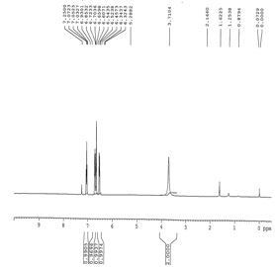

**3.2 MASS spectroscopy**:

The molecular mass of the product 2-methyl aniline was characterized by MASS spectroscopy. The molecular mass in positive scan is *m/z* **108.2** (Fig. 2).

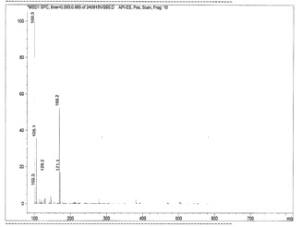Fig 2

**3.3 Surface area measurements**:

The low pressure N2 BET surface analyzer was used to measure the surface area. Table 3 lists the surface area of Pd/C catalysts that have been exposed to radiation and those that have not.

**Table 3. Surface Area**

|  |  |  |  |
| --- | --- | --- | --- |
| Sl.No | Catalyst Used | BET surf area m2/g | Langmuir Surf area m2/g |
| 1 | Macro Pd/C | 572.9564 | 862.8573 |
| 2 | Macro Pd/C 150 kGy Irradiated | 621.1100 | 939.8726 |
| 3 | Macro Pd/C 200 kGy Irradiated | 743.1941 | 1104.90 |
| 4 | Macro Pd/C 250 kGy Irradiated | 807.9050 | 1200.4033 |
| 5 | Micro powder Pd/C | 702.6682 | 1059.9547 |
| 6 | Micro powder Pd/C 150 kGy | 838.4344 | 1268.3614 |
| 7 | Micro powder Pd/C 200 kGy | 903.9725 | **References:**  [1] Hammer B. and Nørskov J.K, Ad Catal., 2000, 71.  [2] Rodriguez JA, Theoretical Chem. Accounts, 2002, 107,117-129.  [3] [Pribytkov](http://link.springer.com/search?facet-author=%22A.+S.+Pribytkov%22) AS, [Baeva](http://link.springer.com/search?facet-author=%22G.+N.+Baeva%22) GN, [Telegina](http://link.springer.com/search?facet-author=%22N.+S.+Telegina%22) NS,.et.al., [Kinetics and Catalysis](http://link.springer.com/journal/10975), 2006, 5, 765-769.  [4]. G. Vanmathi, U.P. Senthilkumar and B. Suresh., International Journal of Chem Tech  Research, 6: 13, 5291 – 5297, ( 2014).  1392.1153 |
| 8 | Micro powder Pd/C 250 kGy | 991.8263 | 1482.0662 |

The dispersion of palladium particles was shown by the observation that the surface area of the irradiated catalysts increased relative to the non-irradiated ones.

**3.4 Scanning electron microscopy**:

Pd/C agglomerates are broken up into small-sized particles, which increases surface area, according to the SEM images (Fig. 3-10). Pd/C particle size decreases as electron beam irradiation dosage increases.

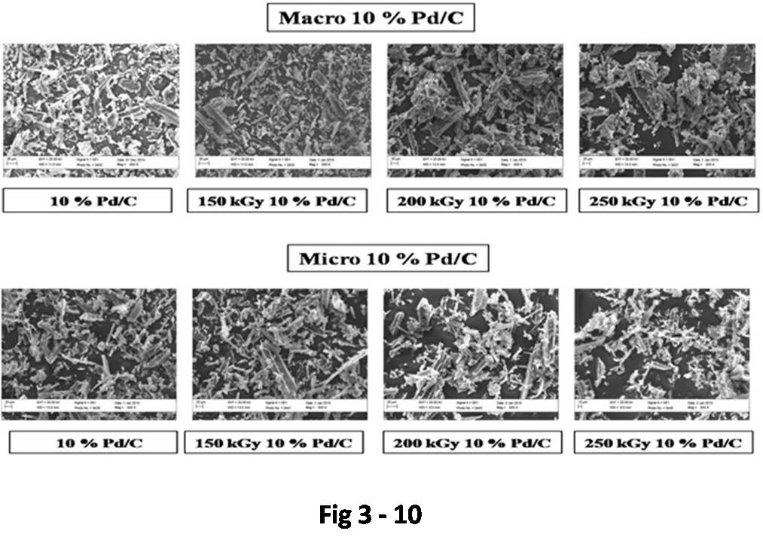**SEM images of 10% Pd/C**

**3.5 EDS studies:**

EDS studies (Fig 11 – 18) reveal that Atomic percentage of palladium in 10% Pd/C (50% wet) is 79.91% and the micro powder Pd/C is 94.35%.

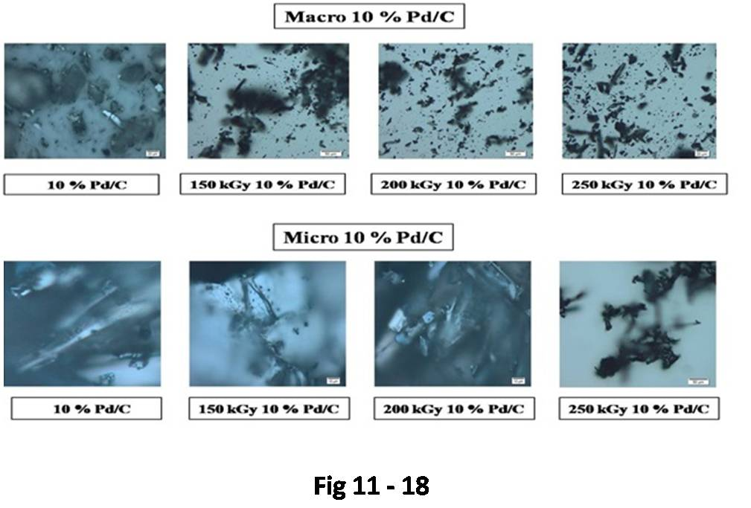**3.6 Catalytic Studies**:

All of these reduction processes with different Pd/C catalysts that were treated with electron beams demonstrated increased catalytic activity. When the same processes were repeated using the irradiation Pd/C catalyst after 3, 6, and 9 months, it was discovered that, in contrast to newly irradiated catalysts, the reaction efficiency in terms of product yield and hydrogenation reaction time was maintained. It has been discovered that the irradiation catalyst efficiency remains unchanged for almost a year. Thus, this study advances Pd/C catalyst's greener strategies.

**3.7 Conclusion**

Using Micro Pd/C, the response time is approximately 250 kGy > 200 kGy > 150 kGy > un-irradiated Micro Pd/C (0 kGy). When 10% Pd/C is used, the response rate is 250 kGy > 200 kGy > 150 kGy > 10% Pd/C that has not been exposed to radiation (0 kGy). The findings demonstrate that, in comparison to the initial system without radiation, the reaction time gradually decreases with an increase in dosage, with a net decrease of 55–75%. When utilizing Micro Pd/C, the reaction time is faster than when using 10% Pd/C. This could be explained by Micro Pd/C's high atomic percentage and BET surface area. The Pd/C catalyst's XPS data indicates that the metal particles stable on the carbon support's surface, increase in degree of dispersion, and decrease sintering following high-energy electron irradiation. The increased degree of Pd particle dispersion, which leads to the increased catalytic activity, is confirmed by the rise in BET and Langmuir surface area of the irradiation catalysts. This work advances the environmentally friendly uses of Pd/C catalyst.

**References:**

[1] B. Hammer and J. K. Nørskov, Ad Catal., 2000, 71.

[2] J. A. Rodriguez , Theoretical Chem. Accounts, *107*, 2002, 117-129.

[3] A. S. [Pribytkov](http://link.springer.com/search?facet-author=%22A.+S.+Pribytkov%22) , G. N. [Baeva](http://link.springer.com/search?facet-author=%22G.+N.+Baeva%22) , N. S. [Telegina](http://link.springer.com/search?facet-author=%22N.+S.+Telegina%22),.et.al.; [Kinetics and Catalysis](http://link.springer.com/journal/10975), *5*,2006, 765-

769.

[4]. G. Vanmathi, U.P. Senthilkumar and B. Suresh., International Journal of Chem Tech

Research, *6: 13*, 2014, 5291 – 5297.

.