DATA MINING TECHNIQUES

First Author: Mrs. K. Jayanthi Vagini Second Author: Ms .M. Nancy
Assistant Professor, Student, Department of CS with Data Analytics, Department of CS with Data Analytics,
KPR College of Arts Science and Research, KPR College of Arts Science and Research,
Avinashi Road, Arasur, Coimbatore. Avinashi Road, Arasur, Coimbatore.

Third Author :Mr .B .Muthuselvam
Student,
Department od CS with Data Analytics,
KPR College of Arts Science and Research,
Avinashi Road, Arasur, Coimbatore

ABSTRACT:
In order to extract important insights and knowledge from huge and complicated databases, data mining techniques are essential. The necessity for efficient and effective methods to analyse, evaluate, and find patterns grows more and more important as the volume of data keeps increasing exponentially. An overview of several data mining approaches, such as classification, clustering, association rule mining, and anomaly detection, is given in this abstract.The goal of classification algorithms is to divide data into preset classes according to their characteristics. They are extensively utilised in applications including sentiment analysis, disease detection, and email screening. Support vector machines (SVM), Decision Trees, and Naive Bayes are common classification techniques.
KEYWORDS:
Association rule mining, Anomaly detection, Naive Bayes, Hierarchical Clustering, Isolation Forest, Scalability, Data Warehouse, Performance Evaluation.
INTRODUCTION:
Organisations and individuals are constantly bombarded with massive volumes of data in today's data-driven world from a variety of sources, including corporate transactions, social media, sensors, and scientific research. It has become crucially important to find useful insights and knowledge from this data. By revealing hidden patterns, correlations, and trends within enormous and complicated datasets, data mining techniques—a branch of the larger fields of artificial intelligence and machine learning—have become effective tools for tackling this problem.
Data mining techniques include a wide range of methodologies that make it easier to extract useful information from unstructured data. These approaches are made to sort through large datasets, find pertinent patterns, and turn them into useful information. Data mining techniques offer essential support for decision-making, strategic planning, risk assessment, and process optimisation across numerous sectors and domains by uncovering significant insights and patterns.
Data points are classified into specified classes or groups according to their qualities, which is one of the basic jobs in data mining. Applications including sentiment analysis, email spam screening, and medical diagnosis are made possible by this method. Clustering, which groups comparable data points together, is another crucial operation that supports customer segmentation, picture segmentation, and anomaly detection by assisting in the identification of natural structures within the data another important data mining technique that reveals intriguing relationships is association rule mining.
DATA MINING TECHNIQUES:
The term "data mining" describes the process of obtaining knowledge from vast amounts of data. In other words, data mining is the science, art, and technology of locating significant patterns in huge and complicated data sets. Theorists and practitioners are constantly looking for better methods to increase the process's effectiveness, economy, and accuracy. Many terms, including knowledge mining from data, knowledge extraction, data/pattern analysis, and data dredging, have meanings that are similar to or slightly distinct from those of data mining.
Knowledge Discovery from Data, often known as KDD, is another commonly used phrase that data mining uses as a synonym. Others see data mining as just a crucial stage in the knowledge discovery process, when intelligent techniques are used to extract data patterns
- Association
- Classification
- Prediction
- Clustering
- Regression
- Artificial Neural network (ANN) Classifier Method
- Outlier Detection
- Genetic Algorithm

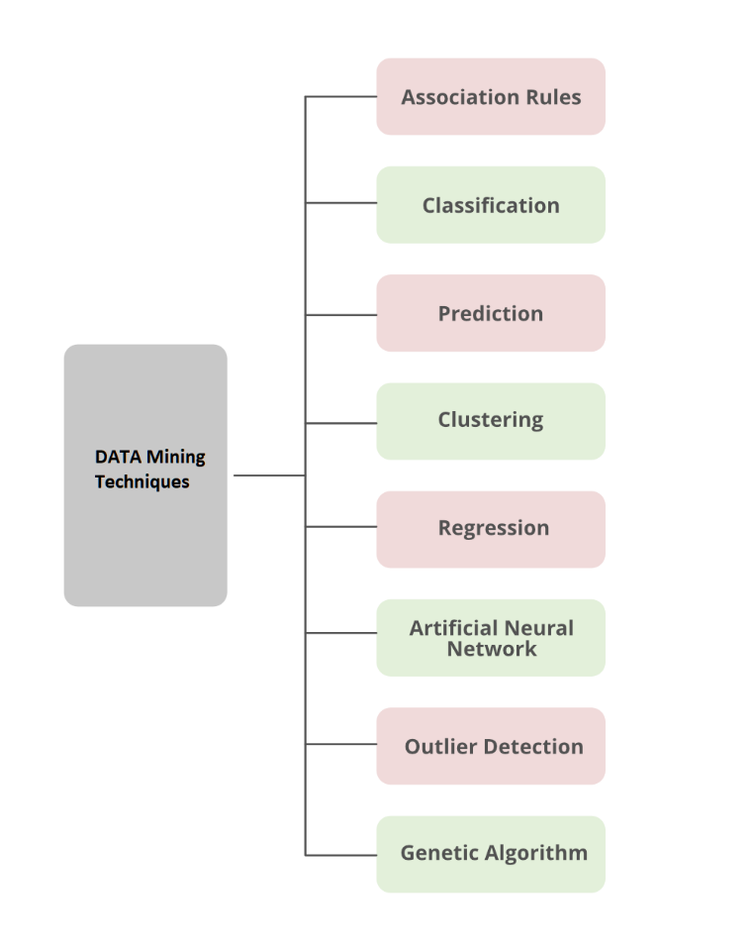
ASSOCIATION RULE:
Finding attribute-value conditions that frequently occur together in a given set of data is known as association analysis. A market basket or transaction data analysis frequently uses association analysis. An important and incredibly dynamic area of data mining research is association rule mining. Associative classification is one type of association-based categorization that entails two phases. An altered version of the common association rule mining method known as Apriori is used to produce association instructions in the main step. The second phase involves building a classifier using the identified association rules.
CLASSIFICATION:
In order to utilise a model to forecast the class of objects whose class label is unknown, classification is the process of identifying a set of models (or functions) that explain and distinguish data classes or concepts. The analysis of a set of training data information—data objects whose class label is known is necessary to determine the model. Different representations of the resultant model are possible, including classification (if-then) rules, decision trees, and neural networks. A different classifier is used in data mining.
- Decision Tree
- SVM(Support Vector Machine)
- Generalized Linear Models
- Bayesian classification:
- Classification by Backpropagation
- K-NN Classifier
- Rule-Based Classification
- Frequent-Pattern Based Classification
- Rough set theory
- Fuzzy Logic

DECISION TREE:
The structure of a decision tree is similar to a flowchart, with each node representing a test on an attribute value, each branch designating the test's result, and the tree leaves standing in for classes or class distributions. Classification rules can be simply created from decision trees. The nonparametric method of decision tree enlistment is used to create classification models. In other words, no presumptions about the sort of probability distribution that the class and other properties satisfy are necessary. Decision trees, particularly those of smaller sizes, are generally simple to read. For a considerably simpler data set, the accuracy of the trees is likewise equivalent to that of two other categorization methods.
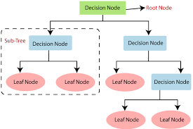
This figure generated on the IRIS data set of the UCI machine repository. Basically, three different class labels available in the data set: Setosa, Versicolor, and Virginia.
SVM:
Support Vector Machines is a supervised learning technique used for regression as well as classification. Regression is said to be performed by the learning methodology when the support vector machine's output is a continuous value, and classification is when the learning methodology correctly predicts the input object's category label. It's possible for the independent variables to be quantitative or not. Kernel equations are functions that convert information that is linearly non-separable in one domain into a different domain whenever the instances are made linearly divided. Kernel equations can be Gaussian, linear, quadratic, or any other equation that accomplishes this particular goal. A classifier that bases its judgement on a linear function of its inputs is one example of a linear classification technique. Applying the kernel equations arranges the information instances such that there is a hyper-plane separating knowledge instances of one kind from those of another at intervals in the multi-dimensional space. Support Vector Machines have the advantage of using specific kernels to alter the issue, allowing us to apply linear classification methods to nonlinear knowledge. Our goal is to include the best hyper-plane to distinguish between two types of instances once we have successfully divided the data into two distinct groups.

GENERALIZED LINEAR MODELS:
Generalised Linear Models: A statistical method for linear modelling, GLM stands for generalised linear models. GLM offers comprehensive model statistics, coefficient statistics, and row diagnostics. Also supported are confidence limits.
BAYESIAN CLASSIFIER:

A statistical classifier is the Bayesian classifier. They are able to forecast class membership probabilities, such as the likelihood that a given sample belongs to a specific class. The Bayes theorem is the foundation of Bayesian classification. The naïve Bayesian classifier, a straightforward Bayesian classifier, has been shown in studies comparing classification algorithms to perform on par with decision tree and neural network classifiers. When used on sizable databases, Bayesian classifiers have also demonstrated great accuracy and speed. The exact attribute value for a particular class is assumed to be independent of the values of the other attributes by naive Bayesian classifiers. Class conditional independence is the name given to this presumption. It is seen as "naive" and was designed to make the computations required simpler. Contrary to naive Bayesian classifiers, Bayesian belief networks are graphical representations that enable the representation of dependencies among subsets of attributes. Classification can also make use of Bayesian belief.

CLASSIFICATION BY BACKPROPAGATION:

A backpropagation network learns by repeatedly analysing a set of training samples and contrasting the network's estimate of each sample with the true class label. Weights are adjusted for every training sample in order to reduce the mean squared error between the network's predicted class and the actual class. Backpropagation is the term for the process of propagating changes in a "backward" direction, or from the output layer via each concealed layer and down to the first hidden layer. The weights will eventually converge, but this is not a given, and the knowledge process will come to an end.
K-NN CLASSIFIER:
The k-nearest neighbour (K-NN) classifier is considered to be an example-based classifier, meaning that training documents are used for comparison rather than an exact class depiction, as are the class profiles used by other classifiers. There isn't a true training section as a result. When a new document needs to be classified, the k closest matches (neighbours) are located; if a sufficient number of them are assigned to a particular class, the new document is also assigned to that class; if not, it is not. Traditional classification techniques also speed up the process of locating the nearest neighbours.
RULE-BASED CLASSIFICATION:
If-Then rules are used in rule-based classification to describe the knowledge. An evaluation of a rule based on the classifier's precision and coverage. If more than one rule is triggered, rule-based classification requires conflict resolution. Three alternative parameters—size ordering, class-based ordering, and rule-based ordering-can be used to resolve conflicts. Some benefits of rule-based classifiers include:
- Rules are easier to understand than a large tree.
- Rules are mutually exclusive and exhaustive.
- Each attribute-value pair along a path forms conjunction: each leaf holds the class prediction
FREQUENT-PATTERN BASED CLASSIFICATION:
Data mining includes frequent pattern discovery, often known as FP discovery, FP mining, or frequent itemset mining. Finding the most prevalent and pertinent patterns in huge datasets is described as the task at hand. The concept of mining transaction databases was first proposed. Subsets (item sets, subsequences, or substructures) that frequently appear in a data collection are defined as those whose frequency exceeds a user- or automatically-specified threshold.
ROUGH SET THEORY:
For classification, rough set theory can be utilised to find structural correlations in noisy or erratic data. It applies to features with discrete values. Therefore, in order to be used, continuous-valued properties must first be discrete. The foundation of rough set theory is the creation of equivalence classes within the supplied training data. The samples of data that make up a similarity class cannot be distinguished from one another since they are all equal in terms of the qualities that describe the data. Rough sets can also be used for relevance analysis and feature reduction, in which the contributions or significance of each attribute are evaluated in relation to the classification task. In feature reduction, attributes that do not contribute to the classification of the provided training data can be identified and removed. Finding the smallest subsets (redacts) of characteristics that can adequately characterise every idea in the given data set is an NP-hard issue. However, strategies to reduce the amount of computing have been put forth. One technique, for instance, uses a discernibility matrix to hold the variations in attribute values for each pair of data samples. To find duplicated qualities, the matrix is examined rather than the complete training set.

FUZZY LOGIC:

The drawback of rule-based classification systems is that they require abrupt cut-offs for continuous attributes. Frameworks for data mining that conduct grouping and classification benefit from fuzzy logic. The advantage of working at a high level of abstraction is provided. Fuzzy logic is typically used in rule-based systems in the following ways:
- Attribute values are changed to fuzzy values.
- For a given new data set /example, more than one fuzzy rule may apply. Every applicable rule contributes a vote for membership in the categories. Typically, the truth values for each projected category are summed

KNOLEDGE DISCOVERY FROM DATA:
- Knowledge extraction from data is a multi-step process known as knowledge discovery from data (KDD). The KDD method includes the steps listed below:
- Data Selection: Choosing the pertinent data for analysis is the first step in the KDD process. This entails locating the data sources and choosing the information required for the analysis.
- Data transformation : It may be necessary to make the data more useful for analysis once it has been cleansed. In order to do this, the data must be transformed into a format that data mining algorithms can use.
- Data Mining: To find patterns and relationships in the data, a variety of data mining techniques are applied in this step. In order to do this, models and algorithms that are suitable for the data and the situation at hand must be chosen.
- Evaluation of Patterns: Following the data mining phase, it is necessary to assess the patterns and correlations found in the data in order to establish their applicability. This entails looking at the patterns to see whether they have any significance and can be utilised to anticipate or decide.
- Preprocessing of the data: The data gathered from various sources may be in a variety of formats and have errors and inconsistencies. To prepare the data for analysis, it must be cleaned and transformed during the data preprocessing stage.
- Knowledge Representation: The correlations and patterns found in the data need to be presented in a way that the end user can comprehend and make use of. This entails presenting the findings in a form that makes sense and can be applied to decision-making.
- Knowledge Refinement: To make the knowledge discovered through the data mining process more usable, more refinement may be required. This entails leveraging end-user feedback to enhance the precision and utility of the findings.
- Knowledge Dissemination: The final phase in the KDD process entails distributing to the end-users the knowledge discovered during the analysis. This entails presenting the findings in a form that is clear and can be applied to decision-making.
ADVANTAGES OF DATA MINING TECHNIQUES:
- Better Decision Making:
Data mining helps to extract useful information from large datasets, which can be used to make informed and accurate decisions. By analyzing patterns and relationships in the data, businesses can identify trends and make predictions that help them make better decisions.
- Improved Marketing:
Data mining can help businesses identify their target market and develop effective marketing strategies. By analyzing customer data, businesses can identify customer preferences and behavior, which can help them create targeted advertising campaigns and offer personalized products and services.
- Increased Efficiency:
Data mining can help businesses streamline their operations by identifying inefficiencies and areas for improvement. By analyzing data on production processes, supply chains, and employee performance, businesses can identify bottlenecks and implement solutions that improve efficiency and reduce costs.
- Fraud Detection:
Data mining can be used to identify fraudulent activities in financial transactions, insurance claims, and other areas. By analyzing patterns and relationships in the data, businesses can identify suspicious behavior and take steps to prevent fraud.
- Customer Retention:
Data mining can help businesses identify customers who are at risk of leaving and develop strategies to retain them. By analyzing customer data, businesses can identify factors that contribute to customer churn and take steps to address those factors.
- Competitive Advantage:
Data mining can help businesses gain a competitive advantage by identifying new opportunities and emerging trends. By analyzing data on customer behavior, market trends, and competitor activity, businesses can identify opportunities to innovate and differentiate themselves from their competitors.
- Improved Healthcare:
Data mining can be used to improve healthcare outcomes by analyzing patient data to identify patterns and relationships. By analyzing medical records and other patient data, healthcare providers can identify risk factors, diagnose diseases earlier, and develop more effective treatment plans.

DISADVANTAGES OF DATA MINING TECHNIQUES:
- Data Quality:
Data mining relies heavily on the quality of the data used for analysis. If the data is incomplete, inaccurate, or inconsistent, the results of the analysis may be unreliable.
- Data Privacy and Security:
Data mining involves analyzing large amounts of data, which may include sensitive information about individuals or organizations. If this data falls into the wrong hands, it could be used for malicious purposes, such as identity theft or corporate espionage.
- Ethical Considerations:
Data mining raises ethical questions around privacy, surveillance, and discrimination. For example, the use of data mining to target specific groups of individuals for marketing or political purposes could be seen as discriminatory or manipulative.
- Technical Complexity:
Data mining requires expertise in various fields, including statistics, computer science, and domain knowledge. The technical complexity of the process can be a barrier to entry for some businesses and organizations.
- Interpretation of Results:
Data mining algorithms generate large amounts of data, which can be difficult to interpret. It may be challenging for businesses and organizations to identify meaningful patterns and relationships in the data.
- Dependence on Technology:
Data mining relies heavily on technology, which can be a source of risk. Technical failures, such as hardware or software crashes, can lead to data loss or corruption.
CONCLUSION:
Techniques for data mining have established themselves as essential instruments in the current era of data-driven decision-making. These strategies help individuals and organisations gain a competitive edge, enhance business procedures, and make wise decisions by allowing them to extract useful patterns, insights, and knowledge from enormous amounts of data.Among the many techniques included in data mining are classification, clustering, association rule mining, and anomaly detection. Each method has a distinct use and can be combined to produce elaborate data analysis plans. Data mining's strength rests in its ability to glean hidden connections, patterns, and prediction models from even the most complicated and unstructured datasets. Businesses that use these strategies can foresee market trends, discover client preferences, improve marketing efforts, and boost overall operational effectiveness.
The ethical ramifications and potential privacy issues related to data mining must be acknowledged, though. As data becomes more widely available and in-depth, it is crucial to follow responsible data usage procedures and guarantee that people's privacy rights are upheld. In addition, the discipline of data mining is always developing as new approaches and algorithms are created to address new problems and opportunities. Businesses and researchers looking to maintain a competitive edge in their respective fields will need to stay on top of these developments.
In conclusion, data mining methods have completely changed how we use and analyse data. Data mining will become more and more important in influencing industry, society, and scientific research as technology develops. It will allow us to fully utilise the enormous amount of data at our disposal while upholding our commitment to ethical and responsible data use.

