Voltage sag reduction using a UVTG-based dynamic voltage restorer
V.S. Karale¹  Asst. Prof. Electrical Engineering Department  Shri sant Gajanan Maharaj college of Engineering Shegaon.  vskarale04@gmail.com | Dr. S. S.Jadhao²  Associate. Prof. Electrical Engineering Department  Shri sant Gajanan Maharaj college of Engineering Shegaon  ssjadhao@ssgmce.ac.in | Dr. Sudhir R. Paraskar³  Prof & Head Electrical Engineering Department  Shri sant Gajanan Maharaj college of Engineering Shegaon .  srparaskar@ssgmce.ac.in

ABSTRACT
Unnecessary clash is caused through voltage dips or sags on both the utility and consumer sides. In order to correct voltage sag. In this Paper, a custom power Device ( DVR ) with voltage source converter (VSC) topology is used. A modified power device called a dynamic voltage restorer (DVR) is used to decrease power quality concerns in the electrical power system network and promote voltage stability. DVRs are normally installed in the delivery network between load feeders and sources. This study discusses a method of voltage sag correction unit vector template generation (UVTG)-based and a dynamic voltage restorer. The results are acquired following simulation with the MATLAB program.
Keywords: dynamic voltage restorer, sensitive load, and voltage sag.

INTRODUCTION
The primary concept in today's power delivery systems is power quality. Poor power quality has a number of repercussions on energy consumers, including production loss, appliance damage, increased power losses, interference with communication lines, & so on. The basic purpose of electrical utility providers is to deliver continuous, constant-magnitude sinusoidal voltage to its customers [1,2]. To improve power quality, custom power devices are employed. Hingorani initially suggested customized power in 1995 [16]. Custom power (CP) is a term that refers to the usage of electronic controllers in power system networks. A few examples of specialist power units include the Distribution Statcom (D-STATCOM), Dynamic Voltage Restorer (DVR), and Unified Power Quality Conditioner (UPQC). Battery Systems (BESS), Distribution Series Capacitors (DSC), and Surge Arresters (SA), Uninterruptible Power Supplies (UPS), Solid-State Fault Current Limiters (SSFCL), Solid-State Transfer Switches (SSTS), and Static Electronic Tap Changers (SETC) are all examples of solid-state devices. Either in series, shunt, or a combination of the two connections are used to connect the CPD devices. Power systems ensure high-quality electrical power supplies, which calls for balanced, sinusoidal voltage and current waveforms. Additionally, the system's voltage level torque should be within a safe range, often within 100+ -5% of its rated value. The performance of the equipment is compromised if the voltage is greater or lower than this predetermined value. There is a requirement for voltage adjustment because when the voltage is low, the television's picture begins to roll and the induction motor's velocity is reduced to the square of the voltage. Today, the electric utility grid's focus on power quality is crucial. Voltage conflict at the PCC causes sensitive industrial equipment to malfunction, which results in the failure of grid component [5, 6]. For reducing this voltage disturbance and safeguard sensitive loads from it, dynamic voltage restorations are an effective solution. The voltage level on the system should also be within a secure range, often within +- 5% of their rated value if the voltage is more or less than this precise value, performance of the voltage sag, which is the majority significant voltage disturbance. The VSC that add a series voltage into the line is known as a DVR. DVR have the ability to function as series active power filters. The UVTG control approach, which is DVR-based, is used to compensate for voltage sag in this paper.

DVR CONFIGURATION
A dynamic voltage restorer's main components are the insertion transformer, harmonic filter, VSC, and energy storage control [9].
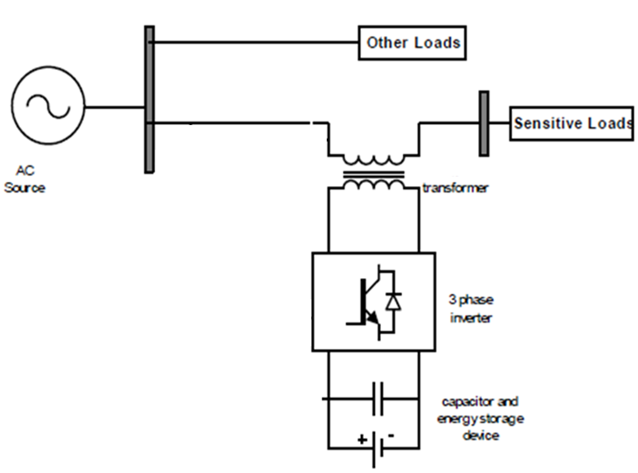
Figure.1 DVR Configuration
The DVR is a device that is associated in series to remove voltage sag. The dynamic voltage restorer solutions for the supply voltage issue by injecting a voltage series into the line, resulting in distortion-free voltage at the load terminal. The subsequent equation illustrates the series converters.
V_{injected}(ωt) = V_{Load}(ωt) – V_{Source}(ωt) (1)
V_{Injected}(t), V_{Load}(t), and V_{Source}(t) are the voltage to be added, load side voltage, and genuine supply voltage of a series converter, respectively."Figure 1.shows the configuration of DVR. The DVR is separated into two sections: a) The power circuit and PI controllers, and b) Circuit that to be controlled. The main circuit i.e. Power is made up of a voltage source converter (VSC), a series linked booster transformer, a passive filter, and some storing energy devices. The DVR circuit is used to compute the responses of the control signal that should be injected from side to side DVR, such as amplitude, frequency, and phase shift. In response to this control signal, the main part of circuit is use for injection of voltage. To remain the load side voltage to susceptible loads within safe limits, the DVR compensates for voltage sag. The DVR is designed to eliminate voltage sag of varying magnitudes for varying durations. Because the delta-star transformer connection in the distribution system does not permit zero sequence voltage to pass through, only positive sequence voltage restoration and negative sequence voltage compensation are essential. The Voltage source Converter employs an insulated gate. i.e. Thyristors are used. It is fueled by an power source and uses an inverter to produce modified Sinusoidal voltage. The filter suppresses switching harmonics and corrects the compensated voltage to be injected. An insertion transformer connected in sequence with the distribution line connects the DVR to the system. The three single phase insertion transformer is used to insert voltage into PCC that is not present. This study's major purpose is to adjust for both symmetrical and unsymmetrical voltage sags.
DC CAPACITOR SELECTION
The value of dc capacitance is selected on the basis of amount of transient energy required when the load varies. The energy stored in the capacitor is used to meet the energy demand of the load for a fraction of the power cycle.[18]
(½){C_{DC}(V²_{DC} –V²_{DC1})}=3V_{f}I_{f} ∆t (4)
Where V_{DC} is the rated voltage, V_{DC1} is the voltage drop allowed during the transient, t is the time required for support, and C_{DC} is the DC bus capacitance.

CONTROL ALGORITHM AND METHDOLOGY
In this part the suggested control technique for the DVR. As demonstrated in figure. 2, the UVTG technique is employed to regulate the DVR in the controlled block diagram DVR in order to provide a reference voltage signal.[2][3][4]
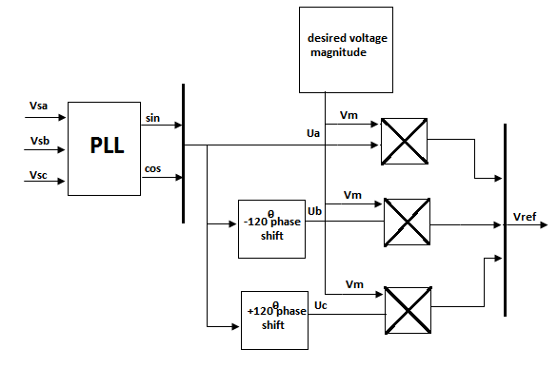
Figure. 2 shows a Overall Control Algorithm
Voltage between the PCC and the load side voltage is controlled by the series filter component (DVR) such that it is balanced, distortion-free, and maintains the appropriate range. The input voltage may be not proper, or power quality problems may exist on the system. To produce the controlled voltage signal by UVTG, the input supply voltage is measured and multiplied by gain equal to 1/Vm ( Vm is the maximum value of the reference voltage ). The PLL is used to coordinate the supply voltage. The equation below shows how to use UVTG and a PLL to generate a three-phase voltage reference signal for a series APF. Three-phase voltage is distorted. Voltages are sensed and sent through a PLL, which generates two quadrature unit vectors (sin_{w}t and cos_{w}t). The in-phase sine and cosine outputs of the PLL are used in equation to compute the supply in phase, 120º displaced three unit vectors (ua,ub, uc) as follows:

(2)
The three-phase reference voltages are obtained by multiplying with Ua ,Ub, Uc by the needed peak value of the phase voltage (Vm).
(3)
338 Volts is the required maximum range of voltage under consideration. The calculated voltages from the reference voltages from Equation (2) are then feed into the comparator device, together with the sensed three phase load voltages. In this way error signal is generated.
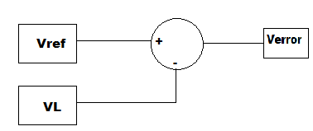
Figure 3: Error signal generation
.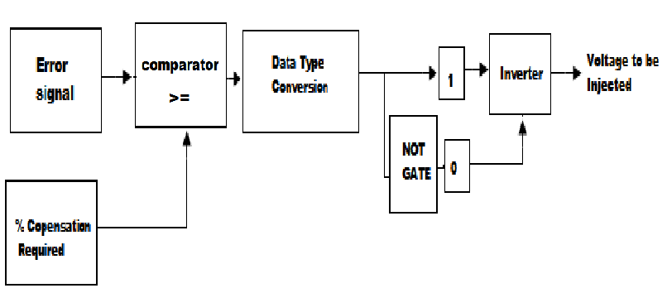
Figure.4 creating pulses to triggered the Gate
Above figure shows the creation of pulses from an error indication as well as the required corrected to be needed. The error signal is compared to the needed % correction, and the output data type is changed with respective required logic. The consistent operation of the signal generates the required pulses for the inverter, which get required correction in the system voltage.
Control algorithm
This controlled algorithm perform the operations like voltage sag detection , various distortion, and harmonics in the system; calculated the voltage correction; generating pulses for triggering the inverter to the PWM-based DC-AC inverter; correcting any anomalies in the series voltage injection; and terminating the trigger pulses when the event has passed. The controller can also be used to convert the DC-AC inverter into rectifier mode and charge the capacitors in the DC energy link in the absence of voltage sags. The control strategy proposed for the system is based on a comparison of a voltage reference and the measured terminal voltage (Va, Vb, Vc).When the supply falls below a particular threshold, voltage sags are detected at 20% of the reference voltage.The error signal is used as a modulation signal to generate a commutation pattern for the voltage source converter's power switches (IGBTs). The commutation pattern is formed using The sinusoidal pulse width modulation (SPWM) technique; the modulation controls voltages. The phase locked loop circuit is intended to produce a single alternating current wave In-phase with the system voltage.
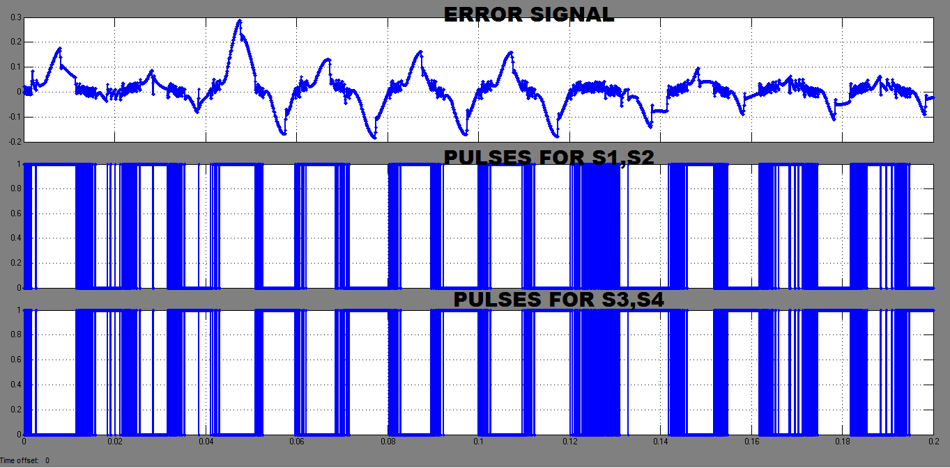
Figure 5: required Pulses for triggering
The comparator creates switching waveform for Series filters. It generates the essential signals for swathing to convert the voltage signal at system to the suitable reference voltage. Consequently, the ripple filter voltage applied to the series transformer effectively eliminates both balanced and unbalanced voltage sags within the power supply.
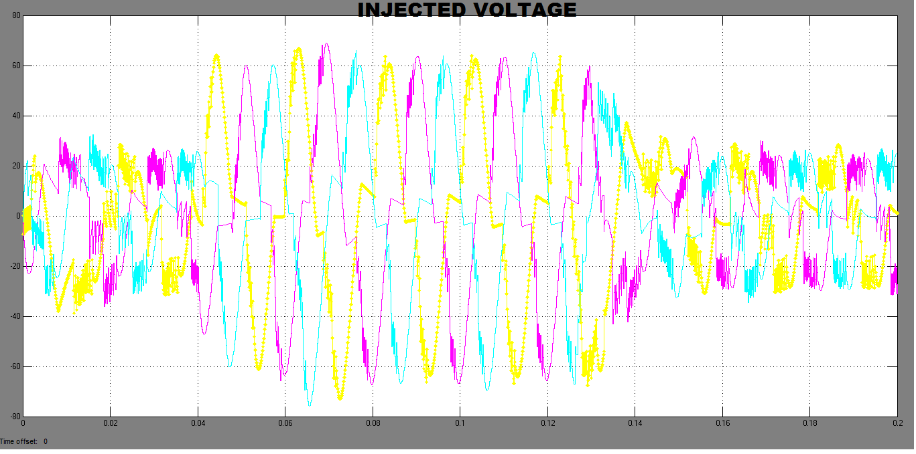
Figure 6: Output of transformer

Above displays the voltage signal that will be inserted in series with the load voltage signal. The injected voltage is the somewhat sine wave voltage induced by winding inductance of transformer.

IV. RESULTS AND SIMULATION MODELLED
Simulation and results for DVR voltage sag correction using a proposed technique is approach. The UVTG control technique was used to evaluate two situations for the DVR, which are listed below usning MATLAB software.
Result 1: Mitigation of 20% Voltage sag from all three Phases.
Sag is usually caused by faults or the start of a sudden significant load. The system under consideration as follow.

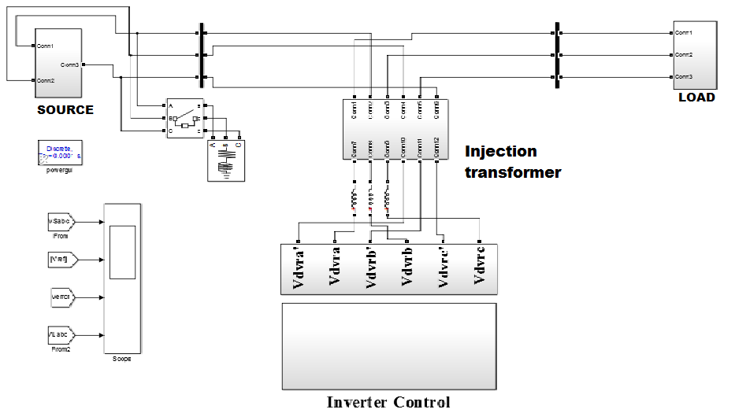
Figure 7 system Under Consideration

The below figure shows the results of 20 percent supply balance voltage sag developed in every phases due to addition of non linear load at 0.04 Second and reduce at 0.12 second displayed in below results. The DVR is in operation and insert the required sag voltage during the disturbance when the supply voltage sag occurs at 0.04 second.

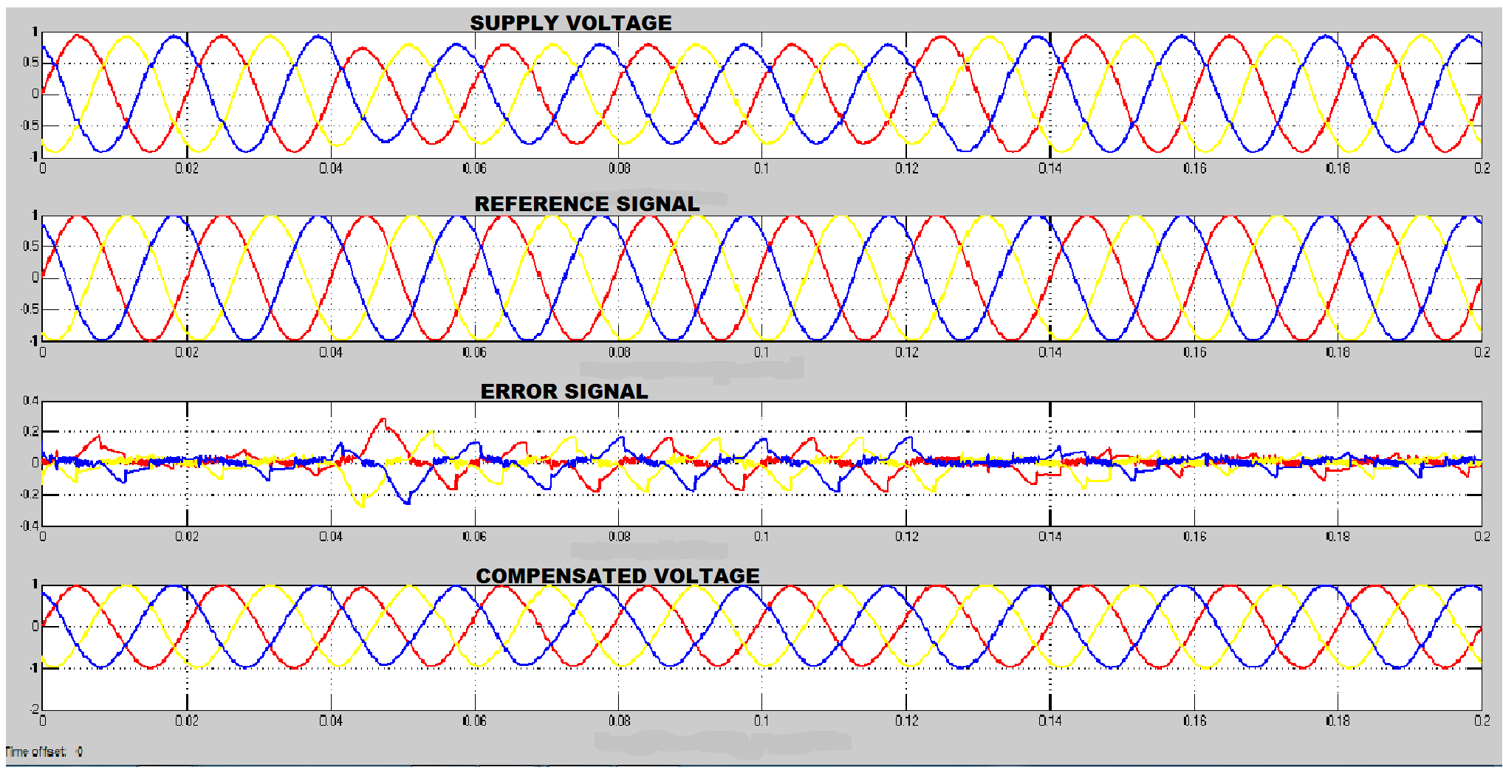

Case I simulation and results are shown in Fig. 8.
System Voltage | Sag | Inserted  voltage | Mitigated voltage
415.00Volts | 0.2 per unit | 0.2 | 1 per unit

Table 1: Case I Observed Output

Result 2: 25% Voltage sag in three phases.
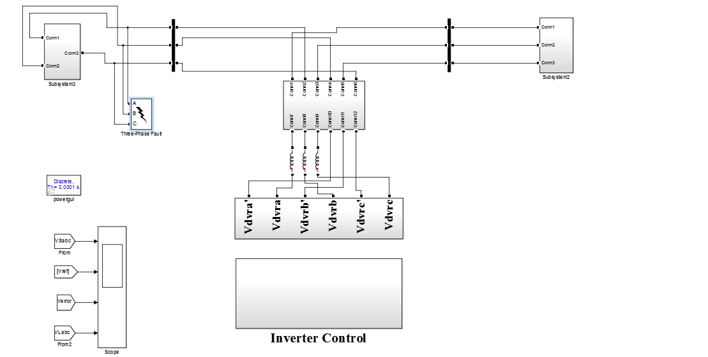
Figure 9 System Under Study

The below figure shows that a 25 Percent Source voltage sag is developed by a LLL-G Fault for the duration of 0.08 second is given in the figure. When the supply voltage reduces, the DVR comes into the actions and compensate the required voltage.

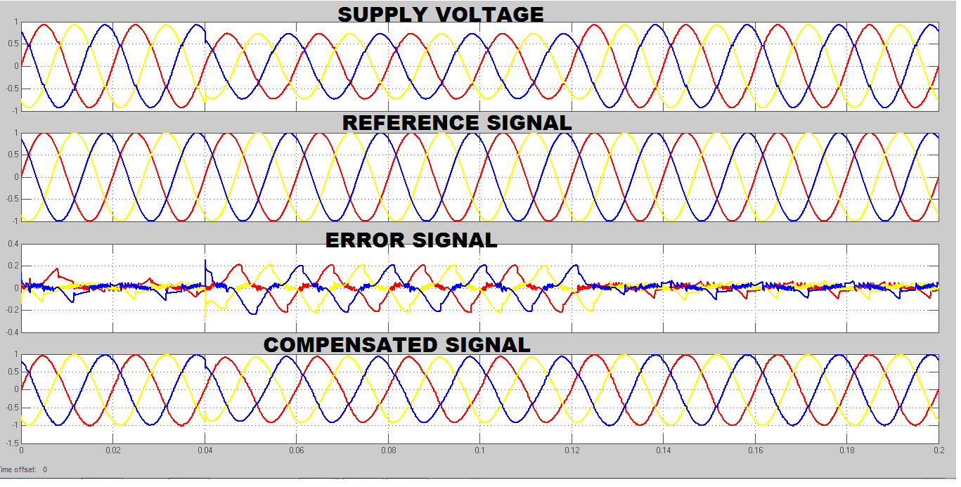

Figure 11 Signals of simulated results.

System Voltage | Sag | Inserted Voltage | Compensated voltage
415Volts | 0.25 per unit | 0.125*2 | 1 per unit

Table 2: Case II Observed Output.

Result 3: 25 Percent sag compensation in R phase.
The below figure shows that 25 percent sag is developed by L-G faults for the duration of 0.08 Second, then the DVR comes into the action and will inject the required magnitude when sag happened at 0.04 second

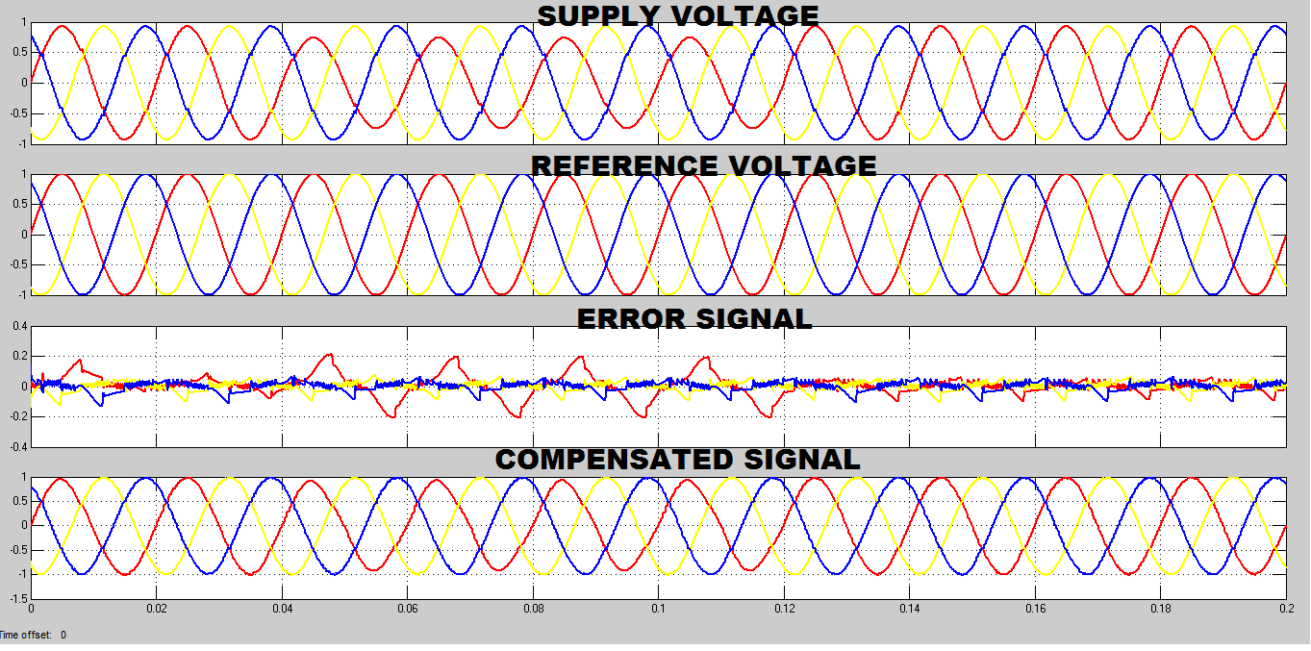
Figure 12: waveform of Results 3.
System Voltage | Sag | Inserted  voltage | Compensate  Voltage
415.00Volts | 0.25 per unit | 0.125*2 | 1 per unit

Table 3: Output Seen

It is demonstrated in both cases that the voltage injected by the inverter equals 1- (Error Voltage) = Sag in per Unit

V. Conclusion
The designing and MATLAB results of a DVR is describe. A projected control algorithm for DVR based on UVTG. The proposed control approach was put to the check using MATLAB models. The results show that the DVR performs adequately in terms of minimizing Power Quality disturbances. The Observations also disclose that the DVR adjusts prompt to sags and has immense voltage directive. The DVR can effortlessly handle various situations of disturbances and compensate the essential voltage component to swiftly rectify any cause in the source voltage for clearing the power quality disturbances.

REFERENCES

- Rosli Omar and Nasrudin Abd Rahim “Mitigation of voltage sag/swell by using DVR” ARPN Journal of Engineering and Applied Sciences, vol. no 4, June 2009.

- Bhim Singh and venkateswarlu.P “A simplified control algorithm for three-phase , four wire unified power quality conditioner” Presented at journal of power electronics ,vol no.1, January 2010

- S. N. Gohil, M.V.Makwana, K.T. Kadivar,G.J.Tetar “Three phase unified power quality conditioner(UPQC) for power quality improvement using UVTG Technique” 2013 International conference on renewable energy and sustainable energy [ICRESE’13].
- B.Singh, a chandra and k al haddad “review of active filters for power quality improvement” IEEE trans. Industrialelectronics,vol 46, No 5,pp.960-97, oct. 1999
- IEEE Std. 1159 – 1995, “Recommended Practice for Monitoring Electric Power Quality”.
- Vijay Karale and Saurabh jadhao “voltage sag mitigation using dynamic voltage restorer” proceeding of 2nd international conference on innovative in electrical & electronics engineering (ICIEE)., No.184, Aug 2015.
- P.Boonchiam and N. Mithulananthan, Thammasat “Understanding of Dynamic Voltage Restorers through MATLAB Simulation,” Int. J. Sc. Tech., Vol. 11, No. 3, July-Sept 2006.
- J. G. Nielsen, M. Newman, H. Nielsen,and F. Blaabjerg, “Control and testing of a dynamic voltage restorer (DVR) at medium voltage level,” IEEE Trans.Power Electron., vol. 19, no. 3,p.806, May 2004.
- Ghosh and G. Ledwich, “Power Quality Aamir Hanif, Mohommad Ahmed Choudhary,and Tahir Mehmood “Feed-Forward Control Strategy for the VSC of DVR for Smooth and Clean Power Flow to Load”.
- Hideaki Fujita and Hirofumi Akagi, “The Unified Power Quality Conditioner”, IEEE transaction on power electronics, VOL. 13, NO. 2, MARCH 1998
- H. Awad, J.Svensson, M. Bollen, “Mitigation of Unbalanced Voltage Dips Using Static Series Compensator”, IEEE Trans. On Power Elec., Vol. 19, No. 13, May 2004
- Hochgraf, R. Lasseter, “Statcom controls for Operation with Unbalanced Voltages”, IEEE Trans. On Power delivery, Vol. 13, No. 2, April 1998.
- Gunther, E.W., Mehta, H.: A survey of distribution system power quality. In: IEEE Trans. on PowerDelivery, vol.10 (1995), No.1, Jan.1995, pp.322-329.
- IEEE recommended Practices and Recommendations for harmonics Control in Electric Power Systems. In:IEEE std.519, 1992.
- Kotwal, C., Pillai, G. N., Gupta, H. O.: Modeling and Simulation of Different Topologies for VSI Based Static Synchronous Series Compensator. In: JEE, Vol.10(2010), Edition-4.
- H. Hingorani “Introducing custom power” IEEE spectrum, vol.32 no.6,June 1995 p 41- 48.
- Bhim Singh ,Amrish Chandra And Kamal AL-Haddad “Power quality problems and mitigation techniques” Published by 2015 John Wiley & Sons,Ltd

