ANTIMICROBIAL ACTIVITY OF SILVER NANOPARTICLES AND ACTION AGAINST MICROBS
Yukti Dewangan^{1*} Dr Radha Krishnan^{2*} Dr Piyush Kumar Thakur^{3*}
^{1&2*} School of Sciences, MATS University, Raipur (CG) India
^{3*}Faculty of Science and Technology, ICFAI University, Raipur (CG) India
Email: yuktidewangan99@gmail.com¹, radhakrishnan2200@gmail.com² piyush.thakur25@gmail.com³

Abstract -Currently, treating infectious diseases caused by microorganisms resistant to antibiotics is a huge concern for the entire globe. Finding alternate methods to cure diseases caused by resistant infections are urgently needed. And the Well-known and effective antibacterial agents are silver nanoparticles. This overview incorporates a retrospective of earlier reviews that have been written as well as recent unique contributions on the development of research on the antibacterial mechanisms of silver nanoparticles. The important subjects covered include bacterial resistance, cell membrane damage, DNA interaction, free radical production, release of Ag nanoparticles and silver(Ag) ions, and the link between resistance to silver ions and resistance to silver nanoparticles. The overview's main objective is to provide a concise summary of the current state of research on the antibacterial properties of silver nanoparticles.
Keywords: Silver nanoparticles, nanotechnology, antimicrobial activity, antimicrobial mechanism, Bacterial resistance.

- Introduction

By manipulating shape and size at a nanoscale (1 nm to 100 nm), nanotechnology is described as the design, characterization, and application of structures, devices, and systems. It is a novel area of study with many scientific and technological uses, especially for developing new materials¹. Recent years have seen the emergence of nanotechnology as a fast expanding subject with several biomedical research applications. Silver has also been used as a disinfectant and antibacterial agent that is generally devoid of side effects. A several types of Antimicrobial activities are present in silver nanoparticles. Silver nanoparticles typically have sizes of less than 100 nm and contain 20 to 15,000 Ag atoms. even at low concentrations Silver nanoparticles have unique antibacterial action due to a high surface-to-volume ratio². Additionally, they have minimal costs, low cytotoxicity, and immunological response³. As a result, there are several potential biomedical uses of AgNPs. They are utilised for molecular diagnosis, medical imaging, and medication administration⁴. AgNPs have been promoted as an effective antibacterial agent that can fight bacteria that cause illnesses both in vitro and in vivo. Gram-ve and Gram +ve bacteria, including multidrug resistant strains, are all covered by AgNPs' antibacterial ability. The capacity of AgNPs to kill different kinds of bacteria is a result of their varied modes of action, which permit them to target germs in many structures at once. AgNPs exhibit several simultaneous modes of action, and when combined with antibiotics or other biological substances that fight bacteria, they have a synergistic impact on pathogens like E. coli and Staphylococcus aureus⁵. AgNPs have attracted a lot of attention, as shown by the significant demand for and investment in associated research. With an estimated 500 tonnes of nanoparticles produced annually in order to satisfy the demands of various sectors, the market for AgNPs has been continuously expanding over the past 15 years⁶. The research of their biological activity and the explanation of their precise methods of action in bacterial and animal cells, has become a topic of concern due to the rise of the nanoparticle market globally and the present offer of goods with included nanoparticles⁷. This analysis aims to identify factors that affect the antimicrobial and toxic effects of Silver NPs, as well as to highlight the benefits of using AgNPs as new antimicrobial agents in addtion with antibiotics, which will deduct the dosage necessary and prevent secondary effects.

2. Antimicrobial Mechanism of Silver Nanoparticle –
AgNPs have been demonstrated strong antibacterial properties against both Gram+ve and Gram -ve bacteria⁸. Silver nanoparticles can enter bacterial cell walls, affecting the composition of cell membranes and potentially causing cell death⁹. They can create reactive oxygen species, make cellular membranes more permeable, and inhibit the duplication of DNA by releasing Ag ions⁹. Respiratory enzymes may become inactive following the uptake of free silver ions into cells, generating reactive oxygen species but inhibiting adenosine triphosphate production¹⁰. Reactive oxygen species have the potential to play a major role in the damage of cellular membranes and DNA alteration. Since sulphur and phosphorus are crucial DNA building blocks, the dealing of Ag ions with these elements can interfere with DNA replication, inhibit cell growth, or even cause the death of microorganisms. Silver ions can stop the production of proteins by unfolding cytoplasmic ribosomes¹¹.
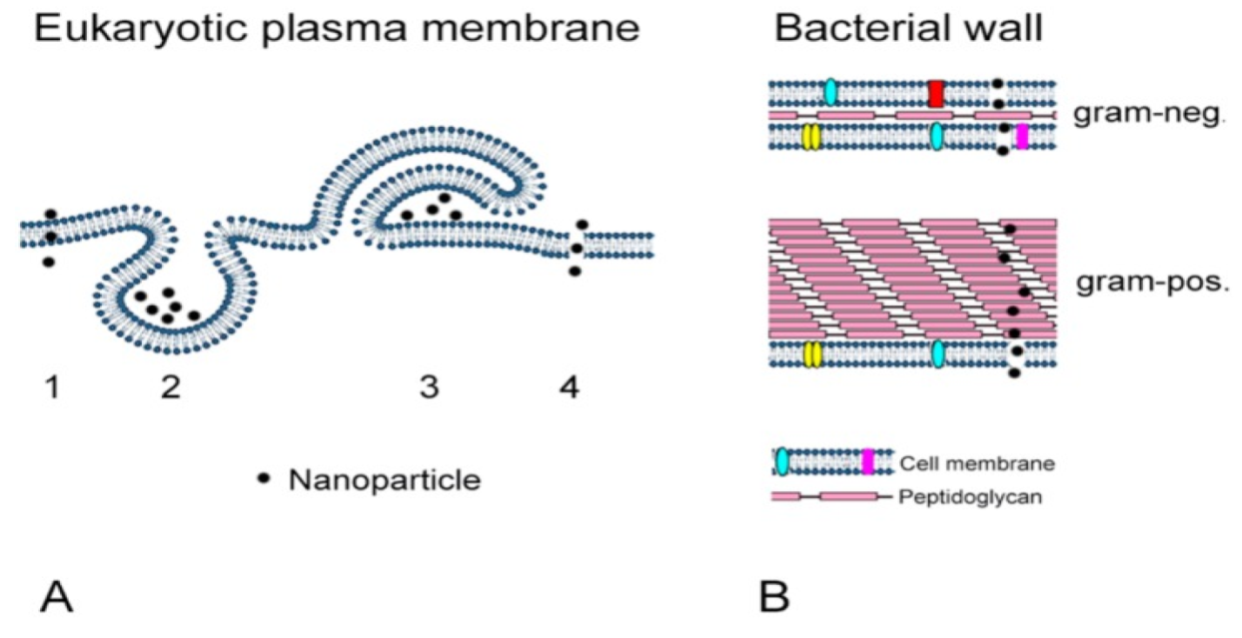

Fig 1. – Uptake of AgNPs by mammalian cells (A) and by bacteria (B). (A) AgNPs can cross the plasma membrane by diffusion (1), endocytotic uptake (2,3), and disruption of membrane integrity (4). (B) AgNPs permeate the cell walls of gram-negative and gram-positive bacteria. Reproduced from [36], MDPI under the Creative Commons Attribution License. (Source - Bactericidal and Cytotoxic Properties of Silver Nanoparticles by Chengzhu Liao, Yuchao Li et;al)

Denaturation of the cellular membrane has the potential to split organelles and possibly cause cell lysis. AgNPs can also perform role in the transduction of bacterial signals. Protein substrate phosphorylation affected bacterial signal transmission, and tyrosine residues on peptide substrates can be dephosphorylated by nanoparticles. Cell apoptosis and stop of cell division can result from signal transduction disruption¹². The level of silver nanoparticle dissolution in exposure medium significantly impacts the antibacterial action and mechanism. The intrinsic features of AgNPs and the medium in which they are dispersed affect how well they dissolve¹³. Due to their increased surface area, smaller spherical or quasi-spherical AgNPs are more likely to release silver¹⁴. The surface of AgNPs is modified by capping agents, which can impact their dissolution behavior¹⁵. The presence of organic or inorganic components in the media can affect the dissolution of silver nanoparticles because they can aggregate with silver nanoparticles or mix with silver ions. In an acidic solution, silver nanoparticles release silver ions more quickly than in a neutral solution¹⁶.
Silver nanoparticles are more effective against Gram-negative bacteria. Gram -ve bacteria have a thinner cell wall than gram-positive ones. The strong cellular membrane may prevent nanoparticles from entering cells¹⁷. The distinct antibacterial responses of gram+ve and gram-ve bacteria to silver nanoparticles show that the uptake of AgNPs is essential to the antibacterial action¹³. It is known that Silver nanoparticle smaller than 10 nm have the potential to penetrate bacterial cells, change cell permeability directly, and harm cells.
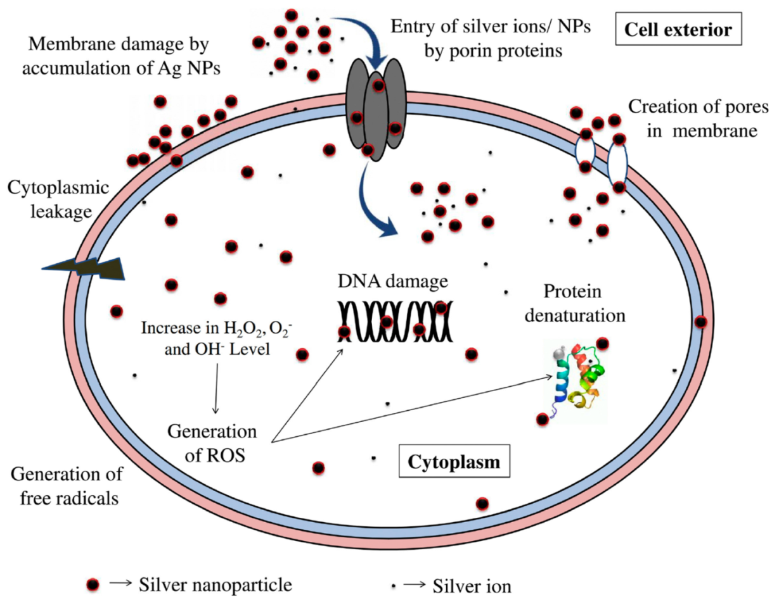

Fig 2. - Bactericidal mechanisms of AgNPs due to their direct contact with the bacterial cell wall and the release of silver ions. ( Source -Bactericidal and Cytotoxic Properties of Silver Nanoparticles by Chengzhu Liao, Yuchao Li et;al)

AgNPs as a Distinct Method of Fighting Human Pathogenic Bacteria;

Silver nanoparticles have proven to be a viable choice for killing certain bacteria. Additionally to being capable to stop the development of multidrug-resistant strains, Silver nanoparticle have certain qualities that make them effective against these bacteria¹⁸⁻¹⁹. Silver is the most effective metallic NPs against microorganisms. Additionally, silver is very biocompatible and simple to use in medicinal applications²⁰. Another feature is that its antibacterial effect has been suggested to be mediated by a variety of mechanisms, some of which are thought to act on the cell membrane, influence intracellular components, and change the respiratory chain²¹. This final one is viewed as important for bacteria to become resistance against Silver nanoparticles, They would've been able to engage in numerous concurrent attacks. These reasons are why AgNPs have also been marketed as an alternative to antibiotics.²²⁻²³.

Using AgNPs in addition with antibiotics, functionalizing or conjugating AgNPs with other molecules has also been suggested as a successful option to achieve significant bactericidal activity without causing the development of bacterial resistance²⁴. Ashmore et al. [74] investigated the antibacterial efficiency of uncoated Silver nanoparticles vs coated Silver nanoparticles with PVP (Ag + PVP) and with a synthetic polymer (Ag + Polymer) against E. coli with the aim of testing this concept. Growth inhibition and MIC test findings revealed that Ag + Polymer was twice as effective as Silver nanoparticles²⁵⁻²⁶ . Given the history described above, which is summarised in Table 1, there are still a number of benefits to using nanoparticles to combat germs.

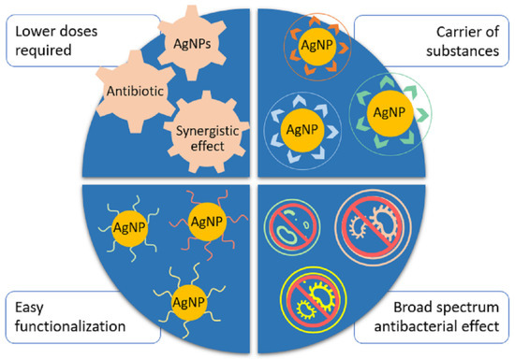

Fig 3.- Advantages of using AgNPs in combination or as an alternative to antibiotics.(Source; Tamara Bruna , Francisca Maldonado-Bravo, Paul Jara and Nelson Caro; Silver Nanoparticles and Their Antibacterial Applications)

Antibiotic used with AgNPs | Bacteria tested | Antibacterial parameters | Reference
Erythromycin, ampicillin, chloramphenicol, cephalothin | Multiresistant S. aureus, S.mutans, S.oralis, S. gordonii, Enterococcus faecalis, E. coli | When coupled with AgNPs, antibiotics' antibacterial activity increased synergistically from no growth inhibition into the vulnerable range | 27
Vancomycin, ampicillin, penicillin | S. aureus, E.coli, K pneumoniae | Ampicillin conjugated with AgNPs is efficient against all microorganisms. When conjugated with AgNP, all antibiotics will have increased antibacterial activity. | 28
Azlocillin | P. aeruginosa | The antibacterial activity of AgNPs conjugated with azlocillin increased from MIC = 8 ppm for azlocillin alone to MIC = 4 ppm AgNPs + azlocillin. | 29
Vancomycin, amikacin | E. coli, S. aureus | Antibiotic-functionalized AgNPs shown synergistic antibacterial activity. Vancomycin resistance to susceptibility in the instance of E. coli. | 30

Table 1. AgNPs combined with Antibiotics and their antibacterial parameters.

Antimicrobial AgNPs in healthcare application - The fields of medicare and health are those where antimicrobial nanoparticle technology is being researched and developed the most³¹⁻³². Silver nanoparticle may be applied to many products with bactericidal properties due to their biocompatibility and rapid functionalization. The usage of AgNPs in face masks to enhance their level of protection is one of their primary uses. The face mask invented by Y. Li et al.³³ that was coated with nanoparticles made from titanium dioxide and silver nitrate shown the capacity to eliminate up to 100% of E. coli and S. aureus CFU within 24 hours. Similar research involved treating a industrially available mask with solutions of AgNPs at 50 and 100 ppm concentration, producing masks with intigrated nanoparticles that may stop the development of E. coli and S. aureus³⁴. These findings are extremely encouraging since face masks enhanced with AgNPs might prevent infections in settings like hospitals where harmful bacteria are persistent in high levels³⁵. additionally the silver's antibacterial action, studies on its healing characteristics and its nanoparticles have led to the expansion of a variety of wound dressings with improved healing and antimicrobial effects. In order to treat superficial wounds, Tian et al.³⁶ applied a solution of AgNPs. They discovered that this therapy helped the wounds heal more quickly and with greater skin regeneration. Due to this identical characteristic, research led to the synthesis of a topical AgNPs solution for treatment on burns and other skin lesions. The outcome was a establishment antibacterial activity without harmful side effects and the capacity to accelerate the healing of wounds³⁷. Additionally, research has been done on the possibility of improving antibacterial action by combining AgNPs with organic compounds. For instance, lignin and polyvinyl alcohol were used to formulate a hydrogel which contained in-situ synthesised AgNPs. The synthesised compound shown strong antimicrobial activity against S. aureus and E. coli, after 10 hours of treatment, practically all bacteria had been killed³⁸.

Conclusion - AgNPs are an amazing antimicrobial agent and currently have excellent antibacterial properties. They address a number of the requirements that are thought to be necessary for new antimicrobial technologies to meet in must be in order to effective, including antimicrobial performance, fast action, and low cytotoxicity. Moreover, Nanoparticles can be altered to achieve selectivity and delivery to certain targets. Their usage against microorganisms must be controlled and assessed to prevent inappropriate exposure of pathogens to sublethal dosages that may encourage the emergence of toleration to this against. Utilising AgNPs minimises the dosages of antibiotic and nanoparticle needed to exert efficient antibacterial activity opposed to variety of bacteria, reducing the possibility of adverse effects. In addition, NPs can be functionalized with various molecules to enhance their antibacterial effect, and they exert antimicrobial activity on a variety of different bacterial types, including Gram+ve and Gram-ve bacteria, as well as resistant strains. Nanoparticles can form complexes can operate as drug carriers or antibiotics. This research highlights the antibacterial mechanism, potential, and possible medicinal uses of silver nanoparticles and offers an overview of their antibacterial usage.

Reference –
- Kesharwani P, Gorain B, Low SY, et al. Nanotechnology based approaches for anti-diabetic drugs delivery. Diabetes Res Clin Pract. 2018;136:52–77. doi:10.1016/j.diabres.2017.11.018
- Oves M, Aslam M, Rauf MA, et al. Antimicrobial and anticancer activities of silver nanoparticles synthesized from the root hair extract of Phoenix dactylifera. Materials Science and Engineering: C. 2018;89:429–443. doi:10.1016/j.msec.2018.03.035
- Samuel MS, Jose S, Selvarajan E, Mathimani T, Pugazhendhi A. Biosynthesized silver nanoparticles using Bacillus amyloliquefaciens application for cytotoxicity effect on A549 cell line and photocatalytic degradation of p-nitrophenol. J Photochem Photobiol. 2020;202:111642
- Pugazhendhi A, Edison TNJI, Karuppusamy I, Kathirvel B. Inorganic nanoparticles: a potential cancer therapy for human welfare. Int J Pharm. 2018;539(1–2):104–111. doi:10.1016/j.ijpharm.2018.01.034.
- Bruna, T.; MaldonadoBravo, F.; Jara, P.; Caro, N. Silver Nanoparticles and Their Antibacterial Applications. Int. J. Mol. Sci. 2021, 22, 7202. https://doi.org/10.3390/ ijms22137202.
- Yaqoob, A.A.; Umar, K.; Ibrahim, M.N.M. Silver nanoparticles: Various methods of synthesis, size affecting factors and their potential applications—A review. Appl. Nanosci. 2020, 10, 1369–1378.
- Ferdous, Z.; Nemmar, A. Health impact of silver nanoparticles: A review of the biodistribution and toxicity following various routes of exposure. Int. J. Mol. Sci. 2020, 21, 2375.
- Cavassin, E.D.; de Figueiredo, L.F.P.; Otoch, J.P.; Seckler, M.M.; de Oliveira, R.A.; Franco, F.F.; Marangoni, V.S.; Zucolotto, V.; Levin, A.S.S.; Costa, S.F. Comparison of methods to detect the in vitro activity of silver nanoparticles (AgNP) against multidrug resistant bacteria. J. Nanobiotechnol. 2015, 13, 1–16.
- Iris Xiaoxue Yin, Jing Zhang, Irene Shuping Zhao , May Lei Mei, Quanli Li, Chun Hung Chu; The Antibacterial Mechanism of Silver Nanoparticles and Its Application in Dentistry 2020:15 2555–2562.
- Ramkumar VS, Pugazhendhi A, Gopalakrishnan K, et al. Biofabrication and characterization of silver nanoparticles using aqueous extract of seaweed Enteromorpha compressa and its biomedical properties. Biotechnol Rep. 2017;14:1–7. doi:10.1016/j.btre.2017. 02.001.
- Durán N, Nakazato G, Seabra A. Antimicrobial activity of biogenic silver nanoparticles, and silver chloride nanoparticles: an overview and comments. Appl Microbiol Biotechnol. 2016;100(15):6555–6570. doi:10.1007/s00253-016-7657-7
- Li L, Li L, Zhou X, et al. Silver nanoparticles induce protective autophagy via Ca 2+ /CaMKKβ/AMPK/mTOR pathway in SHSY5Y cells and rat brains. Nanotoxicology. 2019;13(3):369–391. doi:10.1080/17435390.2018.1550226.
- Noronha VT, Paula AJ, Durán G, et al. Silver nanoparticles in dentistry. Dent Mater. 2017;33(10):1110–1126. doi:10.1016/j.dental.2017.07.002
- . Shanmuganathan R, MubarakAli D, Prabakar D, et al. An enhancement of antimicrobial efficacy of biogenic and ceftriaxone-conjugated silver nanoparticles: green approach. Environ Sci Pollut Res Int. 2018;25 (11):10362–10370. doi:10.1007/s11356-017-9367-9
- . Khorrami S, Jafari F, Zarrabi A, Zarepour A. Is Astragalus gossypinus honey a natural antibacterial and cytotoxic agent? An investigation on A. gossypinus honey biological activity and its green synthesized silver nanoparticles. Bionanosci. 2018;9(3):603–10
- Jacob JM, John MS, Jacob A, et al. Bactericidal coating of paper towels via sustainable biosynthesis of silver nanoparticles using ocimum sanctum leaf extract. Bactericidal Coat Pap Towels Sustainable Biosynth Silver Nanopart Ocimum Sanctum Leaf Extr. 2019;6(4):045401.
- Meikle T, Dyett BP, Strachan JB, White J, Drummond CJ, Conn CE. Preparation, characterization, and antimicrobial activity of cubosome encapsulated metal nanocrystals. ACS Appl Mater Interfaces. 2020;12(6):6944–6954. doi:10.1021/acsami.9b21783.
- Lee, N.Y.; Ko, W.C.; Hsueh, P.R. Nanoparticles in the treatment of infections caused by multidrug-resistant organisms. Front. Pharmacol. 2019, 10, 1153.
- Saeb, A.T.M.; Alshammari, A.S.; Al-Brahim, H.; Al-Rubeaan, K.A. Production of silver nanoparticles with strong and stable antimicrobial activity against highly pathogenic and multidrug resistant bacteria. Sci. World J. 2014
- Ivask, A.; Elbadawy, A.; Kaweeteerawat, C.; Boren, D.; Fischer, H.; Ji, Z.; Chang, C.H.; Liu, R.; Tolaymat, T.; Telesca, D.; et al. Toxicity mechanisms in Escherichia coli vary for silver nanoparticles and differ from ionic silver. ACS Nano 2014, 8, 374–386
- Dakal, T.C.; Kumar, A.; Majumdar, R.S.; Yadav, V. Mechanistic basis of antimicrobial actions of silver nanoparticles. Front. Microbiol. 2016, 7, 1831
- Baptista, P.V.; McCusker, M.P.; Carvalho, A.; Ferreira, D.A.; Mohan, N.M.; Martins, M.; Fernandes, A.R. Nano-strategies to fight multidrug resistant bacteria—“A Battle of the Titans”. Front. Microbiol. 2018, 9, 1141.
- Cheeseman, S.; Christofferson, A.J.; Kariuki, R.; Cozzolino, D.; Daeneke, T.; Crawford, R.J.; Truong, V.K.; Chapman, J.; Elbourne, A. Antimicrobial Metal Nanomaterials: From Passive to Stimuli-Activated Applications. Adv. Sci. 2020, 7, 837–842
- Brown, A.N.; Smith, K.; Samuels, T.A.; Lu, J.; Obare, S.O.; Scott, M.E. Nanoparticles functionalized with ampicillin destroy multiple-antibiotic-resistant isolates of Pseudomonas aeruginosa and Enterobacter aerogenes and methicillin-resistant Staphylococcus aureus. Appl. Environ. Microbiol. 2012, 78, 2768–2774
- Ashmore, D.; Chaudhari, A.; Barlow, B.; Barlow, B.; Harper, T.; Vig, K.; Miller, M.; Singh, S.; Nelson, E.; Pillai, S. Evaluation of E. coli inhibition by plain and polymer-coated silver nanoparticles. Rev. Inst. Med. Trop. Sao Paulo 2018, 60, 1–11.
- Rezazadeh, N.H.; Buazar, F.; Matroodi, S. Synergistic effects of combinatorial chitosan and polyphenol biomolecules on enhanced antibacterial activity of biofunctionalaized silver nanoparticles. Sci. Rep. 2020, 10, 1–13.
- Ipe D.S., Kumar P. T. S., Love R.M., Hamlet S.M. Silver Nanoparticles at Biocompatible Dosage Synergistically Increases Bacterial Susceptibility to Antibiotics. Front. Microbiol. 2020;11:1074.doi:103389/fmicb.2020.01074.
- Ashmore, D.; Chaudhari, A.; Barlow, B.; Barlow, B.; Harper, T.; Vig, K.; Miller, M.; Singh, S.; Nelson, E.; Pillai, S. Evaluation of E. coli inhibition by plain and polymer-coated silver nanoparticles. Rev. Inst. Med. Trop. Sao Paulo 2018, 60, 1–11.
- Alizadeh, A.; Salouti, M.; Alizadeh, H.; Kazemizadeh, A.R.; Safari, A.A.; Mahmazi, S. Enhanced antibacterial effect of azlocillin in conjugation with silver nanoparticles against Pseudomonas aeruginosa. IET Nanobiotechnol. 2017, 11, 942–947.
- Kaur, A.; Kumar, R. Enhanced bactericidal efficacy of polymer stabilized silver nanoparticles in conjugation with different classes of antibiotics. RSC Adv. 2019, 9, 1095–1105.
- Yaqoob, A.A.; Umar, K.; Ibrahim, M.N.M. Silver nanoparticles: Various methods of synthesis, size affecting factors and their potential applications—A review. Appl. Nanosci. 2020, 10, 1369–1378
- Vimbela, G.V.; Ngo, S.M.; Fraze, C.; Yang, L.; Stout, D.A. Antibacterial properties and toxicity from metallic nanomaterials. Int. J. Nanomed. 2017, 12, 3941–3965
- Li, Y.; Leung, P.; Yao, L.; Song, Q.W.; Newton, E. Antimicrobial effect of surgical masks coated with nanoparticles. J. Hosp. Infect. 2006, 62, 58–63
- Hiragond, C.B.; Kshirsagar, A.S.; Dhapte, V.V.; Khanna, T.; Joshi, P.; More, P.V. Enhanced anti-microbial response of commercial face mask using colloidal silver nanoparticles. Vacuum 2018, 156, 475–482.
- Valdez-Salas, B.; Beltran-Partida, E.; Cheng, N.; Salvador-Carlos, J.; Valdez-Salas, E.A.; Curiel-Alvarez, M.; Ibarra-Wiley, R. Promotion of Surgical Masks Antimicrobial Activity by Disinfection and Impregnation with Disinfectant Silver Nanoparticles. Int. J. Nanomed. 2021, 16, 2689–2702
- Tian, J.; Wong, K.K.Y.; Ho, C.M.; Lok, C.N.; Yu, W.Y.; Che, C.M.; Chiu, J.F.; Tam, P.K.H. Topical delivery of silver nanoparticles promotes wound healing. ChemMedChem 2007, 2, 129–136
- Jain, J.; Arora, S.; Rajwade, J.M.; Omray, P.; Khandelwal, S.; Paknikar, K.M. Silver Nanoparticles in Therapeutics. Mol. Pharm. 2009, 6, 1388–1401
- Li, M.; Jiang, X.; Wang, D.; Xu, Z.; Yang, M. In situ reduction of silver nanoparticles in the lignin based hydrogel for enhanced antibacterial application. Colloids Surf. B Biointerfaces 2019, 177, 370–376

