Application of Polyethylene glycol (PEG) as an additive in Drilling Fluids in oil and gas industries
Ananya Dutta ¹, Leema Deori ¹, Supriya Deori ¹, Barkha Saikia ², Gargi Ananya Boruah ²,
Chayanika Bora ^{2*}, Borkha Mech¹

¹ Department of Petroleum Technology, Dibrugarh University, Dibrugarh, Assam, India
² Department of Petroleum Engineering, Dibrugarh University, Dibrugarh, Assam, India

Abstract
The goal of this study is to create an experimental procedure for blending polyethylene glycol (PEG) with drilling mud to create an environmentally friendly drilling fluid, measure the rheological characteristics, filtration characteristics, and density of drilling mud using the Fann VG Meter, Dead Weight Filter Press, and Mud Balance, respectively, and then create an ideal drilling fluid by analyzing various samples made with various molecular weights of PEG. The findings demonstrate that PEG can lower the cost of drilling fluid maintenance while also reducing filtration loss.

Keywords- Polyethylene Glycol (PEG), Rheology, Environment Friendly Drilling Fluid Additive, Lubrication Performance, Sloughing, Oil-Based Drilling Mud, Environmental Pollution
- Introduction
Drilling operations use additives for drilling fluid that are environmentally friendly to lessen the negative effects. Strong inhibition and high lubricity in the oil-based drilling mud help to effectively prevent sloughing and sticking. However, its drawbacks include high costs, environmental pollution, and logging quality issues. Although the water-based drilling mud does not have these issues, it has been hampered in its development by poor lubrication and high friction. Therefore, it is crucial to enhance the water drilling mud's lubrication performance in order to address the aforementioned issues.

  - Introduction to Drilling fluid and its application in oil industry

Drilling fluid helps stabilize the wellbore by exerting hydrostatic pressure against the formation walls. This prevents the collapse of the wellbore and maintains its integrity during drilling. Drilled cuttings produced during drilling are transported to the surface by drilling fluid. Drilling fluid is used to cool both the drill bit and the bottom hole assembly. Additionally, it lubricates, which lessens damage to the drilling machinery.
In order to help stop fluid loss into the formation, drilling fluid creates a filter cake on the wellbore wall. Geologists and petrophysicists can examine formation cuttings brought to the surface by drilling fluid to learn more about the subsurface formations, including their rock type, porosity, permeability, and hydrocarbon content. Drilling fluid may occasionally be used during hydraulic fracturing procedures to move proppants (such as sand) into the fractures and preserve wellbore stability while fracturing. For well control and kick prevention, drilling fluid is necessary. Kicks, or influxes of formation fluids, can happen during drilling and can be detected and controlled with the right monitoring and management of drilling fluid parameters, such as density and pressure.

1.2. Polyethylene Glycol and its importance as an additive:
PEG is a polyol, and its molecular diversity dictates the variety of compounds it can produce. It is extremely helpful in oil drilling because it has strong lubricating performance in addition to good shale inhibition performance. It has basic drilling mud buffer capacity in addition to lubricating and antifriction capabilities.
PEGs come in a variety of molecular weights, ranging from 300 g/mol to 20,000 g/mol, and are manufactured by polymerizing ethylene oxide. PEGs can be either liquids or low melting point solids, depending on their molecular weight. PEG and PEO (which stands for an oligomer) are the names given to ethylene oxide macromolecules with molecular weights less than 20,000 g/mol and more than 20,000 g/mol, respectively.
PEG has been found to be a treatment agent that complies fully with the development idea of water-based drilling mud and is both environmentally safe and biodegradable. Being a polymer that dissolves in water, PEG has established itself as a promising hydrate-inhibitive water-based drilling fluid. Thermodynamic hydrates are effectively inhibited by PEG, which is also less toxic and readily biodegradable [13] [14] [15]. It has been found that PEG reduces filtration loss and also reduces maintenance costs. Apart from the reduction of filtrate loss, the addition of PEG also helps improve the viscosity and density a bit. An ideal drilling fluid is one that shows less filtrate loss and forms a thin and tough mud cake [3]. In a study, the impact of PEG was assessed by examining the rheological and filtration characteristics of drilling fluid with various concentrations of PEG. It was discovered that with the addition of different PEG concentrations, the effects on the change in mud density are almost nonexistent. PEG results in improving the viscosity of the drilling fluid. Through their experiment, they were able to demonstrate that PEG4000 can be used as an active fluid loss-reducing agent and that it can increase wellbore stability by forming thin, resilient mud cakes that will also keep pipes from sticking.
1.3. Objective of the work
The purpose of the project is to develop an experimental procedure for creating an environment-friendly drilling fluid by adding polyethylene glycol to bentonite-based mud, measure the rheological, filtration, and density characteristics of an environment-friendly drilling mud using the Fann VG Meter, Dead Weight Filter Press, and Mud Balance, respectively, and finally create an ideal drilling fluid by analyzing various samples made with various molecular weights.

2. Experimental Analysis
2.1. Apparatus and Chemicals used:
The following apparatus and chemicals are employed in the experimental procedure.
2.1.1. The Hamilton Beach Mixer
The mixing of drilling fluid in this study was done using a Hamilton Beach mixer. To create a consistent drilling mud, it was used to mechanically shear water and other mud additives. The Hamilton Beach mixers come in two varieties: single-speed models and three-speed models. In this study, the three-speed model was employed. 10,000 rpm represents the low speed. 17,000 rpm is the high speed, while 14,000 rpm is the medium speed. [6]
2.1.2. Mud balance
The density of drilling fluid is measured using a tool called a mud balance. It consists of a balance cup and lid with a constant volume and a balance arm with four graduated scales. There are scales for determining specific gravity in gm/cc and density in LB/GAL on one side. On the opposite side are scales that measure pounds per cubic foot (LBS/CU.FT) and pounds per square inch per 1000 feet of depth (LBS/SQ.IN/1000FT). [6]
2.1.3. Fann VG meter
The viscosity and gel strength of drilling mud are measured using this instrument. A rotating cylinder and bob instrument is the direct-indicating viscometer. It is a specific kind of rheometer that has a selectable speed. The way a liquid, suspension, or slurry flows in response to applied force is measured using a rheometer, a laboratory instrument. It is used for fluids that can not be described by a single viscosity value and need more parameters to be set and measured than the viscometer does. It evaluates the fluid's rheological characteristics.
2.1.4. Scientific Weighing Scale
One of the most crucial tools in the lab are scientific weight scales. They are employed to calculate the mass and weight of a wide variety of solids, liquids, and powders. Weight is determined by the force applied to the load cell of weighing scales and balances. They then translate the outcome into mass and present it in several mass units.
2.1.5. pH Meter
A pH meter detects the hydrogen-ion activity in water-based solutions to ascertain whether a solution is acidic or alkaline and express that knowledge as pH. Since it measures the difference in electrical potential between a pH electrode and a reference electrode, the pH meter is frequently referred to as a "potentiometric pH meter."
2.1.6. Calcium Carbonate
Calcium carbonate is an inorganic chemical substance with the chemical formula CaCO₃. It is present in the earth's crust. The crust of the earth contains it. There are numerous other types of it as well, such as marbles, limestone, etc. A well-known non-toxic and odorless chemical is calcium carbonate, a white mineral that occurs naturally in limestones, chalks, marbles, and pearls. Calcium carbonate serves as a weighing component in this drilling mud.
2.1.7. Sodium Hydroxide
One of the inorganic substances, sodium oxide, is typically found as a white solid at room temperature. This chemical combination consists of sodium Na+ cations and hydroxide OH anions. It serves as a pH-regulating agent in the drilling mud. We next assessed the pH of each sample and found that it was maintained in the range of 7-8 as a result of the addition of a pH-regulating agent (NaOH) to the mud.
2.1.8. Xanthan Gum
Extensive use of xanthan gum is made in the oil industry to thicken drilling mud. These liquids lift the drilling bit-cut solids to the surface. Excellent "low end" rheology is offered by xanthan gum. The solids stay suspended in the drilling fluid even after circulation is stopped. The demand for effective control of drilled solids and the widespread use of horizontal drilling have prompted its expansion. It has been added to concrete poured underwater to increase its viscosity and prevent washout. [20]
2.1.9. Bentonite
Bentonite is a naturally occurring industrial rock with water absorption and base exchange capacities that are both significantly higher than those of plastic clays and kaolin. In some bentonites, the absorption of water is accompanied by a significant volume increase and the development of gelatinous masses. [20] Clays in the montmorillonite family, particularly sodium bentonite, have a strong capacity to absorb moisture.
2.1.10. Polyethylene Glycol (PEG)
A polyether compound derived from petroleum, polyethylene glycol (PEG) has numerous uses in both industrial manufacturing and medicine. Depending on its molecular weight, PEG is also known as polyethylene oxide (PEO) or polyoxyethylene (POE). PEG's chemical formula is commonly written as H(O)(CH2CH2)nOH. The most promising polymer for creating hydrate-inhibitive water-based drilling fluids has been widely recognized as polyethylene glycol (PEG), a water-soluble polymer.

2.2. Methods employed
2.2.1. Formulation of drilling fluid:
In this study, samples of base mud with bentonite were prepared. Different polyethylene glycol (PEG) concentrations were added to the base muds along with calcium carbonate, xanthan gum, sodium hydroxide, and other ingredients. In this experiment, PEG was used in concentrations of 0 gm (base muds), 1 gm, 2.5 gm, 4 gm, and 5 gm. Also, PEG of three different molecular weights, which are 200, 600, and 4000, were used. Thus, 13 samples in total were created.
First, 500 ml of distilled water and 10 gm of bentonite are combined to create the base mud. The distilled water was poured into a beaker, and the bentonite was mixed in with the distilled water with the help of a stirrer. Then 10 gm of calcium carbonate, 1 gm of xanthan gum, and 1 gm of sodium hydroxide were added to the prepared base mud. After that, the mud was firmly mixed by the stand mixer, that is, the Hamilton Beach mixer, for about 10 to 15 minutes. Then a minimum soaking time of about 8 hours was given to the mud, with hand stirring from time to time.
2.2.2. Study on Density Behaviour:
After the formulation of the mud, it is followed by measuring the density of the mud in mud balance.
The base stand or carrying case is first set up on a level, flat surface. The collected sample is moved to the mud balance cup after its temperature has been measured and recorded. Any trapped gas or air can be released by gently tapping the mud balance cup's side with the lid. Making sure that some of the test sample is released through the lid's vent hole while twisting the lid onto the mud balance cup. Using a finger to plug the vent hole and cleaning the balance with water, base oil, or solvent. Any surplus solvent, base oil, or water is then wiped off. The assembly is balanced by moving the rider along the arm after the knife edge of the balance is fitted into the fulcrum. The balance is level when the line on the sight glass is centered across the bubble. The density is measured from the rider's side that is closest to the balance cup (the arrow on the rider points to this side). It is reported that measurements were made to the nearest 0.1 lb/gal, 1 lb/ft3, 0.01 g/cm3, or 10.0 lb/in2/1,000 ft.
2.2.3. Rheological analysis:
The use of a Fann VG meter is used to measure rheological characteristics, including plastic viscosity, yield point, and gel strength.
Firstly, the given fluid is placed in the cup, followed by agitation. Once the cup is positioned below the sleeves (The pin in the bottom of the cup fits into the holes in the plate's base), the housing is then raised to its normal position. The cup is then elevated using the nearby support and secured to the scribe line while it is immersed in the rotating cylinder in the sample. Then the desired rpm, time, and temperature is set before turning on the machine. The sample is then stirred and watched for a stable dial reading. Dial readings for both 300 and 600 rpm are then recorded.
2.2.4. Filtration analysis
The mud cake thickness, initial or spurt loss, and filtration loss are all determined using a dead-weight filter press. The nut is taken out from the top, and the piston from the cylinder is removed. The piston is then placed into the weight's bottom so that the threads stick out from the top hole. The nut is tightened onto the piston to hold it in place. The o-ring at the top of the cylinder is inspected for wear or damage. If necessary, it is replaced with a fresh o-ring. The piston is positioned at the bottom of the cylinder by sliding it downward. The O-ring at the top of the cylinder should be lubricated on a regular basis. When using the device for the first time and on a regular basis after that, some instructions need to be followed. Before beginning a test, the cell, particularly the screen, should be clean and dry. Distortion and wear are checked on the gaskets. The reservoir is completely filled with clean, fresh water. The bleed-off valve is turned on. The weight at the cylinder's top is raised and released, allowing it to complete one full stroke. The reservoir is refilled with clean, fresh water. The bleed-off valve is closed. The system is now operational. Before beginning a test, the mud sample’s first temperature data is recorded for further examination. To assemble the test cell, begin by turning the base cap inside out and inserting a rubber gasket. The screen, one sheet of filter paper, and one more gasket are then added. After that, insert and tighten the cell body into the base cap. Pour the freshly mixed sample fluid into the cell, leaving a 0.5" (13 mm) space at the top. A rubber gasket should be installed inside the top cap. Ensuring that it is completely seated around the cap. After that, the cell's body is covered with the top cap, and the entire thing is inserted into the frame. Utilize the T-screw for securing the cell. Connect the line from the dead-weight hydraulic pressure source to the inlet valve on the top cap with a clean, dry graduated cylinder placed beneath the filtrate tube. Clean, fresh water is stored in the reservoir on the dead-weight hydraulic assembly. Before pressurizing the cell, take care to close the bleeder valve. The dead weight should be raised about a foot and then rested. The pressure gauge will register 100 PSI (689.5 kPa) after nearly two-thirds of a stroke. The dead weight is returned to the top of the stroke. The timing of the test should begin immediately. A maximum filtration loss of around 30 mL can be achieved with one piston stroke. The amount of filtrate that has accumulated after 30 minutes is measured. The flow from the pressure source is cut off. To the closest centimeter, the filtrate volume is recorded as 1 cm3. "API Filtrate" for this value is indicated. The duration and the mud's initial temperature are noted. For chemical analysis, the filtrate is saved. The bleed-off valve is opened to release the pressure on the filter press cell at the conclusion of the test. Verify that the cell has completely lost all pressure. The cell is disassembled by removing it from the frame. Away any leftover muck is thrown. The cake that was dropped and the filter paper are carefully stored. With a soft stream of water, the surplus filter cake on the paper is rinsed. Instead of using water to clean the filter cake when testing oil mud, diesel oil is used. The thickness of the filter cake is calculated and recorded to the nearest 1/32" (0.8 mm). Typically, cakes with a thickness of no more than 2/32" are appropriate. The cake's characteristics, such as its firmness, flexibility, sponginess, slickness, rubberiness, and toughness, are kept track of. The test cell after each test is disassembled, and then all surfaces are scrubbed with soap and water. Before storing the device, it is ensured that all of the parts are dry and clean.

- Results and Discussions
After conducting all the experiments for checking parameters like rheological properties, filtration properties, and density, the following results were obtained:

BENTONITE BASE MUD PROPERTIES
Density | 8.4 ppg
Plastic Viscosity | 2.544 cP
Yield point | 3.523
Gel 0 | 1.957
Gel 10 | 2.74
Filtration Properties:

Initial loss | 3 ml
Filtrate loss | 21.8 ml
Mud Cake thickness | 0.19 m

BENTONITE BASE MUD FOR PEG 200 MOLECULAR WEIGHT

PEG Concentration | Density (ppg) | Plastic  Viscosity  (cP) | Yield Point | Gel 0 | Gel 10 | Filtration Property
 |  |  |  |  |  | Initial loss (mL) | Filtration (mL) | Mud cake thickness (mm)
1 gm | 8.4 | 2.86 | 3.76 | 2.23 | 2.86 | 1.3 | 20.4 | 0.18
2.5gm | 8.4 | 3.12 | 3.98 | 2.43 | 2.96 | 0.7 | 18.8 | 0.18
4gm | 8.5 | 3.21 | 4.23 | 2.65 | 3.131 | 1.4 | 16.5 | 0.18
5 gm | 8.5 | 3.327 | 4.46 | 2.87 | 3.323 | 2.6 | 15 | 0.17
Table 1: Various properties of Bentonite mud with increasing concentration of PEG (Molecular weight 200) as an additive.

BENTONITE BASE MUD FOR PEG 600 MOLECULAR WEIGHT

PEG Concentration | Density (ppg) | Plastic Viscosity (cP) | Yield Point | Gel 0 | Gel 10 | Filtration Property
 |  |  |  |  |  | Initial loss (mL) | Filtration (mL) | Mud cake thickness (mm)
1 gm | 8.4 | 3.584 | 3.80 | 2.56 | 2.73 | 1.6 | 19.8 | 0.17
2.5gm | 8.4 | 3.635 | 4.24 | 2.74 | 2.948 | 2.2 | 17.6 | 0.17
4gm | 8.5 | 4.57 | 4.40 | 2.74 | 3.131 | 0 | 15.8 | 0.16
5 gm | 8.5 | 5.678 | 4.87 | 2.98 | 3.23 | 1.4 | 14.4 | 0.15
Table 2: Various properties of Bentonite mud with increasing concentration of PEG (Molecular weight 600) as an additive.

BENTONITE BASE MUD FOR PEG 4000 MOLECULAR WEIGHT

PEG Concentration | Density (ppg) | Plastic Viscosity (cP) | Yield Point | Gel 0 | Gel 10 | Filtration Property
 |  |  |  |  |  | Initial loss (mL) | Filtration (mL) | Mud cake thickness (mm)
1 gm | 8.4 | 4.305 | 3.98 | 3.327 | 3.914 | 1.8 | 18.8 | 0.19
2.5gm | 8.4 | 4.967 | 4.33 | 3.652 | 4.305 | 1.8 | 16.5 | 0.17
4gm | 8.5 | 5.088 | 4.64 | 4.214 | 4.546 | 1.2 | 15 | 0.15
5 gm | 8.5 | 5.87 | 5.12 | 5.301 | 6.125 | 1 | 12.2 | 0.14

Table 3: Various properties of Bentonite mud with increasing concentration of PEG (Molecular weight 4000) as an additive.

  - Study on Density behaviour:

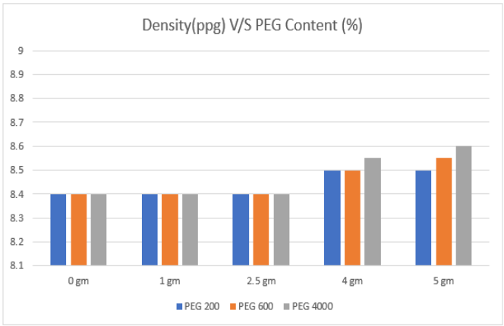
Figure 1: Variation in density with PEG concentration

Fig. 1 illustrates the effect of PEG (200, 600, and 4000 Molecular Weight) concentration on the density of the bentonite-based drilling mud. The density of the bentonite-based mud increases slightly as the PEG concentration increases. When the concentration of PEG is 1 gm, the density of the mud is 8.4 ppg, and it increases to 8.5 ppg as we go on increasing the concentration of PEG, as shown in Fig. 1. As a result, as the concentration of PEG increases, the density of the bentonite-based drilling mud increases slightly.

  - Rheological analysis:

A crucial element in the improvement of the drilling mud's properties is the rheological characteristics of the drilling fluid. Figures 2,3,4,5, and 6 show the variation and comparison of plastic viscosity, YP, and gel strength (GS).

Plastic viscosity (PV) and Yield Point (YP): The plastic viscosity and yield point values of the drilling mud made from bentonite slightly rise as PEG concentration increases. The impact of PEG concentration on PV is shown in Fig. 2. The plastic viscosity performs better as PEG concentration rises from 1 gm to 5 gm. In the case of YP, Fig. 3 illustrates the effect of PEG concentration on YP. The YP rises when the PEG concentration is increased from 1gm to 5gm. Therefore, it can be seen that the addition of PEG concentration shows better improvement in PV and YP.

Gel strength: Figs. 4-6 illustrate the effect of PEG concentrations of MW 200, 600, and 4000 on gel strength. The gel strength increases as PEG concentration rises. As a result, it has been discovered from the figures that the concentration of PEG is correlated with an increase in the rheological properties of the bentonite-based drilling mud, including PV, YP, and gel strength.

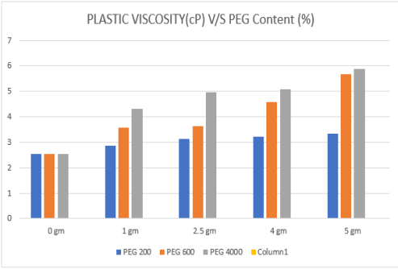
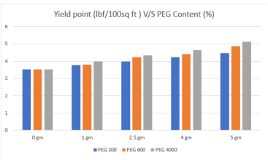

Figure 2: Variation in Plastic viscosity with PEG concentration Figure 3: Variation in Yield Point with PEG concentration

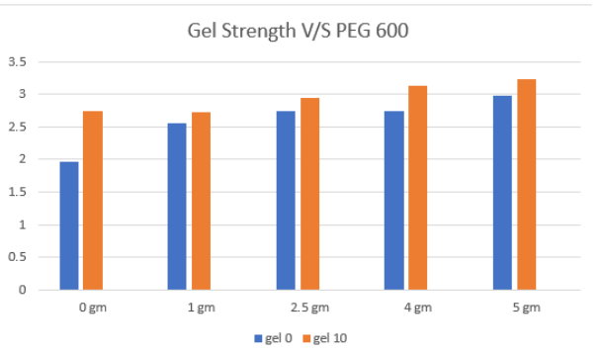
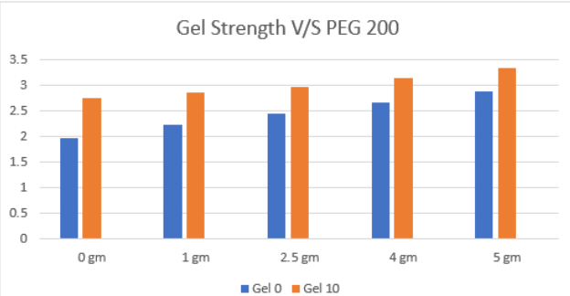
Figure 4: Variation in Gel 0 and Gel 10 with PEG 200 Figure 5: Variation in Gel 0 and Gel 10 with PEG 600

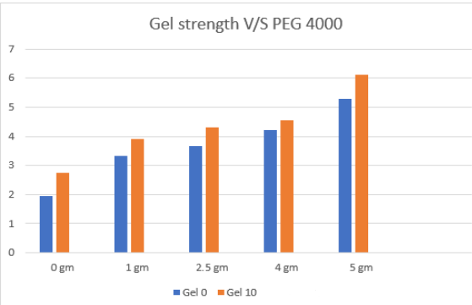
Figure 6: Variation in Gel 0 and Gel 10 with PEG 4000

  - Filtration analysis:
Drilling fluids must possess the ability to form an impervious filter cake on the porous bore hole walls in order to prevent filtrate loss. This property can be attained using the filter press method. In Fig. 7, the filtrate loss of bentonite-based drilling mud vs PEG concentration is shown, followed by the thickness of the mud cake in Fig. 8. The figures show that as PEG concentrations, molecular weights, and concentrations of PEG are changed, the amount of filtrate loss decreases. The filtrate loss volume exhibits a trend toward reduction as PEG concentration rises. Additionally, the volume of fluid lost gradually decreases as PEG's molecular weight rises. This outcome demonstrates that PEG can, to a certain extent, reduce the filtrate volume of drilling mud based on bentonite. Considering that PEG is a long chain molecule with polar groups (hydroxyl groups) at the end of the chain, this makes sense. In order to effectively block the micropores and reduce the volume of the filtrate, the hydroxyl groups were adsorbed on the clay and mud cake's surface. Larger molecular-weight PEG can also block larger micropores through cross-linking adsorption, whereas smaller molecular-weight PEG can only block smaller pores. Fig. 8 illustrates the effect of PEG concentration on mud cake thickness. The thickness of the mud cake is affected by the PEG concentration as well.

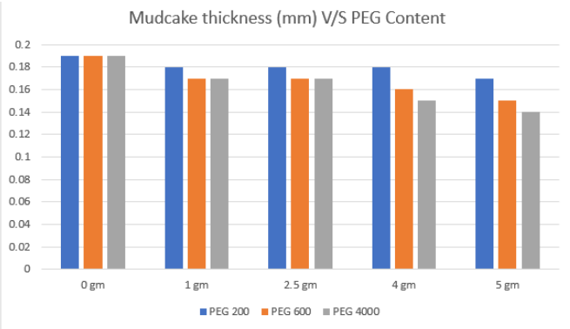
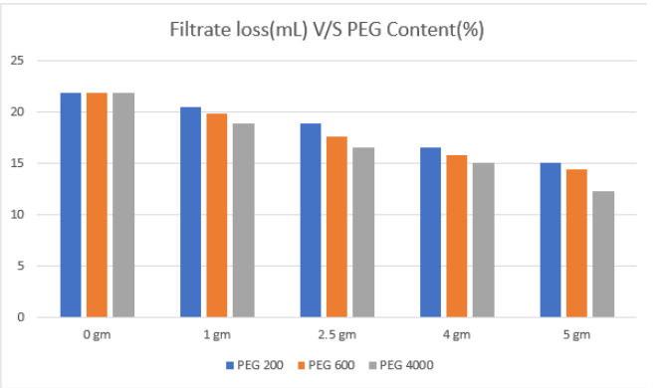

Figure 7 : Variation of Filtrate loss with PEG concentration Figure 8: Variation in mud cake thickness with PEG concentration

After analysing all the experimental results, it was obtained that the PEG 600 molecular weight of 5 gm gives an optimum result due to the reasons that - Higher the molecular weight, the better its filtration properties (less filtrate loss and optimum mud cake thickness). But taking the economic factors into consideration, PEG 600 is a better choice than PEG 200 and PEG 4000. The plastic viscosity is also showing values that are within the desired range, and the prerequisite is a plastic viscosity that is neither high enough to provide too much resistance to flow nor too low that it does not take cuttings along with it to the surface. Additionally, the coefficient of friction decreases with increasing molecular weight; therefore, a higher molecular weight PEG offers more lubricity, which is a desirable phenomenon when replacing oil-based mud. So PEG 600 is better than PEG 200. Along with that, the lower the molecular weight, the better the defoaming properties. So PEG 600 is better than PEG 4000. As can be seen from the results, the gel strength increases with both molecular weight and concentration, so an optimum value of gel strength is needed.

- Conclusion
PEG is non-toxic, inert, colourless and non-volatile. In addition to being highly soluble in water, it is also highly soluble in organic solvents like benzene, carbon tetrachloride, and chloroform. The cloud point effect caused Poly(ethylene glycol) in drilling mud to "phase separate" and transform into a substance that is soluble in oil. A lubricating layer was created by the molecular chain's hydroxyl groups adhering to the metal's and mud cake's surfaces. The drilling mud's capacity to lubricate also decreases as PEG's molecular weight increases and the lubricating film quickly thickens. PEG has several advantages, including high lubricity, strong shale inhibition, and water miscibility in any ratio, which makes it perfect for the production of water-based drilling mud for extremely water-sensitive formations. The variety of PEG's molecular weights influences the variety of products; additionally, it has antifriction qualities and is reasonably priced.

References:
1. Salam, M., Al-Zubaidi, N.S. and Al-Wasiti, A.A., 2019. Lubricating Properties of Water-Based Drilling Fluid Improvement Using Lignite NPs as well as Their Effect on Rheological and Filtration Properties. Association of Arab Universities Journal of Engineering Sciences, 26(1), pp.81-88.
2. ASME Shale Shaker Committee, 2011. Drilling fluids processing handbook. Elsevier.
3. Borah, B., Das, B. M., (2022),"A review on applications of bio-products employed in drilling fluids to minimize environmental footprint", Environmental Challenges Vol.6, 100411
4. Huang, D., Xie, G., Peng, N., Zou, J., Xu, Y., Deng, M., Du, W., Xiao, Y., Huang, J., Luo, P., (2021),“Synergistic inhibition of polyethylene glycol and potassium chloride in water-based drilling fluids”, Petroleum Science 18, 827-838
5. Qin,G., Xu , M., He, M. and Chen, K.,(2021), “Synergistic Effect of Polyaspartate and Polyethylene Glycol on Lubrication Performance of the Water-Based Drilling Mud” ,ACS Omega, 6, 21, 13817–13830
6. Rabia, H. (2002), “Well Engineering & Construction.” Entrac Consulting Limited, London
7. Akpan, E. A.,(2019) "Water-Based Drilling Fluids for High Temperature and Dispersible Shale Formation Applications" Ph.D. Thesis, Petroleum and gas Engineering Division, School of Computing, Science and Engineering, University of Salford, United Kingdom.
8. Nagre, R., Zhao, L., Frimpong, I., & Owusu, P. (2015). “EVALUATION OF SULFONATED ACRYLAMIDE-BASED TETRAPOLYMER AS A RHEOLOGY MODIFIER IN WATERBASED DRILLING FLUID”. Petroleum & Coal, 57(2), 93-100
9. Adekomaya, O. A., Olafuyi, O., (2011), “An Experimental Study of the Effect of Contaminants on the Flow Properties of Oil based Drilling Mud. Petroleum & Coal”, 53(4), 315-319.
10. Bland R., (1992) “Water-based glycol systems acceptable substitute for oil-based muds.” Oil Gas Journal .90(26):5.
11. Bland R, et al., (1996), “Low salinity polyglycol water based drilling fluids as alternatives to oil-based muds” Asia Pacific Drill Technology Society of Petroleum Engineers.
12. Twynam AJ, Caldwell PA, Meads K., (1994), “Glycol-enhanced water-based muds: case history to demonstrate improved drilling efficiency in tectonically stressed shales”, SPE/IADC Drilling Conference. Society of Petroleum Engineers.
13. Jiang, G.; Lin, T.; Ning, F.; Tu, Y.; Zhang, L.; Yu, Y.; Kuang, L.(2011), “Polyethylene Glycol Drilling Fluid for Drilling in Marine Gas Hydrates-Bearing Sediments: An Experimental Study”, Energies 2011, 4, 140−150 DOI: 10.3390/en4010
14. J. Ulbricht et al., (2014), “On the biodegradability of polyethylene glycol, polypeptoids and poly(2-oxazoline)s”, Biomaterials, Volume 35, Issue 17, June 2014, Pages 4848-4861
15. Kawai, F., Yamanaka, H., (1986),” Biodegradation of polyethylene glycol by symbiotic mixed culture (obligate mutualism)”, Arch. Microbiology 146, 125–129
16. Lopes, B.D.M., Lessa, V.L., Silva, B.M. and La Cerda, L.G., 2015. Xanthan gum: properties, production conditions, quality and economic perspective. J. Food Nutr. Res, 54(3), pp.185-194.
17. Akinade, A.E., Wilfred, O.C. and Akin-Taylor, A.M., 2018. Improving the rheological properties of drilling mud using local based materials. Am. J. Eng. Res.(AJER), 7, pp.58-63.
18. Alemdar, A., Güngör, N., Ece, O.I. and Atici, O., 2005. The rheological properties and characterization of bentonite dispersions in the presence of non-ionic polymer PEG. Journal of Materials Science, 40, pp.171-177.
19. Pietrelli, L. Effect of MW and pH on poly(ethylene glycol) adsorption onto carbon. Adsorption 19, 897–902 (2013).
20. Liu, L., Javed, H.U. and Xiao, J., 2022. Engineering emulsion gels as functional colloids emphasizing food applications: A review. Frontiers in Nutrition, 9, p.890188.

