Novel Methods For Formulation Of Nanoparticles And Their Applications In Drug Delivery

Ajit Kumar Varma¹*, Aditi Chaudhary¹, Pratiksha Jayaswal², Beena Goyal³

¹Faculty of Pharmaceutical Sciences, Rama University, Kanpur (U.P.) India-209217

²Chaudhary Sughar Singh Pharmacy College, Jaswant Nagar, Etawah (U.P.) India-206245

³Seth Vishambhrnath College of Pharmacy,Deva Road Barabanki,Lucknow(U.P.) India-225003

*Corresponding author (Email id – ajitpharma007@gmail.com)

ABSTRACT

The goal of nanotechnology in medicine is to treat health problems at the nano scale, where the bulk of living things' components exist and function. It is an emerging field with numerous potential applications ranging from diagnosis through therapy, as well as personalized administration and regenerative health care. Nanomaterials are molecular assemblages that, due to their multifunctional chemistry, may pass through biological obstructions (bio-barriers), gather disproportionately in cancerous tumors, and cure and diagnose only one cell type of cancer. Nanomaterials are molecular ensembles that can pass through biological barriers (bio-barriers), cluster preferentially in cancerous tumor’s, and cure and diagnose only one cancer cell at a time due to their unique chemistry. The current review delved into great detail about nanoparticle synthesis techniques, classification, mechanisms of action, and therapeutic applications of nanoparticles in the current drug delivery system.
KEYWORDS: Biological Barrier, Targeted Medication Delivery, Nano medicine and Nanoparticles.

INTRODUCTION

The goal of Nano medicine, which uses nanotechnology in medicine, is to solve health-related issues at the most biological molecules exist and operate at the nanoscale. With numerous applications ranging from diagnostics to therapy, including targeted delivery and regenerative medicine, it is a young field. Novel medicine delivery techniques are the name given to the new approach. New advances in drug pharmacokinetic and pharmacodynamics characteristics allow for a more logical approach to creating the optimum pharmaceutical administration system. Traditional drug delivery methods lend several advantages over innovative administering methods. [1]
The objective of the Unique Drug Delivery System is to deliver the appropriate medicinal quantity to the suitable part of the body in the quickest period of time conceivable. The medication must be administered at a rate regulated by the body over the span of its use by the drug delivery technique. There are different kinds of novel pharmaceutical methods for delivery. Sustained- or controlled-drug delivery systems, correspondingly, offer pharmacological activity at a predetermined rate, at physiologically effective levels in the blood. Localized pharmaceutical delivery methods provide medicinal products by geographically or temporally limiting drug release (typically rate-limiting) close to the target.[2]
Drug action can be delivered via rate-programmed pharmaceutical delivery systems that modulate molecular diffusion to change drug molecule release. Targeted medication distribution employs carriers as the starting point for either passive or active targeting approaches. Such processes are frequently supported by adequate sensory mechanisms that recognize their transmitter at the target.
Several creative ideas Carriers that are utilized in conjunction with novel drug delivery systems (NDDS) have advantages over traditional dose forms. Previous dosage forms were ambiguous, had a first pass effect, had fluctuations in plasma drug levels, and released drugs quickly. The National Medication Development Strategy is a significant tool in the pharmaceutical industry's efforts to develop the medication market. By improving effectiveness, security, patient acceptance, and product shelf life. The goal of Nano medicine, which employs nanotechnology in medical therapy, is to tackle health-related issues at the Nano size, where the bulk of molecules in life reside.[3]
It is a fast growing discipline with an extensive variety of applications from diagnostics to treatments, including individualized administration and therapeutic regenerative therapy. The term "unusual pharmaceutical delivery methods" is frequently used to characterize the novel technology. Recent improvements in medication pharmacokinetic and pharmacodynamics behavior allow for a more cautious approach to designing the best prescription drug administration system. [4]
The Novel Drug Delivery System's motive is to deliver the required quantity of medication to the correct spot in the body in a suitable amount as rapidly as possible. The medication's delivery system has to distribute the medicine at the rate set by the body all throughout a predetermined treatment time. Novel medicine means of administration come in a variety of forms.Sustained- or controlled-drug delivery systems, respectively, give a to generate benefits in the blood at an agreed-upon rate, extended or constant (Zero-order) releases at effective therapeutic levels. The amount of medication diminished at the point of distribution.[3,4] Current drug delivery to perilous tumor cells, for illustration, might impact healthy tissues, resulting in renal damage, neurological harm, and cardio toxicity. Such issues caused scientists to explore more about unfamiliar DDS. Learning how nanotechnology may solve these difficulties requirements an explanation of how the nanoparticles (NP) function in drug delivery. The three criteria major divisions of the medicinal method of delivery are ingestion of the pharmaceutical or therapeutic product, the the release of the medicament's reactive a component and movement of active components to the sought area to carry out activation over the biology boundary. [5]

Nanoparticles

The use of nanotechnology includes solid atoms with colloids range in size from 10 nm to 1,000 nm. Polymer substances can be employed successfully in the creation of nanoparticles. Certain polymeric compounds have importance because of their widely developed biodegradability and biocompatibility in Polymers that are both synthetic and natural have been utilized in the creation of nanoparticles. [6]
Many studies have been undertaken on the manufacturing process of nanoparticles as targeted medical treatments delivery systems. Targeted medicine transportation can be conducted by either active or passive targeting. Drugs can be actively targeted by adding their molecules with binders specific to cells or tissues. Passive drug targeting can be accomplished through encapsulating the drug molecule in either microscopic particles or nanoparticles. Nanoparticle (NP) are hydrodynamic drug delivery technologies made from both organic as well as partially polymeric materials. NP atoms range in size from 10 nm to 1,000 nm. This dynamic drug delivery device's inner structure fluctuates.Nanospheres that operate arranged in a matrix-like form. [7]

A nanoparticle mesh was used to disintegrate, trap, encapsulate, or connect the medicament. Nanoparticles are small capsules can be established through what method of preparation. Nano spheres are tiny are complex matrix structures in which the medicinal product is mechanically and uniformly split up whereas Nano capsules for are cavity structures encased by a particular kind of polymer membrane.Over the past decade, sustainable nanoparticles of polymeric material, particular those coated with hydrophilic plastics such as poly (ethylene glycol) (PEG), are increasing popularity[8]
Because of their ability to circulate for a longer period of time, target a specific organ, act as DNA carriers in gene therapy, and include proteins, peptides, and genes, long-circulating particles, or LCPs, have been investigated as prospective medicine delivery systems.[9,10]

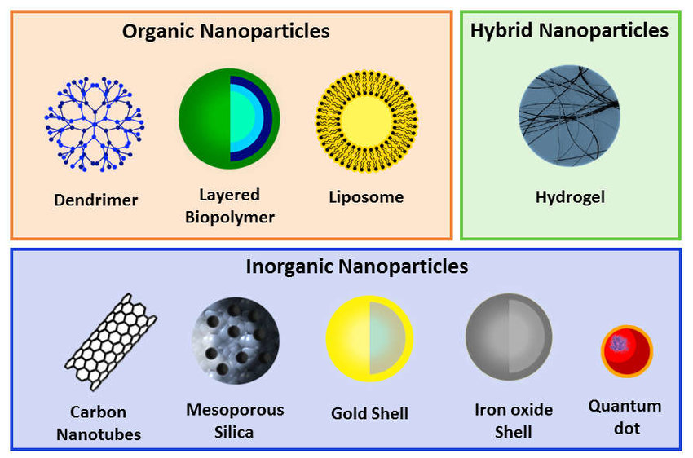

Fig.1:Nanoparticles are classified into several categories.
The Benefits of Nanoparticles [11]
- Enhance the delivery of weakly water-soluble pharmaceuticals.
- To reduce medicine buildup in healthy tissue, provide site-specific targeting.
- Assist in keeping the prescribed substance in the human body for an appropriate amount of time to enable the therapy to be successful.
- Drug bioactivity that has been extended by being shielded from the biological environment.
- NPs exhibit a variety of benefits, including
- Permit drug translocation over endothelial and epithelial barriers.
- Consolidate diagnostic and therapeutic techniques into a single agent.

Classification of Nanoparticles

There are multiple strategies for distinguishing nanomaterials. Nanoparticles have been divided into three types: one, two, and three dimensional nanoparticles.

1) Nanoparticles possessing simply one dimension- Thin films and constructed surfaces are two prominent instances of one-dimensional objects that have been applied for many years in engineering either chemistry, or communications. Very thin films (sizes 1-100 nm) or monolayer in order have recently become common practice in solar cells and reactions. Thin films can be utilized in numerous distinct industries, such as information storage systems, pharmacological and biological sensors, transmission infrastructure, and photonic and magneto-optical circuits. [12]

2) Twodimensionnanoparticles
Carbon nanotubes (CNTs) are generated by expanding a cylinder of graphene into a hexagonal arrangement of carbon monoxide atoms with a dimension of 1 nm and a length of 100 nm. The nanotubes of carbon (CNTs) are divided into two types: single-walled (S) and multi-walled (MWCNTs).The nanotubes made of carbon are notable for their small dimensions as well as their outstanding mechanical, biological in nature, and electrical capacities. Dependent on how the carbon-based leaf has been wrapped around itself, it may possess metallic or semi conductive attributes. Nanotubes are made are a superconductor due to an exceptionally high current density, which may reach one billion amplifications per square metre. The nanotubes made from carbon have twice the durability of the strongest steels. [13]

3) Some Novel Three dimension nanoparticles
a) Fullerenes: These are C60-based spherical cages ranging in size between 28 to more than 100 carbon molecules. The object that is in question is a spherical soccer made of interconnecting carbon pentagonal and hexagonal varieties. Fullerenes are an instance of material with various properties. When pushed to high pressure, they may recapture the way they were originally shaped after the pressure is released. Because they do not react with one another, these kinds of molecules have a high potential for usage as lubricants. Because of its fascinating electrical properties, it has been proposed that they have applications in technological industries for tasks ranging from storage of information to the manufacture of solar cells. These compounds have prospective applications in the expanding field of nanoelectronics.It can be filled with a variety of chemicals and have potential medical applications because they are empty structures with dimensions similar to many biologically active compounds.[14]

b) Dendrimers: Dendrimers are an individual class of nanometric-sized controlled-structure polysaccharides. Dendrimers, which contain numerous functional units on the outermost layer and are typically 10 to 100 nm in diameter and have applications in administering medications and imaging, offer ideal vehicles for selective drug delivery. Dendrimer's design and functionality have attracted a great deal of interest. Modern dendrimers can be quite specialized, with their cores containing functional molecules (such as medicinal or diagnostic compounds).[12,14] They are regarded as the fundamental building blocks for the large-scale production of both organic and inorganic nanostructures, ranging in size from 1 to 100 nm. They can interact with biological structures like DNA and manufactured to have an encapsulating capability or to have metallic nanostructures and nanotubes. Due of dendrimers' diverse reactive surface groups (nanostructure) and compatibility with organic structures like DNA, the medical and biological industries use them extensively. Dendrimers can be found in an assortment of pharmaceutical products, including as nonsteroidal anti-inflammatory pharmaceuticals, antimicrobial and antibacterial therapies, treatment for cancer, Prodrugs and high-throughput capabilities capabilities are two instances of drug discovery examination breakthroughs. Dendrimers are adverse because their electrified surface has sufficient strength to snap the barrier between cells. [15]

C) QuantumDots (QDs):

Quantum dots constitute incredibly small particles that have a very small amount of uncontrolled electrons. Ds are hydrodynamic nanocrystals made from semiconductors that range in size from 2 to 10 nm. QDs can be manufactured via liquid synthesis or electrochemistry is a form a variety of semiconductor-based materials. Cadmium selenide (Cd Se), cadmium telluride (Cd Te), indium phosphide (In P), and indium arsenide (In As) are among the four most often utilized QDs.[16].

Methods of Formulation ofNanoparticles: -

PNP attributes must be modified for each application. The approach of preparation matters in order to get those necessary characteristics. As a result, having beginning procedures for synthesizing PNPs with the properties that are required for particular tasks on hand is quite advantageous. Alternative methods like as the polymerization process set up polymers, ionic gelation, as well as others are used. The ideal approach for manufacturing nanoparticles can be established based on the chemical and physical features of the polymer and the medicament to be loaded. The techniques that are discussed below are the most commonly employed methods for manufacturing nanostructures.[17].

1) Evaporation Method Using Emulsions and Solvents
This is an increasingly common approach to produce nanoparticles. Solvent evaporation was the first manage used for generating PNPs from a. This method involves producing polymer solutions that dissolve in volatile solvents and emulsions. formerly preformed chloroform and dichloromethane polymers were constantly employed; yet, ethyl acetate, which has a superior toxicological profile, should be used alternatively. The emulsion converts into a dispersed form of nanoparticles upon the breakdown of the polymerization solvent, which is then permitted to penetrate through the continuous stage of the solution. The two basic emulsion-formation strategies utilized in traditional procedures are single emulsions, such as oil-in-water (o/w), and double emulsions, such as (water-in-oil)-in-water (w/o)/w. These techniques necessitate ultra-sonication or high-speed homogenization, followed by solvent evaporation via continuous magnetic stirring at room temperature or low pressure. The solidified nanoparticles can then be collected by ultracentrifugation and rinsed with distilled water to eliminate any additives such as surfactants. [10] At the end, the product is lyophilized. The kind and concentration of stabilizer, homogenizer speed, and polymer concentration all had an effect on particle size. High-speed homogenization or ultra-sonication are routinely used to achieve fine particle size.[18].

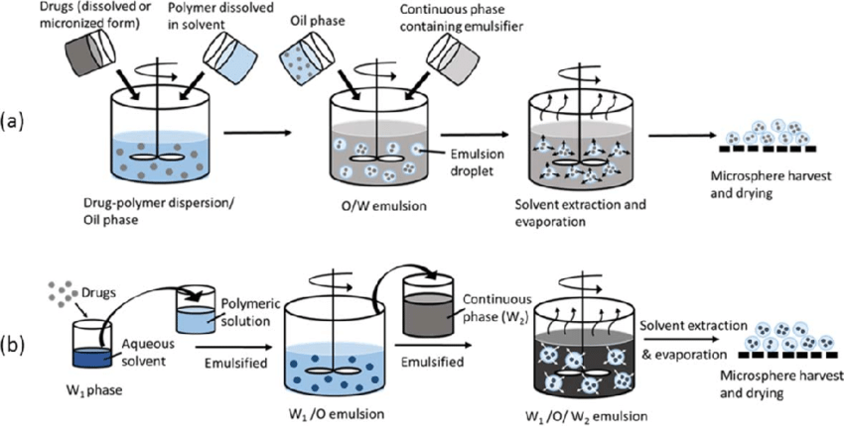

Fig.2:The solvent-evaporation procedure is depicted schematically.

3) Salting Out Method:
The salting-out action is the process of removal of a water-miscible solvent from an aqueous solution. The ultimate objective of salting-out is to draw the salting-out phenomenon by utilising the water-miscible solvent separation technique. Following the full saturation of the polymer and pharmaceutical mixture in a solvent, the salting-out thing (electrolytes such as magnesium chloride along with potassium chloride, or nonelectrolytes such as sucrose) and a magnetic stabilisation known as polyethylene glycol or hydroxyethylcellulose are incorporated.[19].
To increase solvent penetration into the aqueous phase, dilute this oil/water emulsion with a suitable amount of water or aqueous solution. The internal/external phase ratio, polymer concentration in the organic phase, stirring rate, polymer type, and other manufacturing parameters can all be altered as a result of electrolyte concentration and stabilizer type in the aqueous phase. The process, which can be used to create PLA, Poly (meth acrylic), and Ethyl the cellulose Nano spheres, is very productive and simple to scale up. When heat-sensitive material must be processed, sodium chloride out may be preferable because it does not require higher temperatures. The most significant disadvantages are the use of only lipophilic medicines and the several washing processes. [20,21]

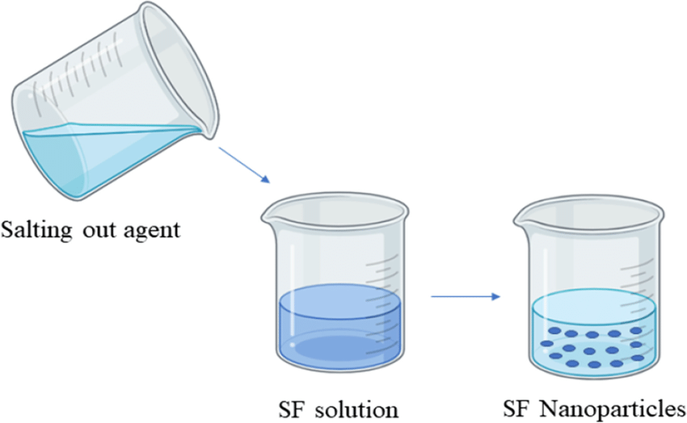

Fig.3:The salting out procedure is depicted graphically

4) Method of Emulsions Diffusion:A different approach well-known technique for creating nanoparticles is this one. To achieve the initial thermodynamic equilibrium of both liquids, the encapsulating polymer is dissolved in a solvent that is only slightly water-miscible (such as propylene carbonate or benzyl alcohol) and saturated with water. The polymer-water filled solvent phase undergoes emulsification in an aqueous solution incorporating a stabilizer, resulting in a diffusion of the solvent to the outer phase and the emergence of Nano spheres or Nano capsules depending on the oil-to-polymer ratio. By its boiling point, the chemical solvent is finally removed either by evaporating or filtering. High encapsulation effectiveness (typically 70%), lack of homogenization, high batch-to-batch consistency, straightforwardness, simplicity of scaling up, and a restricted dispersion are just some of the method's strengths. [12] The huge amounts of water that must be removed from the suspension and the leakage of a medication that is water-soluble into the saturated-aqueous exterior phase during emulsification reduce the effectiveness of encapsulation. The method developed mesotetra (hydroxyphenyl) porphyrin-laden PLGA (p-THPP), doxorubicin-loaded PLGA nanoparticles in and corticosteroid (cy-A-) loaded sodium glycolatenanoparticles, as well as additional drug-loaded nanoparticles.[22]

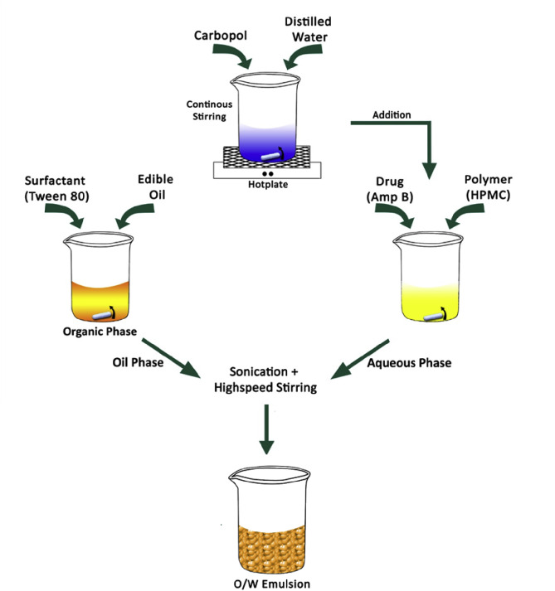

Fig.4:The emulsification/solvent dissemination procedure is illustrated schematically.

5) Mechanism of Solvent Displacement/Precipitation.An established polymer forms precipitates from an organic solution whether or not a surfactant is present. This is the organic solvent that spreads precipitation across aqueous mediums. Acetone and ethanol are semi polar water-miscible solvents capable of dissolving pharmaceutical polymers and/or lipophilic lubricants. The solution is then injected or emptied into a magnetically agitated aqueous solution containing a stabilizer.When an established polymer precipitates from an organic solution, regardless of the presence of a surfactant. This is the organic solvent that causes precipitation in aqueous solutions. Semi polar water miscible solvents acetone and ethanol can dissolve medicinal polymers and/or lipophilic lubricants. Because of the quick solvent diffusion, nanoparticles form instantly. The suspensions are then subjected to a low-pressure treatment to remove the solvent. Particle size is affected by the rate at which the organic phase is injected into the aqueous phase. It has been discovered that increasing the speed at which the two phases are mixed reduces particle size and drug entrapment. It was shown that changing the preparation conditions had an effect on Nano spheres size, drug release, and yield. It was discovered that changing the polymer concentration in the organic phase could aid in the production of Nano spheres of smaller sizes by limiting the polymer to drug ratio to a specific range. [23]

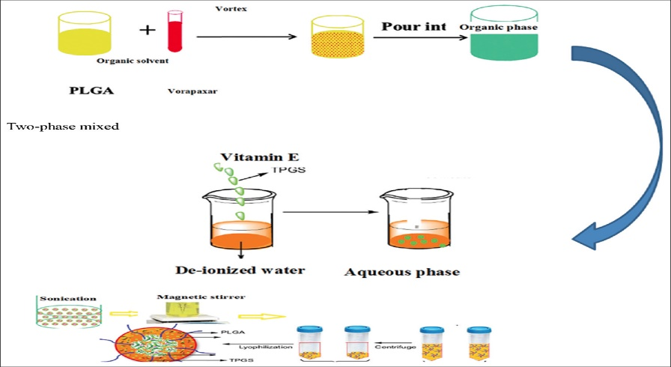

Fig.5:The Nano precipitation technique is depicted schematically.
6) Polymerizationmethod:
Monomers, also known undergo polymerization in an aqueous solution to form nanoparticles in this technique. After polymerization is complete, the drug either adsorbs to the nanoparticles or dissolves in the polymerization media. [24]
Characterization method for Nanoparticles-
1. Morphology and Topography analysis- The fundamental set of details assembled at the initial stage of description is nanoparticle dimension and shape. The size of nanomaterials influences how applicable they are for specific purposes.[25]
2.Dynamic Light Scattering (DLS):It is an extremely frequently employed approach to analyzing hydrophilic particle size distribution and distribution across an assortment of dimensions. DLS is a measurement of light suppression based on the Brownian movement of nanomaterials in dispersion and the association of movement (diffusion coefficient) with size applying. The size distributions range of the fragments can be expressed by the value of the polydispersity index (PDI), which serves as an output of the auto Correlation function. PDI levels range throughout 0 and 1, while 1 providing an exceptionally diverse population and 0 showing a highly homogeneous particulate community. Multi angle DLS additionally may be implemented to analyzeno spherical components such as filaments.The primary points limiting factor to achieving excellent correlation which results in accurate size measurement is disparity.[26]
3.Scanning Electron microscopy (SEM)-ScanningElectron microscopy photographs containing biomolecule-coated particle are of inferior quality. Specimen processing produces dehydration in the which leads to sample reduction. As sample dry, they usually agglomerate, providing new artefacts. Longer investigation deadlines and the inability to estimate disparity pose even more impediments. The use of zeta potential measuring- Zeta potential measurements is an instrument used to assess the electronic charge of nanomaterials in a solution consisting of colloidal particles.Nanotechnology contain an outside charge that attract a thin layer of ions that counteract them (Stern layer). That second layer of particles interacts with the nanoscale as it propagates in the fluid. The electric field that exists at the outermost point of the two separate layers is recognized as the zeta potential of the particles themselves.[24,25]
4.Surface Charge Analysis (zeta potential measurement)- The zeta potential determining methodology is used for assessing the charged surface of nanocrystals in a solution with colloidal particles. As the nanoparticle dissipates through the solution's contents, an additional layer of ions accompanies it. The electric field that exists at the single layer's interface is known as the zeta potential that exists in the fragments, and it generally ranges within 100 and 100 Mv. Nanoparticles are with zeta strengths larger than optimistic 30 mV or less below negatives 30 mV usually are persistent. Dispersions bringing zeta potentials less than or exceeding twenty-five mV will ultimately agglomeration as a consequence of interparticle interaction such as van der Waals and hydrophilic interactions, in addition to the bonding of hydrogen.The implementation of zeta potential measurement to monitor progress of surface the functionalization or change is widespread. [26]
5. Scanning Electron Microscope: The dimensions, influence, and morphology of produced nanomaterials have been identified via scanning electron microscopic examination. In its intended manner, SEM generates exceptionally detailed photographs of the weight of the sample surface. The scanning electron microscope, or SE microscope, operates on the same principles as an optical microscope, except instead of photons, are it measurements electrons dispersed from the material. Because electrons may be accelerated by an electric potential, then their emission wavelength can be reduced to match that of photons. This allows the SEM to magnify depicts up to 200,000 times. Tests the dimension of particles and character development using an electrical or sputter coated object with precision down to 1nm.[27]
6. Entrapment Efficiency- The Entrapment Efficiency (EE%) is also known as Linkage Accuracy. The nanoparticles with drugs in them have been spun at a high speed of 3500-4000 rpm for a duration of thirty minutes, and the resulting supernatant was examined for non-bound concentrations of drugs using a spectrofluorometer. The efficacy of entrapment was subsequently calculated as follows:[25,27]

Drug Entrapment Efficiency(%)= Total amount of drug added – Non bound drug X100
Total amount of drug added

Different Nanoparticles' Pharmacokinetic Parameters:
9.3.1 Metallic nanoparticles: The utilization of metallic nanoparticles, which have been applied in the delivery of biological products such as vaccines and pharmaceuticals for health care. Several precious metals and salts made of metals, such as titanium and metallic silver for the development of metallic nanoparticles, carbon dioxide, zinc oxide, iron, and gold have all been thoroughly studied. Pharmacokinetic analyses of metallic nanoparticles are necessary to ensure their safety. Particle dimensions and classification, environmental paint, the degree of surface accountability, channel of administration, protein the immobilization process species of animal, and quantities are every element that influence the metabolism and absorption of metal nanoparticles. These minuscule particles have a shorter plasma half-life in rats and mice than in rabbits and monkeys. These issues can be overcome by substrate modification together with other suitable coatings, although dermal, inhalation, and oral absorption of these carriers will often be lower. Metallic nanoparticles have been shown to persist for months and have a great propensity to disperse throughout the body. They accumulate in the lymph nodes, liver, and spleen. The non-specific uptake of MPS results in this accumulation. Metallic nanoparticles as small as 100 nm are easily able to penetrate the BBB and be put to use.[28]
9.3.2 Nanoparticles that are both cationic and anionic: Charged nanostructures that come in different sizes have been utilized in drug administration, and energy can frequently be produced by the addition of materials such stearyl an amine used polyurethane for manufacturing these cationic nanoparticles that which enhanced dye permeability within cells and apoptosis. Created cationic nanoparticles using PEG-PLA and charged albumin from cows and observed increased tissue absorption by the liver and spleen. They also showed that cationic nanoparticle enhanced permeation of the BBB and diminished 6-coumarin administration. Heparin and PEG were used to create the cationic magnetic nanoparticles in reemployed, and they found an 11-fold increase in bioavailability. Nowadays, anionic nanotechnology is frequently used in biological disciplines like identification, diagnostics, and medicine due to their superior electrostatic attachment to the negatively charged mucin, cationic nanoparticles are commonly chosen over anionic nanomaterials neverthe less given that charged nanoparticles have been associated with tissue death and hemorrhage, both the benefits and drawbacks of their use should be taken into account.[29]
9.3.3Functionalized/tailored nanoparticles Personalizing nanoparticles increases medicine delivery and bioavailability. Cheng et al. coated nanoparticles that were functionalized with PEG and polyacrylic acid and discovered an upsurge in the circulation half-life. The established systems stayed in the hepatocytes and spleen. The customized nanoparticles were made with PEG and PLGA, and this resulted in increased accumulating and better thermodynamics. In general, nanoparticle customization is done in order to accomplish objectives such as most effective administration of drugs, MPS bypass, tissue targeting, which is and sustained blood flow.[30]
9.3.4 Targeted Nanoparticles- Nanoparticle-targeted administration is a particular to the disease and focused on objectives technique that efficiently distributes drugs to the wanted location. Used PLGA, PEG, anEstimated glomerular filtration rate (EGFR) peptide, which and n poly (3-caprolactone) to synthesized customized lonidamine/paclitaxel nanoparticles exhibiting a better pharmacokinetics profile than commonly accessible formulations.Described the accumulation within cells of targeted nanotechnology using human serum albumin and EGFR peptide to manufacture cetuximab nanoparticles. To attach nanoparticles in order for simpler transportation to the intended place, naturally occurring substances such as folic acid, nicotinamide, and estrogen are used the Nano medicine[31]

Table 1: Preparation techniques of various types of nanoparticles and targeted disease.
Type of Nanoparticles | Target Disease | Method of Preparation | Reference
Poly-alkyl-cyanoacrylate  Nanoparticles | Cancer | Carriers that are delivers substances to a particular location | [32,33]
Nano and micro particles | Enhance oral immune system  (immunization) | The drug is delivered using a micro particulate technique. | [34,35]
Poly-alkyl-cyanoacrylate  (PECA) nanoparticles | Bacterial diseases | Perfloxacine and OFX have been incorporated into PECA nanoparticles. an improved PFX system. | [36,37]
Protein and peptides-based  Nanoparticles | Alzheimer’s disease | Antibodies with monoclonal structures and recombinant proteins that have been engineered are delivered to the BBB by heterologous transporters.  peptide approach. | [38,39]
Chitosan Nanoparticles | Diabetes | The nanoparticles of chitosan have been shown for improving the digestion of insulin across the nasal passages. | [40,41]
Liposome with hyperthermia  as nanoparticles | Ovarian carcinoma | Improved prescription drugs transportation to the tumor.  The condition known as hyper boosts the liposome functioning. | [42,43]
L-nanoparticles | Hepatitis I-B  Hepatocellular carcinoma, Hemophilia, | In human beings, administering an injection of L-particles loaded with a green pigment indicates cancer of the hepatocellular membrane. | [44,45]
Colloidal gold nanoparticles | MC-38 carcinoma tumor | In rodents, nanoparticles of colloidal gold have been used as an agent for administering the tumor necrosis factor (TNF) to a particular portion of the tumor. | [46,47]
Folate-conjugated starch  nanoparticles (StNP’s) | Liver cancer | For the production of the FA-PEG/StNPs, folate has been mixed with PEG subsequently linked to the outermost layer of starch NPs. Doxorubicin has been linked to FA-PEG/StNP. | [48,49]
Liposomes, nanoparticles | Human  nasopharyngeal carcinoma | Drug and genome delivery approach that leverages gold nanoparticles as a means for delivering treatments and chromosomes.  The transcription effectiveness of beta a enzyme called gal utilizing various MMPCs. | [50,51]
Nano diamond (ND) or  Diamondnanoparticles | Ewing Sarcoma  Cells(Cancer) | Nano precious stones have the capacity to introduce tiny interference RNA into the Ewing sarcoma cells.  The procedure of in vivo antitumor genetic medication transfer was looked into. | [52,53]
Silver nanoparticle | Photo-activated gene silencing | The nanoparticles of noble metals have been proposed to be photo-activated carriers for medications administration. SNPs accompanied by photo-liable thiol-terminated DNA amino acids. | [54,55]
Solid Lipid  nanoparticles (SLNP) | Colon cancer | In order to carry pharmaceuticals, electroporation of and the nan carriers are employed. In the current study, SLNP was infused with cyanine type IR-780, flavonoid instruments such as derivatives and photosensitive substance by solvents dissemination. | [56,57]
Novel silver nanoparticles | SARS-CoV-2 | Either messenger RNA (mRNA) or DNA instructions are passed on to the organism to make molecules that duplicate disease antigen with the intent to elicit a reaction from the immune system. | [58]
1-Lipid-based nanoparticles with DNA  2-Material and NPs made of metal  3-Resveratrol-zinc nanoparticles | COVID-19  SARS-Cov-2 viral disease  COVID-19 | DNA the COVID-19 success rate is significantly influenced by these nanoparticles.  Due to their unique characteristics, metals including Au, Ag, Zn, and Cu may be able to suppress the coronavirus.  A carrier is used to deliver the medicine. The virus responds with immuno-anti-inflammatory effects. | [59–60]
1-Iridium oxide Nanoparticles  2-Chitosan nanoparticles | Cancer  Nervous breakdown | These small particles possess a significant part in the COVID-19 success rate.A number of their particular characteristics, minerals such as Au, Ag, Zn, and Cu have a knack for control coronavirus.  It is a medical treatment that is given using a device called a carrier. It answers with an immuno-anti-inflammatory viral counterattack.  A Nano probe for in vivo laser neuroimaging of microRNA and coactive photo thermal examines the tumors has been developed.  It is a biotic macromolecule-based medicines transfer technological advances developed for enhancing the curative properties of not natural neurological circuits. | [61,62]

Nanotechnology Applications
1.Using Nanotechnologies to Treat Cardiovascular Diseases- Cardiovascular disorders claim the lives of millions of people each year. The survival rate of patients with cardiovascular illness has increased thanks to several treatments, but none has enabled complete cardiac regeneration, especially in individuals who have recently experienced a heart attack. Through stem cell therapy, arteries can be prevented from forming.Genetically engineered stem cells may produce more paracrine secretions and have higher survival rates if anti-apoptotic and pro-antigenic genes are included into them due to their inability to transfer large numbers of genes and immune-stimulating characteristics, viral vectors cannot be used to transfer genes into embryonic stem cells. Genes can be effectively transferred to stem cells using biocompatible nanoparticles.[63]. A variety of nanostructures can be utilized to transfer genes to stem cells. It can be used to monitor and track stem cells. Quantum dots can also be utilized to continuously monitor biological cells. Targeted medication delivery utilizingNano stems has been successfully accomplished.These are just a few applications of nanotechnology, but non-viral stem cell therapies hold great promise for the treatment of many more cardiovascular diseases. Before they may be used safely in humans, more study is required to determine how Nano vectors affect a living model's cardiovascular system.[64].
Nanotechnology is also being used for bettering the administering of drugs used to treat cardiovascular diseases. Because proinflammatory alterations might boost permeability to blood vessels and nanoscale molecule retention, it is possible to deliver targeted therapy to sick cardiac tissue. Heart attack or stroke can result from a condition known as coronary artery disease, and it leads to an increase in buildup of plaque on the major arteries. Because the illness develops at the level of cell membranes, nanotechnologies in medicine can be implemented as an effective treatment. Statins are medications are the basis of present therapies for heart disease and stroke, although their usage is limited by their established dose-dependent side effects. Statins could be donated particularly to the spot where they require assistance via nanotechnologies reducing the harm they cause to other cells.

2. Nanotechnology in the Treatment of Brain Diseases: If we address the issue surrounding the barrier between the brain and the blood (BBB), we will be able to treat brain diseases more effectively. The BBB creates a barrier between circulatory blood and brain neuronal tissues. Because it prevents treatments from accessing the brain's CNS and maintains brain harmony, the BBB is an essential barrier in the management of brain illnesses. Even if the BBB is tampered with, medications cannot penetrate the central nervous system, leading to neuro-inflammatory and neurodegenerative diseases such dementia, Alzheimer's disease, Parkinson's disease, and many more [65].
The most significant paths are as follows:
- Transport proteins: carrier-mediated transport and efflux proteins.
- Receptor-mediated transcytosis.
- Adsorptive-mediated transcytosis.
- The Para cellular route and passive transmembrane diffusion.
NPs may pass through the BBB via any of these paths and become picked up by nerves or engaged hepatocytes in the brain. The Different ligands are involved in the receptor-, adsorptive-, and carrier-mediated diffusion of NPs throughout the BBB, that include:
- Ligands that can adsorb proteins from the bloodstream
- Ligands that can directly interact with BBB transporters or receptors
- Ligands that can increase the hydrophobicity and charge of NPs
- Ligands that can improve the circulation time of NPs in the blood
The form and assigned to NPs are also crucial in this scenario. Zwitterion and neutral NPs have a higher circulation a time than both positively and positively charged NPs.Breaking the link between the blood and the brain has allowed NPs to be hired to assist with the management of many different disorders, notably stroke, Alzheimer's, and Parkinson's disease, amongst others.
3. Rheumatoid Arthritis:Experts at the University of Wollongong (Australia) have come up with an innovative type of anti-arthritic medication that can be implemented with small amounts of gold and has less negative effects. Rheumatoid arthritis is an autoimmune illness in which the immune system malfunctions and attacks the patient's joints. In an intriguing fresh study, gold atoms can infiltrate macrophages preventing them from generating aggravation without killing individuals. It has been reported in the issue of Inorganic Biochemistry that via lowering the mass of gold into smaller and smaller particles (50 nm), it was conceivable to supply more gold to autoimmune cells while decreasing cytotoxicity.[63].
4. The Utilization of Different Methods Involving Nanotechnology in Cancer Diagnosis- In tumor therapy, exposed gold particles were found to regulate the expression of heparin-binding peptides which include VEGF165 and bFGF via in vitro experiments and VEGF-induced hemorrhage in vivo. Further investigation in this domain has found that heparin binding molecules are absorbed and destroyed on the outermost layers of AuNPs. [63,64].
5. Diabetes: A number of studies use various kinds of nanoparticles in order to study the incorporation of insulin-loaded nanomaterials with microneedles merged insulin into a chondroitin sulphates matrix prior absorbing it on porous nanoparticles as calcium silicate spongy NPs, and dioxide of silicon spongy NPs. In a comparable way integrated insulin in small particles made of bean lecithin and propylene glycol, produced Nano vesicles, 89.05% insulin encapsulation performance, average particle dimension of 107.4 nm, and zeta potential that was +27.8 mV. Those insulin-loaded small particles will be managed to the skin via either the micron-sized pores caused by the crystalline MN arrays or iontophoresis. The investigation's team used the mouse as a model to look into levels of blood glucose using the various said approaches of delivery of insulin as opposed to that of the standard insulin administered via subcutaneous delivery. The results of this study determined that pre-treatment processes with either the use of i alone or Iontophoresis together with solid MN arrays caused better insulin permeation to the surface of the skin for the two kinds of insulin loaded vesicles and the untreated iontophoresis.
The Effect of Enhanced Permeability and Retention (EPR):-The improved permeability and retention effect is an important phase development for drug delivery uses using nanotechnology. Nanoscale proteins gather more frequently in cancerous cells than in tissue that is normal. This is due to the rapid expansion of blood vessels that is required by quickly developing tumours with a high oxygen consumption. The freshly developed blood vessels have structural flaws and porosity, permitting nanoscale chemicals to get into the cancer tissue. While fast-growing malignancies do not have functional lymphatic relationships, the increased permeability along with the retention effect may allow for targeted delivery of chemotherapy medicines.[65]

6 Infections: -Because of the rise of bacteria that resist antibiotics, nanotechnologies is being used to dispense prescriptions and treat infections. Although the enhanced permeability and retention effect is frequently associated with cancer treatments, the same neurological pathways make the effect feasible for a wide range of diseases and infectious treatment. Vasodilation occurs shortly following infection, improving the permeability of capillary walls.[66]

CONCLUSION:

Nano particulate systems have tremendous promise because they are able to transform largely insoluble, insufficiently consumed, and labile biologic active ingredients into pharmaceuticals. Nanoparticles have a higher intracellular uptake than small particles due to their small size and comparable mobility, and they are accessible to an extensive spectrum of biological targets. Currently, many targeted and new drug delivery systems are being developed to optimized dose form, increase bioavailability and patient compliance, and reduce side effects. Pharmaceuticals can be provided in the most encouraged and exact techniques using nanoparticles.

REFERENCES:

- Roop k khar, s.p vyas, farhan j ahmed, gaurav k jain “the theory and practice of industrial pharmacy “4th edition lachman’s/lieberman’s cbs distributors, 2013; 872, 902, 905, 943.
- Akhgari A, Heshmati Z, Makhmalzadeh BS. Indomethacin electrospun nanofibers for colonic drug delivery: preparation and characterization. Advanced pharmaceutical bulletin. 2013;3(1):85.
- Charman w.n, chan k, finnin BC& chairman SA drug delivery: a key factor in realising the full therapeutic potential of drug. Drug development research, 1999; 46: 316-27.

- Foss Jr CA, Hornyak GL, Stockert JA, Martin CR. (Template-synthesized nanoscopicgold particles: optical spectra and the effects of particle size and shape). The Journal ofPhysicalChemistr, 1994;98(11): 2963-2971.

- Nowack B, Bucheli TD. Occurrence, behavior and effects of nanoparticles in the environment. Environmental pollution. 2007 Nov 1;150(1):5-22.
- BriggerI, Dubernet C, Couvreur P. (Nanoparticles in cancer therapy and diagnosis).Advanceddrugdeliveryreviews, 2002; 54(5): 631-65.
- Zhang P, Qiao ZA, Dai S. Recent advances in carbon nanospheres: synthetic routes and applications. Chemical Communications. 2015;51(45):9246-56.
- Rummel CD, Jahnke A, Gorokhova E, Kühnel D, Schmitt-Jansen M. Impacts of biofilm formation on the fate and potential effects of microplastic in the aquatic environment. Environmental science & technology letters. 2017 Jul 11;4(7):258-67.
- GrefR,MinamitakeY,PeracchiaMT,TrubetskoyV,TorchilinV,LangerR.Biodegradable long-circulating polymeric nanospheres. Science, 1994; 263(5153): 1600-1603.
- 5.Peer D, Karp J.M, Hong S, Farokhzad O.C, Margalit R, Langer R,(Nanocarriers as anemergingplatform for cancertherapy). Nat. Nanotechnol, 2007;2: 761–770.
- Radad K, Al-Shraim M, Moldzio R, Rausch WD. Recent advances in benefits and hazards of engineered nanoparticles. Environmental toxicology and pharmacology. 2012 Nov 1;34(3):661-72.
- CatarinaPR., Ronald JN., Antonio JR.Nano capsulation 1. Method ofpreparationofdrug loaded polymericnanoparticles: Nanotechnology,Biologyand medicine,2006; 2: 8-21
- El-shabouri MH. Positively charged nano particles for improving the oral bioavailabilityofcyclosporine-A.Int JPharm, 2002; 249:101-8.
- Wu T, Pi M, Zhang D, Chen S. Three-dimensional porous structural MoP2 nanoparticles as a novel and superior catalyst for electrochemical hydrogen evolution. Journal of Power Sources. 2016 Oct 1;328:551-7.
- Cloninger MJ. Biological applications of dendrimers. Current opinion in chemical biology. 2002 Dec 1;6(6):742-8.
- Bailey RE, Smith AM, Nie S. Quantum dots in biology and medicine. Physica E: Low-dimensional Systems and Nanostructures. 2004 Oct 1;25(1):1-2.
- Anton N, Benoit JP, Saulnier P. Design and production of nanoparticles formulated from nano-emulsion templates—A review. Journal of controlled release. 2008 Jun 24;128(3):185-99.
- Iqbal M, Zafar N, Fessi H, Elaissari A. Double emulsion solvent evaporation techniques used for drug encapsulation. International journal of pharmaceutics. 2015 Dec 30;496(2):173-90.
- Rivero ER, Neves AC, Silva-Valenzuela MG, Sousa SO, Nunes FD. Simple salting-out method for DNA extraction from formalin-fixed, paraffin-embedded tissues. Pathology-Research and Practice. 2006 Jul 10;202(7):523-9.
- Mecke A., Uppuluri S., Sassanella TM., Lee DK., Ramamoorthy A., Baker JrJR. Directobservation of lipid bilayer disruption by poly (amidoamine) dendrimers. Chem PhysLipids,2004; 132:3-14.
- BilensoyE,SarisozenC,EsendaglG,DoganLA,AktasY,SenM,ManganAN:Intravesical cationic nanoparticles of chitosan and polycaprolactone for the delivery ofMitomycinC to bladder tumors.IntJPharm, 2009;371: 170–176.
- Choi MJ, Soottitantawat A, Nuchuchua O, Min SG, Ruktanonchai U. Physical and light oxidative properties of eugenol encapsulated by molecular inclusion and emulsion–diffusion method. Food Research International. 2009 Jan 1;42(1):148-56.
- Turos E, Shim JY, Wang Y, Greenhalgh K, Reddy GS, Dickey S, Lim DV: Antibiotic-conjugated polyacrylatenanoparticles: New opportunities for development of anti-MRSAagents.BioorgMed ChemLett, 2007;17: 53–56.
- Jung H, Friedl KH, Hiller KA, Haller A, Schmalz G. Curing efficiency of different polymerization methods through ceramic restorations. Clinical Oral Investigations. 2001 Sep;5:156-61.
- Fushimi A, Tanabe K, Hasegawa S, Kobayashi S. Investigation of characterization method for nanoparticles in roadside atmosphere by thermal desorption–gas chromatography/mass spectrometry using a pyrolyzer. Science of the total environment. 2007 Nov 1;386(1-3):83-92.
- Li DF, Yang MF, Xu HM, Zhu MZ, Zhang Y, Tian CM, Nie YQ, Wang JY, Liang YJ, Yao J, Wang LS. Nanoparticles for oral delivery: targeted therapy for inflammatory bowel disease. Journal of Materials Chemistry B. 2022;10(31):5853-72.
- Wang Y, Laborda E, Salter C, Crossley A, Compton RG. Facile in situ characterization of gold nanoparticles on electrode surfaces by electrochemical techniques: average size, number density and morphology determination. Analyst. 2012;137(20):4693-7.
- Fritzen-Garcia MB, Zanetti-Ramos BG, Schweitzer de Oliveira C, Soldi V, Pasa AA,Creczynski-Pasa TB: Atomic force microscopy imaging of polyurethane nano- particlesontodifferent solid. Mater Sci EngC, 2009;29: 405–409.
- Wilczewska AZ, Niemirowicz K, Markiewicz KH, Car H. Nanoparticles as drug delivery systems. Pharmacological reports. 2012 Sep 1;64(5):1020-37.
- BoroumandMoghaddam A, Namvar F, Moniri M, MdTahir P, Azizi S, Mohamad R.Nanoparticles biosynthesized by fungi and yeast: a review of their preparation, properties,andmedical applications. Molecules, 2015; 20: 16540–65.
- Mohanty SK, Swamy MK, Sinniah UR, Anuradha M. Leptadeniareticulata (Retz.) Wight&Arn.(Jivanti):botanical,agronomical,phytochemical,pharmacological,andbiotechnologicalaspects. Molecules.2017; 1019:22.
- Torchilin, V.P. Recent advances with liposomes as pharmaceutical carriers. Nat. Rev. Drug Discov. 2005, 4, 145–160.
- Couvreur, P.; Vauthier, C. Poly alkyl cyanoacrylate nanoparticles as drug carrier: Present state and perspectives. J. Control. Release1991, 17, 187–198.
- Esterhai, J.L., Jr.; Bednar, J.; Kimmelman, C.P. Gentamicin-induced ototoxicity complicating treatment of chronic osteomyelitis.Clin. Orthop. 1986, 209, 185–188.
- Couvreur, P.; Puisieux, F. Nano-and microparticles for the delivery of polypeptides and proteins. Adv. Drug Deliv. Rev. 1993,10, 141–162.
- Lukowski, G.; Müller, R.H.; Müller, B.W.; Dittgen, M. Acrylic acid copolymer nanoparticles for drug delivery. Part II: Characterizationof nanoparticles surface-modified by adsorption of ethoxylated surfactants. Colloid Polym. Sci. 1993, 271, 100–105.
- Fresta, M.; Puglisi, G.; Giammona, G.; Cavallaro, G.; Micali, N.; Furneri, P.M. Pefloxacine mesilate-and ofloxacin-loaded polyethyl cyanoacrylate nanoparticles: Characterization of the colloidal drug carrier formulation. J. Pharm. Sci. 1995, 74, 895–902.
- Cavallaro, G.; Fresta, M.; Giammona, G.; Puglisi, G.; Villari, A. Entrapment of _-lactams antibiotics in polyethylcyanoacrylate nanoparticles: Studies on the possible in vivo application of this colloidal delivery system. Int. J. Pharm. 1994, 111, 31–41.
- Pardridge,W.M. Physiologic-based strategies for protein drug delivery to the brain. J. Control. Release 1996, 39, 281–286.
- Kataoka, K.; Harada, A.; Nagasaki, Y. Block copolymer micelles for drug delivery: Design, characterization and biological significance. Adv. Drug Deliv. Rev. 2012, 64, 37–48.
- Fernández-Urrusuno, R.; Calvo, P.; Remuñán-López, C.; Vila-Jato, J.L.; Alonso, M.J. Enhancement of nasal absorption of insulinusing chitosan nanoparticles. Pharm. Res. 1999, 16, 1576–1581.
- Zhang, X.; Zhang, H.; Wu, Z.; Wang, Z.; Niu, H.; Li, C. Nasal absorption enhancement of insulin using PEG-grafted chitosannanoparticles. Eur. J. Pharm. Biopharm. 2008, 68, 526–534.
- Kong, G.; Braun, R.D.; Dewhirst, M.W. Hyperthermia enables tumor-specific nanoparticle delivery: Effect of particle size. CancerRes. 2000, 60, 4440–4445.
- Ulbrich, K.; Hekmatara, T.; Herbert, E.; Kreuter, J. Transferrin-and transferrin-receptor-antibody6modified nanoparticles enable drug delivery across the blood–brain barrier (BBB). Eur. J. Pharm. Biopharm. 2009, 71, 251–256.
- Shankar, S.S.; Ahmad, A.; Pasricha, R.; Sastry, M. Bio reduction of chloroaurate ions by geranium leaves and its endophytic fungus yields gold nanoparticles of different shapes. J. Mater. Chem. 2003, 13, 1822–1826.
- Panyam, J.; Labhasetwar, V. Targeting intracellular targets. Curr. Drug Deliv. 2004, 1, 235–247.
- Ashihara, H.; Suzuki, T. Distribution and biosynthesis of caffeine in plants. Front Biosci. 2005, 9, 1864–7336.
- Lu, Y.; Low, P.S. Folate-mediated delivery of macromolecular anticancer therapeutic agents. Adv. Drug Deliv. Rev. 2002,54, 675–693.
- Xiao, S. Preparation of folate-conjugated starch nanoparticles and its application to tumor-targeted drug delivery vector. Chin. Sci.Bull. 2006, 51, 1693–1697.
- Yu, D.; Xiao, S.; Tong, C.; Chen, L.; Liu, X. Dialdehyde starch nanoparticles: Preparation and application in drug carrier. Chin. Sci.Bull. 2007, 52, 2913–2918.
- Han, G.; Ghosh, P.; Rotello, V.M. Multi-Functional Gold Nanoparticles for Drug Delivery. In Bio-Applications of Nanoparticles; Chan, W.C.W., Ed.; Springer: New York, NY, USA, 2007; pp. 48–56.
- Kohler, N.; Sun, C.; Wang, J.; Zhang, M. Methotrexate-modified superparamagnetic nanoparticles and their intracellular uptakeinto human cancer cells. Langmuir 2005, 21, 8858–8864.
- Alhaddad, A. Nanodiamond as a vector for siRNA delivery to Ewing sarcoma cells. Phys. Q.-Bio. 2011, 21, 3087–3095.
- Jadoun, S.; Arif, R.; Jangid, N.K.; Meena, R.K. Green synthesis of nanoparticles using plant extracts: A review. Environ. Chem. Lett. 2021, 19, 355–374.
- Brown, P.K.; Qureshi, A.T.; Moll, A.N.; Hayes, D.J.; Monroe, W.T. Silver Nanoscale Antisense Drug Delivery System for Photoactivated Gene Silencing. ACS Nano 2013, 7, 2948–2959
- Chamundeeswari, M.; Jeslin, J.; Verma, M.L. Nanocarriers for drug delivery applications. Environ. Chem. Lett. 2019, 17, 849–865.
- Kulbacka, J. Electroporation and lipid nanoparticles with cyanine IR-780 and flavonoids as efficient vectors to enhanced drug delivery in colon cancer. Bioelectrochemistry 2016, 110, 19–31.
- Ghaz-Jahanian, M.A.; Abbaspour-Aghdam, F.; Anarjan, N.; Berenjian, A.; Jafarizadeh-Malmiri, H. Application of chitosan-based nanocarriers in tumor-targeted drug delivery. Mol. Biotechnol. 2015, 157, 201–218.
- Li DF, Yang MF, Xu HM, Zhu MZ, Zhang Y, Tian CM, Nie YQ, Wang JY, Liang YJ, Yao J, Wang LS. Nanoparticles for oral delivery: targeted therapy for inflammatory bowel disease. Journal of Materials Chemistry B. 2022;10(31):5853-72.
- Yih TC, Al‐Fandi M. Engineered nanoparticles as precise drug delivery systems. Journal of cellular biochemistry. 2006 Apr 15;97(6):1184-90.
- Wilczewska AZ, Niemirowicz K, Markiewicz KH, Car H. Nanoparticles as drug delivery systems. Pharmacological reports. 2012 Sep 1;64(5):1020-37.
- Assa, F. Chitosan magnetic nanoparticles for drug delivery systems. Crit. Rev. Biotechnol. 2017, 37, 492–509.
- Wilczewska AZ, Niemirowicz K, Markiewicz KH, Car H. Nanoparticles as drug delivery systems. Pharmacological reports. 2012 Sep 1;64(5):1020-37.
- Wilczewska AZ, Niemirowicz K, Markiewicz KH, Car H. Nanoparticles as drug delivery systems. Pharmacological reports. 2012 Sep 1;64(5):1020-37.
- Li, Y; Wang, S.;Song, F.X.; Zhang, L.;Yang,W.;Wang, H.X. A pH-sensitive drug delivery system based on folic acid-targeted HBP-modified mesoporous silica nanoparticles for cancer therapy. Colloids Surf. Physicochemical. Eng. Asp. 2020, 590, 124470.
- Shafiei, N.; Nasrollahzadeh, M.; Iravani, S. Green Synthesis of Silica and Silicon Nanoparticles and Their Biomedical and Catalytic Applications. Comments Inorg. Chem. 2021, 41, 317–372.

