A SHORT REVIEW OF THE PHARMACOLOGICAL PROPERTIES OF NORTH INDIAN HERBS OF RUMEX
R. Devi¹*,S.Sakthi²,Dr.R.Srinivasan³,S.Kalaivanan⁴,
Dr.W.Helen⁴
1. Associate Professor,2.B.Pharm Student,3.Dean and Professor,4.Assistant Professor
Faculty of Pharmacy, Bharath Institute of Higher Education and Research, Selaiyur, Chennai.

Corresponding Author
R.Devi
Associate Professor
Department of Pharmaceutics
Faculty of Pharmacy,
Bharath Institute of Higher Education and Research
Chennai.
Email id:devivarshni@gmail.com

ABSTRACT:

The genus Rumex belonging to the family Polygonaceae includes more than 200 species of annual, biennial and perennial herbaceous plants. Some species of this genus are found all over the world, some of them are cultivated. They are mainly distributed in the northern hemisphere and the countries of Europe, Asia, America and Africa. The Rumex species are traditionally used for culinary and medicinal purposes. The roots, flowers, leaves and stem of plants in this genus are used as vegetables and also to treat various health problems such as mild diabetes, constipation, infections, diarrhea, edema, jaundice, hepatobiliary disorders and inflammation. Pharmacological activities have been studied in these species, including antioxidant, antibacterial, antifungal, anti-inflammatory, antiviral, and antitumor properties. In their phytochemical studies, accumulations of flavonoids, anthraquinones, stilbenes and 1,8-naphthalenediol were found. Rumex vesicarius, Rumex Acetosa, Rumex thyrsiflorus and Rumex acetosella are known for their various ethnomedical uses. Although the genus contains more than 200 species, only more than 50 species have been studied phytochemically and pharmacologically. Moreover, the hepatoprotective, antiviral and antidiabetic activities of Rumex cerevisiae are a priority for future pharmacological studies. This review aims to describe the pharmacological and phytochemical properties of Rumex.

INTRODUCTION:

In Polygonaceae (buckwheat) family rumex is the second largest genus which contains more than 200 species [1]. Rumex, which refers to the form of the leaves, is a name that is derived from the Greek words "dart" and "spear" and is mostly distributed in the northern areas at an altitude of above 1000m [2]. This genus contains more perennial herbs along with strong roots, indeterminate inflorescence (racemose inflorescence), and fruits that are covered with a large inner perianth. The eligible parts of leaves (used as food in the form of salads, sauces, and sour soup) , flowers, and seeds are taken as vegetables and medicinal herbs also [3]. The flowers are small, green or red in color, branched clusters are present at the terminal and it grows in the month of April to May. The seeds become mature from the month of May to June [4]. Consuming large amounts of oxalic acid and hydroxy anthracene derivatives that are present in this genus rumex plant and make the food digest. Oxalic acid forms a calcium oxalate stone in the kidney and decreases iron absorption [5]. If the leaves are not cooked properly it can cause vomiting, nausea, stomach cramp, and headache [6]. Because of the resemblance in their morphology, the species belonging to this genus are very hard to differentiate between themselves [7]. It is a excellent source of nutritional compounds like minerals, fat, sugar, protein, and vitamins [8]. These plants are rich in secondary metabolites like polyphenols, flavonoids, anthraquinones, tannins, quinones, glycosides, tocopherols, terpenoids, glucosinolates, carotenoids, diterpene alkaloids, proanthocyanidins stilbenes and lignans [9]. It exhibits pharmacological action like antivirus, antitumor, antidiabetic, anti-inflammatory, antiulcer, antibacterial, antifungal, anti-aging, phytotoxic, cytotoxic, dysenteric, anticoagulant, anti-diarrheal, antiemetic, anti-suppressive agents, anti-mutagenic, anti-hypertensive, anticancer, hepatoprotective, gastrointestinal and cardiovascular protective effects [10]. Some plants are used as natural colorants, paints, cosmetics, toys and textile industries [11].

BIOLOGICAL SOURCE:

Kingdom: Plantae
Class : Magnoliopsida
Phylum: Tracheophyta
Order: Caryophyllales
Family: Polygonaceae
Subfamily: Polygonoideae
Genus : Rumex [12]

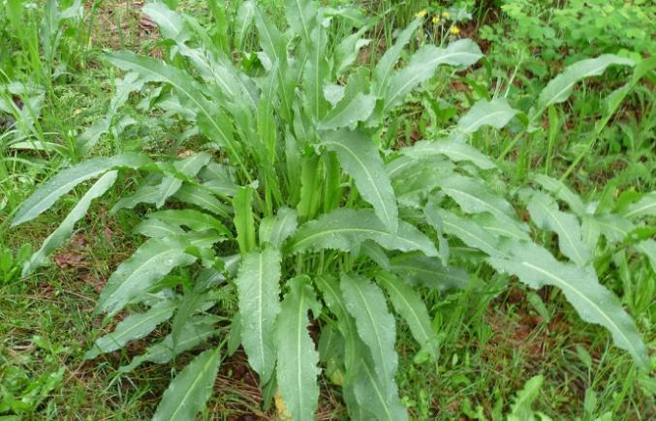
Fig:1. Rumex Plant

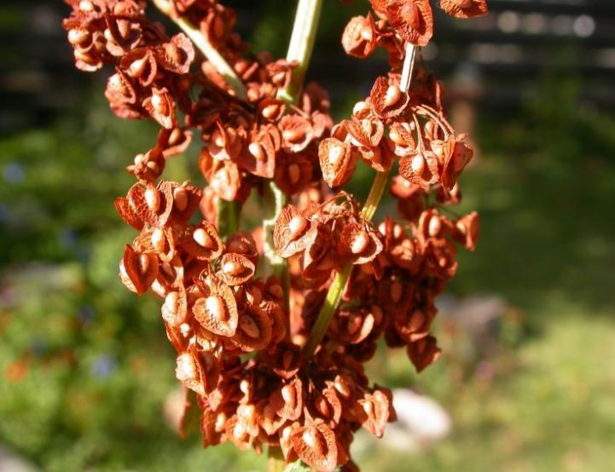

Fig:2. Rumex Flower

GEOGRAPHICAL SOURCE:

Rumex species plays a crucial role in global folks medicine in Southern Africa, India, America, China and Turkey. It is also distributed in France, Italy, Kazakhstan, Newzealand, Norway, Germany, Finland, Europe, Australia, Denmark, United Kingdom, Russia, Ukraine, Switzerland and sweden [13].

MEDICINAL USES:

Rumex species were first used medicinally in China "Shennong's Herbal Classic," which is used in the treatment of fever, gynecological illnesses, scabies, and head lice [14]. Rumex roots, commonly known as dock roots, are used to treat bacterial infections, jaundice, constipation, inflammation, tumors, and cardiovascular problems. Some of the rumex species are used in the treatment of urinary inflammation, dysentery, skin burn, laxative, diuretic, chronic cutaneous diseases, astringent, osteomyelitis skin treatment, hepatitis sedative properties, gallstones, and liver diseases. Leaves and roots of Rumex maritimus are used as Central nervous system depressants, Cathartic, Antipruritic, Purgative, and Antidiarrheal [15].

EXTRACTIONS:

- Leaves, roots, seeds, and flowers are collected
- washed and dried at 25°C or dark place
- Cut into small pieces then carefully loaded in a paper bag.
- In a 70% hydro-methanol solution, 100g of rumex species are extracted at 27°C room temperature.
- Filtered and evaporated at 55°C.
- Again, dried to obtain dried gum [16].

CHEMICAL CONSTITUENTS:

The acid plays a crucial role in Rumex species that mostly contain fatty acids like Linoleic acid, steric acids, benzoic acid, Ferulic acid and palmitic acids, which are separated from Rumex indurates. Likewise, Oxalic acid from Rumex abyssinicus and citric acid, tartaric acid from species of Rumex nervous. Antifungal activity has been detected in the presence of Chrysophanic acid separated from Rumex abissinicus and Rumex nepalensis. Similarly, rumex species root contains ferulic acid and leave contain ascorbic acids act as antitumor and antioxidants agent [17]. More numbers of species are rich source of quinones, which are present in root including anthraquinones, anthraquinones, seco-anthraquinones. They are three significant anthraquinones, 1,5-dihydroxy-3-methyl anthraquinone, 1,3,5-trihydroxy-6-hydroxymethyl anthraquinone, and 1,5-dihydroxy-3-methoxy-7-methyl anthraquinone were isolated from the roots of Rumex crispus through chemical analysis of pharmaceutically important anthraquinones. These substances are used to treat constipation and purify the blood in cases of skin complaints [18]. Most of the flavonoids are obtained from kaempferol and quercetin associated with rhamnosyl, arabinosyl, glucosyl and galactosyl at different positions [19]. Seperate the a chromone glucoside like 2,5-dimethyl-7-hydroxy chromone-7-O-β-D-glucoside, from Rumex gmelini root and also seperate the five chromones such as 2,5-dimethyl-7-hydroxy chromone, 5-methoxy-7-hydroxy-1(3H)-chromone, 2,5-dimethyl-7-hydroxy chromone-7-O-β-D-glucoside, 7-hydroxy-2,3-methyl-chromone and 5,7-dihydroxy-1(3H)-chromone from Rumex nepalensis, Rumex cristatus, Rumex patientia and Rumex gmelinite [20]. The aerial parts of Rumex acetosa were extracted using acetone and water, and the ethyl acetate extract contains high amounts of tannins. The chemical constituents of Rumex species were determined using the Liquid chromatography-mass spectrometry methods. Flowers and stems of Rumex tetanus contain 60 constituents, it can be identified by using untargeted metabolomic profiling and UHPLC-Q-TOF-MS analysis. The majority of phenolic compounds in flowers have been identified as quercetin-3-O-D-glucuronide and in stems epicatechin-3-O-gallate. The highest content of hydroxycinnamic acids are present in Rumex acetosella leaves (18 mgg−1), proanthocyanids from leaves of Rumex crispus, Rumex obtusifolius, and Rumex sanguineus (6.4 to 7.2 mgg−1) and catechins are found in R. sanguineus leaves (13 mgg−1). Isolation of rumex species produce six stilbenes that are Resveratrol, 3,5-dihydroxy-4'-methoxystilbene, 5,4'-Dihydroxy-3-methoxystilbene, (Z)-resveratrol, polydatin and 5,4'-dihydroxy-stilbene-3-O-α-arabinoside. These stilbenes are used as antioxidants agent and cardiovascular protective. 6-hydroxy-11-deoxy-13-dehydrohetisane, 7,11,14-trihydroxy-2,13-dioxohetisane and 6,13,15-trihydroxyhetisan are synthesized from tetra- or pentacyclic diterpenes that are present in the Rumex pictus [21]. The steroids stigmastane, α-cholestanol and β-cholestanol are separated from R.induratus, likewise, β-sitosterol-3-O-β-D-glycoside and β-cholestane are separated from R. patientia [22].

PHARMACOLOGICAL ACTIVITY:

Rumex species are used as food and medicine. These species have more pharmacological and phytochemistry properties. The parts of plants are collected, washed, and dried, and extract from the chemical constituents. Through the chemical constitution pharmacological properties are identified that are used for treating disease and developing modern science [23].

ANTI-INFLAMMATORY ACTIVITY:

The high dose of Rumex patientia root (aqueous extract) 150 mg/kg reduced the edema with indomethacin the positive control at 10 mg/kg, 36.6%. Intestinal epithelial cells treated with methanolic extracts of Rumex roseus's roots and stem indicated anti-inflammatory properties, reducing TNF, IL-6 and IL-8. Rumex crispus root ethyl acetate extract exhibited anti-inflammatory action by preventing Nitric oxide formation and reducing the release of proinflammatory cytokines [24].

ANTIOXIDANT ACTIVITY:

The rumex sample was evaluated in its capacity to scavenge free radicals using the stable radical DPPH for determining the antioxidant activity. Each Rumex sample was dissolved in 1 mL of methanol, mixed thoroughly, and allowed to incubate for 15 minutes in the dark room at temperature of 25°C and varying concentration with the same volume of 0.3 mm DPPH in a solution of methanol. Using a UV-visible spectrophotometer to measure the absorption. antioxidant activity was found in Rumex acetosa by the root of 80% methanol extract showing IC50 = 117.6 μM high scavenging activity to DPPH free radicals and for leaves IC50 = 201.9 μM, fruits and flowers IC50 = 230.8 μM, stems IC50 = 410.9 μM [25].

ANTIMICROBIAL ACTIVITY:

The agar diffusion assay was performed as described as the process given by Cappuccino and Sherman. First, sterilized the Whatman filter paper and saturated it with 100 ml of the extract. Second, Inoculation of young cultures on the surface agar plates. Finally incubate the petri dishes at 37°C for 24 hours. Then it can be carried out in triplicate, and the inhibition zone diameter was calculated and compared with Dimethyl sulfoxide. Antibiotics, penicillin, clotrimazole, and chloramphenicol were utilized. Isolate the root of Rumex japonicus obtained methoxy-stypandrone, naphthalenes and torachrysone indicate the inhibitory activity on both gram-positive and gram-negative bacteria. Rumex sanguineus and Rumex crispus plants have wound healing properties because they have anti-Acinetobacter baumannii activities [26].

ANTIVIRUS ACTIVITY:

Rumex aquaticus 1,4-naphthoquinone and naphthalenes exhibited antiviral activity against Vero cells that were caused with HSV-2 (herpes simplex virus type 2) replication. On a conventional virus produce reduction test and qPCR assay, musizin exhibited dose-dependent inhibitory property, resulting in a 2.00 log10 reduction in HSV-2 at a concentration of 6.25 M. It implied that R. aquaticus might be used to treat people with HSV-2 infections. R. acetosa exhibits antiviral activity through plaque reduction and MTT assay against vero cells [27].

ANTITUMOR ACTIVITY:

Inhibition of cancer cell proliferation by using MTT assays on MCF7 (human breast adenocarcinoma) cell lines, HeLa (human cervical carcinoma) and A431 (skin epidermoid carcinoma) exhibit the Rumex acetosa and R. thyrsiflorus properties. Rumex vesicarius shows greater cytotoxic in vitro with nontoxic on zebrafish development (IG50 = 33.45 - 62.56 μM) at concentration 30 µg/mL. The chloroform stem extract of Rumex vesicarius is applied to the zebrafish embryos for preventing the growth of 100% subintestinal vein blood vessels and around 70% of intersegmental blood vessels. This implies that the chloroform stem extract has evident anticancer properties [28].

ANTIDIABETIC ACTIVITY:

Rumex crispus root produces physcion and Chrysophanol then inhibitory activity exhibited from the alcohol extract of Rumex acetosella in α-glucosidase with IG₅₀ value, they show anti-diabetic properties. The seed of ethanolic extract of Rumex obtusifolius is administered through the oral route, increasing glucose tolerance, decreasing the fasting glucose level, and increasing the glycogen level in the liver. It decreases the low-density lipoprotein cholesterol level, liver enzymes level, and total cholesterol level but it increases the high-density lipoprotein cholesterol level. This Rumex obtusifolius plant shows high potential to cure diabetes [29].

CONCLUSION:

The genus rumex is generally distributed throughout the world, it contains more than 200 species belonging to the family Polygonaceae. Rumex species are used in food, medicine and pharmaceutical industries because it is rich in nutrition, secondary metabolites and pharmacological activities. Leaves, roots, seeds, flowers, and some extracts are used to treat many various diseases like kidney disorder, urinary inflammation, jaundice, skin disease, diuretics, laxatives, regulations of digestive system, diabetes, constipation, chronic cutaneous, analgesic, cancer, gallstones. These species have greater potential for regrowth after wound. Some species contains oxalic acid it makes difficult to digest the food and create stone in kidney or digestive problems. The current studies are focused on the bioactive compounds, biosafety, more evaluation in chemical constituents and their efficiency for developing modern science.

REFERENCES:

- Saleh NAM, Elhadidi N, Arafa RFM. Flavonoids and anthraquinones of some egyptian Rumex species (Polygonaceae) Biochem Syst Ecol. 1993;21:301–303. doi: 10.1016/0305-1978(93)90049-W.
- Liddell HG, Scott R, Jones HS, McKenzie R. A Greek-English lexicon. In: Fontaine D, editor. 9th edn. Oxford: Clarendon Press; 1940. p. 442.
- Wegiera, M., D, S. H. and D, W. (2007). Anthracene derivatives in some Rumex L. species. Acta. Socie. Botanicorum. Poloniae, 76: 103-108.
- Munavum M R, Mudamba L O and Ogur J A. (1984). Isolation and Characterization of the major Anthraquinone Pigments from Rumexabysinica. PlantaMedica, 50: 111-111.
- Siener R, Honow R, Seidler A, Voss S, Hesse A. Oxalate contents of species of the Polygonaceae, Amaranthaceae and Chenopodiaceae families. Food Chem. 2006;98:220–224.
- Tukappa, A.N.K.; Londonkar, R.L.; Nayaka, H.B.; Kumar S.C.B. Cytotoxicity and hepatoprotective attributes of methanolic extract of Rumex vesicarius L. Biological Research 2015, 48, 1-9.
- Trease, G.E.; Evans W.C. Pharmacognosy (13th edn). Bailliere Tindall, London, 1989, 176-180.
- Litvinenko, Y.A.; MuzychKina, R. Phytochemical investigation of biologically active substances in certain Kazakhstan Rumex species. 1. Journal Chemistry of Natural Compounds 2003, 39, 446-449.
- Chelly M, Chelly S, Salah HB, Athmouni K, Bitto A, Sellami H, Kallel C, Allouche N, Gdoura R, Bouaziz-Ketata H. Characterization, antioxidant and protective effects of edible Rumex roseus on erythrocyte oxidative damage induced by methomyl. J Food Meas Charact. 2020;14:229–243.
- Quradha MM, Khan R, Mujeeb-ur-Rehman, Abohajeb A. Chemical composition and in vitro anticancer, antimicrobial and antioxidant activities of essential oil and methanol extract from Rumex nervosus. Nat Prod Res. 2019;33:2554–2559.
- Rogowska, A.; Szakiel, A. The role of sterols in plant response to abiotic stress. Phytochemistry Reviews 2020, 19, 1525-1538.
- Jiang L, S Z. and L X. (2007). Oxanthrone C-glycosides and epoxynaphthoquinol from the roots of Rumex japonicus,.Phytochemistry, 68: 2444-2449.
- Korpelainen H, Pietiläinen M. Sorrel (Rumex acetosa L.): not only a weed but a promising vegetable and medicinal plant. Bot Rev. 2020;86:234–246.
- Martin AC, Zim HS, Nelson AL. American wildlife and plants: a guide to wildlife food habits. New York: Dover Publications; 1951.
- Khare CP. Indian medicinal plants. An illustrated Dictionary. New York: Springer-Verlag; 2007.
- Harborne, J.B. Phenolic compounds, In Phytochemical methods, Springer, Dordrecht, 1973, 33-88,
- Kerem Z, Bilkis I, Flaishman M. A. and Sivan, L. (2006). Antioxidant Activity and Inhibition of r-glucosidase by trans-Resveratrol, Piceid, and a Novel trans-Stilbene from the Roots of Israeli Rumexbucephalophorus L. Journal Of Agriculture and Food Chemistry,, 54: 1243-1247.
- Mei RQ, Liang HX, Wang J, Zeng LH, Lu Q, Cheng YX. New seco-anthraquinone glucosides from Rumex nepalensis. Planta Med. 2009;75:1162–1164.
- Gao LM, Wei XM, Zheng SZ, Shen XW, Su YZ. Studies on chemical constituents of Rumex patientia. Chin Tradit Herbal Drugs. 2002;33:207–209.
- Wang ZY, Cheng JR, Li RM, Wang ZQ. New chromone glucoside from roots of Rumex gmelini. Nat Prod Res Dev. 2009;21:189–191.
- Bicker J, Petereit F, Hensel A. Proanthocyanidins and a phloroglucinol derivative from Rumex acetosa L. Fitoterapia. 2009;80:483–495.
- Yuan Y, Chen W, Zhang S Q and Yang G J. (2001). Study on the structure and activity of new phenolic acid compounds from Erigeron breviscapus. Zhongguozhongyaozazhi, 26: 256-258.
- Cappuccino J.G.; Sherman N. Microbiology: A laboratory Manual. Peason Benjamin Cummings. San Francisco, US, 2008.
- Kim HY, Jeon H, Bae CH, Lee Y, Kim H, Kim S. Rumex japonicus Houtt. alleviates dextran sulfate sodium-induced colitis by protecting tight junctions in mice. Integr Med Res. 2020
- Litvinenko YA, Muzychkina RA. New antioxidant phytopreparation from Rumex thyrsiflorus roots III. Chem Nat Compd. 2008;44:239–240.
- Nishina A, Kubota K, Osawa T. Antimicrobial components, trachrysone and 2-methoxystypandrone, in Rumex Japonicus Houtt. J Agr Food Chem. 1993;41:1772–1775.
- Gescher K, Hensel A, Hafezi W, Derksen A, Kühn J. Oligomeric proanthocyanidins from Rumex acetosa L. inhibit the attachment of herpes simplex virus type-1. Antivir Res. 2011;89:9–18.
- Tukappa NKA, Londonkar RL, Nayaka HB, Kumar CBS. Cytotoxicity and hepatoprotective attributes of methanolic extract of Rumex vesicarius L. Biol Res. 2015;48:19.
- Aghajanyan A, Nikoyan A, Trchounian A. Biochemical activity and hypoglycemic effects of Rumex obtusifolius L. seeds used in Armenian traditional medicine. Biomed Res Int. 2018 doi: 10.1155/2018/4526352.

