Sustainable Filter Media in Effluent Management
^{*,1}K.K. Sivakumar, ²S. Kumar and ³S. Nandhini
^{*,1}Department of Chemistry, AMET University, Chennai.
²Department of Mechanical Engineering, Wollega University, Ethiopia.
³Department of Public Health, SRIHER University, Chennai.

ABSTRACT
As the population is increasing, the effluent from domestic applications rapidly increasing throughout the countries in specific fast developing countries like India since all the living being on the globe is utilizing water vigorously for their all requirements. By looking all these challenges and to look over the newer water demands, the effluent from domestic applications treatment is a feasible alternative for fresh water make up either in industrial and domestic reuse pattern. The main objective of this study is to identify the pollutants qualitatively and quantitatively present in the effluent from domestic applications as well as to bring of the effectiveness of using the waste agricultural byproducts of raw coconut fiber and raw rice husk is combine with natural sand material and natural stones pebbles for the filtration of collected effluent. The effluent from domestic applications. The study of the effluent from domestic applications is collected from the residential hall of Marine institute, Chennai. All physico-chemical quality parameters are measured for collected samples in respect of its inflow and outflow through the filtration chambers. The parameters tested in these study includes pH, Turbidity, Chloride, Total solids, Dissolved solids and Suspended solids, Nitrate, Chemical Oxygen Demand (COD), Phosphate, Coliform (Total and Faecal). It has been identified as, both raw coconut fibers and raw rice husk which might be utilized as an effective alternate conventional filter medias in the removal of pollutants available in the effluent from domestic applications. In parallel Raw Rice husk acts as an adsorbent for removal of chemical pollutants including heavy metals from the effluent of domestic applications and raw coconut fiber removes fungi material as there is large amount of micropores to standard surface area ratio.
Key Word: Adsorption, Agricultural byproducts, Effluent management, Pollutants, Raw Coconut fiber, Raw Rice husk.

INTRODUCTION
The environmental condition in the globe is undergoing threat to its earlier level which is mainly in water cycle compared to other cycles. Unfortunately non availability of water in an mixed sanctification once it is turned into effluent due to various manmade activities. The untreated or partially treated the effluent from domestic applications can pose an environmental and health found risk for humans. If the presence in certain level of coliform (Total and Faecal) bacteria, which is already originated in human intestines, which is the indicators of partially or untreated treated sewage effluent. The bacteria availability in water source is considered as an indicator of recent fecal contamination. Coliforms-Faecal bacteria is not usually harmful, but are easily accountable and which may indicate the occurrence of other disease producing biomaterials carried away in the human intestine such as cholera, diphtheria, E.coli and streptococcal diseases. Availability of domestic water source in the fast developing and developing countries are facing serious menace from contamination problems due to both man-made industrial and agricultural activities. In many countries, ground water is used for drinking purposes and it is adulterated with toxic cations, anions, heavy metal compounds, organic compounds and dye stuffs due to continuous input of effluent from industries [1]. The fast population growth in the amount of the effluent from domestic applications has been increasing rapidly all over the countries. The required qualities in water is highly essential to a healthy ecosystem. The effluent from domestic applications contains high level of N₂ and P concentration leads the growth of aquatic flora and fauna that flourish in nutrient-rich conditions, and over time this can have a negative influence on aquatic/marine life. The effluent of domestic applications from septic systems can leach into the neighboring porous limestone media and ultimately pollute the groundwater, introducing excessive nutrients and even harmful bacteria into surface waters. The effluent from domestic applications is still the vital cause of ecological damage. For the last few decades it has been burning issue for the scientist to select a viable filter media for domestic effluent treatment. The natural fresh water resource is high crisis and becoming a global issue for the experts as extensive use of ground water for decades after decades has led to unannounced recent emergency of natural fresh water resources. Treatment of the effluent from domestic applications might serve two resolutions at the same time. Firstly, purpose of treatment should be fulfilled and secondly, recent crisis of fresh water resources can be solved to meet the regulatory bodies suggestion. So the treatment of effluent from domestic applications has moved into an indispensable issues considering the ecological sectors. In the earlier period of researches, there has been the development of many methods such as chemical oxidation, photolysis, adsorption and microbial degradation, which are used for the treatment of effluent from domestic applications [2,3,4]. The recent developments in the effluent treatment disfavor due to higher capital investment and operational expenditure are the main problems in the disposal of the residual sludge mixed with heavy metals [5]. Ultimately is lead to search for the new possible cheaper, handy in operation and high efficient substituent methods. Utilization of locally available natural bio-resources as a biofilm provision media in the effluent management is an immediate attention for the newer, cost effective technology.
Agricultural by-product is one of the major sources of activated carbons in the effluent management. The activated carbons is used to remove organic and inorganic pollutants from water is widely extended, because of their high surface area, micro porous character and the chemical nature of their surface [6]. The conversion of agricultural by-products into activated carbon functions with two purposes. Firstly, it converts agricultural waste into useful adsorbents. Secondly, activated carbons are being used in water treatment for removing organic, inorganic and heavy metals of environmental or economic concerns [7]. In this research it is attempted that a new substituent of raw materials not using activated carbon. Both form as a pure natural substituent and agricultural waste, coconut fiber and rice husk can be considered. In India, all the states has coconut fiber which is cheap too. Since India is an agricultural country where rice is produced in a large amount. Raw rice husk accounts for approximately 20% of its content rice which is also attracted for the study [8].
The presence of rigid organic matter in coconut such as lignin and cellulose material with relative specific surface area and wetting ability, it seems appropriate choice for microorganism’s adhesion and biofilm tendency [9]. Raw fiber of coconut as biofilm treatment system is introduced at some local authorities in Island countries like Sri Lanka to treat the collected sewage and leachate at waste disposal sites [10]. The higher the amount of microspore’s with standard surface area presenting in coconut fiber leads for the study. More impetuous lignocelluloses can simultaneously function as a support material because of its slower degradation rates as organic material can perform a dual activity by providing substrate for the bacterial metabolism [11]. Raw Rice Husk consists of cellulose, lignin, hemicelluloses and minerals with 22%, 324%, 21% and 15% respectively [12]. Raw Rice Husk has a granular structure, good chemical stability, high mechanical strength, unique chemical composition and low cost [13]. Raw Rice husk, if it is used as filter media, after the expiration of efficiency of filter media, the disposal of the used rice husk might not cause any negative damage to the environment. Moreover it can be used as natural fertilizer. For these reasons, the study is subjected with raw coconut fiber and raw rice husk.
The main objectives of this study include developing the low cost alternative filter media for the conventional effluent management from domestic applications to investigate the efficiency of the developed raw coconut fiber and raw rice husk filter, determining selected physical and adsorptive properties of such natural materials. Moreover, to assess the suitability and operation and maintenance difficulties arising in filter media and its running time, filtration performance of a developed of raw coconut fiber and raw rice husk filter for sustainable use in the effluent management.

METHODOLOGY

Materials
Filter Media
(i) Raw Fiber of the Coconut, (ii) Raw Rice Husk, (iii) ½” stone pebbles and (iv) Sand
Analysis of Grain size
Fiber Coconut, Rice husk and stones pebble is represented in Figure-1 to Figure-6. Besides, fineness modulus of sand is presented in Table 1.
Table 1: Fineness modulus of sand
Sl. No. | Sieve Number | Retained Weight (g) | Retained Cumulative Weight (g) | Percent cumulative weight | FM value
1 | 4 | 12.5 | 12.5 | 2.6 | 2.86
2 | 8 | 31.8 | 44.3 | 9.25
3 | 16 | 97.7 | 142 | 29.64
4 | 30 | 143.4 | 285.4 | 59.58
5 | 50 | 121.1 | 406.5 | 84.86
6 | 100 | 72.5 | 479 | 100

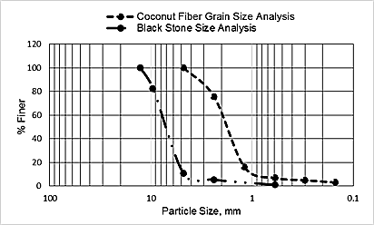
Figure 1: Raw Coconut fiber and stone pebbles Grain size analysis
Figure 2: Rice husk and Stone pebbles Grain Size analysis
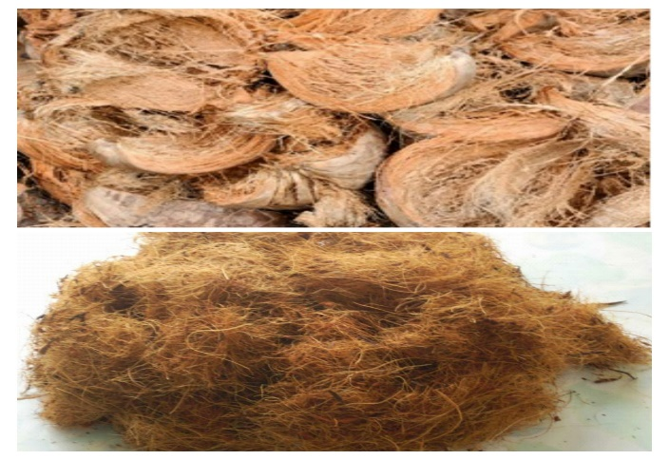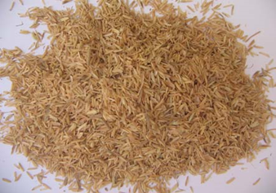
Figure 3: Coconut fiber Figure 4: Rice husk
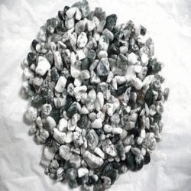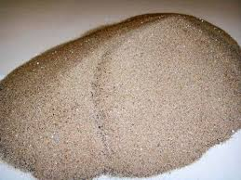
Figure 5: Stone pebbles Figure 6: Sand

Filter Media Assembly
The experiment procedure consists of different two set ups which is shown in the Figure 7. First stage is of all a bucket was taken which had a diameter of 40.50 cm and a height of 40 cm. The instrumental set up has given below. In every phase 2.5 cm sand and 5 cm stone pebbles was provided. Coconut fiber and rice husk were provided in mid layer with 20 cm thickness.
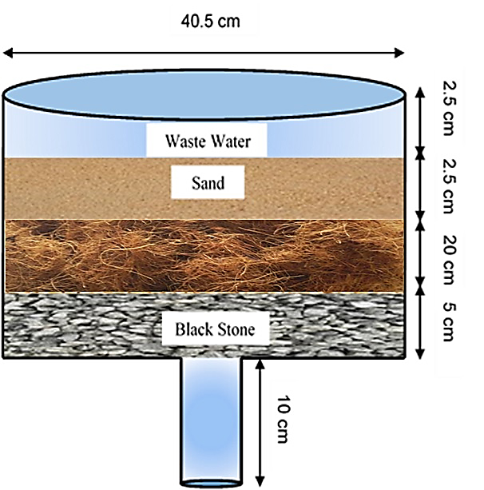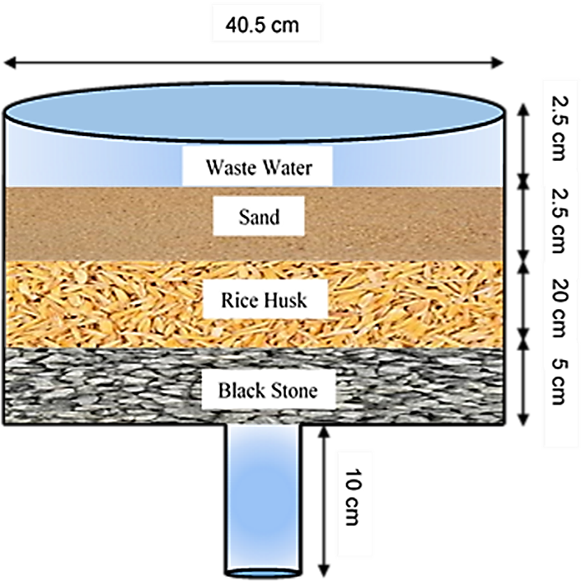
Coconut Fiber
Figure 7: Experimental set up of filter media

RESULT AND DISCUSSION
Many attempts are made in the velocity of effluent passes from inflow to outflow through filter media and in the estimation of all the physicochemical parameters. The physicochemical parameters in this study include pH, turbidity, total suspended solids (TSS), total dissolved solids (TDS), Chemical Oxygen Demand (COD), phosphate, chloride, nitrate, Coliform (Total and Faecal) is measured for collected effluent in filter media of inward flow and outward flow water is shown in Table-2.
Table-2: Filter Efficiency
Parameters | Unit | Effluent characteristics | Coconut Fiber Media | Rice Husk Media | Indian Standard for Discharge  (Irrigated land)
COD | mg/L | 1920 | 1860 | 1790 | 600
pH | -- | 7.69 | 7.71 | 7.57 | 6.5 - 8.5
Turbity | NTU | 223 | 59 | 74 | 50
Phosphate | mg/L | 60.5 | 53.5 | 38.5 | -
Chloride | mg/L | 850 | 845 | 830 | 600
Nitrate | mg/L | 70 | 46 | 45 | 10
Total Suspended Solids (TSS) | mg/L | 2870 | 1395 | 1480 | -
Total Dissolved Solids (TDS) | mg/L | 2890 | 1420 | 1500 | 2100
Total Coliform | Nos. | 31 | 7 | 5 | 1000
Faecal Coliform | Nos. | 26 | 0 | 5 | 200
It has been found that the pH range pf 6.5 to 8.5 in an allowable range according to Inland water quality standards. Turbidity of NTU unit is reduced considerably from the initial measurement. It is also the amount of TSS and TDS has reduced potentially. The presence of nitrate and phosphate in filtered water has too decreased from the initial concentration. The decreased level of chemical oxygen demand (COD) and increased range of faecal coliform provides a warning of failure in water treatment, a break in the integrity of the distribution system, there is possible contamination with pathogens. The amount of coliform (Total and Faecal) has reduced in both filter media. The result is varying in the two different set up is shown by some graphical representation in Figure-8.
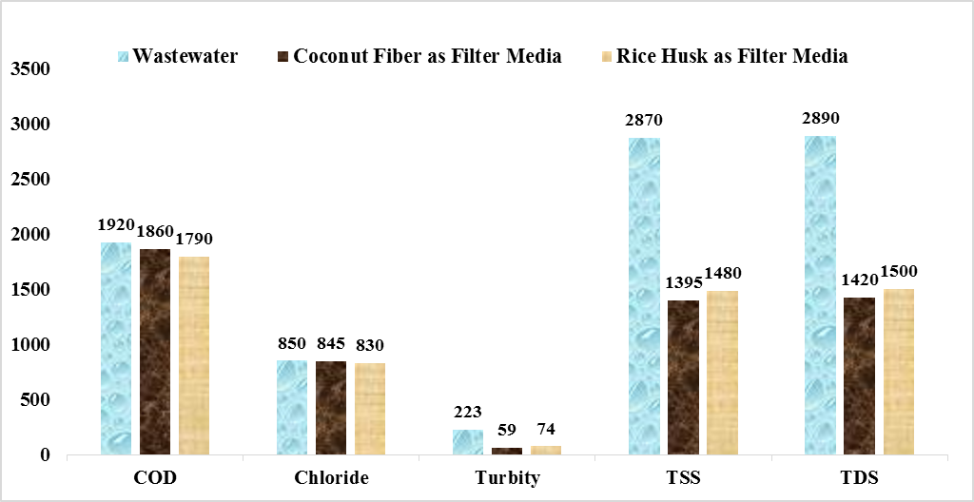
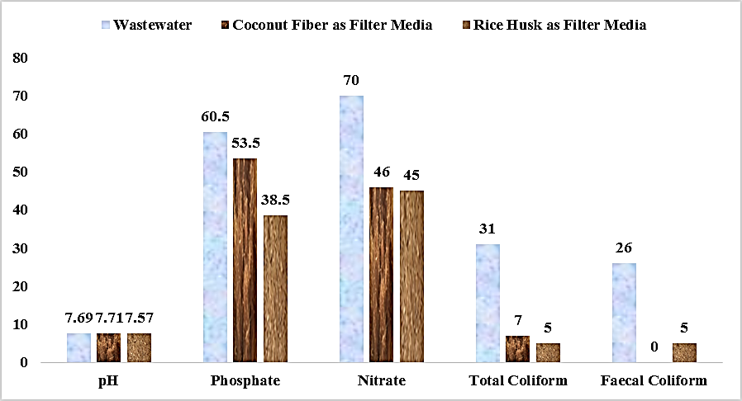
Figure 8: Variation in waste water testing parameters for filter media

CONCLUSION
The study broadly includes the inspection of pollutant present in the effluent from domestic applications and in the assessment of the effectiveness of utilizing raw coconut fiber and raw rice husk combined with sand and stones pebbles in the filtration of domestic effluent sample. The pH value and total coliform value is well suited in line with Inland water quality standard for surface water. The amount of TSS and TDS have been decreased from the initial condition of the effluent from domestic applications. Moreover, the growth of total coliform and fecal coliform has reduced perfectly. So, both raw coconut fiber and raw rice husk are mostly suitable for the effluent management as filter media.

RECOMMENDATION
Even though some investigative parameters in this study is quite good, some parameters have taken under further investigation for their improvement and some other parameters also should investigate like (i) Biochemical Oxygen Demand (BOD), (ii) Dissolved Oxygen (DO) and (iii) Heavy metals. Ultimately the experimental results shows the better adoption in terms of cost, affordability and easy availability of raw coconut fiber and raw rice husk may be used together as filter media with stone pebbles and sand in domestic effluent management.

REFERENCES
1. C. Namasivayam and D. Sangeetha, 2006, Recycling of agricultural solid waste, coir pith in the removal of anions, heavy metals, organics and dyes from water by adsorption onto ZnCl₂ activated coir pith carbon. Journal of Hazardous Materials, 135, 449–452.
2. P.W Lankford and W.W. Eckenfelder, 1990, Toxicity Reduction in Industrial Effluents, Van Nostrand Reinhold.
3. D.H. Kim and M.A. Anderson, 1994, Photoelectrocatalytic degradation of formic acid using a porous titanium dioxide thin-film electrode. Environmental Science and Technology, 28(3), 479-483.
4. A.A.M. Daifullah and B.S. Girgis, 1998, Removal of substituted phenols by activated carbon obtained from agricultural waste, Water Research, 32(4), 1169–1177.
5. D.C. Sharma and C.F. Forester, 1994, A preliminary examination into the adsorption of hexavalent chromium using low-cost adsorbents, Bioresource Technology, 47(3), 257-264.
6. K.K. Sivakumar, Mohamed Haroon Basha and Nandhini, 2021, ZnO/UV induced photocatalytic degradation of textile dyes, Research Journal of Chemistry and Environment, 25(5), 160-165.
7. A.A.M. Daifullah, B.S. Girgis, and H.M.H. Gad, 2003, Utilization of agro-residues rice husk in effluent from domestic applications treatment plans, Materials Letters, 57(11), 1723–1731.
8. K.G. Mansaray and A.E. Ghaly, 1998, Thermogravimetric analysis of rice husks in an air atmosphere, Energy Source, 20(7), 653-663.
9. K.K. Sivakumar and M.S. Dheenadayalan, 2012, Utilization of environmental waste materials in the removal of heavy metals from industrial effluents, European Chemical Bulletin, 1(5).
10. N. Sato, K. Kawamoto, H. Sato, M. Lokuliyanaga, T. Koide and N. Tanaka, 2013, Utilization of a local available biomass resource for The effluent from domestic applications treatment in Sri Lanka: Comparison between initial and current performance of coconut-fiber biofilm treatment system (COTS), Proceedings of 14th International Waste Management and Landfill Symposium.
11. H.N. Chanakya, N. Ramamurthy, V. Shanmukhappa, D. Vinutha and G.B. Deepa, 2004, Biomassbiofilm bioreactors for liquid and solid wastes of agro processing field performance studies, International Conference on Advances in Industrial effluent from domestic applications Treatment, 441-450.
12. P.D. Grover, 1989, Thermochemical characterization of biomass residues for gasification, Indian Institute of Technology.
13. N. Abdel-Ghani, M. Hefny and G.A. ElChaghaby, 2007, Removal of lead from aqueous solution using low cost abundantly available adsorbents, International Journal of Environmental Science and Technology, 4(1), 67-73.

