Watershed Development- A Case Study on Harsule Village

Armaanjot Singh
Student, Punjab Agricultural University, Ludhiana, India – 141004.
Email: armaanjot-2002054@pau.edu
Mukesh Siag, Samanpreet Kaur
Punjab Agricultural University, Ludhiana, India – 141004

Introduction
A watershed is the area supplying water to a stream or river, ranging from small hectares to large expanses. It comprises the ridge line as the outermost boundary and the valley region where water from hilly areas collects. Drainage lines or streams carry water from the ridge line to the valley region, which serves as the outlet of the watershed.
India occupies about 2.4% of the world's geographical area, with a huge population and limited land resources leading to degradation of agricultural lands and conversion into wastelands. Restoring non-forested wastelands is essential to utilize the available land resources fully and prevent further degradation. Wasteland development aims to address the complex and multi-dimensional problems of degraded land and water management, while also developing human resources in watershed development and management.
The chosen site for the watershed development project is located near Harsule Village in Sinnartaluka of Nashik District. It is situated 13 km away from Sinnar town and 33 km from Nashik City, with latitude and longitude coordinates of approximately 19.822455 and 73.940904, respectively. During the summer season, water scarcity becomes an issue, and the water table declines. To tackle this problem, measures are required to recharge the groundwater sources using suitable techniques.

MATERIALS AND METHODOLOGY
- Site selection:

Site selection for watershed development involves the consideration of various factors related to both land characteristics and social aspects. These factors include indicators such as diminished soil fertility, uneven topography, soil degradation, erosion, reduced groundwater levels, absence of land treatment structures, downstream consequences, improper agricultural methods, deforestation, and regions with high rainfall. Additionally, social criteria contribute to the decision-making process, encompassing factors like the presence of small-scale farmers, access to labor, adeptness in managing credit, tribal identity, community engagement and enthusiasm, existence of local institutions, poverty levels, absence of alternative income opportunities, instances of bonded labor, and inability to fulfill basic consumption needs. The chosen location for the watershed development initiative is in close proximity to HarsuleVillage within the Sinnartaluka of Nashik District. This site is situated approximately13 kilometers away from Sinnar town and about 33 kilometers from Nashik City.
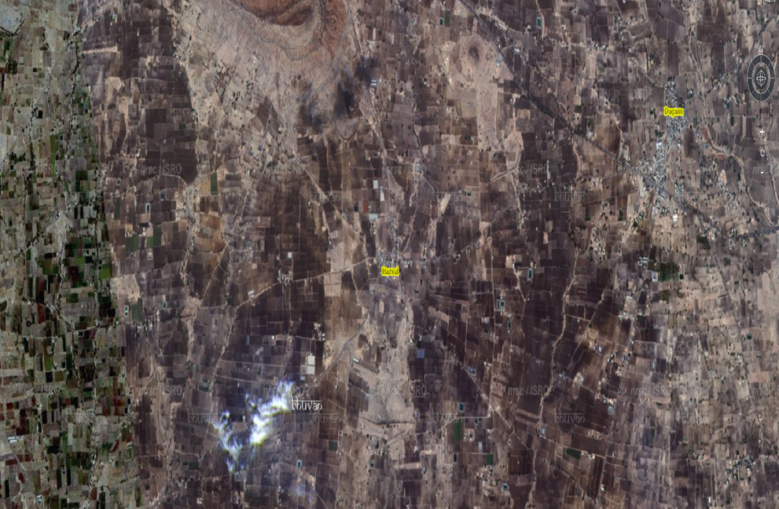
Img: Image from satellite of village Harsule
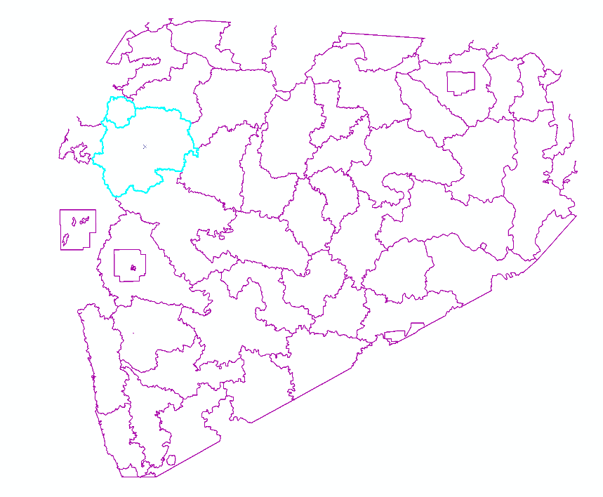
Img: GIS generated image of Nashik district

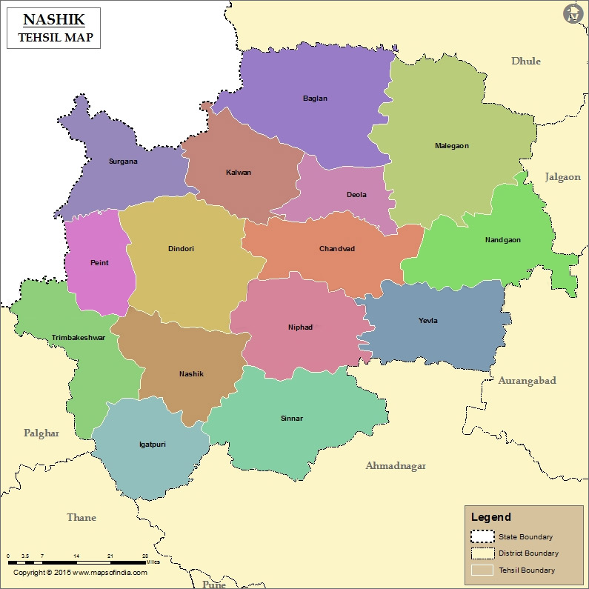
Img: Nashik Tehsil Map from www.mapsofindia.com

- Various watershed area treatments:

1) Bunding: In agricultural land with a slope of 1–6%, little earthen barriers are built to slow down runoff, stop gully and rill formation, and hold water.
2) Continuous Contour Trenches (CCT): To hold water along slopes and stop soil erosion, pits are dug along contour lines.
3) Water Absorption Trench (WAT): Trenches are carved out above agricultural areas to catch rainwater and let it seep into the soil, replenishing groundwater and enhancing soil moisture.
4) Contour Stone Bunds (CSB): Stone bunds are positioned along contour lines to filter runoff water, delay its flow, and spread it out, enhancing infiltration and lowering soil erosion.
5) Gully plug (GP): By acting as a soil trap, gully plugs stop soil erosion during rain and floods. They are built utilizing techniques based on stone.
6) Loose Boulder Structure (LBS): Small barriers are erected across drainage ditches using boulders, fiber rolls, gravel bags, sandbags, or other reusable materials to slow the flow of water, allowing silt to settle and preventing erosion.
7) Earthen Gully Plug (EGP): To hold onto water and promote percolation into the ground, earth plugs are built across gullies.
8) Gabion Structure: In nala locations where other water conservation measures are not practical, gabion structures are created. They aid in preventing soil erosion, and the site of these structures should be carefully chosen to prevent soil blow into banks.
Within the watershed area, these treatments assist control water flow, stop erosion, and improve soil and water resources.

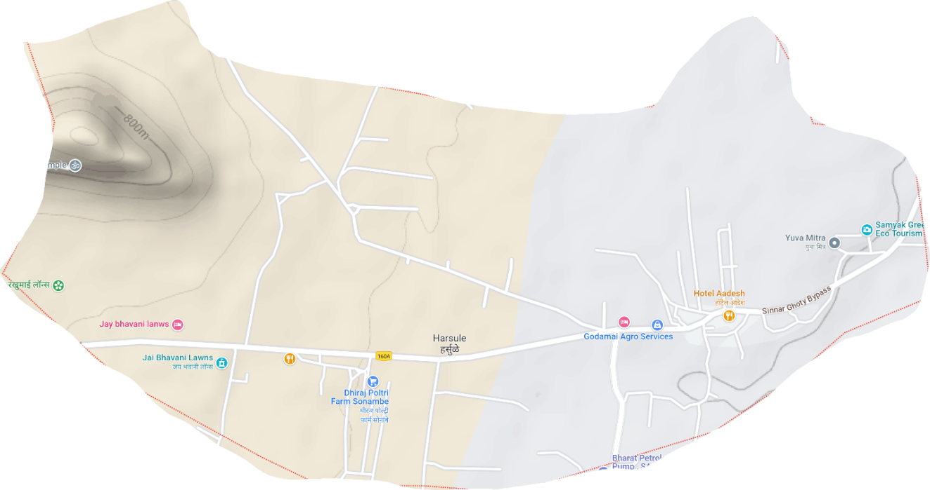
Img: Terrain Image of village Harsule

DATA COLLECTION AND ANALYSIS

- Water Audit:A water analysis is a thorough examination of the water resources in the village. The situation is dire in Harsule, a remote village in Maharashtra that is vulnerable to drought and lacks the natural resources needed for rural living. Villagers must frequently travel great distances to get water because access to safe drinking water is not always guaranteed. Water scarcity has a significant impact on agriculture, necessitating the use of water tankers and wasting resources and money. A scarcity of water has led to many villages abandoning their arable land. In order to address this, a survey was carried out, gathering information from the Gram Panchayat about the availability of water for everyday usage, agriculture, livestock, and other uses.

Table 1: Demographic details
Sr. No | Population Classification |  | Workers in Village | Members involved
1 | Total Population | 782 | Farmers | 638
2 | Male | 408 | Farm Labours | 256
3 | Female | 374 | Labours | 28
4 | No. of Families | 152 | Businessmen | 25
5 | Schedule Caste | 24 | Trader | 5
6 | Schedule Tribe | 165 | Skilled Labour | 150
7 | Sex Ratio | 917 | Milk Business | 103
8 | Children | 104 | Other than Agriculture | 200

Table 2: Animals used for agriculture and other purpose:
Sr. No | Type of Animals | Number of Animals
1 | Hybrid Cows | 50
2 | Hybrid Ox | 20
3 | Cows | 50
4 | Buffalo | 15
5 | Goat | 50

Table 3: Geographic information
Sr. No | Classification of Area | Area(Hectare)
1 | Village Area | 970.14
2 | Area in Forest | 0.4
3 | Irrigated Area | 50
4 | Non-Irrigated Area | 50
5 | Cultivable Area | 30
6 | Actual Cultivable Area | 937.18
7 | Fertile Land | 52.54
8 | Irrigated Area | 322.1
9 | Per Capita Land | 0.37
10 | Area for each family | 1

Table 4: Present Land Use
Sr. No | Present Land Use | Area(hectare)
1 | Total Area | 970.14
2 | Cultivable Area | 291.04
3 | Wheat | 485.07
4 | Soybean | 679.1
5 | Groundnuts | 9.7
6 | Vegetables | 9.7

Table 5: Water required for different crops
Sr. No. | Crops | Need of Water(mm) | Area(hectare) | Total water required(m*3)
1 | Wheat | 500 | 485.07 | 2425.35
2 | Soybean | 550 | 679.1 | 3735.05
3 | Groundnut | 600 | 9.7 | 58.2
4 | Vegetables | 300 | 9.7 | 29.1
 |  |  | Total Water required | 6247.7
Table 6: Need of Water for Animals
Types of Animals | Water required(Gallon) | Water required(lit/year)[m*3] | No. of Animals | Total Required Water(m*3)
Human | 33.02 | 49.27 | 782 | 38533.05
Big Animals | 3-30 | 27.594 | 135 | 3725.19
Small Animals | 0.5-4 | 4.41 | 50 | 207
 |  |  | Total | 42465.24

Water for Living Animals + Water for Crops = 42465.24 + 6247.7 = 48712.94 m3 is the total amount of water needed. The additional water needs in this town are: As a result, the additional amount of water that must be kept is: = 48712.94 48605.784 = 107.156 m3.
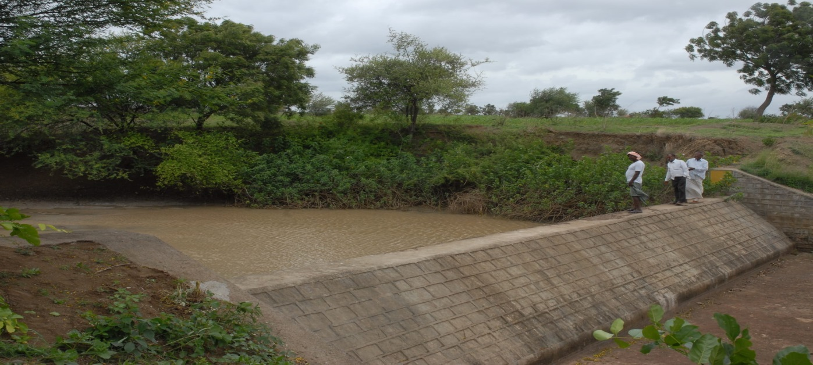
Fig: Nature Based integrated watershed management (side view)

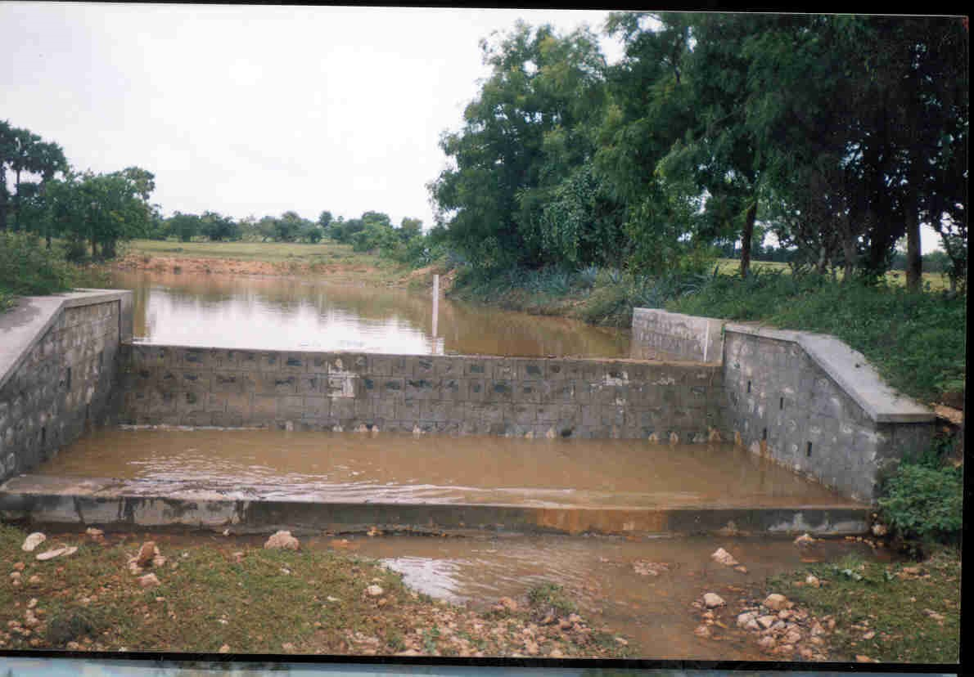
Fig: Nature Based integrated watershed management (front view)

B. General Survey: The survey comprises calculating the depth of the soil using depth ranges and the percentage of erosion using exposed rock. The slope of the land, which is crucial for area treatment and structure design, is computed as 17.22% utilizing RLs (Reduced Levels) at various sites. Utilizing annual rainfall data, average precipitation is determined.
C. Land Capability Classification: Planning soil and water conservation initiatives requires a thorough understanding of land capability classification. It entails methodically classifying various types of land according to their characteristics and capacity for long-term productivity. On-site soil testing is done to categorize the soil into distinct texture groups.
D. Potential Treatments: Suitable treatments are identified, such as seed sowing, farm bunds, pit excavation, small earthen plugs, continuous contour trenches (CCT), horticulture, and agroforestation, based on the general survey and land capability categorization. CCT was picked among them because it is good for holding onto water.
E. CCT Design: The CCT is designed using rainfall data, site and soil characteristics, and land slope in mind. The Watershed Organization Trust in Ahmednagar, India, uses a technique to determine the length and quantity of CCTs. The area treatment plan contains Plantation/Pit excavation/CCT with a total length of 8246.53 meters and a horizontal gap of 11.09 meters between two CCTs. The CCT's cross-section measures 0.54 square meters (0.6 x 0.9), and 1 meter x 1 meter.
F. Water Management: Among all the suggested area treatments, Continuous Contour Trenches, water collecting pits, and agricultural bunds can all keep water in place. A total of 164.38 cubic meters (m3) of water is thought to have been retained in CCT and trenches.

IV. OUTCOMES:
1) According to the water audit, there is a total of 48,605.785 m3 of water accessible to the people to meet their demands.2) The community requires 48,712.94 m3 of water.3) The additional water required by villagers to meet their basic needs is 107.156 m3.4) The identified area treatments include horticulture, agro-forestation, continuous contour trenching (CCT), small earthen plugs, farm bunds, seeding, and pit excavation.5) A total of 164.38 m3 of water was retained by implementing these area treatments.6) An extra 57.224 m3 of water is made accessible through watershed development.
V. CONCLUSION:
Given Data
The chosen site for the watershed development project is located near Harsule Village in Sinnartaluka of Nashik District. It is situated 13 km away from Sinnar town and 33 km from Nashik City, with latitude and longitude coordinates of approximately 19.822455 and 73.940904, respectively. During the summer season, water scarcity becomes an issue, and the water table declines. To tackle this problem, measures are required to recharge the groundwater sources using suitable techniques.

Our findings reveal the outcomes of a comprehensive water audit:
- The assessment demonstrates that the available water supply to fulfill the villagers' needs aggregates to 48,605.785 m3.
- Concurrently, the total water demand for the village reaches 48,712.94 m3.
- To adequately address the general water requirements of the villagers, a supplementary 107.156 m3 of water is imperative.
- The strategies proposed for targeted area improvements encompass diverse measures, including Seed Sowing, Farm Bunds, Pit excavation, Small Earthen Plugs, Continuous Contour Trenches (CCT), Horticulture, and Agro-forestation.
- The amalgamation of these area treatments yields a cumulative water retention of 164.38 m3.
- Further amplifying our efforts, the implementation of watershed development practices contributes an additional 57.224 m3 of water, augmenting the available resources.
- Notably, Harsule village is confronted with an incremental water demand of 107.156 m3, excluding their daily requisites. By judiciously applying various area treatments, we can ensure the conservation of 57.224 m3 of water, thus resulting in a surplus water capacity for the villagers. This enhanced availability of water stands poised to exert a positive influence on agricultural activities, elevating land productivity through the augmentation of groundwater levels.

Scope for Future Work

It was observed that the given research paper lacks with the maps, so we added the maps by using the ArcGIS. We also saw the paper lacks as there are no images of watershed management, so I added images of integrated watershed management. I also observed that no information of storage area was provided, that information would be very resourceful in development of the watershed management by an individual. I could have thought of different ways of development where I could lead this watershed in improvement phase. I could have addressed the general improvement of the watershed and the entire covered area. The management of the local forests and farms could have received more consideration. With a lot of work, further goals in soil conservation, erosion prevention, and degradation prevention might be accomplished. Additionally, I saw that groundwater was being recharged to offer a consistent supply of water for irrigation of forestry and plants.

References
[1] AkhileshJitendra Jagtap1 Sanket Sunil Bhadane2 , has published paper on Watershed Development- A Case Study on Harsule Village (2020).
[2] MaruekCharnsungnern, SittichaiTantanasarit, has published paper on Environmental sustainability of highland agricultural land use patterns for Mae Raem and Mae Sa watersheds, Chiang Mai province. (27 April 2017).
[3] KeighobadJafarzadegan, VenkateshMerwade, has published paper on A DEM-based approach for largescale floodplain mapping in ungauged watersheds (2017)
[4] Scott Haag, Ali Shokoufandeh, has published paper on Development of a data model to facilitate rapid watershed delineation (15 June 2017).
[5] Timothy P. Sullivan, YongliGao, has published paper on Development of a new P3 (Probability, Protection, and Precipitation) method for vulnerability, hazard, and risk intensity index assessments in karst watersheds (2017).
[6] K. Ibrahim-Bathis, S.A. Ahmed, has published paper on Geospatial technology for delineating groundwater potential zones in Doddahalla watershed of Chitradurga district, India (17 June 2017).
[7] Maryam Adhami, SeyedHamidrezaSadeghi, has published paper on Sub-watershed prioritization based on sediment yield using game theory (16 Aug 2016)
[8] Timothy Nyerges, HrishikeshBallal, Carl Steinitz, Tess Canfieldd, Mary Roderick, John Ritzmana, WilawanThanatemaneerat, has published paper on Geodesign dynamics for sustainable urban watershed development (23 April 2016).
[9] Kaswanto and FitriyahNurulHidayatiUtami, has published paper on the disparity of watershed development between northern and southern region of Java Island (2015).
[10] Hsin-Fu Yeh, Youg-Sin Cheng, Hung-I. Lin, ChengHaw Lee, has published paper on Mapping groundwater

