REVIEW AND ANALYSIS OF WATER HYACINTHS AND THEIR ENVIRONMENTAL IMPACT
Dr.G.PRABHAKARAN,Ph.D¹, R.VenkadaLakshmi,M.E², S.Brindha M.E³, P.D.Reshma, M.E⁴
1.Prof, Siddharath Institute Of Engineering&Technology,Andrapradesh
2.Asst.Prof,SRM Madurai college for Engineering&Technology
3. Asst.Prof, Nehru institute of Technology
4.Asst.Prof, JCT college of Engineering&Technology

ABSTRACT:
Water hyacinth, also known as Eichhornia crassipes, is an aquatic plant that is indigenous to the Amazon basin and is frequently a very troublesome invasive species outside of its natural region. Water hyacinth growth is increasing at a rapid rate day after day, making management extremely difficult. According to observation, it is evident that water hyacinth is actually applied and beneficial in a variety of sectors, but no one has been able to investigate its negative effects on the environment. Numerous studies have been done on this, but it is still unclear how they will affect the ecosystem. This essay only reviews water hyacinth from a new angle.
1.INTRODUCTION:
Water hyacinth (Eichhornia crassipes) is a floating aquatic plant native to South America. It is known for its rapid growth rate and ability to form dense mats on the surface of water bodies, including lakes, rivers, and ponds. While water hyacinth possesses attractive flowers, its aggressive nature and ability to reproduce quickly have made it a notorious invasive species in many parts of the world.Water hyacinth has a significant impact on the environment, both positive and negative. On one hand, its dense mats can provide shelter and breeding grounds for various aquatic organisms, such as fish, birds, and insects. The roots of water hyacinth also play a crucial role in water purification by absorbing excess nutrients like nitrogen and phosphorous from the water, thereby reducing the risk of eutrophication.
However, the negative consequences of water hyacinth outweigh its ecological benefits. When the plant proliferates uncontrollably, it can cause severe ecological and socio-economic problems. The dense mats formed by water hyacinth block sunlight from reaching the submerged aquatic plants, thereby hindering their growth. This reduces oxygen levels in the water and leads to the death of fish and other organisms dependent on the ecosystem.Additionally, water hyacinth can impede water flow, block irrigation canals, and hamper navigation, causing economic losses for communities relying on these water bodies. It also hinders recreational activities such as boating, swimming, and fishing. Moreover, water hyacinth can alter the natural balance of aquatic ecosystems, displacing native plants and disrupting the biodiversity of the area.
Efforts have been made to control and manage water hyacinth infestations. Various mechanical, chemical, and biological methods have been employed to remove or control its growth. These include manual removal, harvesting, use of herbicides, and introduction of natural enemies like weevils and beetles that feed on the plant. However, managing water hyacinth infestations remains a significant challenge due to its ability to regenerate from small fragments and its rapid growth rate.In recent years, researchers and innovators have explored different ways to utilize water hyacinth for various purposes. One such application is the conversion of water hyacinth biomass into biofuels through processes like anaerobic digestion or pyrolysis. This helps to address the issue of its excessive growth while producing renewable energy sources.
Additionally, water hyacinth can be used for the production of handicrafts, paper, and other products. The fibrous nature of the plant makes it suitable for weaving baskets, mats, and furniture. Furthermore, water hyacinth can be employed in wastewater treatment systems, acting as a natural biofilter to remove pollutants and improve water quality.In conclusion, water hyacinth is an aquatic plant that holds both positive and negative implications for the environment. While it has ecological benefits such as providing habitat and aiding in water purification, its overgrowth can cause severe ecological and socio-economic problems. Efforts are being made to control its spread, and innovative applications are being explored to utilize its biomass for renewable energy and other products.
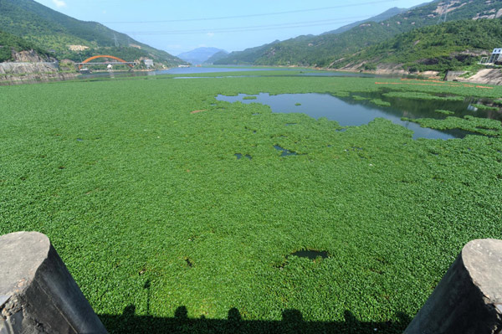
FIG.1. WATER HYANCINTH PLANTS ON UKKADAM (COIMBATORE) LAKES

2.LITERATURE REVIEW:
Ecological Impacts:
Zhang et al. (2018) studied the ecological effects of water hyacinth and emphasized its negative impact on biodiversity, water quality, and ecosystem functioning in aquatic environments.
Zhang et al. (2019) highlighted the ability of water hyacinth to alter nutrient cycles, reduce dissolved oxygen levels, and disrupt aquatic food webs.
Control and Management:
Chandra and Goyal (2016) reviewed various methods for the control and management of water hyacinth, including physical, chemical, and biological approaches. They discussed the advantages and limitations of each method.
Forno et al. (2020) explored the use of biological control agents, such as insects and pathogens, for the management of water hyacinth infestations.
Utilization of Water Hyacinth Biomass:
Ong et al. (2017) investigated the potential of water hyacinth biomass as a feedstock for bioenergy production. They discussed the different conversion technologies, such as anaerobic digestion and pyrolysis, and their feasibility.
Tripathi et al. (2018) explored the utilization of water hyacinth biomass for the production of value-added products like biochar, activated carbon, and biogas.
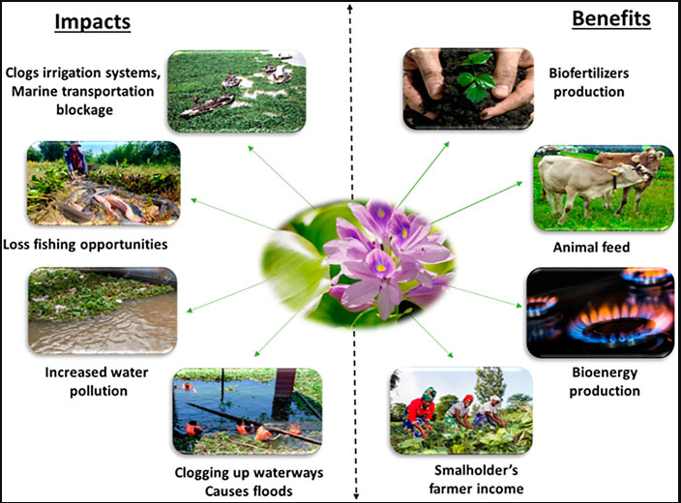
FIG.2. IMPACT ON WATER HYANCINTH PLANTS AT UKKADAM(COIMBATORE) LAKES
Water Hyacinth in Wastewater Treatment:
Njoku et al. (2019) evaluated the efficiency of water hyacinth in the removal of pollutants from wastewater. They discussed its role in nutrient uptake, heavy metal removal, and the enhancement of water quality.
Padmaperuma et al. (2020) reviewed the use of water hyacinth in constructed wetlands for the treatment of municipal and industrial wastewater.
Socio-economic Impacts and Community Involvement:
Akter et al. (2018) assessed the socio-economic impacts of water hyacinth on communities, including the loss of livelihoods and increased costs for agriculture and fisheries.
Kroma et al. (2020) discussed community-based approaches and the involvement of local communities in water hyacinth management and utilization initiatives.
3. CULTIVATION TECHNIQUES
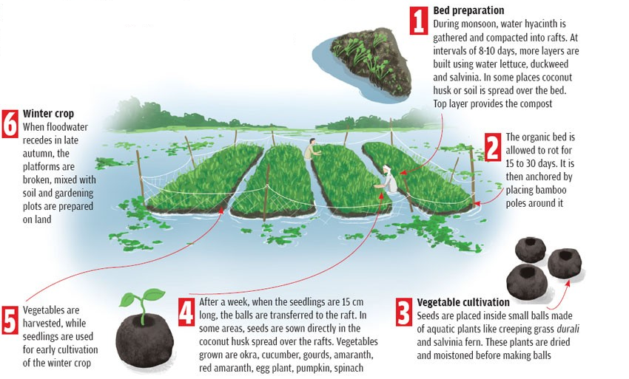
FIG.3. CULTIVATION TECHNIQUES ON WATER HYANCINTH PLANTS
Selection of Plant Material: Obtain healthy water hyacinth plants from a reputable source. Look for plants with vibrant green leaves and well-developed roots.
Water Requirements: Water hyacinth thrives in still or slow-moving water with temperatures between 25°C and 30°C (77°F-86°F). Maintain a water depth of at least 30 cm (12 inches) to allow the plants to root properly.
Nutrient Availability: Water hyacinth requires an abundant supply of nutrients to grow. If cultivating in natural water bodies, test the water for nutrient content. In case of nutrient deficiencies, supplement with appropriate fertilizers to optimize growth. Avoid excessive nutrient inputs that may lead to overgrowth.
Planting Technique: Gently separate water hyacinth plants from the roots. Place them in the water, ensuring that the roots are submerged. Maintain a spacing of about 30-45 cm (12-18 inches) between plants to avoid overcrowding.
Weed Control: Regularly monitor and remove any competing weeds or unwanted plants. This helps prevent the water hyacinth from being overshadowed or outcompeted for nutrients.
Harvesting: Depending on the purpose of cultivation, harvest water hyacinth when it has reached the desired growth stage. For biomass production, harvest when the plants have developed a sufficient biomass. If used for wastewater treatment, harvest when the plants have absorbed significant pollutants.
Waste Management: Properly dispose of harvested water hyacinth to prevent its spread to natural water bodies. Composting or utilizing the biomass for energy production are viable options.
Disease and Pest Management: Monitor for any signs of disease or pest infestations. Remove and destroy affected plants to prevent the spread. Promote a healthy growing environment through proper nutrient management and water quality control.
Legal Considerations: Check local regulations before cultivating water hyacinth, as it may be considered an invasive species in some regions. Obtain any necessary permits or permissions.
3.APPLICATIONS:
Water hyacinth (Eichhornia crassipes) has various applications that can positively impact the environment. Here are some notable applications:
Water Purification: Water hyacinth plays a crucial role in water purification by absorbing excess nutrients, particularly nitrogen and phosphorus, from the water. These nutrients are often the cause of eutrophication, which leads to harmful algal blooms and oxygen depletion. By absorbing and removing these nutrients, water hyacinth helps improve water quality and restore the ecological balance in affected water bodies.
Erosion Control: The dense mats formed by water hyacinth can help control soil erosion along riverbanks and shorelines. These mats act as a natural barrier, reducing the impact of waves and water currents that erode the soil. Water hyacinth can be strategically planted in vulnerable areas to stabilize the soil and prevent erosion, thereby protecting the surrounding environment.
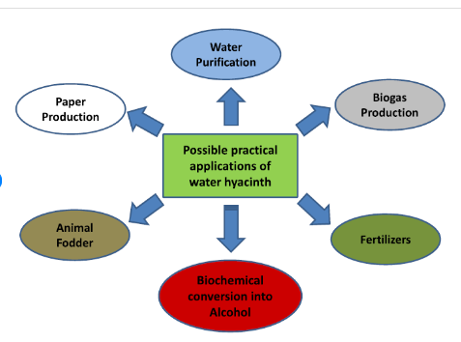
FIG.3. APPLICATIONS OF WATER HYANCINTH PLANTS
Habitat Creation: The thick mats of water hyacinth provide shelter, breeding grounds, and foraging opportunities for various aquatic organisms, including fish, birds, insects, and microorganisms. These habitats contribute to biodiversity conservation and support the ecological balance in aquatic ecosystems. Water hyacinth can increase the availability of habitats for species that rely on floating vegetation.
Phytoremediation: Water hyacinth has the ability to absorb and accumulate heavy metals and pollutants from water bodies. This process, known as phytoremediation, can help remediate contaminated water by reducing the concentration of harmful substances. Water hyacinth can be employed in constructed wetlands or as part of wastewater treatment systems to remove pollutants and improve water quality.
Biofuel Production: The biomass of water hyacinth can be utilized as a renewable energy source. It can be harvested and converted into biofuels through processes such as anaerobic digestion or pyrolysis. This application helps address the issue of excessive growth and invasive spread of water hyacinth while providing an alternative energy option that reduces reliance on fossil fuels.
Economic Opportunities: Water hyacinth can be utilized for various economic purposes, such as handicrafts, furniture, and paper production. The fibrous stems and leaves of water hyacinth make it suitable for weaving mats, baskets, and furniture items. By generating economic opportunities through the utilization of water hyacinth, communities can have a vested interest in its management and control, leading to more sustainable practices.
While water hyacinth has negative impacts when it overgrows and becomes invasive, these applications demonstrate that when properly managed, it can contribute positively to the environment by providing ecological benefits, economic opportunities, and sustainable solutions for water and land management.
4.
CONCLUSION:
Based on the literature review, water hyacinth has both positive and negative impacts on the environment. While it can provide habitat and aid in water purification, its overgrowth can lead to severe ecological and socio-economic problems. Various control and management methods have been explored, including physical, chemical, and biological approaches, but managing water hyacinth infestations remains challenging.In terms of applications, water hyacinth biomass shows potential for bioenergy production through anaerobic digestion or pyrolysis. Its fibrous nature also allows for the production of handicrafts and paper. Additionally, water hyacinth can be utilized in wastewater treatment systems to remove pollutants and improve water quality.
Further research is needed to better understand the ecological impacts of water hyacinth and develop more effective and sustainable management strategies. Exploring innovative uses of water hyacinth biomass and engaging local communities in management efforts can contribute to mitigating its negative effects on the environment while also providing economic opportunities.

5.REFERENCES:
[1] Hellmann, JJ; Byers, JE; Bierwagen, BG; Dukes, JS (2008). Five potential consequences of climate change for invasive species. Conservation Biology 22: 534-543.
[2]Ho, YB; Wong, WK (1994). Growth and macronutrient removal of water hyacinth in a small secondary sewage treatment plant.Resources, Conservation and Recycling.
[3]S. R. M. Kutty, S. N. I. Ngatenah, M. H. Isa, A. Malakahmad Civil Engineering Department, Universiti Teknologi PETRONA, World Academy of Science, Engineering and Technology 60 2009
[4] Jayaweera M.W and Kasturiarachchi J.C, (2004). ”Removal of Nitrogen and Phosphorus from industrial wastewaters by phytoremediation using water hyacinth (Eichhornia Crassipes)”. Journal of Wastewater science and technology. Volume 50, No. 6: Page 217 – 225.
[5] Nesic N. and Jovanovic L. (1996). “Potential Use of Water Hyacinth (E. Crassipens) for Wastewater Treatment in Serbia”. Journal of Wastewater treatment using the Aquatic plant.
[6] Paul Njogu1*, Robert Kinyua1, Purity Muthoni1, Yusuyuki Nemoto2 Biogas Production Using Water Hyacinth (Eicchornia crassipes) for Electricity Generation in Kenya

