“KIDNEY WELLNES :
A GUIDE TO RENAL REHABILITATION”
Author: Dr. G.Sai Chetan MPT(NEURO), Dr.Himanshu Sharma MPT( ORTHO &SPORTS)
(Lecturer and Clinical Physiotherapist in Vydehi Institute of Medical Sciences and research center , Lecturer and Senior Clinical Physiotherapist in Vydehi Institute of Medical Sciences and research center)

INTRODUCTION
Renal failure is a condition that can result in various medical and physical complications, necessitating the need for physiotherapy treatment. This article aims to provide insights into the medical aspects and complications associated with renal failure, as well as the importance of designing an effective physical therapy program. Patients with renal failure often face challenges such as congestive heart failure and peripheral neuropathies, making it crucial to tailor physiotherapy to their specific needs.
Physiotherapy plays a vital role in the overall rehabilitation of individuals affected by renal failure. Rehabilitation is a dynamic process aimed at restoring patients to their maximum possible level of function, physical performance, emotional stability, social adjustment, and work capacity. The success of rehabilitation depends on several factors, including the patient's medical condition stability, motivation, and emotional well-being.
Our rehabilitation program is meticulously designed to enhance the daily lives of individuals dealing with renal failure. This six-week program not only seeks to improve their immediate well-being but also provides a foundation for continued rehabilitation, either through ongoing sessions at Active Body Physiotherapy or within the comfort of their own home environment. It's worth noting that many individuals living with renal failure have demonstrated remarkable resilience. Numerous dialysis and transplant patients have successfully rehabilitated themselves, leading active and fulfilling lives that often encompass careers, sports, and a rich social life.
Renal Failure:
In a healthy state, kidneys perform the critical function of purifying blood by eliminating excess fluids, minerals, and waste products. They also secrete hormones that support bone health and blood composition. However, when the kidneys become impaired, their capacity to function properly is compromised. This can result in the accumulation of harmful waste substances within the body and lead to elevated blood pressure. Furthermore, renal failure can cause the body to retain excess fluids and reduce the production of red blood cells. This medical condition is termed "renal failure."
Anatomy and Physiology of Kidney Failure
The kidneys are paired retroperitoneal organs situated at the posterior abdominal wall, primarily beneath the costal margin. They play a central role in the urinary system, aiding in urine filtration, concentration, biochemical balance, and hormone production.

Structure:
- The kidneys are encased in a robust fibrous capsule that extends into the renal sinus and blends with the walls of the calyces. They are covered by pararenal fat. Each kidney have one superior pole , one inferior pole, medial border , lateral borders, anterior and posterior surfaces.
Parts of the Kidney:
1. Hilum:
- It is situated in the concave part of kidney.
- Anteriorly renal vein exits
- posterior to renal vein renal artery enters.
- posterior to renal artery renal pelvis exits
2. Renal Pelvis:
- Renal pelvis is shaped like Funnel .
- Renal pelvis is Lined by transitional epithelium which has a smooth muscle and connective tissue wall.
- Continues inferiorly as the ureter.
- it bifurcates into major calyces and minor calyces.
3. Cortex:
- Lies beneath the capsule and extends towards the renal pelvis as renal columns located between the pyramids of the medulla.
- Apices of several pyramids open into renal papillae, each projecting into a renal calyx.
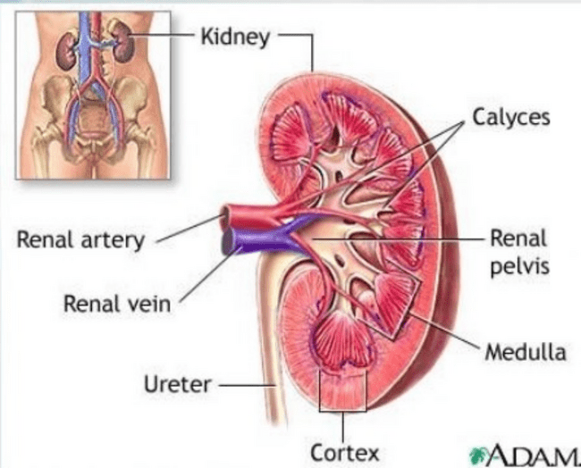
Nephrons:
- These are the functional and histological subunits of the kidney, with approximately 1 million nephrons in each kidney.
- A nephron consists of a glomerulus and a tubule system.
- The glomerulus is a tuft of capillaries surrounded by podocytes, projecting into Bowman's capsule.
- The tubule system includes following structures-
- the proximal convoluted tubule,
- loop of Henle,
- distal convoluted tubule,
- collecting tubule
- duct.
- Glomeruli and convoluted tubules are located in the cortex, while ducts are in the medulla.
- Glomerular capillaries are supplied by the afferent arteriole and drained by the efferent arteriole.
Arterial Supply:
- The renal arteries branch off the aorta at the level of L1-L2, situated behind the pancreas and renal veins.
- These arteries enter the hilum and divide into anterior (apical, upper, medial, and lower) and posterior segments.
Venous Drainage:

- The renal veins communicate widely and eventually unite into 2-3 vessels at the hilum.
- They drain into the inferior vena cava (IVC).
Lymphatic Drainage:
- There are Para-aortic nodes at the L1/L2 level.
- The upper kidney's surface drains through the diaphragm into nodes in the posterior mediastinum.
Physiology of the Kidneys:
The kidneys play a crucial role in maintaining the body's homeostasis by regulating water and electrolytes, retaining essential substances like proteins and glucose, balancing acid-base levels, excreting waste products, and performing endocrine functions.
Water and Electrolyte Regulation:
- Approximately 20% of the total cardiac output is dedicated to supplying blood to the kidneys.
- Urine formation involves two consecutive capillary beds, namely the glomerular and peritubular capillaries.
- Renin plays a pivotal role in elevating angiotensin II levels, while aldosterone facilitates the reabsorption of water and sodium ions in the distal tubule of the nephron.

- In response to increased atrial pressure, the body produces atrial natriuretic hormone (ANP), which encourages the loss of sodium, chloride, and water.
- Antidiuretic hormone enhances the permeability of the distal tubule to water, thereby promoting water reabsorption.
- 1,25-dihydroxy vitamin D3 not only facilitates calcium absorption from the gastrointestinal tract but also stimulates the production of erythropoietin in the bone marrow, leading to the generation of red blood cells.
PATHOLOGY
Polycystic Kidney Disease (PKD):
Polycystic Kidney Disease is a hereditary condition caused by mutations in the PKD1 and PKD2 genes, leading to defects in calcium uptake and resulting in the formation of renal cysts. These cysts can cause the kidneys to enlarge significantly, with some growing up to 20 cm in diameter. PKD can lead to uremia and ultimately kidney failure.
Kidney Stones (Renal Calculi):
Kidney stones, also known as renal calculi, develop when urine becomes saturated with salts like calcium, phosphate, oxalate, and urate, causing changes in pH that promote salt precipitation and stone formation. Hematuria, or blood in the urine, is a common symptom of kidney stones.
Urinary Tract Cancer:
Urinary tract cancer can invade the fat surrounding the kidney and presents symptoms like hematuria (blood in the urine) and pain. Surgical removal of the kidney is a common treatment for this condition.
Nephrotic Syndrome:
Nephrotic syndrome results from the loss of podocyte structure, allowing large proteins to enter the renal corpuscle and leading to increased proteinuria (the presence of excess proteins in the urine).
Alport's Syndrome:
Alport's syndrome is characterized by inflammation of the glomerular capillaries, which ultimately results in glomerulonephritis. This condition leads to irregular thickening of the basement membrane, impairing its ability to effectively filter blood cells and proteins.
Incontinence:
Incontinence is characterized by the inability to control voluntary micturition, or the release of urine from the bladder. It can be caused by various factors, including age, emotional disorders, pregnancy, nervous system damage, stress, excessive laughing, and coughing, leading to issues like wetting, discomfort, and embarrassment.
Types of Renal Failure:
(a) Acute Renal Failure:
- Also known as acute kidney failure or acute kidney injury.
- Develops rapidly over a few days or even hours.
- Acute renal failure can be reversible in patients with good overall health.
(b) Chronic Renal Failure:
- Chronic renal failure is characterized by a gradual loss of kidney function.
- In advanced stages of chronic renal failure, dangerous levels of fluid, electrolytes, and waste accumulate in the body.
Causes of Renal Failure:
Various causes of renal failure include:
1. Glomerular Lesions:
- Primary and secondary glomerular nephritis (e.g., IgA nephropathy, diabetic nephropathy, hypertensive renal atherosclerosis, lupus nephritis, purpura nephritis).
2. Tubular Interstitial Lesions:
- Renal tubular diseases, including chronic pyelonephritis, chronic uric acid nephropathy, obstructive nephropathy, and renal damage due to medications and drugs with renal toxicity.

3. Renal Vascular Disease:
- Renal damages can be due to renal parenchymal or renal vascular impairment, including hypertensive nephropathy, renal vascular hypertension, and small artery sclerosis.
4. Hereditary Renal Disease:
- Resulting from hereditary nephropathy and conditions like Alport's syndrome.
Classification of Chronic Kidney Disease (CKD):
CKD can be classified into stages based on estimated glomerular filtration rate (eGFR) and albumin-to-creatinine ratio (ACR). The stages are as follows:
- Stage 1: Normal, eGFR >90 ml/minute/1.73 m2 with evidence of chronic kidney damage.
- Stage 2: Mild impairment, eGFR 60-89 ml/minute/1.73 m2 with evidence of chronic kidney damage.
- Stage 3a: Moderate impairment, eGFR 45-59 ml/minute/1.73 m2.
- Stage 3b: Moderate impairment, eGFR 30-44 ml/minute/1.73 m2.
- Stage 4: Severe impairment, eGFR 15-29 ml/minute/1.73 m2.
- Stage 5: Established renal failure (ERF), eGFR less than 15 ml/minute/1.73 m2 or on dialysis.
Symptoms and Complications of Renal Failure:
Symptoms of renal failure may include swelling, increased heart rate, nausea, pain, lethargy, shortness of breath, fatigue, and loss of appetite. Complications of renal failure encompass anemia, bleeding tendency, acute pulmonary edema, cardiovascular lesions, hyperkalemia, insufficient blood volume, gastrointestinal bleeding, respiratory failure, and multiple organ dysfunction.
Accompanied Problems and Immunity:
Patients with renal failure may experience immune dysfunction, reduced concentration capacity, memory deficits, decreased attention span, and reduced verbal fluency.
Food to Consume and Avoid:
Proper dietary choices are essential for individuals with renal disease. Low-sodium, low-potassium, and low-phosphorus diets are commonly recommended. Patients should consult with healthcare providers and dietitians for personalized dietary guidance.
Investigations:
Several investigations are necessary for assessing renal function, identifying underlying causes, and evaluating complications of CKD. These investigations include blood tests (e.g., serum urea, creatinine, glucose, electrolytes), urine analysis, serum and urine protein electrophoresis, radiological imaging (e.g., ultrasound, CT, MRI), and renal biopsy in some cases.
Differential Diagnosis:
- Distinguishing between AKI and chronic kidney disease (CKD) can be challenging.
- Clinical history and renal ultrasound can provide valuable information for diagnosis.
- Consider acute on chronic kidney disease when there are both CKD and AKI features.

Management:
- Explain to patients that CKD is a spectrum of disease, and mild CKD is common.
- Monitor eGFR and manage hypertension to prevent kidney damage and cardiovascular risk.
- Encourage lifestyle changes like exercise, maintaining a healthy weight, and smoking cessation.
- Ensure good glycemic control in CKD patients with diabetes.
- Regularly review and adjust medications, avoiding nephrotoxic agents like NSAIDs.
- Immunize patients against influenza and pneumococcus.
Monitoring:
- Monitor eGFR and proteinuria regularly, with the frequency depending on the severity of kidney impairment.
- Repeat eGFR and proteinuria tests to assess the rate of change and confirm CKD diagnosis.
- In newly diagnosed patients with eGFR less than 60 ml/minute/1.73 m2, assess rate of deterioration and perform urinalysis.
- Check for sepsis, heart failure, hypovolemia, and palpable bladder.
- Consider referral based on criteria.
- Monitor cardiovascular risk factors and provide statins for CVD prevention when necessary.
- Offer vitamin supplements for patients at risk of deficiencies.
- Maintain blood pressure control and use renin-angiotensin system antagonists when indicated.
CKD Prevention:
- Aim for blood pressure control according to specific targets based on CKD and comorbidities.
- Use renin-angiotensin system antagonists for specific CKD patient groups.
- Regularly measure serum potassium concentrations when using these drugs.
Nutrition and Exercise:
- Assess nutritional status and prescribe energy and protein intake accordingly.
- Restrict sodium intake.
- Provide dietary advice for patients with hyperkalaemia or hyperphosphatemia.
- Monitor vitamin levels and consider supplementation.
- Advise patients to engage in regular moderate exercise.
Mineral and Bone Disorders:
- Measure calcium, phosphate, parathyroid hormone (PTH), and vitamin D levels based on GFR.
- Consider bisphosphonates for osteoporosis prevention in CKD patients.
- Provide vitamin D supplements when deficiency is present.
- Monitor serum calcium and phosphate concentrations in patients receiving vitamin D supplements.
- Maintain adjusted serum calcium within the normal range in dialysis patients.
- Manage hyperphosphataemia through dietary management and phosphate binders.
Dialysis:
- Hemodialysis and peritoneal dialysis are two common methods for renal replacement therapy.
- Hemodialysis removes waste products by circulating blood through a semipermeable membrane.
- Types of hemodialysis include conventional, daily, and nocturnal hemodialysis.
- Kidney transplant is an alternative to dialysis for patients with end-stage renal disease.
Side Effects of Dialysis:
- Hemodialysis patients may experience reduced exercise tolerance, increased infection risk, malnutrition, anemia, and loss of lean body mass.
- Other side effects include decreased blood pressure and muscle cramps.
Role of physiotherapy in Renal Rehabilitation
Physiotherapy has a wide and efficient role in the renal rehabilitation , it is designed by the proper assessment and diagnosis , basing on the those clinical features the treatment protocol will be designed and adviced to patient , the treatment will not be same for every one it will be changing from one person to other person depending on their clinical features , age etc for example it would be similar to the following case study -
Physiotherapy Assessment:
Subjective Assessment :
- The patient presents with complaints of generalized weakness, impaired bilateral lower extremity (B LE) sensation, decreased balance, and decreased mobility attributed to thrice-weekly dialysis treatment.
- The patient reports difficulties with walking, negotiating stairs, and getting in and out of their vehicle.
Physical Performance Measures:
- 6-minute walk test: 550 meters.
- Berg Balance Scale assessment : 40/56.
- Timed Up and Go test : 24 seconds.
- Gait Speed analysis : 0.86 m/s.
Objective:
- Vitals: HeartRate - 82 bpm, BloodPressure - 124/80 mmHg, Respiratory Rate - 18 breaths/min.
- Reflexes: Dermatomes show variations in reflexes.
- Sensation: Light touch reveals peripheral neuropathy and decreased sensation in bilateral lower extremities.
- Active Range of Motion (AROM): Upper extremity AROM is within normal limits (WNL) except for specific limitations on the right side. Lower extremity AROM is decreased by 25%.
- Passive Range of Motion (PROM): Positive Thomas Test (B), Positive Ober’s Test (B), Positive 90/90 (B).
- Manual Muscle Testing (MMT): Various muscle groups are rated on a scale of 4/5 (B) and ⅘ (B).
- Special Tests: Diabetic Foot Screen identifies issues related to sensation and circulation.
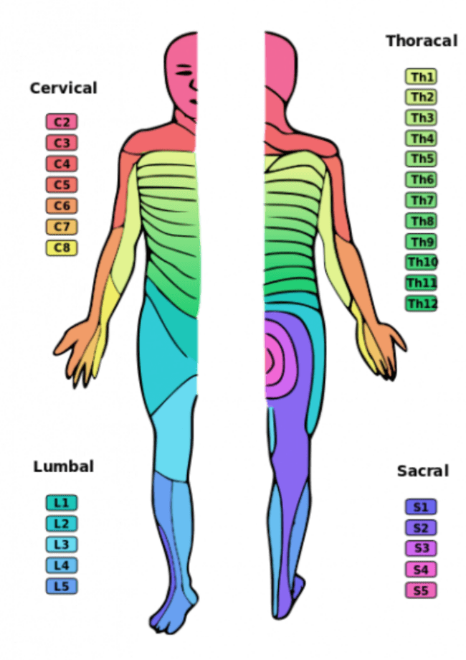
Clinical Impression:
1. The patient's end-stage renal disease is incurable and is being managed through dialysis, leading to secondary functional deficits.
2. Risk factors such as advancing age, diabetes mellitus, hypertension, and chronic urinary tract infections may complicate physical therapy intervention.
3. The patient has lower extremity weakness, impaired balance, decreased sensation, and fear of falling, increasing the risk of falling.
Recommended Exercises:
- Walking: Encourage the patient to engage in walking as it is one of the least strenuous yet highly beneficial exercises. Walking helps with various bodily functions, including digestion, energy level, cholesterol levels, blood sugar and blood pressure control, heart disease risk reduction, improved sleep, and stress reduction.
Exercise Start and Frequency:
- Start with as little as 15-20 minutes of exercise a day to combat fatigue and weakness.
- Emphasize that exercise can help prevent muscle wasting associated with kidney disease.
- Stress the importance of proper stretching before and after exercise to enhance comfort and reduce the risk of cramping.
- Suggest starting slowly and progressively increasing exercise duration and frequency.
- Encourage exercising at least 15-20 minutes a day, three to four days a week.
Summary:
- Remind the patient that nearly every dialysis patient can engage in some form of exercise.
- Always recommend consulting with their doctor before starting any exercise program.
- Advise them to begin slowly with stretching.
- Explain the benefits of exercise, including improved energy levels, reduced risk of other illnesses, better overall well-being, and enhanced physical and mental health.
Limitations:
- Exercise limitations tend to increase with age.
- Exercise limitations may compromise rehabilitation potential in elderly individuals.
- Physically active individuals prior to dialysis may have a better functional status.
- Patient adherence and motivation can impact exercise outcomes.
- Chronic kidney disease may lead to a decrease in the quality of life.
Best Time to Treat:
- The best time for exercise in hemodialysis patients may depend on the individual's circumstances.
- Performing exercise after dialysis may be ideal when blood chemistry levels are optimal, but fatigue may be a limiting factor.
- Exercising during dialysis may improve the efficiency of dialysis but may not be suitable for everyone due to the risk of decreased blood pressure and cramps.
Physical Therapy (PT) Goals in the Acute Care Setting:
Short-term Goals:
- Prevention of contractures, disuse atrophy, and skin breakdown.
- Improvement in strength, mobility, and endurance.
Long-term Goals:
- Enhancing the patient's mobility for the efficient completion of activities of daily living (ADLs).

Exercise Prescription:
- Low to moderate-intensity exercises can increase exercise capacity.
- Patients with chronic kidney disease (CKD) can benefit from stationary bicycle exercise protocols involving exercise three times a week at intensities of 40-70% of their target heart rate (THR).
- Progression should be tailored to the individual patient's condition and abilities.
- Regular exercise can help reduce cardiovascular risks, improve hematocrit levels, and better control blood pressure.
- Most patients experience an increased sense of energy, improved well-being, and enhanced psychological profiles with regular exercise, including reduced anxiety, hostility, and depression, ultimately leading to an improved quality of life.
Types of Exercises:
Several types of exercise are suitable for dialysis patients:
1. Flexibility Exercise: Gentle muscle stretching improves the range of motion and joint flexibility, enhancing functional performance and preventing musculoskeletal injuries.
2. Strengthening Exercises: Strengthening exercises focus on specific muscle groups, increasing muscle mass and strength. These exercises should be done two to three times a week using low resistance but high repetition. Simple and easily accessible equipment is preferred for patient training.
3. Cardiovascular Exercise: Cardiovascular activities involve the rhythmic movement of large muscle groups. The goal is to achieve and sustain increased energy expenditure (approximately 40-85% of peak capacity) for extended periods. Cardiovascular benefits can also be obtained from short but frequent aerobic activities. Patients should start slowly and progress gradually, with close supervision by a physiotherapist.
Overall, it's important to customize exercise plans based on each patient's specific needs and limitations, emphasizing safety and gradual progression. Always encourage close monitoring and supervision by healthcare professionals.

Equipment's for hemodialysis

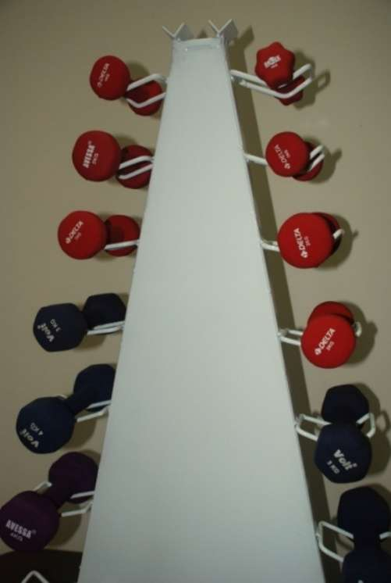
Dumbells for Strength training
Equipment's for the progressive resistance exercise

Exercise Program Phases:

Phase I (Week 0-2):
- Initiating aerobic activity program
- Perform Warm-up exercises for 5-10 minutes at a very light intensity (RPE 8-9 on the Borg Scale).
- Perform 15 minutes of activity at a fairly light intensity (RPE 10-11).
- Cool down for 5-10 minutes at a very light intensity (RPE 8-9).
- Patient should be educated on physical activity, his foot care, management of water intake, fall risk assessment, care giver education, and dialysis support.
- Flexibility exercises: 3 lower extremity (LE) stretches and 3 upper extremity (UE) stretches.
- Strength exercises: 4 lower extremity and 4 upper extremity exercises, 2 sets of 10 repetitions each.
- Balance: 3 exercises on a stable surface.

Phase II (Week 2-6):
- Progress the aerobic program to 20 minutes of aerobic activity at a somewhat hard intensity (RPE 12-13).
- - Progress strength exercises from Phase I to light weights.
- Progress flexibility exercises from Phase I to further range of motion (ROM).
- Balance: 3 exercises on an unstable surface.

Phase III (Week 6-10):
- Progress the aerobic program to 30 minutes of aerobic activity at an intensity ranging from somewhat hard to hard (RPE 13-15).
- Patient education to reinforce Phase II topics.
- Progress strength exercises from Phase II to moderate weights.
- Progress flexibility exercises from Phase II to further ROM.
- Balance: 3 dynamic exercises on both stable and unstable surfaces.
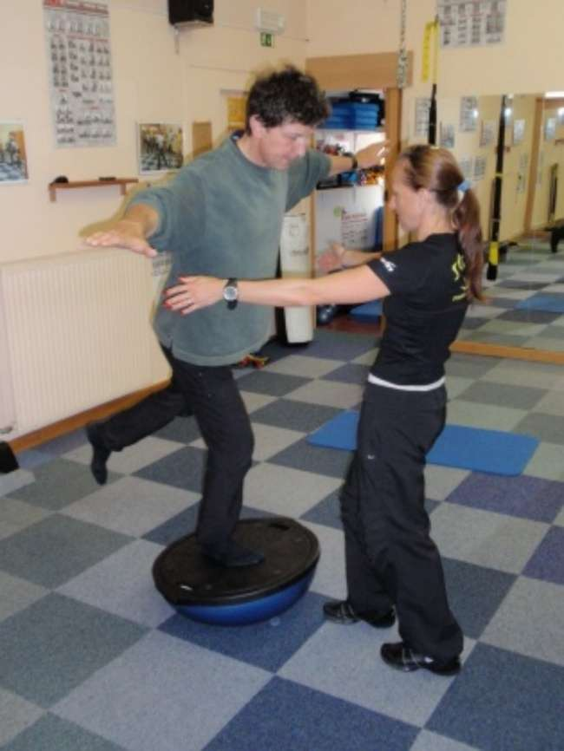

Rationale for Progression:
The progression of the exercise program is designed to challenge the patient's endurance progressively. The Borg Rating of Perceived Exertion Scale is used to monitor intensity due to the patient's use of hypertension medications, which can affect heart rate response to exercise. Strength training is progressed based on the patient's response to activity. The progression follows guidelines from the American College of Sports Medicine (ACSM) for resistance training.

Co-Interventions:
The patient undergoes dialysis three days a week.

Benefits of Exercise:
- Exercise can lead to various health benefits, including weight loss, improved muscle strength, lower cholesterol and blood fat levels, increased cardiac output, and greater physical exercise capacity.
- Exercise also has psychological benefits, enhancing self-esteem, promoting a sense of independence, and helping manage feelings of depression and anxiety.

Additional Benefits of Exercising During Dialysis:
- Exercising during dialysis improves the efficiency of dialysis by aiding the removal of toxins and waste products from the blood.
- It helps maintain muscle strength and exercise tolerance.
- Exercising for at least 30 minutes, at moderate intensity, five times a week is recommended.

Other Exercise Options:
- Hemodialysis patients can benefit from various forms of exercise.
- An exercise prescription tailored to the patient's characteristics and needs should be a standard of care.
- Alternative exercise options include walking programs, water exercises, yoga, Tai Chi, and low-level strengthening exercises.

Conclusion:

The role of physiotherapists and physiotherapy in the management of hemodialysis patients is well-established, and the effectiveness of exercise programs in this population is evident. However, it is crucial to carefully select the right patients and regularly reassess their suitability for exercise, ideally in collaboration with a multidisciplinary team. While patients with lower physical capacity can benefit more from exercise training, it is essential to ensure that exercise is not contraindicated for patients with complex clinical conditions. Exercise can be harmless for individuals with good overall health or other medical conditions, but in renal patients with compromised clinical stability, it may pose a risk of irreversible harm.

Furthermore, in addition to the above statements, the positive impact of medical treatment on the survival of hemodialysis patients underscores the importance of the long-term integration of physiotherapy into the overall treatment plan. The preservation of physical gains achieved through physiotherapy is crucial. Regular patient follow-up during hemodialysis and the implementation of home-based exercise programs, which can enhance clinical effectiveness, should be facilitated through patient records and feedback, whether electronic or face-to-face, from patients and their families.

Notably, the fact that some patients in this population are young adults may necessitate adjustments or intensifications of their exercise programs by physiotherapists, taking into account their clinical status and the potential need for a more active lifestyle, particularly in terms of work and social activities.

References:-
- Kravitz L. From 1998 to 2011: ACSM Publishes Updated Exercise Guidelines. IDEA Fitness Journal. October 2011. Available from: SPORTDiscus with Full Text, Ipswich, MA.
- 6 Minute Walk Test: Rehab Measures Web site. http://www.rehabmeasures.org/Lists/RehabMeasures/PrintView.aspx?ID=895. Published 2013. Accessed March 29, 2015.
- SF-36: Rehab Measures Web Site. http://www.rehabmeasures.org/Lists/RehabMeasures/PrintView.aspx?ID=930. Published 2013. Accessed March 29, 2015.
- Berg Balance Scale: Rehab Measures Web Site. http://www.rehabmeasures.org/Lists/RehabMeasures/PrintView.aspx?ID=888. Published 2013. Accessed March 29, 2015.
- 10 Meter Walk Test: Rehab Measures Web site. http://www.rehabmeasures.org/Lists/RehabMeasures/PrintView.aspx?ID=901. Published 2014. Accessed April 20, 2015
- Timed Up and Go Test: Rehab Measures Web site. http://www.rehabmeasures.org/Lists/RehabMeasures/PrintView.aspx?ID=1057. Published 2014. Accessed April 20, 2015
- Perryman B, Harwood L. Case study. The role of physiotherapy in a hemodialysis unit. Nephrology Nursing Journal. March 2004.Available from: CINAHL with Full Text, Ipswich, MA.
- Painter P, Marcus R. Physical Function and Gait Speed In Patients with Chronic Kidney Disease. Nephrology Nursing Journal. November 2013,Available from: Academic Search Complete, Ipswich, MA.
- Gray P. Management of patients with chronic renal failure. Role of physical therapy. Physical Therapy. February 1982 Available from: MEDLINE, Ipswich, MA.
- Mercer T. Low-volume exercise rehabilitation improves functional capacity and self-reported functional status of dialysis patients. Am J Phys Med Rehabil.2002
11. Jassal SV, Trpeski L, Zhu N, Fenton SSA, Hemmelgarn BR: Changes in survival over the years 1990 –1999 for elderly patients initiating dialysis. 2007
12. Kurella M, Covinsky KE, Collins AJ, Chertow GM: Octogenarians and nonagenarians starting dialysis in the United States. 2007
13. USRDS Data report. http://www.usrds.org/adr_2007.htm 2007
14. Cook WL, Jassal SV: Functional dependencies among the elderly on hemodialysis. Kidney 2008*
15. Lo D, Chiu E, Jassal SV: A prospective pilot study to measure changes in functional status associated with hospitalization in elderly dialysisdependent patients. 2008
16. Forster A, Young J, Lambley R, Langhorne P: Medical day hospital care for the elderly versus alternative forms of care. Cochrane Database 2008
17. Clark GS, Siebens HC: Rehabilitation of the geriatric patient. In: Rehabilitation Medicine, edited by DeLisa JA, Philadelphia, Lippincott, 1993.
18. Eisenberg MG: Dictionary of Rehabilitation. New York, Springer, 1995
19. Johansen KL, Painter PL, Sakkas GK, Gordon P, Doyle J, Shubert T: Effects of resistance exercise training and nandrolone decanoate on body composition and muscle function among patients who receive hemodialysis: a randomized, controlled trial. J Am Soc Nephrol 2006
20. Painter P, Johansen KL: Improving physical functioning: time to be a part of routine care. Am J Kidney 2006
21.Junior Romão JE. Doença renal crônica: definição, epidemiologia e classificação. J Bras Nefrol 2004.
202. Sociedade Brasileira de Nefrologia. Diretrizes brasileiras de doença renal crônica. J Bras Nefrol 2004.
23. Kovelis D, Pitta F, Probst SF, Peres CPA, Delfino VDA, Mocelin AJ. Função pulmonar e força muscular respirató- ria em pacientes com doença renal crônica submetidos à hemodiálise. J Bras Pneumol 2008.
24. Soares A, Zehetmeyer M, Rabuske M. Atuação da fisioterapia durante a hemodiálise visando a qualidade de vida do paciente renal crônico. Rev Saúde UCPEL 2007.
25. Parsons TL, Toffelmire EB, King-VanVlack CE. Exercise training during hemodialysis improves dialysis efficacy and physical performance. Arch Phys Med Rehabil 2006.
26.Jatobá JPC, Amaro WF, Andrade APA, Cardoso FPF, Monteiro AMH, Oliveira MAM. Avaliação da função pulmonar, força muscular respiratória e teste de caminhada de seis minutos em pacientes portadores de doença renal crô- nica em hemodiálise. J Bras Nefrol 2008.
27. Oh-Park M, Fast A, Gopal S, Lynn R, Frei G, Drenth R, et al. Exercise for the dialyzed: aerobic and strength training during hemodialysis. Am J Phys Med Rehabil 2002.
28.Moreira PR, Barros EG. Revisão/Atualização em diálise: capacidade e condicionamento físico em pacientes mantidos em hemodiálise. J Bras Nefrol 1998.
29.Martins MRI, Cesarino CB. Qualidade de vida de pessoas com doença renal crônica em tratamento hemodialítico. Rev Latino-Am Enferm 2005.
30.Churchill DN, Torrance GW, Taylor DW, Barnes CC, Ludwin D, Shimizu A, et al. Measurement of quality of life in end-stage renal disease: the time trade-off approach. Clin Invest Med 1987.
31.Reboredo MM, Henrique DMN, Bastos MG, Paula RB. Exercício físico em pacientes dialisados. Rev Bras Med Esporte 2007.
32.Coelho DM, Ribeiro JM, Soares DD. Exercícios físicos durante a hemodiálise: uma revisão sistemática. J Bras Nefrol 2008.
33.Adams GR, Vaziri ND. Skeletal muscle dysfunction in chronic renal failure: effects of exercise. Am J Physiol Renal Physiol 2006.
34.Ciconelli RM, Ferraz MB, Santos WS, Meinão I, Quaresma MR. Tradução para a língua portuguesa e validação do questionário genérico de qualidade de vida SF-36 (Brasil SF-36). Rev Bras Reumatol 1999.
35.Borg G. Perceived exertion and pain scales. Champaign: Human Kinetics; 1998. 36.Enright PL. The six minute walk test. Respir Care 2003.
37.Kendall FP, McCreary EK. Músculos: provas e funções. 3a ed. São Paulo: Manole; 1990.
38.ATS Committee on Proficiency Standards for Clinical Pulmonary Function Laboratories. ATS statement: guidelines for the six-minute walk test. Am J Respir Crit Care Med 2002.
39.Karvonen MJ, Kental E, Mustala O. The effects of training on heart rate; a longitudinal study. Ann Med Exp Biol Fenn 1957.
40.Tawney KW, Tawney PJ, Kovach J. Disablement and rehabilitation in end-stage renal disease. Semin Dial 2003.

