Pharmacodynamics
Supreet Rupam¹, Assistant Professor, Amity College of Nursing, Amity University Haryana, Gurugram. Email ID- heenasupreet91@gmail.com.

Abstract:
Pharmacodynamics deals with the effect of drugs on different body systems and includes mechanism of action of drugs. When choosing the right molecules, evaluating the safety and effectiveness of therapeutic candidates, and creating the best clinical dosage regimens, it is essential to evaluate drug exposure as well as responses. Numerous factors, including those that are biological, psychological, genetic, pathological, environmental, and pharmacological, can alter how a drug acts, impacting every step from the prescription of the drug to the effects it has on the patient. If any of these conditions apply to a person, the medicine choice and dosage must be altered.
KEY words: Pharmacodynamics, molecules, pharmacological, dosage.

Introduction
Pharmacodynamics is the study of biochemicals, drug molecular and physiological effects of drugs. Pharmacodynamics can be stared as larger branch of learning for pharmacology and relating to all aspects of drug actions to therapeutic, and toxicologic descriptions.
Pharmacodynamics particularly place importance on dose response which means the relationships between drug effect and concentration. Patient characteristics, including age, underlying medical conditions, and concomitant medications vying for binding at the same receptor, such as receptor antagonists, play a pivotal role in influencing pharmacodynamic interactions. Notably, certain medications targeting the same receptor can exhibit varying degrees of efficacy in generating significant biological responses. Understanding the concentration of a drug at its specific receptor site is instrumental in determining the extent of its therapeutic effect. This information is crucial for optimizing treatment outcomes and tailoring medical regimens to individual patients, considering their unique physiological profiles. By considering these factors, healthcare professionals can make more informed decisions to ensure safe and effective medication administration.(Figure- 1)

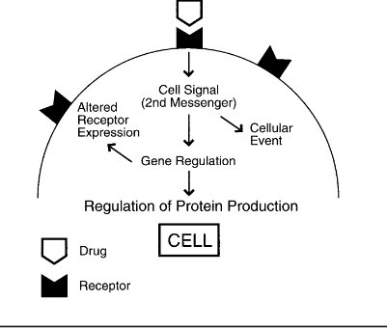
Figure 1 Shows Relationship of Drug Concentration to drug effect at the receptor site.

Principles of Drug Action
The drugs which are given to the patients can change the physiological processes of the human body. Mainly the drugs can control various process of body by following principle.
- Depression: It is the selective suppression of specialised cells activity. For instance, quinidine depresses the heart and omeprazole depresses the production of stomach acid.
- Stimulation: It is the targeted improvement of the activity of specific cells. For instance, pilocarpine stimulates the salivary gland and adrenaline the heart.
- Irritation- It has an adverse & non-selective effect on cells with lower levels of specialisation. Cells may become inflamed, corroded, or necrotic because of irritation.
- Cytotoxic action: It is the selective action on parasites or cancer cells without affecting other cells of the body for example Penicillin, Methotrexate.
Mechanism and Targets for Drug Action
It can be divided into following steps:
- Receptors: Receptors are the primary membrane proteins that are incorporated in cell membranes and receive signals to start cell a reaction. In total, 4 several receptor types:
- Ligand gated ion channels
- G-protein coupled receptors.
- Kinase linked receptors.
- Nuclear receptors.

- Transporter Protein: There are some important carriers that present on the cell membrane which transport the substrate across the membrane against the concentration gradient using energy. For example, Solute carrier proteins (SLE).

- Enzymes: These are the protein molecules which enhance the chemical reactions. Enzymes are primarily responsible for catalysing biological reactions. For instance, Aspirin inhibits Cyclooxygenase and Captopril inhibits ACE.
- Ion Channel: Ion channels are the cell membrane channels that only let certain ions pass through them. For instance, Na, K, Ca, and Cl channels.

Drugs Receptors
A substance that binds to and controls the activity of chemical receptors is referred to as a receptor modulator, also known as a receptor ligand, whether it is endogenous or exogenous. They are ligands that can regulate activity in a positive, negative, or neutral manner with varying degrees of effectiveness by acting on various receptor components. Receptor agonists and antagonists, receptor partial agonists, inverse agonists, orthostatic modulators, and allosteric modulators are some of the categories of these modulators.
It is further divided into four types:
Type I: Ligand-gated ion channels
Membrane proteins play a crucial role in cellular function, particularly in ion channels, and share a similar structure with other ion channels. One common characteristic of these proteins is the presence of a ligand-binding receptor site, typically located in the extracellular region. These receptor sites often act as targets for rapid neurotransmitters, facilitating essential communication between nerve cells. A well-known example of such a neurotransmitter is Gamma-aminobutyric acid (GABA), which interacts with specific receptors on the membrane to regulate neuronal signalling. (Fig-2)
Type 2: G-Protein coupled receptor.
A metabotropic receptor is a type of membrane receptor that starts several metabolic processes to control cell activity. It is also known by the more general term G-protein-coupled receptor. Both metabotropic and ionotropic receptors are used by the neurological system. Metabotropic receptors are indirectly connected to ion channels by signal transduction systems like G proteins, whereas ionotropic receptors directly produce an ion channel pore. For Example- Muscarinic acetylcholine receptors.
Type 3: Kinase Linked receptor:
These membrane receptors, which are many and diverse, mostly react to protein mediators. It includes a connected extracellular ligand-binding domain. For example: insulin receptors.
Type 4: Nuclear receptor
These receptors control the transcription of genes. For example: Steroid receptors.

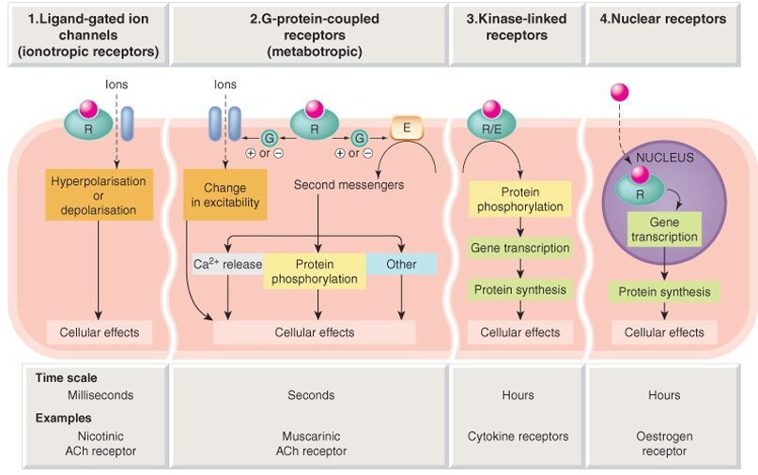
(Figure 2: Shows various Drug Receptors)
DRUG EFFICACY AND DRUG POTENCY
- DRUG POTENCY –
Drugs that are potent cause a reaction by binding to receptors, even at low concentrations. Both its affinity and intrinsic activity are high.
- DRUG EFFICACY-
Drug efficacy refers to the highest response, which can be obtained by a particular drug.
Example: The level of analgesic effect that morphine can produce cannot be duplicated by aspirin. In other words, morphine is more potent than aspirin.
Drug Receptor Interaction
Receptors are large molecules that play a role in chemical communication between and inside cells. They can be found in the cytoplasm or on the cell surface membrane. Receptor activation controls cellular biochemical processes directly or indirectly for example: ion conductance, protein phosphorylation, enzymatic activity.
- Receptors: Receptors are protein molecules that take in chemical signals from the outside of the cell. Chemical signals that attach to receptors produce a reaction or action.
- Agonist: A substance is said to as an agonist when it interacts with a receptor to begin a pharmacological action. A substance or ligand that binds to the same receptor is an agonist. When they bind to the same receptor, antagonists have the most impact. It has significant intrinsic activity and affinity. For example-adrenoceptor agonist.
- Partial Agonist: A partial agonist is a medication that has an affinity that is equal to or lower than that of an agonist but less intrinsic activity. Opioids, for instance, operate as agonists or partial agonists on a variety of receptor types.
- Inverse Agonist: A substance that engages a receptor and has the opposite action as an agonist. For example: chlorpheniramine on H1 receptor.
- Antagonist: Drugs that bind to receptors but do not activate them or block them are referred to as antagonists. It is affine but has no inherent activity. For example: Atropine.
DRUG INTERACTIONS
Drug interaction is the alteration of one substance's impact by the administration of another drug either beforehand or concurrently. It might make one or both medications work better or worse. It may alter the therapeutic, diagnostic, or preventative effects of either medicine.
Causes:
- Administration of two or more medications
- Patient seeks care from numerous physicians o Irrational polypharmacy, concurrent use of prescription and over the counter medications.
- Patient non-compliance: failure to adhere to directions.
Drug interaction can be due to other various reasons:
- Pharmacokinetic interaction:
- The effects of multiple medication use may include changes to GI pH, complexation, sequestration, mucosa, and GI contents that may affect absorption.
- Drug interactions can reduce distribution and shift protein binding because of competitive binding. It could cause toxicity & a decline in effect.

- Pharmacodynamic interaction:
Medicinal interactions can modify physiological activity and drug efficacy by affecting drug-receptor binding. It may have a positive or negative impact on the body.
- Combined effect of drugs:
It is the combination of the medications' heightened effects. Both medications may work better when taken together, or one drug may boost the effects of another.
- Additive effects: When the effects of two or more medications are intensified when taken simultaneously. For Example: Aspirin + Paracetamol (analgesic/antipyretic)
- Potentiation: When the combined effects of two or more medications have a multiplicative effect. For example: Acetylcholine + Physostigmine (inhibits break down)
- Antagonism: When medications are mixed, the effect is diminished or eliminated. A drug's potency may be decreased, or its activity may be inhibited by another substance.
SEVERAL MEASURES TO AVOID DRUG INTERACTION:
- Read the prescription and do as it says.
- Talk to your doctor or pharmacist about the drug's dosage, frequency, duration, and manner of use.
- Inform the doctor of the foods, supplements, medications, and beverages you consume.
- Describe your illness or medical condition to your doctor.
- Visit doctors infrequently (if necessary, have the previous prescription with you).
- Don't use medications that were prescribed by someone else.
- Stop taking medications if any negative side effects are noticed and consult a doctor right once.
Conclusion:
To conclude, pharmacodynamics plays a pivotal role in understanding the effects of medications on the human body, shedding light on the intricate processes that determine a drug's efficacy and safety. By exploring receptor interactions and the relationship between drug concentration and response, healthcare professionals can make informed decisions to optimize patient outcomes and enhance the benefits of pharmacotherapy.

References

- Purves, Dale, ed. (2018). Neuroscience, 6th ed. Sunderland, Mass: Sinauer Associates. p. 103.
- Lees P, Cunningham FM, Elliott J (2004). "Principles of pharmacodynamics and their applications in veterinary pharmacology". J. Vet. Pharmacol. Ther. 27 (6): 397–414..
- Purves, Dale, ed. (2018). Neuroscience, 6th ed. Sunderland, Mass: Sinauer Associates. p. 103. - Cirillo P, Taglialatela V, Pellegrino G, Morello A, Conte S, Di Serafino L, Cimmino G. Effects of colchicine on platelet aggregation in patients on dual antiplatelet therapy with aspirin and clopidogrel. J Thromb Thrombolysis. 2020 Aug;50(2):468-472. - Meng J, Xiao G, Zhang J, He X, Ou M, Bi J, Yang R, Di W, Wang Z, Li Z, Gao H, Liu L, Zhang G. Renin-angiotensin system inhibitors improve the clinical outcomes of COVID-19 patients with hypertension. Emerg Microbes Infect. 2020 Dec;9(1):757-760. - Ramamoorthy S, Cidlowski JA. Corticosteroids: Mechanisms of Action in Health and Disease. Rheum Dis Clin North Am. 2016 Feb;42(1):15-31, vi - Jonsson M, Dabrowski M, Gurley DA, Larsson O, Johnson EC, Fredholm BB, Eriksson LI. Activation and inhibition of human muscular and neuronal nicotinic acetylcholine receptors by succinylcholine. Anaesthesiology. 2006 Apr;104(4):724-33. - Lees P, Cunningham FM, Elliott J. Principles of pharmacodynamics and their applications in veterinary pharmacology. J Vet Pharmocol Ther. 2004 Dec;27(6):397-414. - Dumas EO, Pollack GM. Opioid tolerance development: a pharmacokinetic/pharmacodynamic perspective. AAPS J. 2008 Dec;10(4):537-51. - Cahill CM, Walwyn W, Taylor AMW, Pradhan AAA, Evans CJ. Allostatic Mechanisms of Opioid Tolerance Beyond Desensitization and Downregulation. Trends Pharmacol Sci. 2016 Nov;37(11):963-976

