Current scenario of global soil biodiversity: An overview
Priyanka Sarangi, Puspendu Shit and Partha Pratim Chakravorty*

PG Department of Zoology, Raja Narendra Lal Khan Women’s College (Autonomous), Gope Palace, Medinipur,
West Bengal -721102, India

Abstract:

Soil is the most complex and biologically diverse environment on earth. Soil biodiversity estimates range from several thousand invertebrate species per site to relatively unknown levels of microbial and protozoan variety. This varied population provides a variety of ecosystem services that are critical to agricultural sustainability. Through their effects on the decomposition of dead organic matter, nutrient cycling, and the creation and maintenance of the soil structure, soil organisms control ecological processes. The soil biodiversity is under threat from numerous anthropogenic activities since many of them are particularly vulnerable to diverse edaphic disturbances. The extinction rate of species is predicted to be between 100 and 1,000 times higher than what might be deemed natural as a result of the rapid climate change and other anthropogenic activities, according to the FAO. To strengthen and sustain various soil communities and the roles and services they play throughout all ecosystems, it is important to protect existing natural areas, restore damaged habitats, and use sustainable agriculture techniques.
Keywords: Soil diversity, Community, Threats to ecosystem, Restoration, Sustainability

Correspondence to:*Dr. Partha Pratim Chakravorty, Associate Professor, PG Department of Zoology,
Raja Narendra Lal Khan Women’s College (Autonomous), Gope Palace, Medinipur, West Bengal -721102, India ,
Tel: +919434991868
Email: parthapratimchakravorty@yahoo.in

Introduction:

Soil, which contains over a quarter of the globe's diversity, is the most complex and heterogeneous ecosystem on the planet (Ram, 2019). A modest amount of soil includes an estimated 10 -100 million organisms from over 5,000 species (Ramirez et al., 2015), only a small portion of which has been recorded (Adams and Wall, 2000). There are thousands of invertebrate species per site, according to rough estimates of soil biodiversity, and levels of microbial and protozoan variety are still mostly unknown (Wallwork , 1970).
Bacteria and Archaea, fungi, protists, and many other eukaryotes, including nematodes, oribatid mites, centipedes and millipedes, enchytraeids, tardigrades, springtails, ants, ground beetles, and earthworms, are all part of the soil ecosystem (Zhang, 2013; Stork, 2018; Coleman and Whittman, 2005). Soil communities are graded systems in which a diverse range of organisms thrive. Microbes are of 20 nm to 10 µ in size including virus, bacteria, fungi etc, and microfauna includes soil protozoa and nematodes ranging from (10 µm – 0.1 mm) in size. They both are participated in decomposition of soil organic matter. Mesofauna (0.1 mm - 2 mm) includes mites; springtails, apterygota etc, are soil microarthropod, help to increase the surface of active biochemical interaction in soil. Macrofauna are considered as litter transformer, ecosystem engineer are large soil invertebrates (eg; earthworm, termites) ranging from 2 mm to 20 mm in size and lastly megafauna those are vertebrates are greater than 20 mm in size ( FAO, 2020).
Each functional group contributes to different soil functions, but there is also a significant level of functional redundancy. Human interventions alter the soil structure and diversity of the soil food web (FAO, 2020). Current agricultural practices in many developing nations are unsustainable, resulting in significant volumes of toxic waste being discharged directly or indirectly into soil, air, and water (Yáñ et al., 2002).
The unique set of skills that the soil biota possesses enables it to both prevent disturbances or changes and to recover from them. One of the most important characteristics of biodiversity is the capacity to adapt to change. Higher biodiversity soils are said to have a built-in biodiversity. Resilience and resistance to change are both possible responses. Loss of biodiversity may leave soil with little ability for regeneration and resistance (Allison & Martini, 2008; Downing et al., 2012).

Soil health is determined by four primary biodiversity-based soil processes (carbon transformation, nutrient cycling, soil structure development, and biodiversity control) (Kibblewhiteet al., 2008), as well as linked Sustainable Development Goals (SDGs). These functions, however, are acknowledged as under threat (CEC, 2006; Gardi et al., 2013). The growing global demand for quality protein-rich food resources for the growing world population puts a strain on the need to develop an environmentally sound strategy for maintaining soil health and advancing food security without degrading global soil biodiversity So, it is crucial to focus research on better understanding the links among biodiversity attributes and soil functions and ecosystem services (de Vries et al., 2013).

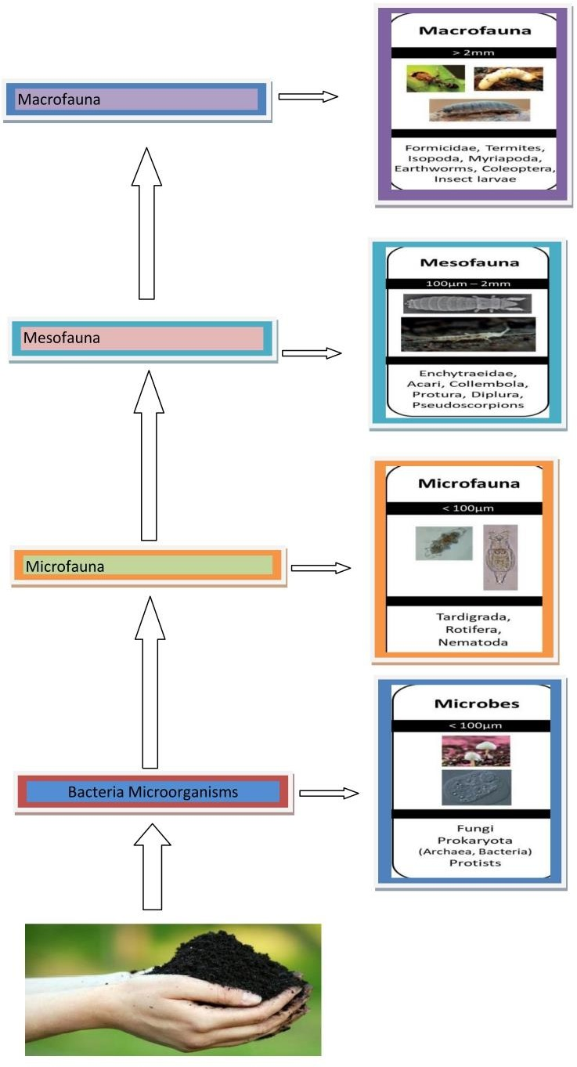

Figure 1: The hierarchical system of soil communities (Orgiazzi et al., 2016)

Soil Biodiversity and Importance:

Highly diversified invertebrate populations can be found in soils, and these communities provide crucial ecosystem functions including mitigation of environmental pollution. Soil invertebrates provide a variety of ecological services that are necessary for agriculture to be sustained. The variability of the soil allows specialized activities such as soil structure maintenance, carbon transformations, nutrient cycling, and the control of pests and pathogens are all powered by self-replicating ecosystem functions (Balvanera et al., 2006; Perrings et al., 2006; Kibblewhite et al., 2008; Chagnon et al., 2015). Soil organisms' burrowing activity alters soil porosity by improving aeration, water penetration and retention, and decreasing compaction (Pisa et al., 2015; Ram, 2019). By increasing soil porosity and water infiltration, earthworms can create up to 8,900 km of channels per hectare, which reduces soil erosion by 50% (Blouin et al., 2013; Gaupp-Berghausen et al., 2015). Foragers, tunnelers, and ground-nesting insects like beetles, ground-nesting bees, ants, and termites transport nutrients through various soil layers. Detritivores, such as nematodes, springtails, earthworms, millipedes, and woodlice, convert decomposing matter and minerals into usable forms, cycle nutrients, and improve soil fertility (Stork and Eggleton, 1992; Kibblewhite et al., 2008; Ram, 2019). Nematodes and mites, for example, promote nitrogen mineralization by feeding on fungal roots and promoting and controlling microbial activity. Dead invertebrates decompose and contribute nitrogen to the soil. By breaking down litter and producing biologically rich casts and excrement, soil invertebrates provide up to 50% of all soil aggregates (Stork and Eggleton, 1992). Because the creation of these big soil aggregates allows for increased soil carbon absorption, these ecosystem engineers contribute to the reduction of fossil fuel emissions and the mitigation of climate change (Lal, 2004a, b; Lavelle et al., 2006; Dirzo et al., 2014). Dead invertebrates decompose and contribute nitrogen to the soil. By dissolving trash and releasing casts and excrement that are rich in organic matter, soil invertebrates also help to the formation of half of all soil aggregates (Stork and Eggleton, 1992). These ecosystem engineers contribute to the reduction of greenhouse gas emissions from fossil fuel use and the fight against climate change because the creation of these huge soil aggregates allows for better soil carbon storage (Lal, 2004a, b; Lavelle et al., 2006; Dirzo et al., 2014).
Many soil invertebrates also help to manage agricultural pests. In crops, nematodes and mites are employed to target disease-causing microorganisms (Stork and Eggleton, 1992; Kibblewhite et al., 2008; Ram, 2019). Predators and parasitoids, such as beetles and parasitic wasps, prey on arthropods that disrupt crop production (Stork and Eggleton, 1992; Gill et al., 2016), and herbivorous soil insects can preferentially eat the seeds of undesirable plants over crop seeds, limiting the spread of aggressive weeds (Honek et al., 2003).

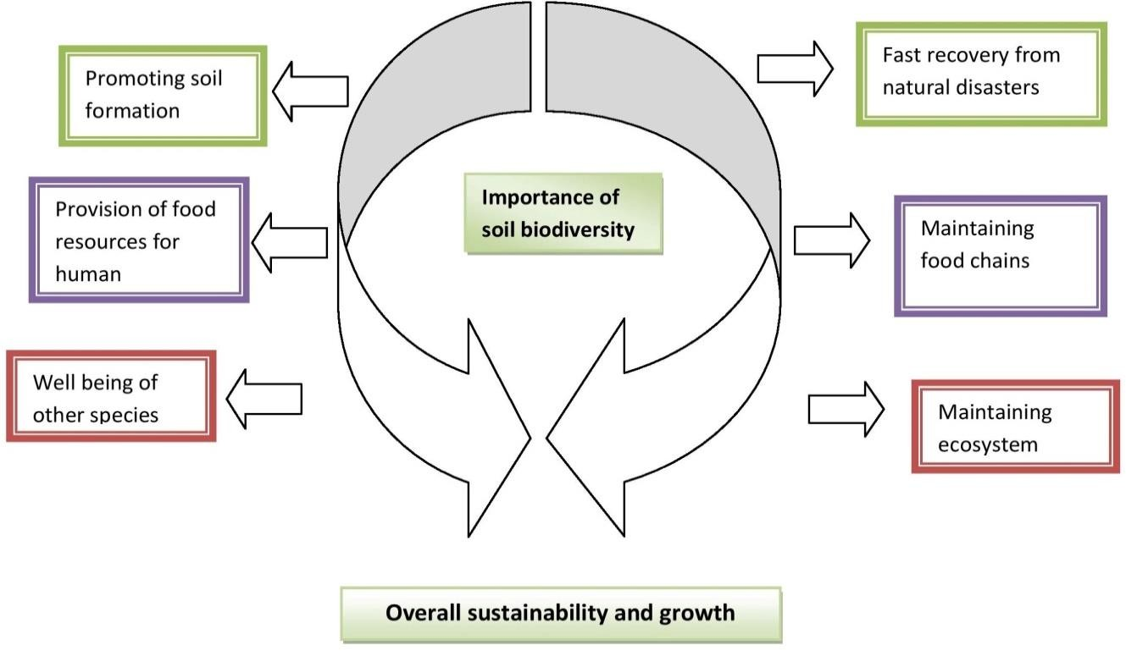

Figure 2: Importance of soil biodiversity (FAO, 2020)

Threats to soil biodiversity:

Soil biodiversity is thought to be deteriorating in both diversity and quantity when soil subsistence declines. Degradation of soil biodiversity can have a big impact on how well soil works, responds to disasters, and bounces back from trouble. Soil biodiversity is negatively impacted by extensive human exploitation, altered land use, loss of soil organic matter, and widespread use of various chemical substances as pesticides, insecticides, fertilizers, etc. (Tibbett et al., 2020).
Due to increased land conversion and agricultural intensification, roughly 60% of soil ecosystem variety has been lost (Diaz et al., 2006; Veresoglou et al., 2015; Singh et al., 2019). Loss of habitat as a result of agricultural intensification and pollution, as well as the indiscriminate use of synthetic pesticides and fertilizers, is regarded to be a major cause of recent insect declination and a growing threat (Hallmann et al., 2017; Forister et al., 2019; Seibold et al., 2019; Sánchez-Bayo and Wyckhuys, 2019; Miliˇci´c et al., 2020).
According to a survey of Food and Agricultural Organization in 2019, one of the main reasons for the decline in soil biodiversity is the extensive use of chemical control methods like pesticides and other similar substances. Now-a-days, a variety of unsustainable farming methods in many developing countries lead to the release of significant amounts of hazardous effluents into the soil and the environment (Yáñ et al., 2002). Pesticides are chemicals that are used to harm or control plant or animal life. Herbicides, fungicides, and insecticides are included in the category of pesticides. Pesticides are in greater demand, and more than half of those utilized come from Asia. China is ranked first among the nations that use the most pesticides globally. Due to their effect on agronomic production and profit margin, pesticides are a significant part of modern agricultural techniques. However, their indiscriminate use damages the microbial communities of soil (Önder et al., 2011). In addition, the FAO stated that from 2015 to 2018, Asia accounted for 52.2% of the world's pesticide usage, followed by the USA (30%), Europe (11.8%), Africa (2%), and Oceania (1.6%). Jammu & Kashmir and Andhra Pradesh used the most chemical pesticides out of all the Indian states. According to statistics on the usage of chemical pesticides in India alone, it is imperative to look for alternatives, particularly to enhance the use of bio pesticides.
60.00%

50.00%

40.00%

30.00%

20.00%

10.00%

0.00%
Asia
Europe
Ocean
Africa
America
Figure 3: Percentage share of pesticide use by different continents. Source (FAO, 2019).

Herbicides, fungicides and insecticides are also being used indiscriminately to kill the weeds, some parasitic fungi and insects as these are the major reducing biotic factors in agriculture and hamper crop yield, productivity (Oliveira et al., 2014).Therefore, herbicides (type of pesticide

that kills specifically targeted herbs), fungicides (type of pesticides that used to control fungi that damage plant) and insecticides (type of pesticide that kills specifically targeted insects) are being used for ensuring higher production by eliminating or suppressing pest population (Meena et al., 2016). So a large account of complex agrochemical compounds is received by soil. Several of those chemical compounds are detrimental to the activity of non-target beneficial soil micro- organisms (Wang et al., 2016).
Pretilachlor and pendimethalin herbicide formulations showed their lethal effects on Collembola (Chakravorty et al., 2015). The diversity and reproduction of orbited mites were significantly impacted by exposure to mixtures of the fungicides mancozeb, copper oxychloride, and metalaxyl (Al- Assiuty et al., 2014). According to a study, insecticide dimethoate has a deleterious impact on Collembola survival (Joy and Chakravorty, 1991).

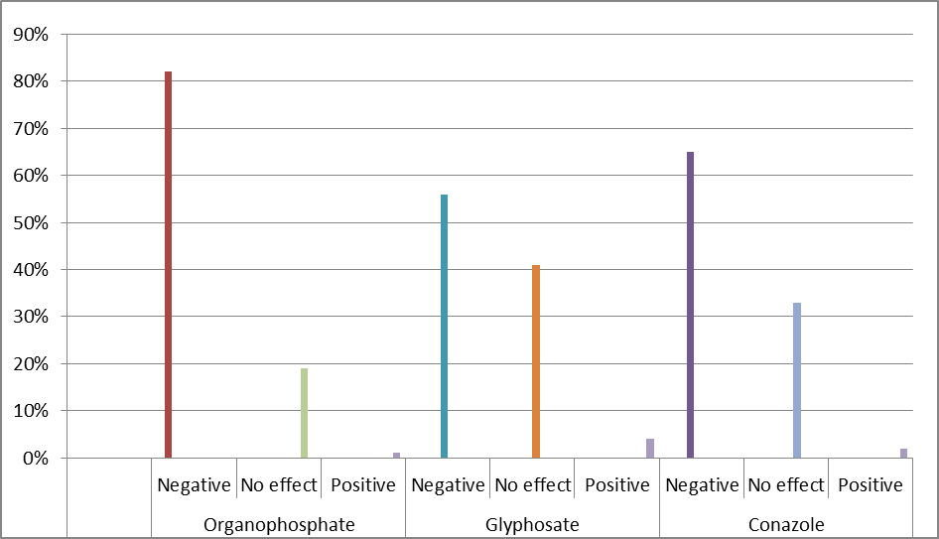
Figure 4: Percentage showing the negative, no effect, and positive effects of an insecticide (organophosphate), herbicides (glyphosate) and fungicides (conazole) on soil invertebrates. Organophosphate- negative effect-82%, no effect- 19%, positive effect-1%, Glyphosate- negative effect- 56%, no effect- 41%, positive effect-3%, Conazole- negative eggect-65%, no effect-33%, positive effect- 2%) (Gunstone et al., 2021).

Table 1: List of some herbicides and their impact on soil microbiota

Herbicides | Effects | References
Atrazine | Inhibitory effects on cyanobacteria | Herman et al., (1986)
2,4-Damine | The activity of Rhizobium sp. is  adversely affected | Fabra et al., (1997)
Bentazone, Prometryn, Simazine,  and Terbutryn | Inhibition of N content occurs | Singh and Wright (2002)
Isoproturon, Triclopyr | Adversely impacts nitrosomonas, Nitrobacter, urea hydrolyzing bacteria, nitrate reductase activity and growth of actinomycetes and fungi | Nowak et al., (2002)
Glyphosate | Growth and activity of azotobacter is  compromised. Inhibits phosphatase activity | Santos and Flores (1995)  Sanninoand Gianfreda(2001)
Oxyluofen,  Propaquizafop | Reduces microbial population in soil transiently | Adhikary et al., (2014)
Paraquat | Inhibits the growth of nitrite oxidizer | Tateo, 1983
Pendimethalin, Pretilachlor | Effect upon several non-target soil organisms.  Reduce the hatching success of Collembola. | Chakravorty et al, 2016 Haque et al., 2011.

Table 2: List of some fungicides and their impact on soil microbiota

Fungicides | Effects | References
Benomyl | Affect arbuscularmycorrhizal  fungi. | Chen et al., (2001)
Captan,  Thiram | Inhibits aerobic N-fixing, nitrifying, denitrifying bacteria  and nitrogenase activity. | Sáez et al., (2005)
Etridiazole | Retards nitrification by  affecting ammonium oxidizers. | Rodgers (1986)
Chlorothalomil,  Mancozeb | Impacts on bacterial activities  related to N cycling and carbon cycling in soil. | Chen et al., (2001),  Cernohlávková et al., (2009)
Copper fungicides | Cellulolytic fungal species and streptomycetes in sandy soilis  decreased. | Kostov and Cleemput (2001)
Pencycuron | Metabolically active soil  bacteria are affected. | Pal et al., (2005)
Fenpropimorph | Bacterial activity in wetlands is  affected. | Milenkovski et al., (2010)
Dimethomorph | Nitrification and ammonification process of  sandy soil is compromised. | Cycon et al., 2010
Dithianon | Bacterial diversity of soil is  declined. | Liebich et al., 2003
Dinocap | The activity of ammonifying  bacteria is inhibited. | Cernohlávková et al., 2009
Fludioxonil | Possesses toxicity towards the  algal activities. | Verdisson et al., 2001
Funaben, Oxafun, Baytun | In application of its higher dose the nitrogenase activity of methylotrophic bacteria is  compromised. | Durska, 2004.

Hexaconazole | Affects bacteria those are  associated with N cycling. | Madhuri and Rangaswamy,  2003
Metalaxyl | Declination of urease activity is  occurred. Phosphatase activity is also affected. | Sukul, 2006
Triadimefon | Shows negative effect towards  soil bacterial communities. | Yen et al., 2009
Triarimol and Captan | The frequency of Aspergillus  sp. is declined. | Wainwright and Pugh, 1975
Oxytetracycline | Declines soil bacterial  population. | Yang et al., 2009.

Table 3: List of some insecticides and their impact on soil micro biota

Insecticides | Effects | References
Arsenic, DDT, and Lindane | Decreases microbial biomass and microbial and  enzymatic activities as a result of longer persistence in  soil | Singh and Singh, 2005
Carbamate insecticides | Inhibits several soil microorganisms, enzymes and nitrogenase activity of  Azospirillum | Sannino and Gianfreda, 2001,Pandey and Singh, 2004
Chlorpyrifos, Quinalphos | Reduces ammonification  process | Madhuri and  Rangaswamy,2002
Metalaxyl and Mefenoxam | Decreases nitrogen-fixing bacteria and microbial  biomass | Monkiedje, 2002
Organophosphate insecticide | Impacts the activity of soil enzymes, several beneficial soil bacteria,and fungal  population and reduces N- | Pandey and Singh, 2004

 | mineralization rate
Neemix-4E | Reduces urease enzyme  activity | Antonious, 2003
Diazinon and Imidacloprid | Inhibits urease-producing  bacterium (Proteus Vulgaris) | Ingram et al., 2005
Chlorinated hydrocarbons | Inhibits methanogenesis | Mahía et al., 2008
Amitraz, Aztec, Cyfluthrin, Imidachlor,andTebupirimphos | Have effect on the activities of urease and phosphate  enzymes | Tu, 1995
Bensulfuron methyl and  Metsulfuron-methyl | Decreases microbial soil  biomass | El-Ghamry et al., 2002
Cyfluthrin, Fenpropimorph, and Imidacloprid | Nregative impact on  nitrification and denitrification process | Tu, 1995
Validamycin | Negative impact on  phosphatase and ureas enzymes | Qian et al., 2007
Quinalphos | Negative impact on the enzyme  phosphomonoesterase | Mayanglambam, 2005

Because pesticides are sprayed in proportion across the entire field, they reach non-target soil microorganisms as well as their target pests. As a result, only around 0.1% of the total amount of pesticides applied reaches the target organisms, while the remainder pollutes the soil and the environment. Unselective pesticide use has a negative impact on soil microcosms, which include soil microfauna in field communities and soil ecosystems (Lo, 2010). Pesticides have a major impact on soil microbiota, a biological indicator of soil fertility that promotes plant growth and development. However, a number of studies have documented how various pesticides affect the activity of soil enzymes that impact soil nutrient status, such as hydrolyzes, oxidoreductase, nitrate reductase, urease, nitrogenase, and dehydrogenase (Santos and Flores, 1995, Fabra et al., 1997, Hussain et al., 2009).

Pesticide use has an impact on biotransformation, including nitrification, ammonification, denitrification, phosphorus dissolution, and S-oxidation (Monkiedje and Spiteller, 2005). In addition, extensive pesticide use in agriculture has a negative impact on reduced microbial carbon biomass (MCB) and the functional diversity of many non-target soil microbial species (Wang, 2006).
Another method of soil contamination is the buildup of heavy metals from the quickly growing industry (Li et al., 2014). Pb, Cr, As, Zn, Ni, and Cd are among the most prevalent heavy metal contaminants and are among the most dangerous inorganic chemical dangers (Chin, 2010, Zhang et al., 2019, Su et al., 2014). According to Li et al. (2014), the main source of heavy metal contamination is the fast growing industry. The buildup of heavy metals can have a number of impacts, including a reduction in the availability of micronutrients and an increase in soil acidity (Lan et al., 2020). Lead (Pb) is regarded as one of the harmful toxicants due to its high toxicity (Qi et al., 2018). According to Dotaniya et al. (2020), Pb causes a decline in soil fertility by reducing the microbial diversity of the soil. The combined effects of Pb and Cd have a significant impact on microbial development (Khan et al., 2010).
Apart from the above mentioned practices, deforestation, land clearing, careless management of forests, improper management of industrial waste etc. are some human-induced land degradation activities that led to soil degradation and considered as a major threat to soil diversity (Bhatia et al., 2019).

Restoration of soil diversity:

Numerous ecological functions depend on soil variety, thus it must be restored (Robinson et al., 2012; Graber et al., 1995). Protecting soil biodiversity is essential for maintaining the whole range of life on Earth. It is critical to preserve existing natural areas, implement sustainable agriculture practices, and restore degraded habitats that may strengthen the diversity of soil communities in order to preserve the diversity of soil communities and their function. Lal (2015) asserts that the restoration of soil quality is dependent on three fundamental procedures: 1. To curtail losses from the soil layer.

- To form a positive soil C budget and thus increase of biodiversity.
- To fortify water and elemental cycling.

The deterioration of soil quality and the reduction of the SOC pool may be brought on by a number of factors. A few of these are the indiscriminate use of plowing, the excessive removal of crop wastes, and the careless use of chemical fertilizers. Contrarily, switching from conventional tillage to conservation agriculture can be successful and lessen degradation. The linked cycling of carbon and water as well as the amplification of elemental cycling can both boost the C sink capacity of soil (Lal, 2015).
The strategies for restoring soil quality can be summarized into the following types: (Lal,
2015).

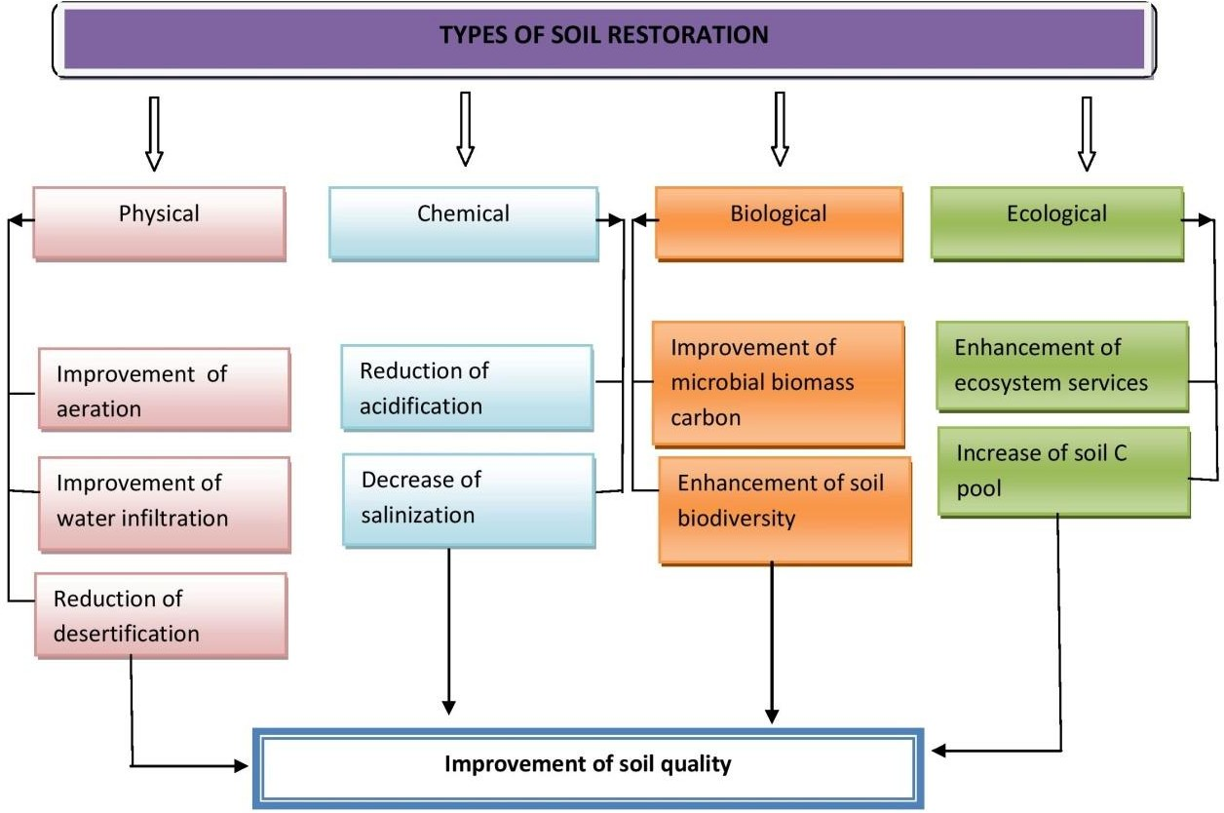

Figure 5: Strategies for restoring soil quality (Lal, 2015).

According to the FAO and ITPS's 2015 World Soil Resources Report, 33 percent of the world's land is "moderately to highly degraded." In order to rehabilitate the degraded lands and ensure the community's overall sustainable development, immediate action must be taken. To increase soil biodiversity, management techniques like crop rotation, irrigation, organic matter addition, and intercropping systems may be used.
One of the key components of soil restoration strategies is the application of microbial-based products to enhance soil health (Timmusk, 2017). Scientists have recently tested a large number of microbial floras for their ability to breakdown pesticides (Kullman and Matsumura, 1996). The five bacterial genera Klebsiella, Acinetobacter, Alcaligenes, Flavobacterium, and Bacillus were discovered to be capable of degrading endosulfan in an efficient manner (Kafilzadehet al., 2015). Seven actinomycete strains were discovered by Jayabarath et al. in 2010 to have excellent carbofuran degradation abilities. Elgueta et al. (2016) discovered that white rot fungus reduce the half-life of atrazine to six days. The microalga Chlamydomonas Mexicana can efficiently break down atrazine (Kabra et al., 2014).

Table 4: Lists of some common pesticide-degrading microorganisms:

Types | Species |  | Example of pesticide  degradation
Bacteria |  | Pseudomonas |  | Aldrin, Endosulfan, (Verma et  al., 2014)
Endrin (Verma et al, 2014),
Parathion (Verma et al, 2014, Upadhyay and Dutt, 2017),
 |  | Flavobacterium
Glyphosate (Upadhyay and
Dutt, 2017)
 |  | Bacillus
Actinomycetes |  | Actinimyces |  | Aldrin (Verma et al., 2014)
 |  | Nocardia |  | Carbofuran (Jayabarath et al.,  2010)
 |  | Streptomyces |  | Diuron (Esposito et al., 1998)

Fungus | White rot fungi, Rhizopus, Mucor, Tricoderma |  | Alachlor (Hai et al.,2012),Atrazine (Hai et al.,2012,Elgueta et al., 2016)Carbofuran(Jayabarath et  al., 2010)
Algae |  | Small green algae | Phorate (Tang, 2018), Atrazine(Kabra et al., 2014) Parathion(Tang, 2018),  Patoran(Shehata et al., 1997)
 |  | Chlamydomonas

Conclusion and future direction:

Unsustainable farming practices are the main hazard to soil biodiversity among a number of other problems. Soil resources serve a crucial role for both human welfare and all terrestrial life. Some crucial elements and methods for restoring soil include reducing soil erosion, boosting the availability of various macro and micronutrients, increasing soil diversity, and strengthening microbial processes. For the selection of the most effective remedial method, prior understanding of the sources, chemistry, and possible dangers of toxic heavy metals and pesticides in contaminated soil is required. The adoption of an integrated strategy for managing soil resources ought to be the main objective. To minimize the negative environmental effects, it is essential to educate farmers, distributors, industry, legislators, and other stakeholders about the selective use of pesticides. Well-designed experiments are needed on the long-term effect of pesticides on microbial communities and their long-term eco-toxicological effects in the soil environment.

References:

Adams, G. A., and Wall, D. H. 2000. Biodiversity above and below the surface of soils and Sediments : linkages and implications for global change. BioScience. 50, 1043–1048.

Al-Assiuty, A.-N. I. M., Khalil, M. A., Ismail, A.-W. A., van Straalen, N. M., and Ageba, M.F.2014.Effects of fungicides and biofungicides on populationdensity and community

structure of soil oribatid mites. Sci. Total Environ.466–467,412–420.

Allison SD, Martiny JBH. 2008. Resistance, resilience, and redundancy in microbial communities. Proceedings of the National Academy of Sciences of the United States of America.105:11512–11519.doi: 10.1073/pnas.0801925105.

Antonious, G.F. Impact of Soil Management and Two Botanical Insecticides on Urease and InvertaseActivity.J. Environ. Sci. Health Part B 2003, 38, 479–488.

Balvanera P, Pfisterer AB, Buchmann N, He JS, Nakashizuka T, Raffaelli D, Schmid B. 2006. Quantifying the evidence for biodiversity effects on ecosystem functioning and services. EcolLett. 2006 Oct;9(10):1146-56. doi: 10.1111/j.1461-0248.2006.00963.x.

Blouin, M.; Hodson, M. E.; Delgado, E. A.; Baker, G.; Brussaard, L.; Butt, K. R.; Dai, J.; Dendooven, L.; Peres, G.; Tondoh, J. E.; Cluzeau, D.; Brun, J.-J. (2013). A review of earthworm impact on soil function and ecosystem services. European Journal of Soil Science, 64(2), 161–182. doi:10.1111/ejss.12025.

Cernohlávková, J.; Jarkovský, J.; Hofman, J. Effects of fungicides mancozeb and dinocap on carbon and nitrogen mineralization in soils. Ecotoxicol. Environ. Saf. 2009, 72, 80–85.

Chagnon, M., Kreutzweiser, D., Mitchell, E. A. D., Morrissey, C. A., Noome, D. A.,and Van derSluijs, J. P.2015.Risks of large-scale use of systemic insecticides to ecosystem functioning and services. Environ. Sci. Pollut. Res. 2015; 22, 119–134.

Chakravorty PP, Haque A, Sanyal S, Das GR.2015.Effects of herbicides on Cyphoderus javanus (Hexapoda: Collembola) under laboratory conditions. Journal of Entomology and Zoology Studies ; 3(1): 220-223.

Chin, N.P. Environmental toxins: Physical, social, and emotional. Breastfeed. Med. 2010, 5, 223–224.

Chen, S.-K.; Edwards, C.A.; Subler, S. Effects of the fungicides benomyl, captan and chlorothalonil on soilmicrobial activity and nitrogen dynamics in laboratory incubations. Soil Biol. Biochem. 2001, 33, 1971–1980.

Cycoṅ M.; Piotrowska-Seget, Z.; Kozdrój, J. Responses of indigenous microorganisms to a fungicidal mixture of mancozeb and dimethomorph added to sandy soils. Int. Biodeterior. Biodegrad. 2010, 64, 316–323.

Dirzo, R., Young, H. S., Galetti, M., Ceballos, G., Isaac, N. J. B., and Collen,B.2014.
Defaunation in the Anthropocene. Science.2014; 345, 401–406. doi:10.1126/science.125181

Downing AS, van Nes EH, Mooij WM, Scheffer M. 2012. The resilience and resistance of an ecosystem to a collapse of diversity. PLOS ONE 7:1–7. doi:10.1371/journal.pone.0046135.

Dotaniya, M.L.; Dotaniya, C.K.; Solanki, P.; Meena, V.D.; Doutaniya, R.K. (2020) Lead Contamination and Its Dynamics in Soil–Plant System. In Lead in Plants

Durska, G.2004.Fungicide effect on nitrogenase activity in methylotrophic bacteria.
Pol. J. Microbiol.53, 155–158.

Elgueta, S.; Santos, C.; Lima, N.; Diez, M.C. Immobilization of The White-Rot Fungus Anthracophyllum Discolor to Degrade the Herbicide Atrazine. AMB Express 2016, 6, 104.

El-Ghamry, A.M.; Xu, J.M.; Huang, C.Y.; Gan, J. Microbial response to bensulfuron-methyl treatment in soil. J. Agric. Food Chem. 2002, 50, 136–139.

Esposito, E.; Paulillo, S.M.; Manfio, G.P. Biodegradation of the Herbicide Diuron in Soil by IndigenousActinomycetes. Chemosphere 1998, 37, 541–548.

Fabra, A.; Duffard, R.; Duffard, A.E. de Toxicity of 2,4-Dichlorophenoxyacetic Acid to
Rhizobium sp in Pure Culture. Bull. Environ. Contam.Toxicol. 1997, 59, 645–652.

FAO.2020.State of Knowledge of Soil Biodiversity - Status, Challenges and Potentialities:Report.Rome: FAO, doi: 10.4060/cb1928en.

Forister, M. L.,Pelton, E. M., and Black, S. H2019. Declines in insect abundance and diversity: we know enough to act now. Conserv. Sci. Pract.1:e80. doi:10.1111/csp2.80 .

Fravel, D.R.; Deahl, K.L.; Stommel, J.R. Compatibility of the biocontrol fungus Fusariumoxysporum strainCS-20 with selected fungicides. Biol. Control 2005, 34, 165–169.

Gaupp-Berghausen, M., Hofer, M., Rewald, B., and Zaller, J. G.2015.Glyphosate-based Herbicides reduce the activity and reproduction of earthworm sand lead to increased soil nutrient concentrations. Sci. Rep. 5:12886. doi: 10.1038/srep12886.

Graber, D.R.; Jones, W.A.; Johnson, J.A. Human and ecosystem health. J. Agromedicine.1995,2,47–64.

Gill, R. J., Baldock, K. C. R., Brown, M. J. F., Cresswell, J. E., Dicks, L. V., Fountain, M. T.,et al.2016. “Protecting an ecosystem service,” in Advances in Ecological Research eds G.

Gunstone T, Cornelisse T, Klein K,Dubey A and Donley N (2021)Pesticides and Soil Invertebrates:A Hazard Assessment.Front. Environ. Sci. 9:643847.
doi: 10.3389/fenvs.2021.643847

Hai, F.I.; Modin, O.; Yamamoto, K.; Fukushi, K.; Nakajima, F.; Nghiem, L.D. 2012. Pesticide Removal by A MixedCulture of Bacteria and White-Rot Fungi. J. Taiwan Inst. Chem. E 2012, 43, 459–462.

Hallmann CA, Sorg M, Jongejans E, Siepel H, Hofland N, Schwan H, et al. 2017. More than 75 percent decline over 27 years in total flying insect biomass in protected areas. PLoS
ONE 12(10): e0185809. https://doi.org/10.1371/journal.pone.0185809.

Haque, A., Das, GR., Chakravorty, PP.2011. effects of herbicides on xenyllawelchi (Hexapoda: Collembola) under laboratory conditions. Bull Environ Contam Toxicol;85:583-236.

Honek, A., Martinkova, Z., and Jarosik, V. 2003.Ground beetles (Carabidae) as seed predators..Eur. J. Entomol.100, 531–544. doi: 10.14411/eje.2003.081

Hussain, S.; Siddique, T.; Saleem, M.; Arshad, M.; Khalid, A. Chapter 5 Impact of Pesticides on Soil MicrobialDiversity, Enzymes, and Biochemical Reactions. Adv. Agron. 2009, 102, 159–200.

Ingram, C.W.; Coyne, M.S.; Williams, D.W.2005.Effects of Commercial Diazinon and Imidacloprid on Microbial Urease Activity in Soil and Sod. J. Environ. Qual. 2005, 34, 1573.

Jayabarath, J.; Musfira, S.A.; Giridhar, R.; Arulmurugan, R. 2010.Biodegradation of Carbofuran Pesticide by Saline Soil Actinomycetes. Int. J. Biotechnol. Biochem. 2010, 6, 187–193.
Joy, V. C., and Chakravorty, P. P. 1991.Impact of insecticides on non-target micro arthropod fauna in agricultural soil. Ecotoxicol. Environ. Saf. 22, 8–16.
doi: 10.1016/0147- 6513(91)90041-M.

Kabra, A.N.; Ji, M.K.; Choi, J.; Kim, J.R.; Govindwar, S.P.; Jeon, B.H. 2014.Toxicity of Atrazine and Its Bioaccumulation and Biodegradation in A Green Microalga, Chlamydomonas. Mexicana. Environ. Sci. Pollutr.2014, 21, 12270–12278.

Kafilzadeh, F.; Ebrahimnezhad, M.; Tahery, Y.2015. Isolation and Identification of Endosulfan Degrading Bacteriaand Evaluation of Their Bioremediation in Kor River, Iran. Osong Public Health Res. Perspect. 2015, 6, 39–46.

Khan, S.; Hesham, A.E.L.; Qiao, M.; Rehman, S.; He, J.Z. Effects of Cd and Pb on soil microbial community structure and activities.Environ. Sci. Pollut. Res. 2010, 17, 288– 296.

Kibblewhite, M. G., Ritz, K., and Swift, M. J. 2008.Soil health in agricultural systems. Philos.

Trans. R. Soc. B Biol. Sci. 2008; 363, 685–701. doi: 10.1098/rstb.2007.2178.

Kostov, O.; Van Cleemput, O. Microbial Activity of Cu Contaminated Soils and Effect of Lime

and Compost on Soil Resiliency. Compost Sci. Util. 2001, 9, 336–351.

Kullman, S.W.; Matsumura, F.1996.Metabolic Pathways Utilized by Phanerochaete Chrysosporium for Degradation of the Cyclodiene Pesticide Endosulfan.
Appl. Environ. Microbiol. 1996, 62, 593–600.

Lal, R. Soil carbon sequestration impacts on global climate change and food Security.
Science.2004a; 304, 1623–1627. doi: 10.1126/science.109.

Lan, M.M.; Liu, C.; Liu, S.J.; Qiu, R.L.; Tang, Y.T. Phyto stabilization of cd and pb in highly polluted farmland soils using ramie and amendments. Int. J. Environ. Res. Public Health 2020, 17, 1661.

Lal, R.Soil carbon sequestration to mitigate climate change.Geoderma.2004b;123, 1– 22. doi: 10.1016/j.geoderma.2004.01.032

Lavelle, P., Decaëns, T., Aubert, M., Barot, S., Blouin, M., Bureau, F., et al.2006.Soil invertebrate and ecosystem services. Eur. J. Soil Biol. 2006; 42, S3–S15.

Liebich, J., Schäffer, A.,Burauel, P.2003.Structural and functional approach to studying pesticide side-effects onspecific soil functions. Environ. Toxicol. Chem. 2003, 22, 784– 790.
Li, Z.; Ma, Z.; van der Kuijp, T.J.; Yuan, Z.; Huang, L. A review of soil heavy metal pollution from mines in China: Pollution and health risk assessment. Sci. Total Environ. 2014, 468– 469, 843–853.

Lo, C.-C. Effect of pesticides on soil microbial community. J. Environ. Sci. Health Part B 2010, 45, 348–359.

Madhuri, R.J.; Rangaswamy, V. Influence of selected insecticides on phosphatase activity in groundnut(Arachishypogeae L.) soils. J. Environ. Biol. 2002, 23, 393–397.

Maloney, S.E. Pesticide Degradation. In Fungi in Bioremediation, 3rd ed.; Gadd, G.M., Ed.; the BritishMycological Society: New York, NY, USA, 2001; Volume 8, pp. 188–223. ISBN
0-521-78119-1

Mahía, J.; Cabaneiro, A.; Carballas, T.; Díaz-Raviña, M. Microbial biomass and C mineralization in agriculturalsoils as affected by atrazine addition. Biol. Fertil. Soils 2008, 45, 99–105.

Madhuri, R.J.,Rangaswamy, V.2003. Influence of selected fungicides on microbial population in groundnut (Arachishypogeae L.) soils. Pollut. Res. 2003, 22, 205–212.

Mayanglambam, T.; Vig, K.; Singh, D.K. Quinalphos Persistence and Leaching Under Field Conditions and Effects of Residues on Dehydrogenase and Alkaline Phosphomonoesterases Activities in Soil. Bull. Environ.Contam. Toxicol. 2005, 75, 1067–1076.

Meena, R.S.,Bohra, J.S., Singh, S.P.,Meena, V.S., Verma, J.P., Verma, S.K.,Sihag, S.K.2006.
Towards the prime response of manure to enhance nutrient use efficiency and soil sustainability a current need: A book review. J. Clean. Prod. 2016, 112, 1258–1260.

Meena, R.S., Kumar, S., Datta, R., Lal, R.,Vijayakumar, V., Brtnicky, M., Sharma, M.P., Yadav, G.S., Jhariya, M.K., Jangir, C.K., Pathan, S.I., Dokulilova, T., Pecina, V., Marfo, T.D.2020. Impact of Agrochemicals on Soil Microbiota and Management: A Review.a 2020, 9, 34.

Miliˇci´c, M., Popov, S., Branco, V. V., and Cardoso, P. (2020). Insect threats and conservation
through the lens of global experts. bioRxiv [Preprint]. doi: 10.1101/2020.08.28.271494.

Milenkovski, S.; Bååth, E.; Lindgren, P.E.; Berglund, O. Toxicity of fungicides to natural bacterial communitiesin wetland water and sediment measured using leucine incorporation and potential denitrification.Ecotoxicology 2010, 19, 285–294.

Monkiedje, A.; Spiteller, M. Degradation of Metalaxyl and Mefenoxam and Effects on the MicrobiologicalProperties of Tropical and Temperate Soils. Int. J. Environ. Res. Public. Health 2005, 2, 272–285.

Nowak, J.; Kaklewski, K.; Klódka, D. Influence of various concentrations of selenic acid (IV) on the activityof soil enzymes. Sci. Total Environ. 2002, 291, 105–110.

Oliveira, C.M.; Auad, A.M.; Mendes, S.M.; Frizzas, M.R. Crop losses and the economic impact of insect pests on Brazilian agriculture. Crop Prot. 2014, 56, 50–54.

Önder, M.; Ceyhan, E.; Kahraman, A. Effects of Agricultural Practices on Environment.
Biol. Environ. Chem.2011, 24, 28–32.

Orgiazzi, A., Bardgett, RD., Barrios, E.2016.Global soil biodiversity Atlas. Italy: European Commission.2016.

Pandey, S.; Singh, D.K. Total bacterial and fungal population after chlorpyrifos and quinalphos treatments ingroundnut (Arachishypogaea L.) soil. Chemosphere. 2004, 55, 197–205.

Pal, R.; Chakrabarti, K.; Chakraborty, A.; Chowdhury, A. Pencycuron application to soils: Degradation and effect on microbiological parameters. Chemosphere 2005, 60, 1513– 1522.

Perrings, C., Jackson, L., Bawa, K., Brussaard, L., Brush, S., Gavin, T., et al.2006.Biodiversity in agricultural landscapes: saving natural capital without losing interest. Conserv.Biol. 2006; 20, 263–264.

Pisa, L. W., Amaral-Rogers, V., Belzunces, L. P., Bonmatin, J. M., Downs, C. A., Goulson, D., et al. Effects of neonicotinoids and fipronil on non-target invertebrates. Environ. Sci. Pollut. Res. 2015; 22, 68–102.

Pokarzhevskii, A.D., van Straalen, N.M., Zaboev, D.P. &Zaitsev, A.S. 2003. Microbial link sand element flows in nested detrital food-webs. Pedobiologia, 47: 213–224.

Qian, H.; Hu, B.; Wang, Z.; Xu, X.; Hong, T. Effects of validamycin on some enzymatic activities in soil. Environ. Monit. Assess. 2007, 125, 1–8.

Qi, X.; Xu, X.; Zhong, C.; Jiang, T.; Wei, W.; Song, X. Removal of Cadmium and Lead from Contaminated Soils Using Sophorolipids from Fermentation Culture of
Starmerella bombicola CGMCC 1576 Fermentation. Int. J. Environ. Res. Public Health
2018, 15, 2334.

Ram, R. L. (ed.) Current Research in Soil Fertility, 1st Edn. DelhiAkiNik Publications.2019.

Ramirez, K. S., Döring, M., Eisenhauer, N., Gardi, C., Ladau, J., Leff, J. W., et al.2015.

Toward a global platform for linking soil biodiversity data. Front. Ecol.Evol.2015; 3:91. doi: 10.3389/fevo.2015.00091.

Robinson, D.; Emmett, B.; Reynolds, B.; Rowe, E.; Spurgeon, D.; Keith, A.; Lebron, I.; Hockley, N.; Hester, R.; Harrison, R.2012 Soil Natural Capital and Ecosystem Service Delivery in a World of Global Soil Change. Soils Food Secur. 2012, 35, 41–68.

Sáez, F.; Pozo, C.; Gómez, M.A.; Martínez-Toledo, M.V.; Rodelas, B.; Gónzalez-López, J. Growth and denitrifying activity of Xanthobacter autotrophicus CECT 7064 in the presence of selected pesticides.Appl. Microbiol. Biotechnol. 2005, 71, 563–567.

Shehata, S.A.; El-Dib, M.A.; Waly, H.A. Effect of Certain Herbicides on the Growth of Freshwater Algae.Water Air Soil Pollut. 1997, 100, 1–12.

Santos, A.; Flores, M. Effects of glyphosate on nitrogen fixation of free-living heterotrophic bacteria.Lett. Appl. Microbiol. 1995, 20, 349–352.

Sánchez-Bayo, F., and Wyckhuys, K. A. G. (2019). Worldwide decline of the entomofauna: a review of its drivers. Biol. Conserv. 232, 8–27. doi: 10.1016/j.biocon.2019.01.020

Sannino, F.; Gianfreda, L. Pesticide influence on soil enzymatic activities. Chemosphere 2001, 45, 417–425.

Seibold, S., Gossner, M.M., Simons, N.K. et al.2019. Arthropod decline in grasslands and forests is associated with landscape-level drivers. Nature 574, 671–674(2019). https://doi.org/10.1038/s41586-019-1684-3.

Singh, G.; Wright, D. In vitro studies on the effects of herbicides on the growth of rhizobia.
Lett. Appl. Microbiol.2002, 35, 12–16.

Singh, J.; Singh, D.K. Dehydrogenase and phosphomonoesterase activities in groundnut (Arachis hypogaea L.) field after diazinon, imidacloprid and lindane treatments.
Chemosphere 2005, 60, 32–42.

Stork, N.E.2018.How many species of insects and other terrestrial arthropods are there on earth? Annual Review of Entamology, 2018; 63: 31–45.

Sukul, P.2006. Enzymatic activities and microbial biomass in soil as influenced by metalaxyl residues. Soil Biol.Biochem.2006, 38, 320–326.

Su, C.; Jiang, L.; Zhang, W. A review on heavy metal contamination in the soil worldwide: Situation, impact and remediation techniques. Environ. Skept. Critics 2014, 3, 24–38.

Tang, W. Research Progress of Microbial Degradation of Organophosphorus Pesticides. Prog.
Appl. Microbiol.2018, 1, 29–35.

Timmusk, S.; Behers, L.; Muthoni, J.; Muraya, A.; Aronsson, A.-C. Perspectives and challenges of microbial application for crop improvement. Front. Plant Sci. 2017, 8, 49.

Tibbett M, Fraser TD, Duddigan S.2020.Identifying potential threats to soil biodiversity.PeerJ.
2020; 8:e9271.http://doi.org/10.7717/peerj.9271

Tu, C.M. Effect of five insecticides on microbial and enzymatic activities in sandy soil.
J. Environ. Sci. Health Part B 1995, 30, 289–306.

Upadhyay, L.S.; Dutt, A. Microbial Detoxification of Residual Organophosphate Pesticides in Agricultural Practices. In Microbial Biotechnology; Springer: Singapore, 2017; pp. 225– 242.
Verdisson, S.; Couderchet, M.; Vernet, G. Effects of procymidone, fludioxonil and pyrimethanil on two non-target aquatic plants. Chemosphere 2001, 44, 467–474.

Verma, J.P.; Jaiswal, D.K.; Sagar, R. Pesticide Relevance and Their Microbial Degradation: A- State-of-Art.Rev. Environ. Sci. Technol. 2014, 13, 429–466.

Wallwork, J. A. Ecology of soil animals.1970.

Wang, M.-C.; Gong, M.; Zang, H.-B.; Hua, X.-M.; Yao, J.; Pang, Y.-J.; Yang, Y.-H. Effect of Methamidophos and Urea Application on Microbial Communities in Soils as Determined by Microbial Biomass and Community Level Physiological Profiles. J. Environ. Sci.
Health B 2006, 41, 399–413.

Wainwright, M.; Pugh, G.J.F. Effect of fungicides on the numbers of micro-organisms and frequency of cellulolytic fungi in soils. Plant Soil 1975, 43, 561–572.

Willis Chan, D. S., Prosser, R. S., Rodríguez-Gil, J. L., and Raine, N. E. Assessment of risk to hoary squash bees (Peponapis pruinosa) and other ground-nesting bees from systemic insecticides in agricultural soil. Sci. Rep. 2018; 9:11870. doi: 10.1038/s41598-019-47805-1

Woodward, and D. A. Bohan (Amsterdam: Elsevier), 2016; 135–206. doi:10.1016/bs.aecr.2015.10.007.

Yáñez, L.; Ortiz, D.; Calderón, J.; Batres, L.; Carrizales, L.; Mejía, J.; Martínez, L.; García- Nieto, E.;Díaz-Barriga, F. Overview of human health and chemical mixtures: Problems facing developing countries. Environ. Health Perspect. 2002; 110, 901–909.

Yang, Q.; Zhang, J.; Zhu, K.; Zhang, H. Influence of oxytetracycline on the structure and activity of microbialcommunity in wheat rhizosphere soil. J. Environ. Sci. 2009, 21, 954– 959.

Yen, J.-H.; Chang, J.-S.; Huang, P.-J.; Wang, Y.-S. Effects of fungicides triadimefon and propiconazole on soil bacterial communities. J. Environ. Sci. Health Part B 2009, 44, 681– 689.

Zhang, X.; Yan, L.; Liu, J.; Zhang, Z.; Tan, C. Removal of different kinds of heavy metals by novel PPG-nZVI beads and their application in simulated storm water infiltration facility. Appl. Sci. 2019, 9, 4213.

Zhang, Z.-Q. (Ed.) Animal Biodiversity: An Outline of Higher-level Classification and Survey of Taxonomic Richness (Addenda 2013).Zootaxa, 3703, 1–82.

