**Cost-effective Well-suited Green Azadirachta Indica Reduced Ag-Tio2: A Potent Spherical Nano Scaffolds**

Dr. Aakash Singh1* Mr. Vikas Chaubey2 Dr. Anod Kumar Singh3 and Dr. P. K. Singh4

[aakashsingh.ucst@gmail.com](mailto:aakashsingh.ucst@gmail.com)1, [vikaschaubey0111@gmail.com2](mailto:vikaschaubey0111@gmail.com2),[anodsingh6789@gmai.com3](mailto:anodsingh6789@gmai.com3), [pksingh.lu@gmail.com](mailto:pksingh.lu@gmail.com)4

1,2IET, Dr. Shakuntala Misra National Rehabilitation University’ Lucknow, Uttar Pradesh India

3,4Department of Applied sciences and humanities, School Of Management Sciences, Lucknow, Uttar Pradesh, India.

***Abstract:***

The profitability of nanoparticles has been steadily increasing due to their diverse applications in catalysis, electronics, energy, and medicine. However, the conventional methods of preparing metallic nanoparticles often involve the use of toxic and combustible chemicals as reducing agents. To address this concern and promote environmentally friendly production, a recent study presents a cost-effective and eco-friendly approach for the green synthesis of Ag-Tio2 nanoparticles using Azadirachta Indica plant extract.

In this research work, Azadirachta Indica plant extract was utilized both as a reducing agent and a capping agent to facilitate the production of Ag-Tio2 nanoparticles. High-purity titanium isopropoxide and the Azadirachta Indica plant extract were used to achieve the synthesis of Silver-doped Tio2 nanoparticles. The color of the reaction mixture shifted from light brown to green, indicating the formation of Ag-Tio2 nanoparticles within one hour of the reaction.

The researchers employed various techniques to confirm the successful formation of Ag-Tio2 nanoparticles. FTIR (Fourier Transform Infrared Spectroscopy), UV-Vis (Ultraviolet-Visible Spectroscopy), XRD (X-ray Diffraction), EDX (Energy Dispersive X-ray Spectroscopy), and SEM (Scanning Electron Microscopy) were employed for characterization purposes.

FTIR analysis confirmed the formation of both Ag-Tio2 nanoparticles and the Tio2 phase. UV-Vis spectroscopy provided further evidence of the successful synthesis of nanoparticles. XRD and SEM studies revealed that the nanoparticles exhibited a spherical morphology, with the size falling within the range suggested by electron microscopy data.

Moreover, EDX analysis confirmed the presence of Ag ions incorporated into the Tio2 lattice, further supporting the successful formation of Ag-Tio2 nanoparticles.

Overall, this study presents a promising method for the green synthesis of Ag-Tio2 nanoparticles using Azadirachta Indica plant extract, offering an eco-friendly alternative to traditional, toxic chemical-based approaches.

**Keywords-** Green synthesis, Ag-Tio2 Nps, *Azadirachta Indica*

**Introduction:**

Currently, nanobiotechnology is a crucial area of research focused on the fusion and design of nanoparticles, which possess unique characteristics such as small dimensions, large surface areas, specific chemical compositions, shapes, and sizes [1-2]. Over the past decade, there has been significant interest in the bio-synthesis of doped and single metal nanoparticles using plant-based methods due to their relieving, eco-friendly, and extensively photo-catalytic properties [3-6]. This approach also offers cost-effectiveness, allowing for increased bulk production of nanoparticles [7]. Eco-compatible biosynthesis of nanoparticles from plants has proven to be faster and results in more stable materials compared to other conventional methods [8-10].

The bioactive synthesis of nanoparticles from plants is considered a valuable and beneficial approach [11-13]. It offers several advantages, including safety, cleanliness, reliability, bio-eco-compatibility, speed, and the generation of ecological byproducts. This process ensures the production of nanoparticles without harmful residues or contaminants. The specific characteristics, composition, and size of the nanoparticles depend on the type of plant extract used and the temperature during the oxide formation process.

The common name for Azadirachta Indica is Neem, and it belongs to the family Meliaceae. This plant species is found in countries such as India, Burma, Bangladesh, Thailand, Cambodia, Iran, Indonesia, Malaysia, Pakistan, Nepal, Sri Lanka, and Vietnam [14-16]. Neem has gained significant interest in the field of medicine due to its various biological activities, including antifungal, antibacterial, anticandidal, antiviral, and anticarcinogenic properties [17-22].

Neem leaves have been traditionally used to treat several health conditions, including eye disorders, leprosy, bloody nose, stomach upset, intestinal worms, loss of appetite, skin ulcers, cardiovascular diseases, diabetes, fever, gum disease (gingivitis), and liver problems.

Moreover, Neem is recognized for its cardioactive phytochemical properties, containing a wide range of cardenolides drugs that have been isolated from the plant Azadirachta Indica gigantean. The plant also contains various biologically active compounds such as triterpenoids, cardenolides, resins, flavonoids, proteolytic enzymes, tannins, sterols, and terpenes, which can aid in the reduction of metals.

Titanium oxide (TiO2) exhibits great potential as a photocatalyst due to its low band gap energy and stability, making it suitable for various applications such as self-cleaning, ecological decontamination, photo-catalysis, and high quantum efficiency. The development of TiO2 nanoparticles, in which Ti forms a complex with Azadirachta Indica gigantean plant extract, is not only biocompatible but also environmentally friendly.

In this study, TiO2 nanoparticles were synthesized using a green synthesis method, and their band gap values were found to vary based on the content of Ag (silver). The effect of Ag doping on the crystal structure of TiO2 nanoparticles was investigated using SEM and spectroscopic techniques. This research builds upon the ongoing study of nanoparticles and their doped derivatives and applications [22-26], focusing on the impact of Ag-TiO2 nanoparticles by utilizing the aqueous extract of Azadirachta Indica.

During the synthesis, titanium isopropoxide served as the initial precursor, while Azadirachta Indica acted as a reducing, stabilizing, and capping agent. The capping agents present in Azadirachta Indica played a crucial role in controlling the shape and size of Ag-TiO2 nanoparticles by increasing the surface energy and preventing agglomeration. This resulted in novel applications where the nanoparticles acted both as reducing agents and surface stabilizers, leading to the formation of spherical-shaped Ag-TiO2 nanoparticles.

The optical properties of the nanoparticles were analyzed using UV-visible (UV-VIS) spectroscopy, while further characterization was performed through X-ray diffraction (XRD), Fourier-transformed infrared spectroscopy (FTIR), and Energy dispersive X-ray spectroscopy (EDX). These techniques provided valuable insights into the properties and structure of the synthesized Ag-TiO2 nanoparticles.

**Synthesis / Material and Methods:**

The chemicals used for the synthesis of Ag-TiO2 nanoparticles were of analytical grade, and purified solvents and double-distilled water were utilized. Specifically, titanium isopropoxide (from Merck), silver nitrate (from Merck), and concentrated hydrochloric acid (from Hi-media) were purchased for this process.

The synthesis of Ag-TiO2 nanoparticles involved the following steps:

**I. Preparation of Azadirachta Indica gigantean plant extract-**

* Fresh leaves of Azadirachta Indica were collected from the University, Campus.
* The collected leaves were cleaned 2-3 times with fresh distilled water to remove dust particles.
* The cleaned leaves were then dried in an oven at a temperature of 60°C for 2-3 hours.
* Once dried, the leaves were crushed into a powdered form.
* 5 grams of the crushed powder were mixed with 250 ml of deionized water in a 500 ml beaker.
* The mixture was boiled for 2-3 hours.
* The resulting extract was filtered and used for further synthesis of Ag-TiO2 nanoparticles.

**II. Green synthesis of Ag-TiO2 nanoparticles:**

* To synthesize TiO2 nanoparticles, 50 ml of Azadirachta Indica plant extract solution and 5 grams of titanium isopropoxide were combined with 15 ml of 0.5 M silver nitrate solution in a 250 ml round bottom flask.
* The pH of the solution was adjusted by adding concentrated hydrochloric acid.
* The mixture of titanium isopropoxide and Azadirachta Indica plant extract was heated at 60°C for 2 hours under stirring.
* After continuous stirring for 2 hours, the solution was allowed to settle down overnight.
* The solution was then centrifuged at 15000 rpm for 10 minutes to obtain the Ag-TiO2 nanoparticles.
* The separated nanoparticles were washed multiple times with ethanol and water.
* The washed nanoparticles were dried in a hot air oven at 80°C and then calcinated at 600°C for 2 hours in a Muffle Furnace.
* Finally, the particles were ground using a motor pistol to achieve the desired particle size suitable for further characterization.After continuous stirring for 2 hours, the solution was allowed to settle down overnight.
* The solution was then centrifuged at 15000 rpm for 10 minutes to obtain the Ag-TiO2 nanoparticles.
* The separated nanoparticles were washed several times with ethanol and water.
* The washed nanoparticles were then dried in a hot air oven at 80°C and subsequently calcined at 600°C for 2 hours in a Muffle Furnace.
* Finally, the particles were ground using a motor pistol to achieve the desired particle size for further characterization.

**Result and Discussion-**

**1. UV-Visible Absorption Spectroscopy-**

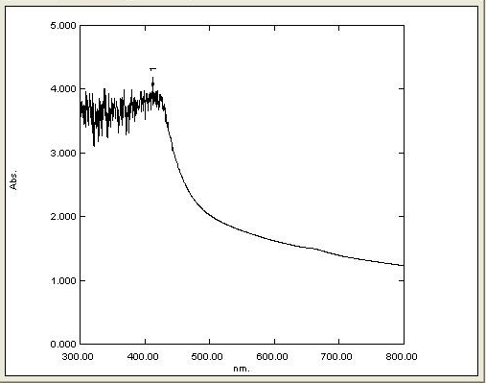

**Fig.1: UV visible Analysis**

The synthesis of Ag-TiO2 nanoparticles through the reduction of aqueous metal ions using Azadirachta Indica plant extract was monitored using a double beam UV-visible spectrophotometer (Shimadzu Model Number. 1800). The absorption peak obtained in the UV-Vis absorption spectra within the visible range of wavelength was at 390 nm, as shown in Figure 1. This peak confirmed the presence of Ti. Additionally, there was another absorption peak observed at 430.0 nm, which further confirmed the successful formation of TiO2 nanoparticles.

**2. FTIR Analysis:**



**Fig.2: FTIR Analysis**

The FTIR analysis confirmed the threefold role of the plant extract as a reducing, capping, and stabilizing agent in the preparation of Ag-doped TiO2 nanoparticles. The FTIR spectral analysis was performed in the range of 400 to 4000 cm-1, and the leaf extract of Azadirachta Indica plant and the synthesized Ag-doped TiO2 nanoparticles were studied using the KBr technique to record the spectra.

Several characteristic bands were observed in the FTIR spectra. The band located near 705 cm-1 corresponds to the Ti-O stretching mode, indicating the presence of TiO2 in the nanoparticles. In the range of 3200 to 3600 cm-1, a band was observed, which corresponds to the stretching vibration of the –OH bond, showing a peak at 3452.27 cm-1, and another band at 1630 cm-1 has been assigned to the first overtone of the fundamental stretching mode of –OH (Fig. 2). These stretching vibrations are attributed to water molecules bound to the surface of the sample.

Furthermore, a band at 1629.91 cm-1 was observed, which is attributed to the Ag-O stretching vibration. This band is absent in the case of pure TiO2, indicating the successful incorporation of Ag into the TiO2 nanoparticles. This confirms the presence of Ag-doping in the TiO2 nanoparticles, which is responsible for the unique properties and potential applications of the synthesized nanoparticles.

**3. X-ray Diffraction Analysis (XRD)-**

X-ray diffraction (XRD) analysis was conducted to examine the crystalline nature of the synthesized product. The results revealed that TiO2 nanoparticles were formed in the form of nanocrystals, with distinct peaks observed at 2θ = 33.21° and 58.97°, corresponding to the (111) and (220) crystal planes, respectively (Fig. 3). The XRD pattern was in accordance with JCPDS card NO. 21-1272, confirming the spherical shape of the nanoparticles.

The X-ray diffraction results displayed strong, intense, and sharp peaks, indicating that the nanoparticles are highly crystalline in nature. The XRD pattern showed only the presence of the TiO2 phase without any impurity peaks.

The crystalline size of both the pure and Ag-doped TiO2 nanocrystals was estimated using Debye-Scherrer's equation:

D = Kλ/β cosθ

Where D is the crystallite size of the TiO2 nanoparticles, λ is the wavelength of the X-ray source (0.1541 nm) used in XRD, β is the full width at half maximum of the diffraction peak, and θ is the Bragg angle. The Scherrer's constant (K) is typically assigned a value from 0.9 to 1.

This analysis provided valuable information about the crystalline structure and size of the synthesized TiO2 nanoparticles, which is essential for understanding their properties and potential applications

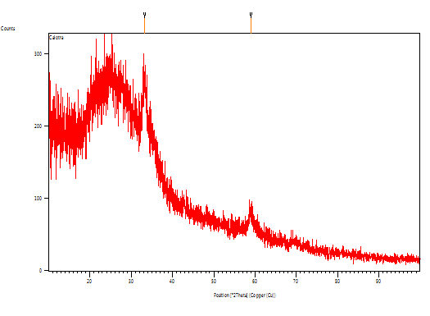

**Fig.3:- X-ray Diffraction Analysis (XRD)**

**4. SEM & Energy dispersive X-ray Analysis**

Energy Dispersive X-Ray Analysis (EDX) is an x-ray technique used to determine the elemental composition of materials. It is commonly performed as an attachment to Electron Microscopy instruments, such as Scanning Electron Microscopy (SEM) or Transmission Electron Microscopy (TEM), where the imaging capability of the microscope allows for the identification of the specimen of interest. EDX analysis generates spectra showing peaks corresponding to the elements present in the sample being analyzed, providing information about its true composition.

In the SEM images, the synthesized nano particles were observed to have diameters in the nano range, with tentative sizes of approximately 22 nm, 15 nm, and 165 nm on the surface, resembling spherical structures. EDX analysis can further verify the elemental composition of these nanoparticles, helping to confirm their chemical properties and potential applications.

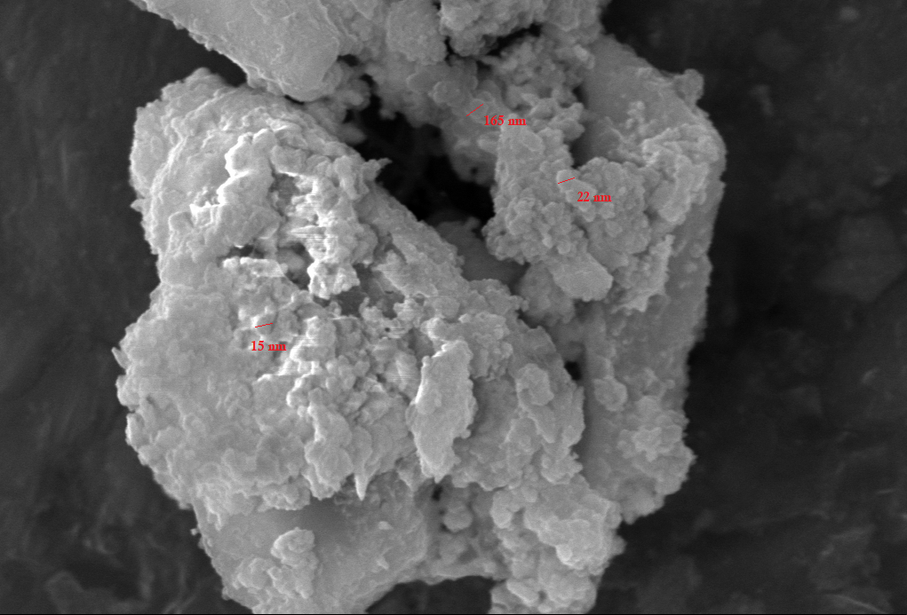 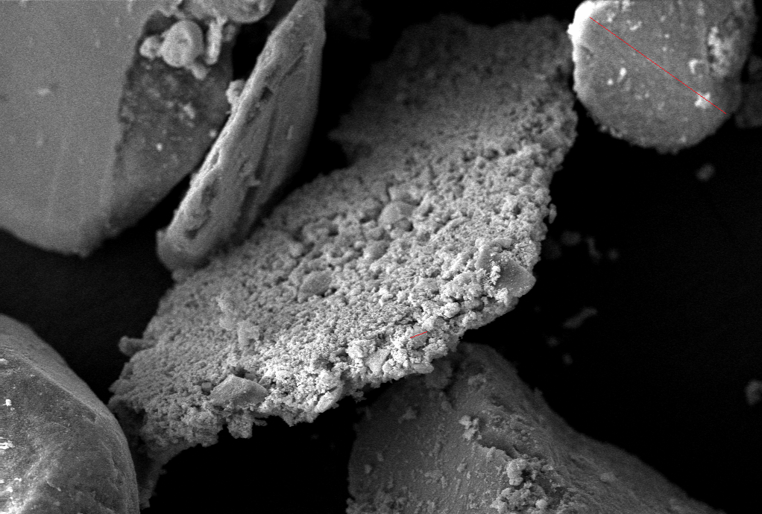



Fig. 4 :- SEM & Energy Dispersive X-Ray Analysis (EDX)

The data obtained from Energy Dispersive X-Ray Analysis (EDX) consists of spectra that display peaks corresponding to the elements present in the sample being analyzed. In this study, Fig. 5 illustrates the results of the EDAX analysis, confirming the presence of metallic zinc oxide in the biosynthesized ZnO nanoparticles.

The composition obtained from the EDAX analysis includes Titanium, Silver, Oxygen, Chlorine, Sulphur, and Carbon. The presence of carbon in trace amounts indicates the involvement of plant phytochemical groups in the reduction and capping of the synthesized TiO2 nanoparticles (Fig. 4).

These EDX results provide valuable insights into the elemental composition of the synthesized nanoparticles and suggest the presence of specific plant-derived compounds that play a role in the reduction and stabilization of the TiO2 nanoparticles during the biosynthesis process.

**Conclusions**

In summary, we have developed convenient and green procedure for the synthesis of spherical Ag doped Ti Nanoparticles from novel plant *Azadirachta Indica* for the first time. The employed plant plays important role as capping agent on the surface of metal Ag-TiO2 NPs.

**Acknowledgements**

Author thankful to the MRC, MNIT Jaipur and IET DSMNRU, Lucknow for the spectral and experimental analyses. We are also thankful to the Department of Physics and Research Laboratory of School of Management Sciences, Lucknow,India.

**References**

1. D. S. Goodsell, Bionanomedicine in action: In Bionanotechnology: Lessons from nature.
   1. John Wiley & Sons, Inc., Hoboken, New Jersey, USA, **2004**.
2. R. P. Singh, V. K. Shukla, Raghvendra, S. Yadav, P. K. Sharma, P. K. Singh, A. C. Pandey, Biological approach of zinc oxide nanoparticles formation and its characterization, *Advanced Materials Letters,* vol. 2, no.4, pp.313-317, **2011**.
3. A. A. Moosa, A. M. Ridha, M. Al-kaser, Process Parameters for Green Synthesis of Silver Nanoparticles using Leaves Extract of Aloe Vera Plant, *Int. J. of Multidisciplinary and Current research,* vol. 3 pp.966–975, **2015**.
4. K. Elumalai, S. Velmurugan, S. Ravi, V. Kathiravan, G. A. Raj, Bio-approach: Plant mediated synthesis of ZnO nanoparticles and their catalytic reduction of methylene blue and antimicrobial activity, *Advanced Powder Technology*, vol. 26, pp. 1639- 1651, **2015**.
5. S. Ambika, M. Sundrarajan, Plant-extract mediated synthesis of ZnO nanoparticles using Pongamia pinnata and their activity against pathogenic bacteria, *Advanced Powder Technology,* vol 26, pp. 1–6, **2015**.
6. A. MA, E. CW, R. CL, Green chemistry and the health implications of nanoparticles, *Green Chem.* vol 8, pp. 417–432, **2006**.
7. S. S. Shankar, A. Rai, A. Ahmad, M. Sastry, Rapid synthesis of Au, Ag, and bimetallic Au core-Ag shell nanoparticles using neem (*Azadirachta indica*) leaf broth. *J. Colloid Interf. Sci.,* vol 275,no. 2, pp. 496-502, **2004.**
8. O. V. Kharissova, H.V. R. Dias, B. I. Kharisov, B.O. Pérez, V. M. J. Pérez, The greener synthesis of nanoparticles, *Trends in Biotechnology,* vol 31, pp. 240–248, **2013**.
9. A. Bankar, B. Joshi, A. R. Kumar, S. Zinjarde, Banana peel extract mediated novel route for the synthesis of silver nanoparticles, Colloids and Surfaces A: Physicochemical and Engineering Aspects. vol 368, pp. 58–63, **2010**.
10. H. P. Singh, S. Sharma, S. K. Sharma, R. K. Sharma, Biogenic synthesis of metal nanocatalysts using Mimosa pudica leaves for efficient reduction of aromatic nitrocompounds, *RSC* *Advances*, vol 4, pp. 37816, **2014**
11. A. T. Harris, R. Bali, On the formation and extent of uptake of silver nanoparticles by live plants. *J. Nanopart. Res.* vol 10,no. 4, pp. 691-695, **2008**.
12. K. N. Thakkar, S. S. Mhatre, R. Y. Parikh, Biological synthesis of metallic nanoparticles. *Nanomedicine: Nanotechnol. Biol. Med.*, vol 6, no 2, pp. 257-262, **2010**.
13. S. Iravani, Green synthesis of metal nanoparticles using plants. *Green Chem*, vol 10, pp. 2638-2650, **2011.**
14. P. C. Sharma, M. B. Yelne, T. J. Dennis, *Data base on medicinal plants used in ayurveda,* vol. 1, pp. 70-71 , **2008**.
15. N. Ahmad, S. Sharma, Green Synthesis of Silver Nanoparticles Using Extracts of Ananas comosus, *Green and Sustainable Chemistry,* vol. 2, pp.141-147, **2012**.
16. G. Alagumuthu, R. Kirubha, Green synthesis of silver nanoparticles using Cissus quadrangularis plant extract and their antibacterial activity, *University* *International Journal of Nanomaterials and Biostructures*, vol. 2, no. 3, pp. 30-33, **2012**.
17. K. B. Ishnava, J. B. Chauhan, A. A. Garg , A. Thakkar, Antibacterial and phytochemical studies on *Azadirachta Indica*  *gigantia* ( L .)R.Br. latex against selected cariogenic bacteria *Saudi J Biol Sci,* vol 19, no 1, pp. 87-91, **2012**
18. N. P. Manandhar, M. P. Manandhar, Folklore medicine of Chitwan District, Nepal. *Ethnobotany*, vol 2, pp. 33, **1990**.
19. J. S. Oliveira, L. V. osta-Lotufo, D. P. Bezerra, N. M. Alencar, J. D. Marinho-Filho, I. S. Figueiredo, In vivo growth inhibition of sarcoma 180 by latex proteins from *Azadirachta Indica*  procera. *Naunyn Schmiedebergs Arch Pharmacol* vol. 382, no 2, pp. 139-149, **2010**.
20. C. D. T. De Freitas, F. C. S. Nogueira, I. M. Vasconcelos, J. T. A. Oliveira, G. B. Dumont, M. V. Ramos, Osmotin purified from the latex of *Azadirachta Indica*  *procera*: biochemical characterization, biological activity and role in plant defense. *Plant Physiol Biochem,* vol 49 no. 7, pp. 738 -743, **2011**.
21. R. Sehgal, S. Arya, V. L. Kumar, Inhibitory effect of extracts of latex of Azadirachta Indica procera against *Candida* *Albicans*: a prilimary study. *Indian J Pharmacol* vol. 37 no.5, pp. 334-335, **2005**.
22. M. C. C. Silva, A. B. da Silva, F. M. Teixeira, P. C. P. D. Sousa, R. M. M. Rondon , J. E. R. H. Jú nior, Therapeutic and biological activities of *Azadirachta Indica*  *Procera* (AIt ). R. Br. *Asian Pac J Trop* *Med* vol 3, no.4, pp. 332-336, **2010**.
23. D. Bhardwaj, A. Singh, R. Singh, Eco-compatible sonochemical synthesis of 8-aryl-7,8-dihydro- [1,3]- dioxolo[4,5-g] quinolin-6(5H)-ones using green TiO2. *Heliyon*, vol. 5, no. 2, 1256-62, **2019**.
24. S. Munjal, A. Singh, Facile and Green Synthesis of Iron and Silver supported Iron Nanoparticles from Novel Plant Extract of Aegle marmelos: Anti-bacterial and Anti-fungal Activity, *Journal of Drug Delivery and Therapeutics,* vol 9, no(3-s), 334-341, **2019**.
25. S. Bhatt, A. Singh, S. Munjal and P. Kumar Poonia, Plant mediated bio synthesis of silver nanoparticles: Characterization and antimicrobial activity. Int. J. Chem. Stud.,vol 6, no 6, 2163-2167, **2018**.
26. S. Munjal, P. Srivastava, A. Singh, P. Jyani, P. S. Gour, Synthesis And Bio-Physical Characterization Of Mg Doped Zn Nanoparticles From Novel Plant , IJIRG, vol 9, no 3, 13-20, **2020**.