BOOK CHAPTER:
NIR Magic: Unveiling the Hidden Potential of Near-Infrared Technology in Revolutionizing Food Processing

Author:
- Miss. Aboli R. Bhatlawande
M.Tech (Food Processing Technology)
Dept. of Food Chemistry and Nutrition
CFT, VNMKV, Parbhani
abolib44@gmail.com
9373112842
- Dr.P.U.Ghatge
Scientist & Assistant Professor
Dept. of Food Chemistry and Nutrition
CFT, VNMKV, Parbhani

- Dr.G.U.Shinde
PI-NAHEP-DFSRDA-ICAR
VNMKV, Parbhani

- Miss. Anushree R.K.
PhD Research scholar
Dept of Food Science & Nutrition
COCS, VNMKV, Parbhani

- Mr. Sagar D. Patil
M.Tech (Agril. Engineering)
Dept of Food Process Engineering
CAET, VNMKV, Parbhani

Abstract:
This book chapter delves into the immense potential of Near-Infrared (NIR) technology in revolutionizing food processing. NIR technology enables detailed molecular-level analysis of food composition, leading to significant advancements in assessing and enhancing food quality, safety, and integrity. The chapter explores diverse applications of NIR technology, including its use in quality control, safety assurance, process optimization, and nutritional analysis. A notable feature highlighted is NIR's non-destructive nature, which accelerates analysis, minimizes waste, and promotes sustainability within the food industry. Furthermore, the integration of NIR technology with artificial intelligence and machine learning enables precise predictive modelling for product quality, shelf-life, and sensory attributes. This integration also yields improved efficiency and cost reduction. Despite these achievements, challenges remain in standardizing calibration models, expanding spectral signature databases, and overcoming limitations for certain food types. Addressing these challenges is crucial for the widespread adoption and advancement of NIR technology. The chapter concludes by underscoring the transformative power of NIR technology, showcasing its ability to uncover concealed insights, streamline operations, and safeguard food integrity. It advocates for embracing the enchantment of NIR technology and harnessing its full potential to enhance food quality, safety, and sustainability, thereby creating a future food processing ecosystem that is both innovative and delightful.

Key words:
Near-Infrared (NIR) technology, Food processing, Molecular-level analysis, Quality control

Introduction
Food processing plays a crucial role in enhancing the shelf life of food products while maintaining their freshness, safety, and nutritional value. Various processing technologies are employed to deactivate microorganisms, improve quality and stability. Infrared (IR) radiation, an electromagnetic wave with longer wavelengths than visible light, has been underestimated but offers numerous advantages over conventional heating methods. IR heating provides faster heating times, higher heat transfer coefficients, reduced quality losses, uniform heating, compact equipment, and energy savings. By exposing food to IR radiation, heat energy is absorbed, and the process can be carried out at ambient air temperature. The spectral distribution and energy intensity of IR radiation can be controlled using optical filters and surface temperature adjustments. Protein absorption and radiation properties of food materials change with decreasing water content, affecting reflectivity and absorptivity. IR has been widely used in the food industry for various processes such as dehydration, pasteurization, frying, roasting, and enzyme inactivation. Infrared radiation is categorized into near-IR (NIR), mid-IR (MIR), and far-IR (FIR) based on wavelength ranges. The interaction of radiation with materials involves absorption, reflection, transmission, and scattering. Absorbed radiation is converted to heat, causing an increase in temperature. The degree of heating depends on the absorptivity of food components and the wavelength of the IR radiation. Stefan-Boltzmann's Law describes the net rate of heat transfer, considering the emissivity, surface area, and temperatures of the emitter and absorber. When IR waves penetrate the material, they cause molecular vibrations and rotations, resulting in the transformation of absorbed energy into heat.(Gupta & Anjum, 2020)

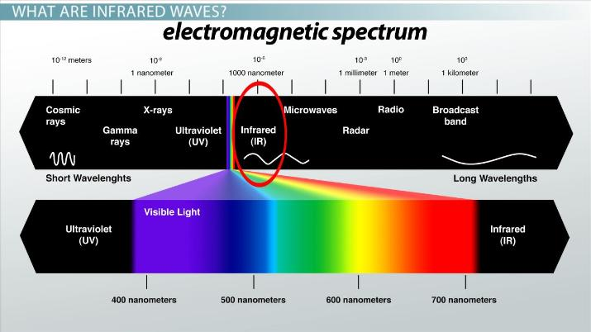

Fig.1 Electromagnetic Spectrum [38]

Infrared waves, also known as infrared radiation or IR waves, are a type of electromagnetic radiation with wavelengths longer than those of visible light but shorter than those of microwaves. The term "infrared" means "below red," referring to the fact that these waves lie just below the red portion of the visible light spectrum. Infrared waves have wavelengths ranging from approximately 700 nanometer (nm) to 1 millimeter (mm), although the exact boundaries may vary depending on the source. They are emitted by objects due to their thermal energy, as all objects above absolute zero temperature emit some form of infrared radiation. Infrared waves are not visible to the human eye, but they can be detected and measured using specialized devices such as infrared cameras and sensors. These devices can convert the infrared radiation into an image or data that can be interpreted by humans.

Flowsheet of classification of Infrared Radiation[11]

Mechanism
Saving energy is very important for food industries to work efficiently. Heat can be transferred to food in three ways: conduction, convection, and radiation. When we heat food, we want to make it last longer and taste better. Temperature measures how fast molecules move. When temperature goes up, the molecules get more energy and cause changes in the food. In regular heating methods, like using fuel or electric heaters, heat goes into the food through the air or direct contact. It takes time for the heat to go from the hot surface to the inside of the food. The temperature and time needed for heating depend on the type of food. Radiation heating happens when heat is transferred through the air. For example, when we broil food, we use radiation. Radiation is a type of energy that makes molecules move. How well it works depends on the energy of the radiation. If the radiation has shorter wavelengths than infrared, it can cause chemical changes in the food. But longer wavelengths in the infrared range are better at turning energy into heat. Infrared radiation goes deep into the food, a few millimetres. Different parts of the food absorb the infrared radiation at different frequencies, which make the molecules move and vibrate. This helps heat the food. When liquids separate in the food, the energy transfer is small, so the food keeps absorbing the infrared radiation. Table 1 shows which parts of the food absorb the radiation at different wavelengths. The food doesn't get filled up with radiation because the excited molecules lose their energy when they collide with other molecules. This energy goes into the air around the food as heat. So, we don't need to use other methods, like blowing hot air, to transfer energy to the food.[11]

Mechanism of Infrared Radiation

Food Component | Absorption Wavelengths (µm)
Water | All wavelengths
Protein | 3–4, 6–9
Fat | 3–4, 6, 9–10
Sugar | 3, 7–10
Table1: Infrared absorption wavelength by relevant food component.[11]

Infrared Emitters
Anything that is above absolute zero temperature gives off infrared radiation, even the Sun and small fires. Infrared emitters are grouped into three types based on the wavelengths they produce: short wave, medium wave, and long wave. This classification depends on the voltage applied to the emitter.
Short wave emitters are very hot and powerful, but they aren't suitable for prolonged food processing as they can cause overheating. Medium wave emitters, operating between 1.4 and 3.0 µm, are good for drying and curing food. Long wave emitters are used for low-temperature processing that combines convection and infrared heating.(Gupta & Anjum, 2020)

Infrared Emitters | Temperature Range | Initial Cost | Operating Cost | Efficiency | Common Power Source | Common Usage
Gas Emitters | 343°C - 1100°C | Higher | Lower | 40% - 46% | Propane or Natural Gas | Industrial Applications
Electric Emitters | 1100°C - 2200°C | Higher | Higher | 78% - 85% | Electricity | Various Applications (Reflector types, lamps, quartz tubes, resistance elements)
Table 2: Classification of Infrared Emitters.[11]

Application of NIR in Food Processing
- Fraud detection in rice varietal integrity using portable NIR spectral data analysis.(Teye & Amuah, 2022)
- Monitoring olive ripening in real-time using affordable handheld NIR technology.(Jiménez Márquez & Beltrán Maza, 2023)
- The influence of potato tuber tissue on the accuracy of predicting dry matter content using FT-NIR spectroscopy(Bedini et al., 2023)
- Creating a multi-product model for accurately determining ethanol content in fermented alcoholic beverages using portable NIR spectroscopy and multivariate calibration.(Fulgêncio et al., 2023)
- Developing an automated pre processing strategy integrated with machine learning multivariate analysis for NIR spectral data.(Arianti et al., 2023)
- Application of comparing portable Vis-NIR hyperspectral imaging and snap scan SWIR hyperspectral imaging techniques to assess meat authenticity.(Dashti et al., 2023)
- Using NIR hyperspectral imaging to simultaneously quantify and visualize the distribution of moisture, ash, and protein in sweet potato (Ipomoea batatas (L.) Lam).(He et al., 2023)
- Application of visible/near-infrared (Vis/NIR) optical biosensors for fruit monitoring purposes.(Wang et al., 2022)
- Exploring the impact of water of crystallization on the detection of MDMA⋅ HCl using NIR spectroscopy.(Kranenburg et al., 2023)
- The emergence of high-power phosphor-converted LEDs that emit in the near-infrared (NIR) range.(Huang, 2021)
- Developing multi-product calibration models using Fourier Transform Near Infra-Red (FT-NIR) spectroscopy to quantify polysaccharide contents in different root and tuber powders.(Masithoh et al., 2020)
- Creating a portable NIR system for analysing mixture powdery food using deep learning techniques.(Zhou et al., 2022)
- Real-time moisture monitoring of edible coated apple chips during hot air drying using miniature NIR spectroscopy and chemometric analysis.(Kapoor et al., 2022)
- Developing a portable NIR system for non destructive assessment of soluble solids content (SSC) and firmness of Nanguo pears.(Yu & Yao, 2022)
- Applying UV-VIS-NIR spectroscopy in membrane separation processes to achieve rapid quantitative compositional analysis, using egg products as a case study.(Puertas et al., 2023)
- Developing, validating, and transferring a chemometric model for authenticity screening in the food chain using two handheld near-infrared spectroscopy (NIRS) devices, enabling rapid analysis.(McVey et al., 2021)
- Metabolomics in food science: emerging applications, insights on food composition, quality, and safety, with promising future trends in understanding food-related metabolites and impacts.(Wu et al., 2022)
- On-line egg freshness monitoring using portable NIR spectrometer and machine learning.(Cruz-Tirado et al., 2021)
- NIR spectroscopy and machine learning for continuous classification of food powders.(Ozturk et al., 2023)
- UV-VIS-NIR spectroscopy for monitoring and predicting sensory shelf-life in strawberries.(Joshi et al., 2022)
- Portable NIR spectrophotometers for assessing watermelon maturity.(Vega-Castellote et al., 2022)
- FT-NIR and linear discriminant analysis for classifying chickpea seeds produced with harvest aid chemical.(Ribeiro et al., 2021)
- NIR and FTIR spectroscopies for rapid and accurate protein content determination in North Atlantic seaweed.(Niemi et al., 2023)
- Segregation of 'Hayward' kiwifruit based on storage potential using Vis-NIR spectroscopy.(Li et al., 2022)
- Feasibility study of determining the end-date of long-ripening cheese maturation using NIR hyperspectral image modelling.(Priyashantha et al., 2021)
- Portable NIR spectrometer for identifying coriander oil adulteration.(Kaufmann et al., 2022)
- Comparison of Raman, FT-NIR, and FT-MIR spectral imaging techniques for lactose prediction in dry milk on metallic surfaces using the single-drop technique.(Caponigro et al., 2023)
- Novel combination of NIR hyperspectral imaging and spectral orthogonalization for detecting fresh fruit inside plastic packaging, enabling automated barcode-less checkouts in supermarkets.(Mishra et al., 2023)
- Impact of caprolactam content on curdlan-based food packaging film and its detection using infrared spectroscopy.(Zhu et al., 2021)
- NIR attribute selection for developing predictive models of vineyard water status.(Marañón et al., 2023)
- Ultrasensitive multiplex immunochromatographic strip test platform based on NIR-IIa' fluorescence for detecting antibiotic residues in milk samples.(Zhang et al., 2022)
- UV-VIS-NIR spectroscopy for rapid authentication and composition determination of cellulose films.(Cazón et al., 2022)
- Rapid and non-invasive estimation of total polyphenol content and antioxidant activity in natural corks using NIR spectroscopy and multivariate analysis.(Díaz-Maroto et al., 2023)

NIR spectroscopy and chemometric analysis to monitor the moisture content of edible coated apple chips in real-time during Hot air drying:
Fruits and vegetable powders are becoming popular because they have great taste, colour, and lots of nutrients. People also like them because they are easy to carry and don't weigh much. This study looked at using these powders to make a coating for sliced apples. The goal was to add more nutrients and improve the apple chips. They used a special tool called miniature NIR spectroscopy to quickly and accurately measure how the coating dried on the apple slices. They compared the coated slices to ones without coating. They found that the spectroscopy tool could tell the difference between the coated and uncoated slices and also track how long they took to dry. The tool worked by looking at the sugar and water in the slices. They also used some math models to predict how much moisture was in the slices. They found that the tool and models were effective in monitoring the drying process and figuring out the moisture content. This study was the first to use this method, and they suggest trying it with different types of sensors to see if it works just as well with other fruits. (Kapoor et al., 2022)

Flowsheet of NIR spectroscopy to monitor the moisture content of edible coated apple chips in real-time during Hot air drying

Applying UV-VIS-NIR spectroscopy in membrane separation processes to achieve rapid quantitative compositional analysis, using egg products as a case study:
Membrane separation technology is widely used in research, the food industry, and the pharmaceutical industry. This study explored the application of UV-VIS-NIR spectroscopy to determine the composition of fractions obtained in a membrane separation process. The researchers focused on an egg membrane filtration as a case study and developed predictive models to quickly determine the dry matter, protein, and cholesterol composition in the feed and the fractions (retentate and filtrate). Using UV-VIS-NIR spectroscopy, the researchers found significant differences in transmittance spectra between the samples. They were able to predict cholesterol, dry matter, and proteins with good statistical significance using this spectroscopy technique combined with chemometric tools. This approach proved to be an efficient and environmentally friendly method for analyzing the composition of membrane filtration processes. It was reliable, non-destructive, and provided quick results. Additionally, it had the potential for real-time analysis, allowing for on-line applications and the ability to control the concentration factor during the separation process. (Puertas et al., 2023)

Flowsheet of UV-VIS-NIR spectroscopy in membrane separation processes using egg
Developing, Validating, and Transferring a Chemometric Model for Authenticity Screening in the Food Chain using Two Handheld Near-Infrared Spectroscopy (NIRS) Devices, Enabling Rapid Analysis:
This study used a handheld device called Neo Spectra Micro, which uses near infrared spectroscopy (NIRS), to determine if oregano is authentic or not. They tested a large number of oregano samples and potential adulterants. The models they developed using software were able to accurately predict whether a sample was authentic oregano or an adulterant. They also tested the models on a second NIRS device and found that the best predictions were obtained when using raw data without any standardization.
The study showed that the Neo Spectra Micro device has great potential as a simple, cost-effective, and reliable tool for quickly determining if oregano is authentic or not. This kind of monitoring can be very useful in preventing food fraud, which can have negative impacts on both the economy and people's health. The results of this study demonstrated the device's excellent performance, and different methods for transferring the models to other devices were successful. In the future, more devices can be assessed and validated using these methods. It is important to consider factors such as handling and testing environment when transferring the models. Overall, this research study showed that the Neo Spectra device can be used at different stages of the food supply chain to quickly and affordably screen for oregano authenticity. Further research can explore the use of these models in real-world situations to understand how different conditions may affect their performance. (McVey et al., 2021)

Metabolomics in Food Science: Emerging Applications, Insights on Food Composition, Quality, and Safety, with Promising Future Trends in Understanding Food-Related Metabolites and Impacts:
Metabolomics is a field that focuses on analysing small molecules in biological systems, and it has become valuable in various scientific disciplines, including food research. This review explores the different analytical technologies used in food metabolomics and highlights novel approaches and data visualization techniques. It compares metabolomics platforms and their suitability for analysing different metabolite classes in food. The application of metabolomics in food composition analysis, food safety testing, and food traceability is discussed. The review also acknowledges the limitations and constraints of current metabolomics applications in the food industry and suggests ways to maximize its potential. The use of metabolomics in food research includes analysing food quality, safety, and traceability. Different analytical platforms such as GC/MS, NMR, and LC/MS are used to analyse volatile and non-volatile compounds in food. Spectroscopic techniques like NIR spectroscopy are suitable for industrial food applications and can be aided by chemometric tools for consistency monitoring. The development of portable NIR devices and other related technologies has facilitated industrial-level metabolomics applications. However, there is a need for improved accuracy, sensitivity, and comprehensive databases of food-related metabolites. Standardization initiatives and integration with other omics technologies, such as genomics and proteomics, can enhance metabolomics research. As metabolomics continues to advance, it will provide deeper insights into the functions and mechanisms of food-related metabolites and optimize food processes. Further exploration is needed for animal-based food products, especially fish and seafood. Spectral fusion technology and the future application of quantum computing can improve the reliability and efficiency of data analysis in food metabolomics. Additionally, there is a need to apply metabolomics to assess uniformity in pre-prepared or convenience food mixtures to ensure consistency and quality. (Wu et al., 2022)
On-line Egg Freshness Monitoring using Portable NIR Spectrometer and Machine Learning:
Egg mislabelling, where stale eggs are sold as fresh, is a recurring issue. NIR spectroscopy has proven effective in assessing egg freshness. This study aimed to evaluate the performance of a small and affordable NIR spectrometer for on-line estimation of egg freshness. The spectral data collected was processed using various techniques and machine learning methods to predict the Haugh unit (HU) value and classify fresh and stale eggs. Both PLS-R and SVM-R regression models performed well, with SVM-R showing the best results in the 1300–1690 nm spectral range. The classification models (PLS-DA and SVM-C) showed that PLS-DA was more accurate in distinguishing fresh and stale eggs, with an 87.0% accuracy and higher sensitivity for identifying stale eggs. The study concluded that a small portable NIR spectrometer is a cost-effective and reliable device for predicting egg freshness, comparable to benchtop devices. Implementing portable NIR sensors at different stages of the egg supply chain could aid food control agencies. The study also proposed a simple and fast analysis using a portable NIR device for local estimation of egg freshness. The middle region of the egg was found to be the most suitable for spectrum acquisition. SVM-R and PLS-R models based on mean spectra from specific regions showed good predictive capability for HU value, while PLS-DA models demonstrated high accuracy in discriminating between fresh and stale eggs based on certain spectra. (Cruz-Tirado et al., 2021)
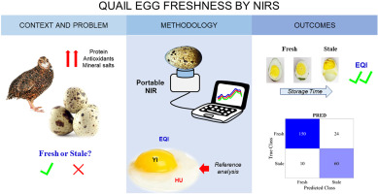

Fig.2 Monitoring Egg Quality Freshness by NIRS(Brasil et al., 2022)
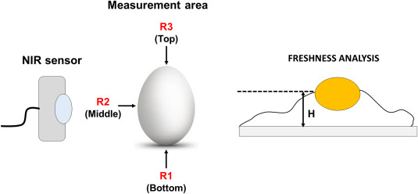

Fig.3 Measurement of Egg by NIR. (Cruz-Tirado et al., 2021)
NIR Spectroscopy and Machine Learning for Continuous Classification of Food Powders:
This study aimed to use Near Infrared (NIR) spectroscopy and Machine Learning (ML) to classify food powders in motion in food production environments. Two NIR sensors were compared, and various methods were tested to find the best ML pipeline This study aimed to use Near Infrared (NIR) spectroscopy combined with Machine Learning (ML) to classify food powders in motion. Two NIR sensors were compared, and various methods were tested to find the best ML pipeline. The optimal approach involved pre-processing the spectra using autoencoders and using support vector machines with all spectral wavelengths. The results showed high accuracy for different sample speeds, ranging from 91.68% to 99.52%. The study demonstrates the potential of using low-cost NIR sensors and ML methods to classify food powders in motion, which can help prevent errors and ensure food safety in production environments. Future work will focus on transferring the ML models from static to moving conditions using transfer learning and domain adaptation. (Ozturk et al., 2023)
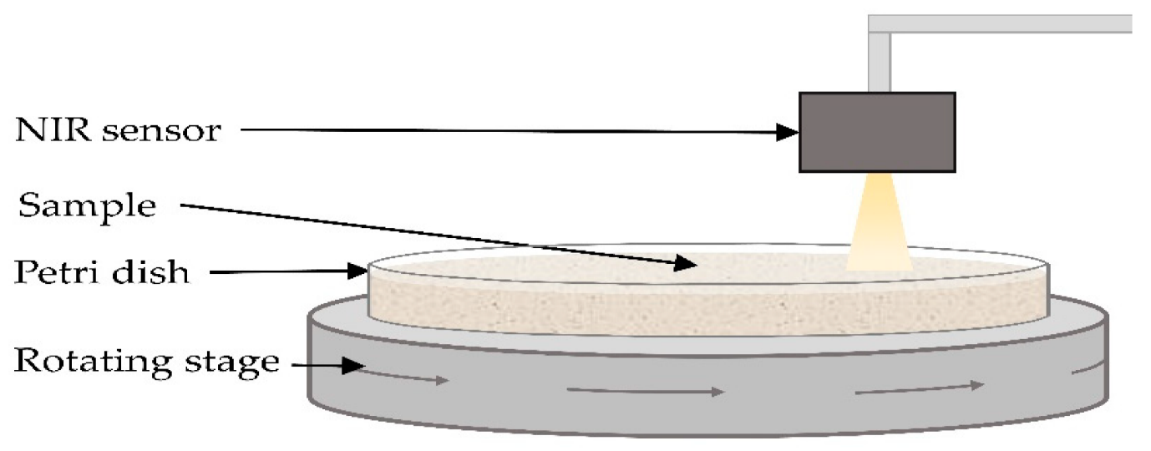

Fig.4 NIR Sensor for Classification of Food Powder(Bowler et al., 2022)

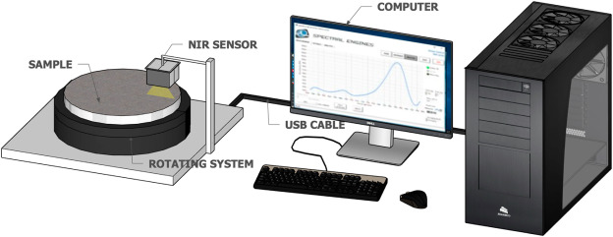

Fig.5 NIR Setup for Classification of Food Powder.[4]

UV-VIS-NIR Spectroscopy for monitoring and predicting sensory shelf-life in Strawberries:
This study examined the use of UV-VIS-NIR reflectance to predict the sensory shelf-life and the number of days strawberries can be stored under refrigeration. Different classification methods were compared, and partial least squares regression (PLSR) models were used for prediction. The models showed similar performance using UV-VIS, NIR, and UV-VIS-NIR datasets. The models could estimate the remaining days until spoilage based on sensory scores and storage duration. By analyzing the reflectance data, important indicators for storage duration and shelf-life were identified, such as red color and water absorption. Reflectance spectroscopy can be a useful tool for estimating storage duration and shelf-life of strawberries, and it has potential applications in food processing, fruit maturity assessment, and disease detection. Continuous monitoring of fruit spoilage and the development of predictive models using reflectance spectra can be valuable in the food industry. (Joshi et al., 2022)

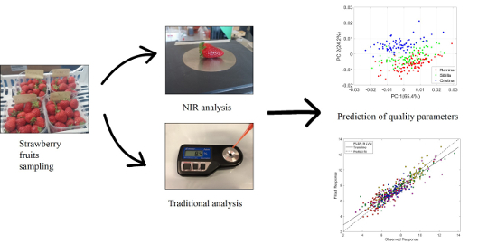

Fig.6 Monitoring shelf life of strawberries by using UV-VIS-NIR(Mancini et al., 2020)
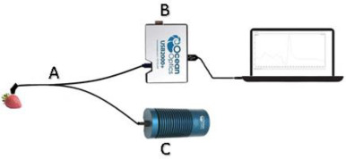

Fig.7 Setup for Monitoring shelf life of strawberries by using UV-VIS-NIR.[26]

Segregation of 'Hayward' kiwifruit based on storage potential using VIS-NIR Spectroscopy:
This study focused on the use of visible-near infrared (Vis-NIR) spectroscopy to forecast the storage potential of kiwifruit at harvest. By developing machine learning classification models based on Vis-NIR spectral data, the researchers were able to segregate kiwifruit into two groups based on their storability. The models showed promising results, with a significant percentage of fruit correctly predicted as either having short or long storability. The study also included an independent validation using data from a new season, further demonstrating the robustness of the models. Implementing segregation strategies based on the model predictions could lead to significant cost savings by reducing fruit loss, repacking, and condition checking expenses. The study highlights the value of using spectroscopic techniques for reducing fruit loss and food waste in postharvest horticultural systems and emphasizes the importance of external validation for practical applications of these technologies.(Li et al., 2022)
Portable NIR Spectrometer for identifying Coriander Oil Adulteration:
Coriander oil, extracted from coriander seeds, is a valuable ingredient with anti-inflammatory and anti-aging properties. However, it is susceptible to adulteration with other vegetable oils like palm olein, canola oil, and soybean oil. This study aimed to determine the authenticity of coriander oil and detect adulteration using analytical techniques. Principal component analysis (PCA) helped distinguish pure oils, while linear discriminant analysis (LDA) and k-nearest neighbours algorithm (k-NN) were used for classification. Partial Least Squares (PLS) regression models provided accurate results for adulteration detection, indicating their usefulness in quality control during coriander oil processing. The study demonstrated that a portable NIR spectrometer could differentiate pure coriander oil from adulterated samples. LDA-stepwise showed better results for identifying adulteration, while PLS models with specific smoothing techniques and derivative analysis performed well for quantifying adulterants. The informative region of the NIR spectra yielded better results than using the entire spectra or selected wavelengths. The findings suggest that portable NIR spectrometers have potential for fast authentication and quality control in the coriander oil industry. (Kaufmann et al., 2022)
Novel combination of NIR hyperspectral imaging and Spectral Orthogonalization for Detecting Fresh Fruit inside Plastic Packaging, Enabling Automated Barcode-Less Checkouts in Supermarkets:
Automated checkout systems in supermarkets are becoming more popular, eliminating the need for barcodes. One challenge is recognizing objects, especially fresh produce in semi-transparent plastic packaging. This study proposes a solution using near-infrared hyperspectral imaging and spectral orthogonalization to remove the plastic contribution from the images. By doing so, the study demonstrates that the plastic can be removed, improving the visibility of the fruits inside the bags. This technique can enhance the automated checkout process by improving the recognition of fresh products. The study successfully removed the plastic contribution from spectral images of fresh fruit inside plastic packaging, allowing for proper fruit detection. A small set of plastic spectra was needed to define the projection space. Once the data was projected, regular machine learning operations could be performed. One limitation is the potential temperature rise in the scanning system due to the use of infrared light sources. Future work will focus on including more types of fresh produce and fine-grained fruit detection. (Mishra et al., 2023)

Conclusion:
In conclusion, NIR technology has brought remarkable potential and transformative possibilities to food processing. It can analyse and understand the composition of food at a molecular level, revolutionizing how we assess and improve food quality, safety, and integrity. We explored various applications of NIR technology, such as quality control, safety assurance, process optimization, and nutritional analysis. It empowers food processors to make informed decisions and take their operations to new heights, from quickly assessing raw materials to monitoring production processes in real-time.
One fascinating aspect of NIR technology is its non-destructive nature. It can analyse samples without damaging them, speeding up analysis and reducing waste, which makes it a sustainable solution for the food industry. NIR technology has also integrated with other advancements like artificial intelligence and machine learning. This has led to predictive modelling, accurately predicting product quality, shelf-life, and sensory attributes, while also reducing costs and improving efficiency. However, there are ongoing challenges that need attention, such as standardizing calibration models, expanding spectral signature databases, and addressing limitations in certain types of food. These areas require further exploration for the widespread adoption and advancement of NIR technology in food processing. NIR magic has gone beyond traditional food processing, opening up new possibilities. With its ability to reveal hidden insights, streamline operations, and protect food integrity, NIR technology has reshaped the industry. As we move forward, let's embrace the enchantment of NIR magic and leverage its full potential to enhance food quality, safety, and sustainability, creating a more innovative and delightful food processing ecosystem for future generations.

Acknowledgment:
The work was executed/carried out under the financial assistance for the international training provided by the Indian Council of Agricultural Research (ICAR) through the National Agricultural Higher Education Project (NAHEP)

Reference:
- Arianti, N. D., Saputra, E., & Sitorus, A. (2023). An automatic generation of pre-processing strategy combined with machine learning multivariate analysis for NIR spectral data. Journal of Agriculture and Food Research, 13. https://doi.org/10.1016/j.jafr.2023.100625
- Bedini, G., Chakravartula, S. S. N., Nardella, M., Bandiera, A., Massantini, R., & Moscetti, R. (2023). Prediction of potato dry matter content by FT-NIR spectroscopy: Impact of tuber tissue on model performance. Future Foods, 8, 100241. https://doi.org/10.1016/j.fufo.2023.100241
- Bowler, A. L., Ozturk, S., Rady, A., & Watson, N. (2022). Domain Adaptation for In-Line Allergen Classification of Agri-Food Powders Using Near-Infrared Spectroscopy. Sensors, 22(19). https://doi.org/10.3390/s22197239
- Brasil, Y. L., Cruz-Tirado, J. P., & Barbin, D. F. (2022). Fast online estimation of quail eggs freshness using portable NIR spectrometer and machine learning. Food Control, 131, 108418. https://doi.org/10.1016/J.FOODCONT.2021.108418
- Caponigro, V., Marini, F., Scannell, A. G. M., & Gowen, A. A. (2023). Single-drop technique for lactose prediction in dry milk on metallic surfaces: Comparison of Raman, FT – NIR, and FT – MIR spectral imaging. Food Control, 144. https://doi.org/10.1016/j.foodcont.2022.109351
- Cazón, P., Cazón, D., Vázquez, M., & Guerra-Rodriguez, E. (2022). Rapid authentication and composition determination of cellulose films by UV-VIS-NIR spectroscopy. Food Packaging and Shelf Life, 31. https://doi.org/10.1016/j.fpsl.2021.100791
- Cruz-Tirado, J. P., Lucimar da Silva Medeiros, M., & Barbin, D. F. (2021). On-line monitoring of egg freshness using a portable NIR spectrometer in tandem with machine learning. Journal of Food Engineering, 306. https://doi.org/10.1016/j.jfoodeng.2021.110643
- Dashti, A., Müller-Maatsch, J., Roetgerink, E., Wijtten, M., Weesepoel, Y., Parastar, H., & Yazdanpanah, H. (2023). Comparison of a portable Vis-NIR hyperspectral imaging and a snapscan SWIR hyperspectral imaging for evaluation of meat authenticity. Food Chemistry: X, 18. https://doi.org/10.1016/j.fochx.2023.100667
- Díaz-Maroto, M. C., Alarcón, M., Díaz-Maroto, I. J., Pérez-Coello, M. S., & Soriano, A. (2023). Rapid and non-invasive estimation of total polyphenol content and antioxidant activity of natural corks by NIR spectroscopy and multivariate analysis. Food Packaging and Shelf Life, 38, 101099. https://doi.org/10.1016/j.fpsl.2023.101099
- Fulgêncio, A. C. da C., Resende, G. A. P., Teixeira, M. C. F., Botelho, B. G., & Sena, M. M. (2023). Combining portable NIR spectroscopy and multivariate calibration for the determination of ethanol in fermented alcoholic beverages by a multi-product model. Talanta Open, 7. https://doi.org/10.1016/j.talo.2023.100180
- Gupta, N., & Anjum, N. (2020). Infrared heating and its application in food processing. http://www.thepharmajournal.com
- He, H. J., Wang, Y., Wang, Y., Liu, H., Zhang, M., & Ou, X. (2023). Simultaneous quantifying and visualizing moisture, ash and protein distribution in sweet potato [Ipomoea batatas (L.) Lam] by NIR hyperspectral imaging. Food Chemistry: X, 18. https://doi.org/10.1016/j.fochx.2023.100631
- Huang, X. (2021). Emerging high-power NIR-emitting phosphor-converted LEDs. Green Energy and Environment, 6(5), 617–619. https://doi.org/10.1016/j.gee.2020.11.021
- Jiménez Márquez, A., & Beltrán Maza, G. (2023). ‘In Situ’ olive ripening monitoritation by low-cost handheld NIR. Smart Agricultural Technology, 5. https://doi.org/10.1016/j.atech.2023.100233
- Joshi, P., Pahariya, P., Al-Ani, M. F., & Choudhary, R. (2022). Monitoring and prediction of sensory shelf-life in strawberry with ultraviolet-visible-near-infrared (UV-VIS-NIR) spectroscopy. Applied Food Research, 2(2). https://doi.org/10.1016/j.afres.2022.100123
- Kapoor, R., Malvandi, A., Feng, H., & Kamruzzaman, M. (2022). Real-time moisture monitoring of edible coated apple chips during hot air drying using miniature NIR spectroscopy and chemometrics. LWT, 154. https://doi.org/10.1016/j.lwt.2021.112602
- Kaufmann, K. C., Sampaio, K. A., García-Martín, J. F., & Barbin, D. F. (2022). Identification of coriander oil adulteration using a portable NIR spectrometer. Food Control, 132. https://doi.org/10.1016/j.foodcont.2021.108536
- Kranenburg, R. F., Ramaker, H. J., Weesepoel, Y., Arisz, P. W. F., Keizers, P. H. J., van Esch, A., Zieltjens – van Uxem, C., van den Berg, J. D. J., Hulshof, J. W., Bakels, S., Rijs, A. M., & van Asten, A. C. (2023). The influence of water of crystallization in NIR-based MDMA·HCl detection. Forensic Chemistry, 32. https://doi.org/10.1016/j.forc.2022.100464
- Li, M., Pullanagari, R., Yule, I., & East, A. (2022). Segregation of ‘Hayward’ kiwifruit for storage potential using Vis-NIR spectroscopy. Postharvest Biology and Technology, 189, 111893. https://doi.org/10.1016/J.POSTHARVBIO.2022.111893
- Mancini, M., Mazzoni, L., Gagliardi, F., Balducci, F., Duca, D., Toscano, G., Mezzetti, B., & Capocasa, F. (2020). Application of the non-destructive NIR technique for the evaluation of strawberry fruits quality parameters. Foods, 9(4). https://doi.org/10.3390/foods9040441
- Marañón, M., Fernández-Novales, J., Tardaguila, J., Gutiérrez, S., & Diago, M. P. (2023). NIR attribute selection for the development of vineyard water status predictive models. Biosystems Engineering, 229, 167–178. https://doi.org/10.1016/j.biosystemseng.2023.04.001
- Masithoh, R. E., Lohumi, S., Yoon, W. S., Amanah, H. Z., & Cho, B. K. (2020). Development of multi-product calibration models of various root and tuber powders by fourier transform near infra-red (FT-NIR) spectroscopy for the quantification of polysaccharide contents. Heliyon, 6(10). https://doi.org/10.1016/j.heliyon.2020.e05099
- McVey, C., McGrath, T. F., Haughey, S. A., & Elliott, C. T. (2021). A rapid food chain approach for authenticity screening: The development, validation and transferability of a chemometric model using two handheld near infrared spectroscopy (NIRS) devices. Talanta, 222. https://doi.org/10.1016/j.talanta.2020.121533
- Mishra, P., Chauhan, A., & Pettersson, T. (2023). Seeing through plastics: A novel combination of NIR hyperspectral imaging and spectral orthogonalization for detecting fresh fruit inside plastic packaging to support automated barcode less checkouts in supermarkets. Food Control, 150. https://doi.org/10.1016/j.foodcont.2023.109762
- Niemi, C., Mortensen, A. M., Rautenberger, R., Matsson, S., Gorzsás, A., & Gentili, F. G. (2023). Rapid and accurate determination of protein content in North Atlantic seaweed by NIR and FTIR spectroscopies. Food Chemistry, 404. https://doi.org/10.1016/j.foodchem.2022.134700
- Ozturk, S., Bowler, A., Rady, A., & Watson, N. J. (2023). Near-infrared spectroscopy and machine learning for classification of food powders during a continuous process. Journal of Food Engineering, 341. https://doi.org/10.1016/j.jfoodeng.2022.111339
- Priyashantha, H., Höjer, A., Saedén, K. H., Lundh, Å., Johansson, M., Bernes, G., Geladi, P., & Hetta, M. (2021). Determining the end-date of long-ripening cheese maturation using NIR hyperspectral image modelling: A feasibility study. Food Control, 130. https://doi.org/10.1016/j.foodcont.2021.108316
- Puertas, G., Cazón, P., & Vázquez, M. (2023). Application of UV-VIS-NIR spectroscopy in membrane separation processes for fast quantitative compositional analysis: A case study of egg products. LWT, 174. https://doi.org/10.1016/j.lwt.2023.114429
- Ribeiro, J. P. O., Medeiros, A. D. de, Caliari, I. P., Trancoso, A. C. R., Miranda, R. M. de, Freitas, F. C. L. de, Silva, L. J. da, & Dias, D. C. F. dos S. (2021). FT-NIR and linear discriminant analysis to classify chickpea seeds produced with harvest aid chemicals. Food Chemistry, 342. https://doi.org/10.1016/j.foodchem.2020.128324
- Teye, E., & Amuah, C. L. Y. (2022). Rice varietal integrity and adulteration fraud detection by chemometrical analysis of pocket-sized NIR spectra data. Applied Food Research, 2(2). https://doi.org/10.1016/j.afres.2022.100218
- Vega-Castellote, M., Sánchez, M. T., Torres, I., de la Haba, M. J., & Pérez-Marín, D. (2022). Assessment of watermelon maturity using portable new generation NIR spectrophotometers. Scientia Horticulturae, 304. https://doi.org/10.1016/j.scienta.2022.111328
- Wang, M., Xu, Y., Yang, Y., Mu, B., Nikitina, M. A., & Xiao, X. (2022). Vis/NIR optical biosensors applications for fruit monitoring. In Biosensors and Bioelectronics: X (Vol. 11). Elsevier Ltd. https://doi.org/10.1016/j.biosx.2022.100197
- Wu, W., Zhang, L., Zheng, X., Huang, Q., Farag, M. A., Zhu, R., & Zhao, C. (2022). Emerging applications of metabolomics in food science and future trends. Food Chemistry: X, 16. https://doi.org/10.1016/j.fochx.2022.100500
- Yu, Y., & Yao, M. (2022). A portable NIR system for nondestructive assessment of SSC and firmness of Nanguo pears. LWT, 167. https://doi.org/10.1016/j.lwt.2022.113809
- Zhang, Y., Liao, T., Wang, G., Xu, J., Wang, M., Ren, F., & Zhang, H. (2022). An ultrasensitive NIR-IIa’ fluorescence-based multiplex immunochromatographic strip test platform for antibiotic residues detection in milk samples. Journal of Advanced Research. https://doi.org/10.1016/j.jare.2022.10.008
- Zhou, L., Tan, L., Zhang, C., Zhao, N., He, Y., & Qiu, Z. (2022). A portable NIR-system for mixture powdery food analysis using deep learning. LWT, 153. https://doi.org/10.1016/j.lwt.2021.112456
- Zhu, J., Wang, Q., Han, L., Zhang, C., Wang, Y., Tu, K., Peng, J., Wang, J., & Pan, L. (2021). Effects of caprolactam content on curdlan-based food packaging film and detection by infrared spectroscopy. Spectrochimica Acta - Part A: Molecular and Biomolecular Spectroscopy, 245. https://doi.org/10.1016/j.saa.2020.118942
- https://study.com/academy/lesson/infrared-waves-definition-uses-examples.html

