Original Chapter
Female reproductive organ cancer and the recent advances in their treatment, also AI used for cancer treatment.
Tejaswini P. Masne
Department of Pharmaceutical Chemistry
Smt. Kishoritai Bhoyar College of Pharmacy, Kamptee, Nagpur (441001), Maharashtra, India.
Email Id- tejaswinimasne20@gmail.com

Introduction
Cancer is a leading cause of death worldwide, accounting for nearly 10 million deaths in 2020 .Cancer is a generic term for a large group of diseases that can affect any part of the body. Other terms used are malignant tumours and neoplasms. One defining feature of cancer is the rapid creation of abnormal cells that grow beyond their usual boundaries, and which can then invade adjoining parts of the body and spread to other organs; the latter process is referred to as metastasis. Widespread metastases are the primary cause of death from cancer.
There are various cancer involved in the whole world that are as lung cancer, throat cancer, colorectal cancer, stomach cancer, breast cancer, uterus/ cervix cancer, ovarian cancer, prostate cancer, testicular cancer, etc. In this chapter, female reproductive organ cancer involves that are as breast cancer, uterus/cervix cancer and ovarian cancer, etc. this chapter also involves recent treatment used for cancer treatment and also how the artificial intelligence (AI), machine learning involves in cancer treatment.
Types of Female reproductive organ cancers:
- Breast Cancer
- Uterus / Cervix Cancer
- Ovarian Cancer
- Vaginal Cancer
- Vulvar Cancer
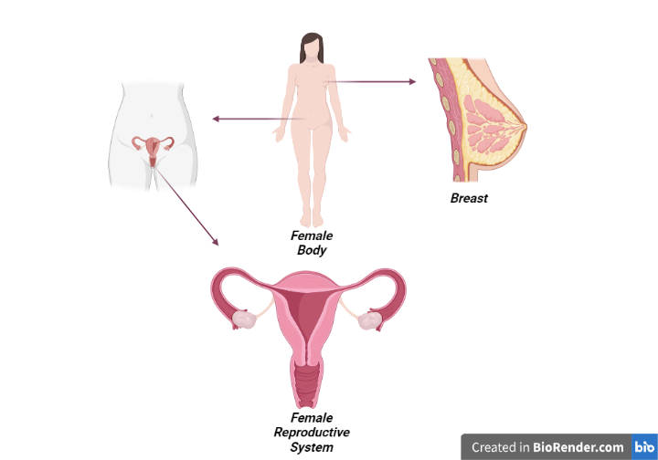
Fig. no. 1-

- Breast Cancer
Breast cancer is a disease in which abnormal breast cells grow out of control and form tumours. If left unchecked, the tumours can spread throughout the body and become fatal.
Breast cancer refers to cancers originating from breast tissue, most commonly from the inner lining of milk ducts or the lobules that supply the ducts with milk. Benign (non-invasive) cancer is a type of cancer that does not affect other organs. On the other hand, malignant (invasive) cancer spreads to neighboring tissues, making invasive cancer prognosis challenging due to varying clinical outcomes¹. Thus, early and precise diagnosis and prognosis are crucial for timely decision making by physicians to improve patients’ survivability. Survivability can be categorized as short-term (<5 years) or long-term (>5 years). Prognostications aid physicians who work with short-term survivable patients with a multi-featured disease².Cancer cells are very similar to cells of the organism from which they originated and have similar (but not identical) DNA and RNA. This is the reason why they are not very often detected by the immune system, in particular, if it is weakened³. Cancer cells are formed from normal cells due to a modification / mutation of DNA and / or RNA. These modifications / mutations can occur spontaneously (II Law of Thermodynamics - increase of entropy) or they may be induced by other factors such as: nuclear radiation, electromagnetic radiation (microwaves, X-rays, Gamma-rays, Ultraviolet-rays etc.), viruses, bacteria and fungi, parasites (due to tissue inflammation / irritation), heat, chemicals in the air, water and food, mechanical cell-level injury, free radicals, evolution and ageing of DNA and RNA, etc. All these can produce mutations that may start cancer. Cancer can be called therefore "Entropic Disease" since it is associated with the increase of entropy of the organism to the point where the organism cannot correct this itself. External intervention is required to allow the organism to return to a stable entropic state⁴.
Cancer develops if the immune system is not working properly and / or the amount of cells produced is too great for the immune system to eliminate⁵. The rate of DNA and RNA mutations can be too high under some conditions such as: unhealthy environment (due to radiation, chemicals, etc.)⁶, poor diet (unhealthy cell environment)⁷, people with genetic predispositions to mutations⁸ and people of advanced age (above 80)⁸.
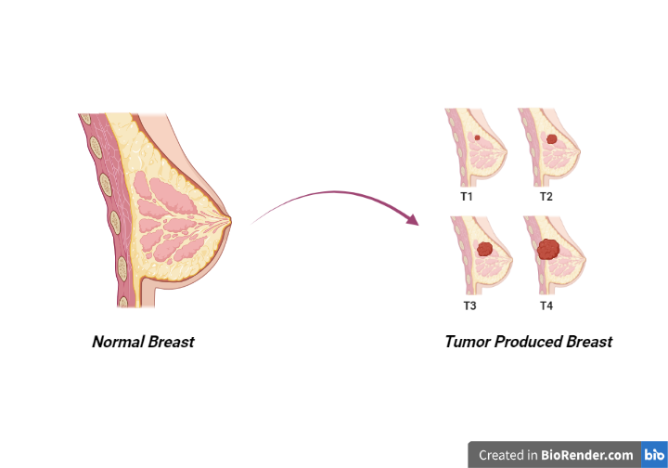
Fig. no.2-

Surgery
The most standard breast surgery approaches are either total excision of the breast (mastectomy), usually followed by breast reconstruction, or breast-conserving surgery (lumpectomy). Lumpectomy entails the excision of the breast tumor with a margin of surrounding normal tissue. The recommended margins status is defined as “no ink on tumor”, meaning no remaining tumor cells at the tissue edge⁹. Studies show that total mastectomy and lumpectomy plus irradiation are equivalent regarding relapse-free and overall survival (OS)¹⁰. Contraindications for breast-conserving surgery include the presence of diffuse microcalcifications (suspicious or malignant-appearing), disease that cannot be incorporated by local excision with satisfactory cosmetic result, and ATM (ataxia-telangiesctasia mutated) mutation (biallelic inactivation)¹¹.
The surgery to remove axillary lymph nodes is useful to determine cancerous cell spread and for therapeutic purposes. For instance, axillary lymph node dissection (ALND) can improve survival rated by removing remaining tumor cells. ALND used to be the goal standard for removing positive lymph nodes. However, clinical trials showed that sentinel lymph node biopsy (SLNB) had the same effect as ALND regarding disease-free survival (DFS) and OS¹². Other clinical trials demonstrated that ALND was not necessary for all patients with positive lymph nodes. Moreover, most patients who receive radiation and systemic treatment after SLNB have negative lymph nodes as these treatments are sufficient in eliminating residual tumor cells¹¹.

2.2. Radiotherapy
Radiation therapy has been used to treat cancer since Röngten discovered the X-ray in 1895¹². High-energy radiations are applied to the whole breast or a portion of the breast (after breast-conservative surgery), chest wall (after mastectomy), and regional lymph nodes¹³. A meta-analysis showed that radiation following conservative surgery offered more benefits to patients with higher-risk BC while patients with small, low-grade tumors could forego radiation therapy¹⁴. Postmastectomy radiation to the chest wall in patients with positive lymph nodes is associated with decreased recurrence risk and BC mortality compared to patients with negative lymph nodes¹⁵. A radiation boost to the regional node radiation treatment can be incorporated after mastectomy for patients at higher risk for recurrence¹⁶. This additional radiation boost to regional nodes following mastectomy is associated with improved (DFS) but is also associated with an increase in radiation toxicities such as pneumonitis and lymphedema¹⁷. Radiotherapy can be administered concurrently with personalized therapy (anti-HER2 therapy or endocrine therapy).
As one of the major side effects of radiotherapy is cardiotoxicity, it is critical to minimize exposure to the heart and lungs¹⁸. Additional techniques can be used to reduce the radiation exposure to the heart, lungs, and normal tissue such as prone positioning, respiratory control, or intensity-modulated radiotherapy¹⁹.
Advanced invasive BC can exhibit radiation therapy resistance²⁰. The hypoxic tumor microenvironment, which lacks oxygen, leads to increased cell proliferation, apoptosis resistance, and radiotherapy resistance²¹. The major player of this resistance is the HIF-1α (hypoxia-inducible factor 1 alpha) protein²². Indeed, HIF-1α overexpression is caused by low oxygen levels within the microenvironment and promotes the maintenance of hypoxia by allowing tumoral cells to survive in a hypoxic microenvironment²³⁻²⁵. Cancer stem cells (CSC) could also have a role in radiation therapy resistance²⁶. CSC can self-renew and initiate subpopulations of differential progeny, and a hypoxic microenvironment is ideal for CSC survival and proliferation²⁷⁻²⁸.
Radiation therapy is used to treat all BC subtypes, but its implication is more important for TNBC, as there is no personalized therapy for this subtype. It has been shown that radiotherapy benefits TNBC patients both after conserving surgery and mastectomy²⁹⁻³⁰.

2.3. Chemotherapy
BC chemotherapy comprises several families of cytotoxic drugs, including alkylating agents, antimetabolites and tubulin inhibitors³¹. Cyclophosphamide is a nitrogen mustard alkylating agent causing breakage of the DNA strands³². The mechanism of action for anthracyclines (doxorubicin, daunorubicin, epirubicin, and idarubicin) includes DNA intercalation, thereby inhibiting macromolecular biosynthesis³³. Taxanes, including docetaxel and paclitaxel, bind to microtubules and prevent their disassembly, leading to cell cycle arrest and apoptosis³⁴.
Chemotherapy can be administered in the neoadjuvant or adjuvant setting and for metastatic BC treatment.

2.3.1. Neoadjuvant Chemotherapy (NAC)
Neoadjuvant chemotherapy was initially administered for non-metastatic but inoperable BC, defined as unreachable tumors³⁵. Then, chemotherapy was used before the surgery for operable tumors to facilitate breast conservation³⁶.
Studies demonstrated that chemotherapy administered before surgery is as effective as administered after surgery³⁷⁻³⁹. The NSABP-B-18 trial compared the effects of doxorubicin and cyclophosphamide administered either postoperatively or preoperatively. This trial showed that NAC reduces the rate of axillary metastases in node-negative BC patients⁴⁰.
Some patients fail to achieve pathologic complete response after a full course of NAC. Unfortunately, there is no consensus regarding the treatment strategy to follow for patients with residual disease after surgery⁴¹⁻⁴². The BC subtype plays an important role in the response to NAC. Indeed, TNBC and HER2+ BC are more likely to be sensitive to chemotherapy. Hence, NAC is a good strategy to maximize pathologic complete response in these BC subtypes⁴³.

2.3.2. Adjuvant Chemotherapy
Adjuvant chemotherapy is administered to BC patients with lymph nodes metastases or a high risk of recurrence⁴⁴. The standard chemotherapy treatment comprises an anthracycline and a taxane. The two most common regimens are cyclophosphamide and doxorubicin for four cycles followed by paclitaxel for four cycles. Then patients are given the previous combination of therapies followed by either weekly paclitaxel for 12 weeks, or docetaxel every 3 weeks for four cycles⁴⁵⁻⁴⁶.
Like neoadjuvant therapy, patients with HR-negative BC receive more benefits from adjuvant therapy (i.e., reduction of BC recurrence and mortality) than HR+ BC patients⁴⁷. However, for patients with HR+, node-negative BC associated with a high Oncotype recurrence score (≥31), calculated from the expression of 16 BC-related genes and 5 reference genes, adjuvant chemotherapy reduces the risk of recurrence⁴⁸. The TAILORx clinical trial showed that HR+ BC patients with a low Oncotype recurrence score do not benefit from chemotherapy alone⁴⁹.
According to the molecular BC subtype, chemotherapy can be administered with targeted therapies. Patients with HR+ BC should receive endocrine therapy after chemotherapy is completed, and HER2+ BC patients should receive trastuzumab combined with chemotherapy⁵⁰. For TNBC patients, front-line therapy includes a combination of taxane and anthracycline⁵¹.
One of the major drawbacks of chemotherapy is its side effects. The early side effects (0–6 months of treatment) involve fatigue, alopecia, cytopenia (reduction in the number of normal blood cells), muscle pain, neurocognitive dysfunction, and chemo-induced peripheral neuropathy. The chronic or late side effects (after 6 months of treatment) include cardiomyopathy, second cancers, early menopause, sterility, and psychosocial impacts⁵².
As mentioned previously in this review, chemotherapy is composed of taxanes, anthracyclines and cyclophosphamide. Each of these molecules can lead to resistance in BC patients⁵³.
One mechanism of resistance is by overexpressing p-glycoprotein, an ATP-binding cassette (ABC) family member, which confers resistance to anthracycline and taxanes⁵⁴. Breast cancer resistance protein (BCRP), another ABC family member, induces resistance to anthracycline but not taxanes when overexpressed⁵⁵. Microtubule alterations can also lead to taxane resistance. The overexpression of β-tubulin III induces paclitaxel resistance⁵⁶. Moreover, mutations in microtubule-associated proteins (MAPs) affect microtubule dynamics and improve taxane resistance⁵⁷. Multiple enzymes are known to be involved in the cyclophosphamide detoxification, leading to its resistance. For example, aldehyde dehydrogenase upregulation detoxifies aldophosphamide a type of cyclophosphamide, and mutations in glutathione S-transferases, enzymes involved in drug-metabolizing conjugation reactions, can also affect cyclophosphamide detoxification⁵⁸⁻⁵⁹.
Surgery, radiotherapy, and chemotherapy are complementary strategies in the treatment of BC patients. However, they are not sufficient to effectively treat all BC molecular subtypes, as they do not have the same response to radiotherapy or chemotherapy. Thus, personalized therapies are essential in the process for BC treatment.

AI is expected to take a pivotal role in future developments of medical fields that are mainly dependent on technology and imaging, including radiation oncology (RO), without obviating the role and human aspects of involved health care providers. As a subset of ML, deep learning (DL) is based on artificial neural networks and is able to automatically extract hierarchical features of multiple source data to use them in different clinical applications, including imaging, volume contouring, and treatment planning⁶⁰⁻⁶¹. AI and DL are progressively integrated in breast cancer diagnosis including imaging and pathology⁶². Data from multiple sources (mammography, ultrasound, CT, MRI, pathology, surgical reports, radiation therapy, follow-up imaging) are processed by bioinformatics technology to predict outcomes and to guide multidisciplinary therapeutic approaches, including radiation therapy (RT). Risk assessment algorithms, using information on geometrical, temporal, and spatial variations of recurrence risks as well as on toxicity and cosmetic outcomes will be integrated to guide treatment planning algorithms, to optimise treatment choices, and e thereby e outcomes⁶³.
- Uterus / Cervix Cancer
The uterus is the place where the child grows during pregnancy. The uterus is the size and shape of a hollow and inverted pear [1-3]. It is part of the female reproductive system and is located in the lower abdomen, between the bladder and the rectum, and is connected to the vagina by the cervix. On both sides of the uterus are the ovaries, which contain eggs [4-6]. The ovaries are connected to the uterus by the fallopian tubes.
In some people, the uterus may not be in the inter flex and motor state. The three common modes are:
➢ Too much ant flexed;
➢ Cross and reverse;
➢ Retroflexed and reversed.
These abnormal arrangements do not inherently cause any medical problems. However, the retrograde uterus lies directly above the vagina. Therefore, in cases of increased abdominal pressure [12], the probability of the uterus falling into the vagina is higher. Uterine prolapse is especially common in those with a history of pelvic floor injury and may cause many problems for women [13-15].
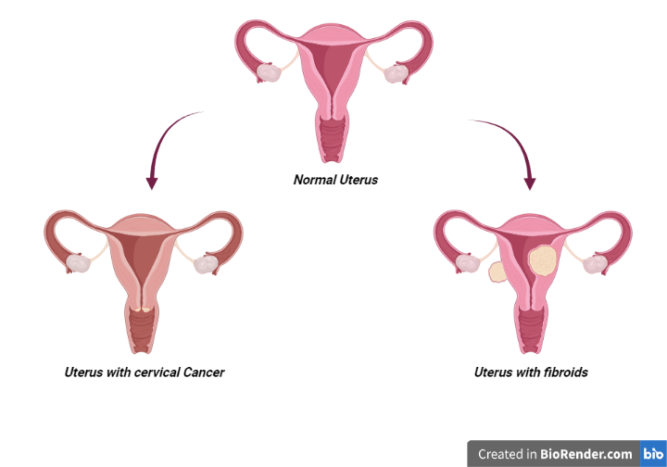
Fig. no. 3-
Cervical cancer occurs when cervical cells become abnormal and multiply rapidly. The cervix is a part of the female body that is located between the vagina and the uterus. Failure to diagnose or treat this cancer on time will definitely threaten a person's life [16-18]. Cervical cancer used to be the leading cause of death for American women, but it is now the most preventable female cancer. Routine Pap smear tests, HPV vaccines and HPV testing have made it easier to prevent cervical cancer. Knowing the symptoms of cervical cancer helps in early diagnosis and timely treatment.
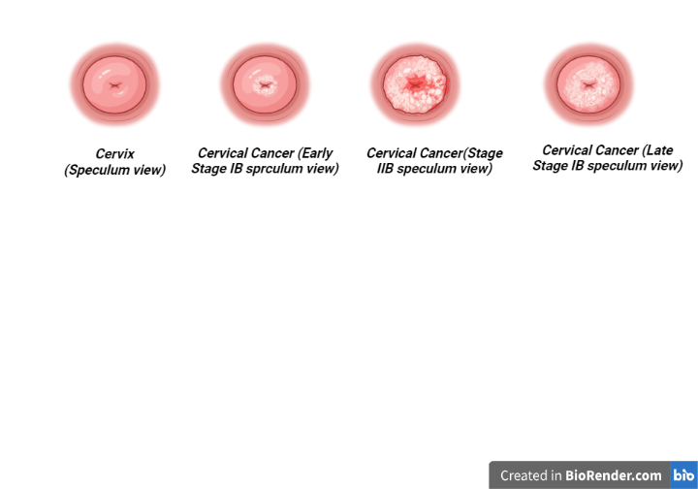
Fig.no. 4-

The stage of the cancer gives you enough information about its size and spread. Here, type means the type of cell from which the cancer started. The grade refers to how abnormal the cells look under the microscope. Your doctor will use all of this information to help decide what treatment you need [51].
➢ Step 1 At this stage, the cancer is only in the cervix. Surgery is the main treatment. Some people also need chemotherapy [52].
➢ Step 2 At this stage, the cancer has spread outside the cervix to surrounding tissues. The main treatments are a combination of chemotherapy and radiation therapy and sometimes surgery [53].
➢ Step 3 At this stage, the cancer has spread to surrounding structures or to the lymph nodes in the pelvis or abdomen. Treatment is usually a combination of chemotherapy and radiotherapy (chemotherapy) [54].
➢ Step 4 Stage 4 means the cancer has spread to the bladder or back passage (rectum) or beyond.
The main treatments include chemotherapy with cancer-targeted drugs, surgery, radiotherapy, or symptom control.
- Surgery in the first stage of cancer If you have stage 1 cancer, you may need to have a hysterectomy. In addition to removing the uterus in this surgery, the fallopian tubes and ovaries are also removed during a procedure called bilateral salpingo-oophorectomy (BSO). The surgeon may also take samples from the lymph nodes in the pelvic and abdominal areas, as well as other nearby body parts. These samples are sent to the laboratory to determine the spread of cancer. The most common hysterectomy technique is to make a large incision in the middle of the abdomen and remove the uterus. In some situations, it may be possible to use the laparoscopic hysterectomy method. This method is also known as keyhole hysterectomy. In this surgical method, it is necessary to make small cuts on the body to use a special type of telescope (laparoscope) and other surgical tools. In this way, the surgeon is able to see the inside of your body and remove the uterus through the vagina only by making small incisions.
➢ You will probably be able to leave the hospital after three to five days. This time is shorter if the keyhole surgery method is used. However, you will need several weeks to fully recover.
➢ After surgery, it is necessary to walk as soon as possible. This work is very important; Even if you must stay in bed, you should do regular leg movements to help with circulation and prevent clots from forming in your body. To prevent complications, your nurse or physiotherapist will teach you exercises.
➢ After you leave the hospital and return home, you will need exercises to improve your strength and fitness. Talk to your doctor or physical therapist about the most appropriate exercises. Stage 2 and 3 uterine cancer surgery If you have stage 2 or 3 uterine cancer and the cancer has spread to the cervix or lymph nodes around the pelvis, you may need a complete or radical hysterectomy. This surgery involves removing more parts of the cervix and the upper part of the vagina along with the lymph nodes in the pelvic region. In order to reduce the risk of cancer recurrence, radiation therapy or chemotherapy may also be prescribed. Surgery for advanced uterine cancer (stage 4) Debunking surgery may be performed in advanced stages of uterine cancer. In this surgery, as much as possible, cancerous tissues are removed from the body. This surgery will not cure the cancer; But it may improve some cancer symptoms. Your doctor will discuss with you whether or not debunking surgery is appropriate.
- Radiation therapy for uterine cancer If, in the opinion of the treatment team, there is a high probability of the cancer returning, you will be prescribed a course of radiation therapy. Also, if surgery is not possible, radiation therapy is used to slow down the growth and spread of cancer. To treat uterine cancer, there are two radiation therapy models ➢ Internal radiation therapy (brachytherapy) A plastic tube is placed inside the uterus and therapeutic radiation reaches the uterus through this way.
➢ External radiation therapy A device is used to transmit radiation to the pelvic area. A course of external beam radiation therapy, for five days a week, with a weekend break, is prescribed to you as an outpatient treatment.
The treatment time is only five minutes. Depending on the stage and location of the uterine cancer, the entire course of radiation therapy may last approximately 4 weeks. Some women take internal radiation therapy (brachytherapy) at the same time as external radiation therapy. There are different types of brachytherapy including low, medium and high dose. In low doses, radiation transfer is done slowly; For this reason, it is necessary for the device to remain inside your body for a longer period of time. During brachytherapy, your presence in the hospital is mandatory. Your doctor will provide the necessary explanations regarding this matter. Radiation therapy is associated with side effects. The skin of the target area may become red and sore. Radiation therapy may also cause hair loss. Pelvic radiation therapy may affect the bowels and lead to nausea and diarrhea. With the continuation of the treatment process, there is a possibility of severe fatigue. Many of these side effects disappear after the end of the treatment period; However, about 5% of women struggle with long-term treatment complications such as diarrhea and intestinal bleeding.
- Chemotherapy of uterine cancer If you have stage 3 or 4 uterine cancer, you may be prescribed a course of chemotherapy. Chemotherapy can be used after surgery to prevent cancer from returning. In connection with more advanced cancers, chemotherapy is used to reduce the spread of cancer and the appearance of symptoms. Chemotherapy is usually administered by injecting drugs into a vein (intravenous injection). You can usually go home the same day after chemotherapy, but sometimes you may need to stay in the hospital for a short time. Chemotherapy is usually used periodically in the form of a treatment period and a rest period to recover the body.

- Ovarian Cancer

Epithelial ovarian cancer generally presents at an advanced stage and is the most common cause of gynaecological cancer death. Treatment requires expert multidisciplinary care. Population-based screening has been ineffective, but new approaches for early diagnosis and prevention that leverage molecular genomics are in development. Initial therapy includes surgery and adjuvant therapy. Epithelial ovarian cancer is composed of distinct histological subtypes with unique genomic characteristics, which are improving the precision and effectiveness of therapy, allowing discovery of predictors of response such as mutations in breast cancer susceptibility genes BRCA1 and BRCA2, and homologous recombination deficiency for DNA damage response pathway inhibitors or resistance (cyclin E1). Rapidly evolving techniques to measure genomic changes in tumour and blood allow for assessment of sensitivity and emergence of resistance to therapy, and might be accurate indicators of residual disease. Recurrence is usually incurable, and patient symptom control and quality of life are key considerations at this stage. Treatments for recurrence have to be designed from a patient’s perspective and incorporate meaningful measures of benefit. Urgent progress is needed to develop evidence and consensus-based treatment guidelines for each subgroup, and requires close international cooperation in conducting clinical trials through academic research groups such as the Gynecologic Cancer Intergroup.
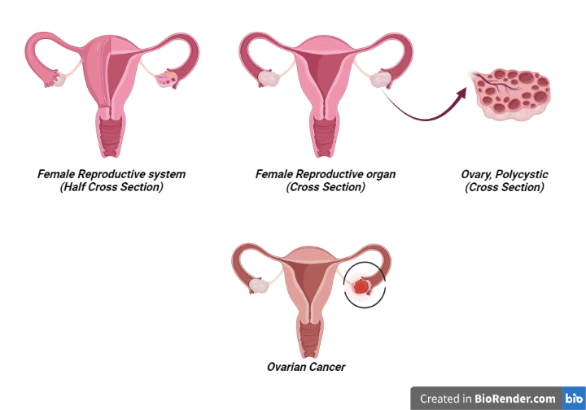
Fig. no. 6-
Primary debulking surgery (PDS) followed by chemotherapy has become the standard of care in advanced EOC since the 1980s, despite few upfront randomised trials defining its actual benefit.17 No residual tumour (R0) after PDS is the most important prognostic factor for survival.18 Two randomised clinical trials comparing PDS and chemotherapy with neoadjuvant chemotherapy (NACT) followed by interval debulking surgery (IDS) showed similar survival with a low operative morbidity when NACT and IDS were used.19,20 Both trials have been criticised for their low R0 rates and low survival rates. However, it should be noted that most of the patients had extensive stage IIIC or IV disease. To help the debate, the TRUST trial (NCT02828618) randomising NACT versus PDS in advanced EOC is ongoing in selected centres with 50% or more R0 rates and the results will be available in a few years. The choice between PDS and chemotherapy or NACT and IDS is controversial.21 Further research is needed on how to select patients for PDS or NACT, including better and validated imaging or laparoscopic scoring systems and algorithms to predict operative morbidity.
- Vaginal Cancer

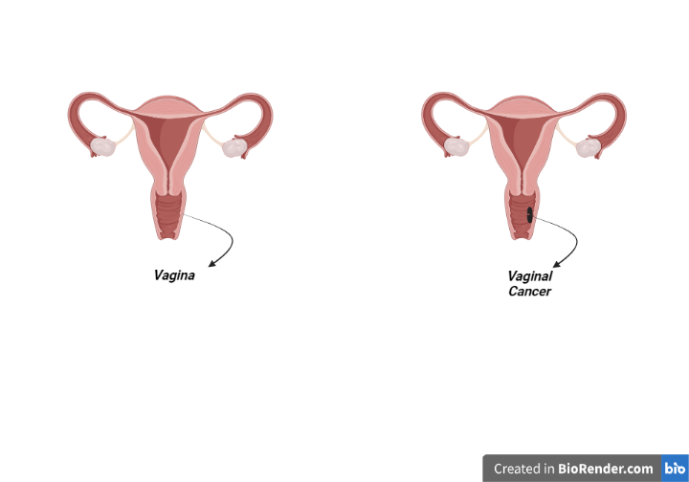
Fig.no. 7-

- Vulva Cancer
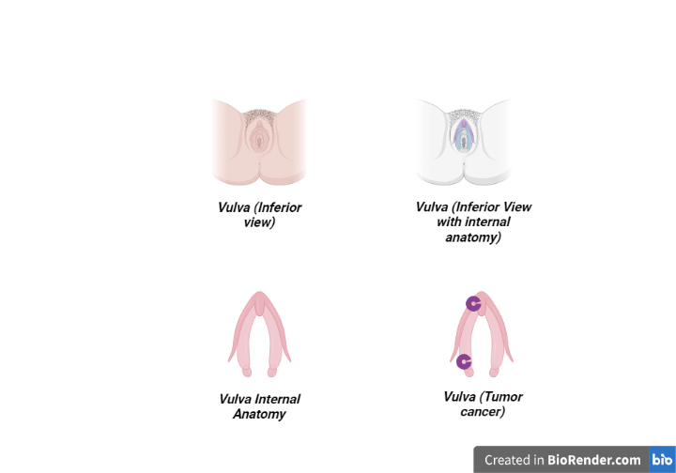
Fig.no.8-

REFERENCES

Pang, T., Wong, J.H.D., Ng, W.L. and Chan, C.S., 2020. Deep learning radiomics in breast cancer with different modalities: Overview and future. Expert Systems with Applications, 158, p.113501.

Cancer-Its various types along with causes, symptoms, treatments and stages, in: cancer info guide, 2009. http://www.cancer-info-guide.com/ (15 Mar. 2010).

Mieszkowski, M. R., Cancer – A biophysicist’s point of view. In: Digital Recordings. 04 Sept. 2006. http://www.digitalrecordings.com/publ/cancer.html (15 Mar 2010).

Immune system. In: Kids Health. 2010. http://kidshealth.org/parent/gener al/body_basics/immune.html# (16 Mar. 2010).

Helmberg, A, Carinogenesis. 2010. http://helmberg.at/carcinogenesis. htm (17 Mar. 2010).

Diet and Physical Activity: What’s the Cancer Connection? In: Prevention & Early Detection. 22 Oct. 2009. http://www.cancer.org/docroot/PE D/content/PED_3_1x_Link_Between _Lifestyle_and_CancerMarch03.asp (17 Mar. 2010).

Margot. New SEER Report Documents High Risk of Second Cancers in Cancer Survivors. Oncology Times. 2007; 29(5): 8.

Ershler W.B. The Influence of Advanced Age on Cancer Occurrence and Growth. In: Balducci L., Extermann M, editors. Biological Basis of Geriatric Oncology. Springer US; 2005; 124: 75-87.

Nofech-Mozes, S.; Trudeau, M.; Kahn, H.K.; Dent, R.; Rawlinson, E.; Sun, P.; Narod, S.A.; Hanna, W.M. Patterns of recurrence in the basal and non-basal subtypes of triple-negative breast cancers. Breast Cancer Res. Treat. 2009, 118, 131–137.

Schnitt, S.J.; Moran, M.S.; Giuliano, A.E. Lumpectomy Margins for Invasive Breast Cancer and Ductal Carcinoma in Situ: Current Guideline Recommendations, Their Implications, and Impact. JCO 2020, 38, 2240–2245.

Fisher, B.; Anderson, S.; Bryant, J.; Margolese, R.G.; Deutsch, M.; Fisher, E.R.; Jeong, J.-H.; Wolmark, N. Twenty-Year Follow-up of a Randomized Trial Comparing Total Mastectomy, Lumpectomy, and Lumpectomy plus Irradiation for the Treatment of Invasive Breast Cancer. N. Engl. J. Med. 2002, 347, 1233–1241.

Fisher, B.; Montague, E.; Redmond, C.; Deutsch, M.; Brown, G.R.; Zauber, A.; Hanson, W.F.; Wong, A. Findings from NSABP Protocol No. B-04-comparison of radical mastectomy with alternative treatments for primary breast cancer. I. Radiation compliance and its relation to treatment outcome. Cancer 1980, 46, 1–13.

Sener, S.F. Advances in axillary surgery for breast cancer 2019. J. Surg. Oncol. 2019.

Grubbé, E.H. Priority in the Therapeutic Use of X-rays. Radiology 1933, 21, 156–162.

Boyages, J. Radiation therapy and early breast cancer: Current controversies. Med. J. Aust. 2017, 207, 216–222.

Early Breast Cancer Trialists’ Collaborative Group (EBCTCG); Darby, S.; McGale, P.; Correa, C.; Taylor, C.; Arriagada, R.; Clarke, M.; Cutter, D.; Davies, C.; Ewertz, M.; et al. Effect of radiotherapy after breast-conserving surgery on 10-year recurrence and 15-year breast cancer death: Meta-analysis of individual patient data for 10,801 women in 17 randomised trials. Lancet 2011, 378, 1707–1716.

EBCTCG (Early Breast Cancer Trialists’ Collaborative Group). Effect of radiotherapy after mastectomy and axillary surgery on 10-year recurrence and 20-year breast cancer mortality: Meta-analysis of individual patient data for 8135 women in 22 randomised trials. Lancet 2014, 383, 2127–2135.

Bartelink, H.; Maingon, P.; Poortmans, P.; Weltens, C.; Fourquet, A.; Jager, J.; Schinagl, D.; Oei, B.; Rodenhuis, C.; Horiot, J.-C.; et al. Whole-breast irradiation with or without a boost for patients treated with breast-conserving surgery for early breast cancer: 20-year follow-up of a randomised phase 3 trial. Lancet Oncol. 2015, 16, 47–56.

Whelan, T.J.; Olivotto, I.A.; Parulekar, W.R.; Ackerman, I.; Chua, B.H.; Nabid, A.; Vallis, K.A.; White, J.R.; Rousseau, P.; Fortin, A.; et al. Regional Nodal Irradiation in Early-Stage Breast Cancer. N. Engl. J. Med. 2015, 373, 307–316.

Cheng, Y.; Nie, X.; Ji, C.; Lin, X.; Liu, L.; Chen, X.; Yao, H.; Wu, S. Long-Term Cardiovascular Risk After Radiotherapy in Women With Breast Cancer. JAHA 2017, 6.

Taylor, C.W.; Kirby, A.M. Cardiac Side-effects From Breast Cancer Radiotherapy. Clin. Oncol. 2015, 27, 621–629.

Delaney, G.; Jacob, S.; Featherstone, C.; Barton, M. The role of radiotherapy in cancer treatment: Estimating optimal utilization from a review of evidence-based clinical guidelines. Cancer 2005, 104, 1129–1137.

Gilreath, C.; Boerma, M.; Qin, Z.; Hudson, M.K.; Wang, S. The Hypoxic Microenvironment of Breast Cancer Cells Promotes Resistance in Radiation Therapy. Front. Oncol. 2020, 10, 629422.

Krishnamachary, B.; Penet, M.-F.; Nimmagadda, S.; Mironchik, Y.; Raman, V.; Solaiyappan, M.; Semenza, G.L.; Pomper, M.G.; Bhujwalla, Z.M. Hypoxia Regulates CD44 and Its Variant Isoforms through HIF-1α in Triple Negative Breast Cancer. PLoS ONE 2012, 7, e44078.

Kim, J.; Tchernyshyov, I.; Semenza, G.L.; Dang, C.V. HIF-1-mediated expression of pyruvate dehydrogenase kinase: A metabolic switch required for cellular adaptation to hypoxia. Cell Metab. 2006, 3, 177–185.

Jiang, B.H.; Agani, F.; Passaniti, A.; Semenza, G.L. V-SRC induces expression of hypoxia-inducible factor 1 (HIF-1) and transcription of genes encoding vascular endothelial growth factor and enolase 1: Involvement of HIF-1 in tumor progression. Cancer Res. 1997, 57, 5328–5335.

Blancher, C.; Moore, J.W.; Talks, K.L.; Houlbrook, S.; Harris, A.L. Relationship of hypoxia-inducible factor (HIF)-1alpha and HIF-2alpha expression to vascular endothelial growth factor induction and hypoxia survival in human breast cancer cell lines. Cancer Res. 2000, 60, 7106–7113.

Qi, X.S.; Pajonk, F.; McCloskey, S.; Low, D.A.; Kupelian, P.; Steinberg, M.; Sheng, K. Radioresistance of the breast tumor is highly correlated to its level of cancer stem cell and its clinical implication for breast irradiation. Radiother. Oncol. 2017, 124, 455–461.

Lagadec, C.; Vlashi, E.; Della Donna, L.; Meng, Y.; Dekmezian, C.; Kim, K.; Pajonk, F. Survival and self-renewing capacity of breast cancer initiating cells during fractionated radiation treatment. Breast Cancer Res. 2010, 12, R13.

Lock, F.E.; McDonald, P.C.; Lou, Y.; Serrano, I.; Chafe, S.C.; Ostlund, C.; Aparicio, S.; Winum, J.-Y.; Supuran, C.T.; Dedhar, S. Targeting carbonic anhydrase IX depletes breast cancer stem cells within the hypoxic niche. Oncogene 2013, 32, 5210–5219.

He, M.Y.; Rancoule, C.; Rehailia-Blanchard, A.; Espenel, S.; Trone, J.-C.; Bernichon, E.; Guillaume, E.; Vallard, A.; Magné, N. Radiotherapy in triple-negative breast cancer: Current situation and upcoming strategies. Crit. Rev. Oncol. Hematol. 2018, 131, 96–101.

Nabholtz, J.-M.; Gligorov, J. The role of taxanes in the treatment of breast cancer. Expert Opin. Pharmacother. 2005, 6, 1073–1094.

Penel, N.; Adenis, A.; Bocci, G. Cyclophosphamide-based metronomic chemotherapy: After 10 years of experience, where do we stand and where are we going? Crit. Rev. Oncol. Hematol. 2012, 82, 40–50.

Gewirtz, D. A critical evaluation of the mechanisms of action proposed for the antitumor effects of the anthracycline antibiotics adriamycin and daunorubicin. Biochem. Pharmacol. 1999, 57, 727–741.

Moos, P.J.; Fitzpatrick, F.A. Taxanes propagate apoptosis via two cell populations with distinctive cytological and molecular traits. Cell Growth Differ. 1998, 9, 687–697.

Chira, C.; Kirova, Y.M.; Liem, X.; Campana, F.; Peurien, D.; Amessis, M.; Fournier-Bidoz, N.; Pierga, J.-Y.; Dendale, R.; Bey, P.; et al. Helical Tomotherapy for Inoperable Breast Cancer: A New Promising Tool. BioMed Res. Int. 2013, 2013, 264306.

Montemurro, F.; Nuzzolese, I.; Ponzone, R. Neoadjuvant or adjuvant chemotherapy in early breast cancer? Expert Opin. Pharmacother. 2020, 21, 1071–1082.

Broët, P.; Scholl, S.M.; de la Rochefordière, A.; Fourquet, A.; Moreau, T.; De Rycke, Y.; Asselain, B.; Pouillart, P. Short and long-term effects on survival in breast cancer patients treated by primary chemotherapy: An updated analysis of a randomized trial. Breast Cancer Res. Treat. 1999, 58, 151–156.

van der Hage, J.A.; van de Velde, C.J.; Julien, J.P.; Tubiana-Hulin, M.; Vandervelden, C.; Duchateau, L. Preoperative chemotherapy in primary operable breast cancer: Results from the European Organization for Research and Treatment of Cancer trial 10902. J. Clin. Oncol. 2001, 19, 4224–4237.

Fisher, B.; Bryant, J.; Wolmark, N.; Mamounas, E.; Brown, A.; Fisher, E.R.; Wickerham, D.L.; Begovic, M.; DeCillis, A.; Robidoux, A.; et al. Effect of preoperative chemotherapy on the outcome of women with operable breast cancer. J. Clin. Oncol. 1998, 16, 2672–2685.

von Minckwitz, G.; Rezai, M.; Tesch, H.; Huober, J.; Gerber, B.; Zahm, D.M.; Hilfrich, J.; Costa, S.D.; Dubsky, P.; Blohmer, J.U.; et al. Zoledronate for patients with invasive residual disease after anthracyclines-taxane-based chemotherapy for early breast cancer—The Phase III NeoAdjuvant Trial Add-oN (NaTaN) study (GBG 36/ABCSG 29). Eur. J. Cancer 2016, 64, 12–21.

Gonzalez-Angulo, A.M.; Lei, X.; Alvarez, R.H.; Green, M.C.; Murray, J.L.; Valero, V.; Koenig, K.B.; Ibrahim, N.K.; Litton, J.K.; Nair, L.; et al. Phase II Randomized Study of Ixabepilone Versus Observation in Patients With Significant Residual Disease After Neoadjuvant Systemic Therapy for HER2-Negative Breast Cancer. Clin. Breast Cancer 2015, 15, 325–331.

Early Breast Cancer Trialists’ Collaborative Group (EBCTCG); Peto, R.; Davies, C.; Godwin, J.; Gray, R.; Pan, H.C.; Clarke, M.; Cutter, D.; Darby, S.; McGale, P.; et al. Comparisons between different polychemotherapy regimens for early breast cancer: Meta-analyses of long-term outcome among 100,000 women in 123 randomised trials. Lancet 2012, 379, 432–444.

Citron, M.L.; Berry, D.A.; Cirrincione, C.; Hudis, C.; Winer, E.P.; Gradishar, W.J.; Davidson, N.E.; Martino, S.; Livingston, R.; Ingle, J.N.; et al. Randomized trial of dose-dense versus conventionally scheduled and sequential versus concurrent combination chemotherapy as postoperative adjuvant treatment of node-positive primary breast cancer: First report of Intergroup Trial C9741/Cancer and Leukemia Group B Trial 9741. J. Clin. Oncol. 2003, 21, 1431–1439.

Sparano, J.A.; Wang, M.; Martino, S.; Jones, V.; Perez, E.A.; Saphner, T.; Wolff, A.C.; Sledge, G.W.; Wood, W.C.; Davidson, N.E. Weekly paclitaxel in the adjuvant treatment of breast cancer. N. Engl. J. Med. 2008, 358, 1663–1671.

Berry, D.A.; Cirrincione, C.; Henderson, I.C.; Citron, M.L.; Budman, D.R.; Goldstein, L.J.; Martino, S.; Perez, E.A.; Muss, H.B.; Norton, L.; et al. Estrogen-receptor status and outcomes of modern chemotherapy for patients with node-positive breast cancer. JAMA 2006, 295, 1658–1667.

Paik, S.; Tang, G.; Shak, S.; Kim, C.; Baker, J.; Kim, W.; Cronin, M.; Baehner, F.L.; Watson, D.; Bryant, J.; et al. Gene expression and benefit of chemotherapy in women with node-negative, estrogen receptor-positive breast cancer. J. Clin. Oncol. 2006, 24, 3726–3734.

Sparano, J.A.; Gray, R.J.; Makower, D.F.; Pritchard, K.I.; Albain, K.S.; Hayes, D.F.; Geyer, C.E.; Dees, E.C.; Perez, E.A.; Olson, J.A.; et al. Prospective Validation of a 21-Gene Expression Assay in Breast Cancer. N. Engl. J. Med. 2015, 373, 2005–2014.

Anampa, J.; Makower, D.; Sparano, J.A. Progress in adjuvant chemotherapy for breast cancer: An overview. BMC Med. 2015, 13, 195.

Cardoso, F.; Senkus, E.; Costa, A.; Papadopoulos, E.; Aapro, M.; André, F.; Harbeck, N.; Aguilar Lopez, B.; Barrios, C.H.; Bergh, J.; et al. 4th ESO-ESMO International Consensus Guidelines for Advanced Breast Cancer (ABC 4). Ann. Oncol. 2018, 29, 1634–1657.

Tao, J.J.; Visvanathan, K.; Wolff, A.C. Long term side effects of adjuvant chemotherapy in patients with early breast cancer. Breast 2015, 24 (Suppl 2), S149–S153.

Coley, H.M. Mechanisms and strategies to overcome chemotherapy resistance in metastatic breast cancer. Cancer Treat. Rev. 2008, 34, 378–390.

Fojo, T.; Menefee, M. Mechanisms of multidrug resistance: The potential role of microtubule-stabilizing agents. Ann. Oncol. 2007, 18, v3–v8.

Faneyte, I.F.; Kristel, P.M.P.; Maliepaard, M.; Scheffer, G.L.; Scheper, R.J.; Schellens, J.H.M.; van de Vijver, M.J. Expression of the breast cancer resistance protein in breast cancer. Clin. Cancer Res. 2002, 8, 1068–1074.

Kamath, K.; Wilson, L.; Cabral, F.; Jordan, M.A. BetaIII-tubulin induces paclitaxel resistance in association with reduced effects on microtubule dynamic instability. J. Biol. Chem. 2005, 280, 12902–12907.

Rouzier, R.; Rajan, R.; Wagner, P.; Hess, K.R.; Gold, D.L.; Stec, J.; Ayers, M.; Ross, J.S.; Zhang, P.; Buchholz, T.A.; et al. Microtubule-associated protein tau: A marker of paclitaxel sensitivity in breast cancer. Proc. Natl. Acad. Sci. USA 2005, 102, 8315–8320.

Sládek, N.E. Aldehyde dehydrogenase-mediated cellular relative insensitivity to the oxazaphosphorines. Curr. Pharm. Des. 1999, 5, 607–625.

Gonzalez-Angulo, A.M.; Lei, X.; Alvarez, R.H.; Green, M.C.; Murray, J.L.; Valero, V.; Koenig, K.B.; Ibrahim, N.K.; Litton, J.K.; Nair, L.; et al. Phase II Randomized Study of Ixabepilone Versus Observation in Patients With Significant Residual Disease After Neoadjuvant Systemic Therapy for HER2-Negative Breast Cancer. Clin. Breast Cancer 2015, 15, 325–331.

Early Breast Cancer Trialists’ Collaborative Group (EBCTCG); Peto, R.; Davies, C.; Godwin, J.; Gray, R.; Pan, H.C.; Clarke, M.; Cutter, D.; Darby, S.; McGale, P.; et al. Comparisons between different polychemotherapy regimens for early breast cancer: Meta-analyses of long-term outcome among 100,000 women in 123 randomised trials. Lancet 2012, 379, 432–444.

Citron, M.L.; Berry, D.A.; Cirrincione, C.; Hudis, C.; Winer, E.P.; Gradishar, W.J.; Davidson, N.E.; Martino, S.; Livingston, R.; Ingle, J.N.; et al. Randomized trial of dose-dense versus conventionally scheduled and sequential versus concurrent combination chemotherapy as postoperative adjuvant treatment of node-positive primary breast cancer: First report of Intergroup Trial C9741/Cancer and Leukemia Group B Trial 9741. J. Clin. Oncol. 2003, 21, 1431–1439.

Sparano, J.A.; Wang, M.; Martino, S.; Jones, V.; Perez, E.A.; Saphner, T.; Wolff, A.C.; Sledge, G.W.; Wood, W.C.; Davidson, N.E. Weekly paclitaxel in the adjuvant treatment of breast cancer. N. Engl. J. Med. 2008, 358, 1663–1671.

Berry, D.A.; Cirrincione, C.; Henderson, I.C.; Citron, M.L.; Budman, D.R.; Goldstein, L.J.; Martino, S.; Perez, E.A.; Muss, H.B.; Norton, L.; et al. Estrogen-receptor status and outcomes of modern chemotherapy for patients with node-positive breast cancer. JAMA 2006, 295, 1658–1667.

Paik, S.; Tang, G.; Shak, S.; Kim, C.; Baker, J.; Kim, W.; Cronin, M.; Baehner, F.L.; Watson, D.; Bryant, J.; et al. Gene expression and benefit of chemotherapy in women with node-negative, estrogen receptor-positive breast cancer. J. Clin. Oncol. 2006, 24, 3726–3734.

Sparano, J.A.; Gray, R.J.; Makower, D.F.; Pritchard, K.I.; Albain, K.S.; Hayes, D.F.; Geyer, C.E.; Dees, E.C.; Perez, E.A.; Olson, J.A.; et al. Prospective Validation of a 21-Gene Expression Assay in Breast Cancer. N. Engl. J. Med. 2015, 373, 2005–2014.

Anampa, J.; Makower, D.; Sparano, J.A. Progress in adjuvant chemotherapy for breast cancer: An overview. BMC Med. 2015, 13, 195.

Cardoso, F.; Senkus, E.; Costa, A.; Papadopoulos, E.; Aapro, M.; André, F.; Harbeck, N.; Aguilar Lopez, B.; Barrios, C.H.; Bergh, J.; et al. 4th ESO-ESMO International Consensus Guidelines for Advanced Breast Cancer (ABC 4). Ann. Oncol. 2018, 29, 1634–1657.

Tao, J.J.; Visvanathan, K.; Wolff, A.C. Long term side effects of adjuvant chemotherapy in patients with early breast cancer. Breast 2015, 24 (Suppl 2), S149–S153.

Coley, H.M. Mechanisms and strategies to overcome chemotherapy resistance in metastatic breast cancer. Cancer Treat. Rev. 2008, 34, 378–390.

Fojo, T.; Menefee, M. Mechanisms of multidrug resistance: The potential role of microtubule-stabilizing agents. Ann. Oncol. 2007, 18, v3–v8.

Faneyte, I.F.; Kristel, P.M.P.; Maliepaard, M.; Scheffer, G.L.; Scheper, R.J.; Schellens, J.H.M.; van de Vijver, M.J. Expression of the breast cancer resistance protein in breast cancer. Clin. Cancer Res. 2002, 8, 1068–1074.

Kamath, K.; Wilson, L.; Cabral, F.; Jordan, M.A. BetaIII-tubulin induces paclitaxel resistance in association with reduced effects on microtubule dynamic instability. J. Biol. Chem. 2005, 280, 12902–12907.

Rouzier, R.; Rajan, R.; Wagner, P.; Hess, K.R.; Gold, D.L.; Stec, J.; Ayers, M.; Ross, J.S.; Zhang, P.; Buchholz, T.A.; et al. Microtubule-associated protein tau: A marker of paclitaxel sensitivity in breast cancer. Proc. Natl. Acad. Sci. USA 2005, 102, 8315–8320. [Google Scholar] [CrossRef] [PubMed][Green Version]

Sládek, N.E. Aldehyde dehydrogenase-mediated cellular relative insensitivity to the oxazaphosphorines. Curr. Pharm. Des. 1999, 5, 607–625. [Google Scholar] [PubMed]

Simonyan K, Zisserman A. Very deep convolutional networks for large-scale image recognition. Computer Science. 2014. Available from: URL, https:// arxiv.org/pdf/1409.1556.pdf.

Girshick R, Donahue J, Darrell T, Malik J. Rich feature hierarchies for accurate object detection and semantic segmentation. Available from: URL, https:// arxiv.org/abs/1311.25242014.

Kyono T, Gilbert FJ, van der Schaar M. Improving workflow efficiency for mammography using machine learning. J Am Coll Radiol 2019 May 30. pii: S1546-1440(19)30596-4.

Brouwers P, van Werkhoven E, Bartelink H, et al. Predictors for poor cosmetic outcome in patients with early stage breast cancer treated with breast conserving therapy: results of the Young boost trial. Radiother Oncol 2018;128:434e41.

Esmaeilzadeh AA, et al., Correction: Recent advances on the electrochemical and optical biosensing strategies for monitoring microRNA21: a review, Analytical Methods, 2023

Esmaeilzadeh AA, et al., Cytotoxic study of green synthesized pure and Ag-doped α-Fe2O3 nanoparticles on breast cancer (MCF-7) cell line, Nanomedicine Research Journal, 2022 7 (4), 370-377

Esmaeilzadeh AA, et al., Recent advances on electrochemical and optical biosensing strategies for monitoring of microRNA-21: A review, Analytical Methods, 2022 15 (1), 132- 132

Esmaeilzadeh AA, et al., Study of Silybin in Plant Effective Substance for use in targeted liposomal nanoparticles in the treatment of liver cancer, Archives of Pharmacy Practice, 2020 11 (1), 35

F Beiranvandi, et al., Investigation Of Medical Services In Patients With Diabetes And CardioVascular Disease & High Blood Pleasure In ICU With Radiological & Pathology Point: The Original Article, Journal of Pharmaceutical Negative Results, 2022 4417-4425

M Milanifard, Effects of Micronutrients in Improving Fatigue, Weakness and Irritability, GMJ Medicine, 2021 5 (1), 391-395

E Yahaghi, F Khamesipour, F Mashayekhi, F Safarpoor Dehkordi, MH Sakhaei, M Masoudimanesh, MK Khameneie. Helicobacter pylori in vegetables and salads: genotyping and antimicrobial resistance properties. BioMed Research International. 2014 12;2014: 757941.

M Yazdanian, A Rahmani, E Tahmasebi, H Tebyanian, A Yazdanian, SA Mosaddad. Current and Advanced Nanomaterials in Dentistry as Regeneration Agents: An Update. Mini Reviews in Medicinal Chemistry. 2021;21(7):899-918.

S Sayad, SAY Ahmadi, M Moradi, R Nekouian, K Anbari, F Shahsavar, A metaanalysis on diagnostic accuracy of serum HLA-G level in breast cancer, Expert Review of Precision Medicine and Drug Development, 2020 5 (2), 109-114

Esmaeilzadeh, A.A. and Nasirzadeh, F., 2023. Uterus Cancer. Eurasian Journal of Chemical, Medicinal and Petroleum Research, 2(5), pp.63-83.

