Cancer molecular Biomarkers of Melanoma
Vallem .Asha¹ Jayanthi chavali ², Vamsi krishna ²
Student – Sri Padmavati Mahila Visvavidyalayam Womens University India
Project faculty- environment protection training research institute -Eptri ,Hyderabad Gachibowli.
Abstract:-
Melanoma is a type of skin cancer that develops from melanocytes, the cells that produce the melanin pigment that gives skin its colour. Survival rates for melanoma are increased by early detection and treatment. The two main methods for melanoma diagnosis are clinical evaluation and biopsy. However, it is still difficult to histopathologically discriminate between pre-malignant melanocytic lesions and early invasive melanoma. As a result, additional techniques have been used to diagnose melanoma, including a thorough clinical history, imaging, genetic testing, and biomarkers. In order to aid in the early identification and diagnosis of melanoma, this review examines recent developments in biomarkers. Circulating tumour cells (CTCs), melanoma-associated antigens (MAAs), S100B, microRNAs (miRNAs), and other biomarkers may help with the detection, diagnosis, and prognosis ofmelanoma. The use of biomarkers in the diagnosis of melanoma is still being refined, though.
Introduction
Melanocytes, which are the skin's pigment-producing cells, give rise to melanoma, an aggressive form of skin cancer. It is still the most deadly type of skin cancer [1-3]. Nevertheless, melanoma may be curable with early detection and treatment [1-4]. It accounts for nearly 80% of skin cancer-related deaths in the US, making it the deadliest form of skin cancer and the fifth most frequent cancer overall. Over 1 million people in the United States currently have melanoma, with incidence rates steadily rising since the 1970s. Additionally, it makes up 1.7% of all cancer cases worldwide, with developed nations seeing an increase in incidence [1-6]. Despite the fact that the 5-year relative survival rate has grown to 93.7%, the survival rate for advanced-stage illness is still quite low (29.8%) [1-4]. This rise in overall popularity is the result of a number of causes. advancements in immunological and tailored medicines as well as diagnostic strategies. Fair-skinned populations and lower latitude locations are typical risk factors [1-3]. Additionally, men and older patients with an average age of diagnosis of 65 are more likely to be diagnosed [1-3]. Melanoma can show in a variety of ways, such as a new or changing mole, a patch or bump that differs from other skin lesions, or a sore that does not heal, making it difficult to diagnose. Additionally, the different melanoma cytomorphologic presentations constitute an immuno-histologic difficulty [4–8]. This is due to the possibility that its immunohistomarkers mirror those of other tumours, including carcinomas and other tumours including germ cell tumours and neuroendocrine tumours. The primary methods for melanoma diagnosis are a clinical examination and a biopsy [1]. However, even with a biopsy, it can be difficult for clinicians to tell the difference between a benign mole and a melanoma [2-8]. For a more accurate diagnosis, further imaging and genetic testing have been required [2, 6, 8, 9, and 15]. The problems in differentiating between a benign mole and a melanoma underscore the necessity for additional tests to aid in diagnosis, even though clinical examination and biopsy are the gold standards for melanoma diagnosis [1-4,7-12]. The morbidity and mortality linked to melanoma must be reduced through early detection and prevention through sun protection. Therefore, finding disease-related biomarkers has therapeutic and prognostic ramifications, especially in advanced-stage melanoma, where prompt detection and therapy can increase survival rates [1-3, 16-31]. In this post, we'll talk about the most recent melanoma diagnosis techniques, including histological analysis, imaging, and clinical signs. We will also look into the possible contributions that some biomarkers may make to the diagnosis and prognosis of melanoma. Therefore, the purpose of this work is to provide an outline of t he current methods for diagnosing melanoma using various biomarkers.
Methodology
Articles about melanoma and biomarkers were looked up in PubMed to examine their position in melanoma diagnosis over the past ten years. Using the Boolean operator "and/or," the mesh terms "melanoma," "biomarkers," "diagnosis," and "prognosis" were implemented. The search criteria was set to only include documents from the past ten years (2013–2023). Then, free full texts and abstracts were chosen. We chose articles on randomised controlled trials, meta-analyses, and clinical trials. Additionally, the chosen search criteria were configured to produce English-language papers that were written by humans. To find publications that best reflected the goal and concentration of this manuscript, additional screening of the generated abstracts was conducted. After that, the article's content was checked for appropriateness with the aim ofthe newspaper. Table 1 below lists the inclusion and exclusion criteria. Figure 1 below shows the Prisma flow for the selected research.

Table 1: Inclusion and exclusion criteria
Inclusion criteria | Exclusion criteria
1) Literature relevant to the role of biomarkers in the diagnosis or prognosis of melanoma | ) The studies that did not discuss biomarkers and melanoma were excluded because the study's objective was focused on the role of biomarkers in melanoma
2) The studies must be original case-control studies, cohort studies, or randomized clinical controlled trials. | 2) Sccoping reviews or other research types that weren't data-driven were excluded.
3) The selected studies may be heterogeneous but must have measurable endpoints | 3) Qualitative studies were excluded
4) Human studies. | 4) Human studies.
5) The studies must be published in a peer-reviewed journal to maintain validity and reliability. | 5) The studies published in non-peer-reviewed journals and dissertations were excluded.
6) The studies must be originally published in English for readability by the reviewers. | 6) The studies originally published in a language other than English were discarded.
7) Works of literature published between 2013 and 2023

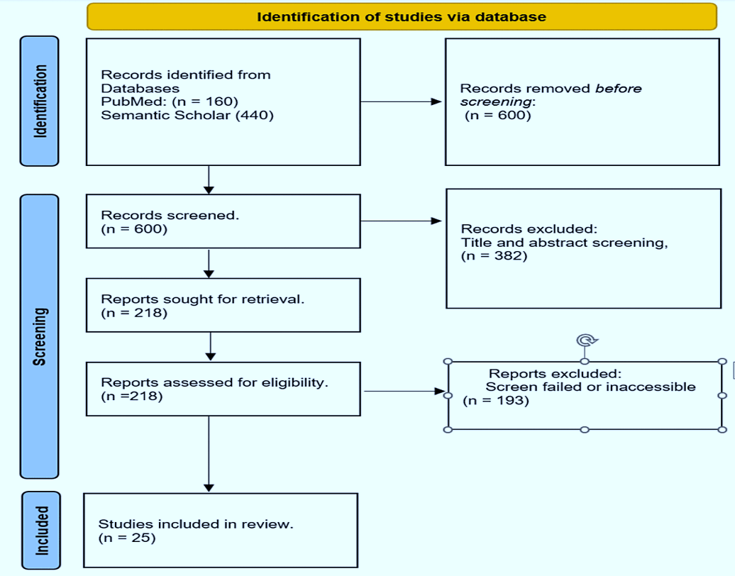
Current melanoma diagnosis techniques Clinical Markers

Recognising atypical lesions is the initial step in the diagnosis of melanoma [1-3,6-12-15]. The ABCDE technique is a simple acronym created to help members of the public and healthcare professionals recognise possible melanomas based on their traits. The letters stand for asymmetry, uneven border, colour variability/change, dimension, and progression—five crucial features of an aberrant skin lesion. Early-stage or in situ melanomas are commonly linked to these traits. The irregularity in the lesion's shape, when one half is different from the other, is referred to as asymmetry. The blurring, notching, or unevenness of the lesion's border is referred to as border irregularity. Having a variety of colours, such as different shades of brown or black, or changing colour, is referred to as colour variability or change. growing increasingly darker or paler. The lesion's size, usually greater than 6 millimetres, is referred to as its diameter. Evolving/evolution is the term used to describe changes in the lesion's size, shape, colour, or texture over time [1,6-8,14,15]. A biopsy is carried out if a lesion is determined to be potentially malignant, and the tissue is examined under a microscope to confirm the diagnosis [1-8]. Tissue sampling accuracy can be increased with dermoscopy [1-3,6,8,12-16].
Imaging
Imaging methods include ultrasonography, magnetic resonance imaging (MRI), and computed tomography (CT) scans can help in the diagnosis of melanoma in addition to clinical indicators. While MRI and CT scans can offer precise views of the interior structures of the skin and surrounding tissue and help rule out metastasis to other organs, ultrasonography is beneficial for determining the thickness of melanomas [1,3-8, 16-23]. Patients with stage 0-II cutaneous melanoma according to the AAD and stage 0 to IIIB according to the NCCN are advised not to have any baseline tests. For patients with stage III and higher disease, the ESMO and NCCN advise whole-body PET and brain magnetic resonance imaging (MRI). For individuals with tumours that are pT3b and above, the ESMO advises PET and MRI of the brain. Additionally, according to NCCN, patients with early-stage disease, symptoms of metastatic disease, and high-risk disease, such as those who present with a positive sentinel lymph node, microscopic satellite or in-transit metastatic lesions on pathology, or clinically palpable lymph nodes, should be given consideration for PET and MRI brain scans [24]. While suggesting PET and MRI brain imaging for individuals with palpable lymph nodes (Grade B), CCA does not advise imaging for those with positive sentinel lymph nodes (Grade B) [24].
Histopathologic Analysis

The histological examination is the gold standard for melanoma diagnosis. To ascertain whether the lesion is cancerous, a pathologist examines the biopsy specimen under a microscope [1-8]. Under a tissue microscope, a typical melanoma might be described in a variety of ways. A pathologist would often search for a number of distinctive features of the tumour while examining a melanoma under a microscope. For instance, the placement of melanocytic cells in sheets and nests as well as the existence or absence of perineural invasions. The quantity of lymphocytes, or TILs (tumor-infiltrating lymphocytes), present within the lesion is one of its additional characteristics. TILs may be a sign that the immune system is fighting melanoma cells because it has determined that they are aberrant [25–32]. The pathologist may call the TILs "brisk," "non-brisk," or other terms. They may also use the adjectives "mild" or "moderate," or they may say "absent" [1,3,5-6,8,]. The kind of melanoma, the depth of invasion, the presence or absence of ulceration, the mitotic count, the presence or absence of regression, and the presence or absence of satellite lesions are additional factors that distinguish melanoma under a tissue microscope. The pathologist may also consider the type of material, the method used to remove the lesion, the location of the lesion on the body, the side of the body it was on, the melanoma subtype, the border of the excision, the size of the tumour, and whether it is in situ or invasive [4-6].
Melanoma Biomarkers for Diagnosis

Atypicalities in collagen-like sequences or structural proteins, oncogenic BRAFV600E mutations, UV-induced DNA mutations, molecular signalling pathways, or UV-induced DNA mutations are examples of genetic and cellular structural alterations that characterise early melanoma. These intricate early or late molecular alterations and processes in a cell may result in the synthesis of chemokines, cytokines, endopeptidases, phaeomelanin precursors, melanin-associated antigens, dimeric proteins like S100-B, RNA/DNA microarrays products, and other tumorigenic consequences. Early melanoma detection and treatment continue to have a positive impact on patient survival and prognosis [1-3,6-9,15]. Biomarkers are molecules that can be found in blood, tissue, or other biological samples that can give information about a disease's presence or progression [6–12]. MicroRNAs (miRNAs), Melanoma-Associated Antigens (MAAs), There are several potential biomarkers for the diagnosis of melanoma, including 100B, CRP, LDH, and circulating tumour cells (CTCs) [4,6–12]. Numerous other possible melanoma biomarkers have also been identified and thoroughly studied in written works. These include melanoma-inhibitory antigens (MIAs), circulating tumour DNA, cell-free DNA, and Melan-A [5-14,18-25]. The current status of biomarkers for melanoma detection is still in its infancy [6-14,18-25] because no single biomarker presently meets the criteria for a minimum usable test (ctDNA). We'll talk about these distingu.ishing characteristics (see conceptual depiction in Figure 2 below
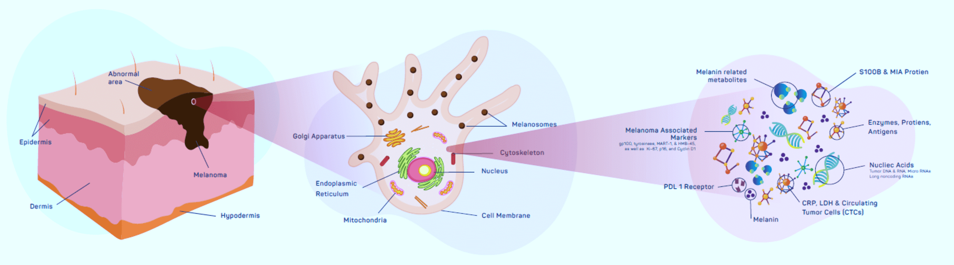

A framework for identifying the attributes of the least-inconvenient biomarker tests
Assessment of the sensitivity, specificity, positive predictive value (PPV), negative predictive value (NPV), and area under the receiver operating characteristic curve (AUC-ROC) are all part of the framework for figuring out the minimally meaningful biomarker test characteristics [17,18].The proteins known as MAAs (Pmel-17/gp100 and MART-1/Melan-A) are exclusively expressed by melanoma cells and not by healthy cells. Due of their capacity to provoke an immune response and their selectivity to melanoma cells, they have received substantial research as possible biomarkers for melanoma. In melanoma patients, it has been demonstrated that the expression of MAAs correlates with the course of the illness and the prognosis [5-8]. Other research [9] examined the expression of various MAAs in melanoma patients and discovered that the expression of one MAA, MAGE-A3, was substantially related to the disease. with dismal survival results [4-11-14]. Patients with high levels of MAA (CYT-MAA) had an 81% higher probability of recurrence than those with undetectable levels, according to the prognosis. Irene et al. came to the conclusion that MAA is a significant predictive biomarker, especially in patients who have had their tumours removed, in a research to assess the prognostic importance of MAA in 117 patients [31]. Over the past ten years, studies on the function of Melan-A have shown inconsistent results. According to several research, Melan-A, a particular T-cell recognised membrane protein, has a high sensitivity of 93% and specificity of 99% for distinguishing non-melanocytic cells from melanoma, particularly for initial tumours. Contrarily, other authors showed reduced sensitivity (about 86%) and raised concerns regarding its specificity due to its staining capabilities. Non-pigmented epithelium or its descendants, such as Leydig, adrenocortical, ovarian, and theca cells, as well as other pigmented epithelium, such as the retina [26]. Additionally, it has been shown that in some circumstances, a subpopulation of lesions lacking MAA or HLA expression exhibits fast remission. Although the specific relationship's mechanism is still not fully known [32–34].
Small non-coding RNA molecules called miRNAs target certain mRNA molecules to control gene expression. They have been recognised as possible biomarkers for melanoma as well as other malignancies. The expression of miRNAs in melanoma and their potential application as prognostic and diagnostic biomarkers have been the subject of numerous investigations. For instance, some researchers have found that the expression of a number of miRNAs differs between melanoma patients and healthy controls, indicating that these miRNAs may be used as diagnostic biomarkers [6-15,33]. The possible use of other biomarkers, such as microRNAs and exosomes, for the diagnosis of melanoma has been raised in some review studies [26–33]. The authors hypothesised that these indicators would possibly increase the precision of melanoma diagnosis and forecast disease progression and therapeutic response [4–15]. In a study that examined 126 samples of human bloodAt more advanced stages of cancer, miRNA levels drastically changed, similar to melanoma [34]. There is some promise in the potential of miRNA as a prognosticating molecule for progression, according to other research. For instance, Shanthi et al. made similar conclusions in a pooled meta-analysis of 2669 patients, despite the fact that their findings were ambiguous, with an overall effect size of 1.043 (95% CI 0.921-1.181; p = 0.506) and a 4.3% mortality rate for individuals with this marker.
CTCs are initial tumour cells that are shed and go into the bloodstream. Due to their capacity to reveal information regarding tumour metastasis and treatment response, they have been investigated as potential biomarkers for a number of malignancies, including melanoma. CTCs were reported to be related with poor prognosis and disease progression in a number of further investigations that looked into their presence in melanoma patients [4–15]. Additionally, a number of other studies have linked CTC to a poor prognosis. For instance, Morcelin et al. [36] found that positivity rates in early-stage melanoma were better than late-stage, with 2.45 and 2.42 for progression-free survival and overall survival, respectively. This finding was based on a meta-analysis of 5433 melanoma patients from 53 studies to determine the prognostic value of CTC.
Biomarkers have become promising melanoma diagnostic tools, including circulating tumour DNA (ctDNA) and cell-free DNA (cfDNA). Studies [6–10] have shown the potential of ctDNA as a biomarker for melanoma detection. In a research with 135 patients who had advanced melanoma, 57% of the patients had ctDNA found [13]. The study team discovered that ctDNA was related to tumour load, illness stage, and overall survival. Additionally, patients with smaller tumours and earlier disease stages had ctDNA found, indicating that ctDNA might be helpful for diagnosing melanoma at an earlier stage [13–15]. According to the study's findings, ctDNA may be a helpful tool for melanoma diagnosis, particularly when traditional diagnostic techniques like biopsy are not an option. A secreted protein called MIA that is overexpressed in melanoma cells has been proven to be useful for prognostic and diagnostic purposes [4-15,37-39]. However, due to its poor sensitivity and specificity, it is not very useful as a solo biomarker. A study looked into the diagnostic use of the blood marker for melanoma inhibitory activity (MIA) in individuals with stage I or stage II cutaneous melanoma who were being monitored. 5,334 MIA serum levels from 1,079 consecutive stage I and stage II melanoma patients were included in the study. These values were collected during routine follow-ups at predetermined intervals. The area under the receiver-operating characteristics curve, Somers' Dxy rank correlation, and the sensitivity and specificity of MIA were all calculated. The research discovered that 137 patients with a sensitivity of had metastases. MIA tests of 65.6% and 67.6% in stage II and stage I patients, respectively. For patients in stages I and II, the specificity was 76.9% and 66.7%, respectively. In that study, 12.0 ng/ml was shown to be the most trustworthy normal upper limit for MIA when compared to 8.8 and 15.0 ng/ml.
Furthermore, elderly men and women with an increased Breslow thickness had significantly more false-positive readings, according to multivariate analysis. Furthermore, according to the study's findings, MIA levels rose in 5.6% of persons with early-stage melanoma and as much as 89.5% of patients with late-stage melanoma [25]. In the blood of melanoma patients, ctDNA can be found as a promising biomarker [4-6,8-15,20-25]. Its diagnostic performance is currently unknown, hence more clinical trials are needed to confirm it. Over the past century, HMb-45 has also been investigated as a potential immunohistochemistry marker. This monoclonal antibody has a sensitivity of between 66 and 97%, notably in an initial lesion, with a lower sensitivity for its metastatic form. It stains glycoproteins (gp100, Pmel17) between the junctional nevus cells and melanoma. Its specificity for melanoma diagnosis has also been found to range between 91 to 100% in a number of published publications, but sadly, it has a poor ability to identify its desmoplastic variation [26]. Over the years, researchers have looked at how elevated lactate dehydrogenase (LDH) levels link to indicators of general survival in melanoma. The usefulness of the degree of LDH change from baseline in predicting overall survival (OS) has been examined over the years, albeit it hasn't been quantitively defined. Numerous research and recommendations have supported the importance of this marker. Arana et al. linked the change from baseline as a predictor of OS in a 10-year retrospective analysis to evaluate the predictive efficacy of circulating blood biomarkers in 48 patients [38]. Henry et al. found significant correlation values between the serum biomarkers S100B, LDH, MIA, and proteasome in a different study to examine the diagnostic and predictive usefulness of a combination of comparative biomarkers in 121 individuals. OS and these identifiers [39]. Elevated LDH was suggested by the 7th AJCC as a way to classify metastatic lesions. The 8th edition of this proposal, however, changed it to include anatomic sites for the M1C metastatic category [37].
Recently, it has been extremely successful to use non-invasive techniques to examine the expression of melanotic genes in skin lesions. The non-invasive biopatch collection method has shown significant success in numerous investigations measuring the existence of gene expression. For instance, Gerami and his research team showed in their study that a noninvasive approach like this increased biopsy sensitivity from 95.0% to 98.6% and specificity from 32.1% to 56.9%. Similar increases in sensitivity and specificity—91% and 69%, respectively—of adopting these non-invasive ways of gathering and analysing melanotic gene expression have been reported in some additional research [27–29]. However, although appearing non-invasive, the technique has several drawbacks, such as its inability to identify melanotic lesions that are present on the mucosa, nails, soles of the feet, or palms. as the fact that its predictive value is not yet properly understood [29].
Future developments in the detection of melanoma
Currently, it is visual examination that is used to identify most skin malignancies, including melanoma [1-3]. This lends itself to a variety of imaging modalities, including dermoscopy, reflectance confocal microscopy (RCM), and optical coherence tomography (OCT). Future research in melanoma diagnosis should focus on developing more precise non-invasive diagnostic methods. Using artificial intelligence (AI) to analyse clinical and histological pictures to help with diagnosis and prognosis is one field of research [1-3,28-34]. A rising number of researchers are also interested in creating liquid biopsies to identify circulating tumour cells and cell-free DNA, which could aid in early detection and the monitoring of therapy response [1-3,17-26]. In more advanced melanoma stages, the majority of these compounds were more abundant in serum, and as a result, These signs are hardly ever used in early diagnosis [33]. This population of patients at risk for melanoma may therefore benefit from study designs focused on choosing more sensitive and specific markers for early diagnosis, even though a few other markers have shown promising findings as potential prognostic indicators for the early diagnosis of disease development or the prognosis of therapeutic outcomes. The results for patients may be improved as a result of these scientific developments by enabling the early detection and monitoring of treatment response.
study restrictions
Due to the arbitrary selection of a small number of important biomarkers and the absence of all accessible markers, selection bias may have been a factor in this investigation.
Conclusions
In conclusion, melanoma is a form of skin cancer that arises when melanocytes, skin cells, overgrow. For a successful course of therapy and better patient outcomes, early melanoma detection and diagnosis are important. There are numerous techniques and technologies available for detecting the various biomarkers that have been identified as potential diagnostic tools for melanoma. A number of interesting biomarkers are now being investigated for use in the diagnosis of melanoma, which is an active research area. In general, research into potential biomarkers for melanoma diagnosis is still ongoing, although more work is required to establish these biomarkers' clinical value. Before being employed in clinical practise, their diagnostic performance must be confirmed in extensive clinical trials. The methodology for identifying the minimally meaningful properties of biomarker testsensures that only biomarkers with high diagnostic accuracy are utilised in clinical practise by providing a standardised method for evaluating the diagnostic accuracy of biomarkers.
References:-
- Saginala K, Barsouk A, Aluru JS, Rawla P, Barsouk A: Epidemiology of melanoma. Med Sci (Basel). 2021, 9:63. 10.3390/medsci9040063
- Khushalani NI, Truong TG, Thompson JF: Current challenges in access to melanoma care: a multidisciplinary perspective. Am Soc Clin Oncol Educ Book. 2021, 41:e295-303. 10.1200/EDBK_320301
- Matthews NH, Li WQ, Qureshi AA, Weinstock MA, Cho E: Epidemiology of Melanoma. Cutaneous Melanoma. Codon Publications, Brisbane (AU); 2017. 10.15586/codon.cutaneousmelanoma.2017.ch1
- Welch HG, Mazer BL, Adamson AS: The rapid rise in cutaneous melanoma diagnoses. N Engl J Med. 2021, 384:72-9. 10.1056/NEJMsb2019760
- Pawlik L, Morgenroth S, Dummer R: Recent progress in the diagnosis and treatment of melanoma and other skin cancers. Cancers (Basel). 2023, 15:10.3390/cancers15061824
- Ward WH, Lambreton F, Goel N, Yu JQ, Farma JM: Clinical Presentation and Staging of Melanoma. Ward WH, Farma JM (ed): Codon Publications, Brisbane (AU); 2017. 10.15586/codon.cutaneousmelanoma.2017.ch6https://www.ncbi.nlm.nih.gov/books/NBK481857/.
- Deacon DC, Smith EA, Judson-Torres RL: Molecular biomarkers for melanoma screening, diagnosis, and prognosis: current state and future prospects. Front Med (Lausanne). 2021, 8:642380. 10.3389/fmed.2021.642380
- Davis LE, Shalin SC, Tackett AJ: Current state of melanoma diagnosis and treatment. Cancer Biol Ther. 2019, 20:1366-79. 10.1080/15384047.2019.1640032
- de Miranda FS, Barauna VG, Dos Santos L, Costa G, Vassallo PF, Campos LC: Properties and application of cell-free DNA as a clinical biomarker. Int J Mol Sci. 2021, 22:10.3390/ijms22179110
- Lee JH, Long GV, Boyd S, et al.: Circulating tumour DNA predicts response to anti-PD1 antibodies in metastatic melanoma. Ann Oncol. 2017, 28:1130-6. 10.1093/annonc/mdx026
- Knuever J, Weiss J, Persa OD, Kreuzer K, Mauch C, Hallek M, Schlaak M: The use of circulating cell-free tumor DNA in routine diagnostics of metastatic melanoma patients. Sci Rep. 2020, 10:4940. 10.1038/s41598-020-61818-1
- Switzer B, Puzanov I, Skitzki JJ, Hamad L, Ernstoff MS: Managing metastatic melanoma in 2022: a clinical review. JCO Oncol Pract. 2022, 18:335-51. 10.1200/OP.21.00686
- Hamid O, Robert C, Daud A, et al.: Safety and tumor responses with lambrolizumab (anti-PD-1) in melanoma. N Engl J Med. 2013, 369:134-44. 10.1056/NEJMoa1305133
- Syeda MM, Wiggins JM, Corless BC, et al.: Circulating tumour DNA in patients with advanced melanoma treated with dabrafenib or dabrafenib plus trametinib: a clinical validation study. Lancet Oncol. 2021, 22:370-80. 10.1016/S1470-2045(20)30726-9
- FDA Approves Blood Tests That Can Help Guide Cancer Treatment. (2020). Accessed: January 3, 2023: https://www.cancer.gov/news-events/cancer-currents-blog/2020/fda-guardant-360-foundation-one-cancer-liquid-biopsy.
- Vider J, Croaker A, Cox AJ, et al.: Comparison of skin biopsy sample processing and storage methods on high dimensional immune gene expression using the Nanostring nCounter system. Diagn Pathol. 2020, 15:57. 10.1186/s13000-020-00974-4
- Garcia J, Kamps-Hughes N, Geiguer F, Couraud S, Sarver B, Payen L, Ionescu-Zanetti C: Sensitivity, specificity, and accuracy of a liquid biopsy approach utilizing molecular amplification pools. Sci Rep. 2021, 11:10761. 10.1038/s41598-021-89592-8
- Ray P, Le Manach Y, Riou B, Houle TT: Statistical evaluation of a biomarker. Anesthesiology. 2010, 112:1023-40. 10.1097/ALN.0b013e3181d47604
- Nguyen LT, Saibil SD, Sotov V, et al.: Phase II clinical trial of adoptive cell therapy for patients with metastatic melanoma with autologous tumor-infiltrating lymphocytes and low-dose interleukin-2. Cancer Immunol Immunother. 2019, 68:773-85. 10.1007/s00262-019-02307-x
- Guo Y, Zhang X, Wang L, et al.: The plasma exosomal miR-1180-3p serves as a novel potential diagnostic marker for cutaneous melanoma. Cancer Cell Int. 2021, 21:487. 10.1186/s12935-021-02164-8
- Tsao H, Atkins MB, Sober AJ: Management of cutaneous melanoma. N Engl J Med. 2004, 351:998-1012. 10.1056/NEJMra041245
- Arnolds O, Zhong X, Tuo Yip K, et al.: NMR-based drug development and improvement against malignant melanoma - implications for the MIA protein family. Curr Med Chem. 2017, 24:1788-96. 10.2174/0929867324666170608104347
- Guba M, Bosserhoff AK, Steinbauer M, Abels C, Anthuber M, Buettner R, Jauch KW: Overexpression of melanoma inhibitory activity (MIA) enhances extravasation and metastasis of A-mel 3 melanoma cells in vivo. Br J Cancer. 2000, 83:1216-22. 10.1054/bjoc.2000.1424
- El Fitori J, Kleeff J, Giese NA, Guweidhi A, Bosserhoff AK, Büchler MW, Friess H: Melanoma Inhibitory Activity (MIA) increases the invasiveness of pancreatic cancer cells. Cancer Cell Int. 2005, 5:3. 10.1186/1475-2867-5-3
- Hofmann MA, Gussmann F, Fritsche A, et al.: Diagnostic value of melanoma inhibitory activity serum marker in the follow-up of patients with stage I or II cutaneous melanoma. Melanoma Res. 2009, 19:17-23. 10.1097/CMR.0b013e32831bc78c
- Weinstein D, Leininger J, Hamby C, Safai B: Diagnostic and prognostic biomarkers in melanoma. J Clin Aesthet Dermatol. 2014, 7:13-24.
- Ferris LK, Jansen B, Ho J, et al.: Utility of a noninvasive 2-gene molecular assay for cutaneous melanoma and effect on the decision to biopsy. JAMA Dermatol. 2017, 153:675-80. 10.1001/jamadermatol.2017.0473
- Cullison SRJ, Jansen B, Yao Z, Ferris LK: Risk stratification of severely dysplastic nevi by non-invasively obtained gene expression and mutation analyses. SKIN. 2020, 4:124-129. 10.25251/skin.4.2.5
- Gerami P, Yao Z, Polsky D, et al.: Development and validation of a noninvasive 2-gene molecular assay for cutaneous melanoma. J Am Acad Dermatol. 2017, 76:114-120.e2. 10.1016/j.jaad.2016.07.038
- Mocellin S, Zavagno G, Nitti D: The prognostic value of serum S100B in patients with cutaneous melanoma: a meta-analysis. Int J Cancer. 2008, 123:2370-6. 10.1002/ijc.23794
- Vergilis IJ, Szarek M, Ferrone S, Reynolds S: Presence and prognostic significance of melanoma-associated antigens CYT-MAA and HMW-MAA in serum of patients with melanoma. The Journal of investigative dermatology. 2005, 125:526-31.
- Cormier J, Hijazi Y, Abati A, et al.: Heterogeneous expression of melanoma‐associated antigens and HLA‐A2 in metastatic melanoma in vivo. Int J Cancer. 1998, 75:
- Brochez L, Naeyaert JM: Serological markers for melanoma. Br J Dermatol. 2000, 143:256-68. 10.1046/j.1365-2133.2000.03649.x
- Margue C, Reinsbach S, Philippidou D, et al.: Comparison of a healthy miRNome with melanoma patient miRNomes: are microRNAs suitable serum biomarkers for cancer?. Oncotarget. 2015, 6:12110-12127.
- Sabarimurugan S, Madurantakam Royam M, Das A, Das S, K M G, Jayaraj R: Systematic review and meta-analysis of the prognostic significance of miRNAs in melanoma patients. Mol Diagn Ther. 2018, 22:653-69. 10.1007/s40291-018-0357-5
- Mocellin S, Hoon D, Ambrosi A, Nitti D, Rossi C: The prognostic value of circulating tumor cells in patients with melanoma: a systematic review and meta-analysis. Clinical Cancer Research. 2006, 12:4605-4613.
- Gershenwald JE, Scolyer RA, Hess KR, et al.: Melanoma staging: Evidence-based changes in the American Joint Committee on Cancer eighth edition cancer staging manual. CA Cancer J Clin. 2017, 67:472-92. 10.3322/caac.21409
- Irurzun-Arana I, Asín-Prieto E, Martín-Algarra S, Trocóniz IF: Predicting circulating biomarker response and its impact on the survival of advanced melanoma patients treated with adjuvant therapy. Sci Rep. 2020, 10:7478. 10.1038/s41598-020-63441-6
- Henry L, Fabre C, Guiraud I, et al.: Clinical use of p-proteasome in discriminating metastatic melanoma patients: comparative study with LDH, MIA and S100B protein. Int J Cancer. 2013, 133:142-8. 10.1002/ijc.27991

