IOT BASED PARALYSIS PATIENT HEALTH CARE MONITORING SYSTEM

B.Naveen,
Department of Electronics and Communication Engineering,
Karpagam Institute of Technology,
Coimbatore, Tamil Nadu, India.

P.Swathi,
Department of Electronics and Communication Engineering,
Karpagam Institute of Technology,
Coimbatore, Tamil Nadu, India.
R.Sathish Kumar,
Department of Electronics and Communication Engineering,
Karpagam Institute of Technology,
Coimbatore, Tamil Nadu, India.

P.Ponn Raja,
Department of Electronics and Communication Engineering,
Karpagam Institute of Technology,
Coimbatore, Tamil Nadu, India.

S.Pragadeswaran*
Department of Electronics and Communication Engineering,
Karpagam Institute of Technology,
Coimbatore, Tamil Nadu, India.
Praga1994@gmail.com

ABSTRACT
An IoT-based patient health care monitoring system that leverages IoT technology for real-time patient monitoring. The system integrates wearable biosensors and sensors to collect patient data, which is then transmitted through gateways to a cloud infrastructure. The cloud system employs advanced analytics and machine learning algorithms to identify anomalies and trends in the patient's health data. The system generates alerts for critical situations and provides a user-friendly dashboard for remote patient monitoring by healthcare professionals. The system's advantages include early detection of health issues, reduced hospitalization rates, and improved patient outcomes. However, challenges like data security, privacy concerns, and workflow integration need to be addressed. The integration of IoT technology in healthcare holds the potential to enhance patient care through real-time monitoring and timely interventions .In this system, we have used Arduino UNO. The acquired data is send to the Arduino UNO and then it is analysed. A buzzer is connected to the Microcontroller which is used for the indication purpose. A sensor and LCD display is also connected to the microcontroller .The sensor is used to monitor the patient’s health status which is interfaced with the LCD display to transmit changes. If the system finds any changes in these status ,it immediately send the data to the doctor who is taking are of the patient. In this system, Iot acts like a very powerful tool to save the life of patients. This system will be helpful to the patients as well as to the Doctors.
KEYWORDS: Algorithms, Real-Time monitoring, Arduino UNO.

I.INTRODUCTION
The integration of Internet of Things (IoT) technology with healthcare has opened new avenues for addressing complex medical challenges. This paper introduces an innovative application: an IoT-based monitoring system tailored to the needs of paralysis patients. Paralysis, stemming from various causes such as spinal injuries, strokes, or neurological disorders, necessitates specialized and consistent care. The conventional healthcare model, centered around periodic consultations, falls short in delivering timely interventions and continuous monitoring essential for paralysis patients' enhanced quality of life. In response to these limitations, IoT technology emerges as a transformative solution. By seamlessly integrating wearable devices, sensors, and cloud-based data processing, an IoT-driven paralysis patient health care monitoring system holds the potential to offer real-time insights into patients' conditions. This system can collect vital health data around the clock, enabling healthcare providers to make informed decisions promptly. The significance of such an innovation lies in its ability to not only monitor patients remotely but also to provide actionable data that contributes to tailored treatment plans and early intervention strategies.
By harnessing the capabilities of IoT technology, we aim to contribute to the advancement of healthcare for paralysis
patients, fostering a paradigm shift from episodic care to continuous, personalized monitoring and support.
Paralysis can result from various causes, such as spinal cord injuries, stroke, or neurological disorders. Patients dealing with paralysis often require long-term monitoring, rehabilitation, and prompt medical intervention to manage complications and improve their well-being. The conventional healthcare approach, reliant on periodic hospital visits, does not offer the real-time insights and immediate response that such patients may require. This is where IoT technology steps in, enabling continuous monitoring, data collection, and analysis of vital parameters.
Chronic diseases are extremely variable in their symptom, evolution and treatment. Some, if not monitored and treated early, will end the patient’s life. For several years the standard measure of glucose level, pressure level and heart beat was calculated in specialised health centres. Due to the technological development, there is a great variety of running sensors giving important signs such as blood pressure cuff, glucometer and pulse monitor together with electrocardiogram, which permits the patient to take their vital signs daily. The readings taken daily are sent to doctors and enable them to suggest the medicine and physical exercise routine that enable them to improve the quality of life and overcome such disease. Internet of Things applied to the care and watching of patients is more and more common within the health sector, seeking to boost the standard of life of individuals. The Arduino is a programmable device that can sense and interact with its environment. The combination of Internet of Thing with Arduino is the new approach of introducing IoT in healthcare monitoring system of patient. The entire concept of IoT stands on sensor, gateway and wireless network that modify user to communicate and access the information. IoT offer more guarantee within the health awareness. As a saying goes “Health is wealth” it’s exponentially crucial to form utilisation of innovation for better well-being. Arduino Uno collects the information from the sensor and transfers it to the IoT website.

II. HARDWARE IMPLEMENTATION
There are several existing systems available for patients with paralysis but this system helps to constantly monitor and understand the patient's needs. The sensor in the system aids to transmit the patient's message and the message is displayed on the LCD display. The message will change according to the position of the accelerometer. We must then know their needs and assist them on the basis of their needs. The temperature sensor, humidity sensor and pulse meter were used in this system. These sensors should be for patients with tissues or gloves; they can feel the temperature of the patient, moisture and pulses .If the patient is in a critical situation, it will sound alert with a buzzer when the patient is on the floor or when the pulse speed is above normal levels. This system can help treating patients suffering from paralysis, and it's also very cheap and easy to buy.

III.PROPOSED SYSTEM
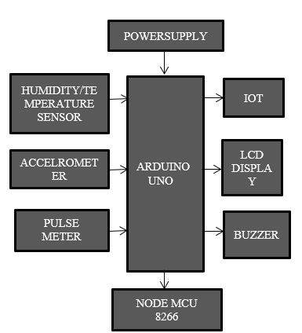
Figure 1.Block Diagram

The IOT just is the web of stuff. Independent technologies can collect and transmit data without human intervention via a wireless network. There are endless personal or business opportunities. In the health care industry, remote monitoring has been possible with IOT-enabled devices that release the possibility of keeping patients safe and healthy and that enable doctors to provide superlative health care. Respond to and enable physical objects to collect information and respond to instructions. To collect, store, handle, manipulate, and manipulate data.
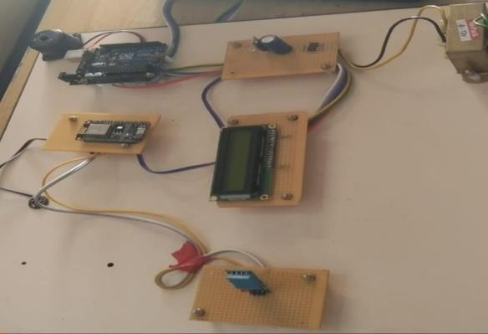
The communications infrastructure that includes protocols and technologies that permit two physical objects to exchanged at is most important. Adafruit IO is a simple and easy-to-use IOT platform for data storage, data viewing and device control. By using the adafruit web page, this project output is displayed on the mobile. Connect the respective sensors to a node MCU which gets connected to a webpage i.e. adafruit io. By using this web page, we can monitor the data gathered by the sensors. Steps to create adafruit account. Click the sign in button in the top right corner of adafruit.com After that, type the email id, username and password. Adafruit account will be successfully created. Create the widgets as your wish. Connect the respective sensor which gets connected to a buzzer. Based on the patient needs it will give sound and the output will be displayed on the LCD display and if the patients pulse or temperature become abnormal it will be displayed on the webpage which will be monitored continuously.

Figure 2 Circuit Connection

A.LCD Display-Nothing
The microcontroller has now displayed there later message on the LCD panel. As a consequence, if there is no movement in the patient. Nothing will be shown.

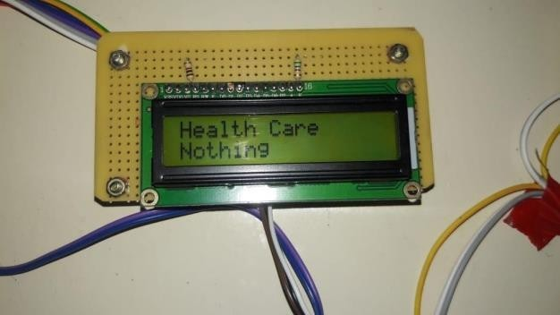

Figure 3 Lcd Display-Nothing

B.LCD Display-Need Food
The performance will be shown depending on the patient's needs. If the accelerometer is set to a certain angle, it will mean that they need food and sound an alarm.

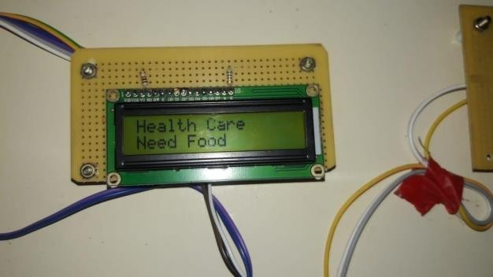

Figure 4 LCD Display-Need Food

C.LCD Display-Need Water
The displayed outputs will assist patients in meeting their needs. They need water or their requirements if the angle changed based on their need it will alert the persons.
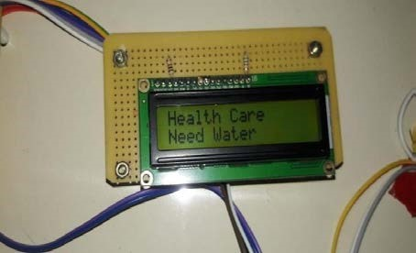

Figure 5 LCD Display-Need Water

D..LCD Display-Going to Toilet
The patient's health will be continuously monitored. If they need to go restroom then they can tilt their hand in a particular position, it will be shown on the LCD display.

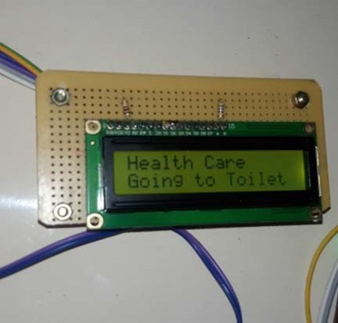

Figure 6 LCD Display-Going to Toilet
E.LCD Display-Emergency
Pulse rate and body temperature will be registered, as well as fear, so that if the patient is in an emergency, or else if they fall down on the floor the in formation will be shown automatically and a continuous warning sound will be produced through buzzer.
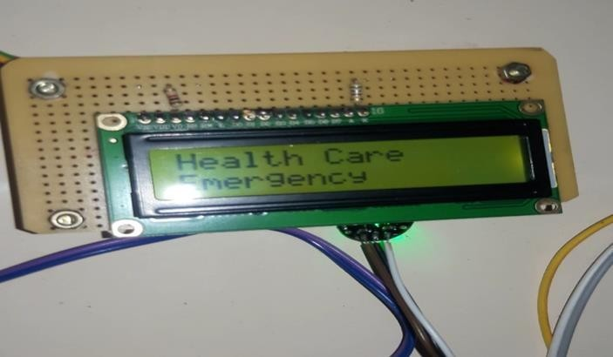

Figure 7 LCD Display-Emergency

IV.RESULT
Adafruit IOT is an easy-to-use IOT platform that is useful for storing data viewing data and controlling devices. We can use Adafruit to track and manage stuff. It will constantly monitor the patient’s health and save their records. In this project pulse rate and temperature and humidity will show on mobile screen using Adafruit webpage.
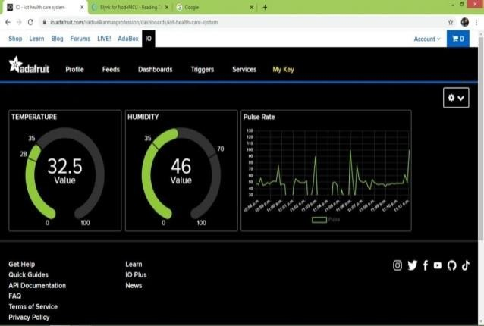

Figure 8 Adafruit Output

V. CONCLUSION
This system is really helpful for paralyses patients. When they need help then they can ask by using some movements they can also survive in this world like normal people by using this movement detection. This system is reliable and cheap and less weight.so they can buy without debt. This system will make paralyses patients to achieve a independent of mobility. This is not a trivial task just because it varies from person to person in its nature and type. Therefore different methods are essential to support these people, and it is our duty as future engineers to develop new technologies to help paralysed patients.

VI. FUTURE SCOPE
In future, we can use the chipset to implement this system. All parts are integrated in the chip, so that we can. This chip fits easily with the patient with paralysis Gloves and bands avoid clothes. But there is one disadvantage that will happen increase cost but the increase.

REFERENCES
[1] S. J. Jung and W. Y. Chung, “Flexible and scalable patient’s health monitoring system in 6LoWPAN,” Sensor Lett., vol. 9,no. 2, pp. 778–785, Apr. 2011.
[2] W. Y. Chung, C. Yau, K. S. Shin, and R. Myllylä, “A cell phone based health monitoring system with self analysis processor using wireless sensor network technology,” in Proc. 29th Annu. Int. Conf. Eng. Med. Biol. Soc., Lyon, France, 2007, pp.
[3] G. Lawton, “Machine-to-machine technology gears up for growth,” Computer, vol. 37, no. 9, pp. 12–15, Sep. 2004.
[4] C. Kim, A. Soong, M. Tseng, and X. Zhixian, “Global wireless machineto- machine standardization,” IEEE Internet Comput., vol. 15, no. 2, pp. 64–69, Mar.–Apr. 2011.
[5] Real time wireless health monitoring application using mobile devices, International Journal of Computer Networks & Communications (IJCNC) Vol.7, No.3, May 2015, Amna Abdullah, Asma Ismael, Aisha Rashid, Ali Abou-ElNour, and Mohammed Tarique .
[6] S.Mathusudhan, A L Nilla, A Pradeep, S Manibharathi and J. Geetha Ramani, "Employ Health Legacy", June 2019.
[7] Iot Based Patient Health Monitoring System by Athiya Meraj Pathan, Vyshnavi Rekkala, Madhu Sudhan Rao B, D.Anuradha, Dr.G.Lakshmi Narayana in Jes(June 2022).
[8] K. Hung, Y. T. Zhang, and B. Tai. Wearable medical devices for telehome
healthcare. In Procs.26th Annual International Conference on the IEEE EMBS, 2004.
[9] Fang, Xiang et al: An extensible embedded terminal platform for wireless telemonitoring, Information and Automation (ICIA), 2012 International Conference on Digital Object Identifier: 10.1109/ICInfA.2012.6246761 Publication Year: 2012 , Page(s): 668 - 673.
[10] S. C. Mukhopadhyay, N. K. Suryadevara, “Internet of Things: Challenges and Opportunities”.

