Title: Aggressive Periodontitis: An In-depth Review
Introduction
Aggressive periodontitis, previously known as early onset periodontitis, stands as a critical topic in dental research due to its early onset, rapid progression, and systemic implications (1). It usually manifests in otherwise healthy individuals, making it a complex oral health issue to manage and understand.
Etiology and Classification
According to the 1999 International Workshop for a Classification of Periodontal Diseases, aggressive periodontitis includes localized and generalized forms, distinguished by the number of teeth affected (2). These categories have remained largely unchanged in the new classification proposed in 2018, which emphasizes a multidimensional staging and grading system for periodontal diseases (3).
Although the etiology remains multifactorial, the main pathogen recognized is Aggregatibacter actinomycetemcomitans, particularly for the localized form. In the generalized form, the microbiota is more complex, often including Porphyromonas gingivalis, Tannerella forsythia, and Treponema denticola (4).
Pathophysiology and Clinical Presentation:
The pathogenesis of aggressive periodontitis involves an interplay between bacterial biofilm and the host immune response. Although these patients exhibit a high microbial challenge, they often lack the typical significant plaque accumulation seen in chronic periodontitis, suggesting an exaggerated host response to the bacterial biofilm (5).
- Localized Aggressive Periodontitis (LAP):
Pathophysiology:
LAP is characterized by severe periodontal destruction localized to the incisors and first molars, usually occurring around the time of puberty. The primary etiological agent associated with LAP is the gram-negative bacteria Aggregatibacter actinomycetemcomitans. The pathophysiology of LAP also involves an immune response dysregulation. Studies suggest that individuals with LAP have neutrophils and macrophages that respond poorly to chemotactic signals, reducing their ability to fight off bacterial infections effectively.
Clinical Features:
LAP usually affects the first molars and incisors, presenting as localized areas of severe periodontal breakdown. The following clinical features are commonly observed:

- Rapid bone loss around affected teeth.
- Deep periodontal pockets.
- Early onset, typically during adolescence.
- Familial aggregation, suggesting a genetic predisposition.
- Minimal plaque and calculus, considering the extensive destruction.

- Generalized Aggressive Periodontitis (GAP):
Pathophysiology:
GAP affects individuals under 30 but can also affect older individuals. This condition is not limited to specific teeth like LAP; instead, it affects at least three permanent teeth other than the first molars and incisors. GAP is associated with a mixed bacterial flora, including Aggregatibacter actinomycetemcomitans and Porphyromonas gingivalis. Like LAP, individuals with GAP often show defects in immune responses, including impaired neutrophil chemotaxis and phagocytosis.
Clinical Features:
GAP affects multiple teeth throughout the mouth and is characterized by the following clinical features:
- Rapid and generalized bone loss around several teeth.
- Deep periodontal pockets affecting multiple sites.
- Affecting patients typically under 30 years of age.
- Familial aggregation and genetic predisposition.
- Plaque and calculus accumulation may be present but not proportional to the extent of destruction. (6)

Management
Effective management of aggressive periodontitis is challenging, given its rapid progression and resistance to treatment. The standard approach involves a combination of mechanical debridement, systemic antibiotics, and in some cases, surgical intervention. The selection of antibiotics should consider the specific pathogenic microflora involved, but a combination of amoxicillin and metronidazole has been found effective in most cases (7).
Moreover, adjunctive therapies like host modulation therapy, use of antimicrobial mouth rinses, and periodontal maintenance programs are fundamental to prevent recurrence (8).
Conclusion
Aggressive periodontitis represents a significant challenge in dental health due to its severe destructive nature, rapid progression, and relative resistance to treatment. Comprehensive understanding of this disease is crucial for dental postgraduate students, not only to manage it effectively but also to counsel patients regarding its potential systemic implications.

References
1.Albandar, J.M. (2014). Aggressive and Acute Periodontal Diseases. Periodontol. 2000, 65, 7-12.
2.Armitage, G. C. (1999). Development of a Classification System for Periodontal Diseases and Conditions. Annals of Periodontology, 4(1), 1–6.
3.Tonetti, M. S., Greenwell, H., & Kornman, K. S. (2018). Staging and grading of periodontitis: Framework and proposal of a new classification and case definition. Journal of Periodontology, 89(Suppl 1), S159–S172.
4.Fine, D. H., & Patil, A. G. (2019). Aggregatibacter actinomycetemcomitans (Aa) under the radar: Myths and misunderstandings of Aa and its role in aggressive periodontitis. Frontiers in Immunology, 10, 728.
5.Pihlstrom, B. L., Michalowicz, B. S., & Johnson, N. W. (2005). Periodontal diseases. The Lancet, 366(9499), 1809–1820.
6.Highfield, J. (2009). Diagnosis and classification of periodontal disease. Australian Dental Journal, 54(S1), S11–S26.
7.Haffajee, A. D., & Socransky, S. S. (2002). Microbial etiological agents of destructive periodontal diseases. Periodontology 2000, 28(1), 192–212.
8.Reddy, M. S., Geurs, N. C., & Gunsolley, J. C. (2003). Periodontal host modulation with antiproteinase, anti-inflammatory, and bone-sparing agents. A systematic review. Annals of Periodontology, 8(1), 12–37.
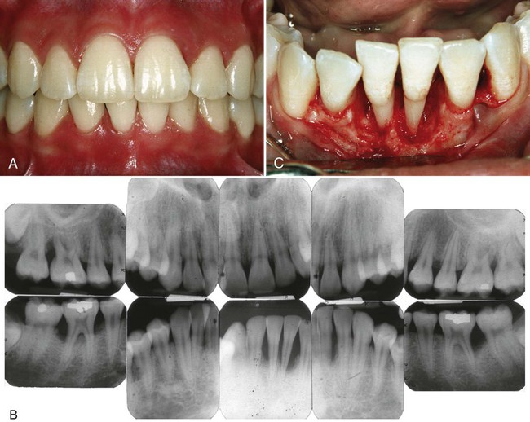
Figure1: Clinical (a and b) and Radiographic (b) picture of Aggressive Periodontitis.

Title: Aggressive Periodontitis: An In-depth Review

Author- ¹Dr. Zeba Rahman Siddiqui,
Reader,
Department of Periodontology,
Career Post Graduate Institute of Dental Sciences and Hospital,
Lucknow, Uttar Pradesh, India.

Phone: +91-9628404498
Email: zeba.rahman1@gmail.com
Co-Author-²Dr.Sidra Rahman, Postgraduate student
Department of Periodontology,
Career Post Graduate Institute of Dental Sciences and Hospital,
Lucknow, Uttar Pradesh, India.

