Future Challenges in Biotechnology Biofuels
Shailaja B. Bhosale
Department of Botany
Late Ramesh Warpudkar ACS college, Sonpeth Dist. Parbhani (MS)
Shailejab886@gmail.com

The growing global concern over climate change and the depletion of fossil fuel reserves has spurred significant interest in renewable and sustainable energy sources. In this pursuit, biotechnology has emerged as a promising solution to address these challenges, particularly in the development of biofuels. Biofuels, which are derived from organic materials such as plants, agricultural waste, and algae, offer a potentially greener alternative to conventional fossil fuels. Despite their potential, the field of biotechnology biofuels faces several future challenges that must be overcome to realize their full potential as a viable energy option. (Sindhu et al., 2019; Debnath et al., 2019; Murphy., 2008).
- Biofuels
Biofuels are renewable energy sources derived from organic materials such as plants, crops, and organic waste. They are considered a viable alternative to conventional fossil fuels like coal, oil, and natural gas because they offer the potential to reduce greenhouse gas emissions and mitigate the impact of climate change. Biofuels have gained increasing attention as the world seeks to transition towards more sustainable and environmentally friendly energy options. Many countries have implemented policies and incentives to promote the use of biofuels, such as blending mandates, tax incentives, and subsidies. Research and development efforts are also ongoing to explore advanced biofuels that can be produced from non-food feedstocks and offer higher efficiency and environmental benefits.
  - Bioethanol
Presently, ethanol is widely used as an engine's combustion fuel in mixtures of as much as eleven percent mixed gasoline. Only eight percent of ethanol has been generated chemically to yet, the other 92 percent have been obtained employing biotechnological methods that use cells from yeast, generally Saccharomyces cerevisiae, are used as the primary catalysts and can create and tolerating ethanol concentrations of up to 20 volume percent (Varfolomeev et al., 2010).
Nevertheless, they can also be generated from other renewable energies, including certain grasses and fibrous plants (Figure 1). Nowadays, bioethanol fuels are most frequently generated from starch- or sugars-rich carbohydrate crops, including as sugar cane or maize. Plant carbohydrates are transformed to ethanol by very labour-intensive and energy-intensive the fermentation process, distillation, and dehydration procedures, and ethanol fuels are less efficient for machines than either diesel or gasoline (Murphy., 2008).
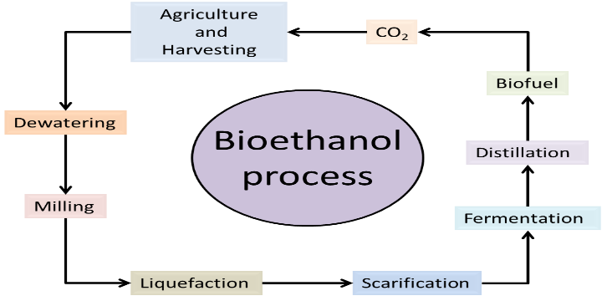
Figure 1 Bioethanol process
  - Biodiesel
During a chemical procedure termed transesterification, which frequently requires having the presence of a catalyst, biodiesel can be made from many kinds of oil seeds, particularly remaining frying oils, and fats from animals. It has been extensively addressed over if vegetable oils used in human diet may be used to make biodiesel. Employing gas chromatography-mass spectrometry, K-nearest fellow citizens, and entirely precise classification, biodiesel and diesel compositions are classified based on the kind of oil used at the time of production (Mazivila et al.,2015).
  - Firewood
The substantial nature of firewood, yet makes it inappropriate for use in lightweight, controlled heating mechanisms that need controlled fuel quality. Wood chips offer advantages in comparison. Small bits of wood, known as wood chips, are generated using a woodchipper to eliminate the trunks and branches. Typical uses for the substance comprise recreational surface, wood pulp production, and mulching of outdoor spaces. Wood chips have been used for bio heating and producing biopower more often since the start of the twenty-first century (Guo et al., 2015).
  - Woodchips
Due to costs and limited storage space, most of the material in paper mills and particleboard factories is stored in its shredded form (chips or woodchips Figure 2)). This material can be stored in specially prepared warehouses (storage halls, metal silos, or concrete silos) where the material should be dried before storage or prepared in the storage yard where the material does not need to be pre-dried.
According to the self-steaming properties of the substance and its potential for destruction over long-term storage, blending is required for all methods of preserving crushed wood product. The most common technique for keeping shredding wood is in heaps on a reinforced concrete storage field where the extent of the heaps is established by the total amount of substance and the mixing process is carried out by various kinds of loader due to the financial costs associated with constructing spaces for storage. Due to the material's requirements, we suggest preserving shredding hardwood in storage for at least four months. Yet industries remember material for three months to many years because there is a limited supply of it (Szadkowska et al., 2022).
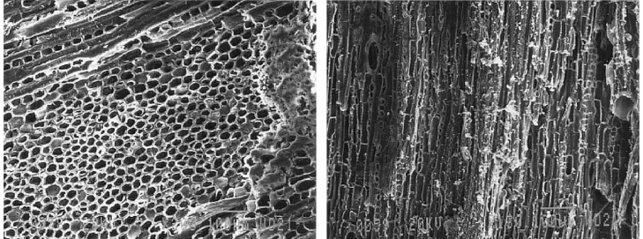
Figure 3 Internal structure of Woodchips
  - Charcoal
In the forms of fuelwood, charcoal, pyrolysis-driven production of energy, and biofuels, trees can provide biomass that is renewable. Charcoal is the most frequent kind of pyrolyzed fuel. This is produced all over the emerging the world, and it generates a fuel which is light, brimming with energy, and transportable. Wood is gradually pyrolyzed to create charcoal, frequently in basic agricultural industrial settings, usually with the wood immersed in the soil to keep oxygen out. Despite firewood, charcoal can be carried easily from cultivation regions to urban centres, and use of it is expected to rise in developing economies in decades to come (Dobie et al., 2015).
  - Biomethane
Some of the biofuels produced from biogas, an important form of energy from renewable sources, is biomethane. Yet, as biogas is an origin of biomethane, it must first be sterilized since it involves contaminants that are undesirable such H2S, NH3, siloxanes, water, etc. Methods for purifying biogas are addressed from an ingredient standpoint, as well as any modifications to its characteristics. The different characteristics and possibilities for both solid and liquid adsorbents along with the chemical interactions utilized during biogas washing to yield biomethane appropriate as a fuel source to replace or decrease consumption of fossil fuels are subsequently addressed after a brief discussion regarding substances utilized for technologies with a specific emphasis on biogas cleaning up (Chaemchuen et al., 2016).
  - Biohydrogen
To reduce the varieties imposed on by carbon dioxide pollution and the gradual depletion of fossil fuel resources, studies are progressing globally on the creation of naturally occurring generation of biohydrogen as an environmentally friendly energy source (Figure 3). Conventional hydrogen production methods that primarily rely on fossil fuels for the generation of electricity may be substituted with biohydrogen in the not-too-distant future. While biohydrogen study is still in its infancy, significant research on pilot- and laboratory-scale devices has lately been released with positive results (Show et al., 2012).
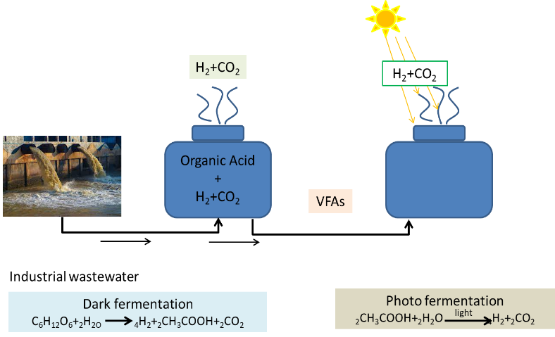
Figure 4 Production of biohydrogen
  - Biogas
Waste that is organic in nature breakdowns methanogenically within anaerobic situations to generate biogas, which is a combination of methane & carbon dioxide. A defined cultivation of a fermentation as well as syntropy together with an acetolactic & hydrogenotrophic methanogen may generate biogas. Heterogeneous cultures can be used as well as an inoculum to produce biogas, including the microorganisms discovered in cow dung \ wastewater sewage. These operations thermodynamic, kinetics, and nature of syntrophic collaboration, alongside the variety of metabolism routes for fatty acid degradation and methane production, have all been extensively examined.
- 3. Production of biofuels
3.1 Pyrolysis
In this method, oil receives chemical changes because of heating. The entire process finished without the assistance of both air and oxygen. Through this approach, vegetable, non-edible, & animal fats may all be transformed into biodiesel. The biodiesel generated through this technique has properties that are comparable to that of diesel fuel. Implementing this approach, the soybean oil's thickness decreased to 9.5 cSt.
3.2 Degumming
The density of the oil may be reduced utilizing this simple & affordable approach. In this process, the oil gets heated and agitated when certain acid is present for 13-17 minutes, and the mixture is then left in place for five to seven days for the response to complete. The bottom part of the combination encompassed sticky stuff. To reduce the acid quantity, degummed oil needs to be washed with warm water two to three times. By employing acid operations of 1 percent, 2 percent, three percent, four percent, and five percent at forty-two degrees Celsius for 12 minutes while stirring, degummed Karanja oil. By using four percent acid, the thickness of Karanja oil decreased from 45.69 cSt to around 37 cSt. Engine efficiency improves when degummed Karanja oil is mixed with diesel at a rate of twenty percent.
3.3 Preheating
This simple and inexpensive approach could decrease the viscosity of the oil. Despite improving the cetane stage, this method effectively eliminates the oil of phosphatides, protein, carotene, and other sticking components. In this process, the oil gets heated and agitated for 15-18 minutes with a particular acid exists, and the resulting mixture is then left in situ for between six and eight days for the process to complete. Slippery chemicals made up the bottom part of the combo. Degummed oil must be cleaned using hot water multiple times to minimize the concentration of acid. Degummed Karanja oil was created through acid processes involving 1 percent, 2 percent, 3 percent, 4 percent, and 5 percent at forty-two degrees Celsius for 15 minutes while stirring. The thickness of Karanja oil was reduced from 44.70 cSt to approximately 40 cSt by using five percent acid. Degummed Karanja oil is infused into diesel at a rate of 22 percent to increase engine performance.
- 4. Concerns of biofuels for futuristic challenges
Durability in bioenergy, which is particularly for biofuels, is essential for the development of the power sector in future generations. Given a 59 percent decrease in carbon dioxide emissions, measured in carbon dioxide substitutes, when compared with traditional diesel, the consumption of rapeseed biodiesel presents a fantastic opportunity.
The adverse environmental impacts of land utilization changes, which could raise emissions and decrease the proportion of the predicted save, are not considered in this conclusion. Following the rise in demand for biofuels, here may be modifications to the utilization of land and industrialization of farming that might result in additional greenhouse gas emissions and have an impact on biodiversity, soil quality, and natural assets. Confirm that biofuels made from the first generation are inefficient form a sustainability and economic point of view.
In contrast to many other more affordable alternatives, such as enhancing energy efficiency and conservation or promoting improved sources of energy where feasible, subsidized biofuels and bioenergy with the aim of reducing greenhouse gas emissions is a less efficient and more costly way of achieving this goal. The makeup of the current support will not only continue considerable but is likely to grow over time. Also, the expense to the taxpayer of biofuel and clean energy initiatives in general can be quite prohibitively costly, especially once contrasted to their advantage, which is occasionally undesirable.
The raw materials, which are produced in intense concentrated where one of the primary threats to diversity is the conversion of enormous agricultural systems and natural environments like grasslands into intensive monocultures. Non-native feedstocks are also potentially invasive and may harm ecosystems, potentially impacting processes such as pollination, land regrowth, retention of carbon, natural chemical cycles, and preventing flooding.
- 5. Application of biofuels in biotechnology
Vegetable oils could grow prevalent in food, animal feed, and bio-based industrial goods mainly a consequence of biotechnology improvements in fatty acid content. The complicated metabolic engineering of oil seeds to generate omega-3 polyunsaturated fatty acids that are that resemble fish oil is one of the most remarkable recent developments in oilseed biotechnology. Vegetable oils generated such a result are of greater purity for use by humans to boost brain & cardiovascular health.
Also, such oils might prove useful in aquaculture feeds as an alternative to fish oil as a supply of long-chain omerga-3 lipids in the diets of farm-raised fishes. The isolation of genes that regulate the creation and breakdown of novel fatty acid buildings, such as some with hydroxy- as epoxy-residues which are excellent for industrial applications such as lubricants, plasticizing agents, or precursors to nylon, has also made progress. To generate vegetable oils having novel performance, these genes are often transferred into established oilseed crops from animals with little economic guarantee.
Agriculture & fuel marketplaces demonstrate why innovation could decrease the turbulence in the ethanol business. A parameterization framework explains how biofuels impact the prices for both commodities.
5. 1. Bioelectromagnetic
Bioelectromagnetic activation on living organisms employing extremely low-frequency electromagnetic radiation is drawing a growing enthusiasm for biotechnology and biofuels purposes. Microalgae have emerged as the most likely candidates for producing biomass due to their ability to grow rapidly, generate substantial quantities of lipids, carbohydrates, and proteins, thrive in inadequate water, record while recycle carbon dioxide from commercial flue gases, and eliminate contaminants from agricultural, industrial, and municipality wastewaters.
Bioenergetic boosting technologies may be employed as a possible tool for biological remediation by accelerating the pace at which different contaminating elements present in waste streams are absorbed by microbes, keeping into account the increasing importance of the recycling and disposal of waste in protecting natural resources.
5.2. Biofuels in industry
Trichoderma reesei, the biotechnological powerhouse of the species, generates the cellulases which are significant for commercial purposes, especially so when it involves the production of biofuels of the second generation from cellulose debris. Through the introduction of a sexual cycle in T. reesei/Hypocrea jecorina, genetic modification has not only drastically enhanced manufacturing procedures but also offered intriguing insights into the biology associated with these fungi. This has greatly helped both basic and applied research.
Concepts of industrial collaboration to the biofuel enterprises are based on the input-output assessment of producing networks demonstrating that linkages among the biofuel industries are possible and that these synergies could improve the environmental impact of first-generation biofuels for mobility. Structural and economical synergies between the sectors could accomplish this. Also, it will be investigated how merging of systems and the energy system employed and distributed might enhance the ecological sustainability of biofuels for transport using the concept of corporate integration.
5.3. Biofuels in transportation
The application of biodiesel as an enhanced energy source to replace petroleum-based gasoline in vehicles is growing in acceptance. As of right now, more than 66 nations throughout the globe have embraced biofuel, which has driven up the demand for biodiesel.
Biodiesel is a specific such fuel for compression-ignition vehicles which holds a lot of say they will. Biodiesel made with vegetable oils may also be employed in instead of diesel fuel. Presently soybean, rapeseed, and palm oils are used mainly for the generation of biodiesel.
Biofuel, and particularly biodiesel, is one alternative biofuel that has a lot of guarantees. The word "biofuel" is referring to liquid or gaseous fuels for transportation that are mostly made from biomass. In general, biofuels are thought to serve several goals, such as long-term viability a decline in emissions of greenhouse gases, a stronger regional social structure, agriculture & supply safety.
5.4. Biofuels and food security
The influence of biofuels on food security in countries that are developing is a topic with considerable dispute. The fact that biofuels undermine food security by increasing the price of food is an important issue. A third of impoverished farmers are paying to cultivate castor beans on a typical of 18percent of their farms via biofuel logistics.
5.5. Biofuels in chemistry
While it is environmentally friendly, biomass is an interesting starting point for fuels for transportation. The carbohydrate polymers cellulose & hemi-cellulose, in addition to cellulose, are the major components of biomass. The converting mechanism may go on with bigger intermediates if oxygen-containing products are permitted. Ethanol has possibilities as an intriguing additive for gasoline. Diesel demands molecules that possess a longer carbon chain (Figure 4). These are only possible using just one of two phases in a process that connect carbon chains along with decreasing polarization. Because of its intricate, highly cross-linked structure, the lignin found in biomass will most efficiently undergo conversion to syngas by liquefaction or used directly as solid fuel.
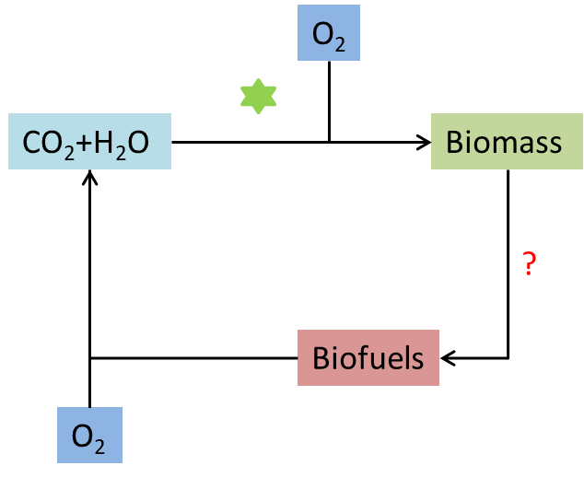
Figure 5 Biofuels from biomass
- Future perspective of biofuels
By the year 2035, bioenergy is projected to make up to 25–35percent of all primary energy used globally (2013, for example), a clear indication of how it continues to increase in significance to the global mix of energy sources. The greatest rise in biofuel production for transport has & continues to be subsidized by government agencies. The availability of every kind of biomasses must grow several folds to reach the lofty goals in the New Policy Scenario, leading to substantial challenges for farming and woodland operations (Ho et al., 2014).
Beyond the year 2020, biofuels may receive funding if they resulted in substantial decreases in greenhouse gases & do not originate using crops used for nourishment for animals and food. Concentrating on the research and development of the second and third generations of biofuels use a broader spectrum of a raw material, such as lignocellulosic substance, garbage, and debris and are not competing with the production of food or promote the production of biodiesel produced from algae can help solve this problem. The referred to as biofuels of the second generation, which are generated from remnants and garbage, have an assortment of benefits, particularly economy. It is possible to generate waste origin biofuels employing a wide range of feedstocks, including as municipal solid waste, sewage effluent, and food scraps.
Within contrast to a plant-based biofuels, third-generation biofuels made from microalgae and cyanobacteria might offer benefits like high yields of biomass and the capacity to develop in culture ponds. Studies in the field have also been conducted by scholars from Latvia.
However, other academics contend that the growth of algae biofuels could additionally result in considerable resource inputs and severe environmental and other harmful repercussions, as is true for all kinds of manufacturing of energy, in addition to any possible environmental and social advantages. Even though it is acknowledged that algal cells are almost ideal as organisms for creating the highly productive and robust crop impacts that are crucial to generally profitable manufacturing of biofuel, biofuels derived from biomass are not the best way to store solar energy due to the low ultraviolet energy density of biodiesel from rapeseed, low solar energy content of bioethanol, and the small solar energy materials of biogas.
In conclusion, biofuels represent a promising avenue for reducing carbon emissions, enhancing energy security, and advancing sustainability goals. However, their widespread adoption must be carefully managed to address environmental, social, and economic concerns. A balanced approach, combining supportive policies, ongoing research, and responsible land-use practices, is essential for the successful integration of biofuels into the global energy mix.
References
Chaemchuen, S., Zhou, K., & Verpoort, F. (2016). From biogas to biofuel: materials used for biogas cleaning to biomethane. ChemBioEng Reviews, 3(6), 250-265.
Chang, W. R., Hwang, J. J., & Wu, W. (2017). Environmental impact and sustainability study on biofuels for transportation applications. Renewable and Sustainable Energy Reviews, 67, 277-288.
De Ory, I., Romero, L. E., & Cantero, D. (2004). Optimization of immobilization conditions for vinegar production. Siran, wood chips and polyurethane foam as carriers for Acetobacter aceti. Process Biochemistry, 39(5), 547-555.
Debnath, D., Khanna, M., Rajagopal, D., & Zilberman, D. (2019). The future of biofuels in an electrifying global transportation sector: imperative, prospects and challenges. Applied Economic Perspectives and Policy, 41(4), 563-582.
Dobie, P., & Sharma, N. (2015). Trees as a global source of energy: from fuelwood and charcoal to pyrolysis-driven electricity generation and biofuels. World Agroforestry Centre.
Guo, M., Song, W., & Buhain, J. (2015). Bioenergy and biofuels: History, status, and perspective. Renewable and sustainable energy reviews, 42, 712-725.
Ho, D. P., Ngo, H. H., & Guo, W. (2014). A mini review on renewable sources for biofuel. Bioresource technology, 169, 742-749.
Lee, O. K., & Lee, E. Y. (2016). Sustainable production of bioethanol from renewable brown algae biomass. Biomass and Bioenergy, 92, 70-75.
Martin, M., & Eklund, M. (2011). Improving the environmental performance of biofuels with industrial symbiosis. Biomass and Bioenergy, 35(5), 1747-1755.
Mazivila, S. J., de Santana, F. B., Mitsutake, H., Gontijo, L. C., Santos, D. Q., & Neto, W. B. (2015). Discrimination of the type of biodiesel/diesel blend (B5) using mid-infrared spectroscopy and PLS-DA. Fuel, 142, 222-226.
Murphy, D. J. (2008). Future prospects for biofuels. Chimica Oggi, 26(1), 14.
Murphy, D. J. (2008). Future prospects for biofuels. Chimica Oggi, 26(1), 14.
Naylor, R. L., Liska, A. J., Burke, M. B., Falcon, W. P., Gaskell, J. C., Rozelle, S. D., & Cassman, K. G. (2007). The ripple effect: biofuels, food security, and the environment. Environment: Science and Policy for Sustainable Development, 49(9), 30-43.
Negash, M., & Swinnen, J. F. (2013). Biofuels and food security: Micro-evidence from Ethiopia. Energy Policy, 61, 963-976.
Oh, P. P., Lau, H. L. N., Chen, J., Chong, M. F., & Choo, Y. M. (2012). A review on conventional technologies and emerging process intensification (PI) methods for biodiesel production. Renewable and Sustainable Energy Reviews, 16(7), 5131-5145.
Petrus, L., & Noordermeer, M. A. (2006). Biomass to biofuels, a chemical perspective. Green chemistry, 8(10), 861-867.
Randrianarison, G., & Ashraf, M. A. (2017). Microalgae: a potential plant for energy production. Geology, Ecology, and Landscapes, 1(2), 104-120.
Rawalgaonkar, D. (2023). Anaerobic Digestion of Brewery Waste Including Spent Yeast and Hops (Doctoral dissertation, University of South Florida).
Santoso, H., & Inggrid, M. (2014). Effects of temperature, pressure, preheating time and pressing time on rubber seed oil extraction using hydraulic press. Procedia Chemistry, 9, 248-256.
Shahid, M. K., Batool, A., Kashif, A., Nawaz, M. H., Aslam, M., Iqbal, N., & Choi, Y. (2021). Biofuels and biorefineries: Development, application and future perspectives emphasizing the environmental and economic aspects. Journal of Environmental Management, 297, 113268.
Show, K. Y., Lee, D. J., Tay, J. H., Lin, C. Y., & Chang, J. S. (2012). Biohydrogen production: current perspectives and the way forward. International Journal of Hydrogen Energy, 37(20), 15616-15631.
Sindhu, R., Binod, P., Pandey, A., Ankaram, S., Duan, Y., & Awasthi, M. K. (2019). Biofuel production from biomass: Toward sustainable development. In Current developments in biotechnology and bioengineering (pp. 79-92). Elsevier.
Szadkowska, D., Auriga, R., Lesiak, A., Szadkowski, J., & Marchwicka, M. (2022). Influence of Pine and Alder Woodchips Storage Method on the Chemical Composition and Sugar Yield in Liquid Biofuel Production. Polymers, 14(17), 3495.
Varfolomeev, S. D., Efremenko, E. N., & Krylova, L. P. (2010). Biofuels. Russian chemical reviews, 79(6), 491.
Viesturs, D., & Melece, L. (2014). Advantages and disadvantages of biofuels: observations in Latvia. Latvia University of Agriculture.
Yin, Z., Zhu, L., Li, S., Hu, T., Chu, R., Mo, F., ... & Li, B. (2020). A comprehensive review on cultivation and harvesting of microalgae for biodiesel production: Environmental pollution control and future directions. Bioresource Technology, 301, 122804.
Yuan, L., & Li, R. (2020). Metabolic engineering a model oilseed Camelina sativa for the sustainable production of high-value designed oils. Frontiers in Plant Science, 11, 11.

