BLOCKCHAIN AND ARTIFICIAL INTELLIGENCE FOR INTERNET OF THINGS
Author: Abi K, Deepika J, Yogesh J
M.Sc. Computer Science and Technology
SRM Arts and Science College, Kattankulathur.
ABSTRACT
Blockchain technology is a distributed and secure system that has attracted widespread attention due to its potential to revolutionize many industries. Artificial Intelligence (AI) is an emerging field of technology that aims to create machines and systems that can perform human intelligence tasks. The convergence of Internet of Things (IoT), blockchain, and artificial intelligence/machine learning technologies paves the way to accelerate digital transformation. This article focuses on the convergence of two technologies: blockchain and AI (AI). Blockchain, IoT, and AI provide great benefits in terms of security, transparency, immutability, privacy and automation of business processes. The integration of AI and blockchain technology holds great promise across various industries, but several challenges must be addressed to fully unlock their potential.The article delves into the synergistic relationship between these two technologies, highlighting their potential to reshape industries ranging from finance to healthcare. However, it also acknowledges the challenges and ethical concerns associated with their implementation.
INTRODUCTION
BLOCKCHAIN
Blockchain technology is a distributed and secure system that has attracted widespread attention due to its potential to revolutionize many industries. The basis of blockchain is a distributed and immutable digital code that records transactions or information in a computer network in a transparent and unprovable manner. Each block in the chain has a transaction log, and once again, the block cannot be modified without the permission of the network partners.
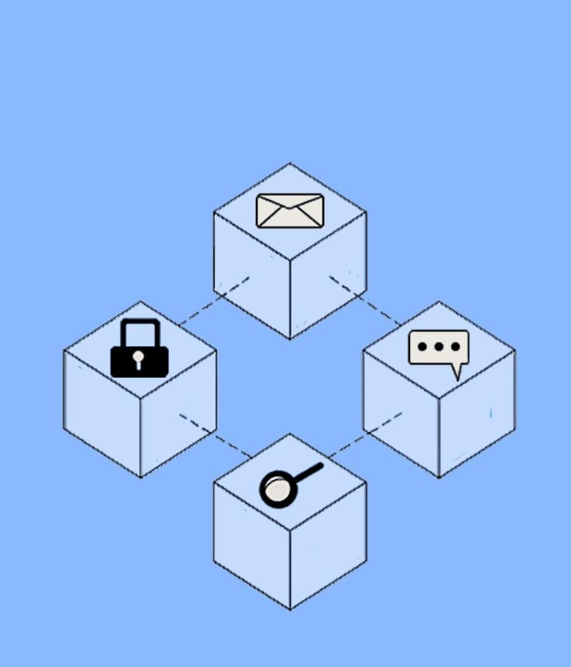

One of the key features of blockchain is its transparency and security. Since data is stored across multiple bases in the network, it is difficult for an organization to manage data, thus increasing trust and accountability. This has led to its widespread use in financial applications such as cryptocurrencies, of which Bitcoin is the most famous example.
Blockchain technology is transcending financial markets. It is used in supply chain management to track the origin and journey of products and ensure authenticity and ethics. Smart contracts are another innovation brought by blockchain, which allows contracts to be executed and enforced according to a set of pre-determined rules.
But blockchain is not without its challenges. Their energy use, especially for proof-of-work-based cryptocurrencies, raises concerns about environmental impacts. For widespread adoption, scalability and interoperability issues also need to be addressed.

Artificial Intelligence
Artificial Intelligence (AI) is a changing field of technology that aims to create machines and systems that can perform human intelligence tasks. Over the years, artificial intelligence has evolved from a theoretical concept to a practical concept that has created many businesses. The fundamentals of artificial intelligence involve creating algorithms and models that allow computers to process data, recognize patterns, and make decisions in ways that simulate human behavior.
Artificial intelligence covers many subfields where machine learning is important. Machine learning involves training algorithms on large data sets to improve their performance over time. Neural networks are a part of machine learning inspired by the structure of the human brain and have successfully performed tasks such as recognition of images and speech.
Natural Language Processing (NLP) is another important field of artificial intelligence that enables computers to understand, interpret and reproduce human language. This has led to advances in chatbots, translation, and sentiment analysis.
Paths to Convergence: Exploring the Synergy of Blockchain and Artificial Intelligence:
This topic dives into the convergence of two technologies: blockchain and artificial intelligence (AI). Deep learning models based on the neural networks that make up human cognition have proven their powerful abilities in pattern recognition, prediction, and decision-making. Blockchain networks, on the other hand, provide a transparent, decentralized business process solution that facilitates immutability of data and trust-based digital interactions.
The combination of blockchain and artificial intelligence promises to enable intelligent automated decision-making based on data transformation that can deliver real-world benefits. This integration can lead to new business models for AI-driven smart contracts, increasing operational efficiency, streamlining operations, improving data security, and providing unprecedented security and reliability.
But this influence extends beyond the business world; including areas such as education, health, energy, social impact, agriculture and urban planning. Combining the capabilities of artificial intelligence and the security of blockchain, this technology can support data-driven decision-making and executive management across the department. This brief envisions a future where the integration of artificial intelligence and blockchain will transform the economy, spur innovation, and facilitate the efficient and transparent distribution of wealth for community support.
Many applications and potential integrations of AI and blockchain technology:
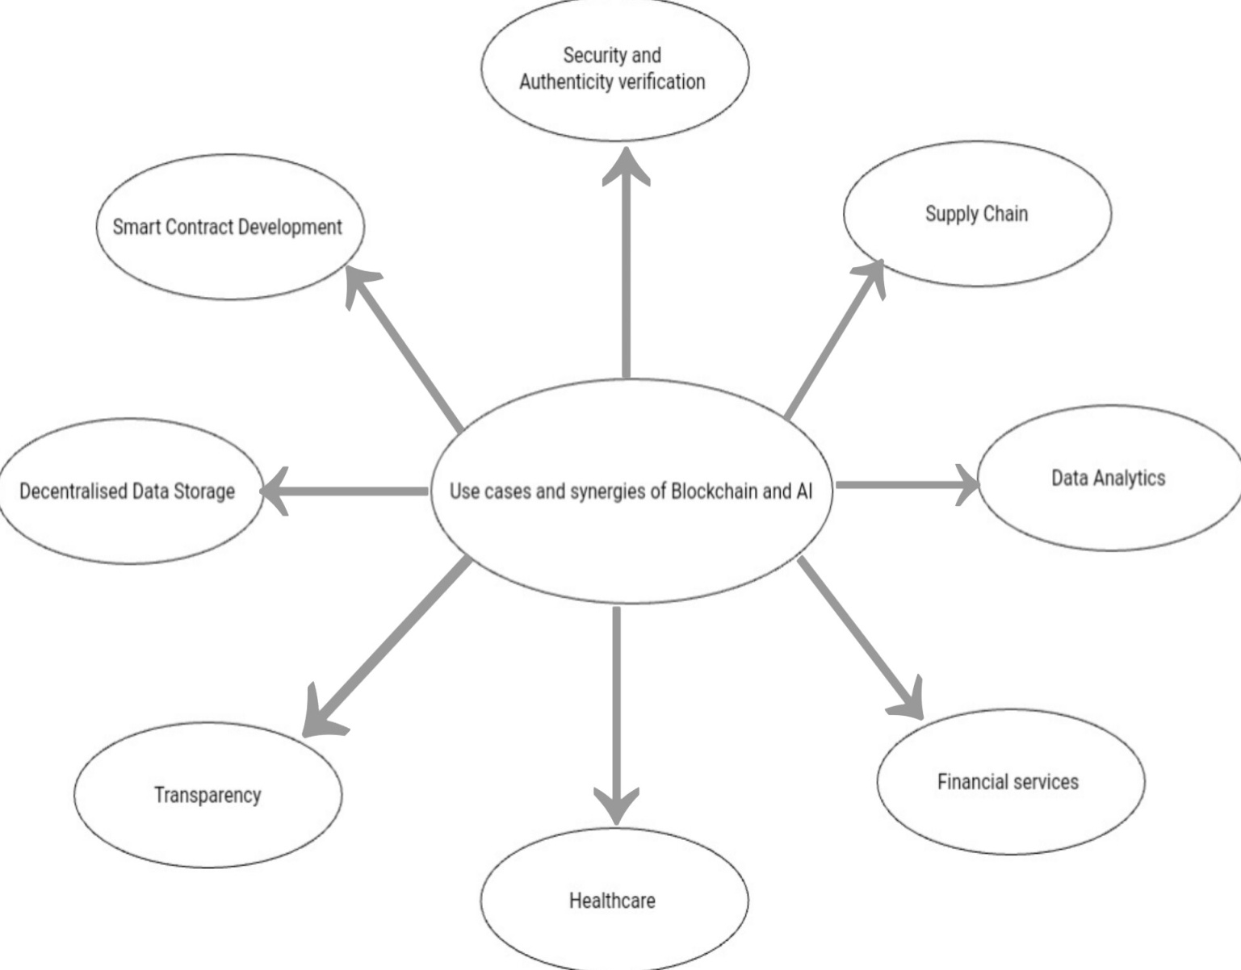
Security:
The connection between intelligence and blockchain can provide transparency Increase security using built-in smart tools tamper-resistant decentralized infrastructure managed security. Due to their decentralized nature, decentralized systems are more resistant to attacks.
Supply Chain:
Artificial intelligence models in blockchain-based smart contracts can perform tasks such as inventory management and ordering. This integration can increase transparency, reduce fraud, improve the quality of delivery processes and even provide disaster relief.
Fact Verification:
The creative capabilities of artificial intelligence, combined with the cryptographic verification of blockchain, can help verify the authenticity of news content. Blockchain can schedule content and verify its provenance, prevent data corruption, and support trustworthy content.
Data Analysis:
Blockchain secure data can be used for big data analysis. Model intelligence can analyze supply chain data, eliminate patterns and provide insights for informed decision-making.
Financial Services:
Artificial Intelligence can use decentralized finance (DeFi) to make financial investments without the need for an intermediary. The composability of blockchain applications allows for complex financial transactions with transparency and security.
Healthcare:
Blockchain's secure data storage combined with AI analysis can lead to accurate diagnoses, personalized treatment plans, and enhanced privacy in healthcare data management.
Transparency:
Blockchain's transparent nature can address the opacity of complex AI models. By recording decision-making patterns on the blockchain, AI models can provide more integrity and transparency in their outputs.
Decentralised data storage:
Blockchain-based storage solutions like File coin and IPFS can safeguard training data integrity and confidentiality, benefiting AI systems.
Smart contract development:
AI-assisted development tools can boost the productivity of smart contract developers. AI-powered APIs can enable the creation of innovative Web3 applications.
Overall, the integration of AI and blockchain has the potential to revolutionize various sectors by enhancing security, transparency, efficiency, and trust in diverse applications.
The integration of AI and blockchain technology holds great promise across various industries, but several challenges must be addressed to fully unlock their potential. Some of these challenges include:
Data collection and Interoperatability :
AI models require diverse datasets, which can be challenging to gather due to privacy concerns and the need to connect different datasets. Interoperability between various blockchain networks and AI platforms is crucial to ensure seamless data exchange and compatibility between these technologies.
Standards and connectivity:
Establishing standards is essential to facilitate connectivity between AI and blockchain systems. Common rules and interfaces should be developed to facilitate communication and information sharing.
Data Privacy:
The integration of artificial intelligence and blockchain may create new privacy issues. The current privacy policy should be updated to address these issues and ensure that the user's privacy is protected while leveraging the benefits of both technologies.
Regulation and Ethics Policy:
The regulatory process must be adapted to the specific challenges presented by this technology. Artificial intelligence and blockchain integration. It is important to address ethical issues such as bias in AI models and misuse of blockchain for malicious purposes.
Technical Complexity:
Using and managing blockchain expertise can be a complex task. It is important to emphasize efficiency, effectiveness, and efficiency when managing security.
Requirements:
Artificial Intelligence and blockchain technology can be resource intensive. Ensuring efficient use of resources, especially in decentralized systems, is a decision.
Lack of Regulation:
The lack of a standard to integrate AI and blockchain could lead to fragmentation and prevent mass adoption.
Despite these challenges, solutions can lead to a future where intelligence and blockchain work together, thereby improving information security, privacy, transparency and performance across multiple projects.
Internet of Things
Internet of Things describes physical devices that are connected to the Internet and have sensors. Smart devices allow sensors to collect data, perform internal operations, and send it to other devices over the internet.
Blockchain and IoT integration
Blockchain was first used for cryptocurrency and financial transactions; all nodes in the network managed and stored transactions. Later, blockchain was adopted by many businesses due to the great benefits it provides. IoT systems are one of these areas. Many IoT applications can greatly benefit from the combination of blockchain and IoT. Blockchain healthcare, smart home, smart city, smart transportation etc. Since it is suitable for IoT applications, it has both decentralization and trust features.
Integrating blockchain technology into IoT systems is not easy. The first important step is to define a blockchain platform to connect IoT to blockchain technology.
Technology Convergence:
The combination of IoT, blockchain and artificial intelligence/machine learning creates the synergy that is the true power of digital transformation. Organizations can integrate new technologies to create connected smart ecosystems. For example, IoT devices can generate large amounts of data that can be securely shared and stored using blockchain technology. AI/machine learning algorithms can find insights from this data to help with decision making and continuous improvement.
Sector-specific impact:
The convergence of IoT, blockchain and artificial intelligence/machine learning technologies is bringing changes in many areas. department. Organizations are using these technologies to improve operations, enhance customer experience, and drive innovation in industries such as healthcare, manufacturing, finance, and technology.
Conclusion:
Major innovations such as blockchain, IoT and artificial intelligence provide great benefits in terms of security, transparency, immutability, privacy and automation of business processes. But when blockchain, IoT and artificial intelligence come together, the impact of these advances could be even greater. We believe that these achievements combined will accelerate the digitalization of the economy. The convergence of Internet of Things, blockchain, and artificial intelligence/machine learning technologies paves the way to accelerate digital transformation. Organizations that embrace this combination can unlock new capabilities, increase operational efficiency, and deliver revolutionary solutions to their customers. Organizations can remain competitive in the digital age and build a successful future through connection, trust and intelligence using a combination technologies.

REFERENCES:
1.Sandner P, Gross J and Richter R (2020) Convergence of Blockchain, IoT, and AI. Front. Blockchain 3:522600. doi: 10.3389/fbloc.2020.522600
2. Ruonan Wang et al.
3.Saima Khan, Omprakash Mangde
4.Ruonan Wang et al.
5.Boar, C., Holden, H., Wadsworth, A. (2020): Impending arrival — a sequel to the survey on central bank digital currency, BIS Paper №107.
6.Liu, M., Yu, R., Teng, Y., Leung, V., Song, M. (2019). Performance Optimization for Blockchain-Enabled Industrial Internet of Things (IIoT) Systems: A Deep Reinforcement Learning Approach. IEEE Transactions on Industrial Informatics.
7.Yin, H. H. S., Langenheldt, K., Harlev, M., Mukkamala, R. R., Vatrapu, R. (2019). Regulating Cryptocurrencies: A Supervised Machine Learning Approach to De-Anonymizing the Bitcoin Blockchain. Journal of Management Information Systems, 36(1), 37–73

