“Carbon Nanotubes: Advancements, Properties, and Promising Futures”
Pavithra K¹, Sandhanam K², Manimaran V^{1*}, Tamilanban T²

¹ Department of Pharmaceutics, SRM College of Pharmacy, SRM Institute of Science and Technology, Kattankulathur, India.
² Department of Pharmacology, SRM College of Pharmacy, SRM Institute of Science and Technology, Kattankulathur, India.

*Corresponding Author:
Dr. V. Manimaran,
Associate Prof,
Dept. of Pharmaceutics,
SRM College of Pharmacy,
SRM Institute of Science and Technology,
Kattankulathur, Chengalpattu,
India.
manimarv@srmist.edu.in

Abstract:

Carbon nanotubes (CNTs) have acquired significant interest as drug delivery systems in healthcare due to their unique structural characteristics and physicochemical properties. One of the most significant benefits of using CNTs as drug carriers is their ability to enable targeted drug delivery through efficient cellular uptake mechanisms and improved drug delivery techniques. This makes CNTs a promising option for delivering drugs precisely where they are needed in the body. CNTs can either encapsulate drugs within their cores or firmly attach them to their surfaces, surpassing the constraints associated with traditional drug delivery approaches. The versatility of CNTs extends beyond drug delivery, with potential applications in various biomedical fields. These nanotubes hold promise in diagnostics, imaging, tissue engineering, and even gene therapy. However, a comprehensive understanding of CNT's biological behaviour and safety is necessary before their widespread clinical use. Research focusing on their interactions, toxicity, and environmental impact is crucial. CNTs have the potential to revolutionize drug delivery and find applications in various biomedical fields. This chapter provides insights into the structural characteristics, physicochemical properties, and biomedical applications of CNTs in drug delivery. Furthermore, this chapter underscores the importance of future research endeavors to advance CNT-based medicine. As scientists continuously explore the vast potential of CNTs, they hold the key to transforming various industries and driving significant progress in science and technology. Notably, this chapter delves into the potential of CNTs as cutting-edge drug delivery systems in healthcare.

Keywords: Carbon nanotubes, future perspectives, synthesis techniques, characterization, applications, challenges.

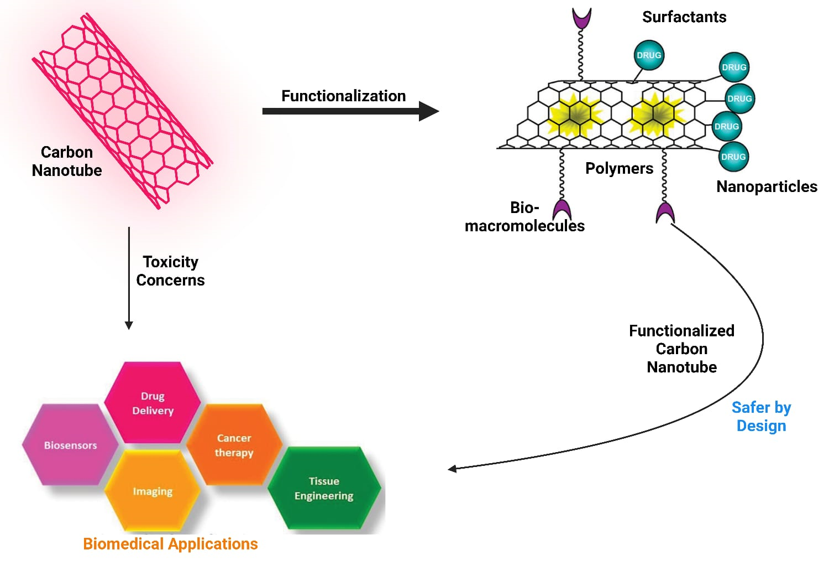

Fig- 1: Schematic Illustration of Biomedical Applications of Carbon Nanotubes

- Introduction:

One of the most investigated forms of carbon is carbon nanotubes (CNTs). Since the early 2000s, the utilization of CNTs as a drug delivery system in healthcare has been prominent following the advent of nanotechnology. They are excellent candidates for use in a wide variety of biological applications like drug delivery and biotechnology due to their distinctive structural characteristics and physicochemical properties. Their ability to effectively serve as potential carriers for innovative drug and gene delivery systems has attracted significant attention, primarily due to their remarkable characteristics. CNTs exhibit efficient uptake by various cell types through multiple mechanisms. (1)
Furthermore, their capacity to encapsulate medicinal substances within their cylindrical cores or adhere them to their surfaces has paved the way for enhanced drug delivery techniques that transcend the limitations of conventional methods. As a result of their exceptional physical, chemical, and biological attributes, CNTs are highly suitable for numerous industrial and biomedical applications. However, a comprehensive understanding of the CNTs' biological characteristics, behaviour, and performance is necessary before they can be employed more widely to find their way into clinical applications. (2) Additionally, CNTs should have well-characterized biological as well as environmental safety aspects when manufactured on a big scale.

- Structure and Classification of Carbon Nanotubes

Multiple forms of carbon allotropes have been studied and recognized, including the notable example of graphene. Graphene is a monolayer of carbon atoms meticulously arranged in a two-dimensional honeycomb lattice structure. Further, one or more graphene sheets are folded in a cylindrical form to make Single-walled carbon nanotubes, Multiwalled carbon nanotubes and carbon nanofibers.(3) Carbon nanotubes are needle-shaped structures comprised of carbon atoms with a graphitic structure along their long axis, making them one-dimensional materials. CNTs are broadly classified into two types: Single-walled carbon nanotubes (SWCNTs) and Multiwalled carbon nanotubes (MWCNTs).
- SWCNTs are cylindrical structures composed of a single layer of graphene rolled into a seamless tube. They exhibit a unique one-dimensional structure, with the carbon atoms forming strong covalent bonds in a hexagonal pattern. SWCNTs can have various diameters and lengths, typically in the 0.4 – 2.0 nm range. Single-walled possess smaller diameter.
- MWCNTs can have different numbers of layers, ranging from a few to several tens of layers, giving them a tube-within-a-tube structure. This may not require a catalyst for the synthesis. MWCNTs generally have larger diameters than SWCNTs up to 100nm. Double-walled carbon nanotubes (DWCNTs) consist of two layers of graphene tubes nested concentrically. They have a tube-within-a-tube structure, with an outer tube and an inner tube separated by a van der Waals gap layer.(4,5)

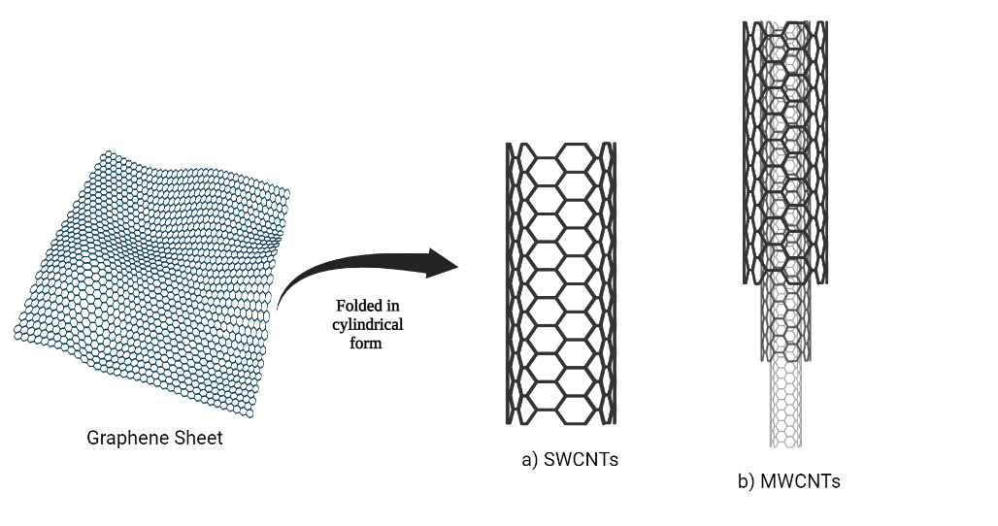
Fig: 2- Schematic Representation of a graphene sheet rolled up to form SWCNTs and MWCNTs

- Properties(6,7):

- Chemical Characteristics: CNTs have chemical characteristics similar to carbon, which is chemically stable. Furthermore, because of its high biocompatibility, chemical inertness, and comprehensive antibacterial and antifungal properties, it has the potential to be used in a wide range of novel applications like various bio-sensors, drug delivery and gene therapy.
- Physical Characteristics: CNTs have many interesting physical properties that have caught the attention of scientists all over the world. CNTs possess varying lengths, ranging from nanometres allowing for customization to suit specific applications. Carbon nanotubes have excellent tensile strength, less weight, and many other great physical properties.
- Thermal Stability: CNTs are considered to be excellent thermal conductors since they can endure high temperatures. They are estimated to have thermal stability of up to 750⁰ C in the air. Carbon nanotubes transfer 15 times more watts per minute than copper cables.

- Synthesis of CNTs

There are two key distinctions between the production of SWCNTs and MWCNTs. Firstly, the production of SWCNTs requires the presence of a catalyst, whereas MWCNTs can be produced without one. Secondly, the production process for SWCNTs is more complex and results in lower purity compared to MWCNTs. (8)There are five primary methods commonly used for the fabrication of CNTs:
  - Carbon Arc-Discharge Method
  - Laser ablation Method
  - Chemical Vapour deposition
  - Spray pyrolysis Method
  - Flame Synthesis Method(9)
The carbon arc-discharge method is a widely used technique for producing CNTs. It involves passing a high current through carbon electrodes in an inert gas environment. The resulting intense heat vaporizes a carbon source, typically graphite, leading to the formation of CNTs. This method is particularly effective in producing large quantities of MWCNTs.
The laser ablation technique involves using a high-energy laser to vaporize a target material, which then condenses to form CNTs. This method is capable of producing high-quality SWCNTs and can also be adapted for MWCNT production. (4)
In Chemical Vapour Deposition (CVD) a carbon-containing gas is introduced into a high-temperature chamber where it decomposes and forms carbon atoms. These atoms then grow into CNTs on a substrate with the assistance of a catalyst. CVD allows for control over growth parameters and can produce high-quality CNTs in both single-walled and multi-walled forms.
In the spray pyrolysis technique, a precursor solution is atomized into fine droplets and heated to high temperatures, causing the precursor to decompose and form solid particles. These particles, including CNTs, are collected on a substrate or filter. The spray pyrolysis method offers scalability, uniform deposition, and control over material composition, making it suitable for large-scale CNT production and another nanomaterial synthesis. (10)
The flame synthesis method involves introducing a hydrocarbon gas into a flame or combustion zone, where the high temperatures cause the gas to decompose into carbon atoms. These atoms then aggregate and form CNTs as they cool down. The method allows for large-scale production of CNTs and offers control over their properties through reaction parameter adjustments.
After synthesis, to purify newly produced CNTs derived from fullerenes, amorphous carbon, and metals, the following techniques are commonly employed: acid refluxing, sonication with surfactant assistance, or air oxidation. These methods help refine and remove impurities from the CNTs to enhance their quality and properties.(11)
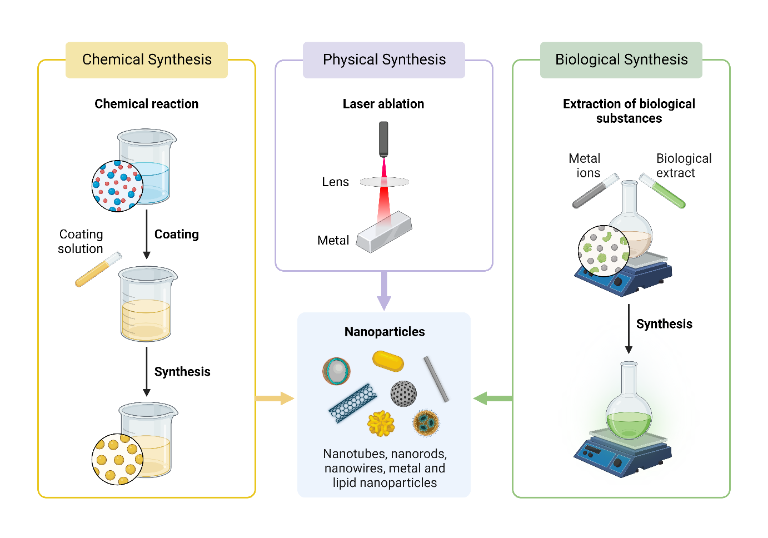
Fig: 3 – Schematic Process of Synthesis of Carbon Nanotubes

- Biomedical Applications of Carbon Nanotubes

CNTs have attracted significant attention in biomedical applications due to their unique properties. They offer advantages such as high cell internalization, strong drug-loading capacity, and the ability to target specific cells through functionalization. in-vivo use of CNTs is facilitated by their inherent physicochemical features, including significant optical absorption in the near-infrared range, Raman scattering, and photoacoustic capabilities. These properties make CNTs promising candidates for drug delivery applications, particularly in cancer therapy.(12) Recent studies have focused on utilizing CNTs for immunotherapy, gene therapy, and cancer treatment. Testing novel materials and various cell lines is crucial for advancing research in cancer treatment using CNTs.

- Drug Delivery
Low selectivity and short half-lives may lead to difficulties and even lethal problems with the administration of medication, making efficient drug administration essential in the medical industry. Biocompatibility and optimal size for medication and gene delivery are investigated in CNTs.

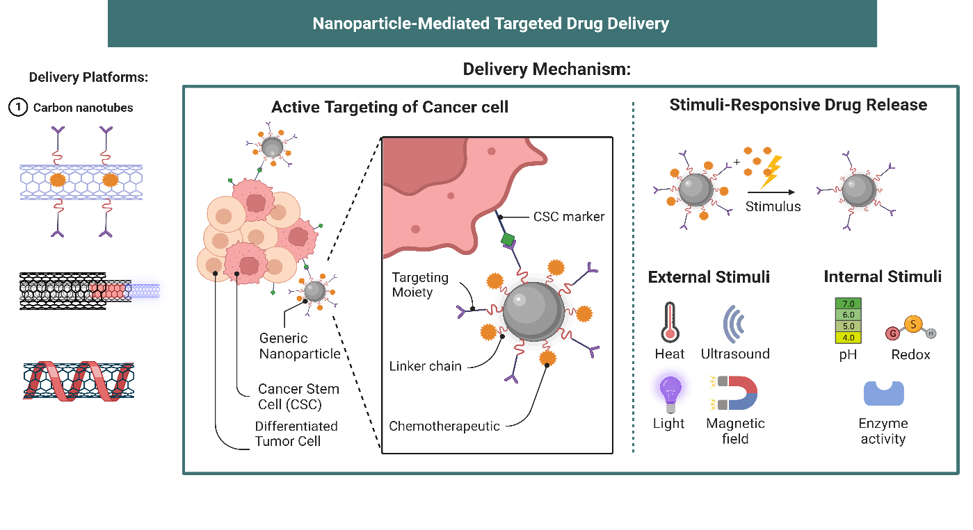
Fig: 4- Potential therapeutic targets for the removal of cancer cells (CCs) are surface indicators unique to CCs. By joining targeting molecules to drug-delivery nanoparticles, active targeting may be accomplished. These molecules have the ability to attach only to the markers present on CCs. After binding, both internal and external events might cause drug release.

Oxidized CNTs are preferred as drug vehicles due to their surface carboxylic groups, easy functionalization, and reduced metal impurities, making them more efficient at crossing cellular barriers. Long hydrophilic polymers like PAA, chitosan, and PEG are commonly used for drug delivery to tumors due to their biocompatibility and passive targeting through enhanced permeability and retention.(1) However, double targeting, such as the combination of passive and active strategies, is often used. The addition of folic acid (FA), recognized by the over-expressed FA receptor on several human tumor cells, is an efficient strategy to increase cellular uptake of drug-loaded CNTs. FA-functionalized CNTs wrapped in hydrophilic polymers were demonstrated to be able to enter cancer cells by an endocytotic, energy-dependent mechanism mediated by the FA receptor. (13)
Another potential targeting strategy involves the loading of paramagnetic particles that can direct the movement of the CNTs in an applied magnetic field. This strategy was also used by Chen et al., who loaded CNTs with magnetic particles loaded with transferrin for cell internalization and quantum dots for imaging. However, dual targeting is often used, such as the blending of reactive and aggressive techniques.(14) Gene therapy or gene delivery Regardless of the functional groups they may have on their surface, CNTs have the ability to penetrate cells, enabling the delivery of genes, proteins, and intracellular medicines. Because short interfering RNA (siRNA) is delivered into the cytoplasm, this is particularly interesting for the development of gene silencing treatments.(8)
Oxidized CNTs are preferred as drug vehicles due to their surface carboxylic groups, easy functionalization, and reduced metal impurities, making them more efficient at crossing cellular barriers. Long hydrophilic polymers like PAA, chitosan, and PEG are commonly used for drug delivery to tumors due to their biocompatibility and passive targeting through enhanced permeability and retention. However, double targeting, such as the combination of passive and active strategies, is often used.(15) The addition of folic acid (FA), recognized by the over-expressed FA receptor on several human tumor cells, is an efficient strategy to increase cellular uptake of drug-loaded CNTs. FA-functionalized CNTs wrapped in hydrophilic polymers were demonstrated to be able to enter cancer cells by an endocytotic, energy-dependent mechanism mediated by the FA receptor.
Another potential targeting strategy involves the loading of paramagnetic particles that can direct the movement of the CNTs in an applied magnetic field. This strategy was also used by Chen et al., who loaded CNTs with magnetic particles loaded with transferrin for cell internalization and quantum dots for imaging. However, dual targeting is often used, such as the blending of reactive and aggressive techniques.(6)

- Gene therapy or gene delivery
Regardless of the functional groups they may have on their surface, CNTs have the ability to penetrate cells, enabling the delivery of genes, proteins, and intracellular medicines. Because short interfering RNA (siRNA) is delivered into the cytoplasm, this is particularly interesting for the development of gene silencing treatments.(7)

- Biosensors
A few CNT-based enzyme biosensors have been created that can identify analytes that block an enzyme's ability to catalyse reactions, despite the fact that the bulk of CNT-based enzyme biosensors published thus far are designed to identify an enzyme's substrate. The biosensor for metal ions created by Moyo et al. is one such instance. This team applied horseradish peroxidase (HRP) to a composite made of maize stem and MWCNTs. Metal ions will prevent HRP from reducing peroxide, enabling lead and copper ions to be detected amperometry ally at concentrations of g/L.(16)

- Medical Imaging
SWNTs offer enhanced near-infrared II fluorescence imaging with improved tissue penetration and spatial resolution. Resonance-based Raman imaging Several organizations have also investigated biological samples' in vitro and in vivo imaging using SWNTs' Raman scattering. CNTs have a high NIR absorbance that may be exploited for photoacoustic imaging. By adding organic dyes or covering them with gold shells, CNTs' photoacoustic signals can be significantly improved. (17)CNTs may also be used as a T2-contrast agent in magnetic resonance (MR) imaging by using metal nanoparticle contaminants linked to nanotubes. Additionally, various organizations have created nuclear imaging using functionalized CNTs that are tagged with radioactive isotopes. CNTs have a lot of promise as novel imaging probes for biological multimodal imaging.(18)

- Tissue Engineering
Nanobiotechnology uses CNTs for applications in biosensors and organ regeneration. Nevertheless, creating CNT-based tissue engineering applications is very difficult because of the intricacy of biological systems. This study focuses on the most recent advancements in CNT-based tissue engineering, where a number of cutting-edge methods have been developed from the interaction of live cells and tissues with nanotubes. (19)Techniques for tissue engineering and organ regeneration have already been reevaluated as a consequence of this combination. CNT-based tissue engineering faces challenges due to biological system complexity, but surface chemistry improves biocompatibility, enabling new treatments and tissue scaffolding materials for organ regeneration. It is appropriate for applications requiring blood compatibility because of its high mechanical strength and chemical inertness, particularly for cardiopulmonary bypass operations. The use of CNTs in these cardiovascular operations significantly increased the mechanical properties of the implantable stents and decreased postoperative thrombogenicity.(20)

- Conclusion and Future Perspectives

In summary, CNTs possess unique properties that make them highly suitable for a wide range of biomedical applications, including drug delivery, gene therapy, biosensing, medical imaging, and tissue engineering. Their advantages, such as high cell internalization, strong drug loading capacity, and the ability to target specific cells, hold great potential for improving therapeutic outcomes. However, toxicity, scalability, and characterization challenges must be addressed to ensure the safe and effective use of CNTs in biomedical applications. Ongoing research aims to overcome these challenges and optimize the synthesis methods of CNTs. Additionally, the thermal stability and conductivity of CNTs make them attractive for heat transfer applications, opening new possibilities in areas such as electronics and energy storage systems.
Looking toward the future, researchers are actively working on advancing drug delivery systems by enhancing the targeting capabilities and controlled release of therapeutic agents using CNTs. Gene therapy is another area where CNTs show promise, with efforts focused on improving gene delivery efficiency and ensuring safety. In bioimaging and biosensing, the sensitivity and resolution of CNT-based techniques are being improved to enable early disease detection and precise monitoring of biological processes. CNTs also hold significant potential in tissue engineering, where researchers are developing scaffolds with enhanced properties to promote tissue regeneration and the growth of functional tissues and organs.
Overall, the future of CNTs in biomedical applications looks promising, with ongoing research and development driving innovations in drug delivery, gene therapy, bioimaging, biosensing, tissue engineering, and regenerative medicine. Continued efforts in these areas hold the potential to revolutionize healthcare, leading to innovative solutions and improved patient outcomes.

- Abbreviations

CNT: Carbon Nanotubes
SWCNTs: Single-walled carbon nanotubes
MWCNTs: Multiwalled carbon nanotubes
DWCNTs: Double-walled carbon nanotubes
CVD: Chemical Vapour Deposition
CCs: Cancer Cells
siRNA: Small interfering Ribonucleic acid
PAA: Poly acrylic acid
PEG: Poly Ethylene Glycol
HRP: Horseradish Peroxidase
MR: Magnetic Resonance

- References

1. Mehra NK, Jain K, Jain NK. Pharmaceutical and biomedical applications of surface engineered carbon nanotubes. Drug Discov Today. 2015 Jun;20(6):750–9.
2. Singh S, Vardharajula S, Tiwari P, Erdal Eroğlu, Komal Vig, Dennis V, et al. Functionalized carbon nanotubes: biomedical applications. Int J Nanomedicine. 2012 Oct;5361.
3. Science of Fullerenes and Carbon Nanotubes. Elsevier; 1996.
4. Bianco A, Kostarelos K, Partidos CD, Prato M. Biomedical applications of functionalised carbon nanotubes. Chemical Communications. 2005;(5):571.
5. Alshehri R, Ilyas AM, Hasan A, Arnaout A, Ahmed F, Memic A. Carbon Nanotubes in Biomedical Applications: Factors, Mechanisms, and Remedies of Toxicity. J Med Chem. 2016 Sep 22;59(18):8149–67.
6. Zhang W, Zhang Z, Zhang Y. The application of carbon nanotubes in target drug delivery systems for cancer therapies. Vol. 6, Nanoscale Research Letters. 2011. p. 1–22.
7. Zare H, Ahmadi S, Ghasemi A, Ghanbari M, Rabiee N, Bagherzadeh M, et al. Carbon nanotubes: Smart drug/gene delivery carriers. Vol. 16, International Journal of Nanomedicine. Dove Medical Press Ltd; 2021. p. 1681–706.
8. Salah LS, Ouslimani N, Bousba D, Huynen I, Danleé Y, Aksas H. Carbon Nanotubes (CNTs) from Synthesis to Functionalized (CNTs) Using Conventional and New Chemical Approaches. Vol. 2021, Journal of Nanomaterials. Hindawi Limited; 2021.
9. Sinha N, Yeow JTW. Carbon Nanotubes for Biomedical Applications. IEEE Trans Nanobioscience. 2005 Jun;4(2):180–95.
10. Anzar N, Hasan R, Tyagi M, Yadav N, Narang J. Carbon nanotube - A review on Synthesis, Properties and plethora of applications in the field of biomedical science. Vol. 1, Sensors International. KeAi Communications Co.; 2020.
11. Singh B, Singh GB, Baburao C, Pispati V, Pathipati H, Muthy N, et al. IJRPC 2012, 2(2) CARBON NANOTUBES-A NOVEL DRUG DELIVERY SYSTEM. Available from: www.ijrpc.com
12. Saliev T. The Advances in Biomedical Applications of Carbon Nanotubes. C (Basel). 2019 May 23;5(2):29.
13. Rajaram Divekar S. CARBON NANOTUBES AN ADVANCED DRUG DELIVERY SYSTEM-A REVIEW. Int J Pharm Sci Res [Internet]. 2020;11(8):3636. Available from: http://dx.doi.org/10.13040/IJPSR.0975-8232.11
14. Sheikhpour M, Naghinejad M, Kasaeian A, Lohrasbi A, Shahraeini SS, Zomorodbakhsh S. The applications of carbon nanotubes in the diagnosis and treatment of lung cancer: A critical review. Int J Nanomedicine. 2020;15:7063–78.
15. Alshehri R, Ilyas AM, Hasan A, Arnaout A, Ahmed F, Memic A. Carbon Nanotubes in Biomedical Applications: Factors, Mechanisms, and Remedies of Toxicity. Vol. 59, Journal of Medicinal Chemistry. American Chemical Society; 2016. p. 8149–67.
16. Lamberti M, Pedata P, Sannolo N, Porto S, De Rosa A, Caraglia M. Carbon nanotubes: Properties, biomedical applications, advantages and risks in patients and occupationally-exposed workers. Vol. 28, International Journal of Immunopathology and Pharmacology. SAGE Publications Inc.; 2015. p. 4–13.
17. Simon J, Flahaut E, Golzio M. Overview of carbon nanotubes for biomedical applications. Vol. 12, Materials. MDPI AG; 2019.
18. Murjani BO, Kadu PS, Bansod M, Vaidya SS, Yadav MD. Carbon nanotubes in biomedical applications: current status, promises, and challenges. Vol. 32, Carbon Letters. Springer; 2022. p. 1207–26.
19. Chen S. The Application and Future Trend of Carbon Nanotubes Based on the Development and Properties. Vol. 2022, Highlights in Science, Engineering and Technology ESAC. 2022.
20. Maiti D, Tong X, Mou X, Yang K. Carbon-Based Nanomaterials for Biomedical Applications: A Recent Study. Vol. 9, Frontiers in Pharmacology. Frontiers Media S.A.; 2019.

