**IRRIGATION**

**By: Alisha Ray, S.B. Jasmine, Bismaya Ranjan Singh, Ankita Senapati**

[rayalisha683@gmail.com](mailto:Rayalisha683@gmail.com)

**C V Raman Global University, Mahura, Bhubaneswar, 752054**

**Abstract:**

In India, spatial and temporal variation of precipitation has been boundless varying from 11000 mm to 90 mm. The average annual per capital water availability has declined from 5000 cubic meter in year 1950 to 1545 cubic meter in year 2011 and estimated to reduce further to 1341 and 1140 cubic meter in year 2025 and 2050, respectively. Agriculture sector, which provide 54.6% of total employment to growing population, alone consumes more than 90% of total groundwater draft in irrigation. Over the years, groundwater has become dominant source of irrigation due to its independent access and timely availability of water. This outrageous dependency on groundwater has led to depletion of water table in 64% district of the country between TE2002 and TE2016. With collective efforts of government at various levels, utilized irrigated potential including both surface and ground water has increased to 87 Mean while ultimate irrigation potential touched 140 Mha. In year 2015, government has bundled all ongoing irrigation schemes into Pradhan Mantri Krishi Sinchayee Yojna (PMKSY) in which micro irrigation as an integral component.

# **Introduction:**

Water is the most precious thing for human beings, animals and as well as plants also occurs on the planet earth. Without water there is no life on the earth. Water is a substance which is formed from two chemical elements which are hydrogen and oxygen. Water is tasteless odourless and colourless found in the liquid form. It is a major part of photosynthesis and also required for translocation of nutrients.

# **Definition:**

Artificial application of water to the soil with different methods for providing moisture which is essential to the plant growth with different methods is known as irrigation.

# **History of irrigation:**

Irrigation was invented in Sumer, currently known as Iraq, near around 5,500 BC by the ancient Sumerians. Irrigation system was developed because of domestic use and saving the crops at the time of drought. There are many ancient civilizations that flourished in the valleys of great rivers - Nile valley of Egypt, Indus valley of India and Pakistan and Huang He valley of China.

# 

# **Global Scenario:**

* According to many archaeological investigations, there is evidence of irrigating barley crop in Mesopotamia, Egypt and Iran as far back as the 6th millennium BC.
* Remain three irrigation canals radiocarbon found by archaeologists dated from the 4th millennium BC, 3rd millennium BC and the 9th century BC.
* 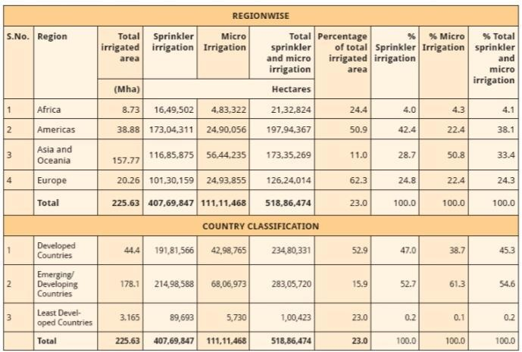As per International Commission on Irrigation and Drainage, Annual Report 2014-15 , world-wide, the area equipped for irrigation is about 318 million hectare, while the actual irrigated area is about 300 million ha.

# **Indian Scenario:**

* The history of irrigation and it’s development in India can be traced back to prehistoric times. Irrigation is also defined in Vedas and Indian scriptures.
* There are many civilisations flourished on the bank of rivers and harnessed the water for sustenance of life.
* In the ancient time irrigation can be possible through wells, canals, tanks and dams which were beneficial to the community.
* Irrigation Projects in India are classified into three categories viz. Major, Medium and Minor Irrigation.
* Projects which have a Cultivable Command Area of more than 10,000 hectare are termed as Major Projects, those which have a CCA of less than 10,000 hectare but more than 2,000 hectare are termed as Medium projects and those Irrigation Projects which have a CCA of 2,000 hectare or less are known as Minor projects.

# **Types of Irrigation Technique:**

In general, the goal is to supply the entire field uniformly with water, so that each plant has the amount of water it needs, neither too much nor too little. The various irrigation techniques are as under:

## Surface irrigation:

* + When the water is distributed or supplied over the soil surface by gravity is known as the surface irrigation.
  + It is the most common irrigation technique which is used by most of the farmers in their field. It is also known as Flood irrigation.
  + **Advantages**: They have relatively low energy requirements in routine operations. This type of irrigation technique can be developed at the farm level with minimum investment.

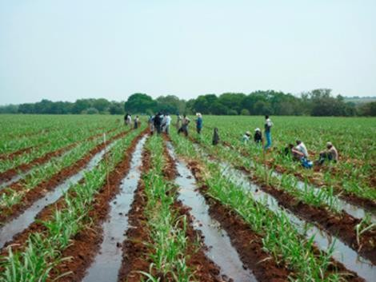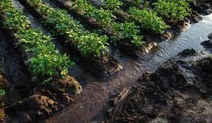

|  |  |
| --- | --- |
| **a). Border irrigation**   * + The land is divided into number of long parallel strips called borders.   + These borders are separated by low ridges.   + The border strip has a uniform gentle slope in the direction of irrigation.   + Each strip is irrigated independently by turning the water in the upper end.   + The water spreads and flows down the strip in a sheet confined by the border ridges. | BIr |

**b).Check basin irrigation**

* + It is the most common method.
  + Here the field is divided into smaller unit areas so that each has a nearly level surface.
  + Bunds or ridges are constructed around the area forming basins within which the irrigation water can be controlled.
  + The water applied to a desired depth can be retained until it infiltrates into the soil.
  + 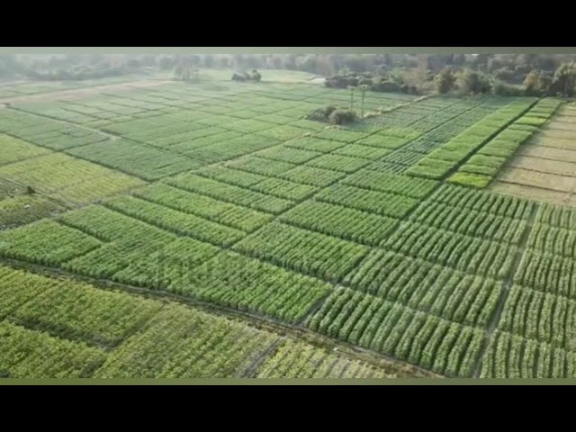 The size of the basin varies from 10m2 to 25 m2 depending upon soil type , topography, stream size and crop.

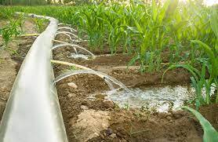**C). Furrow irrigation**

* + Used in the irrigation of row crops.
  + The furrows are formed between crop rows.
  + The dimension of furrows depend on the crop grown,  
     equipment used and soil type.
  + Water is applied by small running streams in furrows   
    between the crop rows.
  + Water infiltrates into soil and spreads laterally to wet the area between the furrows.
  + In heavy soils furrows can be used to dispose the excess water.

## Subsurface irrigation/Subsoil Irrigation:

* + Water gradually wets the root zone by capillary movement through subterranean perforated pipes and deep ditches at 15-30 m intervals.

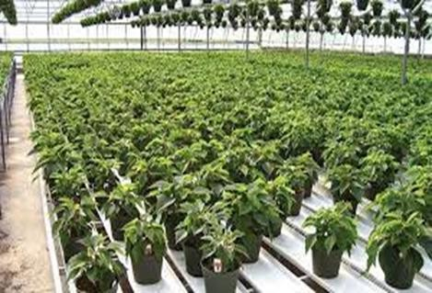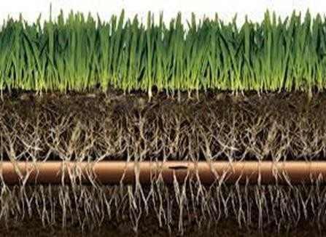

## Sprinkler irrigation:

* + Sprinkler irrigation is also known as the Overhead irrigation. Application of irrigation water is similar to natural rainfall.
  + Water is sprayed into the air through sprinklers. This type of irrigation system is mostly suitable for the row, field and tree crops.
  + **Advantages :** Water is applied in a consistent manner. Water savings ranging from 25% to 50% for various crops.There is no risk of runoff or erosion.

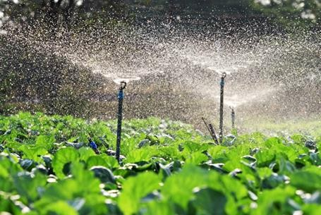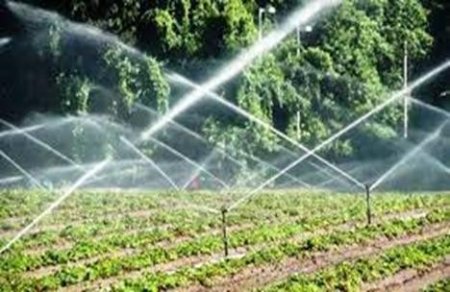

## Drip irrigation:

* + Simcha Blass discovered drip irrigation in Israel, and the water flow rate per dripper is typically 1-4 lit/hr & the water diffuses through the soil due to capillary action.
  + The main pipeline, submains, laterals, and emitters are all part of it. Drip irrigation is also known as Trickle irrigation.
  + **Advantages**: No land levelling is required. It can save up to 70% of water and even more. Herbicides and fertilizers are applied to the crop by solublising into the irrigation water.

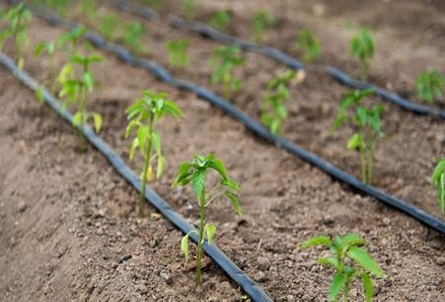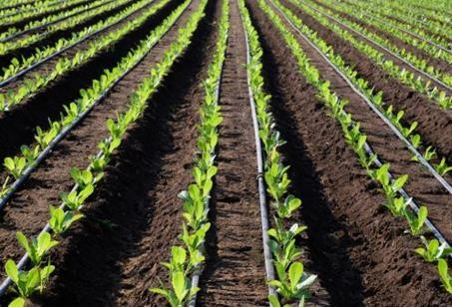

# **Sources of Irrigation:**

* + Various sources of irrigation in India are canals, tanks , tube wells and other wells, with tube wells and canals together accounting for about 70 % of total irrigation.
  + Compared to 2001-02, irrigation during 2012-13, through tube wells has increased by about 31% whereas that through tanks has declined by about 20%.There has been 16 % increase in net irrigated area during the period.
  + Irrigation through canals hah increased by meager 3 % . Private canals accounted for only 1 % share as most of the canals are government owned.
  + Among major states, canal irrigation is more popular in Tamil Nadu, Kerala , J& K and Chhattisgarh over irrigation through Tube Wells.
  + Whereas in Northern states of Punjab, Rajasthan, Bihar , UP etc share of tube wells in irrigation is significantly higher.

# **Irrigated Area Under Crops (2011-12) :**

* + There has been about 18% increase in total gross area under irrigation since 2001-02 with about 92.6 million hectares being irrigated in 2012-13 compared to about 78. million hectares in 2001-02.
  + During the period, Food crops have accounted for about 82-84 % of gross irrigated area under all crops.
  + Amongst about 18% gross irrigated area under non food crops, oilseeds, cotton and fodder crops accounted for 8-9 % , 3-4 % and 3 % respectively.

# **Conclusion:**

* In India, groundwater has become dominant source of Irrigation. On the other hand, there is large gap between the ultimate and utilized surface water potential. With continual diminishing per capital water availability coupled with groundwater exploitation, it has become imperative to switch to efficient water saving technologies and alternative source of irrigation like canal water, rainwater harvesting.
* Rapid depletion of water table, low irrigation efficiency, and frequent droughts indicate towards water crisis in near future if existing water use pattern is not rectified. Irrigation infrastructure needs to be further improved to harvest rainwater and increase storage capacity in order to utilize runoff water. Micro irrigation has scope for improving irrigation efficiency up to 90 per cent.
* Further, micro irrigation and optimum crop plan will play decisive role in conservation of water resources and food security of the nation.
* Virtual water trade should be balanced instead of orienting it towards export. Farmers should be made aware of the various government schemes to utilize their utmost potential which is lacking in some states.

**References:**

* Central Water Commission (CWC) 2017. Reassessment of Water Availability in India Using Space Inputs. Basin
* Dhawan, B. D. 2002. Technological change in Indian irrigated agriculture: A study of water saving methods. Commonwealth Publishers, New Delhi.
* Central Groundwater Board (CGWB) 2017. Dynamic Ground water resources of India, Ministry of Water Resources. River Development and Ganga Rejuvenation Government of India, Faridabad.
* Central Water Commission (CWC) 2015. Water and related statistics. Directorate of Information System Organisation, water planning and projects wing Report, New Delhi.