Fuel Cell Technology: Driving Towards a Greener Future.

Soumen Maity
UG Chemistry (Hons) final year student
Department of Chemistry
Vijaygarh Jyotish Ray College
8, 2, Jadavpur Central Rd, Bijoygarh, Jadavpur, Kolkata 700032
West Bengal
India

Abstract
Fuel cell technology has emerged as a promising alternative energy source due to its high efficiency, low emissions, and potential for diverse applications. This review paper explores the latest developments in fuel cell technology, categorizing various types based on electrolyte, operating temperature, and electrical efficiency. It discusses fuel cell setups, competing technologies, and ongoing research efforts. Additionally, the paper outlines fuel cell applications in stationary, portable, and transport sectors, highlighting their potential to revolutionize clean energy solutions.

Keywords
Fuel cell, AFC (Alkaline fuel cell), PEMFC (Proton exchange membrane fuel cell), DMFC (Direct methanol fuel cell), PAFC (Phosphoric acid fuel cell), MCFC (Molten carbonate fuel cell), SOFC (Solid oxide fuel cell), Anode, Cathode, Electrolyte, Stationary, Portable.

1. Introduction
One of the most difficult issues that must be forcefully addressed in the present is the dependency on fossil fuels. This is due to the fact that using them is not environmentally friendly and causes severe problems including air pollution and global warming. Development and economic security are impacted by this issue. It is very likely that there will be a fossil fuel substitute that is also more efficient, sustainable, and environmentally benign. One of the most promising technological developments to address the issue among all the various renewable energy-related technologies is fuel cell technology. The general opinion is that fuel cells are an environmentally friendly, quiet, and efficient device that can generate power and heat from fossil fuels, biofuels, and hydrogen created from renewable energy sources like wind and solar energy. The main hurdles preventing commercial introduction still are too high cost, lack of durability, too high system complexity and a lack of fuel infrastructure. Renewable energy usage is already rising. Around 140 GW of the 300 GW of new energy production capacity that was produced globally between 2008 and 2009 was powered by renewable sources. In 2005, 16.5% of the world's primary energy came from renewable sources. Within four decades, renewable energy sources might offer about 80% of the world's energy, according to the special report on renewable energy sources and mitigating climate change [1,2]. One of the most promising technologies that can be created in connection with the growing supply of renewable energy is fuel cell technology. According to [3,4], fuel cell technology is progressively developing into a viable alternative to traditional internal combustion engine generators and batteries.

2. Fuel cell and its principle
An electrolyte and two electrodes make up the basic components of each fuel cell. A fuel, like as hydrogen, is oxidized at the negative anode, while oxygen is reduced at the positive cathode. From one side to the other, ions are moved via the electrolyte. The operating temperature range depends on the type of electrolyte. The catalyst that may be utilized and the fuel's purity are both determined by this window of operation. A hydrogen-oxygen fuel cell's voltage in open circuit is 1.23 V at 298 K. The cell voltage varies between 0.5 and 1 V when under load.
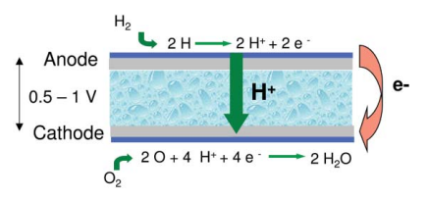

Fig. 1 Basic structure of a fuel cell

3. Different types of fuel cell
Six types of fuel cells have evolved in the past decades. They are-
3.1 Alkaline fuel cell, AFC
The AFC uses liquid potassium hydroxide as its electrolyte. The temperature is typically around 80 °C, although it can reach 200 °C. The AFC is now employed by spacecraft to generate electricity. Because basically only pure hydrogen can be utilised as fuel, the use of AFCs is constrained. The AFC has a power density of about 0.1 and 0.3 W cm⁻². In the kW range, alkaline fuel cells are very accessible [8].
3.2 Proton exchange membrane fuel cell, PEMFC
The PEMFC uses a cation-exchange membrane as its electrolyte. About 80 °C is the working temperature. Cold starts are feasible below 0 °C. The PEMFC is the preferred fuel cell for use in transportation applications. Additionally, PEM fuel cells are being developed for stationary applications. The PEMFC is sensitive to fuel contaminants. The PEMFC has a power density that falls between 0.35 to 0.7 W cm⁻². PEM fuel cells in the 1 W to 250 kW range are currently being developed [8].
3.3 Direct methanol fuel cell, DMFC
A version of the PEMFC that makes use of the same electrolyte is the direct methanol fuel cell. Methanol in water is directly oxidized to CO2 as a fuel. The DMFC's power density is significantly lower than the PEMFC's. At cell voltages as low as 0.2-0.3 V, maximum power densities of 0.25 W cm⁻² are achieved [5] [6]. High noble metal loadings, at least 1.2 mg cm⁻², are used in comparison to the PEMFC. The DMFC is being developed primarily for 1-100 W portable applications. Micro fuel cell technologies could potentially replace batteries due to the high energy density of methanol [8].
3.4 Phosphoric acid fuel cell, PAFC
The PAFC uses liquid phosphoric acid as its electrolyte. The temperature is about 200 °C when it is working. Reformate with CO concentrations of up to 1-2% can be used in the PAFC. In 2003, 245 of the 200 kW systems for the fuel cell with the greatest commercial success to date were already in place. The PAFC has a power density of around 0.14 W cm⁻² [7].
3.5 Molten carbonate fuel cell, MCFC
The electrolyte in the MCFC is a molten mixture of lithium, sodium, and potassium carbonate. In operation, the temperature ranges from 600 to 700 °C. The possibility of internal reformation of hydrocarbon fuels is made possible by the high working temperature. The MCFC has a power density in the region of 0.1-0.12 W cm⁻². MCFC systems have a power range of 50 kW to 5 MW [8].
3.6 Solid oxide fuel cell, SOFC
In the SOFC, yttrium stabilised zirconia is typically utilised as the solid electrolyte. The SOFC can run between 600 °C and 1000 °C depending on the electrolyte and the material composition of the electrodes. Fuels ranging from hydrogen to higher hydrocarbons and natural gas can be employed. The SOFC is primarily being developed for stationary power production systems with capacities between 1 kW and 5 MW. However, it is also regarded as a significant choice for 5-kW or less auxiliary power units installed inside of automobiles. The SOFC's power density ranges from 0.15 to 0.7 W cm⁻² [8].
However, there are currently several fuel cell models on the market. The substance of the electrolyte determines how fuel cells are traditionally categorised. Operating temperatures, electrical efficiency, and usual uses vary amongst them. The key distinctions between the most popular fuel cell types on the market are shown in Table 1.
Table 1- Fuel cell types according to electrolyte [9]

Fuel cell type | Typical electrolyte | Typical anode and cathode catalyst | Operation temperature (°C) | Electrical efficiency (%)
Low-temperature proton exchange membrane | Solid Nafion | Anode: Platinum supported on carbon.  Cathode: Platinum supported on carbon. | 60-80 | 40-60
High-temperature proton exchange membrane | Solid composite Nafion, Polybenzimidaz-ole doped in phosphoric acid | Anode: Platinum-Ruthenium supported on carbon  Cathode: Platinum-Ruthenium supported on carbon | 110-180 | 50-60
Solid oxide | Solid yttria-stabilized zirconia (YSZ) | Anode: Nickel-YSZ composite  Cathode: Strontium-doped lanthanum magnetite (LSM) | 800-1000 | 55-65
Molten Carbonate | Liquid alkali carbonate (LiCO₃, Na₂CO₃, K₂CO₃) in Lithium aluminate (LiAlO₂) | Anode: Nickel Chromium (NiCr)  Cathode: Lithiated Nickel oxide (NiO) | 600-700 | 55-65
Phosphoric acid | Concentrated liquid phosphoric acid (H₃PO₄) in Silicon carbide (SiC) | Anode: Platinum supported on carbon  Cathode: Platinum supported on carbon | 160-200 | 36-45
Alkaline | Potassium hydroxide (KOH) water solution,  Anion exchange membrane | Anode: Nickel  Cathode: Silver supported on carbon | 80-200 | 60-70
Direct methanol | Solid Nafion | Anode: Platinum-Ruthenium supported on carbon  Cathode: Platinum supported on carbon | Ambient-110 | 36-60
Direct ethanol | Solid Nafion, Alkaline media, Alkaline-acid media | Anode: Platinum-Ruthenium supported on carbon  Cathode: Platinum supported on carbon | Ambient-120 | 20-40
Direct ethyele glycol | Solid Nafion,  Anion exchange membrane (AEM) | Anode: Platinum supported on carbon  Cathode: Platinum supported on carbon | Ambient-130 | 20-40
Microbial | Ion exchange membrane | Anode: Biocatalyst supported on carbon  Cathode: Platinum supported on carbon | 20-60 | 15-65
Enzymatic | Membrane-less, Ion exchange membrane | Anode: Biocatalyst supported on carbon  Cathode: Biocatalyst supported on carbon | 20-40 | 30
Direct carbon | Solid yttria-stabilized zirconia (YSZ), Molten carbonate,Molten hydroxide | Anode: Graphite or carbon-based material  Cathode: Strontium-doped lanthanum magnetite (LSM) | 600-1000 | 70-90
Direct Borohydride | Solid Nafion,  Anion exchange membrane (AEM) | Anode: Gold, silver, nickel or platinum supported on carbon  Cathode: Platinum supported on carbon | 20-85 | 40-50
Direct formic acid | Solid Nafion | Anode: Palladium or platinum supported on carbon  Cathode: Platinum supported on carbon | 30-60 | 30-50

4. Fuel cell setup: from single cell to systems
Single cell. The electrolyte performs dual roles as an electrical insulator and gas separator in addition to transmitting ions from one electrode to the next. The locations of the electrochemical reactions are the electrodes. Along with having the appropriate catalysts, the electrode architecture should be such that the reactants and products are transported to and from the catalyst-electrolyte interface as quickly as feasible. The power is generated by a single fuel cell, as shown in Fig. 2, as a function of the cell's area, current density, and voltage. For practical applications, the usual cell voltage under load circumstances is just 0.7 V [8].

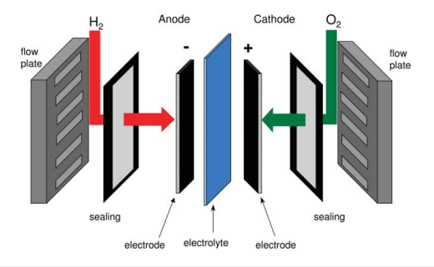

Fig. 2 Fuel cell components of a single cell

Stacks. As a result, connecting several cells in series to create a fuel cell stack is a popular practice. Two adjacent cells are connected by flow plates. These flow plates should have a high electronic conductance and function as a gas separator between the two neighboring cells. They are also known as separator plates or bipolar plates when a single plate is utilized for the anode side of one cell and the cathode side of the other cell. On the cell side of the flow plates are flow patterns that produce an even distribution of reactants throughout the cell area. On the underside, heat is transferred to a system heat exchanger by cooling liquid flow patterns. The stack power and voltage are obtained by the number of cells × the individual cell power and voltage. A three-cell stack is schematically drawn in Fig. 3. [8]

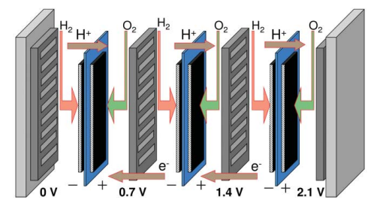

Fig. 3 Schematic, simplified overview of a fuel cell stack.

Systems. Although the fuel cell is the core of any fuel cell system, it does require a number of other parts in order for it to function and complete its task in the application. A typical fuel cell setup is shown schematically and simply in Fig. 4. The components other than the fuel cell stack and the fuel processor are often called balance of plant components. These balance of plant components play a significant role in terms of system cost, system efficiency, and system durability.
Except for the DMFC, hydrogen is oxidised to protons at the anode in low temperature fuel cells. The hydrogen can either be created from another fuel in a device known as a fuel processor or supplied from a hydrogen storage container. Alcohols or hydrocarbons are typically employed as fuels to supply fuel processors. The primary fuel and the kind of fuel cell have a significant impact on how difficult the fuel processing is. Fuel processing may be done inside of high temperature fuel cells like the MCFC and SOFC. Internal reforming is the term used to describe this process.

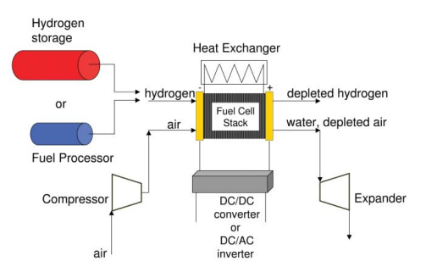

Fig. 4 A simplified overview of a fuel cell system.

The air pressure must be increased from the surrounding pressure to a level that relies on the operation pressure and the overall system's pressure decrease. This might be as little as 100 mbar gauge pressure or as high as several bars. With rising pressure, the fuel cell stack's power typically rises.
The product of the individual cell voltage, which is generally 0.6–0.7 V DC, and the number of cells determines the voltage of the fuel cell stack. Typically, AC power is required for stationary applications, which necessitates the use of a DC/AC inverter [8].

5. Competing technologies
Photovoltaic panels, thermal solar power plants, waste incineration, gas turbines, diesel engines, gas engines, Rankin cycles, combined Rankin-Brayton cycles, nuclear power plants, wind turbines and hydropower facilities are all compared in Fig. 5 [8]. Fuel cells have one of the highest energy efficiencies among these technologies. Fuel cells have advantages in the portable sector, high efficiencies and capacity factors in the stationary sector, and high efficiencies and fuel flexibilities in the transportation sector.
Fuel cells offer better theoretical and actual efficiencies and emit few to no emissions. Heat engines, on the other hand, contribute significantly to global pollution and are limited by the Carnot efficiency between their low and high working temperatures. Heat engines contain numerous dynamic components that cause noise and vibrations, restricting their applicability, whereas fuel cell stacks are static devices with no noise or vibration.
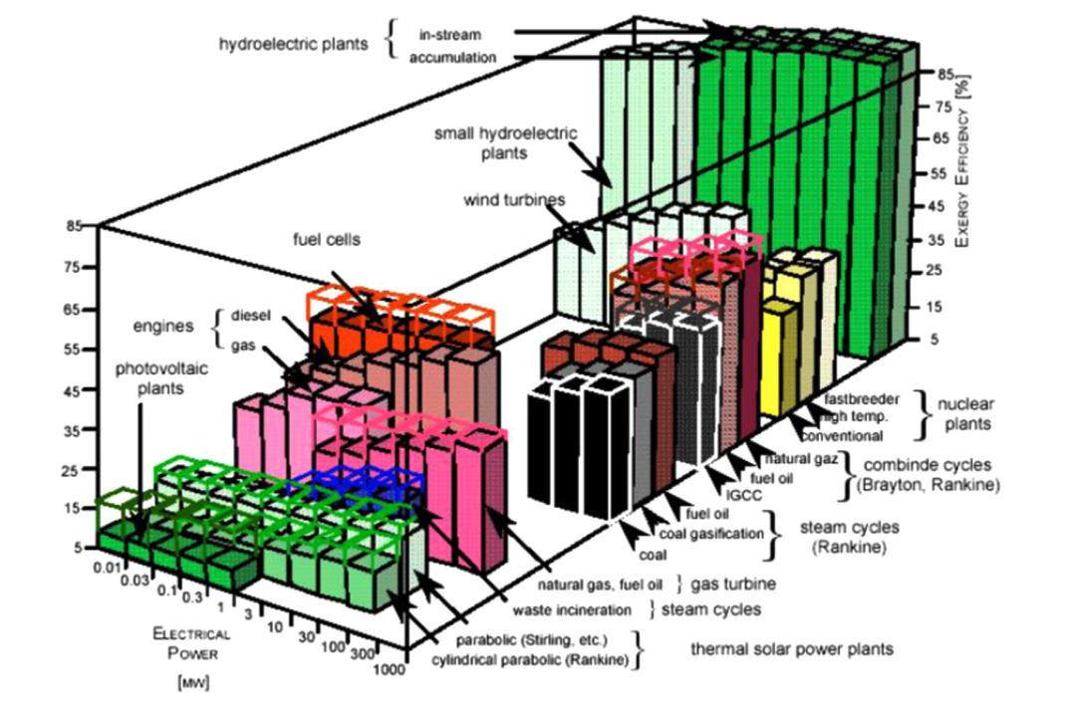

Fig. 5 Energy efficiencies of main energy conversion devices. [10]

A hydrogen-based fluid and atmospheric air are commonly used as the fuel and oxidant in fuel cells and heat engines, respectively. However, heat engines use combustion to mix the fuel and oxidant, whereas fuel cells combine the two substances electrochemically. Additionally, fuel cells immediately convert chemical energy into electrical work. In contrast, the production of electricity by heat engines entails a multi-step process that includes combustion in order to create thermal energy from the internal chemical energy of the fuel. Next, this thermal energy is transformed into mechanical energy, and eventually, using a generator, this mechanical energy is transformed into electrical energy. A device's total system efficiency often falls as the number of energy conversion processes grows in the device. Batteries and fuel cells both employ internal oxidation-reduction processes to convert a fuel's chemical energy to direct current (DC) power. However, the two energy devices have very different electrode compositions and functions. In contrast to fuel cells, which employ reactants that are supplied from a separate storage device, batteries use chemical energy stored in their electrodes to power electrochemical processes.
Technical problems with rechargeable batteries, such as their limited capacity for power storage and retrieval, depth of charge, and number of charge/discharge cycles, restrict their use. In contrast, fuel cells do not suffer from leakage or corrosion of cell components when not in use, unlike batteries.
In summary, fuel cells, heat engines, and batteries are all electrochemical devices that have their advantages and disadvantages. Developing more efficient and cost-effective energy generation alternatives is crucial for achieving sustainable and sustainable energy solutions.

Table 2- Technoeconomic comparison between fuel cells and their competitors. [11]

Technology | Efficiency (%) | Lifetime (Years) | Capital cost ($/kW)
Phosphoric acid fuel cell | 30-45 | 5-20 | 1500
MCFC/ gas turbine hybrid | 55-65 | 5-20 | 1000
SOFC/ gas turbine hybrid | 55-65 | 5-20 | 1000
Steam cycle (coal) | 33-40 | >20 | 1300-2000
Gas turbine cycle (natural gas) | 30-40 | >20 | 500-800
Microturbine | 15-30 | 5-10 | 800-1500
Nuclear | 32 | >20 | 1500-2500
Hydroelectric | 65-90 | >40 | 1500-3500
Wind turbine | 20-50 | 20 | 1000-3000
Geothermal | 5-20 | >20 | 700-1500
Solar photovoltaic | 10-15 | 15-25 | 2000-4000

6. Current and future research and development
6.1 Current status: In the last ten years, the fuel cell industry has achieved many key milestones. Customised fuel cells for electric cars became 83% less expensive between 2002 and 2012, falling from $275/kW to $47KW [12]. This reduction was primarily due to the decrease in platinum group metals (PGM) loading in PEM stacks, which has decreased by two orders of magnitude since the 1960s [13]. Between 2002 and 2012, the fuel cell industry had the most patents issued across a range of alternative energy industries, with 44% of these patents coming to US inventors. This was followed by 33% from Japan, 7% from Korea, and 6% from Germany [12]. Over 60% of these patents were acquired by General Motors, Honda, Toyota, Samsung, and UTC Power. The number of patents granted reflects the level of industrial research in renewable sectors.

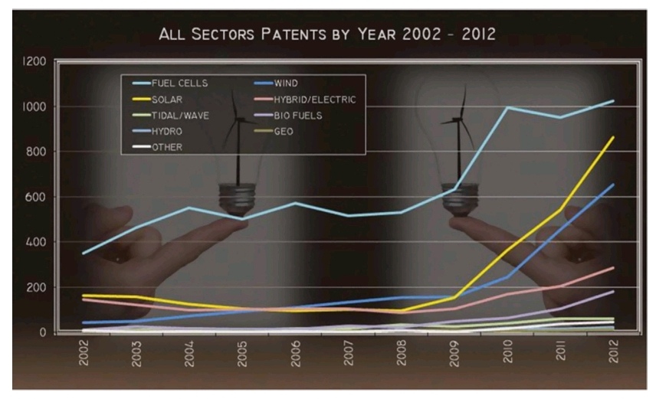

Fig. 5 Patents granted in the alternative energy sector between 2002 and 2012 [14]

6.2 Future targets: The fuel cell industry faces significant challenges in achieving widespread commercialization. Advancements in fuel cell technology are crucial for hydrogen production, storage, and delivery. To lower prices and improve fuel cell durability, fundamental advancements in material engineering, nanotechnology, transport phenomena, electrocatalysts, stack engineering, measurement technologies, molecular process modelling, auxiliary component development, and multi-phase science are required. Understanding liquid water formulation and interactions can improve water balance and avoid flow misdistribution, enhancing fuel cell performance and efficiency [15]. Key limitations call for R&D focus from both industrial and academic communities include:
a) Creating electrolyte materials with stable conductivity across a wide range of humidity and temperature.
b) Reducing or eliminating catalyst PGM loading.
c) Increasing the tolerance for catalyst and membrane contaminants.
d) Analysing the stability of the membrane and catalyst with voltage and humidity cycling.
f) Creating noise- and cost-reducing air management solutions.
f) Improving and simplifying fuel reformation procedures.
g) Producing updated progress reports and cost evaluations for specialist markets.

7. Application of fuel cell in the stationary, portable fields, and transportation.
Applications for fuel cells were noted as having different characteristics, such as high-power reliability (telecommunication, high-tech manufacturing facilities, data processing, and call centers), emission minimization or elimination (urban areas, industrial facilities, airports, and vehicles), areas with limited access to the utility grid (portable applications, remote areas), and applications for biological waste gases management. However, this section reviews fixed and portable fuel cell applications [16].

7.1 Fuel cell application in portable sector
The portable power production market is driven by the increasing demand for quality, density, and time performance in power supply. Fuel cells offer energy density, durability, simple design, and low cost, making them suitable for portable applications. They are primarily used in outdoor personal uses, commercial applications, and emergency relief efforts. Fuel cells also help preserve the environment and reduce noise. The second market is consumer electronic devices, with fuel cells being potential candidates for portable personal electronics.
They can provide power for communication switching nodes, transmission towers, and reception systems. Portable battery chargers, miniature demonstration vehicles, and educational kits are also growing. Due to their silent operation, high power, and light weight, portable DMFCs and PEMFCs are preferred power systems for portable electronic equipment in the military. The issue with big PEM fuel cells (>2kW), however, is that they require hydrogen fuel to run, despite the fact that hydrogen should be produced from already-available logistic fuels [17, 18, 19].
2012 held great potential for portable fuel cells. It should be noted that compared to 2011, there was still a 174% rise in fuel cell shipments. Unit shipments in 2013 were almost 13,000 less than in 2012. However, the portable fuel cell market saw a significant increase in shipments from 2013 to 2014, with several manufacturers reporting annual sales in the 10,000-unit level.
Table 3- Power Demand for portable devices that may require fuel cell. [20]

Devices | Power required (W)
Cellular phone, Digital camera | 1
Notebook personal computer | 20-30
Flashlight and toys | 1-10
PlayStation portable (PSP) | 2
Robot | 10-15

7.2 Fuel cell application in stationary sector
Stationary fuel cells, including PEMFC, SOFCs, MCFCs, AFCs, and PAFCs, can be used in power plants for various applications [19]. Low-temperature fuel cells are faster during start-up, while high-temperature systems produce heat for other applications and operate directly on fuels [21]. They can serve as primary power sources, remote area power supplies, hybrid power systems, distributed power, or emergency backups. And we can divide the stationary sector into two parts. One is large stationary power plants (power output from 300 kW up to 20 MW), and the other is small-medium power plants (power output from a few watts up to 10 kW for small stationary power plants and from 10 kW up to 300 kW for medium stationary power plants).

7.2.1 Large stationary power plants: Fuel cells can aid in the transition from massively centralized to decentralized distributed energy production. Both on a household-by-household basis and on a basis of larger residential blocks, they can be utilized for domestic electric power or CHP distributed generation. Although they function at low temperatures of between 100 and 200 degrees Celsius, proton exchange membrane fuel cells (PEMFC) and phosphoric acid fuel cells (PAFC) are frequently employed for CHP applications. For bigger residential block-based CHP generation, high-temperature fuel cells are a better option. The architecture of fuel cell CHP generating systems can be either grid-dependent or grid-assisted.
As the system must accommodate dynamic load fluctuations in the first scenario, it is more difficult and expensive. However, the issue may be resolved by increasing the fuel cell system appropriately and combining it with battery banks or ultracapacitors. When load demand is low, grid-assisted systems export power to the grid; when load demand is high, they import electricity. [22]
7.2.2 Medium and small stationary power plants: Medium-small power plants (MSPs) are designed for supplying electric power and heat to various structures, including cottages, administrative buildings, and hospitals. These fuel cell-based power plants are excellent for generating electricity, co-generation, and other industrial and commercial uses. They can function as an onsite or continuous power backup and provide premium grade power from independent power sources. The electric power system (EPS) industry, requiring for high reliability but not necessarily large operating lifetimes, favors PEMFCs and DMFCs as the predominant fuel cell types. A 1-kW combined heat and power (CHP) generating plant was created by the Japanese firm "Ebara Ballard". According to Japanese government requirements, the device was made for use for ten years. The Japanese business "Fuji electric" created a comparable device that is likewise intended for a 10-year functioning lifespan. These items cost between $12,000 and $16,000 [23].
In remote-area power supply (RAPS) applications, where electricity may be required in grid-isolated places like islands, deserts, woods, and remote technical services, small power units are especially crucial. In an Australian initiative, hydrogen is produced by electrolysis using wind energy and used in low-power fuel cell units to provide heat and electricity at the Antarctic base on "Bechervaise" Island. The Australian government provided a grant of $600000 for this project [23].
The limited availability of fossil fuels is making renewable energy sources like wind and solar power promising alternatives due to their environmental impact. Energy storage mediums must be explored to ensure production can continue during unforeseen occurrences. Combining energy storage systems with renewable energy sources through an electrolyser is considered a sustainable process for producing and exploitation of renewable energies.
Standard fuel cell systems have been championed by several developed countries, including the USA, Canada, Japan, South Korea, and Europe. Companies like Fuel Cell Energy, “Accumentris”, “ClearEdge”, and “Bloom Energy” are known for producing stationary fuel cells. The progress of stationary applications has been fueled by government support and the rapid growth of installations of micro-e CHP units [24].

7.3 Fuel cell application in transportation sector
Since the transport sector is responsible for 17% of yearly worldwide greenhouse gas emissions, it plays a significant role in the development of clean energy technology. The industry is making investments in technology that promise considerable reductions in hazardous emissions and improved energy conversion efficiency in order to deal with this problem. Fuel cells, which offer near-zero emissions without compromising vehicle propulsion efficiency, have shown efficiencies that are almost twice those of conventional internal combustion engines. These fuel cells are an excellent potential replacement for existing combustion engines since they include features including static operation, fuel flexibility, modularity, and minimal maintenance needs. By 2025, Japan plans to have two million fuel cell electric cars (FCEVs) on the road and 1,000 hydrogen refuelling facilities [25, 26].

8. Conclusion
The way we generate and use energy might be completely changed by fuel cell technology. with the capacity to produce electricity via the chemical reaction of oxygen and hydrogen. An eco-friendly, dependable, and efficient replacement for conventional fossil fuel-based power generation is provided by fuel cells. Even if there are still issues to be solved, like lowering costs and enhancing durability, fuel cell technology has advanced considerably in recent years. Fuel cell technology offers a viable route to a more sustainable future as the globe looks for methods to decrease greenhouse gas emissions and tackle climate change.

References
[1] Alaswad A, Dassisti M, Prescott T, Olabi AG. Technologies and developments of third generation biofuel production. Renew Sustain Energy Rev 2015; 51:1446e60.
[2] Mitigation, C. C. (2011). IPCC special report on renewable energy sources and climate change mitigation. Renewable Energy, 20(11).
[3] Carter D, Wing J. The fuel cell Industry review 2013. 2013. FuelCellToday Johnson Matthey PLC.
[4] Baroutaji A, Carton J, Sajjia M, Olabi AG. Materials in PEM fuel cells. In: Reference module in material science and engineering, 2016; 2015.
[5] X. Ren, P. Zelenay, S. Thomas, J. Davey and S. Gottesfeld, J. Power Sources, 2000, 86, 111.
[6] H. Dohle, H. Schmitz, T. Bewer, J. Mergel and D. Stolten, J. Power Sources, 2002, 106, 313.
[7] R. D. Breault, in Handbook of Fuel Cells, ed. W. Vielstich, A. Lamm and H. A. Gasteiger, Wiley, Chichester, UK, 2003, vol. 4, ch. 59.
[8] de Bruijn, F. (2005). The current status of fuel cell technology for mobile and stationary applications. Green chemistry, 7(3), 132-150.
[9] Sharaf, O. Z., & Orhan, M. F. (2014). An overview of fuel cell technology: Fundamentals and applications. Renewable and sustainable energy reviews, 32, 810-853.
[10] von Spakovsky MR, Olsommer B. Fuel cell systems and system modeling and analysis perspectives for fuel cell development. Energy Convers Manage 2002; 43:1249–57.
[11] Srinivasan S. Fuel cells: from fundamentals to applications. New York: Springer; 2006.
[12] The Department of Energy hydrogen and fuel cells program plan: an integrated strategic plan for the research, development, and demonstration of hydrogen and fuel cell technologies. US Department of Energy; 2011.
[13] Spendelow J, Papageorgopoulos D. Platinum group metal loading in PEMFC stacks. US Department of Energy. Record#11013; 2011.
[14] Clean Energy Patent Growth Index 2012 Year in Review. Heslin Rothenberg Farley & Mesiti P.C. 〈http://cepgi.typepad.com/heslin_rothenberg_farley_/ 2013/03/clean-energy-patent-growth-index-2011-year-in-review.html〉.
[15] Wang Y, Chen KS, Mishler J, Cho SC, Adroher XC. A review of polymer electrolyte membrane fuel cells: technology, applications, and needs on fundamental research. Appl Energy 2011; 88:981–1007.
[16] Larminie James, Dicks Andrew. Fuel cell system Explained. 2nd ed. 2003.
[17] Cacciola G, Antonucci V, Freni S. Technology up date and new strategies on fuel cells. 2001.
[18] Mekhilef S, Saidur R, Safari A. Comparative study of different fuel cell technologies. 21 October 2011.
[19] Spiegel Coleen S. Designing & building fuel cells. 1st ed. 2007.
[20] Kundu PP, Dutta K. Hydrogen fuel cells for portable applications. Compend Hydrogen Energy 2016:111-31.
[21] Andu´ jar JM, Segura F. Fuel cells: history and updating. A walk along two centuries. 25th March 2009.
[22] Upreti Girish, Greene David L, Duleep KG, Sawhney Rapinder. Fuel cells for non-automotive uses: status and prospects. 16th February 2012.
[23] Bagotsky Vladimir S. Fuel cells: problems and solutions. 2009.
[24] Khaitan SK, Raju M. Int J Hydrogen Energy 2012;37:2344-52. [43] Lewis J. Stationary fuel cell. Insight into Commercialisation. Int J hydrogen energy 2014; 39:21896-901.
[25] Plunkett JW. Plunkett’s automobile industry almanac 2011. Houston, TX: Plunkett Research; 2010.
[26] The Department of Energy hydrogen and fuel cells program plan: an integrated strategic plan for the research, development, and demonstration of hydrogen and fuel cell technologies. US Department of Energy; 2011.

