IoT based keyboard for

physically challenged people

Mr. Krishna Mehar P Tirumala, Assistant Professor, Presidency University, Bengaluru

Mr. Riyazulla Rahaman J, Assistant Professor, Presidency University, Bengaluru
Abstract:

The Gesture-Based Keyboard project aims to revolutionize the way we interact with computers and devices by utilizing hand gestures as an alternative input method. This project combines the power of Raspberry Pi, a versatile microcontroller, and an IR sensor to enable intuitive and hands-free interaction. By capturing and interpreting hand movements, users can simulate keyboard inputs without physical key presses.
The hardware setup involves integrating the IR sensor module with the Raspberry Pi, ensuring secure connections and proper power supply. The sensor detects infrared signals reflected off hand movements, which are then processed and analyzed to recognize specific gestures.
On the software side, the project leverages various libraries and technologies. The RPi. GPIO library is used to interface with the Raspberry Pi's GPIO pins, while the input library enables the simulation of keyboard inputs. A Python script is developed to read the IR sensor's output, process the data, and detect gestures based on predefined thresholds or machine learning algorithms.
To achieve accurate gesture recognition, the project involves extensive calibration and testing. Calibration ensures optimal sensitivity, noise reduction, and adaptability to different lighting conditions. Additionally, debounce techniques are implemented to handle unintended multiple gestures and false detections.
The gesture-based keyboard system offers several advantages. It enhances accessibility for individuals with physical disabilities who may have difficulty using traditional keyboards. Moreover, it provides a hands-free input option, enabling users to interact with devices when their hands are occupied or when touch-based input is impractical.

Introduction:

The project utilizes Raspberry Pi, a single-board computer, as the core hardware component. It provides the necessary processing power, GPIO pins, and interfaces for connecting and controlling other hardware components.
The Raspberry Pi is a reasonably priced, credit-card-sized computer that connects to a computer monitor or television and makes use of a regular keyboard and mouse. The Raspberry Pi Foundation, a UK nonprofit with the mission of promoting computer literacy and facilitating access to computer science education, is the manufacturer of the Raspberry Pi line of single-board computers. With the help of this powerful small gadget, individuals of all ages may learn about computing and how to programme in languages like Scratch and Python. It has all the features of a desktop computer, including the ability to play high-definition video, browse the internet, create spreadsheets, word documents, and play games. IoT-based, widely utilised Raspberry Pi is used for real-time image/video processing.
Raspbian OS is officially provided by Raspberry Pi Foundation and is based on Debian. Additionally, they offer NOOBS OS for the Raspberry Pi. Many Third-Party OS versions, including Ubuntu, Archlinux, RISC OS, Windows 10 IOT Core, etc., are available for installation. The official operating system for Raspberry Pi is free to use. This operating system is effectively optimised for Raspberry Pi use. The Raspbian GUI has tools for office, games, office work, programming in Python, and browsing. The operating system should be stored on an SD card, with a minimum suggested storage size of 16 GB. Because it gives developers access to the on-chip hardware, or GPIOs, the Raspberry Pi is more than just a computer. We can connect things like LEDs, motors, sensors, etc. and operate them via accessing GPIO.
It has an on-chip GPU (Graphics Processing Unit) and a Broadcom Processor SoC with ARM support. The Raspberry Pi's CPU runs at speeds ranging from 700 MHz to 1.2 GHz. In addition, it includes 256 MB to 1 GB of SDRAM built right into the device. Additionally, the Raspberry Pi has on-chip SPI, I2C, I2S, and UART modules.
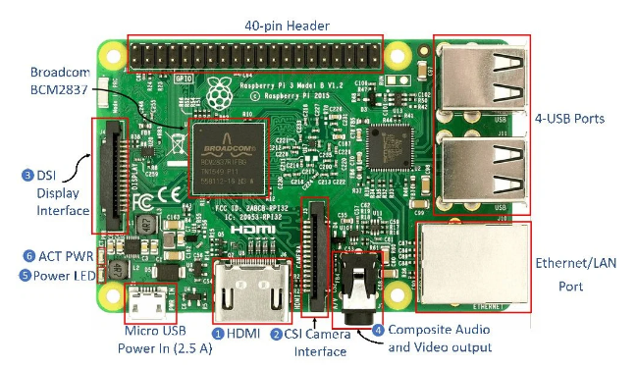
Fig 1. Raspberry Pi
- HDMI (High-Definition Multimedia Interface): It is used to send digital audio or video data without compression to devices like digital TVs and computer monitors. Typically, the HDMI port makes it easier to connect the Raspberry Pi to a digital television.
- CSI Camera Interface: The Broadcom Processor and Pi camera are connected via the CSI (Camera Serial Interface) interface. Two devices can connect electrically thanks to this interface.
- DSI Display Interface: Utilising a 15-pin ribbon wire, the LCD is connected to the Raspberry Pi utilising the DSI (Display Serial Interface) Display Interface. Fast High-resolution display interface is offered by DSI and is used primarily for delivering video data from the GPU directly to the LCD display.
- Composite Video and Audio Output: Video and audio signals are sent to audio/video systems via the composite video and audio output connection.
- Power LED: An LED that is used to indicate power is red in colour. If power is connected to the Raspberry Pi, this LED will turn ON. If the supply voltage falls below 4.63V while it is directly connected to 5V, the device will begin blinking.
- ACT PWR: Green LED on the ACT PWR indicates SD card activity..
The most fundamental and widely used sensor in electronics is the infrared (IR) sensor or IR Sensor Module. It is utilised in wireless technology for features like remote controlling and object detection. IR sensors typically comprise an Infrared (IR) LED and a Photodiode; collectively, these components are referred to as a "IR pair." A special purpose LED called an IR LED can emit infrared light with wavelengths between 700 nm and 1 mm. Our eyes cannot see these kinds of radiation. In contrast, an IR Receiver LED or photodiode detects infrared light. A radiation-sensitive optoelectronic component having spectral sensitivity in the infrared wavelength range of 780 nm to 50 m is known as an infrared sensor (IR sensor). Motion now frequently uses IR sensors.
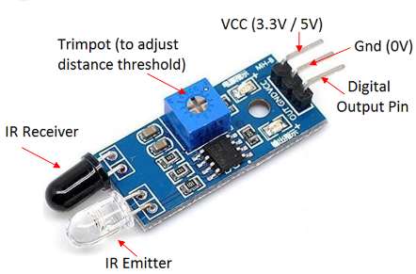
Fig 2. IR Sensor Module

Jumper wires are used to establish electrical connections between the IR sensor module and the Raspberry Pi's GPIO pins. A suitable power supply, such as a micro USB adapter, is required to power the Raspberry Pi.
A digital multimeter is a test instrument used to measure two or more electrical quantities, primarily resistance (ohms), voltage (volts), and current (amps). For technicians working in the electrical and electronic industries, it is a typical diagnostic tool. Analogue metres with needles have long since been supplanted by digital multimeters due to their enhanced impedance, increased accuracy, and reliability. The voltmeter, ammeter, and ohmmeter—single-task metres used to measure voltages, amps, and ohms—are all combined into digital multimeters. They frequently come with a number of extra specialised features or cutting-edge alternatives. Therefore, technicians with certain requirements might look for a model that is tailored to their requirements.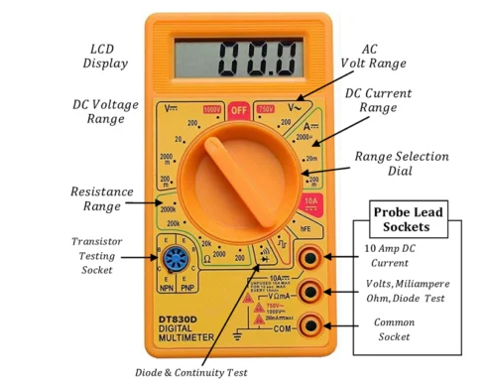
Fig 3. Digital Multimeter

Different Keyboards types:
The finest keyboard for you will rely on your needs and intended uses among the many different models that are now on the market. Additionally, your decision may be influenced by the keyboard layout you select, such as QWERTY or AZERTY. Making use of the countless alt code key keyboard shortcuts for creating symbols also benefits from having a longer keyboard with a separate number pad.
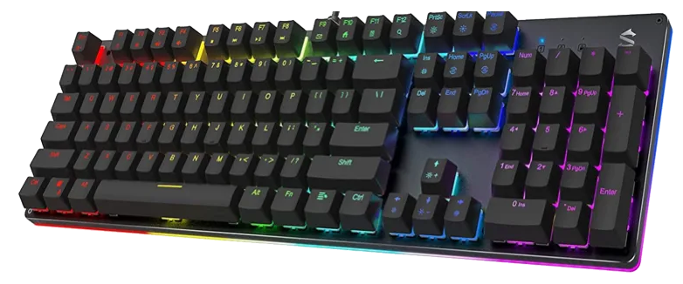  Mechanical Keyboard | 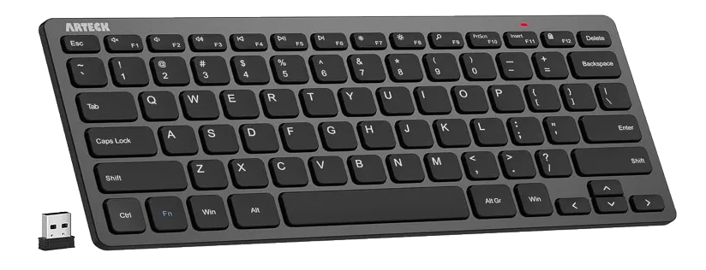  Bluetooth Wireless Keyboard | 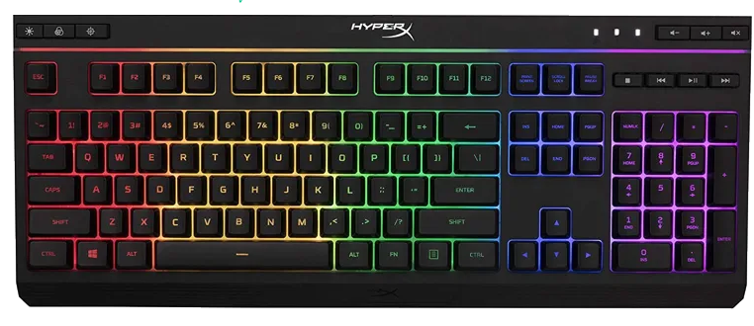  Membrane Keyboard
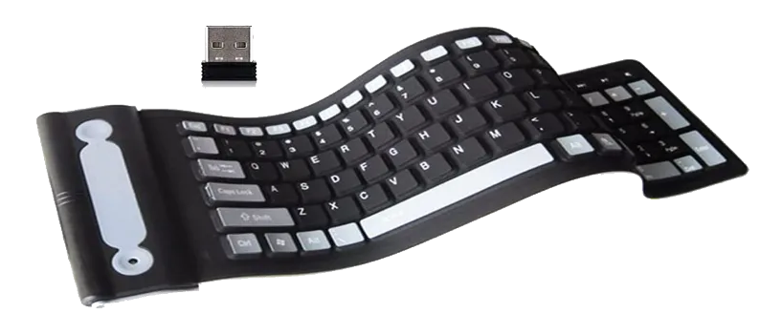  Flexible Foldable Keyboard | 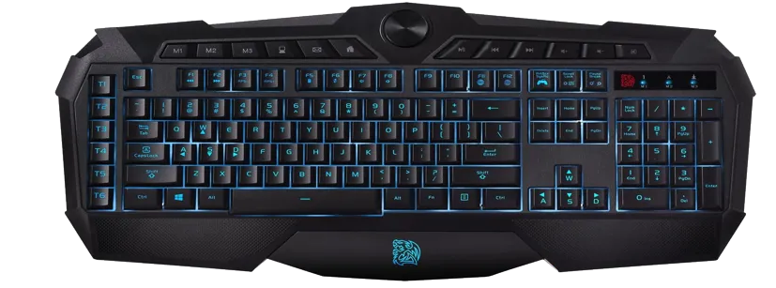  Multimedia Keyboard | 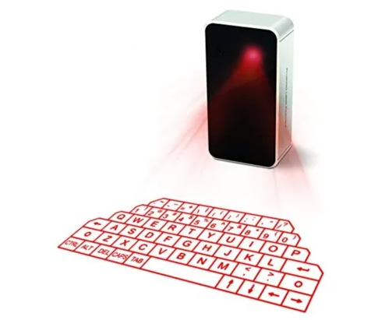  Projection Keyboard
Fig 4. Types of Keyboards
The main categories of computer keyboards are those that are described above. As was already noted, several keyboard models could fit into more than one category. A multimedia keyboard, for instance, could be mechanical or wireless. Additionally, there are specific gaming keyboards that fall under the mechanical or multimedia category.
Raspbian, a Debian-based operating system, is commonly used with Raspberry Pi. It provides a Linux environment and essential tools for development. The project is implemented using the Python programming language, which offers simplicity, flexibility, and a wide range of libraries and modules for sensor interfacing, data processing, and gesture recognition. The RPi.GPIO library is utilized to interface with the Raspberry Pi's GPIO pins. It provides functions for controlling and reading digital signals. The Uinput library enables the creation of a virtual input device that simulates keyboard inputs. It allows the Raspberry Pi to generate keyboard events based on detected gestures.
The hardware, software, and tools mentioned above provide a comprehensive setup for developing the gesture-based keyboard system using a Raspberry Pi and an IR sensor.

Block diagram & Description:

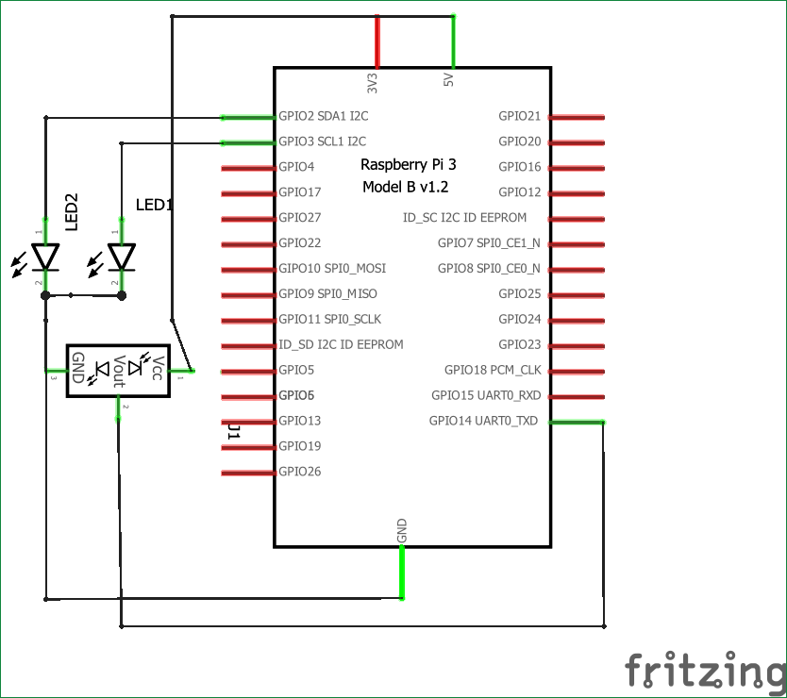
Fig 5. Block diagram
The block diagram illustrates the components and their interconnections in a gesture-based keyboard project using Raspberry Pi and an IR sensor. Here's a detailed description of each component:
Raspberry Pi serving as the central processing unit, the Raspberry Pi is the core component of the system. It provides the necessary computational power and GPIO pins for interfacing with external devices. The GPIO pins allow bidirectional communication between the Raspberry Pi and other hardware components.
The IR sensor plays a crucial role in capturing hand gestures. It emits and detects infrared signals, which are reflected off hand movements. The sensor converts the received signals into electrical data that can be interpreted by the Raspberry Pi.
The keyboard represents the output device in the system. It is connected to the Raspberry Pi and is responsible for emulating key presses based on the detected gestures. By simulating keyboard inputs, the system enables users to interact with a computer or device without physically pressing keys.
For many years, computers have been controlled by “touched” devices such as mouses, keyboards, and touchscreen displays. But today there is a growing trend for using touch-free gesture control.
As virtual and augmented reality technologies have recently gained popularity, hand gesture detection technology is also becoming more widely used. To recognise our hand motions and utilise them to control the Raspberry Pi media player, we'll use the MediaPipe Python module. Six hand gestures will be used in this instance, including the open and closed fist and the up, down, left, and right movements of the hand. The video can be played and paused using the open and closed fist movements. Left and right motions are used to fast-forward and reverse the video, while up and down gestures are used to increase and decrease volume.
A framework called MediaPipe is used to create multimodal, cross-platform (Android, iOS, web, edge devices), applied Machine Learning pipelines that combine quick ML inference, traditional computer vision, and media processing (such as video decoding). The prebuilt Python and other language packages that MediaPipe has made available include
- Object Detection
- Face Detection
- Hand Tracking
- Pose Estimation
- Multi-hand Tracking
- Hair Segmentation
PyPI offers the MediaPipe Python package for Linux, macOS, and Windows. To install MediaPipe on a Raspberry Pi 4, use the command line:
Using the command below, you can install it on Raspberry Pi 3 if you don't have Pi 4:
Interconnections:
Both the IR sensor and the keyboard are connected to the Raspberry Pi. The connections are made using the Raspberry Pi's GPIO pins.
The IR sensor is attached to the Raspberry Pi's GPIO pins, enabling signal transmission between the two parts. Through this link, the Raspberry Pi is able to receive information from the IR sensor and decipher the hand motions that were recorded.
The keyboard is also linked to the Raspberry Pi, enabling the system to generate simulated key presses based on the recognized gestures. The Raspberry Pi sends the appropriate signals to the keyboard, triggering the desired key inputs.
Through these interconnections, the system forms a closed loop, where the IR sensor captures hand gestures, the Raspberry Pi processes the data, and the keyboard emulates the corresponding keystrokes, providing a gesture-based input mechanism.
Results (Model’s image):

Fig 6. Gesture Keyboard
The final device/model of the gesture-based keyboard project is a compact and portable system that enables users to interact with a computer or device using hand gestures instead of physical key presses. It incorporates a Raspberry Pi, an IR sensor, and a keyboard emulation mechanism.

Fig 7. Hands moment

Fig 8. Result
The device consists of a Raspberry Pi board, housed in a protective case with appropriate openings for the GPIO pins, power supply, and peripheral connections. The IR sensor module is securely mounted on the device, typically positioned in a way that allows it to capture hand movements effectively.
The Raspberry Pi serves as the brain of the device, handling the processing of the captured gesture data. It communicates with the IR sensor through the GPIO pins, receiving the sensor's output signals. The Raspberry Pi runs the necessary software, including libraries for GPIO interfacing and gesture recognition algorithms.
To provide user feedback, the device incorporates LED indicators or a small display screen. These indicators can light up or display relevant information, such as successful gesture detection or system status.
During operation, users perform hand gestures within the sensor's range, and the IR sensor captures the movements. The Raspberry Pi processes the sensor data, recognizes specific gestures, and generates corresponding keyboard inputs. These simulated keystrokes are then sent to the connected computer or device, allowing users to control and interact with it.

Challenges faced:
- Hardware Integration: Integrating the IR sensor with the Raspberry Pi and ensuring proper connections can be a challenge, especially for beginners. Understanding the pin layout, voltage requirements, and wiring can require careful attention and troubleshooting.
- Sensor Calibration: Achieving accurate and consistent readings from the IR sensor may require calibration. Adjusting sensitivity, range, and threshold values may be necessary to optimize the sensor's performance and minimize false detections or missed gestures.
- Gesture Detection and Classification: Developing algorithms or models to detect and classify hand gestures based on sensor data can be complex. It may involve exploring different signal processing techniques, machine learning algorithms, or computer vision approaches. Balancing accuracy, speed, and robustness in gesture recognition can be challenging.
- Latency and Responsiveness: Achieving real-time performance and minimizing latency between gesture detection and simulated keystrokes is vital for a smooth user experience. Optimizing code execution, reducing computational overhead, and considering hardware acceleration options can help improve responsiveness.
- Documentation and Support: Documenting the project thoroughly, including setup instructions, code documentation, troubleshooting guides, and FAQs, is essential for others to replicate and understand the project. Providing adequate support channels, such as forums or online communities, can assist users in troubleshooting and addressing their queries.

Conclusion:

The final device/model represents a compact and portable solution, enabling users to control computers and devices with simple hand gestures. Its potential applications span across various domains, including accessibility, virtual reality, and smart home control.
Overall, the gesture-based keyboard project has proven to be a significant step towards advancing human-computer interaction. It offers a more natural and intuitive input method that has the potential to enhance user experiences, improve accessibility, and pave the way for future innovations in the field of human-machine interfaces. As technology continues to evolve, the gesture-based keyboard project sets the stage for further exploration and refinement, ultimately shaping the way we interact with technology in the years to come.

