Modular Construction Techniques: Revolutionizing the Future of Building

Shivanth.T  School of Engineering  Presidency University  Bangalore, India | Dr. Jagdish H Godihal  Prof.-CIV and Deputy Dean -Academic Research  School of Engineering  Presidency University  Bangalore, India

Abstract
Modular construction is an innovative building method that utilizes three-dimensional units manufactured off-site and assembled on-site. It explores the stability of light steel walls, thermal-shielding effects of module floors, fire barriers, and heat transfer limitations that contribute to overall fire resistance. Internal module walls and ceilings are constructed with fire-resistant plasterboard and mineral wool for acoustic purposes. The study emphasizes the significance of these fire resistance and acoustic insulation measures in modular construction. The study highlights these measures' significance in ensuring modular buildings' safety and comfort. This book review contributes to the advancement of modular construction by offering practical approaches for streamlining the design, manufacturing, and assembly processes. The integration of BIM and lean principles provide valuable insights for professionals in the construction industry seeking to enhance efficiency and productivity. Overall, the research underscores the benefits of modular construction and highlights its potential for future development through the integration of innovative technologies.
Keywords: Modular construction, Building Information Modeling (BIM), Lean Construction, Prefabricated Prefinished Volumetric Construction (PPVC), Scenario-Based Analysis (SBA), Integrated Process Improvement (IPI), Value Stream Map (VSM)

Introduction

Modular construction, also known as volumetric construction or modular building system, is a revolutionary method of construction that utilizes three-dimensional or modular units. These units are manufactured in a factory setting and then transported to the construction site for assembly. The process involves meticulous logistics and coordination to ensure seamless integration of the modular units. A key feature of modular construction is that the units are fully fitted out in the factory before being transported to the site. This means that the units come equipped with all necessary finishes, fixtures, and services such as plumbing and electrical systems. This level of preparation ensures that the on-site construction process is streamlined and efficient. [1]
Upon arrival at the construction site, the modular units are stacked onto prepared foundations to form the desired building structure. These units can be configured to create complete rooms, room partitions, or specialized units such as bathrooms or elevators. This flexibility allows for versatile design possibilities and efficient utilization of space.
Modular construction finds wide applications in various building types, including hotels, student residences, military accommodations, and social housing. It is particularly efficient for projects requiring a large number of identical units, such as multi-unit residential buildings as shown in Figure 1.
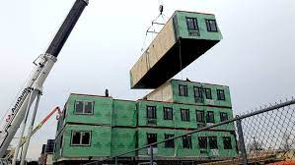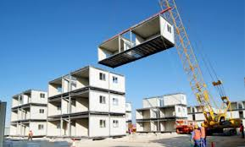 Fig.1: Modular Buildings
Modular units can be constructed using different materials, including heavy gauge steel, timber frames, concrete, and composites. Additionally, modular construction can be combined with panel systems to create hybrid or composite structures, further expanding design possibilities.
Modular construction offers a cost-effective, time-efficient, and sustainable alternative to traditional construction methods. Its speed, quality control, and environmental impact advantages make it a compelling option for many construction projects.
Prefabricated Prefinished Volumetric Construction (PPVC) is a specific type of modular construction where internal elements such as walls, floors, and ceilings are finished before assembly. PPVC provides benefits such as faster construction, increased productivity, and enhanced quality control. It has been widely adopted in various sectors, including residential, hotel, and hospital construction, over the past 20 years. [1]
PPVC modules can be categorized into two types based on load paths. Load-bearing wall modules are common in concrete buildings, where the walls transfer gravity loads to the foundation and resist lateral loads. Corner-supported modules, often made of steel or steel-concrete composite materials, transfer gravity loads to edge beams, columns, and foundations. Steel modules offer design flexibility and faster construction due to bolted connections, although they may require additional measures to address durability concerns such as corrosion and fire. Concrete modules are preferred for residential buildings due to their durability and ease of inspection. [2]
Despite the benefits of PPVC, its implementation in high-rise buildings is not yet widespread. Challenges such as structural design, joint flexibility, manufacturing tolerances, and construction tolerances affect overall building stability. Ensuring continuity in the beam-column frame and relying on lateral resisting systems become crucial for high-rise buildings. Efforts are underway to address these challenges and promote the use of modular construction in high-rise projects.
Researchers have extensively analyzed the use of modular systems in multi-story and high-rise buildings, highlighting their potential in terms of design standardization and repetition. Integration of innovative technologies, such as Building Information Modeling (BIM), 3D laser scanners, and robotic installations, has been discussed to enhance modular and industrial construction processes.
Comparative analyses have been conducted between different construction methods, such as panel and modular systems, to determine cost-effectiveness and implications for single-family homes. Other studies have focused on structural considerations, seismic influences, construction efficiency prediction, and alternative construction scenarios. [2]
In summary, modular construction offers numerous advantages over traditional methods, including speed, productivity, and quality control. Ongoing efforts are being made to overcome challenges and promote the use of modular construction, particularly in high-rise projects. Technological advancements and research contribute to the continuous improvement and adoption of modular construction in the industry.

Characteristics of Modular Buildings:

Standardized Three-Dimensional or Room Size Volumetric Units
- Standardization of modules in modular construction.
- Mass production of identical units in controlled factories.
- Stricter quality control and inspection protocols for superior construction quality.
- Reduction of waste through controlled factory production.
Sustainability and Waste Reduction
- Sustainable practices in modular construction.
- Minimization of environmental impact and waste generation.
- Reduction of on-site activity and disturbance.
- Promotion of sustainability through factory production and waste reduction.
Flexibility and Reuse of Volumetric Units
- Movable and flexible nature of modular buildings.
- Dismantling, refurbishment, and relocation of modules.
- Reduction in demand for raw materials and energy consumption.
- Consideration of transportation costs due to the size and weight of units.
Efficient Construction Process
- The Shift of construction phase away from the building site.
- Quicker and more efficient factory processes.
- Simultaneous construction and site work.
- Completion of projects in a shorter time compared to traditional methods.
Importance of Planning and Coordination
- Collaboration between stakeholders from early stages.
- Involvement of clients, consultants, manufacturers, contractors, and suppliers.
- Early consideration of logistics, design, and foundations.
- Careful inspection and installation of modular units.
Ease of Renovation
- Simplification of renovation projects through modular construction.
- Selection and installation of suitable modules.
- Flexibility in modifying and updating existing buildings.
- Reduction of disruption and cost compared to traditional methods.[1]

Benefits of Modular Construction

The benefits of modular construction are as follows:
- Modular construction allows for simultaneous construction with site and foundation work.
- Projects can be completed 30% to 50% faster compared to traditional construction methods.
- Reduced risk of weather delays as a significant portion (60-90%) of construction is completed inside a factory.
- Three-dimensional or modular units are built using quality materials and undergo factory QA/QC management and control.
- Modular buildings meet the same building standards as conventionally constructed structures.
- Modular units can be manufactured in a factory and easily assembled on-site, enabling construction in difficult-to-reach areas.
- Units can be easily disassembled by removing joints and connections, allowing for relocation or reconfiguration.
- Modular construction saves on commissioning, defect, and repair costs compared to traditional methods.
- Wastage reduction is achieved through controlled production environments, leading to cost savings.
- Modular buildings can be dismantled, relocated, or repurposed, reducing the demand for raw materials.
- Recycling of materials and inventory control in factory production reduces wastage.
- Enhanced safety on-site and in the factory result in fewer accidents.[1]

Challenges in Modular Construction:

Lightweight modular unit
The transportation logistics of modular units from the factory to the construction site have an impact on the size and weight of each module. Local regulations and transportation constraints determine the maximum dimensions of modules to comply with regulatory requirements. Additionally, the lifting of modules during stacking and assembly places limitations on the weight of each unit.
In order to reduce weight and increase performance, composite design techniques can be utilized in modular construction. Composite slab and beam designs can replace traditional steel structures, resulting in lighter floors and improved structural stiffness. This design approach not only reduces weight but also allows for larger headroom, which is important in modular construction due to the double slab system.
To further reduce module weight, lightweight materials such as lightweight concrete can be used in slim floor systems. Additionally, lightweight partition walls can be incorporated for non-structural purposes while still providing necessary acoustic and fire protection. Hoisting weight can be further minimized by employing composite designs in columns, separating the weight of the concrete infill from the steel components.
Overall, optimizing the size and weight of modular units is crucial for efficient transportation and assembly. By utilizing composite design and lightweight materials, modular construction can achieve lighter modules, improved performance, and increased efficiency without compromising structural integrity. [2]

Fast installed joining techniques
In modular construction, the way the different parts of the building are connected is important. Welded connections are commonly used for steel modules, and they need to be strong and rigid. The joints between the modules can be classified into different types, each with its own details and performance.
When using steel modules in high-rise buildings, it is more efficient to have the modules connected to a central core. This allows for faster construction compared to traditional methods. However, using only steel modules can make the columns larger and more expensive. To solve this, a combination of steel and concrete can be used to keep the column sizes manageable while still providing strength. The joining techniques for different building elements have been shown in Figure 2.
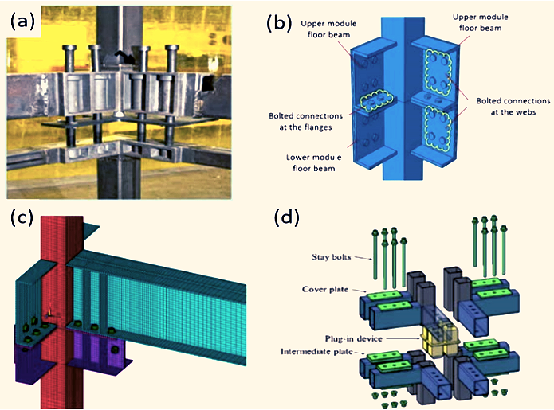Fig.2: Typical beam-beam connection (a) VectorBloc System (Bowron, 2016), (b) Corner Joint J1 (Mao, 2017), (c) Perimeter Joint J2 (Lee et.al., 2017), and (d) Interior Joint J3 (Chen et.al., 2017)
There are different methods for joining the modules together. One approach is using bolted connections, but this can be challenging and may require modifications to the modules. Another method involves connecting the columns outside the modules using threaded bars. However, this approach can also have its difficulties and may not provide enough strength for tall buildings.
The design of these joints is important for the overall stability of the building. Engineers need to carefully consider the best way to connect the modules to ensure the building is safe and structurally sound. [2]

Automation Technologies
Currently, there are still manual labor tasks involved in the production of modular units and the construction site, which limits the productivity and efficiency of Prefabricated Prefinished Volumetric Construction (PPVC). This is because the initial cost of automation technologies is high, and there is a lack of support from local authorities. Manual processes during the manufacturing of modules can lead to errors in verticality, horizontality, and water leakage issues, causing problems during on-site assembly. At the construction site, the lack of automated machinery results in longer adjustment times for lifting chains and manual module positioning.
However, the industry is gradually adopting automation in construction. Automated equipment is being used in factories to manufacture building components faster and with better quality control as shown in Figure 3. On-site work is also becoming more mechanized, such as using machinery for interior fit-outs. The future goal is to achieve 3D printing of entire modular units and utilize 3D laser scanners for quick and accurate measurements of module alignment.
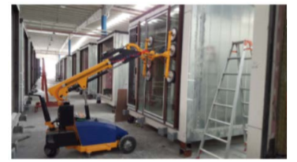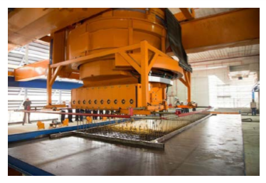Fig.3: Automated types of equipment used to build the module, (J. Y. R. Liewa et.al., 2018)
Technologies like Radio-Frequency Identification (RFID) systems and Building Information Modeling (BIM) are being implemented to improve asset and inventory management, streamline communication between project parties, and enable virtual walkthroughs of buildings before construction. Augmented reality (AR) and virtual reality (VR) can enhance BIM models, allowing for better identification and resolution of potential issues. Cloud-connected mobile devices enable real-time sharing of BIM models on-site, facilitating efficient decision-making. Additionally, BIM models can be used to calculate the center of gravity of each module, aiding in module stabilization during lifting and minimizing damage.
Overall, advancements in technology are transforming the modular construction industry, increasing productivity, and improving the quality of construction processes. [2]

Fire resistance and acoustic insulation
Fire resistance and acoustic insulation are crucial aspects of modular construction. Fire resistance in modular construction is achieved through several factors:
- Stability of light steel walls: The load applied to the walls and the fire protection on the internal face of the modules contributes to the overall stability during a fire.
- Thermal-shielding effect: The module floors have a thermal-shielding effect due to the presence of the ceiling beneath, enhancing the load capacity and fire resistance.
- Fire barriers: Fire barriers are placed between modules to prevent the spread of smoke and fire in the cavity between them, effectively limiting fire spread.
- Heat transfer limitation: Double-leaf walls and floor-ceiling constructions in the modules restrict heat transfer during a fire.
Typically, the internal faces of module walls and ceilings are constructed with two layers of 15 mm plasterboard, with at least one layer being fire-resistant plasterboard. Mineral wool is inserted between C-sections for both fire resistance and acoustic purposes. The combination of the floor, ceiling, and load-bearing light steel walls ensures a fire-resistance rating of 120 minutes, depending on the sheathing board used on the exterior of the modules. The double-layer walls and floor-ceiling construction also provide excellent resistance to airborne and impact sound, particularly when supplemented with an external sheathing board. Additionally, the use of a thin concrete floor screed on the light steel floor or as a composite slab between walls or edge beams can further enhance sound reduction and floor stiffness, minimizing vibrations. [3]

Future scope using BIM

BIM application in modular construction
Building Information Modeling (BIM) is a cutting-edge digital technology that has revolutionized the construction industry. It encompasses the creation and management of detailed 3D models, along with essential data, to facilitate the efficient planning, design, construction, and operation of buildings and infrastructure projects. BIM goes beyond traditional 2D drawings, enabling stakeholders to collaborate in a virtual environment, thereby improving communication, reducing errors, and enhancing overall project outcomes. With its ability to streamline processes and provide valuable insights, BIM has become an indispensable tool in modern construction, shaping the way projects are conceptualized and executed.
The principles of the modular construction process focus on integrating Building Information Systems (BIM) and Lean. A computer tool called MCMPro that could create diagrams and work charts based on a plan is used. Value Stream Mapping (VSM) was developed using Lean principles to reduce waste in factory operations. MCMPro leverages AutoCAD Visual Basic for Applications 2009 and uses scene-based analysis (SBA) to generate design drawings as shown in Figure 4. Tools include modular ideas and best practices, as well as architecture and design.
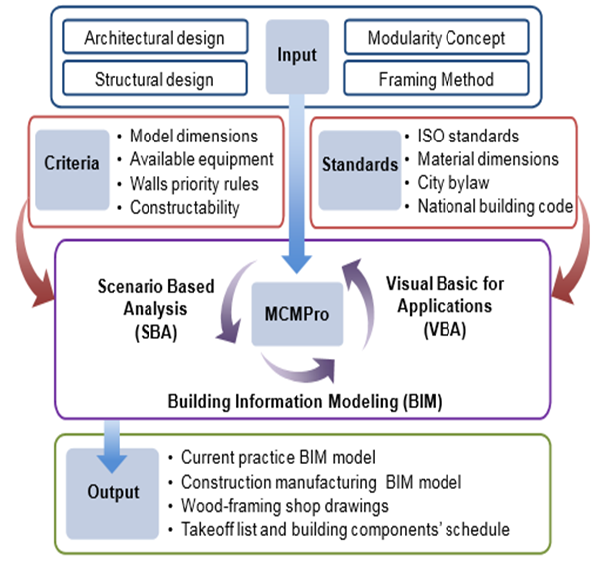
Fig.4: Scenario-Based Analysis (SBA) Process, Mansooreh Moghadam et.al., (2012)

Lean design concepts are then used and a VSM is created to optimize production lines based on the prevention plan. VSM graphically displays the flow of data and information, identifying opportunities for improvement and disposal. Integrated process improvement (IPI) aims to increase efficiency, standardize processes, reduce delays and solve problems as shown in Figure 5. The simulation model is used to test the VSM and refine it until a good result is obtained. This study demonstrates the effectiveness of the BIM/LEAN model in reducing waste, time and resource use in the construction of modular buildings. [4]

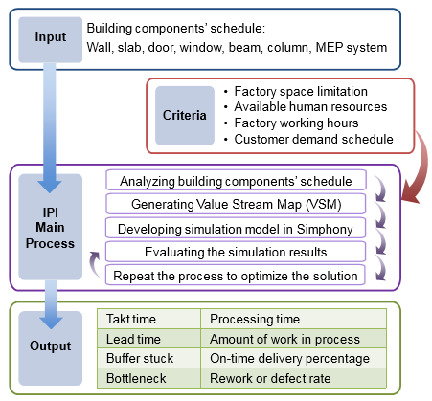
Fig.5: Integrated Process Improvement (IPI) process, Mansooreh Moghadam et.al., (2012)
Despite the numerous benefits it offers, such as reduced labor requirements, onsite greenhouse gas emissions, improved schedules, and product quality, the extensive pre-project planning and interdisciplinary coordination required have hindered its widespread adoption. [6]
The emergence of Building Information Modeling (BIM) provides a solution to these challenges and facilitates the integration of modular construction. By leveraging the capabilities of BIM, the benefits and challenges of implementing it in modular construction can be clearly identified. BIM models enable improved coordination by detecting clashes and reserving space for access. Resolving interferences involve determining system priority based on functionality to ensure optimal performance.
MEP coordination is a critical aspect of modular construction, given the lack of detailed design for building systems. BIM technology offers an opportunity to enhance this process by fostering collaboration between design engineers and construction contractors. It enables early consideration of constructability issues and facilitates dialogue between specialists and designers.
However, the current construction delivery model falls short in supporting modular construction due to the extensive planning and MEP coordination required. Integrating BIM into construction projects makes modular building technologies more effective and desirable. It streamlines the entire process, from planning and design to manufacturing and construction, by identifying conflicts early on and expediting conflict resolution. BIM reduces reliance on traditional paper plans and specifications. Further research should focus on organizational and legal issues related to implementing BIM in construction projects to enhance modular construction. [6]

Discussion
Modular construction and conventional building are two distinct approaches to constructing structures, each with its own set of advantages and limitations. In modular construction, building components are fabricated off-site in a controlled factory environment and later assembled on the construction site like building blocks. This approach offers significant time savings since off-site production can occur concurrently with on-site preparation, resulting in faster project completion. The speed and efficiency of modular construction make it a preferred choice for projects with tight timelines or urgent needs. Another key benefit of modular construction lies in its enhanced quality control. The standardized processes and factory-controlled conditions ensure a higher level of precision and consistency in the final product. This leads to a reduction in defects and rework, ultimately resulting in cost savings for the project. Moreover, the controlled environment of the factory also allows for better optimization of resources, leading to less material wastage. Sustainability is another noteworthy advantage of modular construction. With less on-site construction activity and reduced transportation of materials, there is a smaller carbon footprint associated with modular projects. The minimized disruption to the surrounding environment during construction further adds to its eco-friendliness. However, modular construction does come with certain limitations. The design flexibility is somewhat limited to the available modular configurations, making it less suitable for intricate or highly customized architectural designs. While some customization is possible within the modular framework, it may not cater to the specific needs of every project. On the other hand, conventional building involves constructing the entire structure on-site using traditional construction materials and techniques. This approach provides greater design flexibility, as architects and builders can adapt the structure to specific site conditions and tailor it to meet the owner's specific requirements. This makes conventional building an excellent choice for projects where unique architectural designs or complex layouts are essential. Despite its flexibility, conventional building methods tend to have longer construction timelines compared to modular construction. Sequential on-site construction processes and potential weather-related delays can extend project schedules, impacting overall project costs and timelines.

Conclusion
Both modular construction and conventional building have their merits and drawbacks. Modular construction excels in terms of speed, efficiency, quality control, and sustainability, making it a viable option for projects with standardized designs and time-sensitive requirements. On the other hand, conventional building provides greater design flexibility, allowing for customized structures and adaptations to unique site conditions. The choice between the two methods ultimately depends on the project's specific requirements, budget constraints, and desired outcomes.

References
  - Muhamad Faiz Musa, Mohd Reeza Yusof, Mohammad Fadhil Mohammad and Noor Sahidah Samsudin (2016),” Towards The Adoption Of Modular Construction And Prefabrication In The Construction Environment: A Case Study In Malaysia”, ARPN Journal of Engineering and Applied Sciences, Vol. 11, No. 13
  - J. Y. R. Liewa, Z. Daia and Y. S. Chuaa, “Steel Concrete Composite Systems for Modular Construction of High-rise Buildings ”, 12th International Conference on Advances in Steel-Concrete Composite Structures (ASCCS 2018) ,Universitat Politècnica de València, València, Spain, June 27-29
  - R. Mark Lawson, Ray G. Ogden and Rory Bergin (2018),” Application of Modular Construction in High-Rise Buildings”, Journal Of Architectural Engineering 18(2): 148-154
  - Mansooreh MOGHADAM, Aladdin ALWISY, Mohamed AL-HUSSEIN(2012), “Integrated BIM/Lean Base Production Line Schedule Model for Modular Construction Manufacturing,” Construction Research Congress 2012.
  - Kisi KP, Mani N, Lee N, Shrestha J, Shrestha K, Kayastha R. “Opportunities and challenges for modular construction in developing nations: A case study in the Nepalese construction industry.” In 7th Canadian Society for Civil Engineers (CSCE) Annual Conference 2019 Jun 12 (pp. 1-9).
  - Lu, Na, and Thomas Korman. "Implementation of building information modeling (BIM) in modular construction: Benefits and challenges." In Construction Research Congress 2010: Innovation for reshaping construction practice, pp. 1136-1145. 2010.
  - Julius Endzelis, Mindaugas Daukšys (2018) , “Comparison Between Modular Building Technology and Traditional Construction”, Kaunas University of Technology, Faculty of Civil Engineering and Architecture Studentu str. 48, LT-51367 Kaunas, Lithuania
  - Zhao Xu, Tarek Zayed, Yumin Niu, Comparative analysis of modular construction practices in mainland China, Hong Kong and Singapore, Journal of Cleaner Production (2019), https://doi.org/10.1016/j.jclepro.2019.118861
  - Karthik Subramanya , Sharareh Kermanshachi and Behzad Rouhanizadeh, “Modular Construction vs. Traditional Construction: Advantages and Limitations: A Comparative Study,” Proceedings of the Creative Construction e-Conference (2020) 012
  - A. Alwisy alwisy, M. Al-Hussein malhussein and S. H. Al-Jibouri,” BIM Approach for Automated Drafting and Design for Modular Construction Manufacturing,” Publication: Computing in Civil Engineering (2012)
  - Khubaev A.O., Saakyan S.S., Makaev N.V,” World Practice In The Field Of Modular Construction,” published in article of National Research Moscow State University of Civil Engineering : Vol 11, No 2 (2020)
  - Mindaugas Daukšys, Julius Endzelis, “Comparison Between Modular Building Technology and Traditional Construction,” article in Architecture, Energy and Environmental Studies, Evaluation research, Published by: Exeley Inc in 2018

