Chapter-
Management And Treatment of Breast Cancer
Pushpendra Kumar Rajput, Assistant Professor Department of Paramedical Sciences, Swami Vivekanand Subharti University, Meerut
Vishant Pal, Biochemistry Demonstrator, Department of Paramedical Sciences, Swami Vivekanand Subharti University, Meerut

Abstract
An Overview of Management And Treatment of Breast Cancer is provided in this chapter. With particular focus on the basic cell structure, Causes, sign and symptoms, breast anatomy, types of cancer, diagnosis, treatment and risk factor. Breast Cancer is a prevalent and deadly disease that affects women worldwide. It is a malignant tumor that develops in the breast soft tissue. National Cancer Awareness Day is celebrated on November 7 in India to increase awareness of the condition's importance and promote early detection, treatment, and diagnosis to try and slow down the rapid spread of cancer. Early warning signs of cancer, we might use the phrase CAUTION. there are two types of types of cancer first, A pre-cancer called in situ breast cancer (ductal carcinoma) begins in a milk duct but does not spread to the rest of the breast tissue and Second, any form of breast cancer that has expanded (invaded) into the nearby breast tissue is referred to as invasive (or infiltrating) breast cancer. There are different types of diagnosis techniques of screening breast cancer like mammography, MRI, USG etc. There is many types of treatment or therapy techniques like chemotherapy, Surgery, Radiation therapy etc.
Introduction
Cancer is largely a disease of lifestyle. They comprise factors like age, color, gender, and family history that people cannot change. When cancer is identified in its early stages, it is easier to treat. The key to preventing cancer is early detection and early treatment. Knowing one's body and what is "normal" for them, as well as reporting symptoms to a doctor, can assist a person ensure that, if they do have cancer, it is detected early enough for better and more efficient treatment.
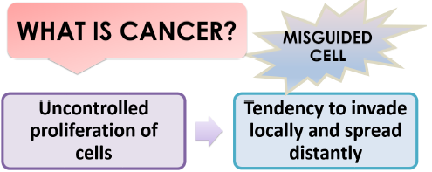
Figure: Image shows definition of cancer

The most common cancer among women is now thought to be breast cancer. Numerous factors have been identified as breast cancer risk factors. Early pregnancy age (greater than 30 years) is one of them, having only one baby, and menopause at a late age. Additionally recognized as a risk factor is a diet that contains lots of fat. Exercise has been shown to protect against breast cancer. The quick transition to a prosperous lifestyle has resulted in a significant decrease in physical activity and an increase in the consumption of meals high in fat. Breast cancer risk factors include obesity in postmenopausal women and high-fat diets throughout adolescence. Regular breast self-examination by women themselves is one of the best ways to detect breast cancer in its early stages. the likelihood that breast cancer will be cured if it is discovered early.
Symptoms and sign of cancer
A person may notice certain warning signs that indicate something is unexpected or distinct from one another. Early cancer symptoms can be quite vague and challenging to diagnose. To help us remember the early warning signs, we might use the phrase CAUTION.
C: A change in bowel habits
A: A wound that won't go away
U: Unusual bleeding from any bodily orifice and unexplained weight
loss
T: Bulging or thickening
I: Discomfort
O: Overt modification of a wart or mole
Nagging cough, shortness of breath, and hoarseness

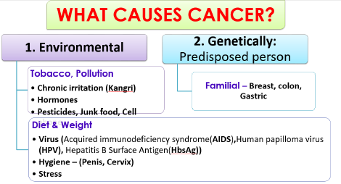
Figure: Image shows causes of cancer.

What is cell
The fundamental structural and functional components of the human body are cells. An average human body has 37.2 trillion cells. Organelles make up a cell. These organelles include the nucleus, which serves as the command and control center of the cell, mitochondria, which is known as the energy source, lysosomes, which serve as the garbage collector for worn-out or damaged cell parts, the golgi apparatus, which uses a mechanism to transport proteins, and endoplasmic reticulum. Reticulum are responsible for producing lipids (fats) and proteins. Cell Membrane is the name of the protective outer layer, and cytoplasm is the term used to describe the jelly-like fluid in which all of these organelles are suspended.
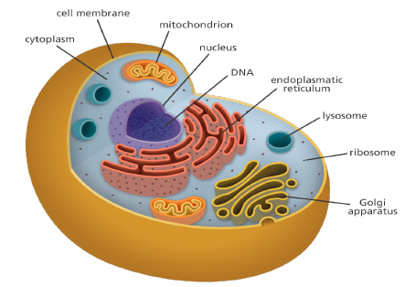
Figure: Image shows Cell.

Cell division and cell death
The life cycle of a cell includes birth, growth, reproduction, and death. The cell further splits into two daughter cells when it reaches the limit of its ability to grow. Cell division is the process in question.
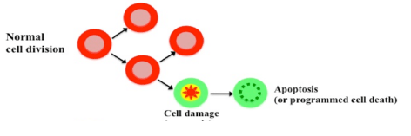
Figure: Image shows cell division and cell death.

New cells of that type T proliferate in their place when damaged or aging cells die. Apoptosis is the name for this mature cell death mechanism.
Cancer cell v/s normal cell
In order to heal damaged tissue or as a result of growth and development (such as during childhood), normal cells expand. Before a tumor can form, particular genetic changes must occur in one or more cells. Cancer cells typically develop as a result of a succession of mutations, which alter the genetic sequence. These mutations can either be inherited, or more frequently, they are brought on by carcinogens—substances that cause cancer—in our environment. Some alterations are handled by the body's defense mechanisms. If hazardous external substances such as cigarettes, a high-fat diet, the environment, and/or abnormally fast growth overwhelm them, they become unable to control the development of damaged cells, which is known as a tumor.
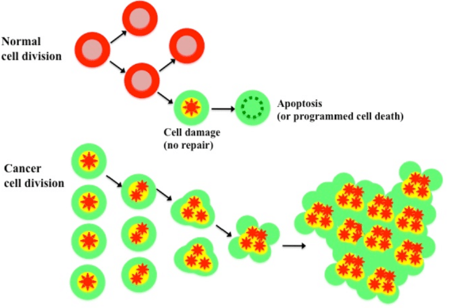
Figure: Image shows cell division and cell death.

Types of tumor
There are two types of tumors: benign and malignant. Noncancerous tumors do not invade or spread to nearby tissues. However, benign tumors can occasionally be rather large and heavy.
They typically don't grow back after being removed. Malignant tumors, or those that can spread to or infect surrounding tissues, include cancerous tumors. Additionally, Some cancer cells may separate as these tumors form, travel through the blood or lymph system to far-off parts of the body, and form secondary tumors that are different from the primary tumor. We refer to this process as metastasis.
Metastatic cancer is a type of cancer that has spread from the site of its origin to another location in the body. Metastasis is the process by which cancer cells spread to various organs or tissues inside the body. Additionally, breast cancer can spread to organs like the liver, lungs, and bones that are further removed from the breast. Brain cancer may spread from breast cancer less frequently. Stage IV or metastatic breast cancer is defined as breast cancer that has progressed to a distant site in the body. Even if the cancer has spread, it is still given its original name. For instance, the term metastatic breast cancer is used to describe breast cancer that has spread to the lungs rather than lung cancer. Regardless of how far it has progressed or if it can be managed, breast cancer can be treated.
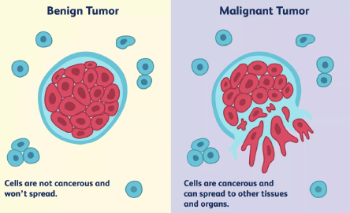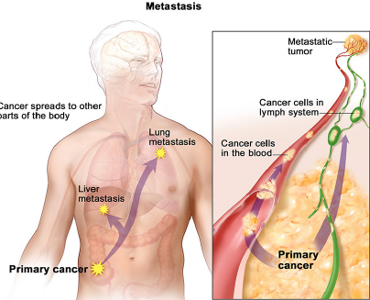
Figure: Image shows Benign tumor and Malignant tumor & Metastasis.

Risk factor for cancer
Two main classifications can be used to classify cancer risk factors. Modifiable Risk Factors: A person's risk of developing cancer can be affected by their behaviors and environmental exposures. They may theoretically be changed so they are changeable. Example: Alcohol, tobacco, and obesity.
Risk variables that cannot be changed are known as non-modifiable risk factors. Examples include genetics and infections (viruses/microbes).
Breast anatomy
Breast cancer can be invasive or noninvasive. Breast cancer that has spread to the surrounding tissues is invasive. Breast lobules or milk ducts are the limit of noninvasive breast cancer. The majority of breast malignancies, known as ductal carcinoma or lobular carcinoma, begin in the ducts or lobules. Little ducts that connect the glands, lobules, and lobes carry the milk from the lobes to the nipple. The nipple is located in the center of the areola, the darker area that surrounds it. Along with lymphatic and blood veins, the breast is permeable. Cells receive food by blood, while bodily waste is removed by the lymphatic system. lymphatic vesselslink the Bean-shaped, tiny lymph nodes, helping in the body's defense against infection.
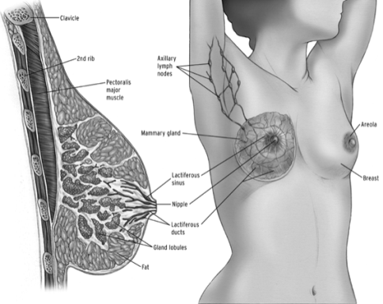
Figure: Image shows Anatomy of Breast.

Mammary Cancer
Breast cancer is a mass of cancerous cells that develops from breast cells (malignant tumor). Breast cancer is a disorder in which uncontrollably proliferating abnormal breast cells form tumors.
If the tumors are not treated, they could spread throughout the body and result in death. Breast cancer cells first manifest in the milk ducts and/or milk-producing lobules of the breast. The initial form (in situ) doesn't present a danger to life. Cancer cells may invade nearby breast tissue and infiltrate it.
As a result, tumors develop, leading to lumps or thickening. Invasive cancers have the potential to spread metastatically to nearby lymph nodes or other organs. Death could arise from metastasis. The patient, the type of cancer, and the extent of its spread all influence the course of treatment. Treatment options include surgery, radiation therapy, and medication. Although it can affect both men and women, it mostly affects women. A breast lump or an abnormal mammography are frequently the earliest symptoms of breast cancer. Breast cancer stages can range from early, curable breast cancer to metastatic breast cancer with a variety of treatments.
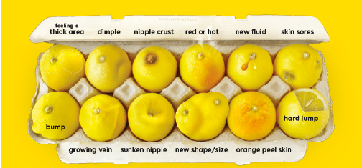
Figure: Image shows abnormal mammogram.

The National Health Mission has offered some recommendations about breast cancer screening. The age range for screening women for breast cancer set by the Indian government is 30-65 years. A medical officer with training will do the clinical breast examination. The target group will be instructed on how to perform a breast self-examination, which they can use as a self-tool to find any abnormalities.
Symptoms and Signs
In the majority of instances, there are no symptoms, however in more advanced stages, following indicators may appear:
A. firm, painless node or lump in the breast or armpit.
b. Swelling and soreness in the breasts.
c. Breast discharge.
d. A change in the breast's size, shape, or appearance, or wrinkling of the breast skin
e. A recently flipped nipple.
f. The skin around the breasts itching, crusting, or scaling.
g. The patient typically has no pain.
h. Having breast lumps does not always indicate the presence of cancer; some lumps develop as a result of cysts or infections.
i. Nipple adjustments
a) Ulceration
b) Pulling back or inverting
c) Uncontrollable discharge
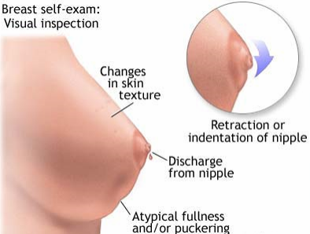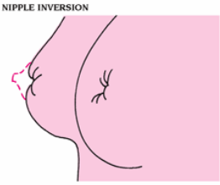
Figure: Image shows Retraction and nipple inversion.

Myths About Breast Cancer
Myth: Teenage girls do not receive Mammary Cancer
Fact: Although it can happen to extremely young women, breast cancer is more probable to influence women older than of 35 year.
Myth: Breast cancer always runs in families
Fact: The majority of women with breast cancer are unrelated to anyone who has been diagnosed with them. Only 5–10% of cases have a hereditary component. Even while breast cancer runs in the family, this does not necessarily indicate that a specific person will get the illness.

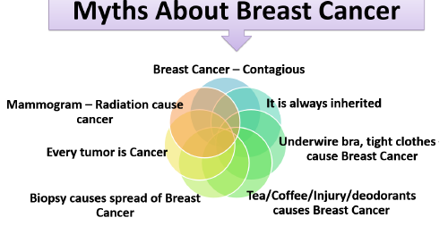
Figure: Image shows Myths about cancer.

Breast cancer types
Invasive or non invasive breast cancer are two types of cancer spread in breast. Spread of breast cancer to the surrounding tissues is invasive. Breast lobules or milk ducts are the limit of non invasive breast cancer. The majority of breast malignancies, known as ductal carcinoma or lobular carcinoma, begin in the ducts or lobules. When a tumor is removed during a biopsy, a pathologist assesses it is ductal or lobular carcinoma. A pathologist is a doctor who specializes in examining cells, tissues, and organs to detect diseases and assessing laboratory data. It is referred to as invasive or infiltrating ductal or lobular carcinoma if the disease has spread to the nearby tissue from the duct or lobule. In situ, which means "in place," is a term for cancer that is solely present in the duct or lobule and is non-invasive. Ductal carcinoma in situ (DCIS) accounts for the majority of in situ breast malignancies. Surgery, radiation therapy, and hormone therapy are frequently used to treat DCIS.
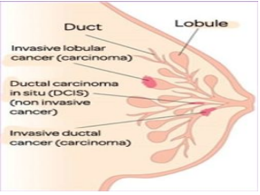
Figure: Image show Invasive and Non- Invasive cancer.
Clinical Breast Examination (CBE):
For the following signs, both breasts are visually assessed and palpated from both sides in various positions. If anything suspicious or abnormal is found, further investigation is advised.
Examining: Any asymmetry in the size and contour of the breasts, changes in the skin, including dimpling, retraction, and ulceration, both nipples' levels, nipple retractions, and inverted nipples.
Palpation can reveal lumps, swelling in the arm pit (axillary area), supraclavicular area, and infra clavicular area, as well as any secretion from the nipple, color of the discharge, lumps, and nature of lumps.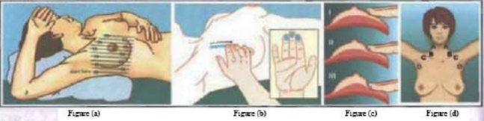
(a) Patients should be examined while sitting and lying down with their lateral hand overhead in order to highlight any changes in the breasts. By putting a little pillow under the shoulder or lower back, the breast can be centered.
(b) The finger pads of the middle three fingers should be used to palpate (not compress) the breast in a circular motion while applying uniform pressure in a vertical strip pattern (Figure a).
(c) Pressure on palpation
1. Light pressure for tissue in the superficial layer of the breasts;
2. Medium pressure for the middle layer;
3. and deep pressure for tissue next to the chest wall.
(d) Nodes : A& B - Supra clavicular area; C. Infra clavicular area; D. Axillary area.
Interpretation
Following are some possible interpretations for the CBE results:
1. Negative or normal: No abnormalities upon palpation or ocular inspection.
2. High Risk: Breast cancer screening and treatment algorithms classify individuals with benign breast conditions and a personal history of breast cancer in the breast or the opposite breast as being in the "High Risk Group."
3. Asymmetry is clearly present and can be felt or seen as abnormal. Either probably malignant or probably non-malignant conditions are possible. The patient will be treated in accordance with the screening and management algorithm for breast cancer if there are any Distinct, firm breast lumps, whether there are any armpit swellies, recent nipple retraction or distortion, skin dimpling or retraction, ulceration, or bloody nipple discharge.
Presence of anyone of the signs shall be considered as abnormal.
Probably Malignant | Probably Non Malignant
Discrete, hard mass in the breast that may or may not be accompanied with armpit edema. | Other lumps in the breast
Recent retraction or deformation of the nipple | Non bloody nipple discharge
Skin dimpling or retraction
Ulceration

Breast Cancer Diagnosis
Breast ultrasound: a device that uses sound waves to produce sonograms, or images, of particular breast tissues.
Diagnostic mammography - If you have a breast problem, such as lumps, or if a breast area seems worrisome on a screening mammography, your doctor might advise getting a diagnostic mammogram. This particular breast X-ray is more detailed.
Breast Magnetic Resonance Imaging (MRI): a specific kind of physical examination that utilizes a computer and a magnet. The MRI scan will provide a detailed image of areas inside the breast.
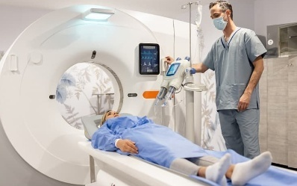
Figure: Image shows Breast magnetic resonance imaging (MRI).

Treatment for Breast Cancer
Radiologists and pathologists work together with medical professionals with specialties in various areas of cancer treatment, such as surgery, radiation oncology, and medical oncology, to provide cancer care.
Make a comprehensive treatment plan that includes a variety of therapy for the patient. A team with multiple functions is what this is. Physician assistants, nurse practitioners, oncology nurses, social workers, pharmacists, genetic counselors, nutritionists, therapists, and others are among the additional medical specialists who work on cancer care teams. The biology and behavior of breast cancer have an impact on the therapeutic strategy. While some tumors are enormous and developing slowly, others are little and growing quickly. Treatment options and suggestions are very individualized and are determined by a variety of factors, including:
- The tumor's subtype, which comprises the tumor's HER2 status, ER status, PR status, and nodal status.
- The cancer's stage
- Age, overall health, menopause status, and patient preferences.
- The results of genetic testing indicating the existence of known mutations in hereditary breast cancer genes, such as BRCA1 or BRCA2,.
The following are the most prevalent therapies for early-stage and locally progressed breast cancer:
a) Surgery;
b) Radiation therapy;
c) Chemotherapy;
d) Hormone therapy;
e) Targeted therapy;
f) Immunotherapy;
g) Neoadjuvant systematic therapy for metastatic breast cancer

Surgery
Surgery to remove the tumor from the breast and/or examine the lymph nodes for cancer is typically one of the earliest treatments for someone who has been diagnosed with breast cancer that has not spread to other parts of the body. The following categories exist:
1. Lumpectomy - This requires the removal of the tumor along with a narrow margin of cancer-free, healthy tissue surrounding it..
2. Mastectomy – This is when the entire breast is surgically removed. Mastectomies come in a variety of varieties.
Radiation therapy
In radiation therapy, high-energy x-rays or other particles are utilized to kill cancer cells. Medical doctors who specialize in providing radiation therapy as a cancer treatment are known as radiation oncologists.. Radiation therapy comes in a variety of forms:
1. Whole breast irradiation – External beam radiation therapy is used to treat the entire breast in whole breast irradiation.
2. Radiation therapy called partial breast irradiation (PBI) focuses only on the area of the breast where the tumor is instead of the entire breast.
3. Brachytherapy- Radioactive sources are inserted into the tumor during this type of radiation therapy.

Chemotherapy
Chemotherapy is the practice of using drugs to eradicate cancer cells. This is often accomplished by stopping the cancer cells from multiplying, dividing, and creating new cells. It can be given before to surgery to reduce the size of a large tumor, make surgery easier, and/or reduce the risk of recurrence. When it is given before surgery, it is known as neoadjuvant chemotherapy. Adjuvant chemotherapy, which is given after surgery to reduce the likelihood of recurrence, may also be applied.

Hormonal Therapy
Hormonal therapy, commonly known as endocrine therapy, is often advised for persons with ER- or PR-positive breast cancer. Blocking the hormones, either alone or in conjunction with adjuvant or neoadjuvant chemotherapy, can help avoid recurrence and death in as they require hormones to fuel their growth, these malignancies.

Targeted therapy
A type of pharmaceutical treatment known as "targeted therapy" specifically targets the tissues, proteins, or genes that promote the growth and survival of tumors. This type of treatment limits damage to healthy cells while stopping the growth and spread of malignant cells..

Immunotherapy
Biologic therapy, often known as immunotherapy, aims to strengthen the body's inherent defenses against cancer. It makes use of substances that can be produced by the body or in a lab to enhance, target, or restore immune system function. For advanced or metastatic breast cancer, the following medications are prescribed:

Side Effects
The following are some of the side effects of breast cancer treatment-
1. Hair Loss
2. Lymphedema
3. Chemobrain
4. Peripheral neuropathy

References

https://www.cancer.gov/about-cancer/understanding/what-is-cancer
https://www.britannica.com/list/6-cell-organelles
https://www.researchgate.net/figure/Schematic-of-normal-cell-vs-cancer-cell-division-
This-figure-was-redrawn-based-on-the_fig2_307205581
https://www.afro.who.int/news/7-warning-signs-cancer
https://www.webmd.com/cancer/cancer-early-warning-signs#1
https://www.cancer.gov/about-cancer/causes-prevention/risk
cancerindia.org.in › cancer-statistics
https://www.webmd.com/breast-cancer/default.html
https://www.who.int/news-room/fact-sheets/detail/breast-cancer
https://www.moh.gov.sa/en/awarenessplateform/ChronicDisease/Documents/Breast%20Cancer.pdf
https://www.cancer.net/sites/cancer.net/files/asco_answers_guide_breast.pdf
https://www.wbhealth.gov.in/NCD/uploaded_files/all_files/MO_Module_for_PBS_for_NCDs.pdf
https://www.cancer.net/cancer-types/breast-cancer/types-treatment
https://www.cdc.gov/cancer/breast/basic_info/diagnosis.html

