Geospatial Technology for Sustainable Development – A case of Keonjhar District of Odisha
Dr. Adikanda Ojha Dr. Jajnaseni Rout
State Project Officer Assistant Professor
MGNREGS Society Dept. of Geography
Dept. of Panchayatiraj and Drinking Water Ravenshaw University
Odisha Odisha
adikanda.ojha@gmail.com jajnasenirout@gmail.com
Abstract
Economic, social and environment are three dimension s of sustainlibilty that point out by the 2030 agenda for SD. Natural resources degraded through human activities affects by classifying the events which relate the ecosystem mechanisms. The activities which interact with the ecosystem mechanisms through human activity which can checked for classifying, which impact on natural resources. Geospatial technology has used for assessing the communal progress works and produces the production of SD at a district level. The main objective of the study is to show the influence of implementation of SDGs on the development of community livelihood and overall infrastructure Development. The study area has been taken the Keonjhar district of Odisha which was one of the vulnerable district of Odisha. MGNREGA provided work to community have improved satisfactory in all the 13 blocks of the Keonjhar district. MGNREGA MIS report (2019) indicates that the 2267 numbers of village clusters dynamically contributed in the program. The 575708 Lakhs workers were elaborate in MGNREGA program of the district. The research area has more than 26389 things over an area of 653900 Ha of land. The number of properties established during the period 2009 till 2019. It has found that mostly the things remained for irrigation, conservation of water, water collecting structure and drought proofing works. From 2017 and 2018, there is mandate and growth in rural sanitation works in the study area.

Key words - SDG, MGNREGA, Geospatial, conservation, ecosystem
Introduction
The Millennium Development Goals (MDGs) approved through the UN Millennium Summit on 8th September 2000 was the first integrated stand of the world to free the world of scarcity and increase the lot of mortality. Execution of MDGs was up to 31st December, 2015 and from 1ST January, 2016 SDGs are in force. SDG has the main objectives are poverty, the requirements of the civilization and security of the sphere lacking decreasing resources desired for next generations. In the year 2030 agenda for SD ideas out that sustainability have three dimensions: economic, social and environment. Society affects the natural resources can be checked by classifying the events will cooperate through ecosystem mechanisms. Earth Observation (EO) system collects the data of the lithosphere, hydrosphere, biosphere, atmosphere and their relations through Geospatial technology, which enhanced by in-situ and survey data. Geospatial technologies implant a range of modern tools along with EO data, Global Position Systems (GPS), Geographic Information Systems (GIS) and the Internet to simplify online mapping and investigation of the Earth and community (AAAS, 2018). Geospatial technology for detecting the public level improvement mechanism and manufactures the income of SD at a district level. The study has connected the system supplies provided through ICTs to recover the information of the resources which developed under MGNREGA scheme. This analysis trusts on reason of the economy contributes essential push to the community improvements healthy inside the compass of the environment and of the conservation of natural resources.
The Figure 1 shows the conversation of surpluses between the three supports of sustainability of the programs as MGNREGA. SD has formed which is a stable incorporation of environment, society and economy of the economy which measured by community and it is depended on the environment. There are 260 types of works which approved under MGNREGA and these types of works are interrelated to natural resource, water facilitation, agriculture, infrastructure, transportation and sanitation and other associated actions (MGNREGA Guide, 2019).
The main objective of the study is to show the impact of implementation of SDGs on the development of community livelihood and overall infrastructure Development.

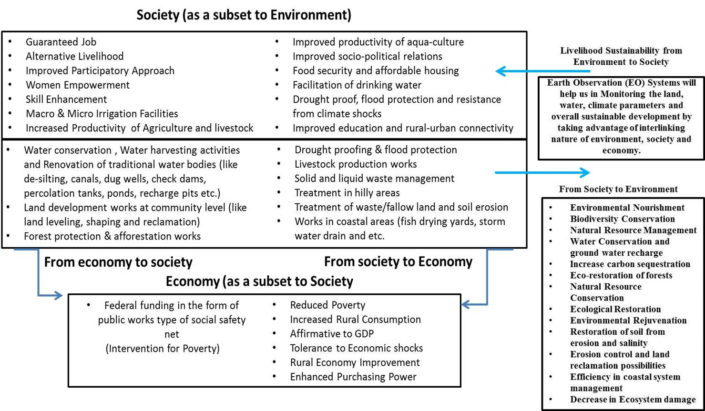
Figure 1 A representation of relations between the three pillars of Sustainable Development due to the interferences like community works on Natural Resources.

ICT is a tool which allow the transparency in the procedure of MGNREGA due to the great size of the programme, geographical extent, financial implication, beneficiaries and stakeholders. ICT confirms transparency and supports in information dissemination, facilitates online watching and valuation of the programme (Reddy, 2013). A committed web gateway exists for the social recording of project actions and to provision the ‘Right to Information’ act. The portal offers brief information about the active works, completed mechanism and growth of resources. The management information system (MIS) simplifies recording of profits increased in this NREGA program (NREGA Web Portal, 2019). The geo-tagged information put in the public area under a portal named GeoMGNREGA which made on Bhuvan platform developed by Indian Space Research Organisation’s (ISRO). Bhuvan provides essential online geospatial provision to MGNREGA project through an integrated view of resource information. In GeoMGNREGA, the supplies to envisage properties at the state, district and block level. Properties can be envisaged based on the work category. The dashboard is available at GeoMGNREGA which provides statistical data of the Geo-tagged properties (MGNREGA MIS, 2018; GeoMGNREGA MIS, 2018; ISRO, 2016). The figure 2 signifies the indication of Geo-portal which publishes geo-tagged properties information to the public under MGNREGA project.
Study Area
MGNREGA execution is for the entire country with the solitary exclusion of the urban population. Phase I was first executed in 2006 in the 200 poorest districts in India. The districts were precisely targeted by the Planning Commission of India based on the regressive status of Indian districts.

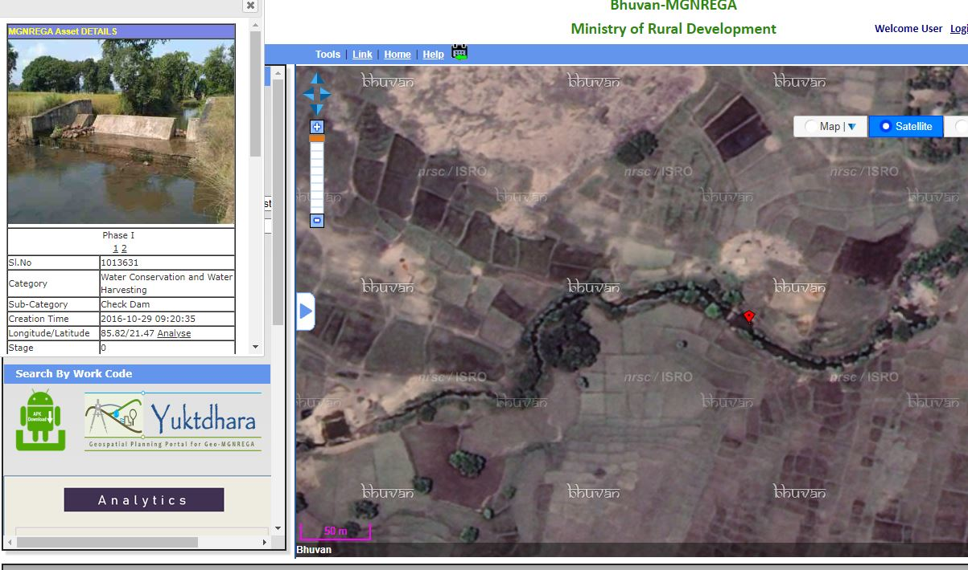
Figure 2 This is photo of GeoMGNREGA web-portal, which enables the MGNREGA with signal of a geo-tagged photograph of the asset.

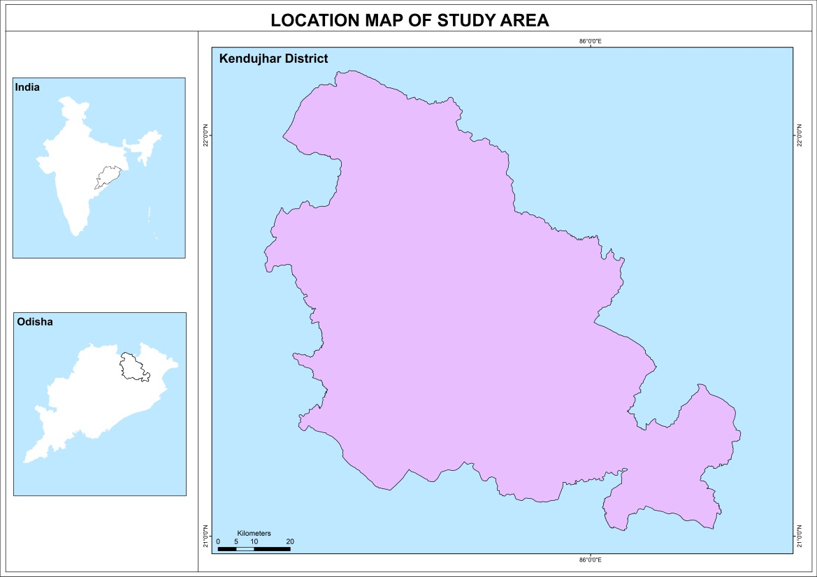

Figure 3. Keonjhar district of Odisha State, India

Keonjhar District is one of the district of Odisha. The district is also one of the fifth Scheduled Areas of Odisha. The Keonjhar town (Kendujhargarh) is the district headquarters of Keonjhar. Anandapur, Champua, and Kendujhar are the three sub-divisions of this district. The half of the eastern part of the district is the plains which is Anandapur. The western part is surrounded with a hills of range containing peaks such as Gandhamardan (3477 ft), Mankadnacha (3639 ft), Gonasika (3219 ft) and Thakurani (3003 ft). The half of the area is covered by forests of Northern tropical deciduous type of trees of the Keonjhar district which are Sal, Asan, Jamu, Arjuna, Kusum, Kangada, Mahua, Mango, Kendu. The highlands encompass of groups of rugged scarps and the mountain tops perform to be suddenly peaked. They have widespread tablelands on their summits. In some areas, isolated hills increase sharply from the plains but most areas have a general elevation of over 600m. The highlands originate the watershed for a number of rivers, including the Baitarani River.
The Geographical area of the district is 8,303 km^{2.} The district situated between 21° 0'46.44"N to 22° 9'34.61"N latitude and 85°11'3.49"E to 86°21'30.93"E longitude. The temperature in the district rise quickly in the spring with the maximum temperatures documented in the month of May rise up to 38 °C. The maximum logged temperature is 43.3 °C. The weather chills during the monsoon in June and residues cool till the end of October. The temperature in the month of December can drip down to 7°C. The minimum temperature documented was 1°C. The average annual rainfall is 1910.1 mm. Keonjhar district total population is 1,801,733 according to the census 2011. The population density of 217 inhabitants per square kilometre (560/sq mi). The concentration of Scheduled Tribes is the highest in the Keonjhar subdivision and lowest in the Anandapur subdivision. The majority of Scheduled Tribes are employed in agriculture, mining or quarrying.
Database and Methodology
EO systems allow catching the information from the space, storing/archiving, managing and distributing the Geo-spatial data. The current status of the EO technology has the capability to growth the active principles of human beings, growth of social economy and influence to the SDGs (Paganini & Petiteville, 2018). EO satellites attains Very High Spatial Resolution (VHSR) images which is widely misused to generate LU/LC maps to combination with agricultural, ecological and socio-economic issues with measuring ecosystems position, checking biodiversity and deliver efforts to social difficulties (Gaetano, Ienco, Ose, & Cresson, 2018). Visual interpretation of Satellite data will capable to identify events like transportation, rural sanitation, irrigation, drought proofing as afforestation, land development, conservation of water and gathering. The EO data is the LU/LC (Landuse/landcover) dynamic map which can prepare at compulsory intervals, which not only the composition but also the general view of land cover changes for planning, monitoring and evaluation tool. Table 1 shows the activities of MGNREGA that interrelate with ecosystem and with the geospatial assessor of the communication.

Table 1 Community works under MGNREGA which relation with Natural Resources and linked Geospatial Assessor
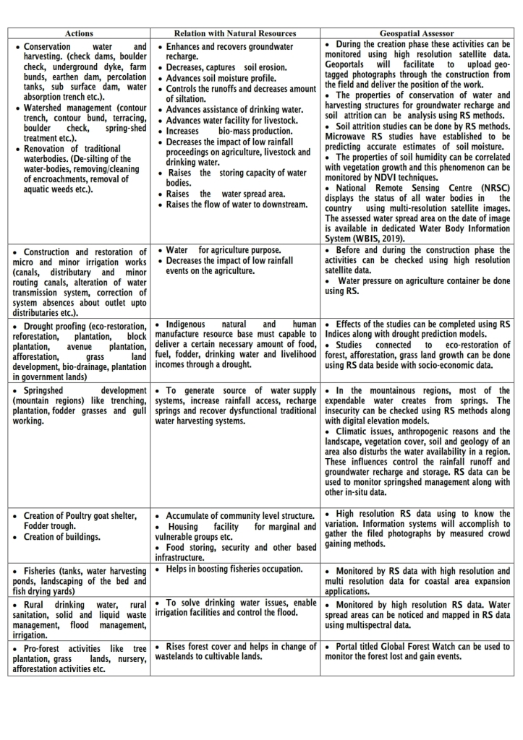

Henceforth, observing the food safety struggles is the one of most important displays to analysis Social Safety Nets (SSNs). Land expansion works, drought proofing actions, soil conservation approaches and irrigation assistances are required to show the outcome in advanced agriculture efficiency. The vegetation measurement crosses through geospatial databases is currently a dangerous technique to extent the properties of local and global-scale agricultural production. The common technique is the Normalized Difference Vegetation Index (NDVI) method. It signifies the climate and water effect on vegetation. The variation between visible and near-infrared reflectance signifies photo synthetically live vegetation. It is again used to concept a vegetation index. The lower value of the NDVI specifies humidity pressure on vegetation, producing from extended water shortage. Higher the NDVI values reproduce ideal rising circumstances if the greenness is higher than that faced. Maximum NDVI provides the higher NDVI value of the increasing season and signifies highest vegetation photosynthetic action. Maximum NDVI donates the movement of vegetation health for the studies which duration over many years (Burgan, & Hartford, 1993; Bhatt et al., 2017).
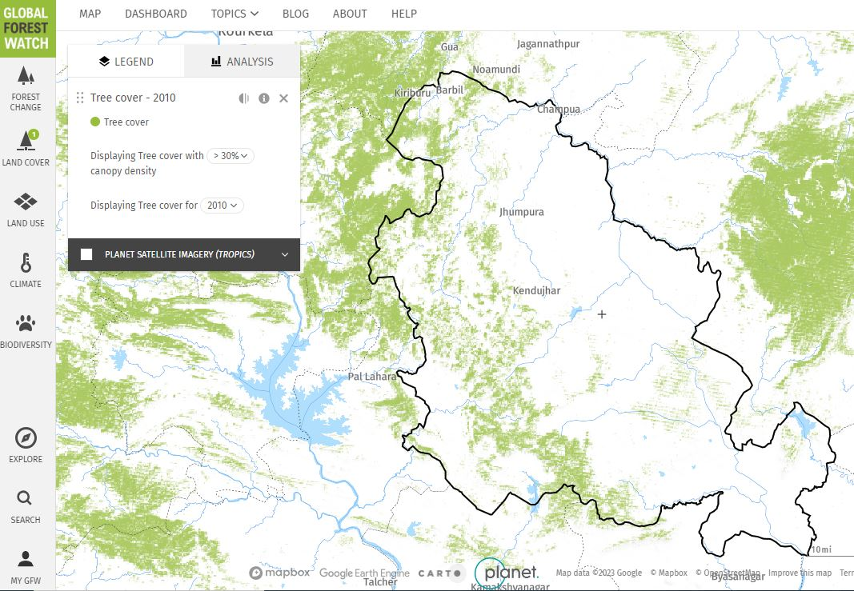
The geospatial technology methods are valuable technique for analysis of water resources and conservation policies (Shakoor, Shehzad, & Asghar, 2006). Satellite-based Water Body Information Systems (WBIS) deliver suitable evidence on the water spread area and other resultant material. Natural water bodies are, example: canals, rivers, lakes, aquaculture/pisciculture, reservoirs, ponds, irrigation services (WBIS, 2019). Maximum of water is mainly used for agriculture, drinking water, cottage industries and livestock production drives in the rural community.
The populations of rural community are regularly appeals the outputs of trees and forest in their area for numerous reasons like uses by the household as fuel and food, inputs in the agricultural system, as fodder and protection, causes of income and employment (Wackernagel, & Rees, 1998). Soil conservation works, afforestation, tree plantation, boundary plantation, agro-forestry, block plantation and agro horticulture works are in the program of this SSN. They have encouraging properties on the forest conservation by straight generous acceptable obtaining energy and dropping the dependence on forest resources. The forest area monitoring contributes the proposal of the essential of the peri-rural population in the forest. The Figure 4 shows the forest based web based GIS created called ‘Global Forest Watch’. This type of entries is extremely appreciated to display the variations in the forest areas.

Figure 4 A example of Keonjhar district surroundings with Global Forest Watch on geo-portal
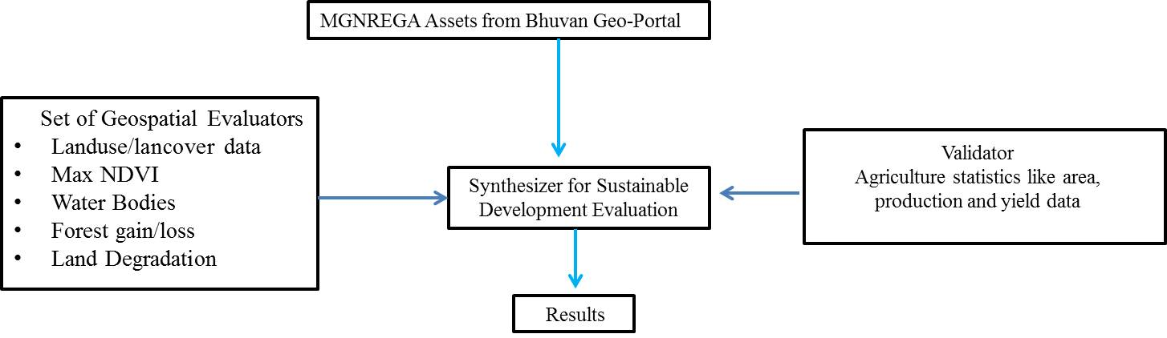
Figure 5. Method for rapid estimation of development through Geospatial assessors and agriculture productivities

Land deprivation records were formed for the years 2009 and 2019. The forest degradation and afforestation was recycled as a display to portion of the forestry section from global forest geo-portal.
Discussion
Community development works in MGNREGA programme in all the 13 blocks of the Keonjhar district. MGNREGA MIS report (2019) suggesting that the number of villages are 2267 and have vigorously joined in this platform. A total of 575708 Lakhs workers were intricate in MGNREGA program in this district. The area under research covers more than 26389 resources over an area of 653900 Ha. of land. The table 2 showing the total number of effects established from the year 2009 till 2019. It is evident that generally the resources were for irrigation, water conservation, water harvesting and drought proofing activities. During the year 2017 and 2018, there is mandate and growth in rural sanitation works in the study area.

Table 2. MGNREGA resources of Keonjhar District

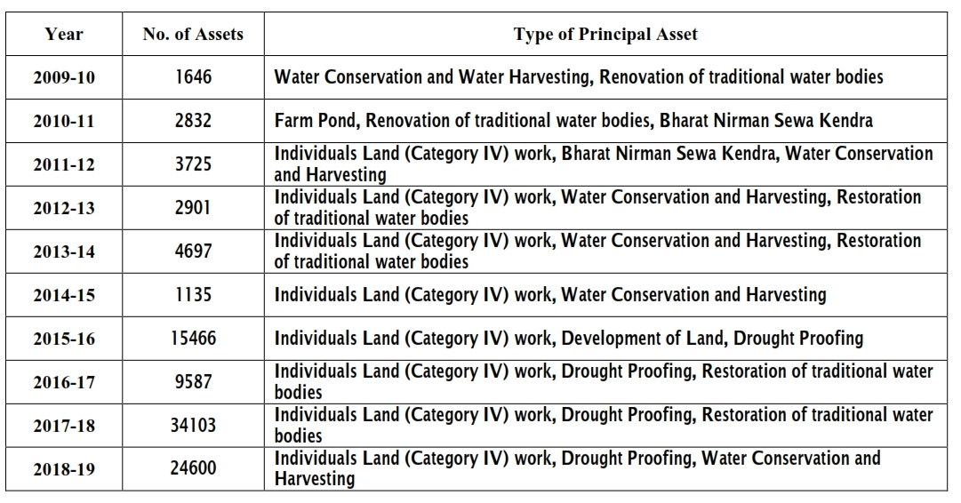
Source: Dashboard of MGNREGA of the year 2018; Dashboard of GeoMGNREGA of the year 2018

The figure 6 shows the LULC map during the year 2009 and 2019. After analysing the time series LULC maps, approvals which change of patches of wastelands to agriculture. The figure 7

showing the maximum NDVI resulting from the tested points at the hotspots that are consuming high strength of land growth activities, irrigation amenities and soil fertility expansion activities. The maximum NDVI is over 250 samples showing sharp progress of the vegetation in the study area. The maximum NDVI have enhanced from 0.40 to 0.52 over duration of 10 years. Around 150 water bodies in the study area were analysed. The figure 7 signifies the samples of GeoMGNREGA website to recover the hotspots evidence of the completed works under MGNREGA. The figure 7 signifies the type of hotspots for numerous resources at block level.

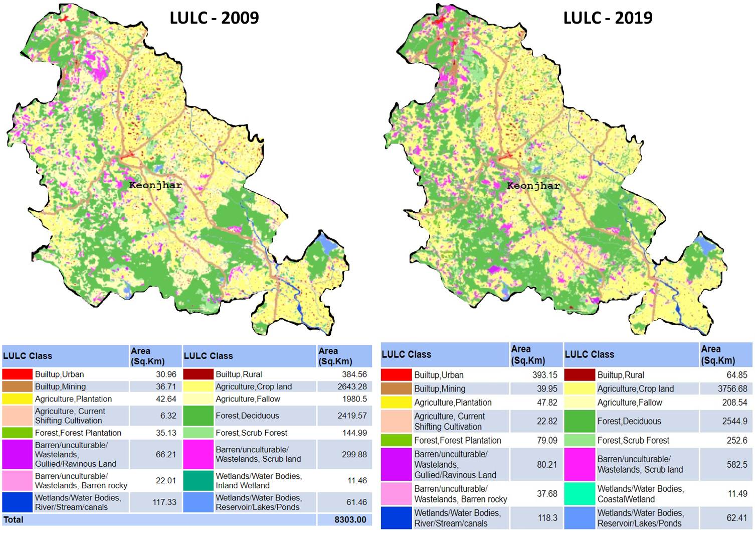
Figure 6. Land Use/Land Cover maps of Keonjhar district (2009 and 2019)
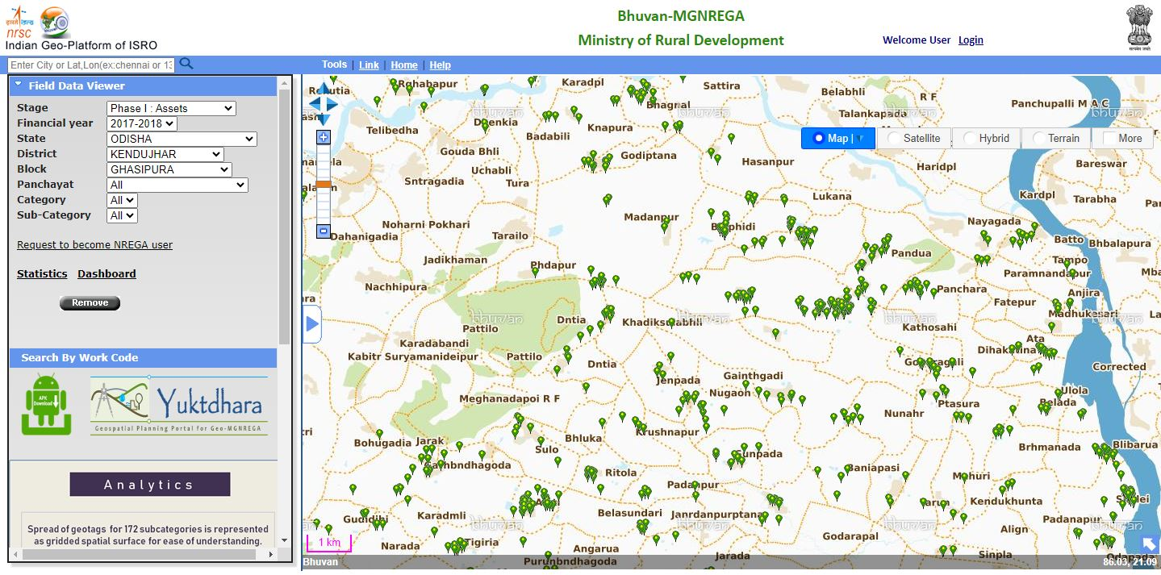
Figure 7. Spatial distribution of resources for the year 2017-2018 in block Ghasipura

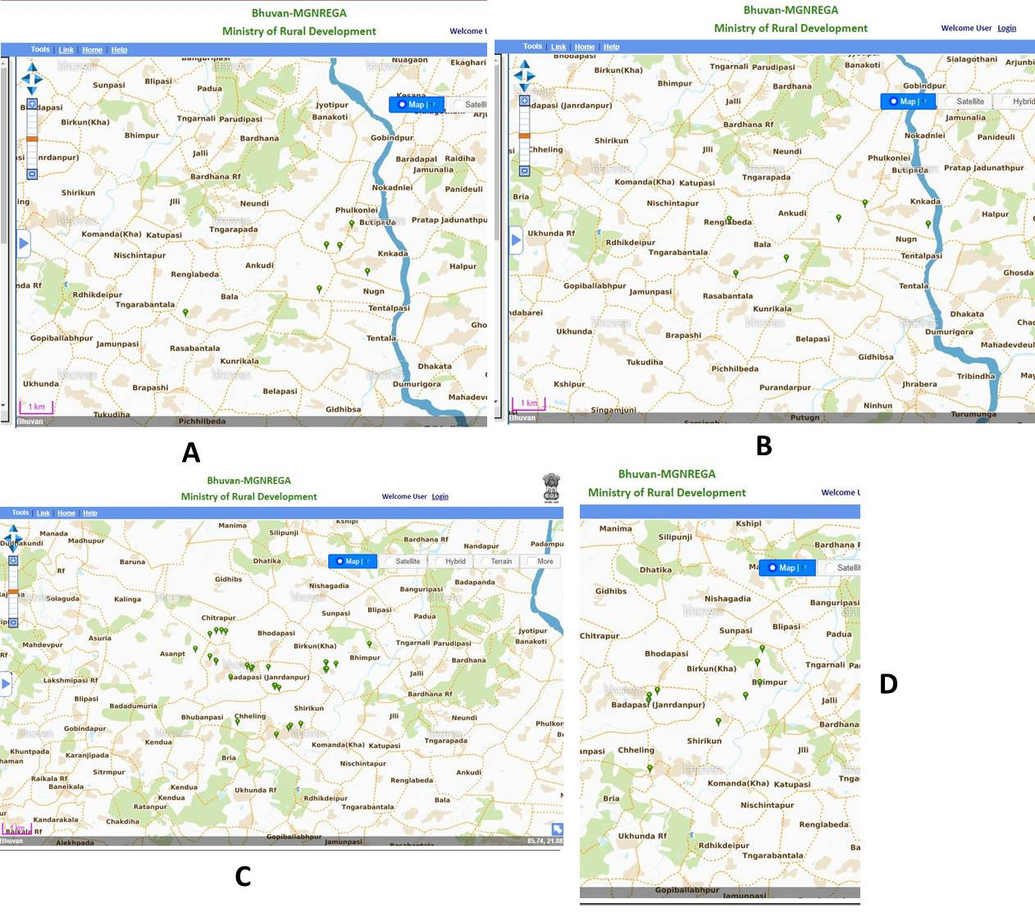
Figure 8. MGNREGA Hotspots of resources in Ghasipura block of Keonjhar district. A - Resources relating to Rural drinking water work. B - Resources relating to Drought proofing. C - Restoration of traditional water bodies. D - Water conservation and harvesting

Table 3. Analysis of dynamics from the geospatial assessors of Keonjhar district (2009 – 2019)
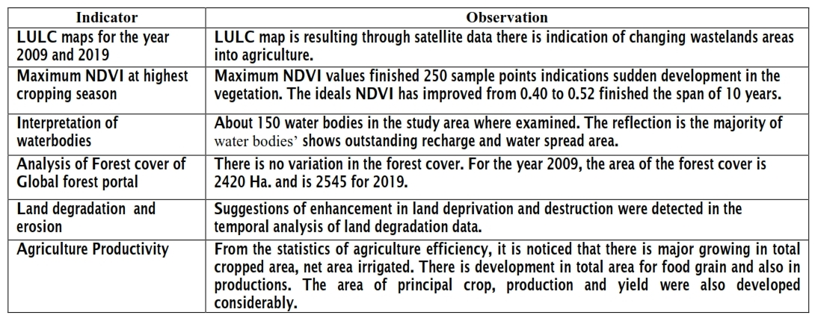

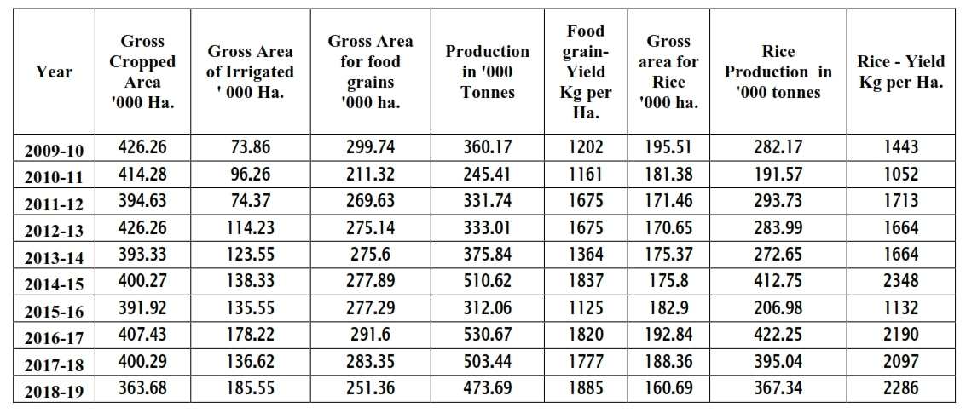
Table 4. Agriculture statistics (2009 – 2019) for Keonjhar district

The Table 3 showing the outcomes achieved for the study. It is detected that there is a developmental plan of land growth for agricultural productivity. Analysis shows that the water harvesting actions have an encouraging influence in the research area for drinking water and irrigation facilities which provided. The water emergency problem faced by farmers during drought period is now pleased after the farm ponds in this area. The farm ponds are used in storing rainwater and continuously increasing the groundwater level in surrounding areas. The vital moisture content for the fields is accessible during the year. Many were incompetent to appliance the impress though farmers were responsive of the concept assumed the values of digging ponds previously, but by MGNREGA programme was finished promising. The visual interpretation technique is used to study the high-resolution satellite data which indicates the development of the renovation of degraded lands.
Numbers of water renovation works were occurred under MGNREGA project in Keonjhar district. These are marked in the VHSR satellite imageries; example has shown in figure 9 where the renovation activities have inclined the water spread area. It is showing an area where the land use patterns have overcome because of land expansion actions.

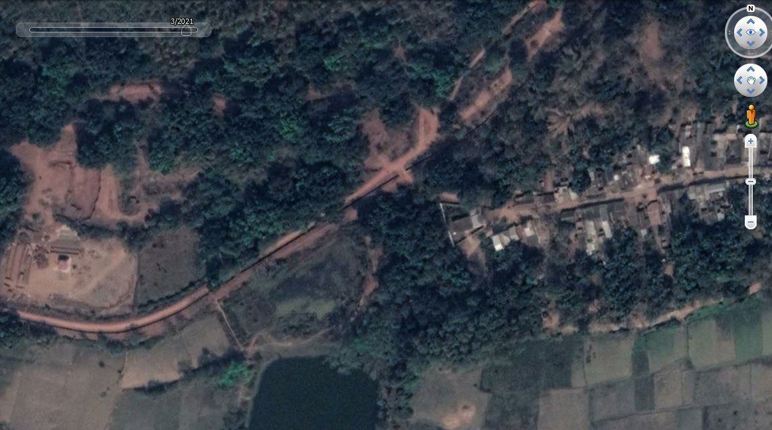
A
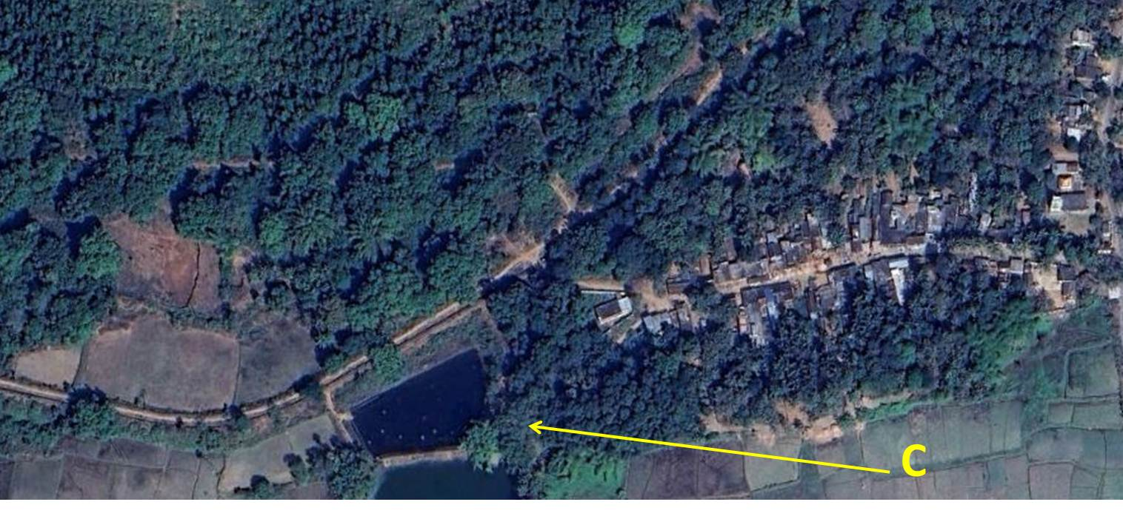
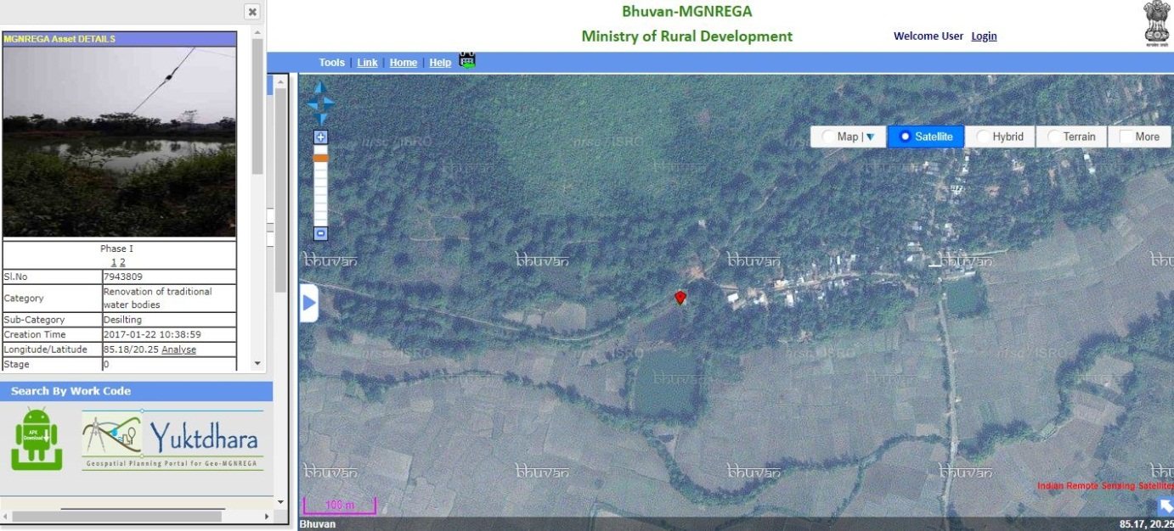
B

Figure 9. Renovation of minor irrigation tank through MGNREGA community work in Keonjhar District. (A) Satellite imagery of March 2017 showing less water spread area in the Reservoir. (B) resources at the reservoir in GeoMGNREGA (C) Satellite imagery of March 2018 with more water spread area.

Conclusion
The analysis concludes that the results which are improved because of resources of MGNREGA community works. The outcomes approve the MGNREGA resources are positively aiding for educating sustainable development which helps to influence on natural resources. The water conservation and gathering have produced in assisting irrigation and drinking water in the research area. Restoration of traditional water bodies and water gathering structures have controlled to developed water availability and therefore the growth in area under irrigated crop production. Maximum minor irrigation tanks have restored to their actual ability. The outcomes of this important programme have facilitated green and blue revolution in the research area. The study describes the community mechanism under MGNREGA are substantial the confident outcomes in all three proportions of SD in resilient rural infrastructure in the measurement of community, increases the viable eco-restoration procedure for the ecosystem through the rural areas rises the socio-economic element at the national level. The study established the process of geospatial technology to extent the profits which are accumulated the environment and socio-economic levels from the community activities of MGNREGA programme.

References

- Allen, P. (1999). Reweaving the food security safety net: Mediating entitlement and entrepreneurship. Agriculture and Human values, 16(2), 117-129.
- Basiago, A. D. (1998). Economic, Social and Environmental Sustainability in Development theory and Urban Planning practice. Environmentalist, 19(2), 145-161.
- Beegle, K., Coudouel, A. & Monsalve, E. (2017). Realizing the Full Potential of Social Safety Nets in Africa, World Bank, Washington, DC.
- Bello, O. M., & Aina, Y. A. (2014). Satellite remote sensing as a tool in disaster management and sustainable development: towards a synergistic approach. Procedia - Social and Behavioral Sciences, 120, 365-373, https://doi.org/10.1016/j.sbspro.2014.02.114.
- Bhatt, U. S., Walker, D. A., Raynolds, M. K., Bieniek, P. A., Epstein, H. E., Comiso, J. C. Zhang, J. (2017). Changing seasonality of panarctic tundra vegetation in relationship to climatic variables. Environmental Research Letters, 12(5). https://doi.org/10.1088/1748-9326/aa6b0b.
- Bose, N. (2017). Raising consumption through India’s national rural employment guarantee scheme. World Development, 96, 245-263. https://doi.org/10.1016/j.worlddev.2017.03.010.
- Burgan, R. E., & Hartford, R. A. (1993). Monitoring vegetation greenness with satellite data. General Technical Report INT-297. Ogden, UT: US Department of Agriculture, Forest Service, Intermountain Research Station (13).
- Campagna, M. (2005). GIS for sustainable development. CRC Press, Boca Raton.
- Desai, S., Vashishtha, P., & Joshi, O. (2015). Mahatma Gandhi National Rural Employment Guarantee Act: A Catalyst for Rural Transformation. National Council of Applied Economic Research, (7259), New Delhi.
- Devuyst, D. (2000). Linking impact assessment and sustainable development at the local level: the introduction of sustainability assessment systems. Sustainable development, 8(2), 67-78. https://doi.org/10.1002/(SICI)1099-1719(200005)8:2<67::AID-SD131>3.0.CO;2-X
- Esteaves, T., Rao, K. V., Sinha, B., & Roy, S. S. (2013). Environmental Benefits and Vulnerability Reduction through Mahatma Gandhi NREGS: A Synthesis Report. Ministry of Rural Development, Government of India and Deutsche GIZ, New Delhi.
- Gaetano, R., Ienco, D., Ose, K., & Cresson, R. (2018). MRFusion: A Deep Learning architecture to fuse PAN and MS imagery for land cover mapping. arXiv preprint arXiv:1806.11452.
- Giribabu, D., Mohapatra, C., Reddy, C. S., & Prasada Rao, P. V. V. (2019). Holistic Correlation of World’s Largest Social Safety Net and its Outcomes with Sustainable Development Goals. International Journal of Sustainable Development & World Ecology, 26(2), 113-128.https://doi.org/10.1080/13504509.2018.1519492.
- Grosh, M.E., Del Ninno, C., Tesliuc, E., & Ouerghi, A. (2008). For protection and promotion: The design and implementation of effective safety nets. The World Bank. Washington, DC.
- Indian Planning Commission. (2007). Eleventh Five Year Plan. Government of India. OUP, New Delhi. Vol. III.
- ISRO (2016), Retrieved from https://www.isro.gov.in/isros-geo-portal-bhuvan-gateway-to-indian-earth-observation.
- MGNREGA Dashboard (2018). Retrieved from http://mnregaweb4.nic.in/netnrega/nrega-reportdashboard/.
- MGNREGA Guide (2019). Master Circular - A Guide for Programme Implementation FY 2018-2019. Retrieved from http://nrega.nic.in/Netnrega/WriteReaddata/Circulars/AMC_2018-19_nk_v3_21.03.18.pdf.
- Narain, P., Rai, S. C., & Bhatia, V. K. (1999). Inter district variation of development in southern region. Journal of the Indian Society of Agricultural Statistics, 52, 106-120.
- Nayyar, R. (2005). Planning for the Development of Backward Districts (2005). Chronic Poverty Research Centre Working Paper. https://dx.doi.org/10.2139/ssrn.1756833.
- Paganini, M., & Petiteville, I. (2018). Satellite Earth Observations in Support of the Sustainable Development Goals, European Space Agency.
- Raju, N. A. (2015). Land capability and suitability in Vizianagaram district of Andhra Pradesh using Remote Sensing and GIS techniques. IOSR Journal of Humanities and Social Science, 20(7), 56-64.
- Ranaware, K., Das, U., Kulkarni, A., & Narayanan, S. (2015). MGNREGA Works and their impacts. Economic & Political Weekly, 50(13).
- Rao, S. N. (2014). Economic restructuring programme: Naidus developmental experiment in Andhra Pradesh, 1995 to 2001. Centre for Political Studies, Jawaharlal Nehru University.
- Shakoor, A., Shehzad, A., & Asghar, M. N. (2006). Application of remote sensing techniques for water resources planning and management. In Advances in Space Technologies, 2006. International Conference, IEEE, 142-146.
- Singh, R. K., Murty, H. R., Gupta, S. K., & Dikshit, A. K. (2009). An overview of sustainability assessment methodologies. Ecological indicators. 9(2), 189-212. https://doi.org/10.1016/j.ecolind.2008.05.011.
- Subbarao, K., Del Ninno, C., Andrews, C., & Rodríguez-Alas, C. (2012). Public works as a Safety Net: Design, Evidence and Implementation. The World Bank, Washington, DC.
- Tiwari, R. et al. (2011). MGNREGA for Environmental Service Enhancement and Vulnerability Reduction : Rapid Appraisal in Chitradurga district, Karnataka. Economic & Political Weekly, 46(2).

