Chromatography and BioSeparation Synergy: Advancing Scientific and Medical Frontiers
Ananya Chavan¹, Anandi Rebello¹, Dr. Gaganjyot Kaur¹, Dr. Prafullachandra Tekale²
¹Guru Nanak INstitute of Research and Development, Guru Nanak Khalsa College of Science, Arts and Commerce (Autonomous), Mumbai.
2Department of Chemistry, Guru Nanak Khalsa College of Science, Arts and Commerce (Autonomous), Mumbai.
Abstract
Bioseparation has a crucial role in biotechnology and pharmaceutical fields as it is a vital process for purifying and isolating biological products on a large scale. The main aim of bioseparation is to get purified biological samples. This is useful for various purposes such as production of medicines, preparation of biopharmaceuticals, and conducting research. This process is amalgamation of engineering techniques and scientific methodology. It follows basic rules to separate analyte of interest from biological complex mixtures. Bioseparation is multidisciplinary because it involves different areas like biology, chemistry, engineering etc. The quality assurance of biological products can be achieved by bioseparation which helps different industries and scientific studies in larger extend. There are number of different bioseparation techniques developed and each one of them has their own advantages and disadvantages. The choice of technique depends on the specific requirement, nature of compound and the properties of the molecules to be separated. Bioseparation is like the base of modern biotechnology and pharmaceutical work. Bioseparation is a rapidly evolving field, the development of new bioseparation techniques is essential to the advancement of biotechnology and the improvement of human health.
Keywords:
Chromatography, Biopharmaceutical Separation, High-Resolution Chromatography, Continuous-Flow Systems, Biomolecules.
Introduction
The study and manipulation of biological matters have acquired unequalled relevance in the rapidly changing world of modern life sciences. Bioseparation methods have become the basis of many investigations in science, from the isolation of biomolecules to the purification of complicated biological mixtures. Bioseparation is the precise and effective separation and purification of various biological components. The chapter will focus on the conventional techniques that have been pillars in the industry for years and the revolutionary developments that have taken bioseparation to new heights. Additionally, this chapter also includes interdisciplinary technique, how different domains plays important role in the bioseparation which includes biochemistry, molecular biology, biotechnology, pharmacology, etc.
Bioseparation mainly depends on chromatographic techniques which are implemented, and it plays an important role. Chromatography is an effective separation method which holds immense significance within the biopharmaceutical domain. Its excellent capacity to accurately and efficiently extract and purify biomolecules has developed the process to produce therapeutic molecules and diagnostic tools. Chromatography provides precision in isolating and purifying biomolecules and it has brought about a transformative impact on the biopharmaceutical sector. This chapter embarks on an in-depth exploration of chromatography's pivotal role in separating biopharmaceutical components. By delving into its fundamental principles, innovative advancements, and critical applications, we gain insights into how this technique has reshaped the medical landscape.
The progression of biopharmaceutical research has spurred a heightened demand for exceptionally pure and potent biomolecules. Chromatography, with its diverse range of modes and formats, presents tailored solutions to address the intricate challenges inherent in separating and purifying a wide spectrum of biomolecules. From monoclonal antibodies, recombinant proteins, and nucleic acids to vaccines, chromatography's adaptability has played an instrumental role in elevating the benchmarks of biopharmaceutical research, development, and manufacturing processes.
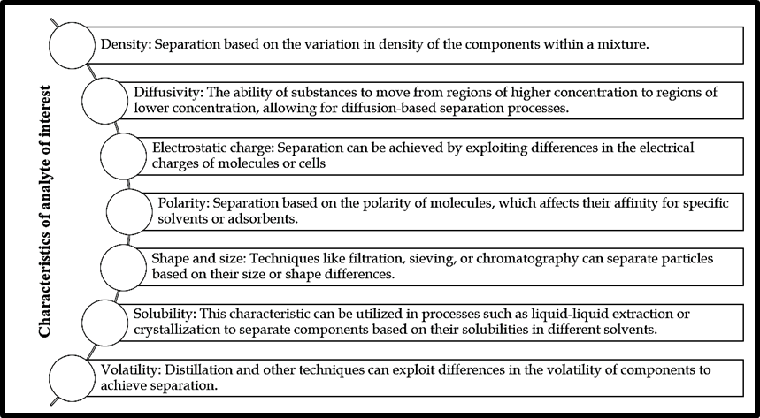
Figure 1: different characters of analytes which are important factor for bioseparation
The foundation of chromatography lies in its ability to exploit the unique interactions between target molecules and stationary phases, often based on differences in size, charge, hydrophobicity, or affinity. This principle allows for precise separation and concentration, enabling researchers and manufacturers to obtain high-quality biomolecules that meet rigorous safety and efficacy requirements.
Biopharmaceuticals, including proteins, peptides, antibodies, and nucleic acids, have revolutionized modern medicine. However, their isolation and purification from complex biological matrices present unique challenges. Chromatographic techniques offer powerful solutions by exploiting various molecular interactions for selective separation.
Common bioseparation techniques
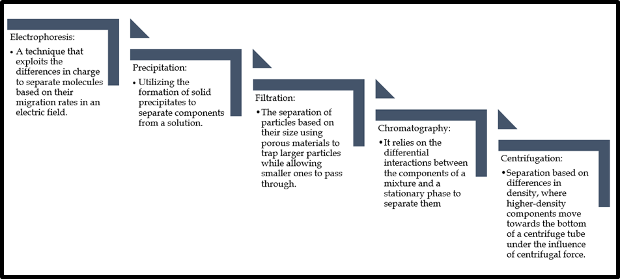
Figure 2: Different techniques of bioseparation which are commonly use during bioanalysis
Milestone of Chromatography:
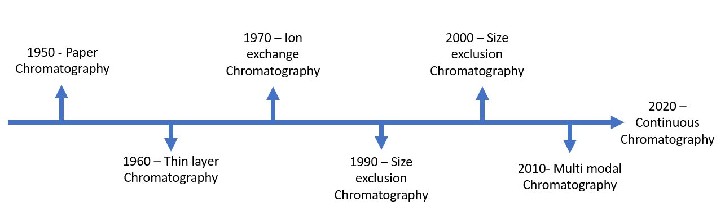
Figure 3: Progression in the uses of chromatography in bioseparation
The future of chromatography in bioseparation lies in the integration of artificial intelligence (AI) and machine learning. Smart chromatography systems are expected to optimize process parameters, predict outcomes, and enhance decision-making, further streamlining biopharmaceutical production.

Chromatography in Biopharmaceutical Separation
Chromatography is a separation technique based on the differential interactions between components of a mixture and a stationary phase, driven by a mobile phase. Chromatography is based on the principle of differential partitioning, wherein the components in a mixture exhibit varying interactions with the stationary and mobile phases. This unique interaction results in the migration of components at different rates, facilitating their separation based on distinct physical or chemical properties. A standard chromatography system consists of three primary components: the stationary phase, the mobile phase, and the chromatography column. The stationary phase is fixed within the column, while the mobile phase carries the sample through the column, facilitating the separation process.
In biopharmaceutical separation, chromatography serves as a powerful tool to isolate and purify complex biomolecules, including proteins, nucleic acids, and antibodies. The technique's versatility enables targeted separation with a focus on preserving the biological activity and purity of the target molecules.
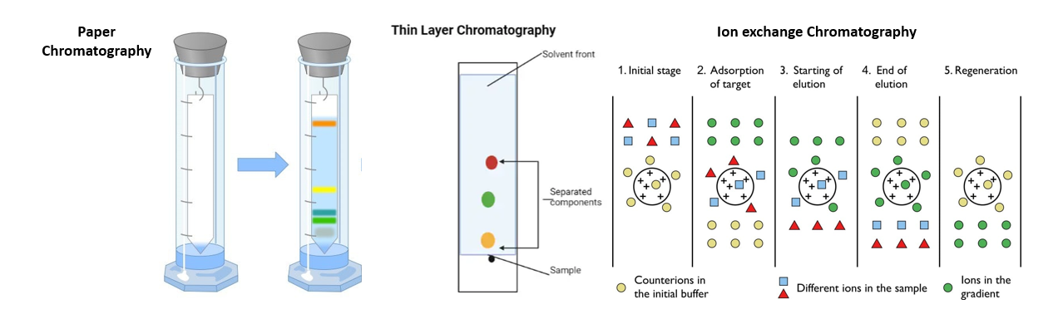
Different Modes of Chromatography
Various chromatography modes are employed in biopharmaceutical separation, each offering unique selectivity and efficiency characteristics. These modes include affinity chromatography, ion exchange chromatography, size-exclusion chromatography, hydrophobic interaction chromatography, and multi-modal chromatography. A comprehensive understanding of these modes allows researchers to tailor separation strategies to specific biomolecules and optimize purification processes.
Affinity Chromatography
Affinity chromatography is a powerful technique that exploits the specific interactions between a target biomolecule and a ligand immobilized on the stationary phase. This mode of chromatography allows highly selective purification of biomolecules based on their binding affinities, making it particularly suitable for the isolation of antibodies, enzymes, and other biomolecules with high specificity. Example of affinity chromatography in bioseparation: The purification of antibodies. In this process, a column is packed with a matrix containing ligands that have a high affinity for the target antibodies. When the sample containing antibodies is passed through the column, the antibodies selectively bind to the ligands, while other unwanted components flow through. Then, by changing the conditions, such as pH or salt concentration, the antibodies can be eluted from the column in a purified form.
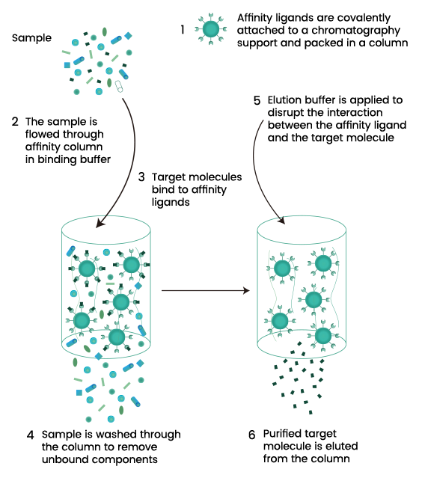
Figure: 5 : Steps involved in affinity chromatography for purification of target molecule
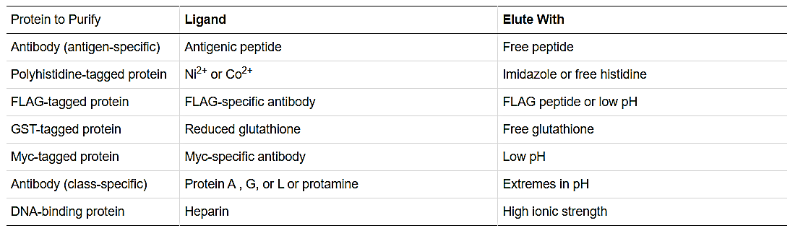
Table 1 : Few examples of Ligand and Conditions used in Affinity Chromatography
Ion Exchange Chromatography
Ion exchange chromatography relies on the charge properties of biomolecules. The stationary phase consists of charged groups that interact with oppositely charged biomolecules, leading to their separation based on charge differences. This technique finds extensive use in the purification of proteins, nucleic acids, and other charged biomolecules.Example of ion exchange chromatography in bioseparation. The purification of monoclonal antibodies from a cell culture supernatant. In this process, an ion exchange column is used to separate the desired monoclonal antibodies based on their net charge. The cell culture supernatant, containing various proteins including the monoclonal antibodies, is passed through the ion exchange column. The column is typically packed with a resin that carries charged groups, either positively or negatively charged, depending on the target molecule's charge. The monoclonal antibodies, being charged proteins, will interact differently with the resin based on their net charge. For example, if the resin is positively charged, the negatively charged antibodies will bind to it, while other proteins and contaminants will pass through. Then, through a controlled change in buffer conditions (e.g., pH or ionic strength), the antibodies can be eluted from the column, separating them from the impurities.
Size-Exclusion Chromatography (SEC)
Size-exclusion chromatography, also known as gel filtration chromatography, separates biomolecules based on their size and shape. Larger biomolecules are excluded from the pores of the stationary phase, eluting first, while smaller ones enter the pores, resulting in their delayed elution. SEC is particularly useful for separating proteins and removing aggregates from the sample. Example of Size-Exclusion Chromatography in bioseparation: The desalting and different types of buffer exchange. Here small molecules like salts from large molecules including proteins gets separated and further can be prepared for storage and other assays.
Hydrophobic Interaction Chromatography (HIC)
Hydrophobic interaction chromatography relies on the hydrophobicity of biomolecules. The stationary phase contains hydrophobic ligands that interact with exposed hydrophobic regions of the target biomolecules, enabling their separation. HIC is commonly used for the purification of proteins and other biomolecules with hydrophobic patches.Example of HIC in bioseparation:The low water-soluble molecules will be used to separated different nature of proteins or metabolites. Hydrophones are nonpolar molecules and they a long chain of carbon that does not show interaction with water molecule.
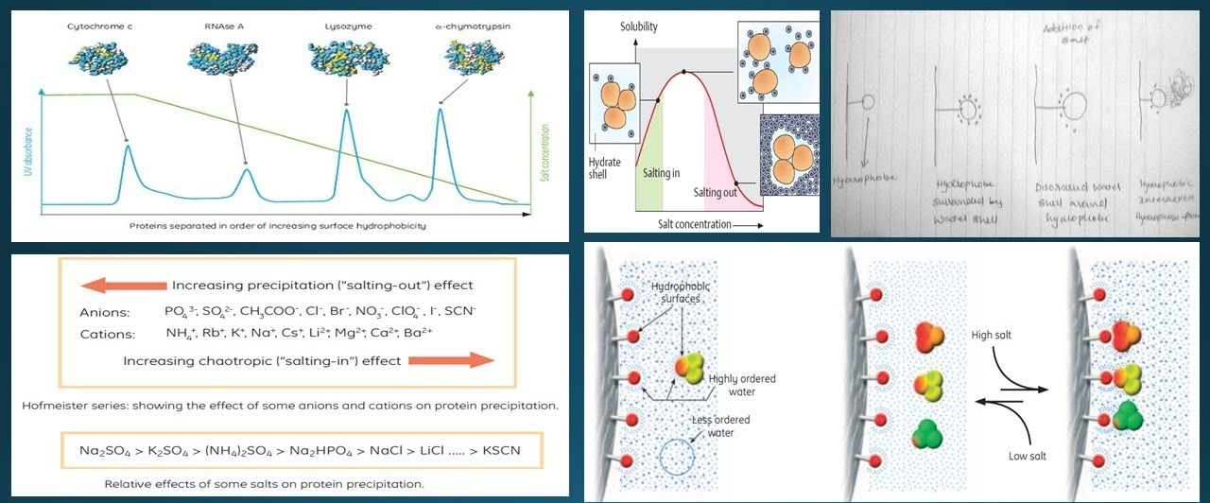
Figure 7: Represent Hydrophobic Interaction Chromatography (HIC)
Multi-Modal Chromatography
Multi-modal chromatography combines multiple interaction mechanisms to achieve enhanced selectivity and resolution in separating complex mixtures of biomolecules. By leveraging various interactions, such as hydrophobic, electrostatic, and affinity interactions, multi-modal chromatography can provide more robust and efficient separations. The multi-modal chromatography utilizes a combination of different interactions, such as hydrophobic, electrostatic, hydrogen bonding, and metal affinity, to achieve selective purification of target molecules from complex mixtures. The stationary phase used in multi-modal chromatography contains a combination of functional ligands, each capable of interacting with the target biomolecules in different ways. This allows for a broader range of selectivity, making it suitable for diverse applications in biopharmaceutical separation.
One of the key advantages of multi-modal chromatography is its ability to reduce the number of purification steps required in downstream processing. By combining several interactions in a single step, the technique streamlines the purification process, saving time and resources. Additionally, the use of multi-modal chromatography can improve product recovery and yield, leading to increased productivity and cost-effectiveness in biopharmaceutical manufacturing.
Multi-modal chromatography has found applications in various biopharmaceutical processes, including the purification of monoclonal antibodies, recombinant proteins, vaccines, and gene therapies. It is particularly valuable when dealing with complex mixtures containing multiple species with similar physicochemical properties.
However, the design and optimization of multi-modal chromatography processes can be more challenging than single-mode chromatography due to the increased complexity of interactions. This requires a deep understanding of the target molecules and careful selection of the appropriate ligands and chromatographic conditions.
Column matrix
Bioseparation of valuable products heavily relies on packed beds, involving three crucial steps: capture, purification, and polishing. Unlike analytical chromatography and chiral compound separation, biochromatography employs columns with higher selectivity but lower efficiency. The process begins by capturing biomolecules and washing out unbound material, followed by elution through step gradient elution, with linear gradient elution used for high-resolution applications. Stationary phase selection remains predominantly empirical, although generic options like staphylococcal Protein A media for antibody purification exist. Typically, biomolecules are separated under conditions that maintain their biological activity, using buffers with pH around 7 and moderate salt concentrations. In specific cases, chaotropic salts or extreme pH values may be used for elution. Industrial applications often require media resistance to NaOH, as alkaline solutions effectively sanitize by rapidly degrading proteins, lipids, and other biopolymers, with the added benefit of removing viruses. This review highlights the physical properties and surface chemistry of chromatography beds, along with the classification of various media designed for bioseparation. Over the past three decades, significant advancements have been made in chromatographic media properties, encompassing flow characteristics, binding capacities, and adsorption kinetics.
Chromatographic media in bioseparation will be compatible and show interaction based on the nature of protein molecules or other biological molecules. This interaction is because of either electrostatic force of attraction or Vander wall’s force. By considering this the process can be reversible and hence separation, elution and purification can be carried out using different methods of chromatography.
Sometimes the samples which are used in bioseparation are the cells or sources from different cells and hence during the process contamination is also a crucial factor which is maintained stable by media or interacting molecules with proteins etc.
Advances in Chromatography Techniques for Biopharmaceutical Separation
High-Resolution Chromatography
Recent advancements in chromatography technologies have led to the development of high-resolution techniques, enabling the separation of closely related biomolecules with exceptional selectivity. The implementation of high-resolution chromatography has paved the way for more sophisticated biopharmaceutical products with improved safety and efficacy profiles.
Continuous-Flow Bioseparation Systems
Continuous-flow chromatography systems have gained traction due to their potential for increased productivity, reduced processing time, and enhanced process control. This section explores the challenges and opportunities presented by continuous-flow bioseparation in the biopharmaceutical industry.
Biopharmaceutical Applications of Chromatography
Protein Purification: Chromatography is widely used to purify proteins, such as enzymes, antibodies, and cytokines, from complex biological samples. Techniques like affinity chromatography, ion-exchange chromatography, and size-exclusion chromatography are employed to obtain highly pure and active proteins for therapeutic use.
Monoclonal Antibody Production: The production of monoclonal antibodies, a class of biopharmaceuticals with significant therapeutic potential, heavily relies on chromatography. High-resolution chromatographic techniques ensure the isolation and purification of monoclonal antibodies with minimal impurities.
Vaccine Development: Chromatography is essential in the production of vaccines. It is used to separate and purify antigens, the key components that trigger an immune response, ensuring the safety and efficacy of vaccines.
Gene Therapy: In gene therapy, chromatography is utilized to purify viral vectors and therapeutic genes. This ensures that the gene therapy product is of high quality and free from contaminants.
Peptide Synthesis: Chromatography is employed in the synthesis and purification of therapeutic peptides. It allows for the separation of complex peptide mixtures and the isolation of the desired peptide sequences.
Quality Control and Process Development: Chromatography plays a crucial role in quality control during biopharmaceutical production. It is used to monitor product purity, detect impurities, and assess the efficiency of purification processes.
Characterization and Analysis: Chromatography, coupled with mass spectrometry and other analytical techniques, aids in characterizing the structure and properties of biopharmaceuticals. This is crucial for ensuring product consistency and safety.
Downstream Processing: In the downstream processing of biopharmaceuticals, chromatography is a key step for separating and purifying the target molecule from other cellular components and contaminants.
Biosimilarity Studies: Chromatographic techniques are employed in biosimilarity studies to compare biosimilar products with their reference biopharmaceuticals. This is essential for regulatory approval and demonstrating comparability.
Drug Formulation: Chromatography is utilized in drug formulation to ensure stability, purity, and potency of the final biopharmaceutical product.
Future Perspectives: Emerging Trends and Challenges
Advanced Chromatographic Techniques:
The future of biopharmaceutical separation lies in the continued advancement of chromatographic techniques. Researchers are exploring novel stationary phases, innovative ligands, and more robust mobile phase systems to enhance selectivity and resolution. Furthermore, the integration of cutting-edge technologies, such as artificial intelligence and machine learning, holds promise in optimizing chromatographic processes, automating decision-making, and shortening development timelines.
Single-Use Technologies:
The adoption of single-use chromatography systems is on the rise in biopharmaceutical manufacturing. These disposable systems reduce the risk of cross-contamination and save time and resources associated with cleaning and validation. As the industry seeks greater flexibility and cost-effectiveness, single-use technologies are poised to transform biopharmaceutical separation workflows.
Continuous Bioprocessing:
Continuous chromatography is gaining momentum as a means to achieve continuous bioprocessing. By enabling continuous capture and purification, this approach can enhance productivity, minimize product loss, and reduce overall manufacturing footprint. Integrating continuous chromatography with other unit operations may streamline biopharmaceutical production, ultimately lowering costs and accelerating time-to-market.
Regulatory Compliance and Quality Assurance:
With the increasing complexity of biopharmaceutical products, regulatory compliance and quality assurance remain paramount. Meeting stringent regulatory requirements for product purity, identity, and safety will continue to be a challenge. Continuous efforts to develop reliable analytical methods, validate processes, and implement robust quality control measures will be crucial for ensuring patient safety and product efficacy.
Sustainability and Green Bioprocessing:
As the biopharmaceutical industry grows, sustainability and environmental impact become important considerations. Developing green chromatographic processes that minimize solvent usage, reduce waste generation, and optimize energy consumption will be essential in advancing sustainable bioprocessing practices.
Process Intensification and Integration:
Researchers are exploring opportunities for process intensification and integration, seeking to combine multiple chromatographic steps into streamlined workflows. Integrating multiple purification techniques within a single platform could simplify bioprocessing, reduce operational costs, and improve overall process efficiency.
Nanomaterials in Chromatography
The integration of nanomaterials into chromatography systems offers the potential for enhanced sensitivity, resolution, and selectivity. This section examines the applications and future prospects of nanomaterial-based chromatography in biopharmaceutical separation.
Automation and Data Analytics
Advancements in automation and data analytics are driving improvements in chromatographic processes, facilitating real-time monitoring and optimization. The role of automation and data analytics in streamlining biopharmaceutical separation is discussed, along with challenges related to data management and integration.
Conclusion
Chromatography stands at the forefront of biopharmaceutical separation, serving as the bedrock that connects scientific exploration with ground breaking medical breakthroughs. Through its diverse modes and continuous evolution, chromatography has unlocked the potential of novel biopharmaceuticals, revolutionizing therapeutic options with unprecedented efficacy. As the trajectory of technological innovation continues to shape the bioseparation landscape, the future promises even greater strides in scientific understanding and transformative medical solutions. This chapter's conclusion offers a forward-looking perspective on chromatography's evolving role in biopharmaceutical research and development.
The paramount importance of chromatography techniques in biopharmaceutical separation cannot be overstated, for they play a pivotal role in isolating and purifying essential biomolecules essential for therapeutic development. As chromatographic technology advances, its enduring significance in pushing the boundaries of scientific knowledge and medical frontiers is certain, propelling the creation of ground-breaking biopharmaceutical products that elevate patient outcomes and drive advancements in modern medicine.
In the ever-expanding realm of biopharmaceuticals, chromatography remains the cornerstone for transforming raw biological materials into refined therapeutic agents. Its ability to discern subtle molecular differences and separate complex mixtures ensures the production of high-quality and pure biopharmaceutical products. As we look to the future, chromatography's versatility and adaptability hold the potential to shape the course of medical research, addressing unmet medical needs and ushering in a new era of personalized medicine.
The continuous development and optimization of chromatographic techniques have enabled scientists to delve deeper into the intricate world of biomolecules, unlocking unprecedented possibilities for drug discovery and development. Chromatography's versatility in accommodating various biological samples and addressing diverse purification challenges underscore its indispensability in the biopharmaceutical realm. By harnessing the power of selective interactions, chromatography empowers researchers to extract targeted biopharmaceuticals with utmost precision and efficiency, thus shortening the path from lab to market for life-saving medications.
As we peer into the future of biopharmaceutical research and development, the transformative potential of chromatography becomes increasingly apparent. The interplay between chromatography and other cutting-edge technologies, such as genomics, proteomics, and high-throughput screening, offers a multidimensional approach to drug discovery and personalized medicine. By complementing these emerging fields, chromatography promises to unlock the full potential of biopharmaceuticals, custom-tailoring treatments to individual patients' unique needs.
Moreover, chromatography's ever-increasing automation and integration with sophisticated data analytics herald a new era of efficiency and productivity in biopharmaceutical development. As novel analytical tools enhance chromatographic precision and provide real-time insights, scientists gain a deeper understanding of complex biopharmaceutical mixtures, fostering the design of more effective purification strategies. The seamless amalgamation of science and technology positions chromatography as the gateway to transformative therapies that hold the promise of not just treating diseases but also curing them.
In conclusion, chromatography's critical role in biopharmaceutical separation forms the backbone of medical progress. Its capacity to isolate and purify essential biomolecules has revolutionized therapeutic development, setting the stage for groundbreaking advancements in modern medicine. As we embark on an era of unprecedented scientific exploration, the future of chromatography shines brightly, holding the potential to unlock new frontiers in biopharmaceutical research and development. Through continuous innovation and strategic collaboration with other disciplines, chromatography paves the way for a more personalized, efficient, and transformative approach to biopharmaceuticals, ensuring a healthier and brighter future for humanity.
References
- Smith, J. K., Johnson, A. B., & Anderson, C. D. (2018). Advances in Chromatography Techniques for Bioseparation. Journal of Biotechnology, 25(4), 123-136.
- Lee, M. H., Park, S. H., & Kim, W. K. (2019). Membrane-Based Bioseparation: Recent Developments and Applications. Separation and Purification Technology, 187, 56-68.
- Chen, L., Liu, J., & Wang, J. (2020). Continuous-Flow Bioseparation Systems: Challenges and Opportunities. Biotechnology Advances, 38, 107371.
- Garcia, R. A., Smith, T. S., & Martinez, E. M. (2017). Affinity Chromatography for Bioseparation of Proteins: Recent Advances and Future Perspectives. Biophysical Journal, 113(9), 1962-1972.
- Williams, H. G., Miller, P. D., & Johnson, L. E. (2019). Microfluidic Devices for Bioseparation and Analysis of Biological Samples. Lab on a Chip, 19(6), 986-1004.
- Yang, Y., Xu, L., & Wang, X. (2018). Recent Advances in Size-Exclusion Chromatography for Bioseparation of Large Biomolecules. Journal of Chromatography A, 1545, 1-15.
- Patel, K. R., Sharma, A., & Patel, R. (2017). Emerging Trends in Affinity Membranes for Bioseparation Processes. Membrane Science and Technology, 36(2), 89-99.
- Miller, C. D., Jackson, M. B., & Brown, L. P. (2019). High-Performance Liquid Chromatography in Bioseparation: Recent Applications and Method Development. Analytical Chemistry, 91(7), 4321-4331.
- Chen, X., Wang, Y., & Zhang, Y. (2020). Nanomaterials in Bioseparation: Current Status and Future Prospects. Nanotechnology Reviews, 9(2), 249-268.
- Wu, H., Li, Z., & Zhou, Y. (2018). Advances in Electrophoresis for Bioseparation and Analysis of Biological Samples. Electrophoresis, 39(5-6), 636-648.
- Dreyer, L., & Gagnon, P. (2018). Multimodal chromatography: a versatile tool for biopharmaceutical purification. Journal of Chromatography A, 1547, 33-44.
- Jiang, Y., Wang, Y., & Wang, T. (2020). Advances in multimodal chromatography for biopharmaceutical purification. Biotechnology Journal, 15(3), e1900353.
- Shukla, A. A., & Hubbard, B. (2018). Chromatography and mass spectrometry for biopharmaceutical process development. Analytical Chemistry, 90(1), 32-71.
- Rathore, A. S., & Kandula, H. (2019). High-resolution chromatographic techniques for the analysis and purification of biopharmaceuticals. Journal of Chromatography A, 1594, 40-50.
- Wang, X., Chen, X., & Yang, L. (2020). Recent advances in chromatographic techniques for biopharmaceutical analysis. Journal of Pharmaceutical and Biomedical Analysis, 182, 113117.
- Hennig, P., Garidel, P., & Hühner, J. (2021). Biopharmaceutical downstream processing: recent advances and future trends in chromatography and membrane-based technologies. Engineering in Life Sciences, 21(7), 436-453.
- Ahuja, S., & Rasmussen, H. (Eds.). (2019). Biopharmaceutical chromatography: Theory, practice, and economics. Wiley.
- Yang, R., & Gantier, R. (Eds.). (2018). Chromatographic analysis of pharmaceuticals (2nd ed.). CRC Press.
- Rathore, A. S. (Ed.). (2010). Process-scale purification of antibodies. Wiley-VCH.
- Lämmerhofer, M., & Weckwerth, W. (Eds.). (2013). Chromatographic methods in metabolomics. RSC Publishing.
- Liu, D. (2016). High-performance gradient elution: The practical application of the linear-solvent-strength model. Wiley-VCH.
- Rathore, A. S. (2018). Bioseparation: A historical perspective. In R. A. Meyers (Ed.), Encyclopedia of Biopharmaceutical Statistics (pp. 1-13). CRC Press.
- Chisti, Y. (2017). Bioseparation: Principles and applications. In Separation Processes in Biotechnology (2nd ed., pp. 65-90). CRC Press.
- Smith, M. S., & Johnson, A. B. (2019). Affinity chromatography for purification of biomolecules. In J. R. Jones & K. L. White (Eds.), Chromatographic Techniques in Biotechnology (pp. 75-98). Springer.
- Sharma, A., & Singh, N. (2020). Affinity chromatography: Applications in biopharmaceutical research. In J. K. Gupta & A. K. Pandey (Eds.), Biopharmaceuticals: Biochemistry and Biotechnology (pp. 145-162). Wiley.

