ASSESSMENT OF ADDITIONAL FLOOR OVER THE EXISTING PARTIALLY CONSTRUCTED BUILDING AT SRINGERI, CHIKKAMAGALURU DISTRICT KARNATAKA

Pramod K R
Asst.Prof Civil Engineering
¹pramodraghu619@gmail.com,
Sapthagiri College of Engineering, Bangalore57

N Lakshminarasimaiah2
Professor & Head of the Civil Engineering
2laknar_05@yahoo.com
APS College of engineering,
Bangalore-82r

M.B. Ananthayya3
Professor & Head of the Civil Engineering
, ³ananthayya.mb@saividya.ac.in
SVIT College of engineering, Bangalore-64

LATHA M S⁴
³Professor & Head of the Civil Engineering
⁴lathamsm@yahoo.co.in
SVCE College of engineering, Bangalore-57

Siddesh B H
Structural engineer
Siddeshbanghera@outlook.com
Enstructura Consultants (Pvt) Ltd
Bangalore- 560 062

ABSTRACT

In order to evaluate the structural soundness and feasibility study for the construction of number of floors on the existing partially constructed building, detailed physical observations were made to understand the existing structural system, Dimensional measurement of the existing RC members was verified at various levels. Non-destructive/Semi- destructive tests were carried out to assess the strength / condition of structural members. The framing layout at different levels and results of the non-destructive tests were used as in-put data for carrying out independent theoretical analysis and design check of the existing critical structural members using structural analysis software “ETABS”. Based on the observations, results of Non-destructive tests, theoretical verification / design check, appropriate restoration measures are recommended for the deficient structural members.

Keywords—RC frame,load bearing wall,existing building

INTRODUCTION

The existing partially constructed SBI building at Sringeri Taluk, Chikkmagalur district is a combination of RC framed and loadbearing wall structure (size-stone masonry walls) comprising of part-basement and columns are raised in ground floor level up-to lintel height. It was reported that, the construction work was stopped during the year 2002 (20 years back) due to some administrative issue.Now the concerned authorities are planning to continue the construction work. In view of this, they desired to assess the structural soundness and feasibility study to verify the number of floors which can be constructed on the existing partially constructed building.Hence, a reference was made to Enstructura Consultants (Pvt) Ltd., Bengaluru, by the concerned authorities to assess the structural soundness and to evaluate the feasibility study for construction of number of floors over the existing building.In response to this, a detailed evaluation study was carried out by us on 13th and 14th August, 2022. This report, in brief, summarizes the outcome of the inspection carried out.

II. PHYSICAL OBSERVATIONS
Building details:
Following are the structural details collected at site.
1. Building comprises of part-basement and ground floor (Without roof)
2. In the profile of the natural ground level, downward slope (approximately 5 to 6 mt) was observed from front side to rear side of the building. Hence part basement floor was provided.
3. Part of the basement floor is proposed to be used as strong room/treasury.
4. Plinth beam was not provided in longer span/direction at ground floor level.
5. Building is a combination of RC framed and size stone masonry load-bearing wall structure, where the peripheral RC Columns are supported on strip foundation (1.0m Width) and size-stone masonry wall foundation was observed throughout the periphery of the building. Following are the observations made consequent to detailed inspection of the building:
1) No Signs of foundation settlement was observed in any part of the building.
2) Accumulation of debris, growth of vegetation/weeds and stagnation of water was observed on RC slab at ground floor.
3) Growth of weeds in the setback region and algae/ fungus growth on RC members, size stone masonry walls was observed.
4) Water leakage from basement ceiling slab was observed at few locations.
5) Column extension and staircase dowel rebars are exposed to atmosphere for a long period leading to corrosion stains.
6) It was observed that a few column reinforcements are corroded at floor level in ground floor.
7) Spalling of cover concrete/exposure of rebars was observed in RC beams in basement floor ceiling level.
In order to evaluate the structural soundness of the building, following probing tests were resorted to:
- Verification of dimensional measurements of all structural members.
- Examination of foundation system and verification of soil at founding level.
- Semi-Destructive test on RC columns to assess the compressive strength of in-situ concrete
- Non-destructive tests to assess the quality / strength of in-situ concrete in RC members.
- Rebound Hammer test on RC members.
- Ultrasonic Pulse Velocity test on RC columns and beams.
- Cover-meter studies to map the disposition of reinforcement and cover concrete thickness in RC members.
- Carbonation test on rc members.
- Dimensional verification of structural RC members.
- Detailed physical observations were made to understand the existing structural system. Detailed dimensional measurement verification of the existing RC members was made at various levels and recorded for theoretical verification.
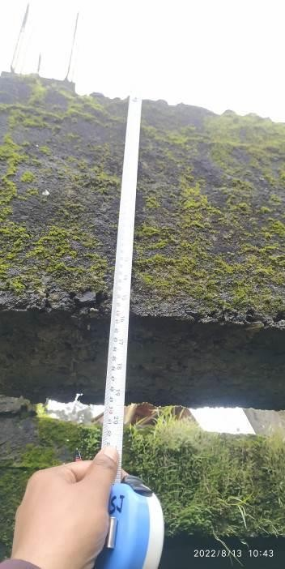

Fig-1 Physical dimensional measurement is in progress (Photo No 12)
- Examination of foundation system and verification of soil at foundation level.

To examine the foundation system and to verify the soil at founding level, trial pits at random / accessible region were excavated (two locations) adjacent to the column up to founding level.
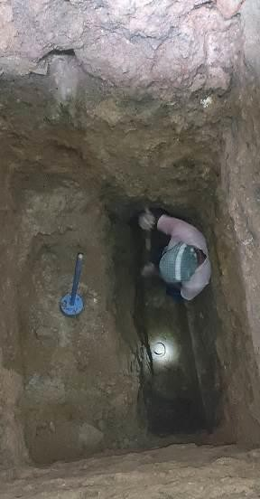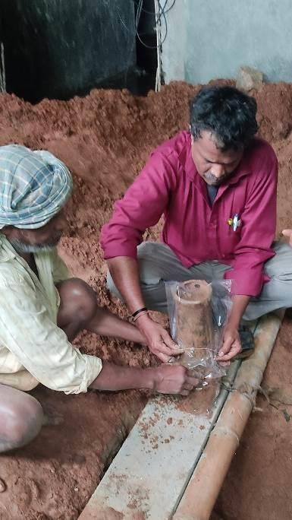

Fig-2 Examination of existing foundation and soil sample collection

From the results of soil investigation test, it is revealed that the soil is Blackish/Yellowish Sandy Silt with mica and Safe bearing capacity is 15 t/m² at 3.0 m depth from the basement floor level.

Semi-Destructive test on RC columns to assess the compressive strength of in- situ concrete.
In order to assess the strength of concrete, Semi-destructive test such as core test was resorted. The core samples were extracted from identified RC columns for laboratory tests. The extracted core samples were subjected to compressive strength test after necessary trimming and capping as per the guidelines in IS: 516: Part 4: 2018.
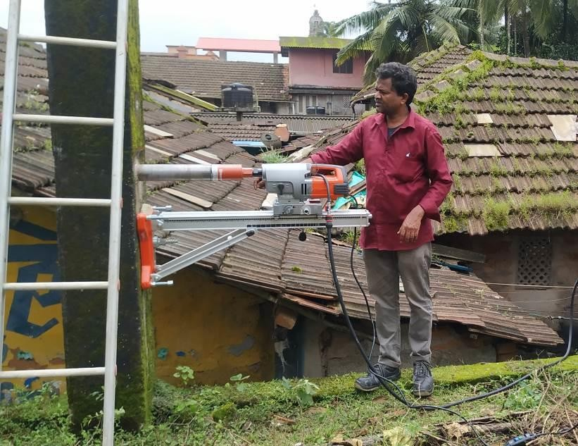

Fig-3 Core extraction in process
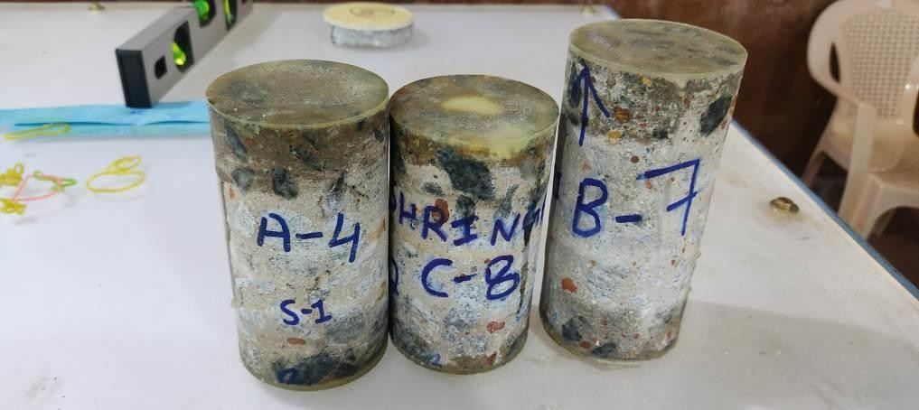
Fig-4 Extracted core samples

From the results of the Semi-Destructive test, it is inferred that the compressive strength of in-situ concrete in tested RC columns is found to be in the range of 21 N/sq.mm to 24 N/sq.mm.

- Non-Destructive tests to assess the quality / strength of in-situ concrete in RC members.

Rebound Hammer test on RC members:

Rebound Hammer test was carried out on the RC members at random in order to assess the surface hardness / quality and strength of in-situ concrete. The tests were conducted using Schmidt Rebound Hammer from M/s. Proceq, Switzerland as per the guidelines in Indian Standard IS: 516-(Part-5/Section 4)-2020. Position of hammer during testing was horizontal /vertical.

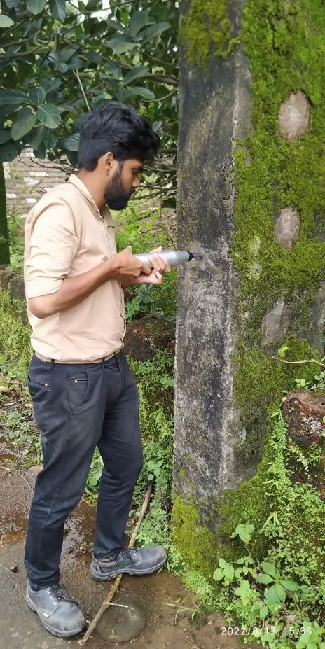
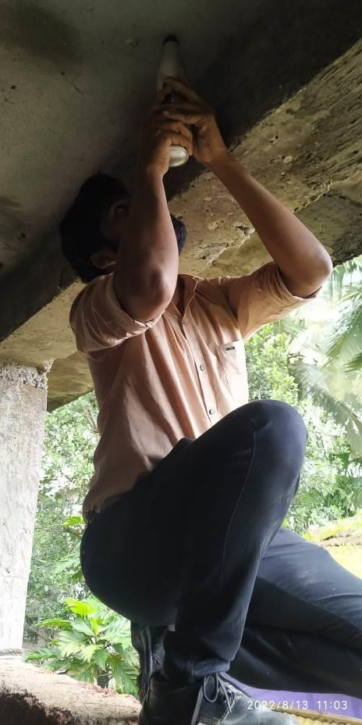

Fig-5 Rebound Hammer test on rc members in progress.

From the results of the Rebound Hammer test, it is revealed that the estimated strength of concrete in the tested RC columns is found to be in the range of 23 to 28 N/sq.mm, where as in slab and in RC Wall it is in the range of 18 to 20 N/sq.mm.
- Covermeter studies to map the disposition of reinforcement in RC members. Covermeter test was carried out on RC members at random in order to assess the thickness of cover concrete and dia of peripheral rebars. The test was conducted using Profometer-5+ from M/s. Proceq, Switzerland. The results of the test are

Fig-5 Cover meter study on RC Column

From the results of Covermeter test, it is revealed that the cover concrete provided to the rebars is as mentioned below at unaffected regions.
- For columns - 30 to 45 mm
- For beams – 20 to 30 mm
- For Slabs – 20 to 25 mm**
**Inclusive of plaster.

The provided cover concrete in RC members is Satisfactory in unaffected regions.

Carbonation test on rc columns.
Carbonation test was carried out on rc column using phenolphthalein indicator in dilute methyl alcohol to assess the extent of carbonation in cover concrete as per the guidelines in Indian Standards IS:516-(Part-5/Section 3)-2021.
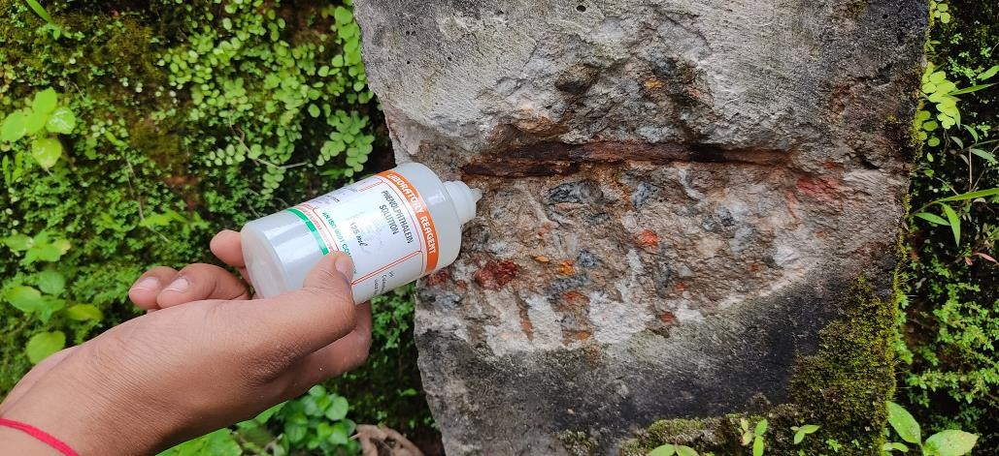
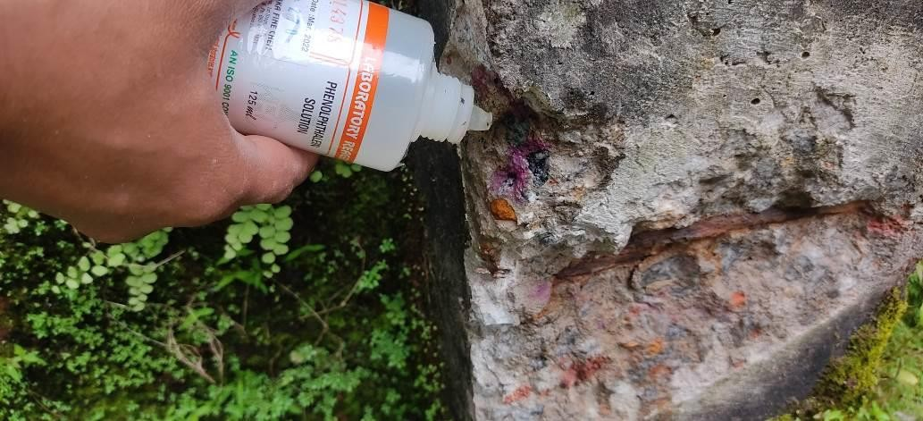

Fig-6 Carbonation test in progress

From the test results, it is inferred that, the carbonation front in concrete has reached upto reinforcement level in affected columns, indicating cover concrete has already lost its alkalinity which is essential to protect the reinforcing bars against potential corrosion.

III. Theoretical Analysis And Design Verification

Theoretical verification is carried-out by independent analysis and design check of the existing building. Three-dimensional analytical model was generated as per the framing plan prepared and dimensional data collected at site, using structural analysis software ETABS The design loads are considered as per the guidelines in the relevant Indian standards. The material properties are assigned as per the results of the non-destructive tests carried-out.

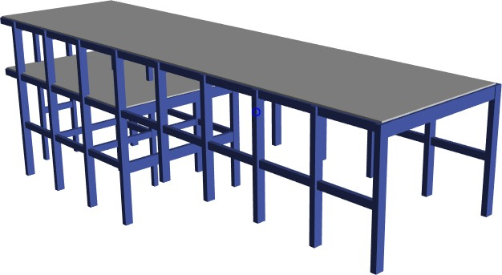

Fig-7 -D view of the analytical model of the building generated using ETABS software.

- The grades of concrete and steel considered for analysis:
The grade of concrete considered is M 20 for all RC members.
The grade of reinforcing steel considered is Fe 415 for all RC members.

Design standards for the theoretical verification
Design check was carried out for all the design loads based on the following “Indian Standard specifications or codes of practice.
IS 875 – 1987- Code of practice for design loads | Part 1 – Unit weight of Building Materials Part 2 – Live loads
IS : 456 – 2000 – code of Practice for Plain and reinforced concrete
SP 16 – 1980 –Design aid for Reinforced concrete to IS : 456-1978

Loads
The design loads were considered as commercial building loadings on all floors.
Dead load

Self-weight of existing rc members
Self-weight of the slab (For 150mm thick) 1x1x0.15 x 25 | : | = 3.75 kN/m²

Super imposed/ dead loads
Table-1
Floor Finishes / WPC | : | 1.5 kN/ m2
External wall- 230mm thick brick wall = 0.23x2.8x22 | : | 14.16 kN/m
Internal wall-150 mm thick brick wall = 0.15x2.8x22 | : | 9.3 kN/m
Size stone masonry wall load on strip footing at grid A - 9  (1.0 m wide and 3.0 m depth) = 1.0x3.0x24 | : | 72.0 kN/m
Size stone masonry wall load on strip footing at grid A – 9  (0.6 m wide and 3.0 m depth) = 0.6x3.0x24 | : | 43.2 kN/m
Size stone masonry wall load on strip footing at grid C – 3  (0.6 m wide and 3.0 m depth) = 0.6x1.8x24 | : | 26.0 kN/m

Live load

Live load on ground floor | : | 4.0 kN/ m²
Live load (Terrace) | : | 2.0 kN/ m²

Load Combinations
The following are the load combinations are considered for the analysis and design check. DL+LL
1.5 DL +LL

Results of the Theoretical Analysis and Design Check:
Analysis and design check of the existing building is carried out for gravity load combinations only seismic loads are not considered for design check.
The outcome of theoretical verification is outlined below.

RC Footing:
Based on the theoretical analysis and design check, the results are tabulated below. SBC considered is 150kN/sqm at 3.0 depth from basement floor. (Building considering part basement plus ground floor only.)

Table-2

Sl No | Column footing | Footing size (L x B x D) (m) | Upward pressure for gravity load  combinations (kN/sqm) | Remark
 | Grid A -9 | Strip footing |  | Hence existing
1. | (Part Basement | 1.0 wide and | 120 to 150 kN/sq.m | footing size is just
 | + Ground floor) | 0.3 m depth |  | adequate to bear
2. | Grid C -3 (Ground floor) | Strip footing  1.0 wide and  0.3 m depth | 100 to 120 kN/sq.m | the part basement  plus ground floor only

From the results of the theoretical analysis and design check, it is found that the size and cross-sectional area of reinforcement provided in the existing columns are found to be “Structurally adequate” for the design loads. (Building considering part basement plus ground floor only).

IV INFERENCES
Following are the inferences drawn, based on the detailed observations and results of probing tests:
- Based on the observations made at site there is no signs of settlement of foundation system in any part of the building.
- From the results of the Non-Destructive tests, it is inferred that the quality and strength of concrete in RC members is satisfactory.
- Based on the theoretical analysis and design check, it is inferred that the cross- sectional area of the existing footings are just adequate to bear the design loads for part basement plus ground floor only
- Based on the theoretical analysis and design check, it is inferred that the cross- sectional area of reinforcement provided in columns, beams and slabs are adequate for design loads for part basement plus ground floor only.
- The observed distress features such as spalling of cover concrete and exposure of rebars in RC members and dampness/damp patches, growth of fungus, algae on internal, external surface of walls are mainly due to weathering action, age effect and ingress of rain water, abandoned building over a long period etc., The building calls for appropriate restoration measures to render the affected region normal.
V Recommended Remedial Measures

Based on the inferences drawn, the following remedial measures are recommended.

Scheme – 1 : Treatment for locally damaged region of RC members.

- Existing spalled /loose concrete in the RC members shall be completely removed by gentle chipping to expose hard / sound concrete.
- Exposed concrete surface shall be grinded to remove all algae/ fungus, loose particles etc.,
- Exposed surface of concrete and reinforcing bars shall be thoroughly cleaned with air and water jet to remove dust particles.
- Two coats of anti-corrosive chemical shall be provided on the exposed and cleaned reinforcing bars as per manufacturer’s specification.
- A layer of weld mesh 50 x 50 x 3 mm shall be placed and fixed to concrete using shear connectors at as per sketch for staircase cutout cantilever beams at basement floor ceiling level.
- 20 mm thick (minimum) polymer modified mortar plaster shall be provided and finished in flush with the adjacent surface over a coat of primer as per manufacturer’s specification and cured.
- Existing honeycombed regions in rc beams shall be grouted with neat cement slurry added with expansive agent after fixing packers with non-return valve as per manufacture’s specifications. (With a pressure of 3 to 4 kg/sq.cm)
- Ground floor columns shall be plastered with polymer modified mortar plaster over a coat of bonding agent after removing all fungus, loose material by grinding as per standards and as per manufacturer’s specification.
VI Conclusion

The existing partially constructed SBI building at Sringeri Taluk, Chikkmagalur district is a combination of RC framed and loadbearing wall structure (size-stone masonry walls) comprising of part-basement and columns are raised in ground floor level up-to lintel height. It was reported that, the construction work was stopped during the year 2002 (20 years back) due to some administrative issue.
Based on the theoretical analysis and design check, it is concluded that the existing footings and columns are structurally adequate for part basement plus ground floor considering gravity loads only.
The observed distress features such as spalling of cover concrete and exposure of rebars in RC members and dampness/damp patches, growth of fungus, algae on internal, external surface of walls are mainly due to weathering action, age effect and ingress of rain water, abandoned building over a long period etc.,
The present distress features, if not attended, will affect the long-term safety, durability and serviceability of such members. Hence the same cannot be ignored. It is essential to carryout suggested remedial measures to render the affected members safe and durable.
On carrying out the recommended measures by experienced agency effectively under the guidance of experienced technical personnel, the distressed members can be rendered safe and serviceable.

REFERENCES

[1] Carlos E Ventura, Mahmoud Rezai, Helmut Prion, Aug 2004, Simplified and detailed finite element models of steel late shear walls, 13th world conference on earthquake engineering, Canada.
[2] Jeffrey W. Berman, Patricia M. Clayton, Laura N. Lowes, Michel Bruneau, Larry A. Fahnestock, and Keh-Chyuan Tsai, 2010, Development of a recentering steel plate shear wall and addressing critical steel plate shear wall research needs, 10th Canadian conference on earthquake engineering, Canada.
[3] Gangisetty Sri Harsha, Dr. H. Sudarsana Rao, Aug 2015, Shear wall analysis & design optimization in high rise buildings, International journal of engineering sciences & research technology (IJESRT).
[4] Kai Hu, Yimeng Yang, Suifeng Mu, Ge Qu, 2012, Study on High-rise Structure with Oblique Columns by ETABS, SAP2000, MIDAS/GEN and SATWE, Elsevier, Vol 31, pages 474-480.
[5] Khushbu Jani, Paresh V. Patel, 2013, Analysis and design of diagrid structural system for high rise steel building, Elsevier, Vol 51, pages 92-100.
[6] Pundkar R. S, Alandkar P. M, 2013, Influence of steel plate shear wall on multi-storey building, international journal of Engineering Research and Applications (IJERA).
[7] Mohammad Anwar-Us-Saadat, Mahmud Ashraf, Shameem Ahmed, 2016, Behaviour and design of stainless steel slender cross-sections subjected to combined loading,Elsevier, Vol 104, pages 225-237.
[8] Masoumeh Gholipour, Mohamad Mehdi Alinia, 2016, Behaviour of multi-story codedesigned steel plate shear wall structures regarding bay width, Elsevier, Vol 122, pages 40-56.
[9] Mohammad hossein Akhavan, Abdolreza Joghataie, Nader K.A.Attari, 2016, Analysis and design recommendations for diagonally stiffened steel plate shear walls, Elsevier, Vol
103, pages 72-80.
[10] Ricky Chana, Faris Albermanib and S. Kitipornchai, 2011, Stiffness and strength of perforated steel plate shear wall, Vol 14, pages 675-679.

